# INDEX

|  |  |  |
| --- | --- | --- |
| *Serial Number* | *Topic* | *Page Number* |
| **i.** | Creating a Employee and Department Table |  |
| **ii.** | Inserting Values of Table |  |
| **iii.** | Create a Primary and foreign Key |  |
| **1.** | Query to display Employee Name, Job, Hire Date, Employee Number; for each employee with the Employee Number appearing first. |  |
| **2.** | Query to display unique Jobs from the Employee Table. |  |
| **3.** | Query to display the Employee Name concatenated by a job separated by a comma. |  |
| **4.** | Query to display all the data from the Employee Table. Separate each Column by a comma and name the said column as THE_OUTPUT. |  |
| **5.** | Query to display the Employee Name and Salary of all the employees earning more than $2850. |  |
| **6.** | Query to display Employee Name and Department Number for the Employee No= 79. |  |
| **7.** | Query to display Employee Name and Salary for all employees whose salary is not in the range of $1500 and $2850. |  |
| **8.** | Query to display Employee Name and Department No. of all the employees in Dept 10 and Dept 30 in the alphabetical order by name. |  |
| **9.** | Query to display Name and Hire Date of every Employee who was hired in 1981. |  |
| **10.** | Query to display Name and Job of all employees who have not assigned a supervisor. |  |
| **11.** | Query to display the Name, Salary and Commission for all the employees who earn commission. |  |
| **12.** | Sort the data in descending order of Salary and Commission. |  |
| **13.** | Query to display Name of all the employees where the third letter of their name is ‘A’. |  |
| **14.** | Query to display Name of all employees either have two ‘R’s or have two ‘A’s in their name and are either in Dept No = 30 or their Manger’s Employee No = 7788. |  |
| **15.** | Query to display Name, Salary and Commission for all employees whose Commission amount is greater than their Salary increased by 5%. |  |
| **16.** | Query to display the Current Date along with the day name. |  |
| **17.** | Query to display Name, Hire Date and Salary Review Date which is the 1st Monday after six months of employment. |  |
| **18.** | Query to display Name and calculate the number of months between today and the date on which employee was hired of department ‘Purchase’. |  |
| **19.** | Query to display the following for each employee earns < Salary> monthly but wants < 3 * Current Salary >. Label the Column as Dream Salary. |  |
| **20.** | Query to display Name with the 1st letter capitalized and all other letter lower case and length of their name of all the employees whose name starts with ‘J’, ’A’ and ‘M’. |  |
| **21.** | Query to display Name, Hire Date and Day of the week on which the employee started. |  |
| **22.** | Query to display Name, Department Name and Department No for all the employees. |  |
| **23.** | Query to display Unique Listing of all Jobs that are in Department number 30. |  |
| **24.** | Query to display Name, Dept Name of all employees who have an ‘A’ in their name. |  |
| **25.** | Query to display Name, Job, Department No. And Department Name for all the employees working at the Dallas location. |  |
| **26.** | Query to display Name and Employee no. Along with their supervisor’s Name and the supervisor’s employee no; along with the Employees’ Name who do not have a supervisor. |  |
| **27.** | Query to display Name, Dept No. And Salary of any employee whose department No. and salary matches both the department no. And the salary of any employee who earns a commission. |  |
| **28.** | Query to display Name and Salaries represented by asterisks, where each asterisk (*) signifies $100. |  |
| **29.** | Query to display the Highest, Lowest, Sum and Average Salaries of all the employees |  |
| **30.** | Query to display the number of employees performing the same Job type functions. |  |
| **31.** | Query to display the total number of supervisors without listing their names. |  |
| **32.** | Query to display the Department Name, Location Name, No. of Employees and the average salary for all employees in that department. |  |
| **33.** | Query to display Name and Hire Date for all employees in the same dept. as Blake. |  |
| **34.** | Query to display the Employee No. And Name for all employees who earn more than the average salary. |  |
| **35.** | Query to display Employee Number and Name for all employees who work in a department with any employee whose name contains a ‘T’. |  |
| **36.** | Query to display the names and salaries of all employees who report to supervisor named ‘King’ |  |
| **37.** | Query to display the department no, name and job for all employees in the Sales department |  |
| **38.** | Display names of employees along with their department name who have more than 20 years’ experience |  |
| **39.** | Display total number of departments at each location |  |
| **40.** | Find the department name in which at least 20 employees work in. |  |
| **41.** | Query to find the employee’ name who is not supervisor and name of supervisor supervising more than 5 employees. |  |
| **42.** | Query to display the job type with maximum and minimum employees |  |

Create table Department

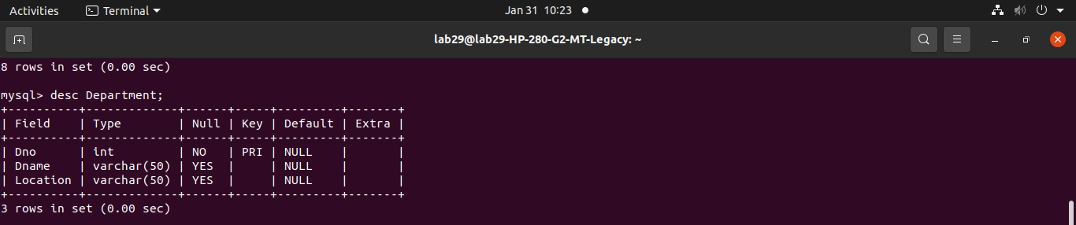

Create table Employee

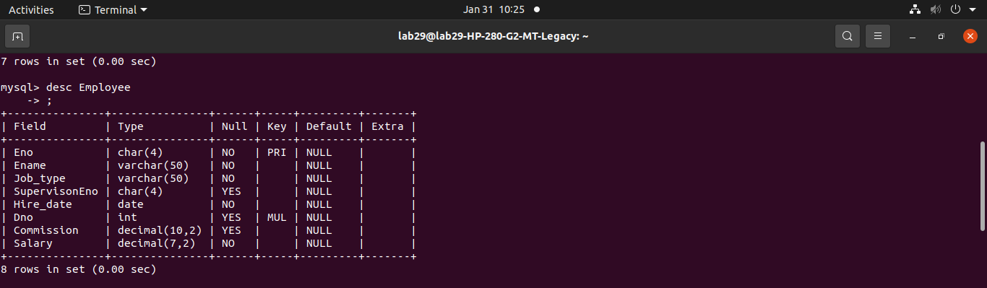

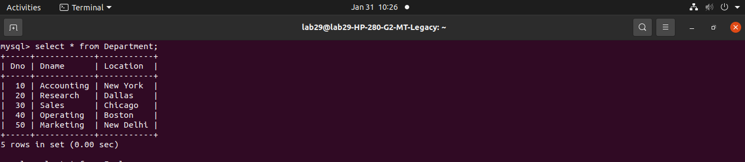Insert values in Department Table

Insert values in Employee Table

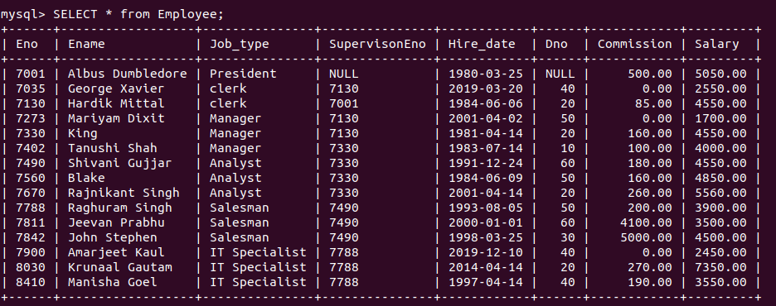

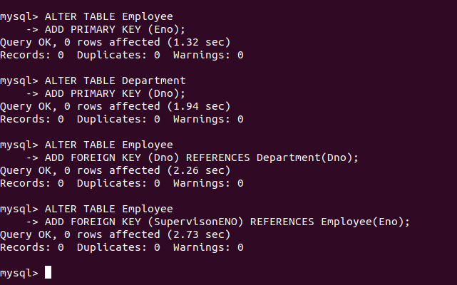Create Primary and Foreign key



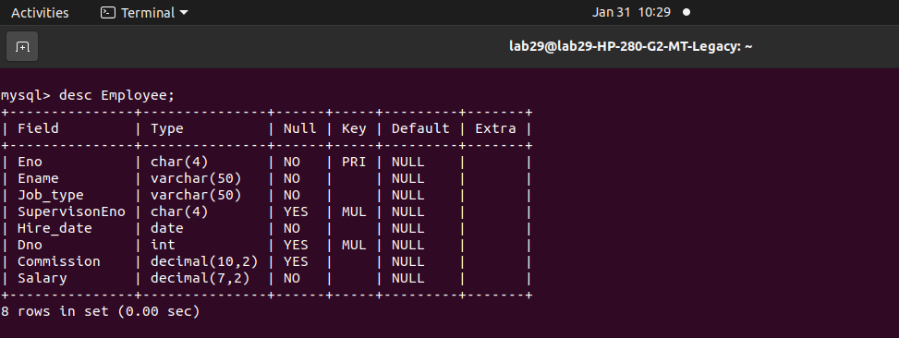

***Q-1: Query to display Employee Name, Job, Hire Date, Employee Number; for each employee with the Employee Number appearing first.***

SELECT Eno AS ‘Employe Number’,

Ename AS ‘Employee Name’,

job_type AS ‘job’,

Hire_date AS ‘Hire Date’

FROM Employee;

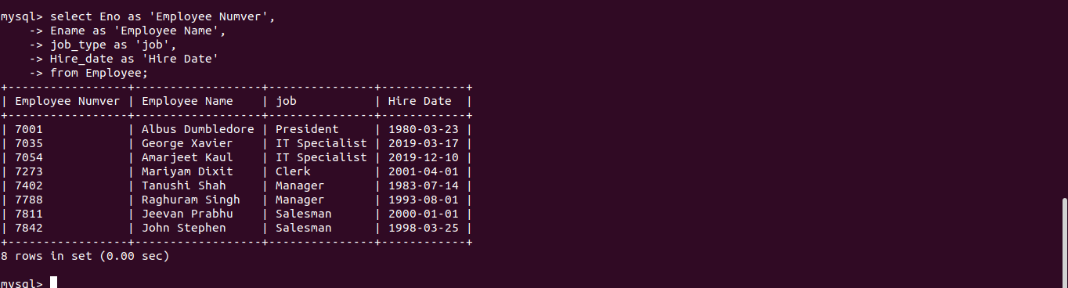

***Q-2: Query to display unique Jobs from the Employee table.***

SELECT distinct job_type AS ‘Unique Jobs’ FROM Employee;

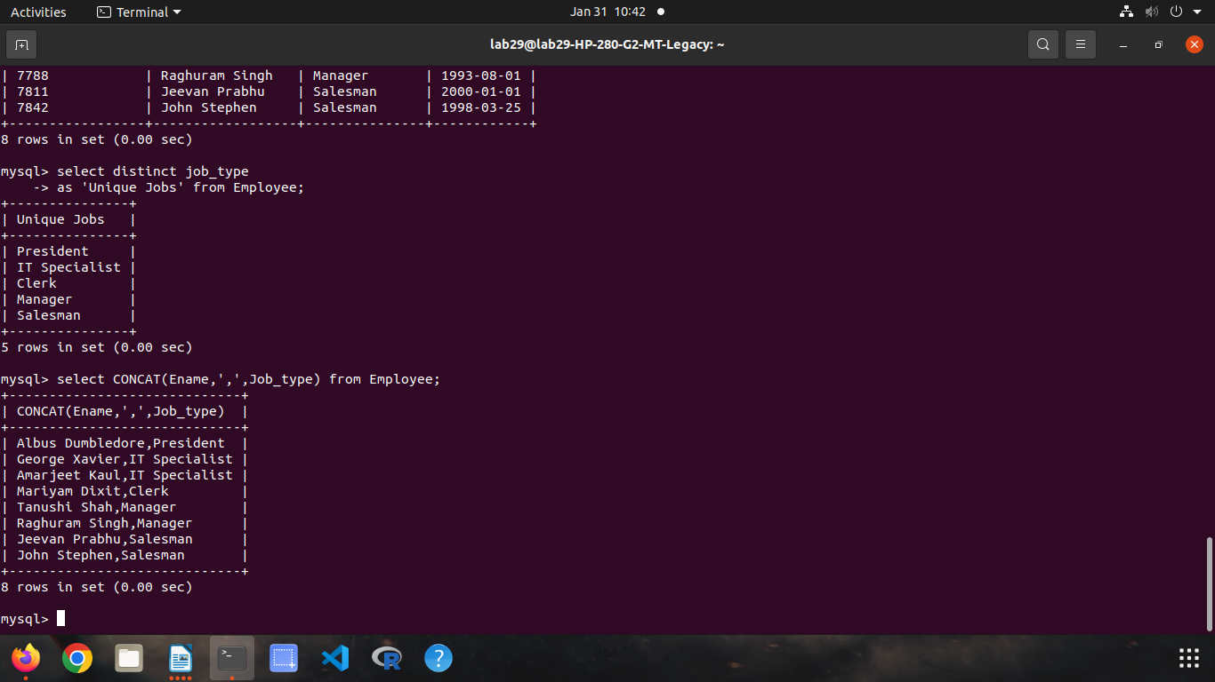

***Q-3 Query to display the Employee Name concatenated by a Job sepetated by a comma.***

Select concat(Ename,’,’,Job_type) from Employee;



***Q-4: Query to display all the data from the Employee Table.Separate each Column by a comma and name the said column as THE_OUTPUT.***

SELECT Concat_WS(‘,’,Eno,Ename,

Job_type,SupervisionEno, Hire_date,

Dno,Commission,Salary)

AS THE_OUTPUT

FROM EMPLOYEE

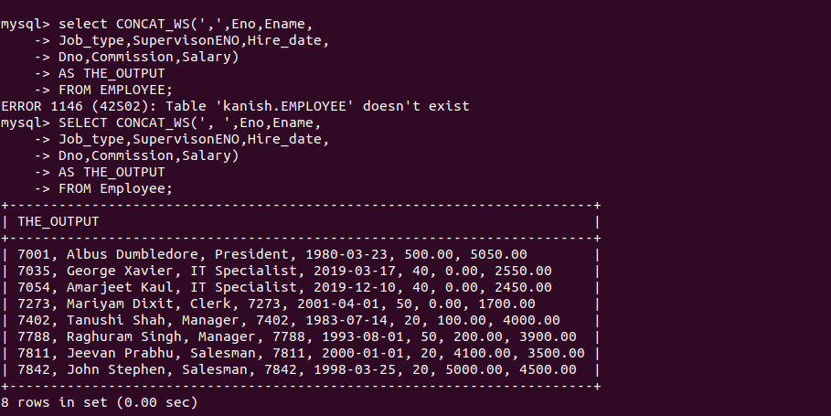

***5. Query to display the Employee Name and Salary of all the employees earning more than $2850.***

Select Ename,Salary from Employee

Where salary >2840;

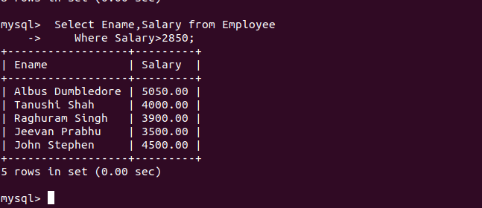

***6. Query to display Employee Name and Department Number for the Employee No= 7900.***

select Ename , Dno from Employee

where Eno=7900;



***7. Query to display Employee Name and Salary for all employees whose salary is not in the range of $1500 and $2850.***

select Ename , Salary from Employee

where Salary Not Between 1500 and 2850;

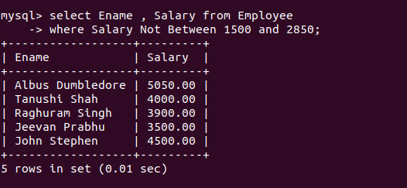

***8. Query to display Employee Name and Department No. of all the employees in Dept 10 and Dept 30 in the alphabetical order by name.***

SELECT Ename,Dno from Employee

where Dno=10 and 30

Order by Ename;

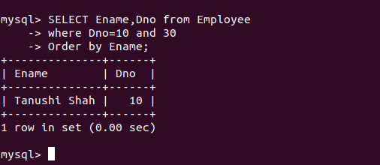

***9. Query to display Name and Hire Date of every Employee who was hired in 1981.***

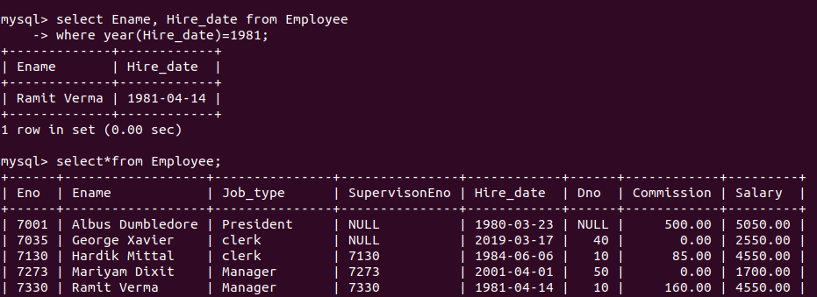select Ename, Hire_date from Employee

where year(Hire_date)=1981;

***10. Query to display Name and Job of all employees who have not assigned a supervisor.***

Select Ename,job_type

From Employee

Where SupervisonEno is null;

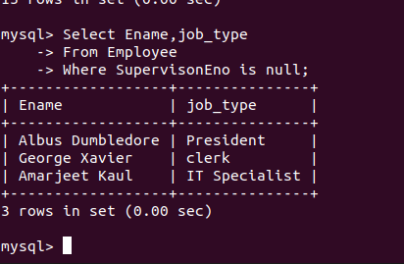

***11. Query to display the Name, Salary and Commission for all the employees who earn commission.***

Select Ename, Salary,Commission From Employee

Where Commission>0.00 and Commission IS NOT NULL;

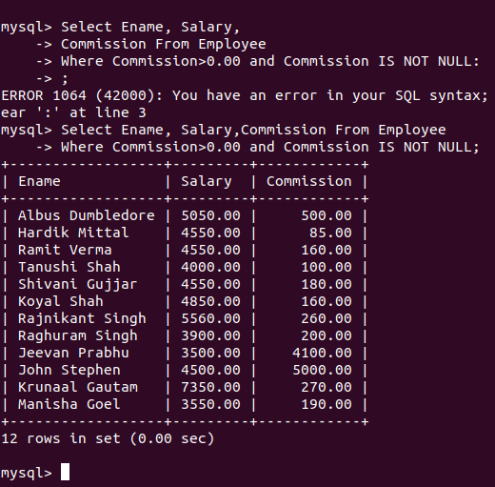

***12. Sort the data in descending order of Salary and Commission.***

ALTER TABLE Employee

ORDER BY Salary DESC;

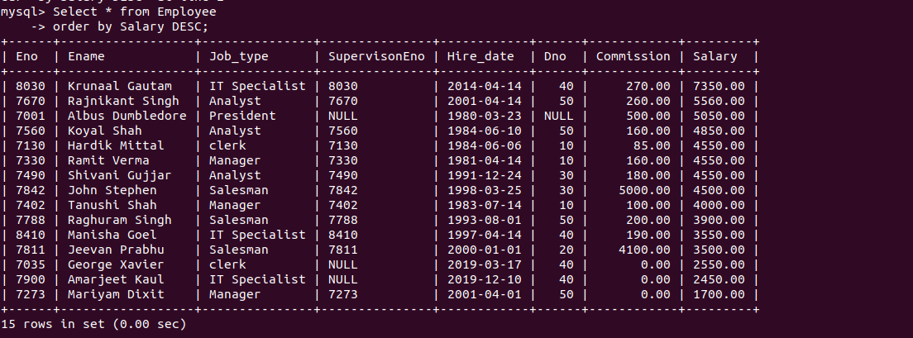

ALTER TABLE Employee

ORDER BY Commission DESC;

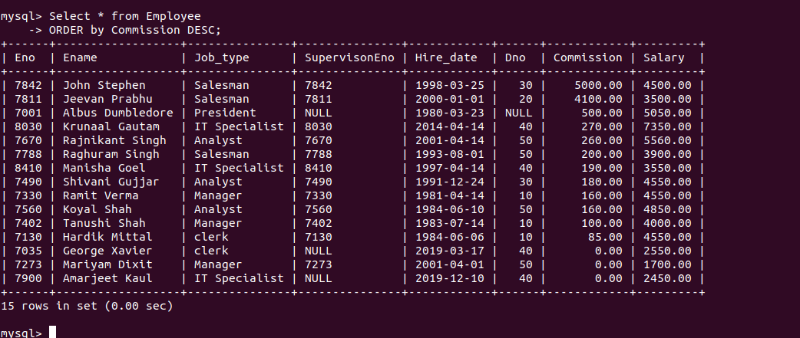

***13. Query to display Name of all the employees where the third letter of their name is ‘A’.***

SELECT Ename from Employee

Where Ename LIKE '__A%';

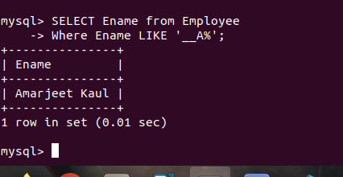

***14. Query to display Name of all employees either have two ‘R’s or have two ‘A’s in their name and are either in Dept No = 30 or their Manger’s Employee No = 7788.***

SELECT Ename FROM Employee

WHERE ( Ename LIKE '%r%r%' OR Ename LIKE '%a%a%')

AND (Dno=30 OR SupervisonEno='7788');

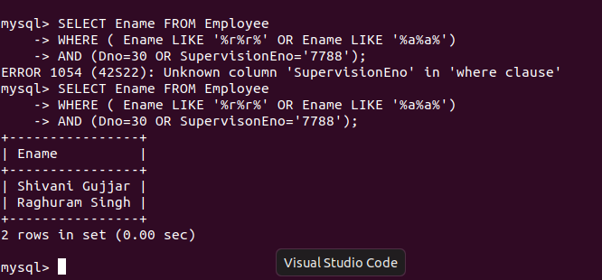

***15. Query to display Name, Salary and Commission for all employees whose Commission amount is greater than their Salary increased by 5%.***

SELECT Ename, Salary, Commission

From Employee

WHERE Commission > Salary+(Salary * 0.05);

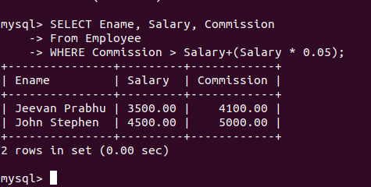

***16. Query to display the Current Date along with the day name.***

SELECT CURDATE(),DAYNAME(CURDATE());

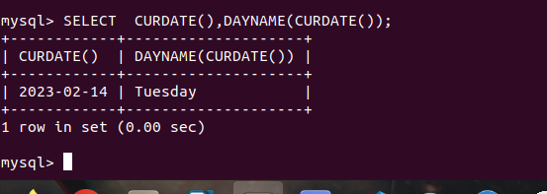

***17. Query to display Name, Hire Date and Salary Review Date which is the 1st Monday after six months of employment.***

SELECT Ename,Hire_date, date_add(date_add(Hire_date, INTERVAL 6 MONTH),

INTERVAL (7-WEEKDAY(date_add(Hire_date, INTERVAL 6 MONTH)))DAY) AS REVIEW_DATE

FROM Employee;

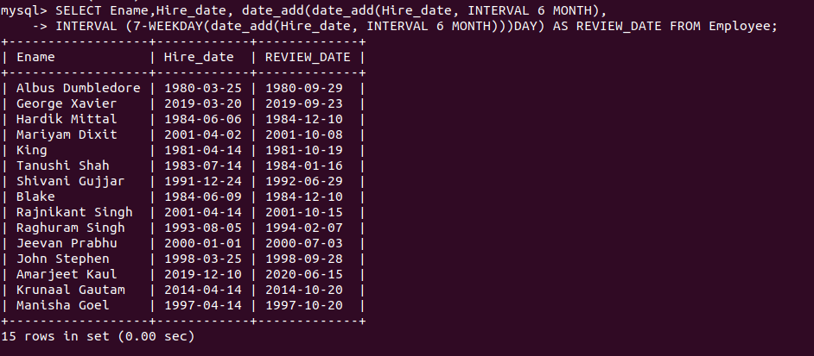

***18. Query to display Name and calculate the number of months between today and the date on which employee was hired of department ‘Purchase’.***

SELECT Ename,

(YEAR(CURDATE())-YEAR(Hire_date))*12+

(MONTH(CURDATE())-MONTH(Hire_date))

AS 'No of months after hire'

FROM Employee, Department

WHERE Employee.Dno=Department.Dno

AND Department.Dname='Purchase';

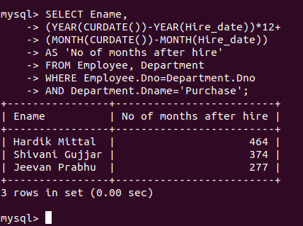

***19. Query to display the following for each employee <E-Name> earns < Salary> monthly but wants < 3 * Current Salary >. Label the Column as Dream Salary.***

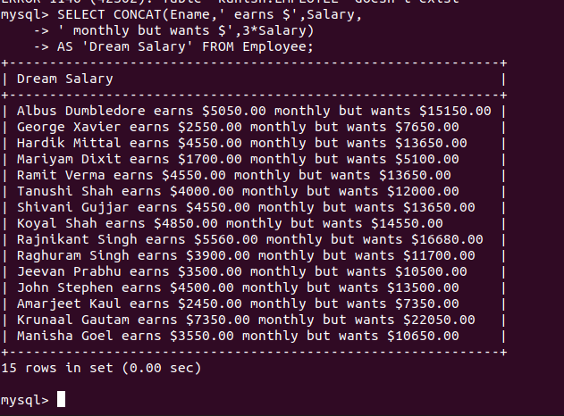SELECT CONCAT(Ename,' earns $',Salary,' monthly but wants $',3*Salary)

AS 'Dream Salary' FROM EMPLOYEE;

***20. Query to display Name with the 1st letter capitalized and all other letter lower case and length of their name of all the employees whose name starts with ‘J’, ’A’ and ‘M’.***

SELECT CONCAT( UPPER(SUBSTRING(Ename,1,1)), LOWER(SUBSTRING(Ename,2,50))) AS NAME,LENGTH(Ename) AS LENGTH FROM Employee WHERE Ename LIKE 'J%'

OR Ename LIKE 'A%' OR Ename LIKE 'M%';

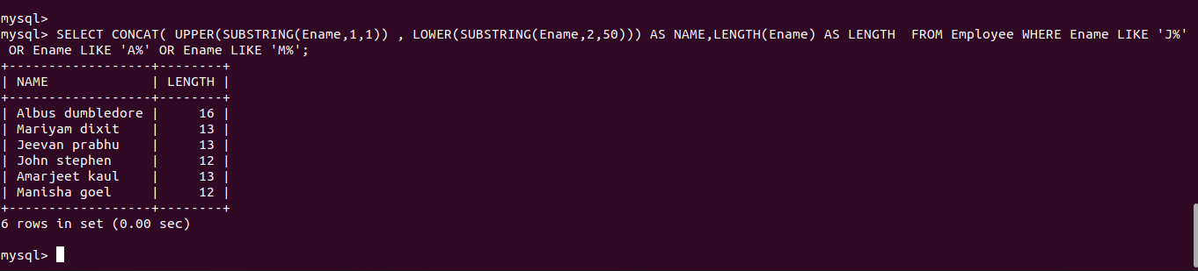

***21. Query to display Name, Hire Date and Day of the week on which the employee started.***

SELECT Ename, Hire_date,

DAYNAME(Hire_date)

AS'Day of Week when Hired'

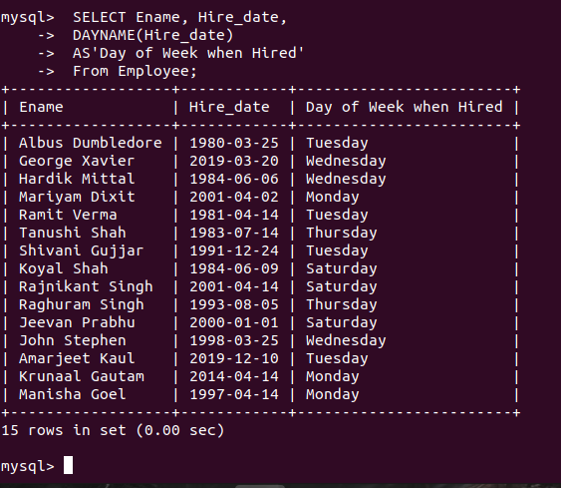 From Employee;

***22. Query to display Name, Department Name and Department No for all the employees.***

SELECT Ename, Dname, Department.Dno

FROM Employee, Department

Where Employee.Dno=Department.Dno;

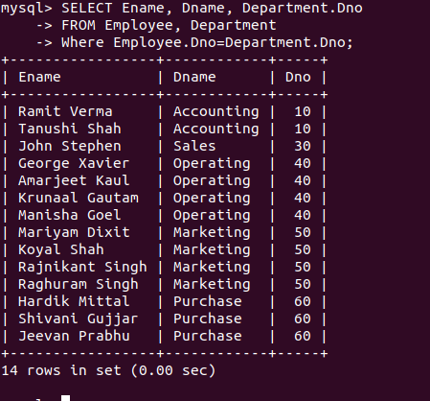

***23. Query to display Unique Listing of all Jobs that are in Department number 30.***

SELECT DISTINCT Job_type

AS 'Unique Jobs in dep 30'

FROM Employee WHERE Dno=30;

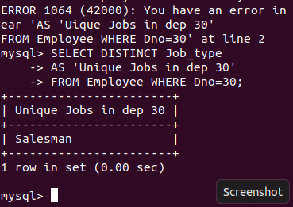

***24. Query to display Name, Dept Name of all employees who have an ‘A’ in their name.***

select Ename, Dname

From Employee, Department

WHERE Employee.Dno=Department.Dno

AND Ename LIKE '%A%';

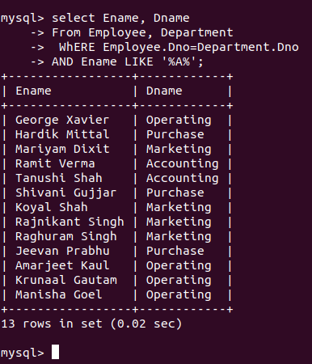

***25. Query to display Name, Job, Department No. And Department Name for all the employees working at the Dallas location.***

SELECT Ename , Job_type, E.Dno, Dname

FROM Employee AS E, Department AS D

WHERE E.Dno=D.Dno AND D.Location='Dallas';

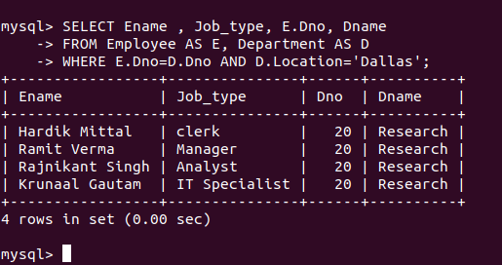

***26. Query to display Name and Employee no. Along with their supervisor’s Name and the supervisor’s employee no; along with the Employees’ Name who do not have a supervisor.***

SELECT e.Ename,e.Eno,d.Ename as SupervisonName,d.Eno as SupervisonEno

FROM Employee AS e LEFT OUTER JOIN Employee as d

ON d.Eno=e.SupervisonEno;

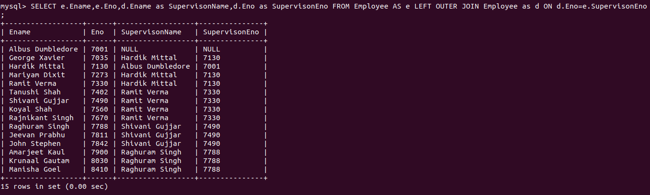

***27. Query to display Name, Dept No. And Salary of any employee whose department No. and salary matches both the department no. And the salary of any employee who earns a commission.***

SELECT A.Ename , A.Dno, A.Salary

From Employee AS A, Employee AS B

WHERE A.Dno= B.Dno ANd A.Salary =B.Salary AND B.Commission > 0.0;

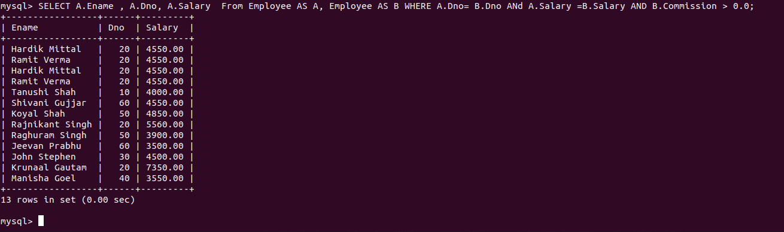

***28. Query to display Name and Salaries represented by asterisks, where each asterisk (*) signifies $100.***

SELECT Ename, REPEAT ('*', (Salary/1000)) AS Salary

From Employee;

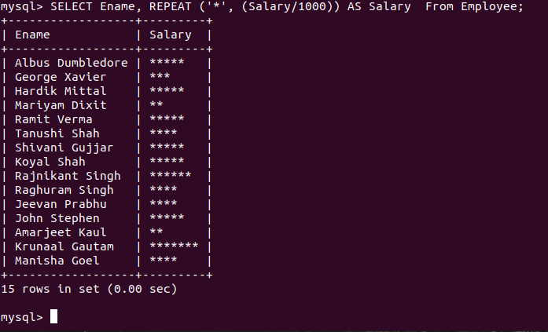

***29. Query to display the Highest, Lowest, Sum and Average Salaries of all the employees***

SELECT MAX(Salary) AS Maximum, MIN(Salary) AS Minimum, AVG(Salary) AS

Average from Employee;

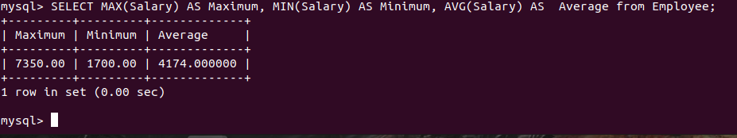

***30. Query to display the number of employees performing the same Job type functions.***

SELECT Job_type,COUNT(*)

FROM Employee

GROUP BY Job_type;

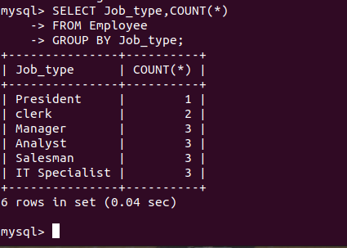

***31. Query to display the total number of supervisors without listing their names.***

SELECT COUNT(DISTINCT SupervisonEno)

FROM Employee;

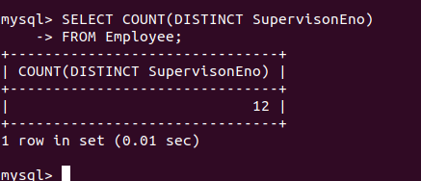

***32. Query to display the Department Name, Location Name, No. of Employees and the average salary for all employees in that department.***

SELECT Dname, Location,

COUNT(*) AS NumberOfEmployees,

ROUND(AVG(Salary),2) AS AvSalary

From Employee

NATURAL JOIN Department

GROUP By Employee.Dno;

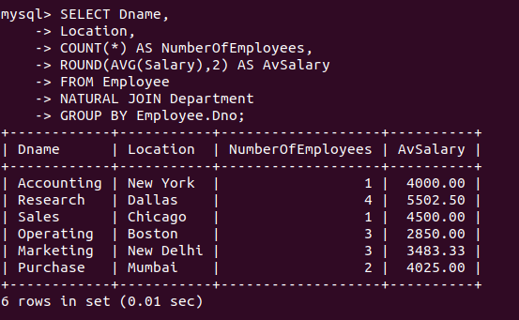

***33. Query to display Name and Hire Date for all employees in the same dept. as Blake.***

SELECT Ename, Hire_Date From Employee WHERE Dno IN(SELECT Dno From Employee WHERE Ename LIKE 'Blake%');

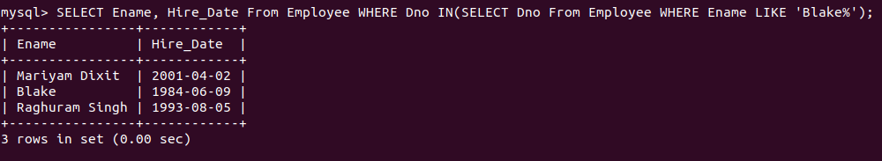

***34. Query to display the Employee No. And Name for all employees who earn more than the average salary.***

SELECT Eno,Ename FROM Employee

WHERE Salary > (Select AVG(Salary) FROM Employee);

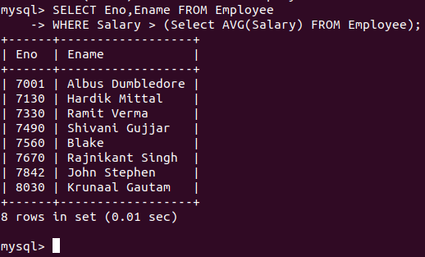

***35. Query to display Employee Number and Name for all employees who work in a department with any employee whose name contains a ‘T’.***

SELECT Eno, Ename

FROM Employee

WHERE Dno IN(SELECT Dno FROM Employee WHERE Ename LIKE '%T%');

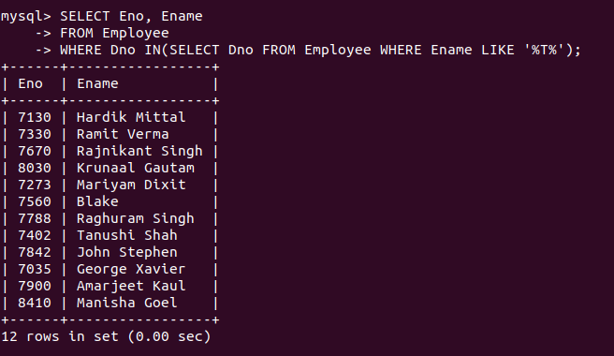

***36. Query to display the names and salaries of all employees who report to supervisor named ‘King’***

SELECT Ename, Salary

FROM Employee

WHERE SupervisonEno = (SELECT Eno FROM Employee WHERE Ename = 'King');

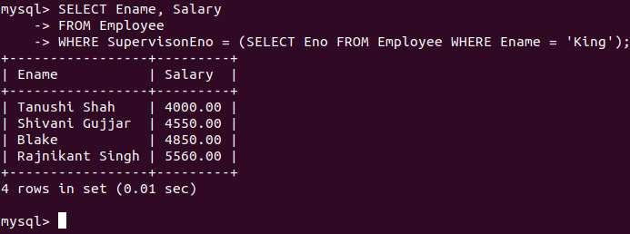

***37. Query to display the department no, name and job for all employees in the Sales department***

SELECT D.Dno, D.Dname, E.Job_type

FROM Department AS D, Employee AS E

WHERE E.Dno = D.Dno AND D.Dname = 'Sales';

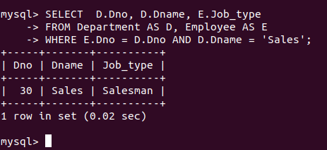

***38. Display names of employees along with their department name who have more than 20 years experience***

SELECT E.Ename, D.Dname

FROM Employee AS E, Department AS D

WHERE E.Dno = D.Dno AND YEAR(CURDATE())-YEAR(E.Hire_date) > 20;

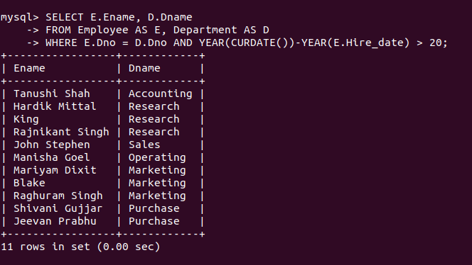

***39. Display total number of departments at each location***

SELECT Count(Dname) FROM Department group by(Location);

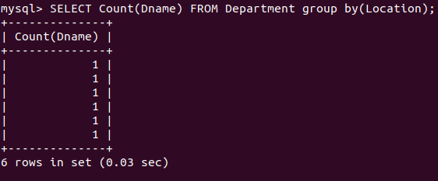

***40. Find the department name in which at least 20 employees work in.***

SELECT Dname From Department

WHERE (SELECT COUNT(*) FROM Employee AS e

WHERE e.dno=dno)>10;

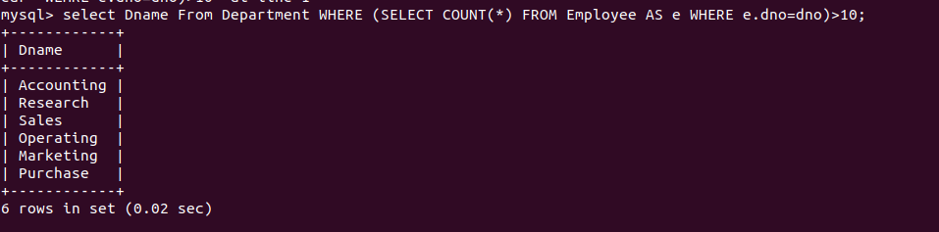

***41. Query to find the employee’ name who is not supervisor and name of supervisor supervising more than 5 employees.***

SELECT GROUP_CONCAT(e.Ename ORDER BY e.Ename ASC SEPARATOR ', ')

AS Employee_names, s.Ename AS supervisor_name

From Employee e inner JOIN Employee s ON e.SupervisonEno = s.eno

WHERE not(e.SupervisonEno is null) GROUP BY e.supervisonEno Having COUNT(*)>=5;

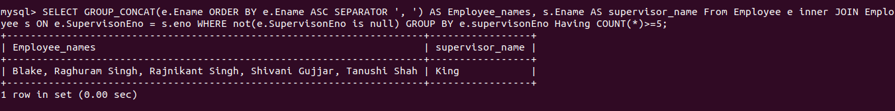

***42. Query to display the job type with maximum and minimum employees***

SELECT Job_type AS Job_type_min_Employee

FROM Employee

GROUP BY Job_type

ORDER BY COUNT(*)

LIMIT 1;

SELECT Job_type AS Job_type_max_Employee

FROM Employee

GROUP BY Job_type

ORDER BY COUNT(*) DESC

LIMIT 1;

