**IT:Network:PowerShell**



**Class Syllabus**

Catalog #10-150-192 & Class #81143

Starts: Week of August 31st Ends: December 14th

**Instructor Information**

**Instructor**: Michael J. Teske

**Office**: BT248G

**Telephone**: (920)498-6835

**E-mail**: [michael.teske@nwtc.edu](mailto:michael.teske@nwtc.edu) (preferred method)

**Email Subject Line**: *POSH*

**Office Hours**: By appointment (see office hours listed below)

**Course Description**: Introduction to PowerShell concepts and how it is used for managing Microsoft networks. Students will develop a fundamental understanding of Windows management using native cmdlets, programming logic and script development.

### Credits: 2

**Class Schedule:**

|  |  |  |  |  |
| --- | --- | --- | --- | --- |
| Day | Format | Course Number | Time | Room# |
| Thursday | Lecture/Lab | 81143 | 11:30am-2:20pm | BT253 |

**Location**: GREEN BAY, BT253

**Pre-requisites:** IT:Network:Network Essentials/IT:Network:Client Operating Systems;IT:Network:Microsoft Server 1

**Textbook**: *Learn PowerShell in a Month of Lunches, 3rd Edition*, Don Jones, Jeff Hicks,

ISBN: 9781617294167

**Additional:** One Microsoft Account:

<http://windows.microsoft.com/en-US/windows-live/sign-up-create-account-how>

**Optional**: External storage drive is recommended (USB thumb drive)

**Academic Coaching at NWTC**

Academic Coaching is available for most courses at NWTC. On the Green Bay Campus, visit us at the Student Success Center in SC215 or check us out at [www.nwtc.edu/academiccoaching](http://www.nwtc.edu/academiccoaching) for more information.

**Course Competencies**: You have the opportunity to learn the following skills in this course:

1. Use PowerShell Help
2. Use PowerShell cmdlets
3. Create PowerShell scripts
4. Use PowerShell providers
5. Use PowerShell remoting and jobs
6. Create PowerShell functions
7. Use WMI/CIM
8. Use PowerShell for Active Directory Management
9. Customize PowerShell environment

**Employability Skills**: In addition to specific job-related training, NWTC has identified core abilities that are transferable and go beyond the context of a specific course. This class addresses the following employability skills:

* *Communicate Effectively*
* *Work Cooperatively and Professionally*
* *Think Critically and Creatively*
* *Solve Problems Effectively*
* *Value Individual Differences and Abilities*
* *Demonstrate Personal Accountability*
* *Demonstrate Community and Global Accountability*

**Student Responsibilities:** As a student of NWTC, you are expected to adhere to the policies of the College, as outlined by the Student Handbook (see below).

* You are responsible for the duties set forth in this class and to communicate any questions, comments or concerns you have to me.
* You are required to monitor your NWTC Student Email account. Acceptable means of communication include e-mail, voicemail or through online discussion forums.
* You are responsible to log into your Starfish portal to monitor your success progress
* You can expect a reply to communication within 1-2 business days.
* Use of correct grammar and punctuation is required in all written communications.

**Student Policies**: Please refer to the NWTC Student Handbook for further definitions and consequences of these behaviors, available through Student Services, the NWTC Bookstore or by visiting <http://www.nwtc.edu> and click on **Current Students** tab.

Please be fully aware of the following Student Handbook policies:

* Academic Integrity (includes Plagiarism, cheating and collusion)
* Affirmative Action/Equal Opportunity Statement
* Assessment
* Copyright Notice
* Refund Policy
* Student Code of Conduct
* Withdrawal from a Class or Program
* Student Rights
* Sexual Misconduct (Title IX)
* Pregnancy and Childbirth (Title IX)
* Accommodation for Religious Beliefs Policy

NWTC is committed to embracing the worth of every individual and promoting a respectful environment. Discrimination and harassment of protected categories in its employment and educational programs is prohibited. For questions or concerns, contact Mohammed Bey, Director of Diversity & Inclusion/Title IX Coordinator, at (920) 498-6826 or [mohammed.bey@nwtc.edu](mailto:mohammed.bey@nwtc.edu).

**Appropriate Use of Technology:** Use of mobile device (tablet, notebook, MP3 player) device during class lecture sessions must be limited to note taking activities only. Internet browsing, sending/receiving email, text messages or other messaging activities are not permitted during class lecture sessions. Unless otherwise stated, no computing device is allowed during written examinations.

**Make-up Tests and Quizzes:** When arrangements are made in advance, reasonable efforts will be made to schedule make-up tests and quizzes. **Tests and quizzes must be made up one day prior to scheduled class meeting time.**  NWTC policy will be in effect for those examinations that can be taken in the Assessment Center (SC365). Lab exams will be handled on a case-by-case.

**Student e-mail:**  NWTC offers a student e-mail account for all students. You are responsible for monitoring your student e-mail account. Student e-mail can be accessed by visiting <http://www.nwtc.edu> and click on the **Current Students** tab. Student technical assistance is available 24 hours a day, 7 days a week. Call toll free: 1-866-235-5037.

**Handouts, Notes, Assignments:** The Network Specialist Capstone Course is a 4th semester course that requires the student to validate their skills gained in previous classes. It is permitted to use lab handouts, notes, assignments, etc. during the Capstone Course - please save your class documents.

**Disability Act Statement:** NWTC complies with all provisions of the Americans with Disabilities Act and makes reasonable accommodations upon request. Please contact Student Accommodations Services for more information regarding the support services available to you, call 920-498-6904.

**Syllabus Changes:** As your instructor, I retain the right to make changes based on the timeline of the class, feedback from learners and/or logistical issues and will inform you as soon as a change is made.

**Attendance and Participation:** Attendance and/or class participation is required. Students are responsible for contacting other students for missed assignments, handouts and notes. You will also be expected to make up missed lab exercises outside of lab and ***not*** during scheduled lab time. It is very important to keep up with the assigned lab exercises as the labs are progressive.

**Class Cancellation:** Class cancellations will be posted as early as possible at: <http://www.nwtc.edu/Lists/CancelClasses/WebView.aspx>

cid:image001.png@01CEDBBE.C74FD490**NWTC Cares about Your Success!**

Throughout the term you may receive emails from Starfish®, a student success project between NWTC and Starfish Retention Solutions. These emails will be regarding your course grades or academic performance. Please pay attention to these emails and take the recommended actions. These are sent to help you be successful!

In the message, you may be asked to contact your course instructor or a specific campus resource, such as academic coaching, academic advising or counseling. These services may also contact you directly.

You may also receive messages from your instructor recognizing academic achievements, known as “kudos.”

You can access Starfish via the tab found in Blackboard.

**Grading Policy**: The grade earned in this course is based on assessments throughout the semester. Assessments come in the form of classroom activities/projects, homework and exams.

**Grading Scale:**

|  |  |
| --- | --- |
| **% Points Attained** | **Grade** |
| 90-100 | A |
| 80-89 | B |
| 70-79 | C |
| 60-69 | D |
| 00-59 | F |

**Course Calendar:** The following is an outline of the semester calendar. This is subject to change.

|  |  |  |  |
| --- | --- | --- | --- |
| Week | Week of | Topic | Chapters |
| 1 | 8/31 | Course Introduction-classroom introduction-Overview;Getting Help | 1,2,3 |
| 2 | 9/7 | Running Commands;Working w/ Providers;The Pipeline | 4,5,6 |
| 3 | 9/14 | Adding Commands;Objects;The Pipeline-Deeper | 7,8,9 |
| 4 | 9/21 | Formatting;Filtering Comparisons | 10,11 |
| 5 | 9/28 | Interlude;Remote Control;WMI/CIM | 12,13,14 |
| 6 | 10/5 | Jobs;Working with many objects | 15,16 |
| 7 | 10/12 | Project week |  |
| 8 | 10/19 | ***Project due*** |  |
| 9 | 10/26 | *Security;Variables;Input and Output* | 17,18,19 |
| 10 | *11/2* | Sessions;Scripting;Parameters | 20,21,22 |
| 11 | 11/9 | Advanced Remoting;Regular Expressions | 23,24 |
| 12 | 11/16 | Active Directory (not in book); Tips/Tricks; Examination of another script | 25,26 |
|  | 11/23 | No class-Thanksgiving Break |  |
| 13 | 11/30 | Toolmaking-Part 1 |  |
| 14 | 12/7 | Toolmaking-Part 2 |  |
| 15 | 12/14 | Final Project due |  |

E-mail the answers to the following questions to your instructor. Please use the e-mail listed above under Instructor Information. *If you have a smartphone, add the Blackboard app found in your store. This will alert you of any changes (announcements, homework) via notification*.

1. What subject heading is to be used when communicating with the instructor?
2. When should missed lab activities be completed?
3. What is the makeup quiz policy?

**Important Dates:**

**Financial Aid disbursement:** September 14th

**60% Date (last day to withdraw without Assoc. Dean Permission):** Week of October 29th

**Last Day of class:** December 14th

**Instructor Schedule (office hours are by appointment and subject to change)**

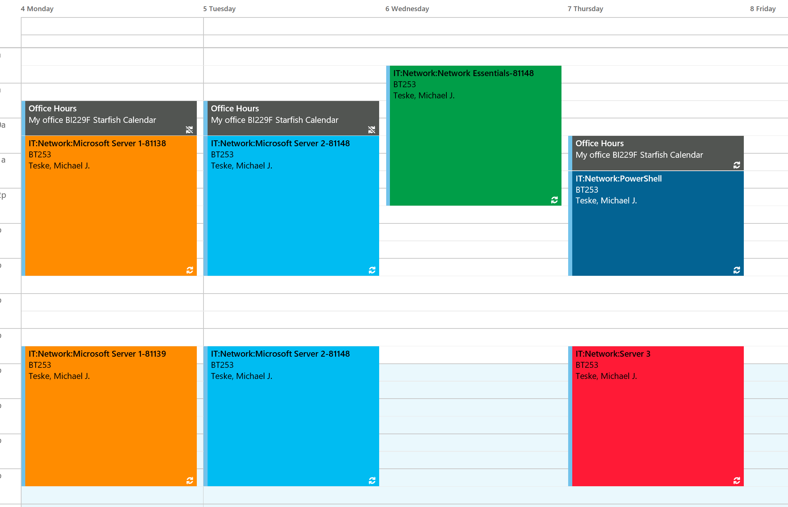

Office Hours are by appointment either in person, Skype [michael.teske@outlook.com](mailto:michael.teske@outlook.com) or Google Hangouts [michael.teske@gmail.com](mailto:michael.teske@gmail.com)