#Links https://winsysblog.com/

#PowerShell Direct https://docs.microsoft.com/en-us/windows-server/virtualization/hyper-v/manage/manage-windows-virtual-machines-with-powershell-direct

* Milk
* Bread
  + Wholegrain
* Butter

[Source of this MarkDown](https://guides.github.com/features/mastering-markdown/)

*This text will be italic*

*This will also be italic*

***This text will be bold***

**This will also be bold**

*You* ***can*** *combine them* [link to Google!](http://google.com)

1. Item 1
2. Item 2
3. Item 3
   1. Item 3a
   2. Item 3b

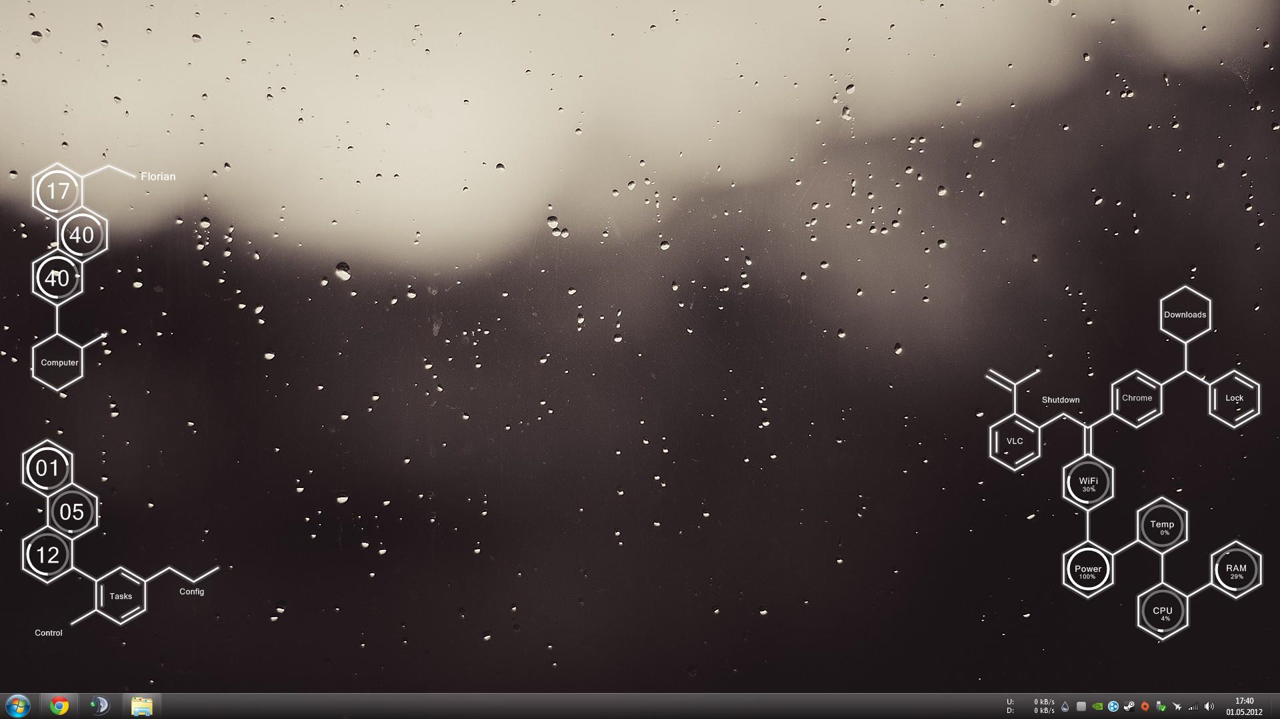 Format: Alt Text

http://github.com - automatic! [GitHub](http://github.com)

As Kanye West said:

We’re living the future so the present is our past. I think you should use an <addr> element here instead.

function fancyAlert(arg) {  
 if(arg) {  
 $.facebox({div:'#foo'})  
 }  
}

def foo():  
 if not bar:  
 return True

get-service | where {$_.enabled -eq $true}

* [x] @mentions, #refs, links, **formatting**, and tags supported
* [x] list syntax required (any unordered or ordered list supported)
* [x] this is a complete item
* [ ] this is an incomplete item

|  |  |
| --- | --- |
| First Header | Second Header |
| Content from cell 1 | Content from cell 2 |
| Content in the first column | Content in the second column |