Dr. Ahmed Abuzaid Ibrahim, DBA  Senior Audit, Finance & Digital Transformation Executive  Ismailia, Egypt  Mobile: +20 100 789 3468  Email: ahmed1900191@gmail.com | 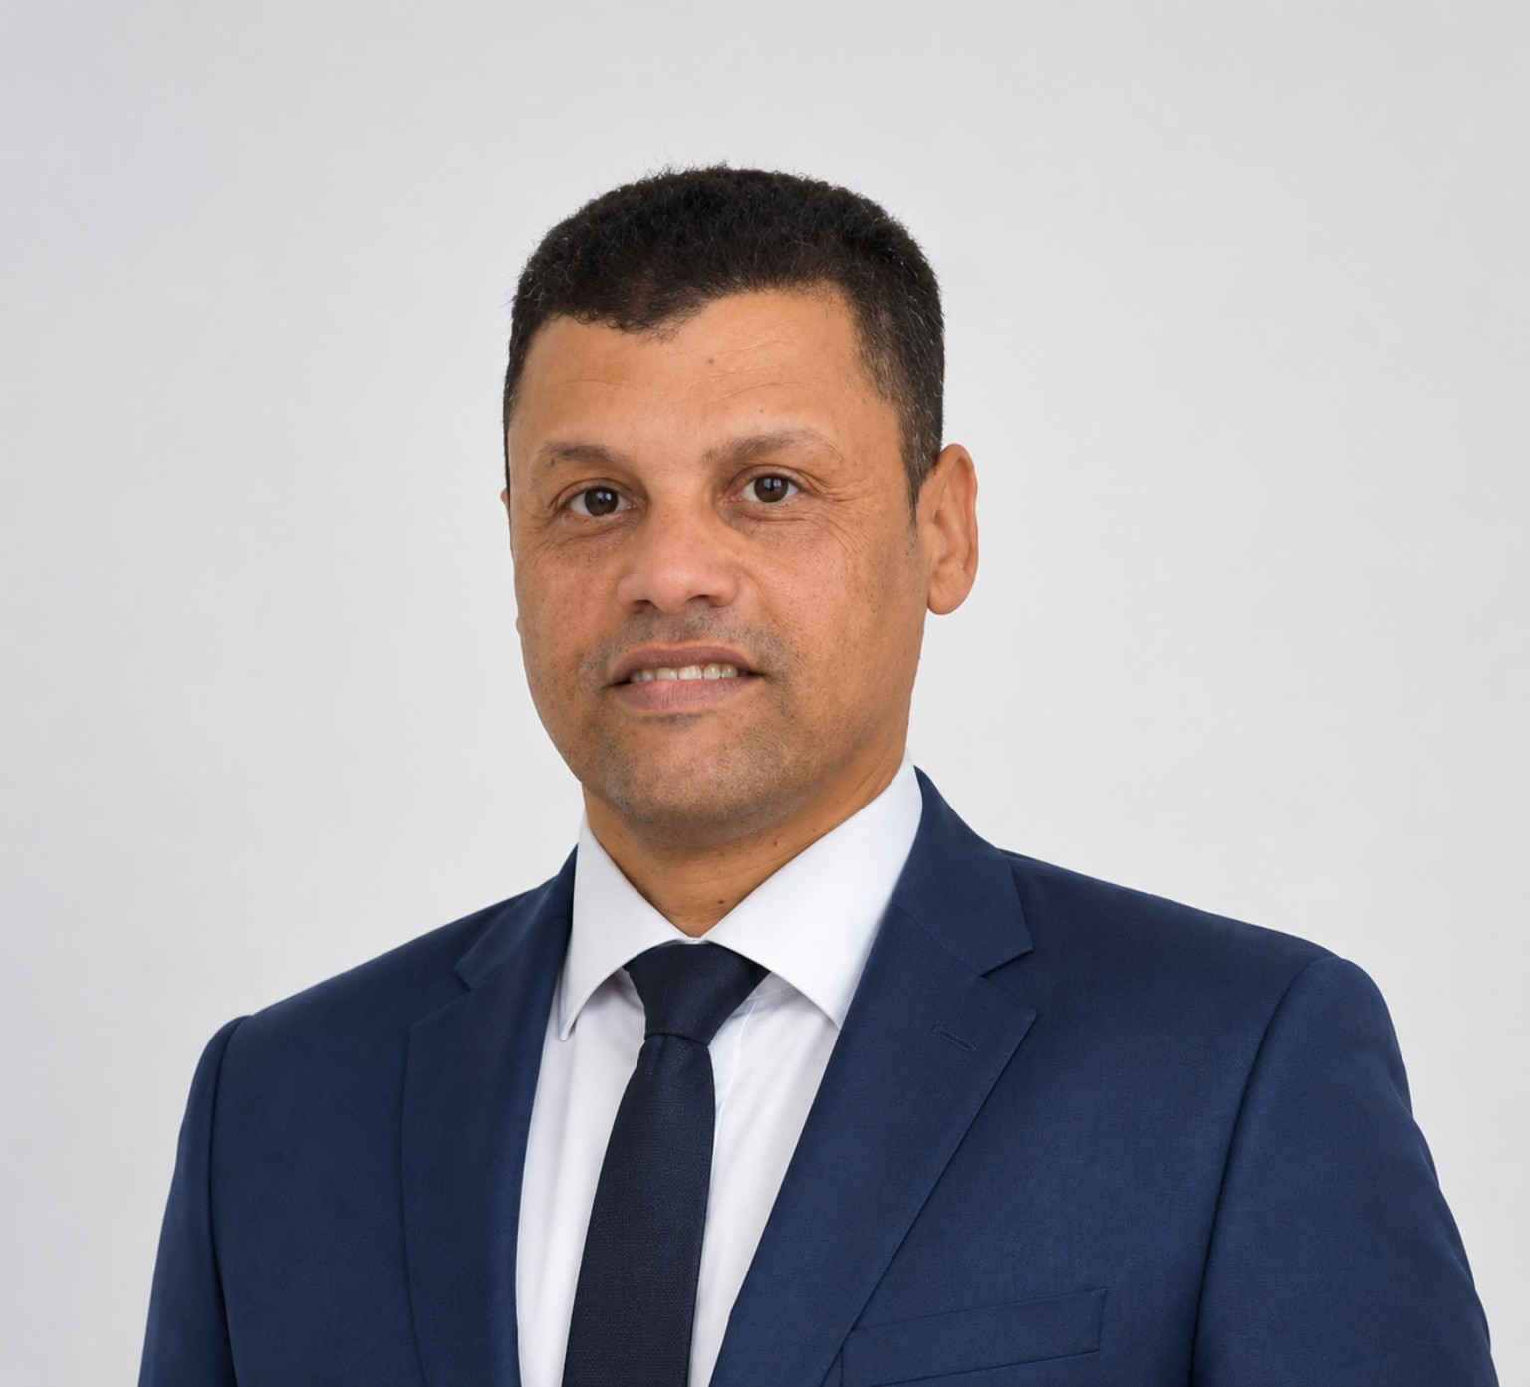

EXECUTIVE PROFILE
Senior Audit, Finance and Digital Transformation Executive with more than 15 years of experience in internal audit, finance, governance, Oracle financial systems, business process improvement and organizational development. Holds a DBA, MBA and a Postgraduate Diploma in Computer Science. Experienced in bridging finance, technology and business strategy through practical digital transformation initiatives.

CORE COMPETENCIES
Internal Audit • Corporate Governance • Financial Management • Digital Transformation • Business Analysis • Oracle Financial Systems • ERP • Risk Management • Business Process Improvement • Executive Reporting • Microsoft Excel Automation

PROFESSIONAL EXPERIENCE
Suez Canal Authority
Deputy Section Head Accountant – Finance & Internal Audit | Jun 2008 – Present
- Financial and operational audit.
- Governance and internal control.
- Business process improvement.
- Digital transformation initiatives.
Suez Canal Aquaculture Company
Audit Department Manager (Executive Assignment) | 1 Year 2 Months
- Managed Internal Audit Department.
- Led business analysis for a fully automated Payroll Management System.
- Designed payroll workflows, dashboards and cost allocation.
Suez Canal Authority
Oracle Financial Systems Developer | 2008–2015
- Developed Oracle financial applications.
- Supported finance automation and reporting.

PROFESSIONAL EXPERIENCE (Continued)
Class Company (Syrian–Egyptian Company)
Sales Accountant / Branch Accountant | 2005–2008
- Prepared executive sales reports.
- Developed an Excel-based Sales Management System still in use today.
IBM Authorized Training Center
Technical Instructor | 2003
- Delivered IBM technical training after completing the IBM Professional IT Program.
Velocity Apparels (Indian Company)
Administrative Operations Coordinator | 2002
- Production coordination, planning follow-up and quality reporting.

EDUCATION
- Doctor of Business Administration (DBA), Suez Canal University. Dissertation: Human Resource Management Strategies and Their Role in Achieving Sustainable Development.
- Master of Business Administration (MBA), Helwan University.
- Postgraduate Diploma in Computer Science, Suez Canal University (Very Good).
- Bachelor of Commerce (Accounting), Suez Canal University.

CERTIFICATIONS
- National Training Academy Leadership Development Program
- CoRT Innovation & Creativity Program (2018)
- Technical Mentor – MATE ROV Egypt (2015)
- IBM Professional IT Training Program (900 Hours)
- IBM Certified WebSphere Studio Application Developer
- CIW Associate
- American University in Cairo Professional Programs

MAJOR PROJECTS
- Payroll Management System implementation.
- Excel-based Sales Management & Reporting System.
- Oracle Financial Systems development and enhancement.

