How to make a simple temperature box to host your RF components for superconducting quantum computing

By Ruiqi, 28 Sep 2020

**Github: https://github.com/tesla-cat/raspberry-pi-temperature-box**

**Part 1 Hardware**

- The design follows the [Optical Breadboards from Thorlabs](https://www.thorlabs.com/newgrouppage9.cfm?objectgroup_id=7325)

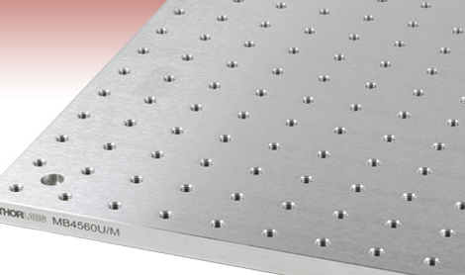

- First make SOLIDWORKS files like the following

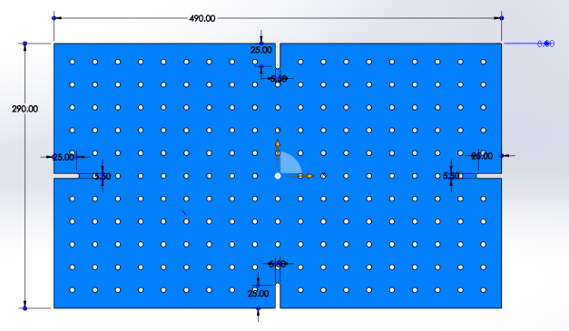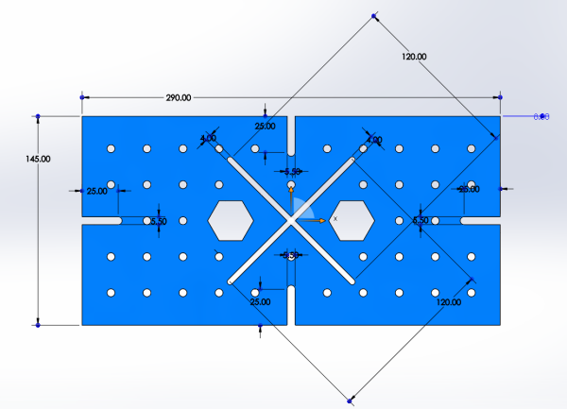

1. bottom.SLDPRT 2. side-short.SLDPRT

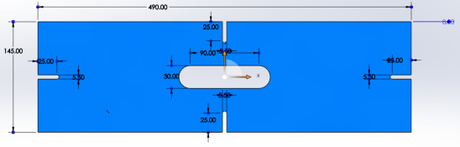

1. side-long.SLDPRT

- Then convert them into .DXF files and submit them to the mechanical workshop on level 1 of CQT

- 1.bottom.DXF, 2.side-long.DXF, 2.side-short.DXF

- The connection of these 3 parts are handled by standard 2020 Series Corner Brackets, I bought them from [here on Amazon](https://www.amazon.sg/Bracket-Aluminum-Brackets-Extrusion-Profile/dp/B08CB2P2GJ/ref=sr_1_9?dchild=1&keywords=ANGLE+BRACKET+20X20&qid=1598836729&sr=8-9) but the shipping took too long

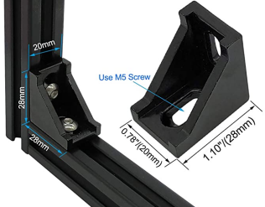

- The assembled box looks like this, with test setup

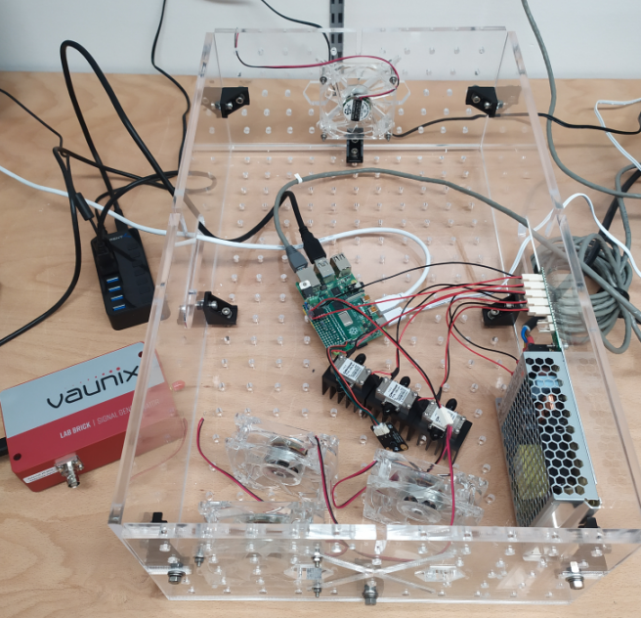

**Part 2 Electronics**

- The control is done by Raspberry Pi 4 Model B, it is not only used for a simple temperature control, but also chosen to handle possible future tasks, for example communicating with the Vaunix 4-8 GHz USB Programmable Signal Generator shown on the left.

- The fans operate at 12V so I made a hand soldered driver using parts found in the electronics workshop on level 2 of CQT, the schematic is

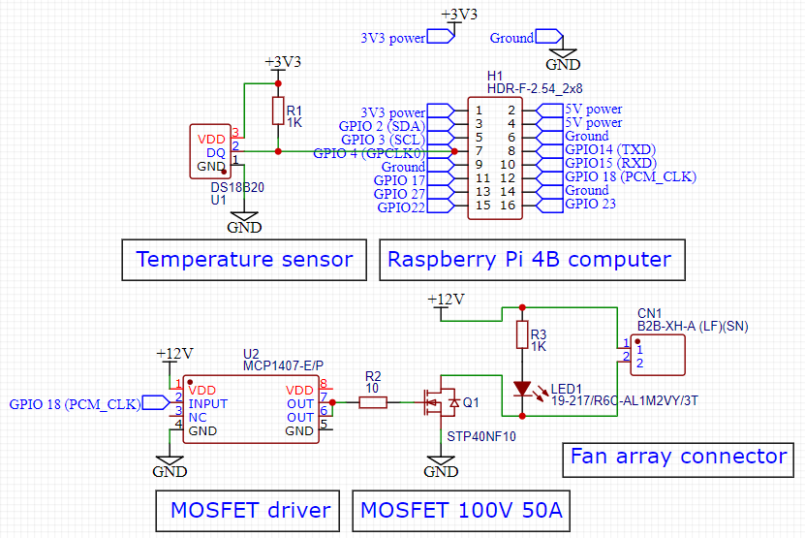

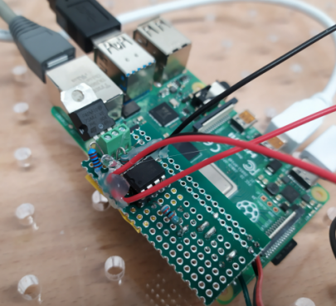

**Part 3 Software**

- First create 3 simple python libraries:

- temperature.py for one-wire communication with the DS18B20 temperature sensor

- pid.py for generating PID control amplitude

- pwm.py for generating the physical PWM signals sent to the MCP1407 MOSFET driver

- Then the main script is app.py

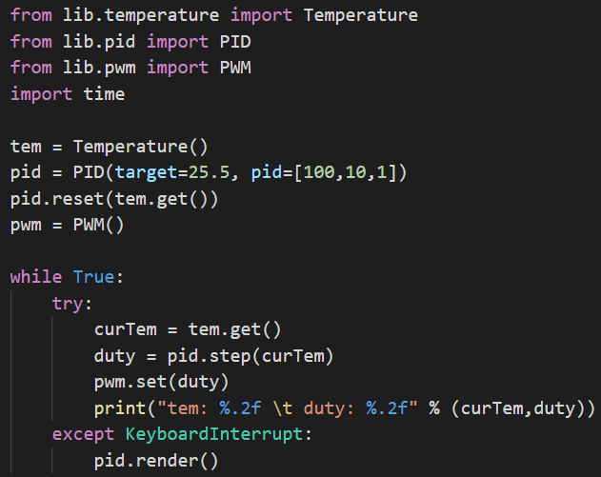

- A test is performed with 3 ZVA-183-S+ 18 GHz Amplifiers running, the following is the measured temperature (minus target value) and the PID output (divided by Kp) overtime during the test, the temperature is stabilized with < 0.1 C fluctuation

