FYS 1120: Lab03

Dorde Antonijevic

08.11.2020

**Abstract**

These experiments are based on FYS1120 Lab1[1]

# **Introduksjon**

Here there are reports on five different experiments, four of them measuring resistance of a voltmeter, ammeter, aluminum rod and a copper rod. The last one is measuring the earth’s magnetic field.

# Teori

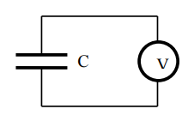

Figur 1: Voltmeter in series with a capacitor

Resistance of a VM. We charge up the capacitor C (1µF) with a 9V source and then let it discharge through the VM. The voltage across the capacitor is given by $V=V_{o}e^{-t/τ}$ where $V_{o}$ is the initial voltage, t time elapsed and $τ=RC$ the time constant for the circuit. Using this we will calculate the R.

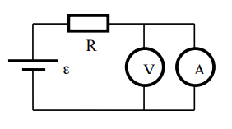Resistance of an AM. We set up a circuit as shown in figure 2. Since the resistance of an AM is very low and the resistance of a VM very high we will assume that all the current is flowing through the AM. For a few different values of the variable resistance R we will measure the voltage drop and the current through the AM. The voltage drop is given by VAM = RAMIAM, using this we will calculate RAM.

Figur 2: Voltmeter and amperemeter in parallel

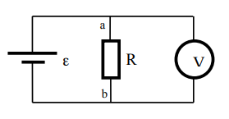Resistance of a Peltier element. We put the element in between something hot and something cold so that it becomes a voltage source. R is a variable resistance. Assume as before that no current flows through the VM. KVL for the circuit in Figure 3 gives us $ε=IR+IR_{ε}$ which we can use to find $R_{ε}$ and $ε$.

Figur 3: Peltier element as a voltage source $ε$

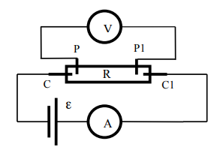

Resistance of copper and aluminum rods. AM gives us the I, VM gives the V, and R is found by R = V/I.

Figur 4: Rod of copper/aluminum R

We measure the strength of earth’s magnetic field by rotating a coil of wire with N windings by 180deg and measuring the induced current. The induced current is given by $I=-\frac{dΦ}{dt}$, where $Φ$ is the flux of the field through the coil. If we orient the coil so that at t = t1(start time) it is normal to the field we get that:

$$Φ=NABcos\left(ωt\right)$$

Where $ω$ is the angular velocity of the coil (assumed constant), t is time elapsed, and A the area enclosed by the coil. The induced current is:

$$I=-\frac{dΦ}{dt}=ωNABsin\left(ωt\right)$$

We will measure the induced current and interpolate the data points with a function on the form $Asin\left(ωt+φ\right)+c$ where $φ$ and $c$ are offset constants we will ignore. Here A is the constant part of the equation for $I$ above. The only unknown is the B, which we will calculate.

# Resultater

**1. Resistance of a voltmeter**

The voltage across the capacitor was measured every 20s for 6 minutes. Here we plot the voltage vs time and ln(voltage) vs time to determine the slope.

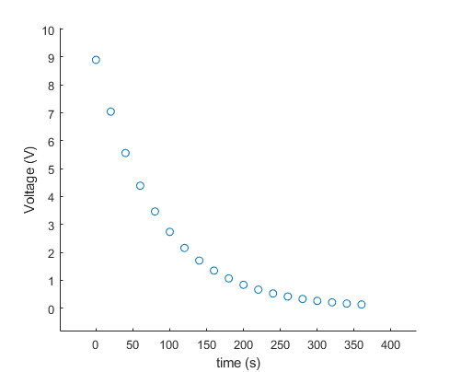

After a time t the voltage is given by

$$V=V_{0}e^{-t/τ}$$

If we plot ln(V) vs time we get

$$ln⁡\left(v_{0}e^{-t/τ}\right)=ln⁡V_{0}-\frac{1}{τ}t⋅1$$

Making $-\frac{1}{τ}$ the slope for the graph.

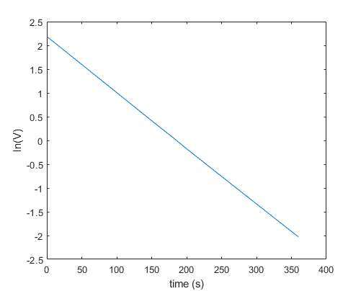

Using MATLAB polyfit function on t, ln(V) gives the slope $-\frac{1}{τ}$ = -0.0117, making $τ$ = 85.47s. Divide that by the supposedly known capacitance C and we get the resistance of the voltmeter.

**Oppgave 1.2**

The capacitor gets charged up almost immediately because there is nothing there to slow the flow of current. So the time constant is determined by the resistance of the wires which is very low. On the discharge the time constant is determined by the resistance of the voltmeter, which is very high.

**2. Resistance of an ammeter**

For values of R measure the current and voltage over the AM.

|  |  |  |  |  |  |
| --- | --- | --- | --- | --- | --- |
| R(Ω) | 500 | 700 | 1000 | 1200 | 1500 |
| I(mA) | 16.997 | 12.306 | 8.7046 | 7.2803 | 5.8486 |
| V(mV) | 360 | 260.00 | 183.6 | 153.6 | 123.4 |

Using this MATLAB script to plot the line and determine the slope. V on the y-axis, I on x. Since V = IR, R would be the slope for the graph.

Y = [360, 260, 183.6, 153.6, 123.4]; %voltage mV

X = [16.997, 12.306, 8.7046, 7.2803, 5.8486]; %current mA

scatter(X, Y);

hold on

p = polyfit(X, Y, 1);

p

x1 = linspace(X(1), X(length(X)), 1000);

y1 = polyval(p, x1);

plot(x1, y1, "red")

xlabel("mA");

ylabel("mV");

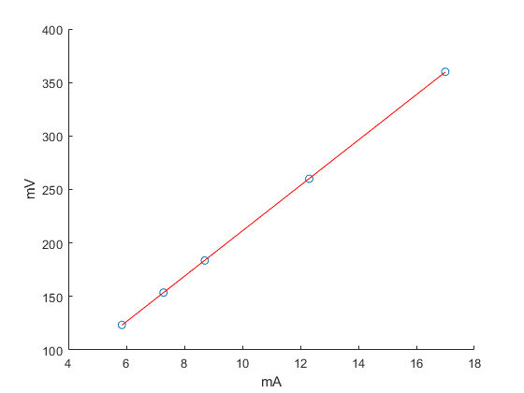

Measured values(blue) interpolated by n=1 polynomial

p =

21.2259 -0.9634

The resistance is 21.23Ω

**3. Resistance of a Peltier element**

Oppgave 3.1

By putting the Peltier element in the palm of my hand we saw an increase in voltage on the meter. By connecting it to a current source one side got hot, the other cold.

Oppgave 3.2

We measure the voltage over the variable resistor for a few different values. The voltage measured should be

$V_{R}=ε-R_{i}I$. Epsilon being the source voltage and Ri its internal resistance. We plot the results with I on the x axis and VR on the y axis. The slope is then Ri and $ε$ the constant which the polyfit function can give us. Obviously $ε$ isn’t constant but we assume that it is.

Y = [0.05203, 0.0728, 0.10755, 0.147002, 0.2335]; %measured voltage

X = [0.05203/1, 0.0728/1.5, 0.10755/2.5, 0.147002/4, 0.2335/10]; %calculated I

scatter(X, Y);

hold on

p = polyfit(X, Y, 1);

p

x1 = linspace(X(1), X(length(X)), 1000);

y1 = polyval(p, x1);

plot(x1, y1, "red")

xlabel("A");

ylabel("V");

p =

-6.3414 0.3809

So the slope -Ri = -6.3414Ω and the constant $ε$ = 0.3809V

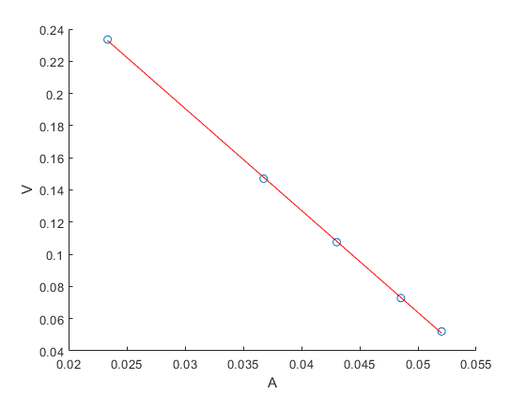

Measured values(blue) interpolated by n=1 polynomial

**4. Resistance of a copper/aluminum rod**

We hook up a bar of metal to a current source and for different values of current measure the voltage drop over it.

Aluminum

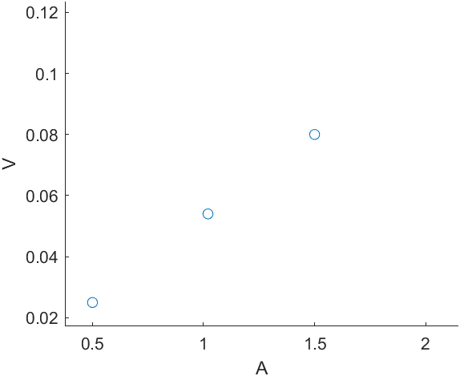

Giving values of R: 0.05Ω, 0.0529Ω, 0.053Ω in order.

For an average value of ca. 0.052 Ω.

Copper

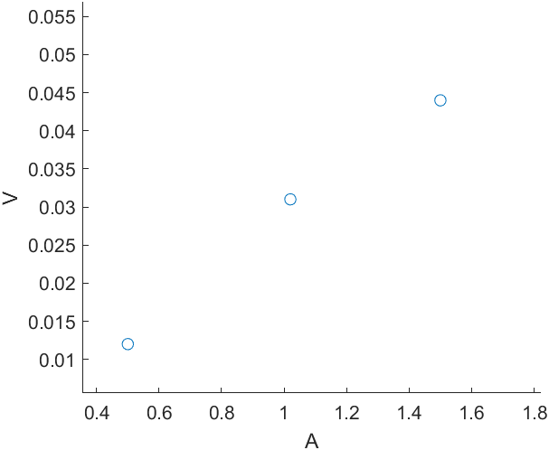

Giving values of R: 0.024Ω, 0.0304Ω, 0.0293Ω in order.

For an average value of ca. 0.028Ω.

By doing a two point measurement we get a much bigger voltage drop for both metals.

**5. Measuring the earth’s magnetic field**

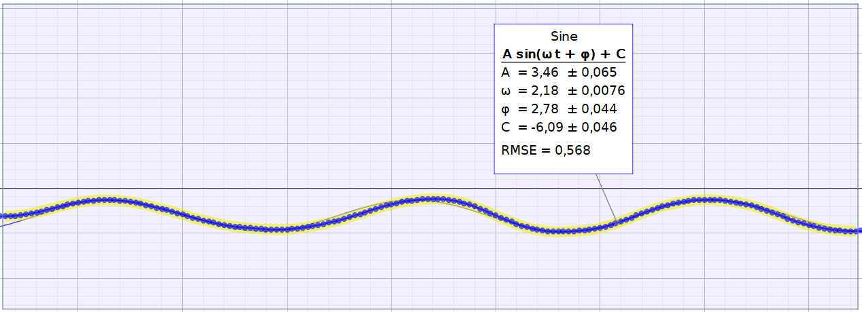

The measured data and a function that interpolates all the points.

$$I=-\frac{dΦ}{dt}=ωNABsin\left(ωt\right)$$

“A” in the function that interpolates I values is A(int)

A(int) =

= 30m2 , = 2.18

B = 3.46 / (30*2.18) = 0.0529T which is way too much.

The current must have been measured in milliamperes, because there is no way we were producing 3.46A(max value) by rotating that coil. Which puts the magnetic field at 52.9 µT, the realistic number.

# **Diskusjon**

Inaccuracies and assumptions in measurements and calculations.

**1. Resistance of a voltmeter**

We assumed that the wires are ideal conductors, so their contribution to the resistance was ignored. Making the actual resistance of the voltmeter lower than calculated. This problem is the same for all experiments.

**2. Resistance of an ammeter**

Same assumptions as for the voltmeter. These two are probably the most accurate of measurements we did, they only depend on the accuracy of the instruments, as all measurements do.

**3. Resistance of Peltier element**

It was assumed that no current travels through the voltmeter, which we found in experiment 1 to be false.

**4. Resistance of metal bars**

The contact point between the wires and the bar was not the whole cross-section of the bar. Making it seem like it had more resistance.

**5. Earth’s magnetic field**

We were surrounded by all kinds of electronic equipment, from the lights above to the computer sitting not half a meter from the coil.

# References

[1] https://www.uio.no/studier/emner/matnat/fys/FYS1120/h19/lab/fys1120_oblig1_elmag_2017_black.pdf