POF

论文阅读读书笔记的要求：

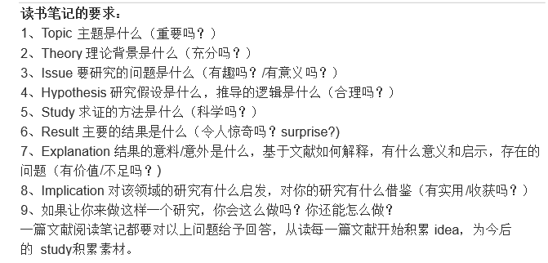

1. **文章信息**

什么杂志，第几期，什么地方有关于什么问题的什么论述，它对于即将做的论文有什么参考作用，或者我对于这个问题有什么自己的见解，可能会有什么贡献等等

作者简介（如果有的话）

1. **背景、目的**

交代本文的写作背景或者写作目的，本文是为了解决什么理论问题或解释现实问题的。通常的做法是交代文章所追述的理论线索。

摘要：POF:remove any dependency and enhance the data-path, define the **FIS**

背景：

1. SDN requires that the underlying forwarding elements (FE) should be flexible and simple.
2. OpenFlow separates the control and forwarding planes. But faces challenges :
3. OpenFlow follow a reactive evolving path.the forwarding plane is **protocol-aware**,that means the FES need to know the **packet formats specificly**
4. Openflow is **stateless**, that means it can not remember the flow status. It’s action’s changing is under the involvement of the controller.就是对于流的处理的改变还是得在控制器的控制下

These two challenges result in the four undesiable consequences as said in the paper

The root reason: **requirement for the underlying forwarding infrastructure to recognize the protocol format**

1. OpenFlow bring the network devices from **black box** to **gray box**, which means that the programmability is still **limited**(what the interface has exposed and what the forwarding plane device has been programmed or hard-wired to support)

目标：或者说SDN真正的目标是保持FES变成白盒，就是对于FES之保持处理和转发的能力，行为在SDN控制器的控制下

1. **主要观点**
2. 将SDN与计算机架构做类比

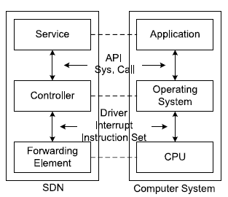

这个模型的特点：

1. the FEs should not require any **priori knowledge** and understand the application **semantics**. Just like that the cpu doesn’t need to know what is exactly going on
2. 正如cpu执行简单的指令一样，作者提出FIS，这是一组协议独立的指令集，可以组成任何的网络服务。每条指令代表一个原语（即不能被中断的**单个独立的功能**）。从而Constructing network services with FIS is just like writing application programs in assembly language
3. 这个FE模型（运行于类似于RISC或者CISC的chip上）带来的前景或者好处
4. The control and forwarding planes are completely **decoupled**
5. 异质FES之间的互通要求可以得到满足
6. 满足SDN所要求的最终的**可编程性**
7. **模型**

POF

1. FES协议无感知，The packet parsing is directed by the controller through a sequence of generic key assembly and table lookup instructions. =》metadata
2. Metadata, search key [one or more {offset, length} tuples]
3. 通用的协议无关的操作，例如AddField；简单数学（加、减、移位），特定函数如（IP checksum 和 TCP checksum）
4. 通过其他的机制扩展可编程性：
5. the data-path to be able to **keep track of** the flow status. =》流元数据【个人理解：流元数据作为流的暂存存储区，会不会是暂存了流的一些信息】
6. 增加允许数据通路灵活的操纵流表的指令。
7. we only store the **unique parameters** with flow entries and let the flow entries that **share the same set of instructions** point to a common instruction block.这个机制出现的目的是每个流向可能会产生相同的指令但具有不同的参数
8. we treat the statistic counters as a shared resource
9. we categorize the possible lookup tables into different types
10. **实验效果与验证**

首先提出两种POF FE原型，基于软件的和基于硬件的

（1） POF typically reduces the forwarding throughput by up to 30%

1. **评论与总结**

（1）将SDN用于异质的FES：

WHAT: provide **higher level abstractions** (WHAT) for the south-bound interface

HOW: ask a smart FE to handle all the detailed work

1. 怎么将POF用于现有的硅片：The first one treats each instruction as a **macro or function**.；The second mode requires software on the FEs to translate and map the POF instructions into the **hardware modules** in ASICs and some NPs for packet parsing and processing.
2. **思考或扩展不理解或者与作者观点不一致的地方**

总结原文可能的扩展方向，或者展望未来可能的研究课题，并且最好能对文章的方法等提出批评，指出下次

1. **参考文献**

参考文献格式:

[1] Abraham Silberschatz. 操作系统概念. 高等教育出版社, 2007.3.