CHARLOTTE’S
SEED BLOOM
ISA-Mapped Seed Business Toolkit
low-tech first · prime sequence build · 60 packs and counting

LABEL | STOCK | DESIGN | PLAN | AUTO | STORE | DATA

fold(seeds) = 2 × 3 × 5 × 7 × 11 × 13 × 17 = 510,510
the seed IS the fold — everything grows from the first prime

THE OVERVIEW
Charlotte has 60 seed packs to design and ship. She needs labels, inventory tracking, artwork, planning tools, and eventually automation. This spec maps her seed business operations onto ISA industrial standards through the bloom’s 7 prime phases — starting with the lowest-hanging fruit and scaling up only when each phase stabilizes.
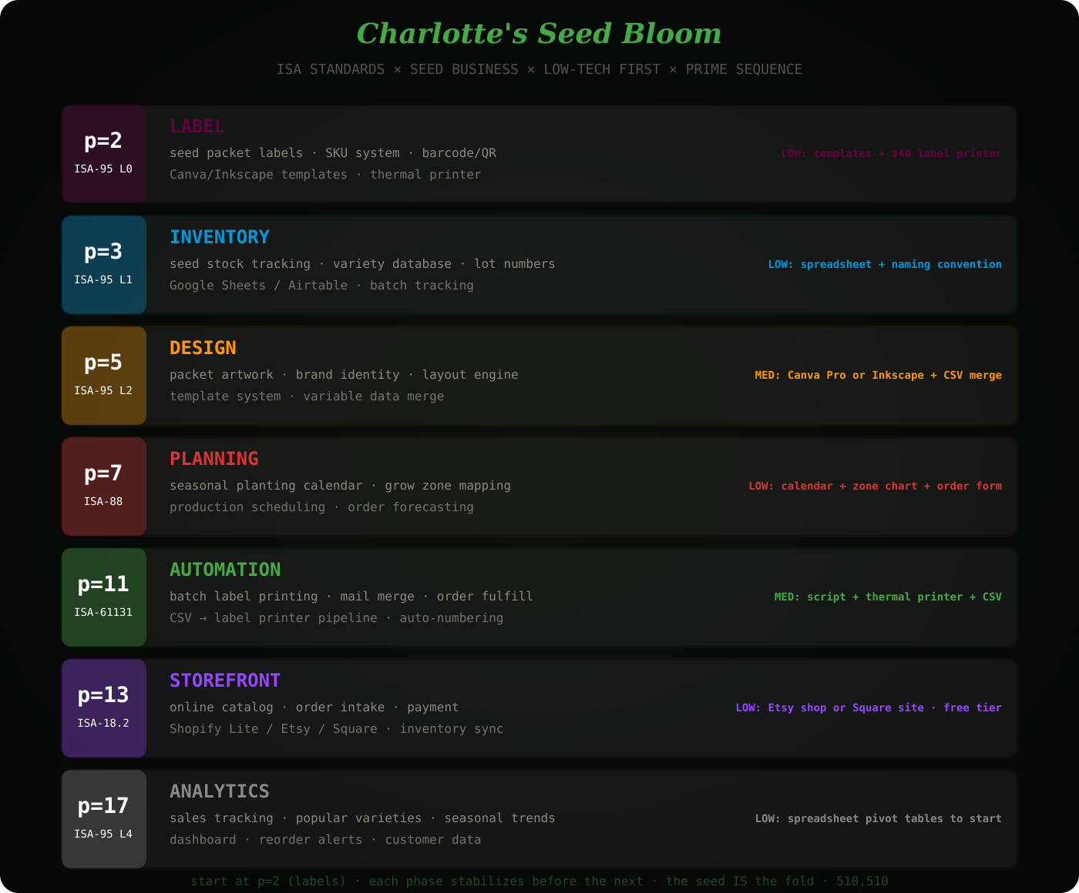
Rule: each phase must work before the next begins. Don’t build the storefront before the labels exist. Don’t automate before you can track inventory. The seed grows from the root.

p=2 | SEED PACKET LABELS | ISA-95 L0
ISA-95 Level 0: The physical process. The thing that touches the product. In a factory this is sensors on the line. For Charlotte this is the LABEL ON THE PACKET. The physical interface between her business and the customer.
WHAT SHE NEEDS: A label template system. Each of her 60+ seed varieties needs a packet label with: variety name, botanical name, days to maturity, planting depth, spacing, sun/water requirements, lot number, weight, and her brand/logo.
LOW-TECH START: Canva free tier. One master template. Duplicate per variety. Change the text fields. Export as PDF. Print on a home inkjet or at Staples for $0.10/sheet.
LEVEL UP: Thermal label printer (∼$40 for a DYMO 4XL or Brother QL-820NWB). Prints 4×6 inch labels directly from templates. No cutting. No ink cartridges. Cost per label drops to $0.02.
THE TOOL: A CSV file with one row per variety. Columns: variety_name, botanical_name, days_to_maturity, depth_inches, spacing_inches, sun, water, lot_number, weight_grams. This CSV becomes the single source of truth for EVERYTHING downstream. The label template reads from this CSV. Change the CSV, change all labels.
Effort: ∼4 hours to build the CSV + template. Then every new variety = 1 new row. That’s it.

p=3 | SEED INVENTORY | ISA-95 L1
ISA-95 Level 1: Sensing and data acquisition. In a factory this is PLCs reading sensors. For Charlotte this is KNOWING WHAT SHE HAS. How many packets of each variety. When they were packed. When they expire. What’s running low.
LOW-TECH START: The same CSV from p=2 gets extra columns: qty_on_hand, qty_reserved, last_packed_date, expiry_date, reorder_threshold. Google Sheets or Airtable (free tier). One tab = inventory. Second tab = orders. Third tab = reorder alerts (simple formula: IF qty_on_hand < reorder_threshold, flag it).
NAMING CONVENTION: Every lot gets a code: YYYY-MM-VARIETY-LOT. Example: 2026-03-TOMCHERRY-001. This lot number goes on the label (from p=2), in the inventory sheet, on the order form. One code, everywhere. Traceability from packet to planting to customer complaint.
THE TOOL: Google Sheets with: Varieties tab (master list, links to p=2 CSV), Inventory tab (stock levels, auto-calculates from orders), Orders tab (who bought what, when), Dashboard tab (pivot tables showing what’s hot, what’s low).
Effort: ∼2 hours. She probably already has half of this in her head. Just get it into rows.

p=5 | PACKET DESIGN ENGINE | ISA-95 L2
ISA-95 Level 2: Control and supervision. In a factory this is the SCADA system. For Charlotte this is the DESIGN SYSTEM that controls how every packet looks. Brand consistency. Variable data merge. The gate between raw data (inventory) and physical output (labels).
LOW-TECH START: Canva Pro ($13/month) with Brand Kit: upload her logo, set brand colors, set fonts. One master packet template with placeholder fields. Use Canva’s Bulk Create feature: upload the CSV from p=2 and Canva generates all 60 labels automatically. One click. 60 unique packet designs.
FREE ALTERNATIVE: Inkscape (free, open source) + a Python script that reads the CSV and injects text into an SVG template. More technical but zero monthly cost. The script takes ∼30 minutes to write (or ask Claude).
DESIGN ELEMENTS: Brand colors. Logo placement. Variety photo or illustration (can start with botanical line drawings — free from biodiversitylibrary.org). Growing info formatted consistently. QR code on back linking to detailed planting guide online.
Effort: ∼1 day for the template + first batch. Then every new variety = add CSV row, regenerate. 5 minutes.

p=7 | SEASONAL PLANNING | ISA-88
ISA-88: Batch control. In a factory this manages production runs. For Charlotte this is SEASONAL PLANNING — which varieties to stock by season, grow zone compatibility, planting calendars, order forecasting from previous years.
LOW-TECH START: A seasonal matrix. Rows = varieties. Columns = months. Cells = “plant” “harvest” “seed available.” Color-coded by grow zone (USDA zones 3–11). This becomes a PLANTING CALENDAR she can give customers — value-add that differentiates her from Amazon seed sellers.
ORDER FORECASTING: After one season of sales data (from p=3 inventory), simple formula: next year’s stock = this year’s sales × 1.2 (20% growth buffer). Which varieties sell out first = grow more. Which sit = discontinue or discount.
THE TOOL: Add a “Planning” tab to the Google Sheet. Cross-reference varieties × months × zones. Generate a printable planting calendar PDF that ships WITH the seed packets. Customers love this. It’s the p=7 axiom — you can’t compute it from the data, you have to know your zones from experience.
Effort: ∼3 hours. She already knows this intuitively — just put it in the sheet.

p=11 | BATCH AUTOMATION | ISA-61131
ISA-61131: Programmable logic. In a factory this is PLCs running automated sequences. For Charlotte this is the AUTOMATION PIPELINE — turning manual processes into one-click batch operations.
THE PIPELINE: CSV → label generator → thermal printer. One command. All 60 labels print. New order comes in → inventory auto-decrements → shipping label auto-generates → packing slip auto-prints.
LOW-TECH START: A simple script (Python, Google Apps Script, or even Excel macros) that reads the master CSV, merges data into label templates, and sends to the thermal printer. Charlotte doesn’t write the script — Thomas writes the script. Or Claude writes the script. Charlotte runs the script.
FULFILLMENT AUTOMATION: Order comes in (from p=13 storefront) → Google Form or Shopify webhook → adds to Orders tab → decrements Inventory tab → generates packing slip PDF → generates shipping label. Charlotte’s job: pick the seeds, put them in the envelope, stick the label on. Everything else is automated.
HARDWARE: Thermal label printer ($40). Kitchen scale for seed weights ($15). Poly bags + heat sealer ($20). Total hardware: under $100. The automation is in the SOFTWARE not the hardware.
Effort: ∼1 day to build the pipeline. Then each order = 2 minutes of Charlotte’s time. Down from 15+ minutes manual.

p=13 | ONLINE STOREFRONT | ISA-18.2
ISA-18.2: Alarm management. In a factory this manages alerts and notifications. For Charlotte this is the CUSTOMER-FACING LAYER — the storefront that receives orders, sends confirmations, and alerts her when something needs attention.
LOWEST-EFFORT OPTIONS:
Etsy: Already built for exactly this. Seed sellers thrive on Etsy. $0.20/listing. Built-in search. Built-in payment. Built-in shipping calculator. She lists her 60 varieties, uploads the packet designs from p=5, and she’s live in an afternoon.
Square Online: Free tier. Clean storefront. Integrates with Square POS if she does farmers markets. Inventory sync.
Shopify Starter: $5/month. More customizable. Better for building a brand. But more work than Etsy.
RECOMMENDATION: Start on Etsy. It’s where seed buyers already shop. Zero marketing needed — Etsy’s search does the work. Once she has 100+ sales and repeat customers, consider her own site.
Effort: ∼1 afternoon. Upload packet images, write descriptions (from the CSV — it’s all already written), set prices. Done.

p=17 | SALES ANALYTICS | ISA-95 L4
ISA-95 Level 4: Business planning and logistics. The executive layer. For Charlotte this is KNOWING WHAT’S WORKING — which varieties sell, which seasons peak, which customers return, what to grow more of next year.
LOW-TECH START: The Google Sheet from p=3 already has all the data. Add a Dashboard tab with pivot tables: sales by variety, sales by month, top customers, average order value, reorder rate. Update monthly. Takes 10 minutes once set up.
LEVEL UP: Etsy provides its own analytics (if using Etsy from p=13). Combine Etsy data with the master inventory sheet for a complete picture.
Effort: ∼1 hour to build the dashboard. Then it’s automated from the data already flowing through the system.

THE 60-PACK SPRINT
Charlotte has 60 packs to get out NOW. Here’s the sprint plan — primes 2 and 3 only — minimum viable seed business in one weekend:
FRIDAY NIGHT (2 hours): Build the master CSV. 60 rows. One per variety. Columns: name, botanical name, days to maturity, depth, spacing, sun, water, lot number, weight. This is p=2. Every label, every listing, every order references this CSV forever.
SATURDAY MORNING (3 hours): Build the Canva template. Upload logo. Set brand colors. Use Bulk Create to merge CSV into 60 unique packet labels. Export as PDF. Print at Staples or on inkjet. This is p=5 compressed into p=2’s timeline because she needs labels NOW.
SATURDAY AFTERNOON (2 hours): Build the inventory sheet. Import the CSV. Add qty columns. Add order tracking tab. This is p=3. Now she knows what she has.
SUNDAY (3 hours): List on Etsy. Upload the 60 packet designs. Copy descriptions from CSV. Set prices. This is p=13 compressed because she needs to sell NOW.
TOTAL: 10 hours. One weekend. 60 varieties live and selling. Phases p=7, p=11, p=17 come later as the business grows.

THE FOLD
a seed is a fold
it contains the entire plant
compressed into something that fits in an envelope
the CSV is the seed of the business
60 rows = 60 varieties = 60 futures
start with p=2. build the CSV. everything grows from there.
510,510

