Parameter Configuration as Pedagogical Design: Shaping Authorship and Creativity in AI-Assisted L2 Poetry Writing

Abstract
When AI assists L2 poetry writing, does it amplify creative agency or diminish authorship? This study reveals the answer hinges on LLM parameter configurations—temperature and top-p settings—which systematically shape learner perceptions. Analyzing undergradute students across temperature conditions (0.3 vs. 0.8), we coded interactions into three types: Constraint Repair, Exemplar Giving, Surprise Harvest. High-temperature generated Surprise Harvest at seven times low-temperature rates (35% vs. 5%), correlating with sixfold higher authorship (62.5% vs. 10%) and doubled satisfaction (4.75/5 vs. 2.0/5). Exemplar Giving showed paradox: 75% rated most helpful yet produced lowest authorship (10%). Findings demonstrate parameters systematically shape interaction types, affecting learner motivation and creative agency—establishing parameter configuration as fundamental pedagogical choice hidden in seemingly technical settings.

Key words: AI-assisted pedagogy, L2 poetry writing, creative agency, LLM parameters, human-AI collaboration

1. Introduction
1.1 The Challenge of L2 Creative Writing Pedagogy

Poetry writing in second language (L2) contexts presents unique challenges: L2 learners must develop linguistic competence while cultivating creative expression and personal voice (Hanauer, 2010). Traditional L2 poetry pedagogy employs scaffolded approaches emphasizing imitation-transformation processes, yet encounters persistent difficulties: limited access to diverse exemplars, insufficient individualized feedback, and constrained exploration beyond predetermined models. Critically, L2 poetry writing raises questions of authorship and creative agency: when do learners perceive poems as genuinely “theirs” rather than assembled from templates?

Yet structured creative pedagogy itself poses risks: overly prescribed approaches may inhibit students’ geniune expression of voice, the fear making errors or expressing vulnerable content (Hanauer, 2010) might interrupt the free flow of creative thought essential to authentic poetry writing. What L2 creative writing pedagogy ultimately seeks is an emotionally safe creative atmosphere—one where learners feel free to experiment without fear of instructor judgment or peer comparison, where linguistic limitations do not become barriers to creative exploration. These questions become urgent as AI writing assistants enter L2 classrooms, potentially transforming collaborative dynamics while offering new possibilities for balancing structure with creative freedom.

1.2 AI as Collaborative Partner in Creative Writing

Large Language Models (LLMs) have transformed AI-assisted creative writing, shifting AI from tool to potential creative partner (Li, 2025). Coenen et al. (2022) identified serendipitous discovery—when AI generates surprising content revealing unconsidered possibilities—as crucial for creative collaboration. Qian et al. (2023) demonstrated that AI redistributes cognitive load, potentially supporting L2 learners facing high linguistic processing demands. Michel et al. (2025) found that AI’s pedagogical value depends on how collaborative interactions unfold. Yet studies rarely examine how different AI configurations affect collaboration: which role—corrective tutor, exemplar provider, or creative collaborator—best serves L2 creative writing pedagogy?

This study utilizes parameter control to investigate this question. LLM generation is controlled by temperature and top-p parameters: lower values (0.3-0.4) produce predictable outputs; higher values (0.8-0.9) generate surprising content (Holtzman et al., 2019; Li et al., 2025; Peeperkorn et al., 2024). By systematically manipulating these parameters, we examine how configurations translate into interaction patterns affecting authorship perception, creative satisfaction, and motivation.

1.3 Theoretical Framework: Three Interaction Types

We predict that parameter configurations will systematically shape three distinct interaction types, each grounded in established pedagogical theory. Low-temperature settings imitate structured scaffolding pedagogies, mimicking processes where teachers identify structural or linguistic issues and provide corrections—what we term Type A: Constraint Repair. Here AI functions as diagnostic tool aligned with Lyster and Ranta’s (1997) corrective feedback taxonomy, surfacing areas needing attention and enabling focused revision. High-temperature settings , with AI being more active and creative, are expected to generate unexpected possibilities uncommon in traditional classrooms—Type C: Surprise Harvest. Following Coenen et al.'s (2022) serendipitous discovery findings, this interaction capitalizes on AI's capacity to expand creative search spaces, supporting learners in transcending predictable patterns. Type B: Exemplar Giving—where AI provides model texts or line options students can select and adapt—may appear across both conditions, representing the universal imitation-transformation process fundamental to creative pedagogy (Hanauer, 2010). However, with AI as creative agent rather than human instructor, students' perception of exemplar-based interactions may differ significantly from traditional classroom experiences, potentially affecting authorship feelings and creative satisfaction in ways requiring empirical investigation.

Figure 1: Three Interaction Types in AI-Assisted L2 Poetry Writing

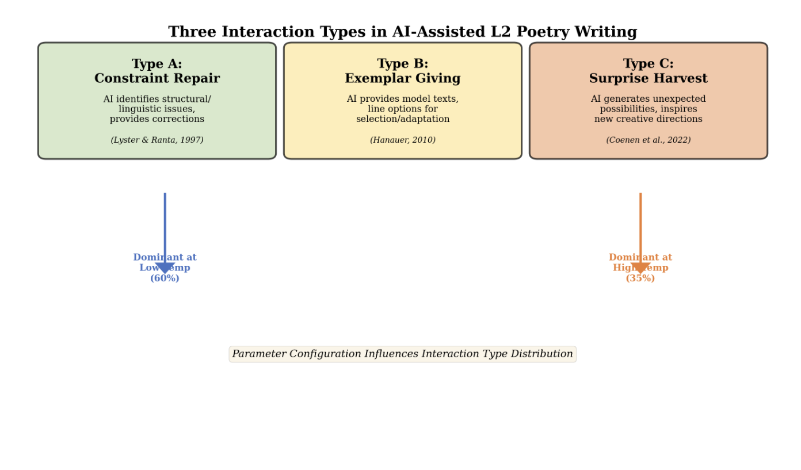

This paper presents preliminary findings examining how LLM parameter configurations affect these three interaction types in AI-assisted L2 poetry writing. The study addresses three research questions:

RQ1: How do different parameter configurations (low vs. high temperature) systematically affect interaction type distribution (Constraint Repair, Exemplar Giving, Surprise Harvest)?

RQ2: How do these interaction types, particularly Surprise Harvest, influence L2 learners' authorship perception and creative satisfaction?

RQ3: What are the pedagogical implications of parameter choices for fostering L2 creative agency and motivation?

Session 1 (November 2024, 10 participants) provides initial evidence that parameter choices systematically influence interaction type distribution. The study contributes by bridging the parameter-pedagogy gap, validating findings through unaware control conditions, and developing a three-interaction-types framework linking technical parameters to pedagogical outcomes.

2. Research Design and Implementation Status

2.1 Platform and Experimental Design

A custom web-based platform (poetry.aitutor.ink) enables systematic investigation of parameter effects through a 2×2 factorial design: Parameter Configuration (Structured: temp=0.3, top-p=0.4 vs. Exploratory: temp=0.8, top-p=0.9) × Awareness Condition (Aware vs. Unaware). Four rooms (A: Structured-Aware; B: Structured-Unaware; C: Exploratory-Aware; D: Exploratory-Unaware) employ identical system prompts with only parameters varied, ensuring observed differences reflect genuine parameter effects.

2.3 Data Collection

We traces three data sources throughout the experiment: (1) Chat transcripts—interactional patterns; (2) Panel discussion—spontaneous reflection from participants; (3) Feedback template—systematic measurement of authorship, satisfaction, and interaction type preferences.

3. Preliminary Findings from Session 1

3.1 Finding 1: Parameter Settings Systematically Affect Interaction Type Distribution

Convergent evidence across all three data sources demonstrates that parameter configuration emerges as the primary determinant of interaction type distribution, which subsequently shapes both authorship perception and collaborative satisfaction in profound ways.

Systematic coding of chat transcripts revealed striking disparities between parameter conditions:

Figure 2: Interaction Type Distribution by Parameter Configuration
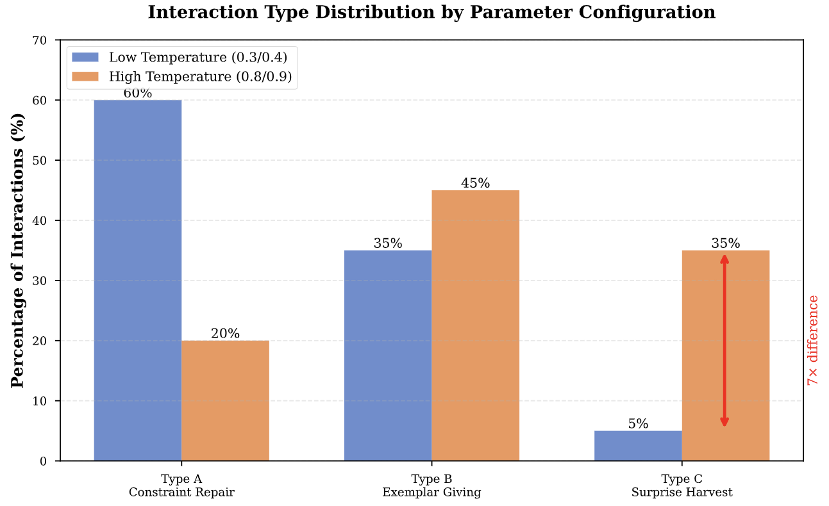

The data illustrates a remarkable pattern: high-temperature settings generated Type C interactions at seven times the rate of their low-temperature counterparts (35% versus 5%), while low-temperature configurations produced three times more Type A interactions (60% versus 20%). This sevenfold difference in Type C frequency represents a fundamental shift in the pedagogical affordances available to learners.
Participants’ spontaneous descriptions during the panel discussion aligned precisely with these quantitative patterns. A Room B participant articulated the low-temperature experience: “It gave me two or three options every time... I just chose,” explicitly describing Type B dominance. Another noted, “Very structured even though I didn't go in with a structured idea,” capturing the prevalence of Type A constraint-focused interactions.
The contrast with high-temperature experiences proved equally striking. While a Room B participant lamented, “I couldn’t feel any sort of creativity,” a Room C participant characterized the AI as “warm-hearted... like a very good friend.” This language difference—mechanical versus relational—suggests fundamentally different collaborative modes: co-creation versus option selection.

Authorship and Satisfaction Outcomes:

The authorship data reveals a sixfold difference in self-perceived authorship (10-20% versus 62.5%) and a 90% satisfaction gap (2.0/5 versus 4.75/5) directly attributable to parameter configuration.

Figure 3: Authorship and Satisfaction by Parameter Configuration

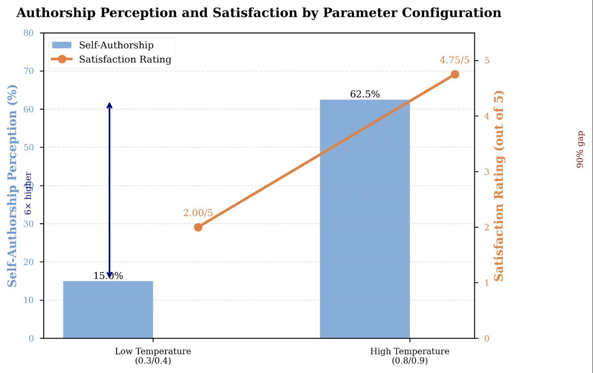

A Room B participant’s written reflection crystallizes the authorship paradox: “I do not feel ownership... other than the last line I wrote myself.” Despite making hundreds of selection decisions throughout the session, this participant claimed authorship only for independently generated content. This profound observation suggests that selection among AI-provided options does not constitute authorship in learners’ phenomenological experience—a finding with significant implications for AI-assisted creative writing pedagogy.

3.2 Finding 2: Type B Creates “Helpful but Alienating” Paradox

Analysis of feedback forms unveiled a fundamental pedagogical tension: while 75% of participants rated Type B (Exemplar Giving) interactions as most helpful, Room B—which experienced 35% Type B interactions—reported merely 10% self-authorship. This paradox reveals a critical disconnect between perceived usefulness and authentic creative agency.

A Room B participant articulated this tension poignantly: “It felt more true and emotional before the AI. After it became more formulaic and didn’t really capture it... good poem in the traditional sense, but I wish it was less structurally rigid.” This observation illuminates how Type B interactions, while pedagogically accessible and immediately satisfying, may inadvertently undermine the very creative authenticity learners seek to achieve.

Pedagogical Implications: The findings suggest that Type B interactions maximize immediate pedagogical comfort while simultaneously minimizing creative agency. Low-temperature parameters (0.3/0.4) generate heavy Type B concentration (35%) that participants find helpful in the moment yet ultimately alienating to their authorial identity. In contrast, high-temperature parameters (0.8/0.9) achieve a more balanced ecosystem—maintaining substantial Type B support (45%) for scaffolding while introducing significant Type C discovery opportunities (35%)—thereby enabling both structured guidance and authentic co-creation.

3.3 Finding 3: Type C Enables Creative Transformation

Figure 4: Type C Presence Predicts Authorship and Satisfaction Outcome

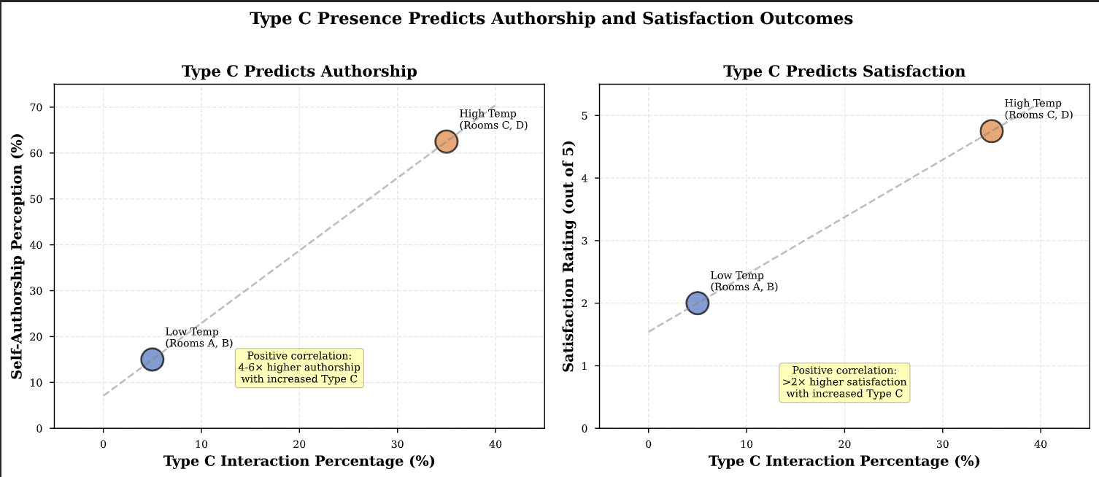

Analysis of high-temperature chat transcripts revealed that Type C (Surprise Harvest) interactions functioned as pivotal transformative moments in the creative process, introducing unexpected possibilities that fundamentally altered participants’ creative trajectories.

An example emerged from Room C, where the AI suggested to one participant: “Would using some found aspects such as citations help highlight the gravity?” This unexpected proposition introduced the found poetry technique—an advanced literary strategy the participant had not previously considered. Rather than simply correcting or exemplifying, the AI expanded the participant’s creative repertoire through genuine surprise.

Another Room C participant described how “the AI reframed the entire interaction from poetry construction to therapeutic creative expression,” illustrating Type C’s capacity to transform not merely the poem but the fundamental purpose and meaning of the creative activity itself.

Chat transcripts from Room B (low-temperature) contained no comparable Type C moments. Instead, interactions remained confined to predictable patterns: Type B exemplar provision (AI offering 2-4 line options such as “Here are a few options based on your dream...”) and Type A minor corrections. The absence of unexpected creative pivots resulted in qualitatively different collaborative experiences.

This experiential difference manifested vividly in participants’ language during panel discussion. Room B participants characterized the AI using mechanical metaphors— “just following instructions”—while Rooms C and D participants employed relational language “warm-hearted,” “like a very good friend.” These contrasting metaphors reflect fundamentally different collaborative modes: technical assistant versus creative partner.

3.4 Finding 4: Interaction Type Differences Are Observable

A particularly revealing moment of meta-awareness emerged during panel discussion when a Room B participant, despite belonging to the unaware condition, spontaneously articulated systematic differences in collaborative experiences across rooms: “Yeah, it’s pretty obvious! Ours took our words and put it in poem form [Type B]. Whereas comparing C and D... there’s a lot of changes to the input [Type C]. For me, it only outputted exactly what I asked [no Type C]. I couldn't feel any sort of creativity.”
This validates that parameter effects are genuine technical phenomena sufficiently salient for learners to notice, suggesting potential for explicit interaction type instruction as AI literacy. The participant precisely identified Type B’s reformulation pattern and Type C’s transformative quality using experiential language (“I couldn’t feel any sort of creativity”) that maps directly onto the theoretical framework.
This meta-awareness validates that parameter effects manifest as genuine technical phenomena sufficiently distinct for learners to perceive, categorize, and evaluate through direct experience. This finding suggests powerful pedagogical potential: rather than requiring explicit technical instruction about temperature and top-p parameters, students might develop sophisticated “AI literacy” by experiencing how different interaction patterns enable or constrain creative agency—learning to recognize, request, and critically evaluate interaction types for their creative goals.

Conclusion

Findings from Session 1 of an ongoing three-session study provide initial evidence that LLM parameter configurations profoundly shape collaborative creative writing experiences through their effects on interaction type distribution. The three-type framework (Constraint Repair, Exemplar Giving, Surprise Harvest) provides theoretical lens for understanding how parameter choices translate into pedagogical outcomes. While preliminary, these findings challenge assumptions about AI parameter configuration as a neutral technical choice, demonstrating that temperature and top-p settings systematically determine which pedagogical interaction types become available to learners. As AI writing assistants become ubiquitous in educational settings, understanding the interaction type implications of parameter configuration becomes essential for pedagogically grounded implementation.

(1981 words)

Declaration of Use of AI in the Writing Process

The author(s) used Claude (Anthropic) and ChatGPT (OpenAI) during the preparation of this work to assist with literature review organization, data visualization code generation, and manuscript editing. After utilizing these tools, the author(s) thoroughly reviewed and edited the content as necessary and assumed full responsibility for the publication’s content. The AI writing assistant used in the research study itself (for participant interactions) utilized Claude Sonnet 4 via OpenRouter API, with parameter configurations (temperature and top-p settings) serving as the primary experimental manipulation.

References:

Coenen, A., Retelny, D., Wu, J., Michaux, J., Narayanan, A., Dang, H., Kua, T., Qian, H., Nham, K., Ma, F., & Agrawala, M. (2022). Wordcraft: Story writing with large language models. In IUI '22: 27th International Conference on Intelligent User Interfaces Companion (pp. 841-843). Association for Computing Machinery. https://doi.org/10.1145/3490100.3516505

Hanauer, D. I. (2010). Poetry as research: Exploring second language poetry writing. John Benjamins Publishing Company.

Holtzman, A., Buys, J., Du, L., Forbes, M., & Choi, Y. (2019). The curious case of neural text degeneration. arXiv preprint arXiv:1904.09751.

Ippolito, D., Yuan, A., Coenen, A., & Burnam, S. (2022). Creative writing with an AI-powered writing assistant: Perspectives from professional writers. arXiv preprint arXiv:2211.05030. https://doi.org/10.48550/arXiv.2211.05030

Li, L., Wei, Y., Xu, M., Xiao, M., He, X., Liu, W., & Liang, S. (2025). Exploring the impact of temperature on large language models: Hot or cold? Procedia Computer Science, 264, 242-251. https://doi.org/10.1016/j.procs.2024.10.130

Li, M. (2025). Generative artificial intelligence in second language writing: A comprehensive review of current research. Language Teaching, 1-29. https://doi.org/10.1017/S0261444824000424

Lyster, R., & Ranta, L. (1997). Corrective feedback and learner uptake: Negotiation of form in communicative classrooms. Studies in Second Language Acquisition, 19(1), 37-66. https://doi.org/10.1017/S0272263197001034

Peeperkorn, M., Bewersdorff, A., & Zhai, X. (2024). Is temperature the creativity parameter of large language models? arXiv preprint arXiv:2405.00492. https://doi.org/10.48550/arXiv.2405.00492

