How do the Urban Characteristics change with distance from Victoria Harbour?

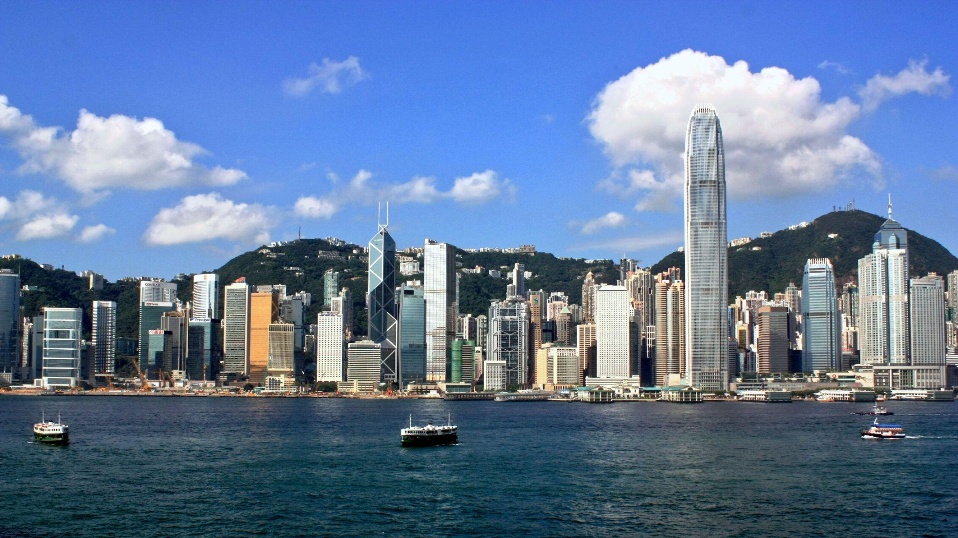

*A picture of the Victoria Harbour including the buildings on Hong Kong island*

Student Name: Wong Kwong Wa Donald

Word Count:

Candidate Number:

Research Question:

How do the Urban Characteristics change with distance from Victoria Harbour?

Introduction

Location of study

Hong Kong Special Administrative Region is a city located in the south of China People's Republic of China. There are few cities bordering Hong Kong, including Shenzhen, Zhuhai and Macau.

The main focus of this study is about finding how has the charistis changed form the distance from Vittoria Harbour, and test the hypothesis. To do so, I decided to start with the steet inside KowLoon, one of the CBDs in Hong Kong. The location we studied is Nathan Road, Yau Tsim Mong District, KowLoon.

Maps

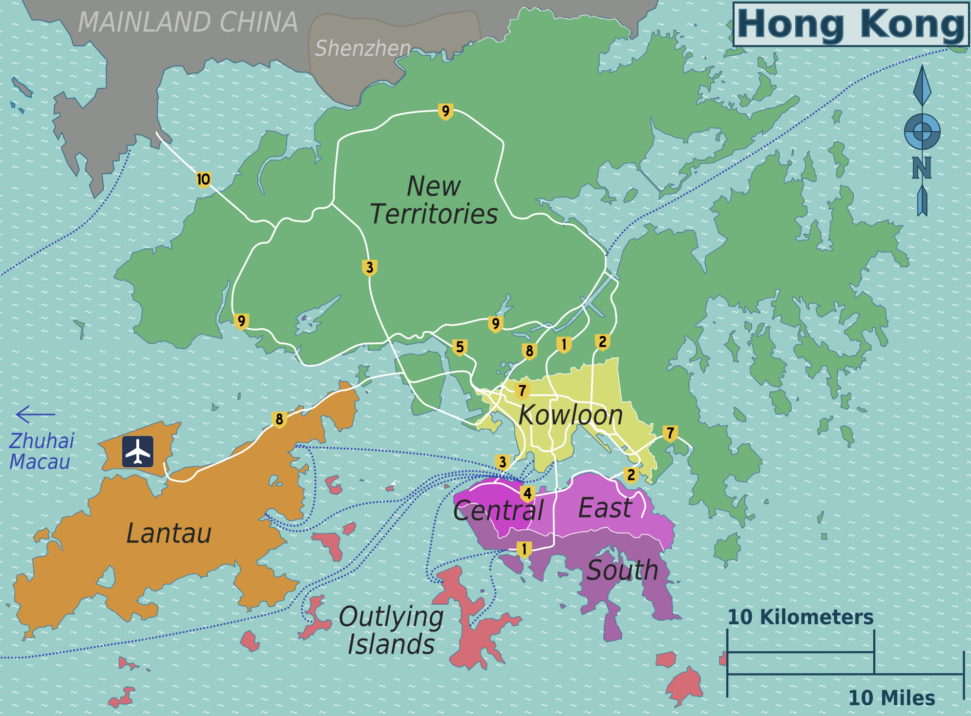

*Map of entire Hong Kong*

*(*[*http://www.maps-of-the-world.net/maps-of-asia/maps-of-hong-kong/*](http://www.maps-of-the-world.net/maps-of-asia/maps-of-hong-kong/) *)*

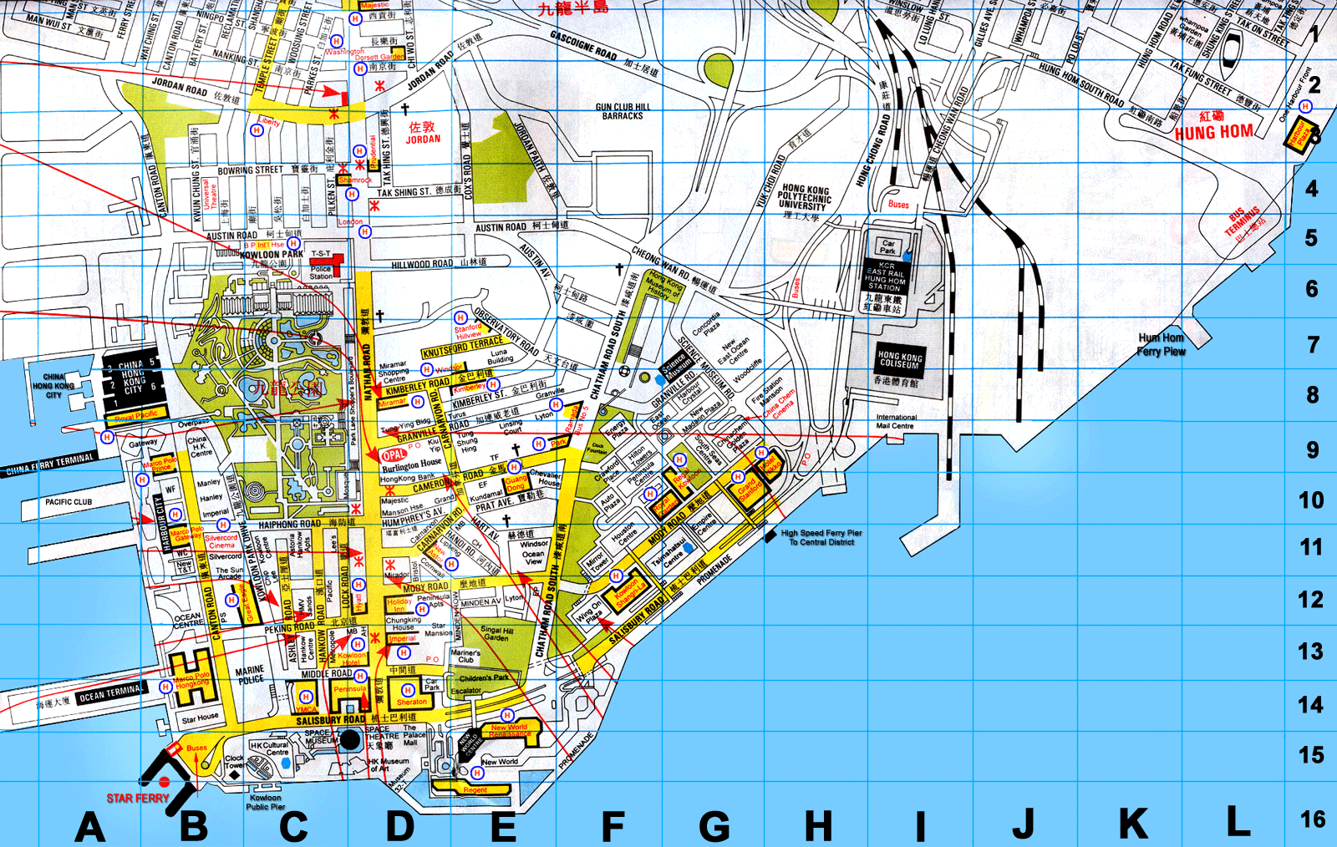

*Map of Kowloon, Hong Kong*

*(*[*https://www.worldmap1.com/map/kowloon-map*](https://www.worldmap1.com/map/kowloon-map) *)*

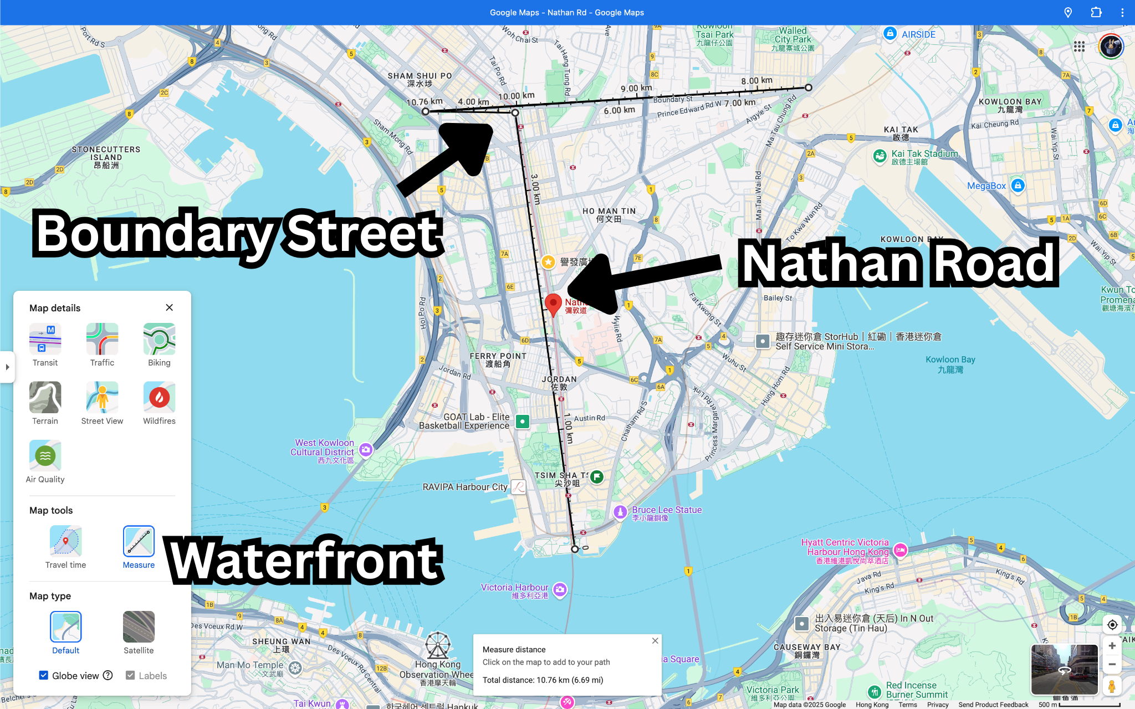

*Map showing Nathan Road from the waterfront to Boundary street*

*(Screen Shot taken on Google Maps )*

Background Theory

Hong Kong is a city with many mountains with less land able to develop. After being colonized by Great Britain, Hong became Financial City instead of industrial city with large number of factories and industry. The Urban model of Hong Kong does not fit the burgess model. The CBD of Hong Kong is Central, however it is not surrounded by factories nor industry. Besides that, the middle class housing is close to the CBD and the working class housing is closer to the factories and industry.

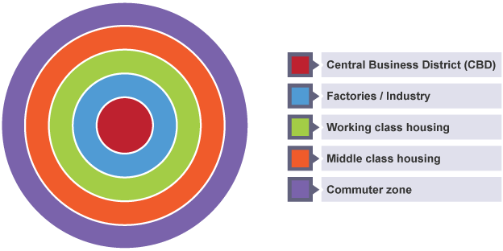

*A picture of burgess model*

*(*[*https://www.bbc.co.uk/bitesize/guides/z3h7sg8/revision/2*](https://www.bbc.co.uk/bitesize/guides/z3h7sg8/revision/2) *)*

Hypothesis

How do unban characteristics change with distance from victoria harbour, Hong Kong?

1. Noise level will decrease with distance from the CBD

I believe that the noise level will decrease with the distance from the CBD because the more distance from the CBD the less accessible the area will be, so there will be less human activities and less noise will be created.

1. EQS will decrease with distance from the CBD

CBD stands for central business district, places away from it will be less economically active since then people will be willing to spend less money to build the architecture so the equity will not be as good as those in CBD.

1. Amount of transport options will decrease with the distance from the CBD

One of the characteristics of CBD is highly accessible, which means that compared to the CBD the places away from it will be less accessible.

Methodology

| Method(s) | types of data | how we did it | why we did it | links to hypothesis |
| --- | --- | --- | --- | --- |
| Noise (DECIBELS) | quantitative | we opened the app that measures the noise level in decibels and walk and stayed in different point and add up all the data then divide them by the amount of members in the group and three because we stay in each points three times (1 min each time) | phone is not a professional device to measure noise level so we are spending more times and take the advantage of each sets of the data which is more accurate compared to use the raw data | the data we received proves the hypothesis that the Noise level will decrease with distance from the CBD |
| EQS (rate/10) | quantitative | We filled in a survey that included the noise level, hygiene level, building quality, amount of litter, crowding, degree of attraction and facilities quality. And reserved a number between -21 to +21 points | there are many factors to decide the Environmental Quality of an area, though the survey, we would have a clue what is the environmental quality of the area we studied about, and reflexed in the most intuitive way — numbers | the rate/10 reduces while the area we studied went away from the CBD, which linked to the hyphthoes that EQS will decrease with distance from the CBD |
| TRAFFIC OPTIONS (lines) | qualitative | We walked approximately 30 meters, around the center point of the place we studded and marked down every single traffic options for publics | This is to show how accessible the area is, by judging how many traffic options are available nearby. | This links to the hypothesis of amount of transport options decreasing with distance from the CBD |

Data Presentation

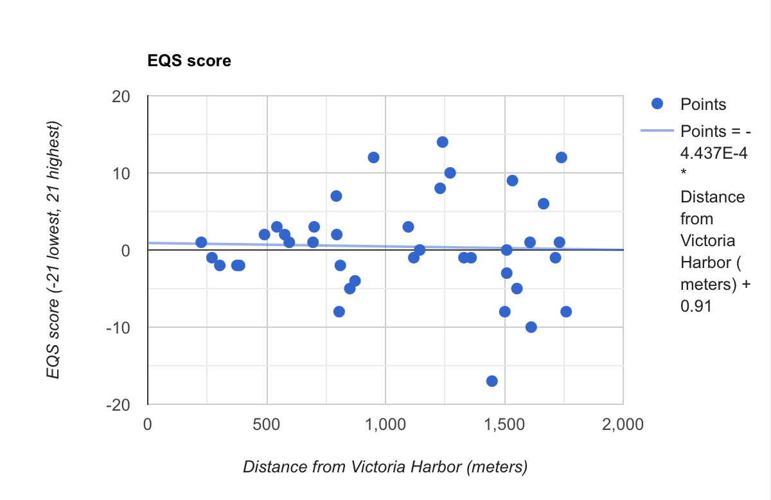

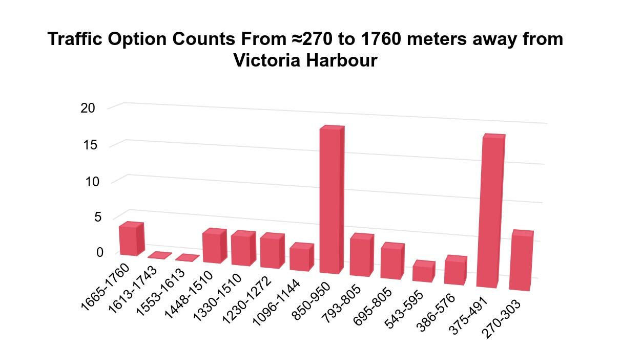

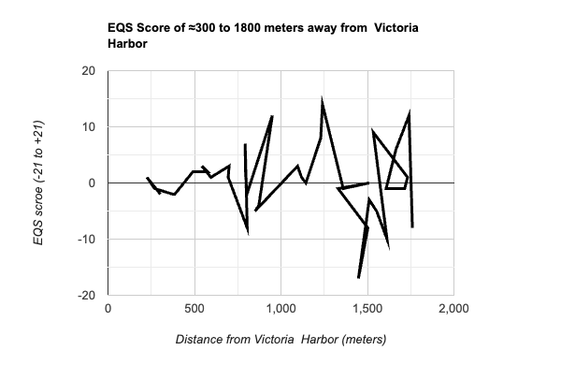

Anylisys

1 EQS

As we can see from the graph, the EQS score has

2 Noice Level

3 Traffic Opions