INDEX

S.NO | PROGRAM | DATE | SIGNATURE
1. | DDA Line Drawing Algorithm Program
2. | Mid Point Circle Algorithm Program
3. | Bresenham’s Circle Algorithm Program
4. | Translation
5. | Scaling
6. | Three Dimentional Transformation
7. | Simple Animation using Transformation
8. | Key-Frame Animation

6. 3 D Transformation c Program Code with output.
Code:-

#include<stdio.h>
#include<conio.h>
#include<graphics.h>
#include<math.h>
void trans();
void scale();
void rotate();
int maxx,maxy,midx,midy;
void main()
{
int ch;
int gd=DETECT,gm;
detectgraph(&gd,&gm);
initgraph(&gd,&gm,"e:\\tc\\bgi");
printf("\n 1.Translation \n2.Scaling\n 3.Rotation \n 4.exit");
printf("enter your choice");
scanf("%d",&ch);
do
{
switch(ch)
{
case 1 : trans();
getch();
break;
case 2 : scale();
getch();
break;
case 3 : rotate();
getch();
break;
case 4 :break;
}
printf("enter your choice");
scanf("%d",&ch);
} while(ch<4);
}
void trans()
{
int x,y,z,o,x1,x2,y1,y2;
maxx=getmaxx();
maxy=getmaxy();
midx=maxx/2;
midy=maxy/2;
bar3d(midx+50,midy-100,midx+60,midy-90,10,1);
printf("Enter translation factor");
scanf("%d%d",&x,&y);
printf("After translation:");
bar3d(midx+x+50,midy-(y+100),midx+x+60,midy-(y+90),10,1);
}
void scale()
{
int x,y,z,o,x1,x2,y1,y2;
maxx=getmaxx();
maxy=getmaxy();
midx=maxx/2;
midy=maxy/2;
bar3d(midx+50,midy-100,midx+60,midy-90,5,1);
printf("before translation\n");
printf("Enter scaling factors\n");
scanf("%d %d %d", &x,&y,&z);
printf("After scaling\n");
bar3d(midx+(x*50),midy-(y*100),midx+(x*60),midy-(y*90),5*z,1);
}
void rotate()
{
int x,y,z,o,x1,x2,y1,y2;
maxx=getmaxx();
maxy=getmaxy();
midx=maxx/2;
midy=maxy/2;
bar3d(midx+50,midy-100,midx+60,midy-90,5,1);
printf("Enter rotating angle");
scanf("%d",&o);
x1=50*cos(o*3.14/180)-100*sin(o*3.14/180);
y1=50*sin(o*3.14/180)+100*cos(o*3.14/180);
x2=60*cos(o*3.14/180)-90*sin(o*3.14/180);
y2=60*sin(o*3.14/180)+90*cos(o*3.14/180);
printf("After rotation about x axis");
bar3d(midx+50,midy-x1,midx+60,midy-x2,5,1);
printf("After rotation about yaxis");
bar3d(midx+x1,midy-100,midx+x2,midy-90,5,1);
}
Screen short of output:-
Translation

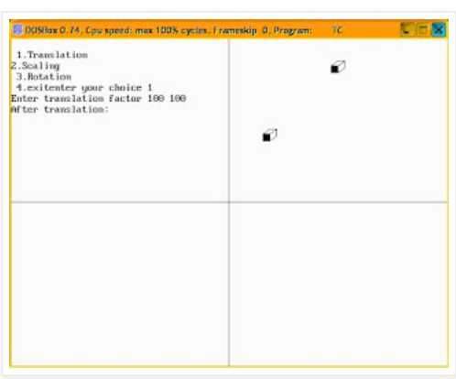

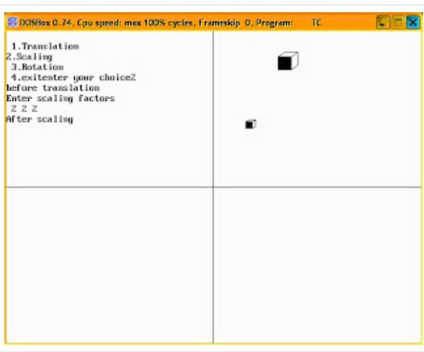
Scaling
Rotation
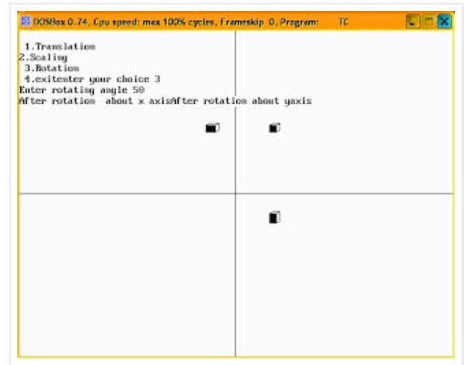

7. Creating animations using Transformations in c- language
#include <stdio.h>
#include <GL/glut.h>
#include <math.h>

// these are the parameters
#define maxHt 800
#define maxWd 600
#define maxLns 10000
#define transSpeed 1
#define rotSpeed 0.02
#define rotateLimit 0.2
#define boundLimitL -200
#define boundLimitR 500
#define grasslandy 230

// Structure for storing lines
typedef struct lines {
int x1, x2, y1, y2;
} LINE;

// Object type structure for storing each body part
typedef struct objects {
LINE edge[maxLns];
int translation, cx, cy, xoffset, yoffset;
float theta;
int rotationState;
int EdgeCount;
} Object;

// the different objects
Object Head, upBody, Tail, downBody, FlegF, FlegB, BlegF, BlegB;
// global
int dinoTranslate = 0;

// basic init function for OPENGL
void myInit(void)
{
glClearColor(1.0, 1.0, 1.0, 0.0);
glMatrixMode(GL_PROJECTION);
glLoadIdentity();
gluOrtho2D(0, maxHt, 0, maxWd);
glClear(GL_COLOR_BUFFER_BIT);
}

// this function tranlates, and rotates a point according to an object and draws it
void rotateandshiftPt(int px, int py, Object obbj)
{
int xf, yf;

xf = obbj.cx + (int)((float)(px - obbj.cx) * cos(obbj.theta)) - ((float)(py - obbj.cy) * sin(obbj.theta));
yf = obbj.cy + (int)((float)(px - obbj.cx) * sin(obbj.theta)) + ((float)(py - obbj.cy) * cos(obbj.theta));
glBegin(GL_POINTS);
glVertex2i(obbj.translation + xf + obbj.xoffset, yf + obbj.yoffset);
glEnd();
}

// this function draws a line using Bresenhams
void drawLineBresenham(int x1, int y1, int x2, int y2, Object obbj)
{
int Dx, Dy, Dxmul2, Dymul2, Pk, xtempi, ytempi;
float lineSlope, xtemp, ytemp;
Dx = abs(x2 - x1);
Dy = abs(y2 - y1);
Dxmul2 = 2 * Dx;
Dymul2 = 2 * Dy;
ytemp = (float)(y2 - y1);
xtemp = (float)(x2 - x1);
lineSlope = (ytemp / xtemp);

if (lineSlope >= -1.0 && lineSlope <= 1.0) {
Pk = Dymul2 - Dx;
if (x1 > x2) {
xtempi = x2;
x2 = x1;
x1 = xtempi;
ytempi = y2;
y2 = y1;
y1 = ytempi;
}
for (xtempi = x1, ytempi = y1; xtempi <= x2; xtempi++) {
rotateandshiftPt(xtempi, ytempi, obbj);
if (Pk < 0) {
Pk = Pk + Dymul2;
} else {
Pk = Pk + Dymul2 - Dxmul2;
if (lineSlope >= 0.0 && lineSlope <= 1.0)
ytempi = ytempi + 1;
else if (lineSlope < 0.0 && lineSlope >= -1.0)
ytempi = ytempi - 1;
}
}
} else {
Pk = Dxmul2 - Dy;
if (y1 > y2) {
xtempi = x2;
x2 = x1;
x1 = xtempi;
ytempi = y2;
y2 = y1;
y1 = ytempi;
}
for (xtempi = x1, ytempi = y1; ytempi <= y2; ytempi++) {
rotateandshiftPt(xtempi, ytempi, obbj);
if (Pk < 0) {
Pk = Pk + Dxmul2;
} else {
Pk = Pk + Dxmul2 - Dymul2;
if (lineSlope > 1.0)
xtempi = xtempi + 1;
else if (lineSlope < -1.0)
xtempi = xtempi - 1;
}
}
}
}
// here all the edges are iterated and drawn
void drawObj(Object obbj)
{
int i;
for (i = 0; i < obbj.EdgeCount; i++) {
drawLineBresenham(obbj.edge[i].x1, obbj.edge[i].y1, obbj.edge[i].x2, obbj.edge[i].y2, obbj);
}
}

// in this function, an object is updated
void updateObj(Object* obbj)
{
obbj->translation = dinoTranslate;

if (obbj->rotationState == 1) {
obbj->theta = obbj->theta + rotSpeed;
if (obbj->theta >= (3.14159))
obbj->theta = obbj->theta - (2.0 * 3.14159);
if (obbj->theta > rotateLimit)
obbj->rotationState = -1;

} else if (obbj->rotationState == -1) {
obbj->theta = obbj->theta - rotSpeed;

if (obbj->theta <= (-3.14159))
obbj->theta = (2.0 * 3.14159) + obbj->theta;

if (obbj->theta < -rotateLimit)
obbj->rotationState = 1;
}
}

// The actual function where the Dinosaur is drawn
void drawDino(void)
{
// an infinite while loop for moving the dinosaur
while (1) {
glClear(GL_COLOR_BUFFER_BIT);
// draw grassland
glLineWidth(5.0);
glColor3f(0.0f, 1.0f, 0.3f);
glBegin(GL_LINES);
glVertex2i(0, grasslandy);
glVertex2i(maxHt, grasslandy);
glEnd();
glPointSize(3.0);
glColor3f(0.9f, 0.5f, 0.6f);
// update all parts

updateObj(&Head);
updateObj(&upBody);
updateObj(&Tail);
updateObj(&downBody);
updateObj(&FlegF);
updateObj(&FlegB);
updateObj(&BlegF);
updateObj(&BlegB);

// draw all parts, also draw joining parts
drawObj(Head);
drawObj(upBody);
drawObj(Tail);
drawObj(downBody);
drawObj(FlegF);
drawObj(FlegB);
drawObj(BlegF);
drawObj(BlegB);

dinoTranslate--; // decreased because moving forward
if (dinoTranslate <= boundLimitL) {
dinoTranslate = boundLimitR;
printf("\ntranslate %d", dinoTranslate);
}
printf("\ntranslate %d", dinoTranslate);
glFlush();
}
}

// TAn object is stored using this function
void storeObj(char* str, Object* obbj)
{
obbj->theta = 0.0;

FILE* fp;
fp = fopen(str, "r");
if (fp == NULL) {
printf("Could not open file");
return;
}
obbj->EdgeCount = 0;
int count = 0, x1, y1, x2, y2;
while (!feof(fp)) {
count++;
if (count > 2) {
x1 = x2;
y1 = y2;
count = 2;
}
if (count == 1) {
fscanf(fp, "%d, %d", &x1, &y1);
} else {
fscanf(fp, "%d, %d", &x2, &y2);
printf("\n%d, %d", x2, y2);
obbj->edge[obbj->EdgeCount].x1 = x1;
obbj->edge[obbj->EdgeCount].y1 = y1;
obbj->edge[obbj->EdgeCount].x2 = x2;
obbj->edge[obbj->EdgeCount].y2 = y2;
obbj->EdgeCount++;
}
}

// printf("\nPolygon stored!");
fclose(fp);
}

// All parts are stored.
void storeAllParts()
{
FILE* fp, *fp2;
int cx, cy;
fp = fopen("centrePts.txt", "r");
fp2 = fopen("offsetDino.txt", "r");
if (fp == NULL || fp2 == NULL) {
printf("Could not open file");
return;
}
// parts
//----------------
// head+neck
storeObj("headDino.txt", &Head);
fscanf(fp, "%d, %d", &cx, &cy);
Head.cx = cx;
Head.cy = cy;
fscanf(fp2, "%d, %d", &cx, &cy);
Head.xoffset = cx;
Head.yoffset = cy;
Head.rotationState = 1;

// upper body boundary(only translation)
storeObj("bodyupDino.txt", &upBody);
upBody.cx = 0;
upBody.cy = 0;
fscanf(fp2, "%d, %d", &cx, &cy);
upBody.xoffset = cx;
upBody.yoffset = cy;
upBody.rotationState = 0;

// tail
storeObj("tailDino.txt", &Tail);
fscanf(fp, "%d, %d", &cx, &cy);
Tail.cx = cx;
Tail.cy = cy;
fscanf(fp2, "%d, %d", &cx, &cy);
Tail.xoffset = cx;
Tail.yoffset = cy;
Tail.rotationState = -1;

// back leg front
storeObj("backlegFDino.txt", &BlegF);
fscanf(fp, "%d, %d", &cx, &cy);
BlegF.cx = cx;
BlegF.cy = cy;
fscanf(fp2, "%d, %d", &cx, &cy);
BlegF.xoffset = cx;
BlegF.yoffset = cy;
BlegF.rotationState = -1;

// back leg rear
storeObj("backlegRDino.txt", &BlegB);
fscanf(fp, "%d, %d", &cx, &cy);
BlegB.cx = cx;
BlegB.cy = cy;
fscanf(fp2, "%d, %d", &cx, &cy);
BlegB.xoffset = cx;
BlegB.yoffset = cy;
BlegB.rotationState = 1;

// lower body boundary(only translation)
storeObj("bodydownDino.txt", &downBody);
downBody.cx = 0;
downBody.cy = 0;
fscanf(fp2, "%d, %d", &cx, &cy);
downBody.xoffset = cx;
downBody.yoffset = cy;
downBody.rotationState = 0;

// front leg rear
storeObj("frontlegRDino.txt", &FlegB);
fscanf(fp, "%d, %d", &cx, &cy);
FlegB.cx = cx;
FlegB.cy = cy;
fscanf(fp2, "%d, %d", &cx, &cy);
FlegB.xoffset = cx;
FlegB.yoffset = cy;
FlegB.rotationState = -1;

// front leg front
storeObj("frontlegFDino.txt", &FlegF);
fscanf(fp, "%d, %d", &cx, &cy);
FlegF.cx = cx;
FlegF.cy = cy;
fscanf(fp2, "%d, %d", &cx, &cy);
FlegF.xoffset = cx;
FlegF.yoffset = cy;
FlegF.rotationState = 1;

//------------------------
fclose(fp);
}

void main(int argc, char** argv)
{

storeAllParts();
glutInit(&argc, argv);
glutInitDisplayMode(GLUT_SINGLE | GLUT_RGB);
glutInitWindowSize(maxHt, maxWd);
glutInitWindowPosition(0, 0);
glutCreateWindow("Walking dinosaur");
myInit();
glutDisplayFunc(drawDino); // actual loop call
glutMainLoop();
}

8. KeyFraming graphics animation(C program for bouncing ball):-
SourceCode-
#include <stdio.h>
#include <conio.h>
#include <graphics.h>
#include <dos.h>

int main() {
int gd = DETECT, gm;
int i, x, y, flag=0;
initgraph(&gd, &gm, "C:\\TC\\BGI");

/* get mid positions in x and y-axis */
x = getmaxx()/2;
y = 30;

while (!kbhit()) {
if(y >= getmaxy()-30 || y <= 30)
flag = !flag;
/* draws the gray board */
setcolor(RED);
setfillstyle(SOLID_FILL, RED);
circle(x, y, 30);
floodfill(x, y, RED);

/* delay for 50 milli seconds */
delay(50);

/* clears screen */
cleardevice();
if(flag){
y = y + 5;
} else {
y = y - 5;
}
}

getch();
closegraph();
return 0;
}

ScreenShort:-

