Hot Hẻm: Sài Gòn Giữa Cái Nóng Hổng Công Bằng—Saigon in Unequal Heat
  - Optimization for Suffering: The Hottest Route Available

I. Introduction
Extreme urban heat exposure is a critical, disproportionately felt environmental injustice that will only worsen with current climate trajectories (Chakraborty et al., 2019). This heterogeneity is driven by both macro-scale morphologies (e.g., land cover, emissivity) and intricate micro-scale streetscapes (e.g., canyon effects, tree canopy) (Oke, 1982), many of which are governed by municipal regulation.
However, conventional thermal mapping often relies on coarse satellite data, which may underrepresent the thermal reality experienced by pedestrians (Middel et al., 2019). Critically, existing coolest route algorithms place the burden of heat mitigation on the individual, treating health and wellbeing as a choice rather than revealing a systemic infrastructural failure.
This project aims to fill this gap by first, fusing street-level visual morphology with thermal and structural remote sensing data, and second, by inverting the optimization to seek the hottest routes. By identifying corridors that maximize sun and minimize shade, this GeoAI workflow provides local municipalities with an actionable, scientific tool to pinpoint and prioritize areas for urgently needed shaded infrastructure and green investment.

II. Data and Study Area

Pedestrian Network and Wards
A pedestrian network graph with a 500-meter buffer was extracted from Python’s osmnx (Boeing, 2017), yielding 28,445 nodes and 74,710 edges for three administrative districts: District 1, District 2, and District 8. Due to API costs and keeping in mind computational efficiency, only six wards were selected as disparate GSV candidates, two from each district of interest: Bến Thành (2,424 nodes) and Cô Giang (1,840 nodes) in District 1, An Khánh (1,119 nodes) and Thảo Điền (1,547) in District 2, and Phường 5 (2,346 nodes) and Phường 6 (2,013 nodes) from District 8.
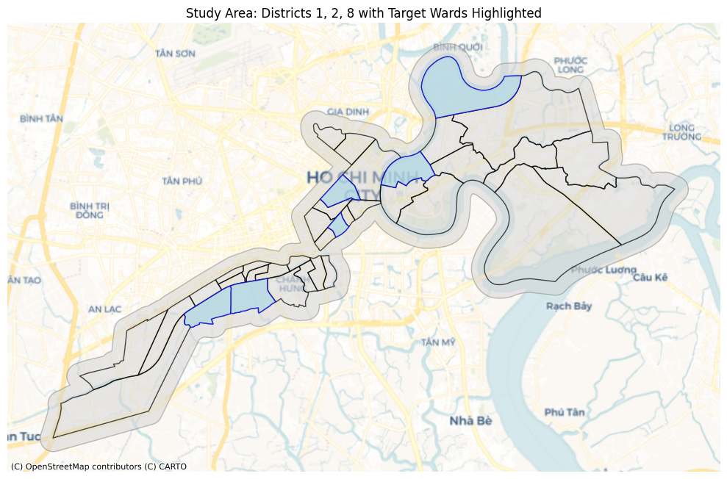
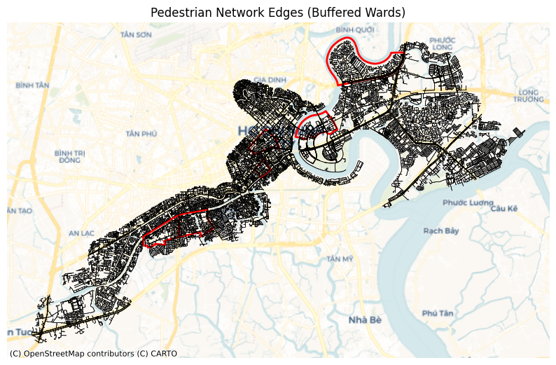

Street-Level Imagery
GSV samples generated 23,806 points from 500-meter buffered wards of interest at 50-meter intervals. Metadata contained 20,457 images, an unfortunate 14.07% decrease due to interruptions, but nonetheless providing sufficient density for training streetscape indices and validating segmentation outputs within wards of interest.

Remote Sensing Rasters
The satellite data was extracted from several different sources (USGS, 2024; Shimada et al., 2014): Landsat 8 / 9 (30m resolution, dry months December thru April, 2023–2025), JAXA LULC (10m resolution, 2025), JAXA PALSAR-2 (ScanSAR, 50m resolution, 2025), ALOS World 3D DSM (30m resolution, 2025).

III. Methodologies
In the interest of computational efficiency, all notebooks and scripting were offloaded from local into cloud computing using Google’s Colab Pro with A100 GPU acceleration. Combining Landsat rasters into a composite was completed in ArcGIS v3.4.

Image Segmentation and Superclass Mapping
GSV images were processed using Mask2Former Swin-Large (Cheng et al., 2022) trained on Mapillary Vistas (facebook/mask2former-swin-large-mapillary-vistas-semantic) (Neuhold et al., 2017), accessed via Hugging Face. The model contains 65 object categories optimized for street-level scene analysis in complex urban environments like Sài Gòn.
GSV images were downloaded at 640 × 640 pixel resolution. Ideally, panoramic images would have been preferable, but due to cost restraints, the static imagery was made to dynamically alter the header to be front-facing.
To improve interpretability and stability for index construction, raw segmentation classes were remapped into seven superclasses: Other (23 classes including persons, animals, terrain, street furniture), Vegetation (1 class), Sky (1 class), Building (7 classes including walls, fences, bridges, tunnels), Pavement/Road (12 classes including sidewalks, bike lanes, parking), Water (2 classes including boats), and Vehicle/Clutter (16 classes including poles, signs, vehicles).
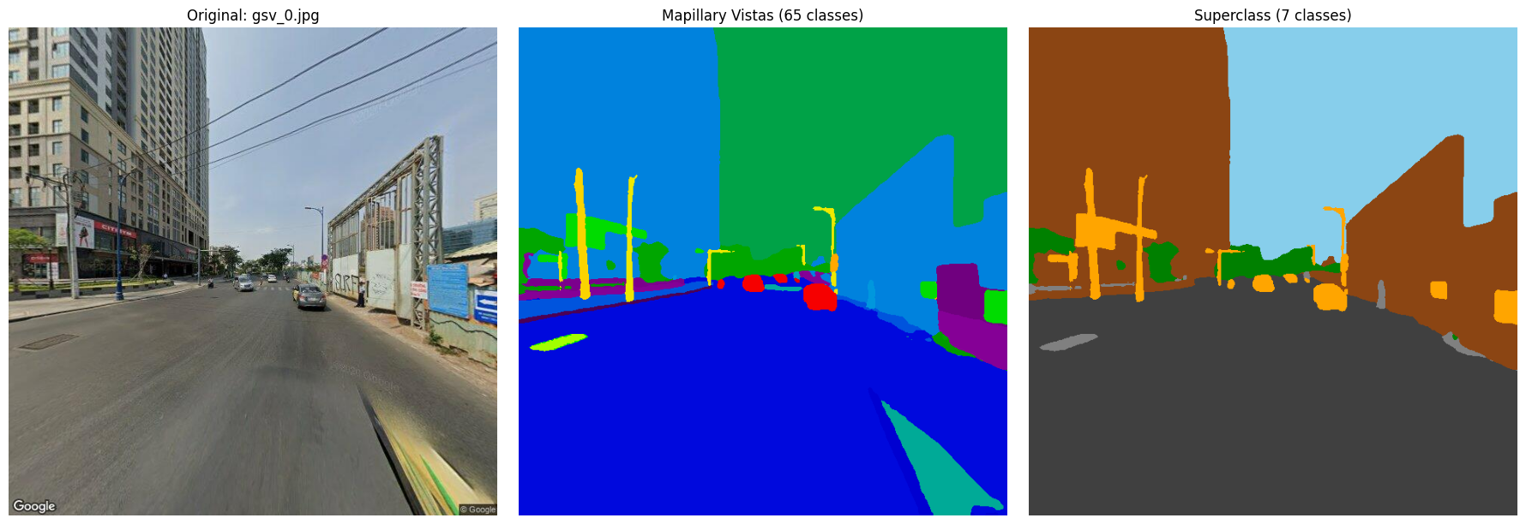

Engineering Indices
The final merged superclass imagery was used to create predictive features (Li et al., 2015). Seven superclass percentages were computed directly from the segmentation masks: pct_vegetation, pct_sky, pct_building, pct_pavement_road, pct_water, pct_vehicle_clutter, and pct_other.
GSV-Derived Features

Raster Extraction
The collection of Landsat rasters moved through the workflow in this order: Create Mosaic Dataset (Data Management), Make Mosaic Layer (Data Management), Cell Statistics (Spatial Analyst), Raster Calculator (Spatial Analyst), Copy Raster (Data Management), Composite Bands (Data Management).
A mosaic dataset was created to combine and stitch together 64 scenes from 2023 thru 2025 during dry season months December thru April. The different mosaic layers were isolated, with maximum LST and averages for other layers. This was to process individual cell statistics to convert DN raw values and re-scale, and raster calculations to calculate NDVI and alter LST from Kelvin to Celsius. Only the QA_PIXEL band was acquired through the 5th tool.

Model Design and Training
Two XGBoost models were trained using the xgboost Python library: a full model including raster and GSV features for maximum predictive power, and a deployment model using only raster features for city-wide application (Chen & Guestrin, 2016).
The input feature space includes: Landsat features, providing thermal and vegetative surface characteristics (ndvi and emissivity); PALSAR features, which quantify surface roughness and density using radar backscatter and texture metrics (palsar_hh_db, palsar_hv_db, palsar_hv_hh_ratio, palsar_glcm_contrast, palsar_glcm_homogeneity, and palsar_glcm_energy); DSM features, representing elevation and sky visibility (elevation_m and sky_view_factor); landcover features from the JAXA classification (landcover_class); and GSV segmentation features, quantifying streetscape morphology by the percentage of segmented superclasses (pct_vegetation, pct_sky, pct_building, pct_pavement_road, pct_water, pct_vehicle_clutter, and pct_other).
The XGBoost parameters were set for robust, regularized learning to capture LST's non-linear mechanisms. The model ran for 500 estimators with a modest 0.05 learning rate and utilized early stopping. Model complexity was controlled by limiting tree depth to 5 and requiring 5 minimum instances per leaf. Variance reduction was achieved by column and row subsampling, randomly selecting 80% of both features and data for each iteration. Finally, L1 and L2 regularization were applied to penalize model complexity and prevent overfitting.

Spatial Cross-Validation
To prevent optimistically biased performance estimates from spatial autocorrelation, a leave-one-ward-out spatial cross-validation strategy was implemented. GSV points sampled at 50-meter intervals share the same 30-meter Landsat pixels, so adjacent points in different folds would leak information under standard K-fold CV. By holding out entire wards during each fold, the model must extrapolate to spatially distinct areas, providing realistic generalization estimates.

Node Prediction and Routing
A patchwork approach was pursued, using the full model (with GSV features) to predict within wards of interest and the deployment model (raster-only) to predict outside of those wards where GSV imagery is unavailable. After generating predictions for network nodes, a prediction raster was derived from them and interpolated to create a hybrid cost surface and a Gaussian blur applied to smooth out interpolation artifacts.
Dijkstra’s algorithm was implemented (Dijkstra, 1959), assigning heat edge costs by combining normalized length and temperature to support three route types with tunable heat penalty and reward parameters: shortest, coolest with a temperature penalty, and hottest with an inverted temperature penalty to reward.

IV. Results

Model Performance
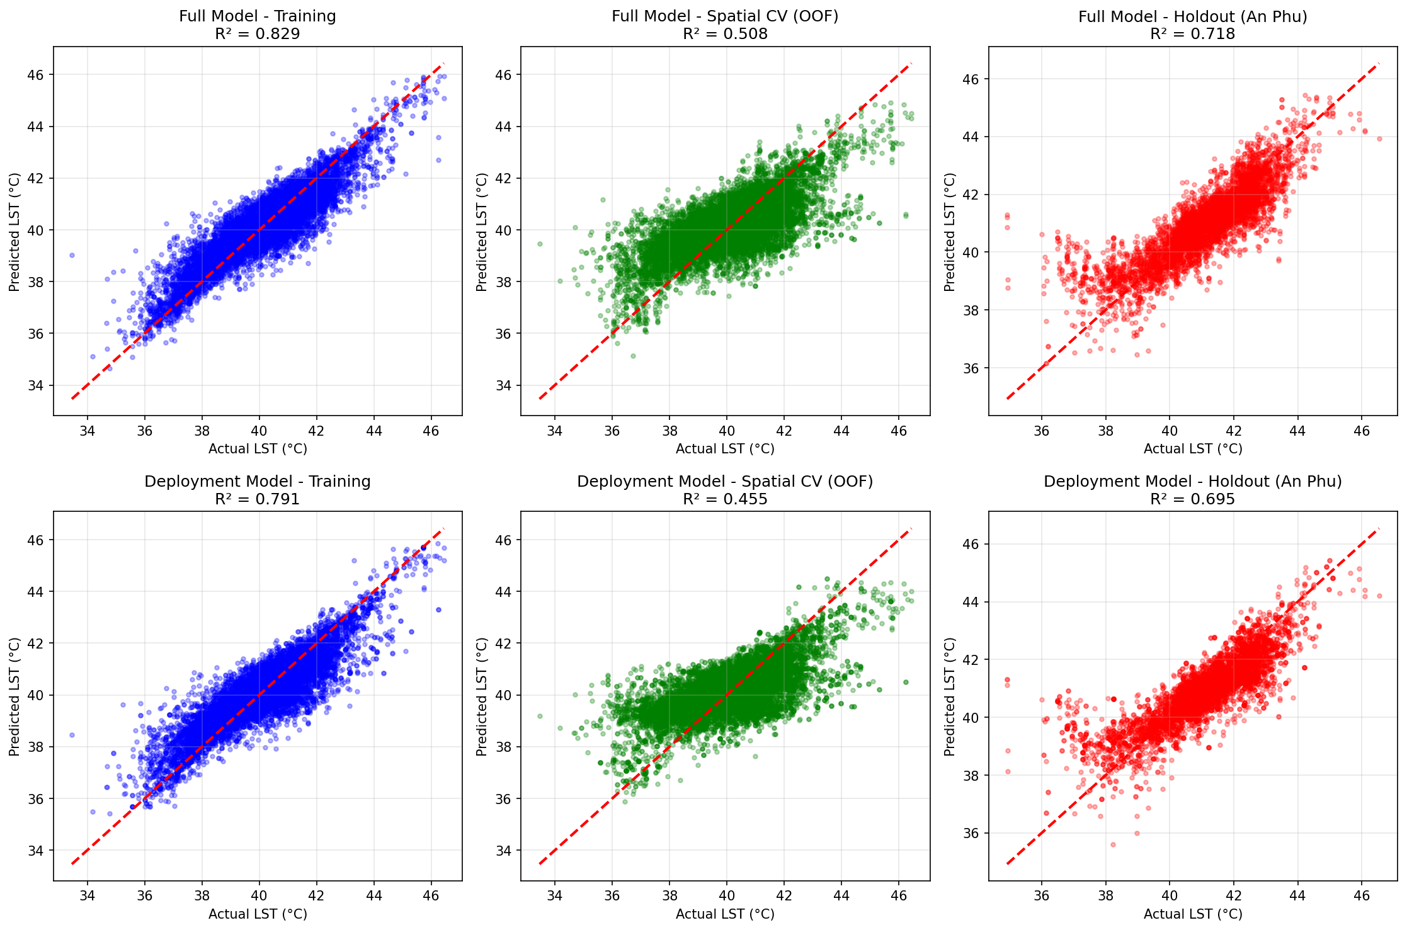
LST Predictions Scatter Plot
Model performance was evaluated using three complementary metrics: training set performance, spatial cross-validation (leave-one-ward-out), and holdout ward (An Phú) performance.
Model Performance Comparison
Metric | Full Model | Deployment Model
Features | 18 | 11
Training RMSE | 0.6203 | 0.6844
Training R² | 0.8285 | 0.7913
Spatial CV RMSE | 1.0510 ± 0.2898 | 1.1061 ± 0.2755
Spatial CV R² | 0.5079 ± 0.2757 | 0.4549 ± 0.2688
Holdout RMSE | 0.8093 | 0.8422
Holdout R² | 0.7180 | 0.6946
Holdout MAE | 0.5909 | 0.6134
The spatial cross-validation reveals substantial inter-ward variability (± 0.27 R²), indicating that some wards are considerably harder to predict than others. The holdout ward (An Phú) achieved higher R² than the spatial CV average, suggesting it shares similar characteristics with the training wards.
The train-holdout gap of approximately 0.10 indicates moderate but acceptable overfitting for a spatial prediction task. The larger train-CV gap (~0.32) reflects inter-ward heterogeneity rather than classical overfitting—different wards have different predictability based on their urban morphology.

GSV Feature Contribution
The contribution of GSV-derived streetscape features was quantified by comparing the full model (with GSV) to the deployment model (raster-only):
GSV Feature Contribution
Metric | Improvement
Spatial CV R² Improvement | +0.0530
Holdout R² Improvement | +0.0234
GSV features provide modest but meaningful improvement, confirming that street-level imagery adds predictive value beyond satellite data alone.

Feature Importance
Feature | Full Model | Deployment Model
landcover_class | 0.2169 | 0.2953
ndvi | 0.1787 | 0.1746
emissivity | 0.1560 | 0.2467
elevation_m | 0.0648 | 0.0746
pct_vegetation | 0.0572 | —
pct_water | 0.0413 | —
pct_sky | 0.0355 | —
palsar_hh_db | 0.0342 | 0.0416
pct_building | 0.0305 | —
sky_view_factor | 0.0289 | 0.0366
The dominant predictors were consistent across both models. Landcover class, NDVI, and emissivity ranked highest, together accounting for over 55% of predictive power. In the full model, GSV-derived streetscape variables (vegetation, water, sky percentages) contributed additional explanatory signal, ranking within the top 10 features.

Node Prediction Coverage
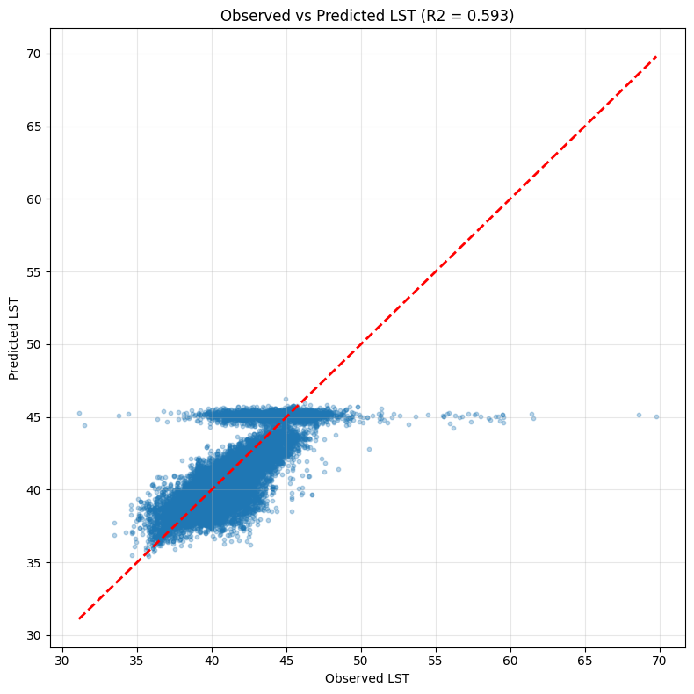
LST Observed vs. Predicted Scatter Plot
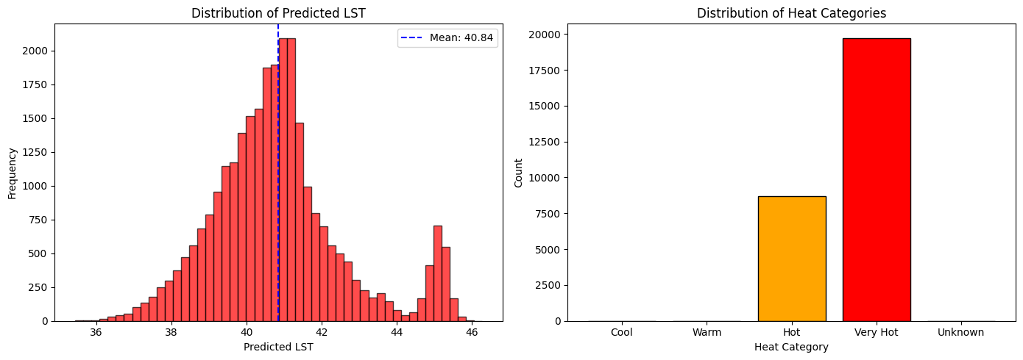
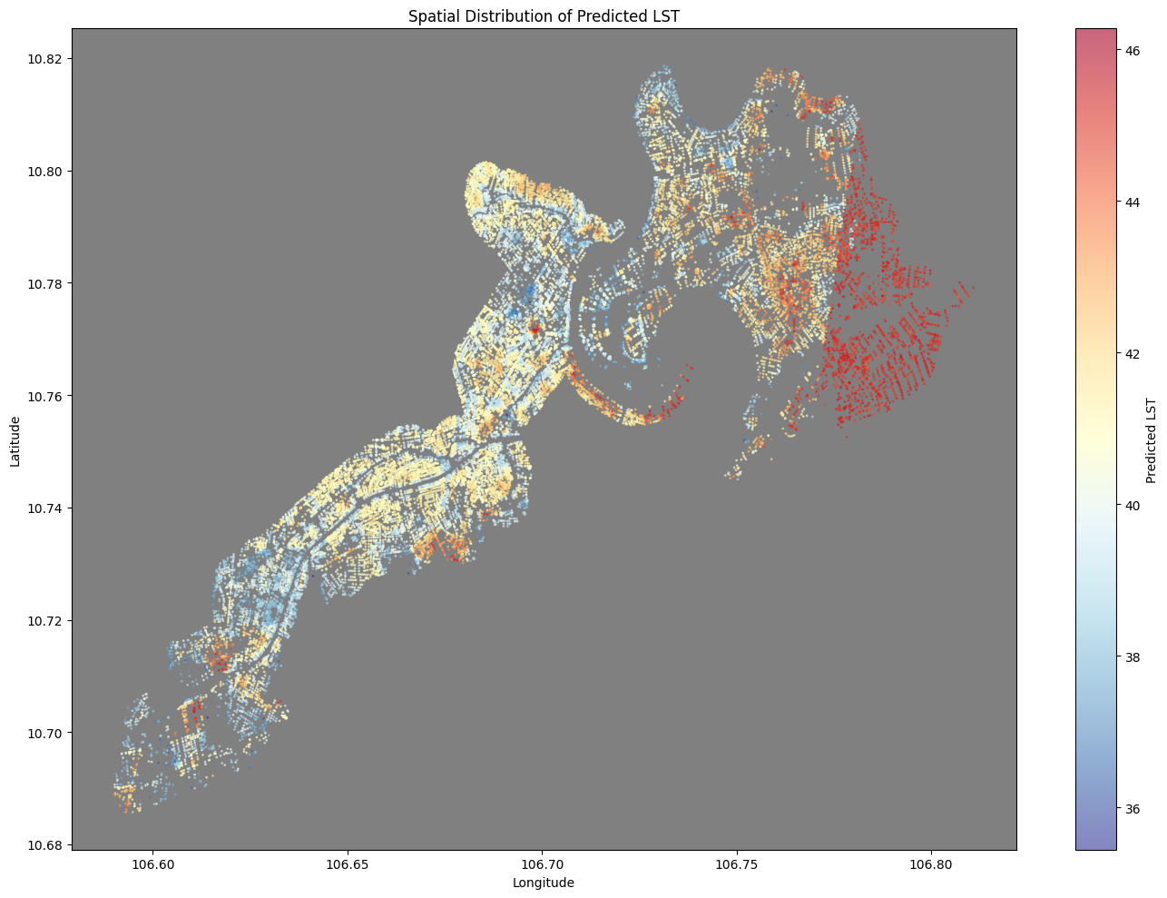
LST Predicted Map
This mean-reverting behavior has critical implications for applying the model to environments outside the training distribution, particularly areas with significant open space, non-tree greenery like grass fields, or non-clustered buildings. The model was trained primarily on the complex street canyon geometry of HCMC's central districts. It may struggle to fully capture the cooling effect of large, continuous patches of greenery and open spaces because these structures were not the dominant features in the training data's morphology. Consequently, it is likely to over-predict the LST in these large, cool areas, pushing the prediction closer to the mean and failing to accurately capture the full range of low temperatures achievable in those settings.

Routing Outcomes
The coolest route increases travel distance but reduces both mean and peak exposure, demonstrating tangible potential for heat-resilient mobility guidance. The hottest route identifies corridors of maximum heat exposure—priority candidates for infrastructure intervention.
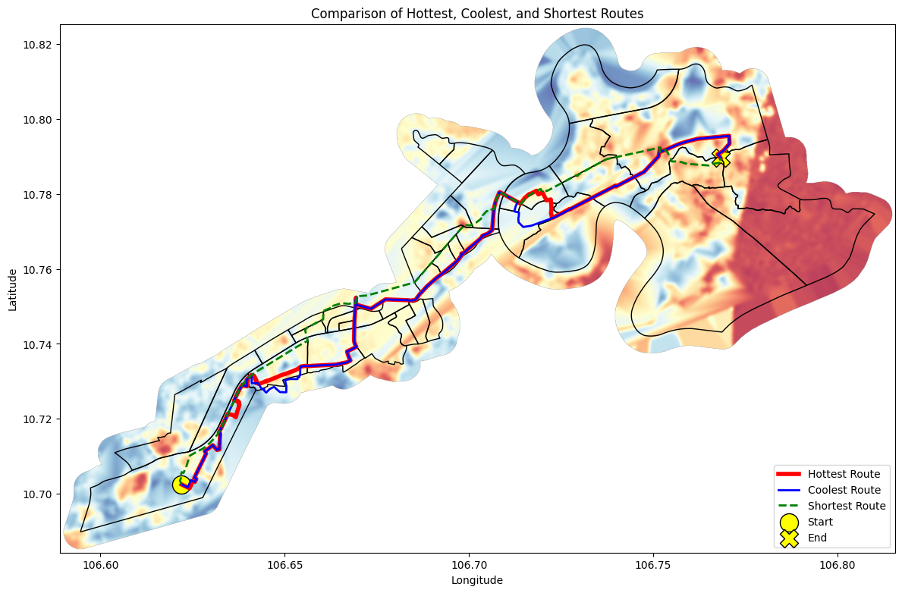
Dijkstra Routes: Hottest, Coolest, and Shortest
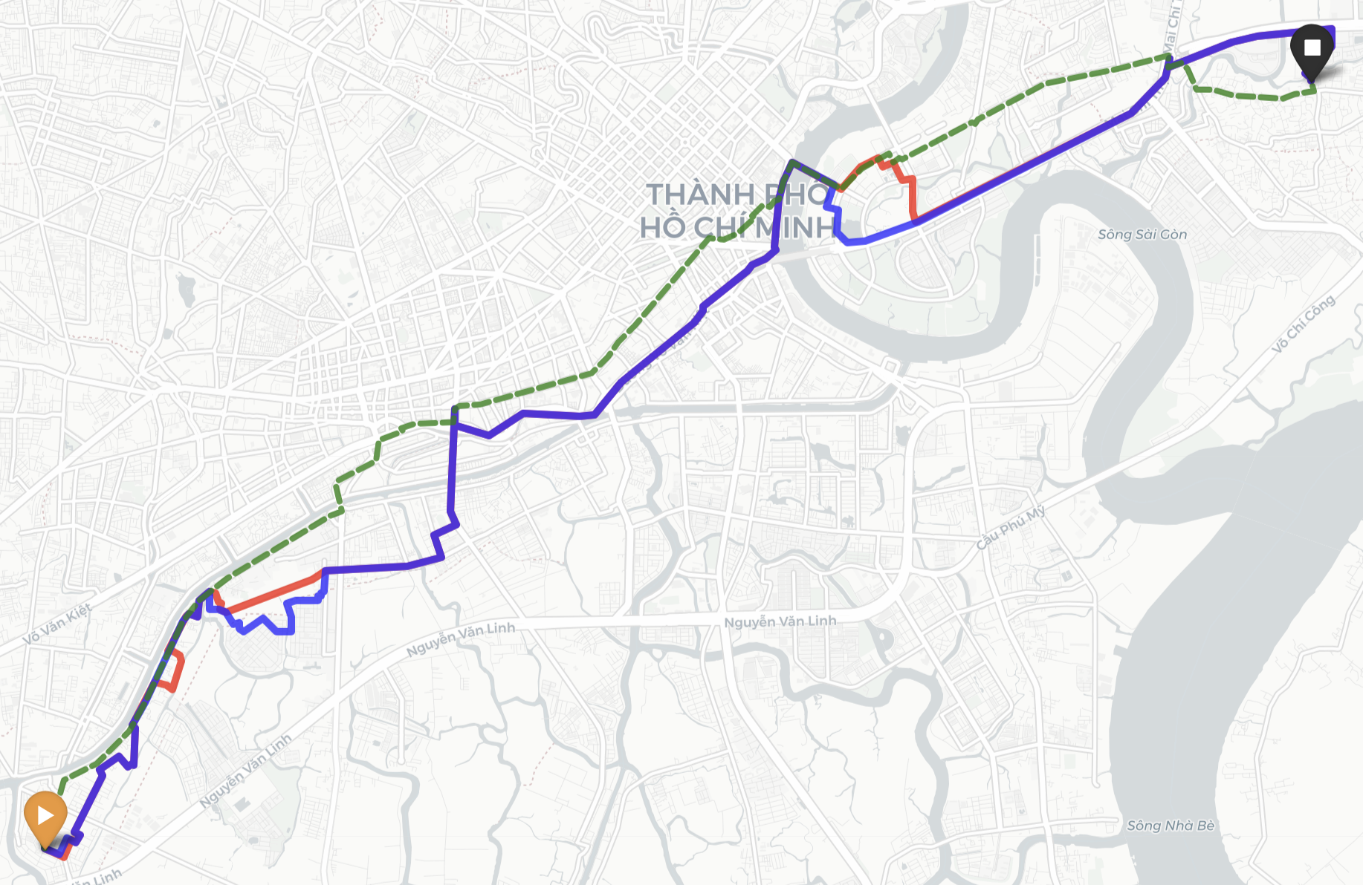
Routing Results
Route | Distance (km) | Average LST | Maximum LST
Shortest | 22.00 | 40.63°C | 45.41°C
Coolest | 27.83 | 40.20°C | 43.95°C
Hottest | 27.38 | 40.40°C | 43.95°C
The coolest route adds 5.83 km (26.5% distance penalty) to reduce average temperature by 0.43°C. This trade-off highlights why infrastructure investment matters more than individual route choice—residents should not bear a 26% distance penalty to marginally reduce heat exposure.

V. Discussion and Limitations
Hot Hẻm demonstrates a scalable approach for integrating human-scale streetscape morphology with city-scale remote sensing to operationalize pedestrian heat risk. The deployment model achieves R² of 0.69 on the held-out An Phú ward, with predictions typically within 0.61°C (MAE) of observed LST, demonstrating robust generalization to unseen areas. However, there are significant limitations for the future.
Some areas with unique urban morphology are harder to predict, and the model may underperform in wards that differ substantially from the training distribution (Middel et al., 2019); GSV images were captured at various times over several years, while Landsat composites represent dry-season 2023–2025 maximum temperatures. Street conditions (e.g., tree canopy, construction) may have changed between GSV capture and satellite observation; sky view factor derived from the 30m terrain DSM captures topographic effects but does not fully represent urban canyon geometry at the street level; current heat-category thresholds skew heavily toward “Hot / Very Hot,” suggesting that categorical calibration (e.g., quantile-based or health-relevant thresholds) should be refined.

VI. Conclusion
This project delivers a reproducible, multi-scale GeoAI pipeline for heat-weighted pedestrian routing in Ho Chi Minh City. By combining GSV-derived segmentation indices with Landsat thermal variables, JAXA SAR structure, and DSM terrain context, the framework achieves strong predictive accuracy (holdout R² = 0.70, MAE = 0.6°C) and enables practical routing alternatives that identify heat exposure corridors.
The key insight is methodological: rather than helping individuals escape heat, the hottest route optimization identifies where pedestrians suffer most, providing municipalities with actionable data for infrastructure intervention. The 26% distance penalty imposed by the coolest route demonstrates that heat avoidance should not be framed as individual responsibility—it is a systemic infrastructure challenge requiring public investment. It should be noted that GSV imagery contains copyright restrictions forbidding their implementations in building applications, so granular streetscape imagery would need to be manually obtained or downloaded from open-source material.
Future extensions should include multi-ward holdout testing, threshold calibration using health-relevant cutoffs, multi-season or diurnal modeling, weather data, uncertainty-aware routing, and Meta’s tree canopy height data (Tolan et al., 2023), and Global Building Atlas’ 3D dataset (Zhu et al., 2025) to further strengthen real-world applicability.

VII. References
Biljecki, F., & Ito, K. (2021). Street view imagery in urban analytics and GIS: A review. Landscape and Urban Planning, 215, 104217.
Boeing, G. (2017). OSMnx: New methods for acquiring, constructing, analyzing, and visualizing complex street networks. Computers, Environment and Urban Systems, 65, 126-139.
Chakraborty, T., Hsu, A., Manya, D., & Sheriff, G. (2019). Disproportionately higher exposure to urban heat in lower-income neighborhoods: a multi-city perspective. Environmental Research Letters, 14(10), 105003.
Chen, T., & Guestrin, C. (2016). XGBoost: A scalable tree boosting system. In Proceedings of the 22nd ACM SIGKDD International Conference on Knowledge Discovery and Data Mining (pp. 785-794).
Cheng, B., Misra, I., Schwing, A. G., Kirillov, A., & Girdhar, R. (2022). Masked-attention mask transformer for universal image segmentation. In Proceedings of the IEEE/CVF conference on computer vision and pattern recognition (pp. 1290-1299).
Dijkstra, E. W. (1959). A note on two problems in connexion with graphs. Numerische Mathematik, 1, 269-271.
Ho, H. C., Knudby, A., Sirovyak, P., Xu, Y., Hodul, M., & Henderson, S. B. (2014). Mapping maximum urban air temperature on hot summer days. Remote Sensing of Environment, 154, 38-45.
Kang, Y., Zhang, F., Gao, S., Lin, H., & Liu, Y. (2020). A review of urban physical environment sensing using street view imagery in public health studies. Annals of GIS, 26(3), 261-275.
Li, X., Zhang, C., Li, W., Ricard, R., Meng, Q., & Zhang, W. (2015). Assessing street-level urban greenery using Google Street View and a modified green view index. Urban Forestry & Urban Greening, 14(3), 675-685.
Middel, A., Lukasczyk, J., Zakrzewski, S., Arnold, M., & Maciejewski, R. (2019). Urban form and composition of street canyons: A human-centric big data and deep learning approach. Landscape and Urban Planning, 183, 122-132.
Neuhold, G., Ollmann, T., Rota Bulo, S., & Kontschieder, P. (2017). The Mapillary Vistas Dataset for Semantic Understanding of Street Scenes. In International Conference on Computer Vision (ICCV).
Oke, T. R. (1982). The energetic basis of the urban heat island. Quarterly Journal of the Royal Meteorological Society, 108(455), 1-24.
Shimada, M., Itoh, T., Motooka, T., Watanabe, M., Shiraishi, T., Thapa, R., & PALSAR Project Team. (2014). New global forest/non-forest maps from ALOS PALSAR data (2007–2010). Remote Sensing of Environment, 155, 13-31.
Tolan, J., Yang, H.-I., Nosarzewski, B., Couairon, G., Vo, H., Brandt, J., Spore, J., Majumdar, S., Haziza, D., Vamaraju, J., Moutakanni, T., Bojanowski, P., Johns, T., White, B., Tiecke, T., & Couprie, C. (2023). Very high resolution canopy height maps from RGB imagery using self-supervised vision transformer and convolutional decoder trained on Aerial Lidar [Dataset]. Meta. https://dataforgood.facebook.com/dfg/tools/canopy-height-maps
United States Geological Survey (USGS). (2024). Landsat 8-9 Operational Land Imagery (OLI) and Thermal Infrared Sensor (TIRS) Collection 2 Level-2 Data.
Voogt, J. A., & Oke, T. R. (2003). Thermal remote sensing of urban climates. Remote Sensing of Environment, 86(3), 370-384.
Zhang, F., Zhou, B., Liu, L., Liu, Y., Fung, H. H., Lin, H., & Ratti, C. (2019). Measuring human perceptions of a large-scale urban region using machine learning. Landscape and Urban Planning, 180, 148-160.
Zhu, X. X., Chen, S., Zhang, F., Shi, Y., and Wang, Y.: GlobalBuildingAtlas: an open global and complete dataset of building polygons, heights and LoD1 3D models, Earth Syst. Sci. Data, 17, 6647–6668, https://doi.org/10.5194/essd-17-6647-2025, 2025.

