Pharmacy Accessibility Analysis: AI_WALK & AI_DRIVE

Co-Authored By: Jill Kalman , Tess Vu, Alex Stauffer, Joey Cahill

University of Pennsylvania School of Design

1. Score Methodology
The AI score is a supply-demand ratio: Rj = Pharmacy Supply / Population within pharmacy catchment
AI = Σ(Rj within poly node catchment)
KZN Walking Catchment: 3km Gauteng Walking Catchment: 2km
KZN Driving Catchment: 10km Gauteng Driving Catchment: 5km

Supply assumed: 1 (KZN) | 1.2 (Gauteng)
Supply ratio between provinces was calculated using available hospital beds as a supply proxy. Hospital data from DAIR indicates
34,791 usable hospital beds in Gauteng, and 27,406 in KwaZulu-Natal ~ 6:5 ratio

2. Summary Report
Score band distribution by province
Distribution stats by province
Top 10 AI_WALK
Top 10 AI_WALK
Bottom 10 AI_DRIVE
Bottom 10 AI_DRIVE
Spatial Autocorrelation
EA_TYPE by province with econ status
Racial Distribution by Province
Walk-to-Drive Correlation
Outlier Concentration

3. Score Interpretation
Score | Meaning
0 | No pharmacy reachable
0 – 0.5 | Pharmacy desert
0.5 – 1.0 | Underserved, could use improvement
1.0 – 3.0 | Adequate, supply and demand at a healthy balance
3.0 + | Well-served
10+ | Overtly concentrated, area has 10x the supply needed to meet population demand
A score of 1 represents exact 1:1 ratio of supply and demand of an area. Supply perfectly matches demand. While adequate on paper, its not ideal in practice, as it sits in a space of precarity. Outside influences like rapid migration or supply chain break can weaken these scores swiftly. This is why a score above 1 is a more ideal representation of healthy access, as it allows cushion for unplanned events.
Table 1

4. Distribution Summary
Metric | Gauteng | KwaZulu-Natal
Total Areas | 20,850 | 17,530
Mean Walk Score | 0.55 | 0.21
Median Walk Score | 0.02 | 0.00
Mean Drive Score | 0.50 | 0.23
Median Drive Score | 0.06 | 0.00
Patterns: Median scores close or equal to 0 across all scores suggests an overwhelming skew of weak accessibility, while the average scores being much higher suggests a small fraction of areas holding the highest accessibility. Further, even at 1.2x supply, Gauteng accessibility scores are over double than KwaZulu Natal, suggesting supply alone is not weakening access, but lack of physical infrastructure for medicine in KZN.
Table 2
 | Gauteng |  | KwaZulu-Natal
 | n | % | n | %
Walking Score (Ai_walk)
=0 | 9,853 | 47.3% | 11,544 | 65.9%
0 – 0.5 | 6,511 | 31.2% | 4,070 | 23.2%
0.5 – 1.0 | 1,584 | 7.6% | 781 | 4.5%
> 1.0 | 2,902 | 13.9% | 1,135 | 6.5%
Driving Score(Ai_drive)
= 0 | 4,531 | 21.7% | 7,673 | 43.8%
0 – 0.5 | 10,981 | 52.7% | 7,800 | 44.5%
0.5 – 1.0 | 1,914 | 9.2% | 923 | 5.3%
> 1.0 | 3,424 | 16.4% | 1,134 | 6.5%
Patterns: Gauteng has overall better access to pharmacies via walking or driving. Although almost one half have non-existent walking access to medicines (Ai_walk=0), 78% of Gauteng has access to medicines within 5km (Ai_drive>0). The same can be said for KZN, but to a lesser extent. With 65% having extremely limited access to medicines via walking (Ai_walk=0), only 56% have some level of driving access within 10km (Ai_drive>0). About a one quarter of Gauteng lives in a medicine-rich area whereas only 11% of KwaZulu Natal has the same access. (Ai_walk and Ai_drive>0.5). Once again, even at only 1.2x supply, Gauteng outperforms KZN by over twofold in medicine-rich areas and access to medicines. This suggests that KZN lacks medical infrastructure to serve populations, even in the most resourceful or developed areas. Its also important to note that accessibility within both provinces is NOT linear, seeing that distribution dips at moderate access (0.5-1), and then turns up at oversupply (>1).
Table 3

(bivariate color map)

GAUTENG

5. Top 10 — AI_WALK (Highest Walking Access)
EA Code | Sub-Place | Municipality | Ai_walk | EA Type | Econ. Status | Pop 2011 | Pop 2023 Est.
79913191 | Tshwane NU | City of Tshwane | 54.47 | Farms | Wealthy | 770 | 242
79911565 | Keinfontein SH | City of Tshwane | 23.45 | Suburbs | Wealthy | 121 | 102
79811482 | Oakdene | City of Johannesburg | 21.28 | Suburbs | Wealthy | 399 | 111
79910793 | Raslou AH | City of Tshwane | 19.86 | Smallholdings | Wealthy | 414 | 205
79910810 | Heuwelsig Estate | City of Tshwane | 19.79 | Suburbs | Wealthy | 338 | 279
79815868 | Tinswalo Estate | City of Johannesburg | 18.55 | Suburbs | Wealthy | 527 | 350
79815554 | Woodmead | City of Johannesburg | 16.04 | Commercial | Non_Residential | 730 | 202
79815135 | Greenstone Park | City of Johannesburg | 15.07 | Commercial | Non_Residential | 340 | 185
79815860 | Woodmead | City of Johannesburg | 14.42 | Commercial | Non_Residential | 730 | 239
79816455 | Kyalami Estate | City of Johannesburg | 12.33 | Suburbs | Wealthy | 743 | 725
Table 4
Pattern: Concentrated in wealthy areas, with declining populations.
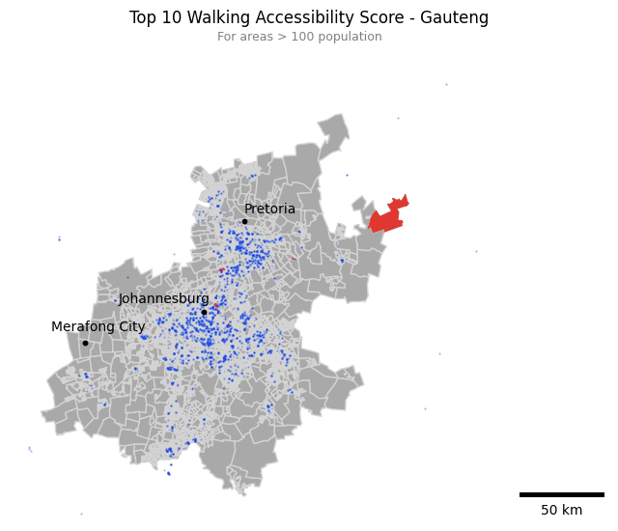
Figure 1

6. Bottom 10 — AI_WALK
EA Code | Sub-Place | Municipality | Ai_walk | EA Type | Econ. Status | Pop 2011 | Pop 2023 Est.
79910985 | Cullinan SP | City of Tshwane | 0 | Collective living | Non_Wealthy | 2,809 | 9,970
76310653 | Rietfontein AH | Mogale City | 0 | Informal residential | Non_Wealthy | 3,036 | 7,336
79911566 | Donkerhoek SH | City of Tshwane | 0 | Smallholdings | Wealthy | 2,971 | 6,220
79914587 | Winterveld Ext 1 | City of Tshwane | 0 | Informal residential | Non_Wealthy | 2,592 | 6,106
79816419 | Zevenfontein Pipeline | City of Johannesburg | 0 | Vacant | Non_Residential | 3,759 | 6,071
79713250 | Modderfontein Deep Levels | Ekurhuleni | 0 | Collective living | Non_Wealthy | 4,785 | 5,784
76110154 | Balmoral Estate | Midvaal | 0 | Suburbs | Wealthy | 769 | 5,174
76110153 | De Deur Estate | Midvaal | 0 | Suburbs | Wealthy | 704 | 5,038
79913634 | Medunsa | City of Tshwane | 0 | Township | Non_Wealthy | 2,506 | 4,537
76110184 | De Deur Estate | Midvaal | 0 | Smallholdings | Wealthy | 604 | 3,851
Table 5
Pattern: Concentrated in non-wealthy Townships, or otherwise car-dependent areas. 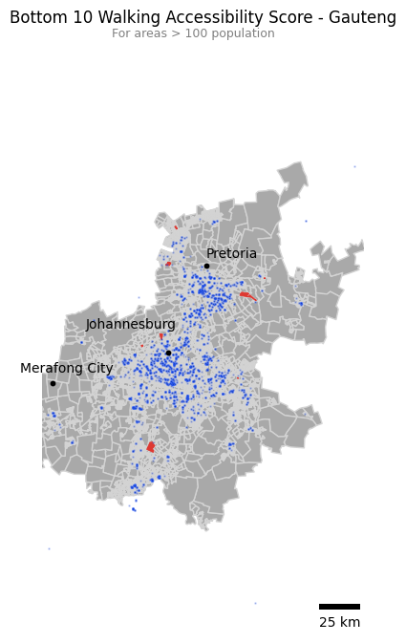
Figure 2

7. Top 10 — AI_DRIVE (Highest Driving Access)
EA Code | Sub-Place | Municipality | Ai_drive | EA Type | Econ. Status | Pop 2011 | Pop 2023 Est.
79811140 | Meredale | City of Johannesburg | 84.96 | Suburbs | Wealthy | 613 | 440
79913191 | Tshwane NU | City of Tshwane | 59.42 | Farms | Wealthy | 770 | 242
79811072 | Meredale | City of Johannesburg | 43.76 | Suburbs | Wealthy | 624 | 366
79811107 | Mondeor | City of Johannesburg | 42.65 | Suburbs | Wealthy | 472 | 308
79811139 | Mondeor | City of Johannesburg | 33.33 | Suburbs | Wealthy | 386 | 232
79811102 | Meredale | City of Johannesburg | 32.52 | Suburbs | Wealthy | 379 | 247
79811060 | Meredale | City of Johannesburg | 31.15 | Suburbs | Wealthy | 543 | 307
79811105 | Mondeor | City of Johannesburg | 29.00 | Suburbs | Wealthy | 501 | 362
79811103 | Mondeor | City of Johannesburg | 29.71 | Suburbs | Wealthy | 728 | 402
79713640 | Saint Andrews | Ekurhuleni | 29.57 | Collective living | Non_Wealthy | 367 | 255
Table 6
Patternfom: Wealthy residentials with declining populations, concentrated in Johannesburg. Access is more than plentiful, with an average of about 50x oversupply. This suggests supply is clustered among these neighboring areas.
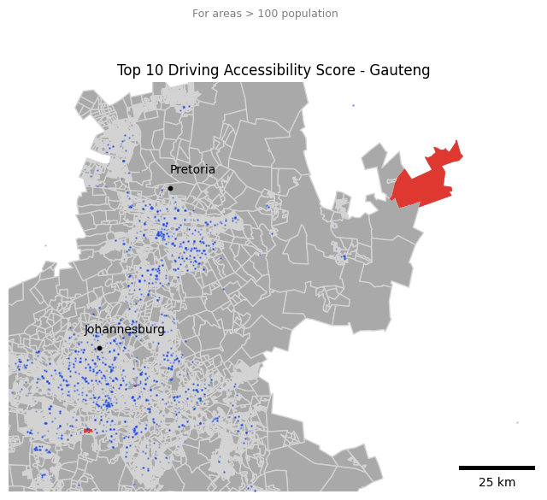
Figure 3

8. Bottom 10 — AI_DRIVE
EA Code | Sub-Place | Municipality | Ai_drive | EA Type | Econ. Status | Pop 2011 | Pop 2023 Est.
76310653 | Rietfontein AH | Mogale City | 0 | Informal residential | Non_Wealthy | 3,036 | 7,336
79911566 | Donkerhoek SH | City of Tshwane | 0 | Smallholdings | Wealthy | 2,971 | 6,220
79914587 | Winterveld Ext 1 | City of Tshwane | 0 | Informal residential | Non_Wealthy | 2,592 | 6,106
76310630 | Vlakplaas AH | Mogale City | 0 | Informal residential | Non_Wealthy | 1,572 | 3,739
76410007 | Randfontein SP1 | Randfontein | 0 | Suburbs | Wealthy | 2,236 | 3,433
79914588 | Winterveld Ext 1 | City of Tshwane | 0 | Informal residential | Non_Wealthy | 1,695 | 3,384
76310565 | Bagale | Mogale City | 0 | Suburbs | Wealthy | 1,191 | 3,241
76610048 | Kokosi Ext 1 | Merafong City | 0 | Township | Non_Wealthy | 822 | 3,166
76610029 | Kokosi Ext 1 | Merafong City | 0 | Township | Non_Wealthy | 795 | 3,090
79910975 | Rayton SH | City of Tshwane | 0 | Smallholdings | Wealthy | 1,753 | 2,952
Table 7
Pattern: Entirely in the City of Tshwane, generally non-wealthy, growing populations. Scores could imply poor road connectivity or minimal demand.
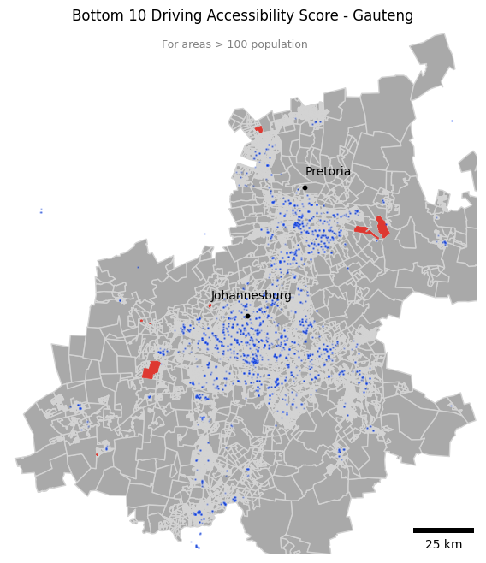
Figure 4

KwaZulu-Natal
- Top 10 — AI_WALK (Highest Walking Access)
EA Code | Sub-Place | Municipality | Ai_walk | EA Type | Econ. Status | Pop 2011 | Pop 2023 Est.
50610306 | Shelly Beach SP | Hibiscus Coast | 14.88 | Commercial | Non_Residential | 546 | 320
59914770 | Umhlanga Ridge | Ethekwini | 12.41 | Suburbs | Wealthy | 479 | 220
59914772 | Umhlanga Ridge | Ethekwini | 12.38 | Suburbs | Wealthy | 479 | 208
59914773 | Umhlanga Ridge | Ethekwini | 12.38 | Suburbs | Wealthy | 479 | 198
59914769 | Umhlanga Ridge | Ethekwini | 12.29 | Suburbs | Wealthy | 371 | 139
59913641 | Umhlanga Ridge | Ethekwini | 12.03 | Suburbs | Wealthy | 623 | 235
59914846 | Umhlanga Ridge | Ethekwini | 11.99 | Suburbs | Wealthy | 307 | 107
59914804 | Umhlanga Ridge | Ethekwini | 11.78 | Suburbs | Wealthy | 479 | 195
59914767 | Umhlanga Ridge | Ethekwini | 11.15 | Collective living | Non_Wealthy | 373 | 136
54210224 | Bhacane SP | Nkandla | 11.14 | Traditional residential | Non_Wealthy | 498 | 269
Table 8
Pattern: Generally wealthy, shrinking areas in eThekwini. Pharmacy points hidden to preserve spatial details.
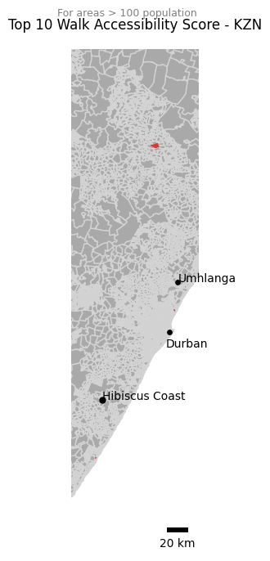
Figure 5
- Bottom 10 — AI_WALK
EA Code | Sub-Place | Municipality | Ai_walk | EA Type | Econ. Status | Pop 2011 | Pop 2023 Est.
52910145 | Abaqulusi NU | Abaqulusi | 0 | Traditional residential | Non_Wealthy | 4,715 | 5,958
52910137 | Abaqulusi NU | Abaqulusi | 0 | Traditional residential | Non_Wealthy | 3,025 | 3,559
59210304 | Thembeni SP | KwaDukuza | 0 | Informal residential | Non_Wealthy | 1,377 | 3,367
59210116 | Njekane SP | KwaDukuza | 0 | Informal residential | Non_Wealthy | 1,293 | 3,358
58610076 | Duku | Mtubatuba | 0 | Traditional residential | Non_Wealthy | 1,101 | 3,357
59910287 | Ensimbini | Ethekwini | 0 | Traditional residential | Non_Wealthy | 1,534 | 3,151
52910134 | Abaqulusi NU | Abaqulusi | 0 | Traditional residential | Non_Wealthy | 2,126 | 3,124
57910165 | Mkwakweni SP | Uphongolo | 0 | Traditional residential | Non_Wealthy | 1,553 | 3,123
58710004 | Ntshingimpisi SP | Mfolozi | 0 | Traditional residential | Non_Wealthy | 1,523 | 3,025
50610224 | Mdlanzi SP | Hibiscus Coast | 0 | Traditional residential | Non_Wealthy | 1,876 | 3,018
Table 9
Pattern: Non-wealthy traditional residentials with growing populations. Pharmacy points hidden to preserve spatial details.
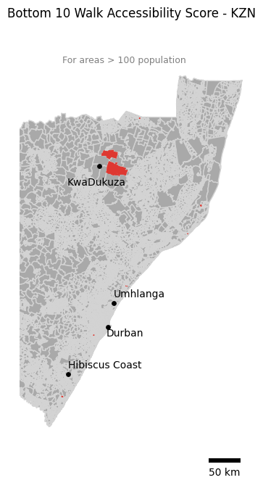
Figure 6

11. Top 10 — AI_DRIVE (Highest Driving Access)
EA Code | Sub-Place | Municipality | Ai_drive | EA Type | Econ. Status | Pop 2011 | Pop 2023 Est.
52410573 | Newcastle NU | Newcastle | 33.72 | Farms | Wealthy | 502 | 178
56610488 | Pietermaritzburg SP | The Msunduzi | 16.73 | Suburbs | Wealthy | 634 | 611
59914461 | Cato Ridge SP | Ethekwini | 15.23 | Suburbs | Wealthy | 383 | 432
53810164 | Mpangele | uMhlathuze | 11.78 | Commercial | Non_Residential | 300 | 273
59914769 | Umhlanga Ridge | Ethekwini | 11.44 | Suburbs | Wealthy | 371 | 139
59914770 | Umhlanga Ridge | Ethekwini | 11.41 | Suburbs | Wealthy | 479 | 220
56610485 | Pietermaritzburg SP | The Msunduzi | 11.27 | Suburbs | Wealthy | 456 | 426
59914804 | Umhlanga Ridge | Ethekwini | 10.79 | Suburbs | Wealthy | 479 | 195
59914767 | Umhlanga Ridge | Ethekwini | 10.64 | Collective living | Non_Wealthy | 373 | 136
59914773 | Umhlanga Ridge | Ethekwini | 10.47 | Suburbs | Wealthy | 479 | 198
Table 10
Pattern: Wealthy, shrinking areas. Car-dependence and the road infrastructure to match.
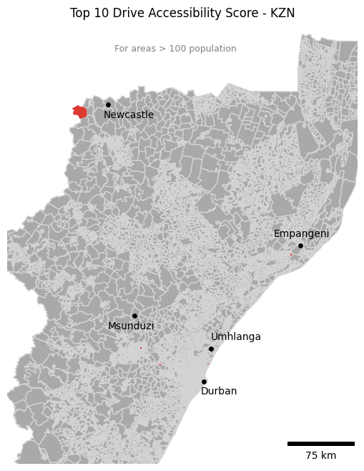
Figure 7

12. Bottom 10 — AI_DRIVE
EA Code | Sub-Place | Municipality | Ai_drive | EA Type | Econ. Status | Pop 2011 | Pop 2023 Est.
52910145 | Abaqulusi NU | Abaqulusi | 0 | Traditional residential | Non_Wealthy | 4,715 | 5,958
52910137 | Abaqulusi NU | Abaqulusi | 0 | Traditional residential | Non_Wealthy | 3,025 | 3,559
59210304 | Thembeni SP | KwaDukuza | 0 | Informal residential | Non_Wealthy | 1,377 | 3,367
58610076 | Duku | Mtubatuba | 0 | Traditional residential | Non_Wealthy | 1,101 | 3,357
52910134 | Abaqulusi NU | Abaqulusi | 0 | Traditional residential | Non_Wealthy | 2,126 | 3,124
57910165 | Mkwakweni SP | Uphongolo | 0 | Traditional residential | Non_Wealthy | 1,553 | 3,123
57610118 | Ngubevu SP1 | Msinga | 0 | Traditional residential | Non_Wealthy | 1,878 | 2,914
59210227 | Njekane SP | KwaDukuza | 0 | Informal residential | Non_Wealthy | 1,265 | 2,672
59910273 | Madundube SP | Ethekwini | 0 | Traditional residential | Non_Wealthy | 1,563 | 2,645
57610147 | Mazabeko SP | Msinga | 0 | Traditional residential | Non_Wealthy | 1,394 | 2,644
Table 11
Pattern: Non-wealthy , traditional residentials with growing populations.
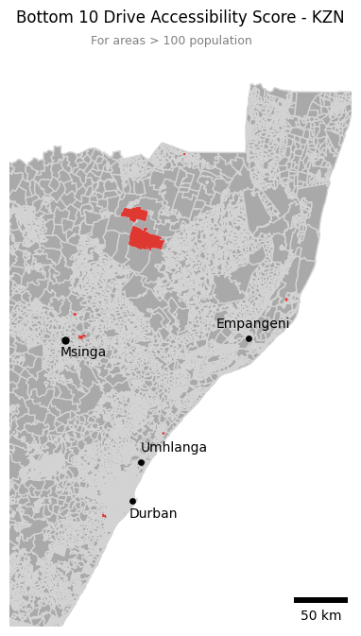
Figure 8
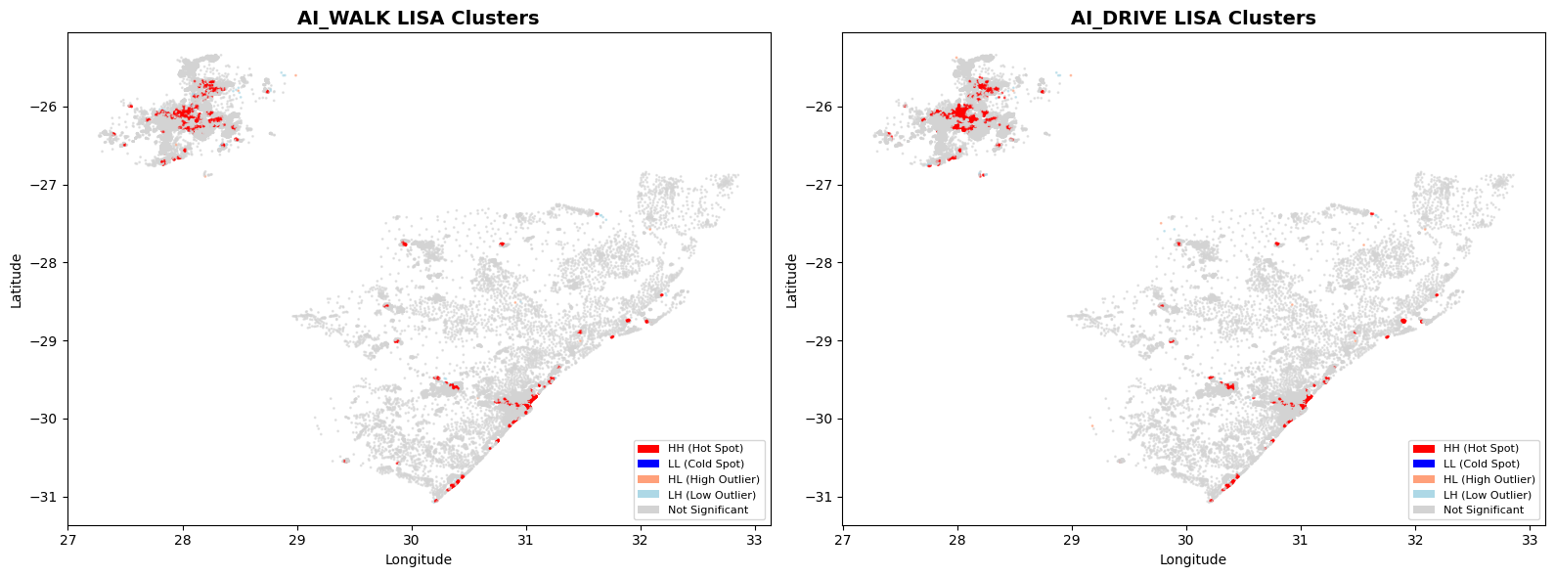
- Spatial Autocorrelation
Figure 9

Variable | Moran’s I | p-value | n areas significant
Ai_walk | 0.64 | 0.005*** | 3733 (12.1%)
Ai_drive | 0.70 | 0.005*** | 3866 (12.5%)
Table 12

HL Clusters- High Walk Scores Surrounded by Low Walk Scores
EA_CODE | Sub-place | Municipality | Province | AI_WALK | EA Type | Econ Status
79816517 | Savannah Hills | City of Johannesburg | Gauteng | 3.4419 | Suburbs | Wealthy
58910095 | Izingwenya A SP | uMlalazi | KwaZulu-Natal | 1.8432 | Traditional residential | Non_Wealthy
79815140 | Linbro Park AH | City of Johannesburg | Gauteng | 4.7287 | Smallholdings | Wealthy
59914461 | Cato Ridge SP | Ethekwini | KwaZulu-Natal | 2.2782 | Suburbs | Wealthy
79811087 | Ormonde View | City of Johannesburg | Gauteng | 4.0100 | Suburbs | Wealthy
54210101 | Malunga SP | Nkandla | KwaZulu-Natal | 2.3989 | Traditional residential | Non_Wealthy
58310044 | Ubombo SP | Jozini | KwaZulu-Natal | 1.6832 | Traditional residential | Non_Wealthy
57910001 | Uphongolo NU | Uphongolo | KwaZulu-Natal | 1.6416 | Traditional residential | Non_Wealthy
54210224 | Bhacane SP | Nkandla | KwaZulu-Natal | 11.1386 | Traditional residential | Non_Wealthy
79910649 | Zwavelpoort AH | City of Tshwane | Gauteng | 6.7502 | Smallholdings | Wealthy
79815135 | Greenstone Park | City of Johannesburg | Gauteng | 15.0720 | Commercial | Non_Residential
Table 13
HL Clusters- High Drive Scores Surrounded by Low Drive Scores
EA_CODE | Sub-place | Municipality | Province | AI_DRIVE | EA Type | Econ Status
79914869 | Winterveld AH | City of Tshwane | Gauteng | 6.1568 | Township | Non_Wealthy
54210101 | Malunga SP | Nkandla | KwaZulu-Natal | 4.1879 | Traditional residential | Non_Wealthy
58910095 | Izingwenya A SP | uMlalazi | KwaZulu-Natal | 1.4429 | Traditional residential | Non_Wealthy
58310044 | Ubombo SP | Jozini | KwaZulu-Natal | 2.3989 | Traditional residential | Non_Wealthy
57910001 | Uphongolo NU | Uphongolo | KwaZulu-Natal | 1.3968 | Traditional residential | Non_Wealthy
54210224 | Bhacane SP | Nkandla | KwaZulu-Natal | 1.8485 | Traditional residential | Non_Wealthy
57910024 | Uphongolo NU | Uphongolo | KwaZulu-Natal | 1.2485 | Traditional residential | Non_Wealthy
54210100 | Malunga SP | Nkandla | KwaZulu-Natal | 2.9762 | Traditional residential | Non_Wealthy
58310011 | Ubombo SP | Jozini | KwaZulu-Natal | 1.5678 | Traditional residential | Non_Wealthy
Table 14
LH Clusters- Low Walk Scores Surrounded by High Walk Scores
EA_CODE | Sub-place | Municipality | Province | AI_WALK | EA Type | Econ Status
76310528 | Rietvei AH | Mogale City | Gauteng | 0.0000 | Smallholdings | Wealthy
79910419 | Spruit | City of Tshwane | Gauteng | 0.0000 | Informal residential | Non_Wealthy
79910875 | Spruit | City of Tshwane | Gauteng | 0.0000 | Informal residential | Non_Wealthy
79910881 | Spruit | City of Tshwane | Gauteng | 0.0000 | Informal residential | Non_Wealthy
79913192 | Sokhulumi | City of Tshwane | Gauteng | 0.0000 | Suburbs | Wealthy
57910077 | Simdlangenstha | Uphongolo | KwaZulu-Natal | 0.0000 | Suburbs | Wealthy
57910078 | Simdlangenstha | Uphongolo | KwaZulu-Natal | 0.0000 | Suburbs | Wealthy
79910877 | Spruit | City of Tshwane | Gauteng | 0.0000 | Informal residential | Non_Wealthy
79913193 | Sokhulumi | City of Tshwane | Gauteng | 0.0000 | Suburbs | Wealthy
…
Total list has 96 clusters
Table 15
LH Clusters- Low Drive Scores Surrounded by High Drive Scores (total =36)
EA_CODE | Sub-place | Municipality | Province | AI_DRIVE | EA Type | Econ Status
79815884 | Leeuwkop Prison | City of Johannesburg | Gauteng | 0.0097 | Collective living | Non_Wealthy
52410572 | Newcastle NU | Newcastle | KwaZulu-Natal | 0.0000 | Farms | Wealthy
79913192 | Sokhulumi | City of Tshwane | Gauteng | 0.0000 | Suburbs | Wealthy
57910077 | Simdlangenstha | Uphongolo | KwaZulu-Natal | 0.0204 | Suburbs | Wealthy
57910078 | Simdlangenstha | Uphongolo | KwaZulu-Natal | 0.0090 | Suburbs | Wealthy
79913193 | Sokhulumi | City of Tshwane | Gauteng | 0.0000 | Suburbs | Wealthy
51410282 | Ladysmith Central | Emnambithi/Ladysmith | KwaZulu-Natal | 0.0000 | Suburbs | Wealthy
79910974 | Rayton SH | City of Tshwane | Gauteng | 0.0000 | Smallholdings | Wealthy
…
Total list has 36 clusters
Table 16

Micro-Patterns

14. EA Type × Province × Econ Status
EA Type | Econ Status | Areas | Avg Walk | Avg Drive | Pop 2011 | Pop 2023 Est
Collective living quarters | Non_Wealthy | 430 | 0.8026 | 0.9862 | 312,652 | 263,080
Commercial | Non_Residential | 471 | 1.9371 | 1.8178 | 298,286 | 212,927
Suburbs | Wealthy | 11,338 | 0.8002 | 0.9124 | 7,119,109 | 6,876,703
Farms | Wealthy | 514 | 0.1081 | 0.2101 | 377,978 | 204,258
Industrial | Non_Residential | 331 | 0.4944 | 0.6088 | 153,540 | 115,388
Parks and recreation | Non_Residential | 29 | 0.1937 | 0.3347 | 14,564 | 8,561
Smallholdings | Wealthy | 502 | 0.2145 | 0.2294 | 237,497 | 195,328
Vacant | Non_Residential | 345 | 0.1749 | 0.2075 | 220,799 | 220,260
Informal residential | Non_Wealthy | 2,482 | 0.0581 | 0.0765 | 1,643,563 | 2,214,360
Township | Non_Wealthy | 8,460 | 0.0970 | 0.1042 | 6,790,017 | 8,761,864
Traditional residential | Non_Wealthy | 6,227 | 0.0109 | 0.0127 | 4,594,750 | 5,315,590
Pattern:
Non-wealthy areas dominate the lowest accessibility scores. Although non-wealthy and non-residential make up the top three, the total population is minimal and are unburdened by high demand.
Table 17

15. Province x Race
Province | Racial Majority | Avg Walk | Avg Drive | N
Gauteng | Mixed | 1.50 | 1.05 | 3,309
Note: Racial distribution based on 2011 SAL level counts. | 50%+ White | 1.08 | 1.10 | 4,737
Note: Racial distribution based on 2011 SAL level counts. | 50%+ Indian | 0.56 | 0.51 | 241
Note: Racial distribution based on 2011 SAL level counts. | 90%+ Black African | 0.09 | 0.11 | 10,904
KZN | 50%+ White | 1.03 | 1.00 | 1,181
 | Mixed | 0.64 | 0.69 | 2,166
 | 50%+ Indian | 0.43 | 0.49 | 1,201
 | 90%+ Black African | 0.04 | 0.05 | 11,713
Pattern: Black Africans are overwhelmingly underserved and neglected. In KZN, white majority areas are the least abundant, but the most well-served. White majority areas have between 10-25x more access than black areas.
Table 18

16. Walk-Drive Correlation
Province | Walk-Drive Correlation
KZN | 0.83 (strong)
Gauteng | 0.25 (weak)
Pattern: In KZN, walk and drive scores move together: if you can't walk to it, you probably can't drive either (remoteness). In Gauteng, they're largely independent: there are many SALs with good drive access but poor walk access (car-dependent sprawl), or high walk but low drive (dense, commercial cores).
Table 19

17. Outlier Concentration
Province | Top 20% of EAs | % of Total Walk Score | % of Total Drive Score
Gauteng | 3,910 EAs | 89.8% | 73.6%
KZN | 3,276 EAs | 96.4% | 90.3%
Pattern: Accessibility is hyper-concentrated. The top 20% scoring SALs possesses over 70% of the access to medicines.
Table 20

