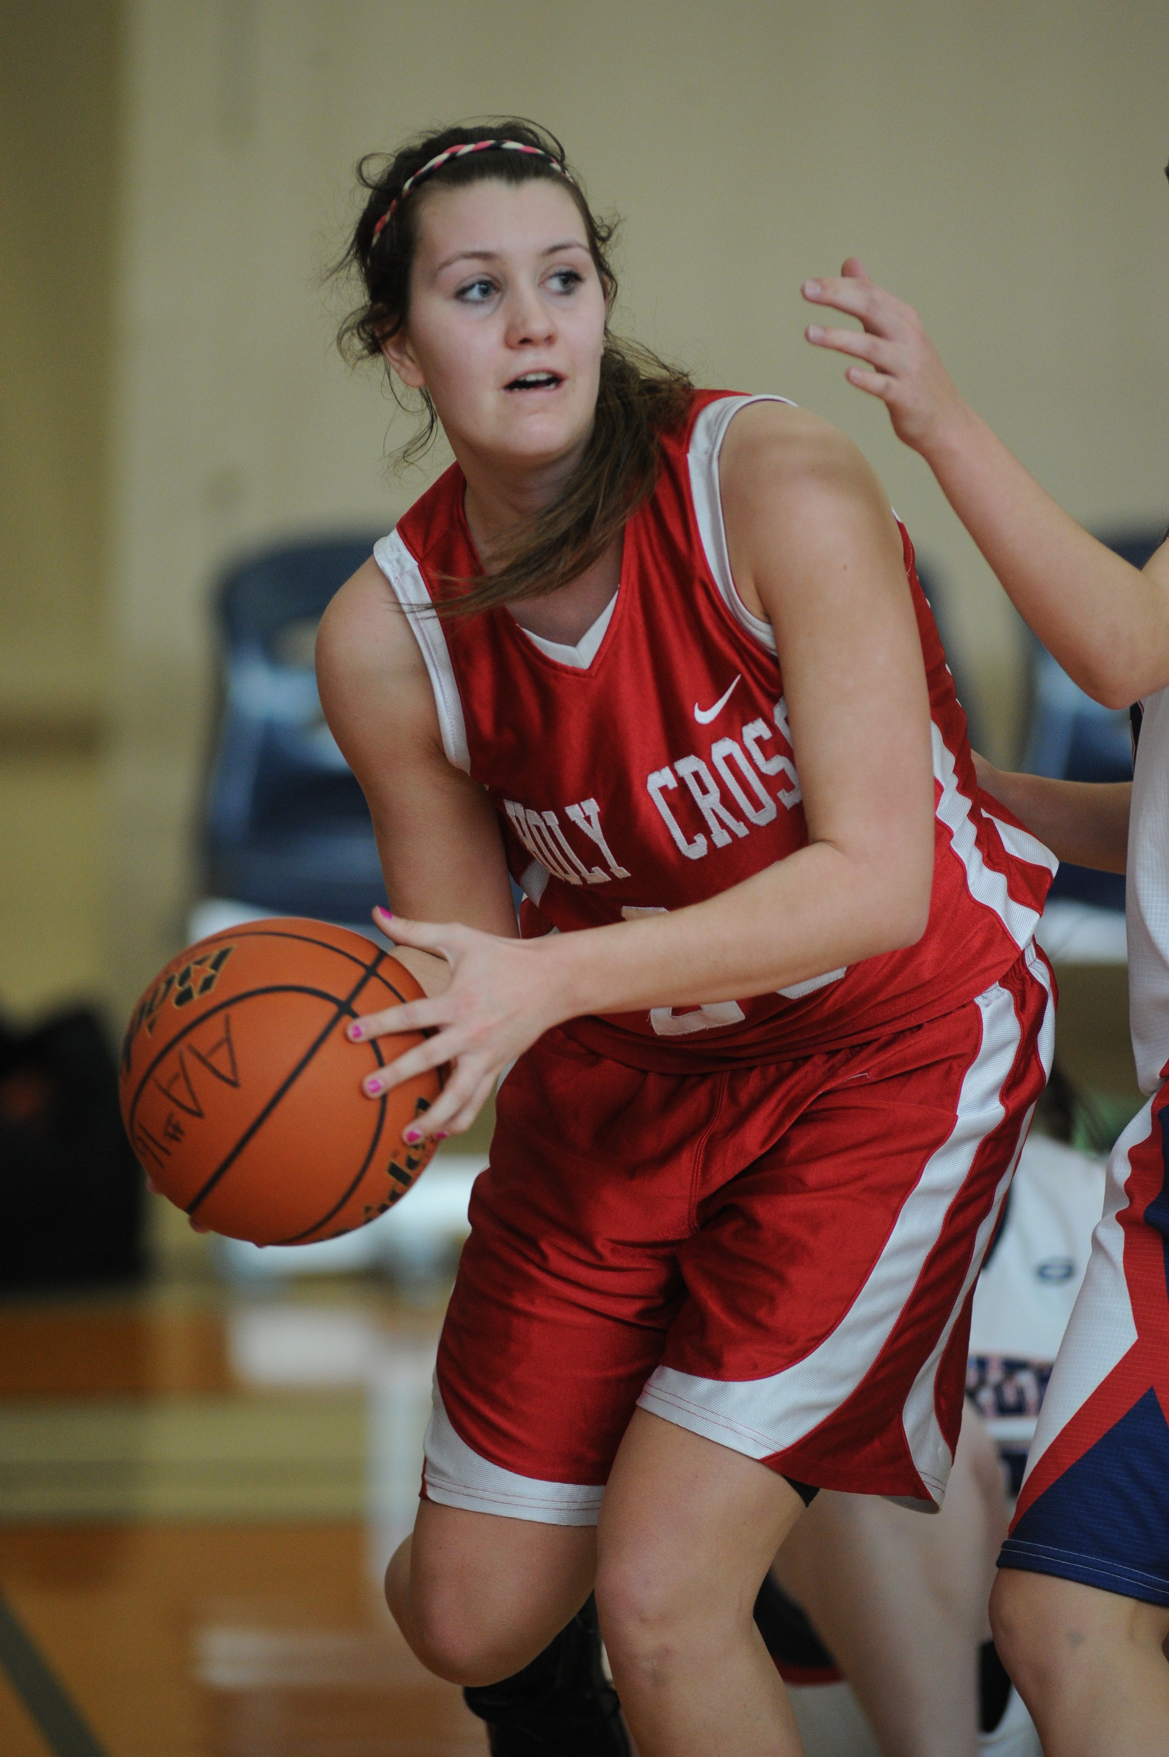

**Tessa Beauchamp Scholarship - 2016**

**26th Street Basketball Tournament**

The Tessa Beauchamp scholarship is established in loving memory of Tessa Beauchamp. Tessa was a caring, compassionate, competitive and beautiful young woman with an incredible spirit and passion for life. Tessa valued family, faith, academics, athletics, and community service. Tessa also faced obstacles and adversity with courage and perseverance. Despite her personal challenges, Tessa went out of her way to make sure everyone around her felt welcome and included. Her warm smile would light up any room. Applicants may view more information about Tessa at [www.tessabeauchamp.org](http://www.tessabeauchamp.org).

Applicants must complete the application form and attempt to provide a “snapshot” of related activities and endeavors in their own lives. Applicants may also choose to provide information in the format of their choice: written response, video, or movie format. ***If choosing to apply electronically please ensure that your video not exceed 5 mb and ensure that you include information about which scholarship you are applying for and which high school you belong to.***

Applicants can email, mail or fax their completed applications to the Scholarship committee using the contact information listed below.

***Purpose***

The purpose of the Tessa Beauchamp Scholarship is to provide financial assistance to a high school student graduate who is enrolling in any post secondary institution.

***Amount***

The amount of the Tessa Beauchamp Scholarship is a $500 disbursement to ONE female applicant.

***Selection Process***

The scholarship committee will review applications to determine scholarship winner. Applications must be submitted by the deadline date.

E-Mail, fax or deliver the completed application to:

Tessa Beauchamp Scholarship Committee

16193 88th Avenue

Surrey, B.C. V4N 1G3

Fax: 604-583-4795

Email: tessa23foundation@gmail.com

***Application deadline: Thursday February 4th, 2016***

***26th Street Basketball Tournament***

***Scholarship Application***

***Personal Information***

|  |  |
| --- | --- |
| Name | |
| Address | |
| City | Province |
| Postal Code | Phone Number |
| Email | |
| High School | |

***Academic Information***

|  |  |
| --- | --- |
| Current High school | |
| Year of Graduation | Grade Point Average |

**Provide information about your educational background, your strengths and abilities and any honors or awards received:**

_________________________________________________________________________

_________________________________________________________________________

_________________________________________________________________________

_________________________________________________________________________

_________________________________________________________________________

_________________________________________________________________________

**Extracurricular Participation: What activities are you involved in and WHY do you feel it is important to be involved in these activities? (art, band, drama, athletics, student council, etc..):**

_________________________________________________________________________

_________________________________________________________________________

_________________________________________________________________________

_________________________________________________________________________

_________________________________________________________________________

_________________________________________________________________________

**Describe your community (e.g. church, faith community, civic, club) activities or volunteer involvement:**

_________________________________________________________________________

_________________________________________________________________________

_________________________________________________________________________

_________________________________________________________________________

_________________________________________________________________________

_________________________________________________________________________

**Explain your educational and career goals:**

_________________________________________________________________________

_________________________________________________________________________

_________________________________________________________________________

_________________________________________________________________________

_________________________________________________________________________

_________________________________________________________________________

**Describe a situation where you faced a difficult obstacle and how you dealt with that adversity:**

_________________________________________________________________________

_________________________________________________________________________

_________________________________________________________________________

_________________________________________________________________________

_________________________________________________________________________

_________________________________________________________________________

_________________________________________________________________________

_________________________________________________________________________

**After reading and learning about Tessa and how she lived her life, please share your experiences and thoughts as to why you would be deserving of this scholarship honoring Tessa’s memory:**

_________________________________________________________________________

_________________________________________________________________________

_________________________________________________________________________

_________________________________________________________________________

_________________________________________________________________________

_________________________________________________________________________

_________________________________________________________________________

_________________________________________________________________________

_________________________________________________________________________

_________________________________________________________________________

_________________________________________________________________________

**References: Please include ONE character reference who is not a family member—this reference must submit a letter. Your reference letter should be submitted with this application in a sealed envelope or mailed electronically. Provide your reference information below:**

**Name_________________________________________________________**

**Relationship to applicant**

I certify that the information in this application is correct to the best of my knowledge, and in the event I am awarded a scholarship, all funds will be used to further my education.

I allow my name/photo to be posted to the Tessa Beauchamp Foundation website in the event that I am awarded a scholarship.

Date ________________ Signature _________________________________