**data types**

string – stored as str# (where # is the maximum length of the string)

numeric

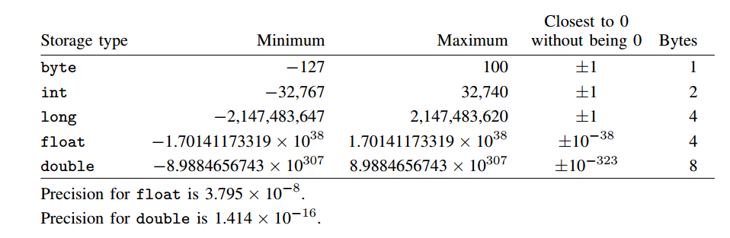

Stata keeps data in memory so you should try to be as parsimonious as possible when creating or storing data.

You may use the compress command to save space. Compress demotes different data types if possible. Compress will never result in a loss of precision or the loss of characters due to string compression. It is a useful command to run before saving a dataset.