**CGRA151 Project Plan**

Student name: Tessa Power

Student ID: 300633153

Name of game: “Geometeroids”

**Vision**

1. Game concept: Geometeroids (“geometrical asteroids”) is a geometry-based remake of Asteroids. The player controls a lone spaceship in a Geometeroid field and must shoot and destroy the Geometeroids. Geometeroids are large, multi-sided shapes that slowly break down into smaller shapes before eventually exploding! The player’s goal is to get the highest score and survive for as many rounds as possible.
2. Game play: Like Asteroids, the player can rotate to face any direction, shoot straight ahead, and use a thruster to move the direction they are facing. Once the ship begins moving in a direction, it continues moving in that direction unless the player uses the thruster in a different direction or it eventually comes to a stop. As the player shoots Geometeroids, they break into smaller shapes. The game screen wraps around both screen axes; Geometeroids that drift off the edge of the screen reappear on the opposite side and continue moving in the same direction. Every so often a Mega-Geometeroid will appear that follows the player.
3. Visual design: A minimal yet colourful outlined design for Geometeroids and the player spaceship; a nostalgic tip of the hat to Asteroids with a modern twist.

**Timetable**

1. A core working program (done by two weeks before deadline):
   1. Player ship that rotates, moves around with thruster, shoots.
   2. Randomly generated Geometeroids that fly around the screen.
   3. Player ship can destroy Geometeroids which break into smaller Geometeroids, i.e., successful overlap detection between bullets and Geometeroids.
   4. Ship is destroyed on collision with Geometeroids, i.e., successful overlap detection between Geometeroids and ship.
   5. HUD with game state (score and lives).
2. A reasonable submission (done by one week before deadline):
   1. Geometeroids with only 3 sides explode into little particles when shot and eventually disappear.
   2. Wrapping walls.
   3. Acceleration from player’s thruster eventually dissipates.
   4. Shooting and explosion sound effects.
3. A well-polished submission (done by project deadline):
   1. Rich main menu with high scores recorded.
   2. Ability to set custom key bindings.
   3. Mega-Geometeroid that follows the player.
   4. Randomly generated rounds that increase in difficulty.
   5. Ext.: Geometeroids display interesting behaviour that makes them appear “alive”, such as rotating, warping, skewing, etc.
   6. Ext.: “Speed Run” mode; destroy as many Geometeroids as possible in a short amount of time to get a high score.
   7. Ext.: Multiplayer mode!

**Appendices**

**Inspiration**

<https://en.wikipedia.org/wiki/Asteroids_(video_game)>

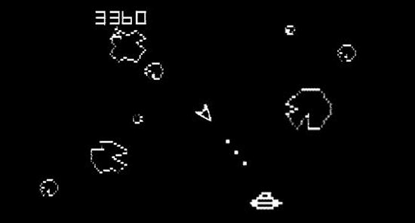

Figure : Original vector-based Asteroids game (Atari 1979), showing ship in centre and floating asteroid shapes.

Source: [Original design of the 1979 Atari game Asteroids](https://www.researchgate.net/figure/Original-vector-based-Asteroids-game-Atari-1979-showing-ship-in-centre-and-floating_fig2_262309733)

**Mock Up**

