MongoDB Backup and Migration to new version

Step1 -Take a backup of your database using following command(Open new terminal)

$mongodump --port 2000

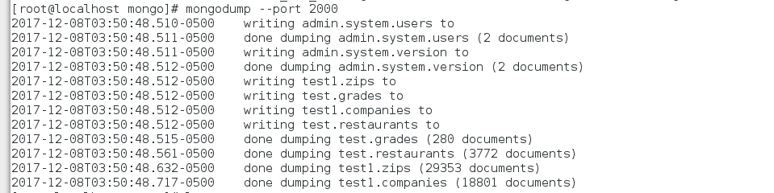

This backup data is present in the following location

/var/lib/mongo/dump/

Step2 - Now to migrate mongodb version from 3.4 to 3.6 you have to stop mongodb server.

$ sudo service mongod stop

Step3 - Now remove the binaries of mongodb 3.4 by using following command

$sudo yum remove -y mongodb-org

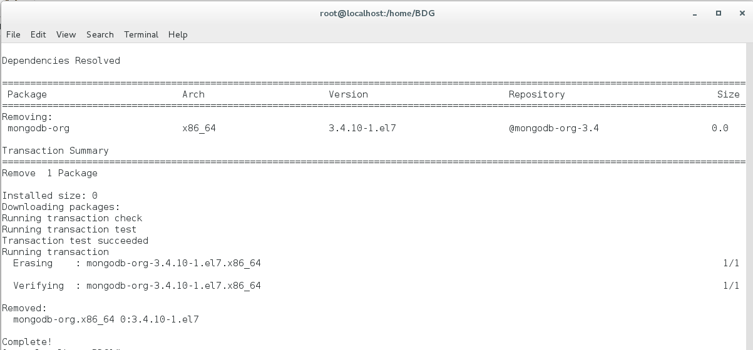

$sudo yum remove -y mongodb-org-server

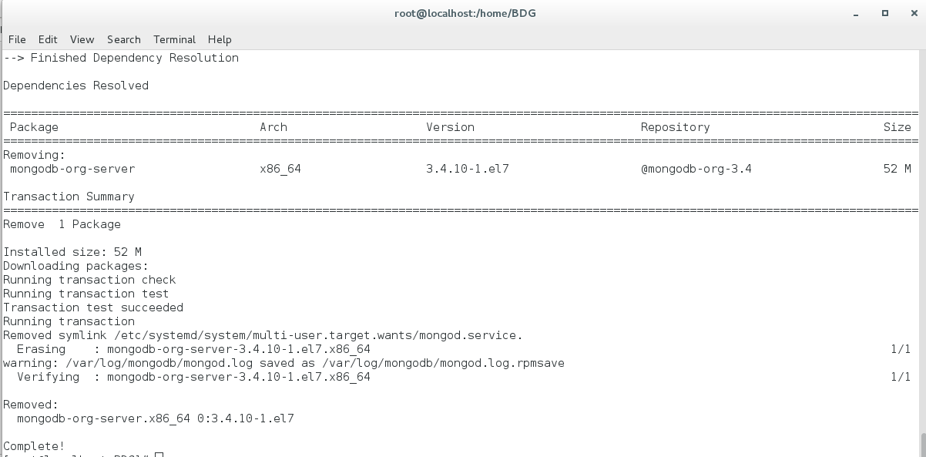

$sudo yum remove -y mongodb-org-shell

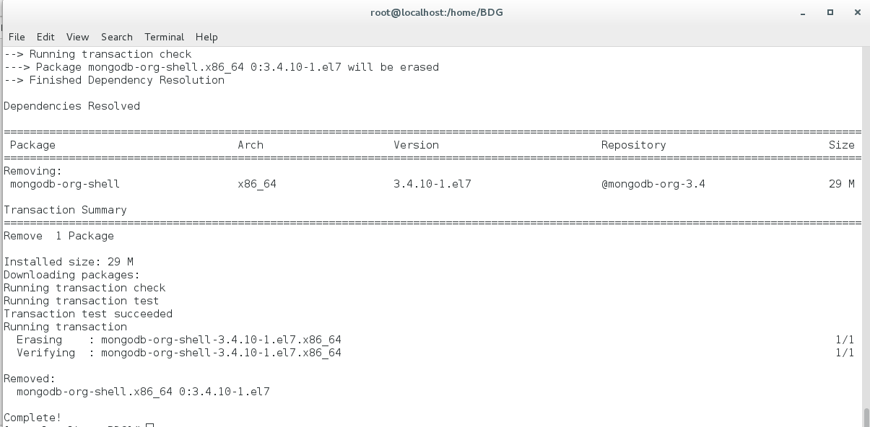

$sudo yum remove -y mongodb-org-tools

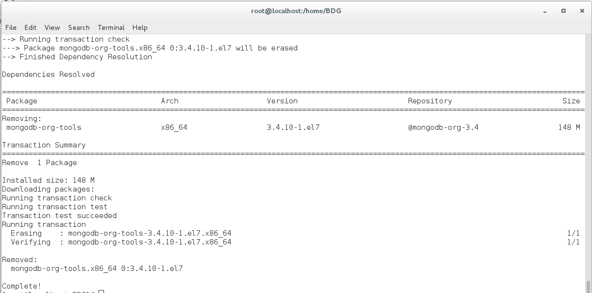

$sudo yum remove -y mongodb-org-mongos

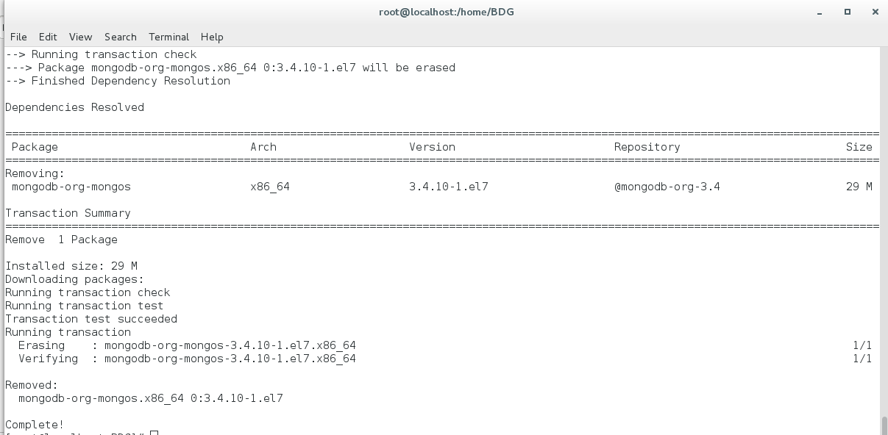

Step4 – Now create new file for mongodb-org-3.6.repo in /etc/yum.repos.d / location

and insert following script in that file.

[mongodb-org-3.6]

name=MongoDB Repository

baseurl=https://repo.mongodb.org/yum/redhat/$releasever/mongodb-org/3.6/x86_64/

gpgcheck=1

enabled=1

gpgkey=https://www.mongodb.org/static/pgp/server-3.6.asc

Step5 - Now run following command to install binaries for mongodb-3.6

$ sudo yum install mongodb-org

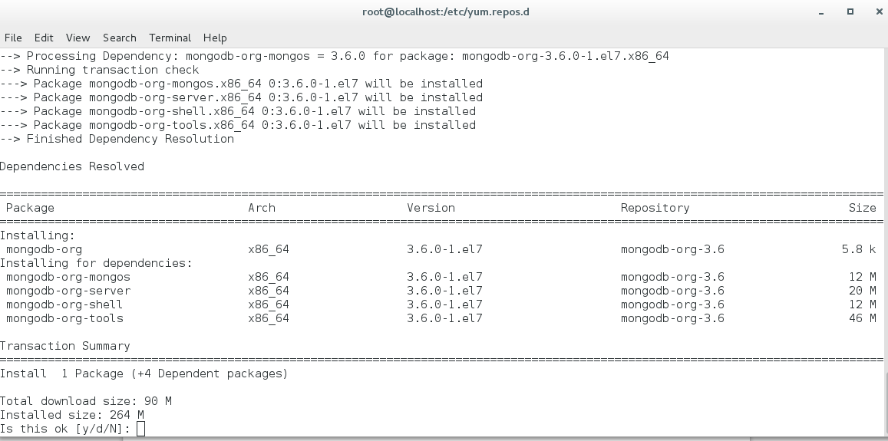

Type “y” and press enter

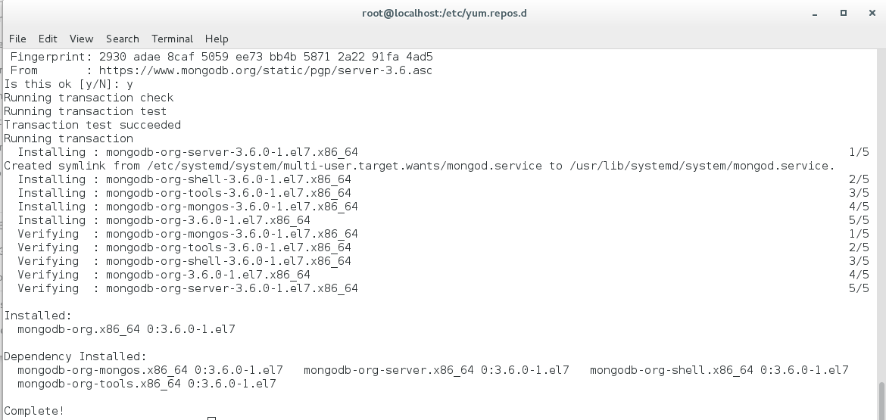

Now again start mongod service using following command

$ sudo service mongod restart

Step6 - Now start your mongodb instance of version 3.6 using following command

$mongod --dbpath /home/BDG/mongo1 –logpath

/home/BDG/mongo1/log/mongod.log –port 2001

Step7 – Now run following command in new terminal to enter into mongo shell

$ mongo –port 2001 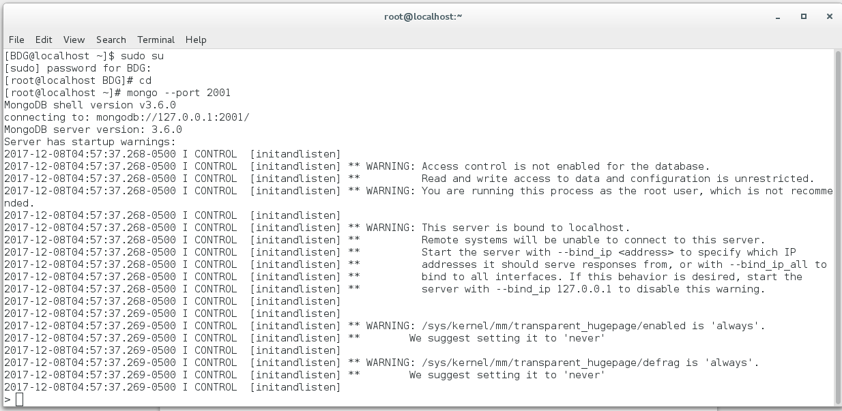

Step8 - Now restore your data from the dump folder to the new version using following command

$ mongorestore --dir /var/lib/mongo/dump/ --port 2001

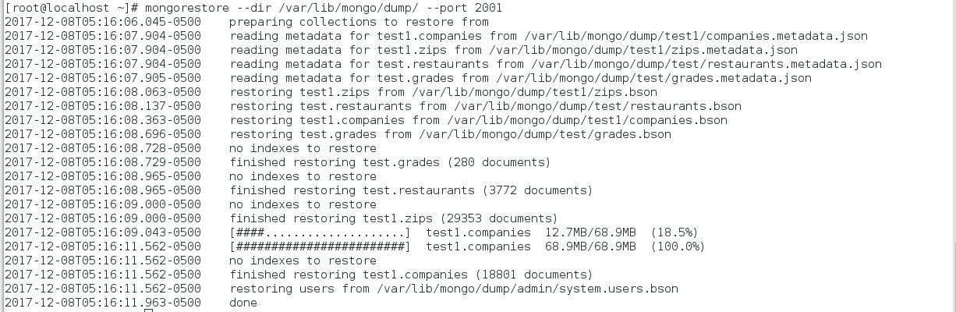

Now you can see your database and collections in new mongo server.

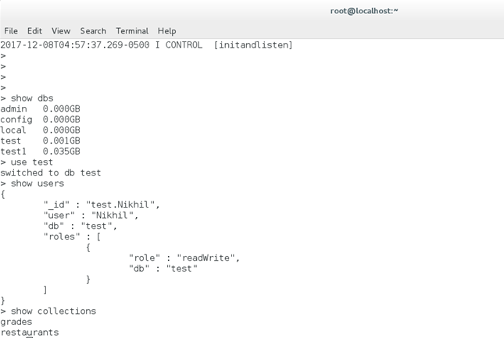

Like this you can migrate from one mongdb version to another version.