**Introduction**

The goal of this project is to create a website that will showcase, describe, and facilitate the purchase of the various crafts (at this point, crochet hats, necklaces, and keychains – but more to come) that my wife and daughter make and are offering for sale.

* Features
  + At minimum, I expect there will be features corresponding to each of the three product categories, galleries for each category, and a template feature giving details about a selected item:
    - Hats
    - Keychains
    - Necklaces
    - Image Galleries
    - Individual Product Details
  + As well as (again looking past the MVP) for:
    - A Contact Form
    - Ratings/Reviews
    - Shopping Cart
    - User Account Creation/Login

It is the second main bullet that contains the features in which data manipulation (create/update/delete) will be a key factor. Being able to add (and provide updates to) product reviews, to add or remove items from the shopping cart and update item quantities, to add, modify, or delete user accounts, and to login or logout will all be actions that I anticipate will be handled by using Redux.

**User Interface Design and Navigation Structure**

Figure 1 shows the basic layout of the homepage, including the header, navbar, and footer. The header, navbar, and footer are displayed sitewide, and so are only depicted in any detail in this first wireframe diagram. The main navbar contains links to the various product categories as a dropdown (as well as links to other info pages – Shipping and Returns, About, and Orders), and to Contact (which will eventually contain a form to join an email list and send questions/comments) and the Shopping Cart (which will eventually contain the functionality common to online carts). At the top there is an image carousel cycling through examples of the various product categories, while at the bottom there are image links to each product category. Clicking one of these will take you to the main page for that particular product (Figure 2).

Figure 2 shows an example of a ‘Main Product Page’ (e.g. Hats), displaying a gallery of images and prices. The images are clickable links that route to a detailed description page for the selected item (Figure 3).

Figure 3 shows a sample ‘Individual Item Page’ (e.g. a specific hat). The leftmost column contains one or more thumbnail images which may be clicked on to see a larger view (displayed in the middle of the screen on large viewports). These can also be scrolled through using arrow buttons. The rightmost column contains a text description of the item and an ‘Add to Cart’ button, which will eventually be wired to the shopping cart functionality. (For the MVP, the ‘Orders’ option in the navbar brings up a printable order form which can be filled out, scanned, and emailed.)

**Figure 1: Homepage, Header, Navbar, and Footer (Header, Navbar, and Footer Repeated Site-Wide)**

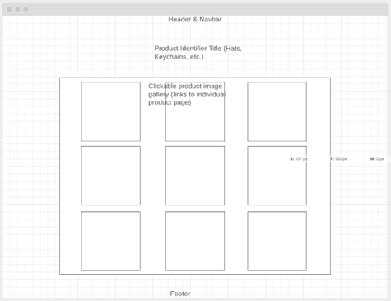

**Figure 2: Sample Main Products Page (e.g. Hats Gallery)**

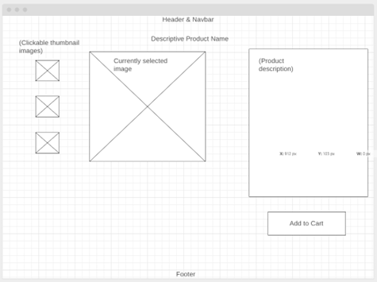

**Figure 3: Sample Individual Product Page (e.g. for a Specific Hat)**

**References**

Wireframe diagrams created using <https://wireframe.cc>