**Classifying Possum Sex with Logistic Regression**

**Possums Dataset from Kaggle**

Tess Anderson, [tanderson4@bellarmine.edu](mailto:tanderson4@bellarmine.edu)

**ABSTRACT**

In this project, I will complete Exploratory Data Analysis and Logistic Regression on a dataset about Possums containing 14 columns and 104 entries. The subjects are possums trapped in 7 different sites and the columns contain detailed information on measurements of each possum trapped. By analyzing the relationship between the different body measurements and the sex of the possum, I will create a Logistic Regression model that can predict the sex of a possum based on its measurements.

1. **INTRODUCTION**

In this project, I use a dataset from Kaggle titled “Possum Regression”. The data frame contains 9 morphometric measurements on each of the 104 mountian brushtail possums, trapped at seven sites from Southern Victoria to central Queensland. On this dataset, I will perform Exploratory Data Analysis to understand the variables contained in the set and their possible relationships to one another. Following EDA, I will conduct Classification analysis using the LogisticRegression function from the Scikit-learn library in Python. My goal in this analysis is to train a Logistic Regression model to accurately classify a possum as male or female based on measurements of its body.

1. **BACKGROUND**
   1. *Data Set Description*

I found this dataset on Kaggle, however it was originally published in the DAAG R package (datasets used in examples and exercises in the book Maindonald, J.H. and Braun, W.J. (2003, 2007, 2010) “Data Analytics and Graphics Using R”). As mentioned, there are 14 columns, 9 of which are morphometric measurements. The others are case, site, age, sex, population. Site tells at which of the seven sites the possum was trapped. Population tells to which population the possum belongs, either Victoria or Other (New South Wales or Queensland).

* 1. *Machine Learning Model*

Logistic Regression is a Machine Learning Model that provides large amounts of mathematical and statistical information about the relationships between independent variables and one dependent variable. In this case, the independent variables are all variables except sex and the dependent variable is sex. The idea behind Logistic Regression is to find a relationship between features and the probability of a particular outcome. To fit the model to the specific dataset, we must split the dataset so that we have a training set and a testing set. Using the training set, which contains most of the entries, we fit the model to the data so that it can make predictions based on the relationships in the data. Afterwards, we use the rest of the data, the testing set, to compare the model’s predictions to the outcomes shown in the data so that we can measure the accuracy of the predictions.

1. **EXPLORATORY ANALYSIS**

This dataset contains 104 entries with 14 columns with various datatypes. There were a few missing values in two columns – they were filled during data preprocessing.

**Table 1: Data Types**

|  |  |
| --- | --- |
| *Variable Name* | *Data Type* |
| Case | Int64 |
| Site | Int64 |
| Pop | Object |
| Sex | Object |
| Age | Float64 |
| Hdlngth | Float64 |
| Skullw | Float64 |
| Totlngth | Float64 |
| Taill | Float64 |
| Footlgth | Float64 |
| Earconch | Float64 |
| Eye | Float64 |
| Chest | Float64 |
| Belly | Float64 |

Most of the numeric variables are approximately Normally distributed, however there are a few to note that follow a bimodal or otherwise abnormal distribution which we should keep in mind throughout analysis. For example, the histograms of the Ear Conch and Tail Length variables show bimodal distributions, while Age and Total Length show significant skew in their distributions.

Shown to the right are boxplots for each of the nine measurement variables – this allows us to easily see where measures of spread and center are for each variable, as well as the outliers present for each variable.

To explore the data more, I examined the trappings by site. More specifically, I made bar plots showing the count of possums caught at each site by sex and by population.

1. **METHODS**
   1. *Data Preparation*

There were several steps I had to take during the Data Preprocessing stage in order to prepare the data for analysis. First, there were 2 missing entries in the age column and 1 missing entry in the footlngth column that needed to be filled. To do this, I used the median imputation method because the distributions are not Normal. Once the missing values were filled with the median value of the column, I proceeded with dropping the case column because it contains a unique value for each entry which is not useful for analysis. Finally, I prepared the categorical variables in the set by using the pd.get_dummies() function which encodes categorical variables into binary code so that they can be easily analyzed with the scikit-learn package later.

* 1. *Experimental Design*

Table 2: Experiment Parameters

|  |  |
| --- | --- |
| **Experiment Number** | **Parameters** |
| 1 | All twelve (12) raw features with 80/20 split for train and test |
| 2 | All twelve (12) raw features with 70/30 split for train and test |
| 3 | All twelve (12) raw features with 85/15 split for train and test |

* 1. *Tools Used*

The following tools were used for this analysis: Python v3.5.2 running the Anaconda 4.3.22 environment for Apple Macintosh computer was used for all analysis and implementation. In addition to base Python, the following libraries were also used: Pandas 0.18.1, Numpy 1.11.3, Matplotlib 1.5.3, Seaborn 0.7.1, SKLearn 0.18.1. Pandas and NumPy are important libraries that I used for data manipulation in Python such as reading the .csv file, dropping columns, filling missing data, etc. Matplotlib and Seaborn are important libraries for data visualization – both were used to create the plots shown in Section III. Finally, SKLearn is the library I used to split the data and to build and train the LogisticRegression model.

1. **RESULTS**
   1. *Classification Measures*

Experiment 1 – The parameters were 80/20 split with random state equal to 40. The classification measures are:

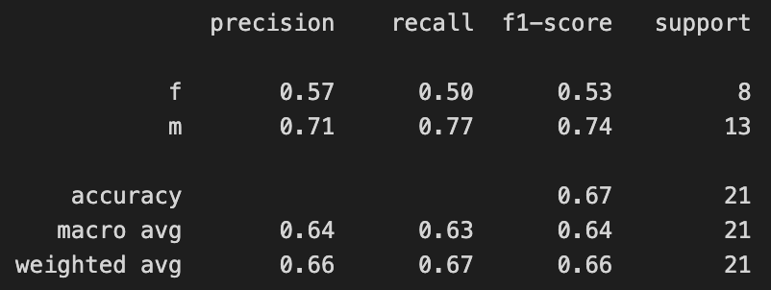

Experiment 2 – The parameters were 70/30 split with random state equal to 40. The classification measures are:

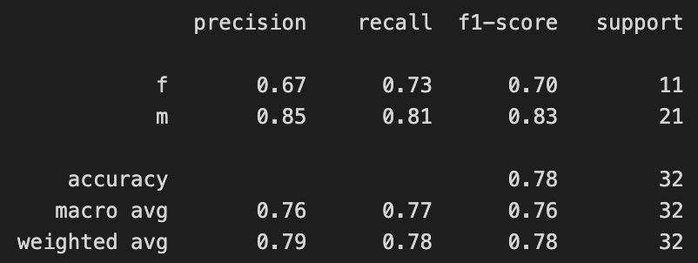

Experiment 3 – The parameters were 85/15 split with random state equal to 40. The classification measures are:

* 1. *Discussion of Results*

The best results came from Experiment 2 with a 70/30 train-test split and random setting of 40. In this experiment, we can see from the confusion matrix that the model predicted male 21 times and was correct 17 of those times. The model predicted female 11 times and was correct 8 of those times. The correctness of the model’s predictions is reflected in the accuracy score – Experiment 2 had the highest accuracy score with 0.78 or 78%. Across every experiment, we can see the model is better at correctly predicting males than females as the precision, recall, and f1-scores are better for males in every experiment.

* 1. *Problems Encountered*

I encountered problems with the accuracy of my model. With all the features included, it does a very good job of predicting the population the possum belongs to – I think this is because of the strong relationship between site and population. When using this data to predict sex, however, I feel that removing some columns would help it predict sex more accurately.

* 1. *Limitations of Implementation*

The major limitation of this model is its accuracy. Most parametric settings lead to pretty poor results – only Experiment 2 had acceptable accuracy of predictions.

* 1. *Improvements/Future Work*

To improve this model, I would experiment with removing variables to narrow down which variables best predict possum sex since these variables, especially site, are better at predicting population in this dataset.

1. **CONCLUSION**

In conclusion, the goal was to build a model which could predict possum sex based on measurements and other factors about trapped possums. The model discussed in this paper does a reasonably good job of doing so, however it is prone to errors and its results can’t be trusted entirely. Using LogisticRegression from Scikit-learn, I trained and tested the classifier but the results showed 78% accuracy at best. This dataset is useful and the features it contains are good – I think the accuracy could be improved by removing variables one at a time to understand how the model’s accuracy is helped or harmed by its presence in the model. Some variables I’d consider removing are Site and Population.

**REFERENCES**

Kaggle Dataset: https://www.kaggle.com/datasets/abrambeyer/openintro-possum