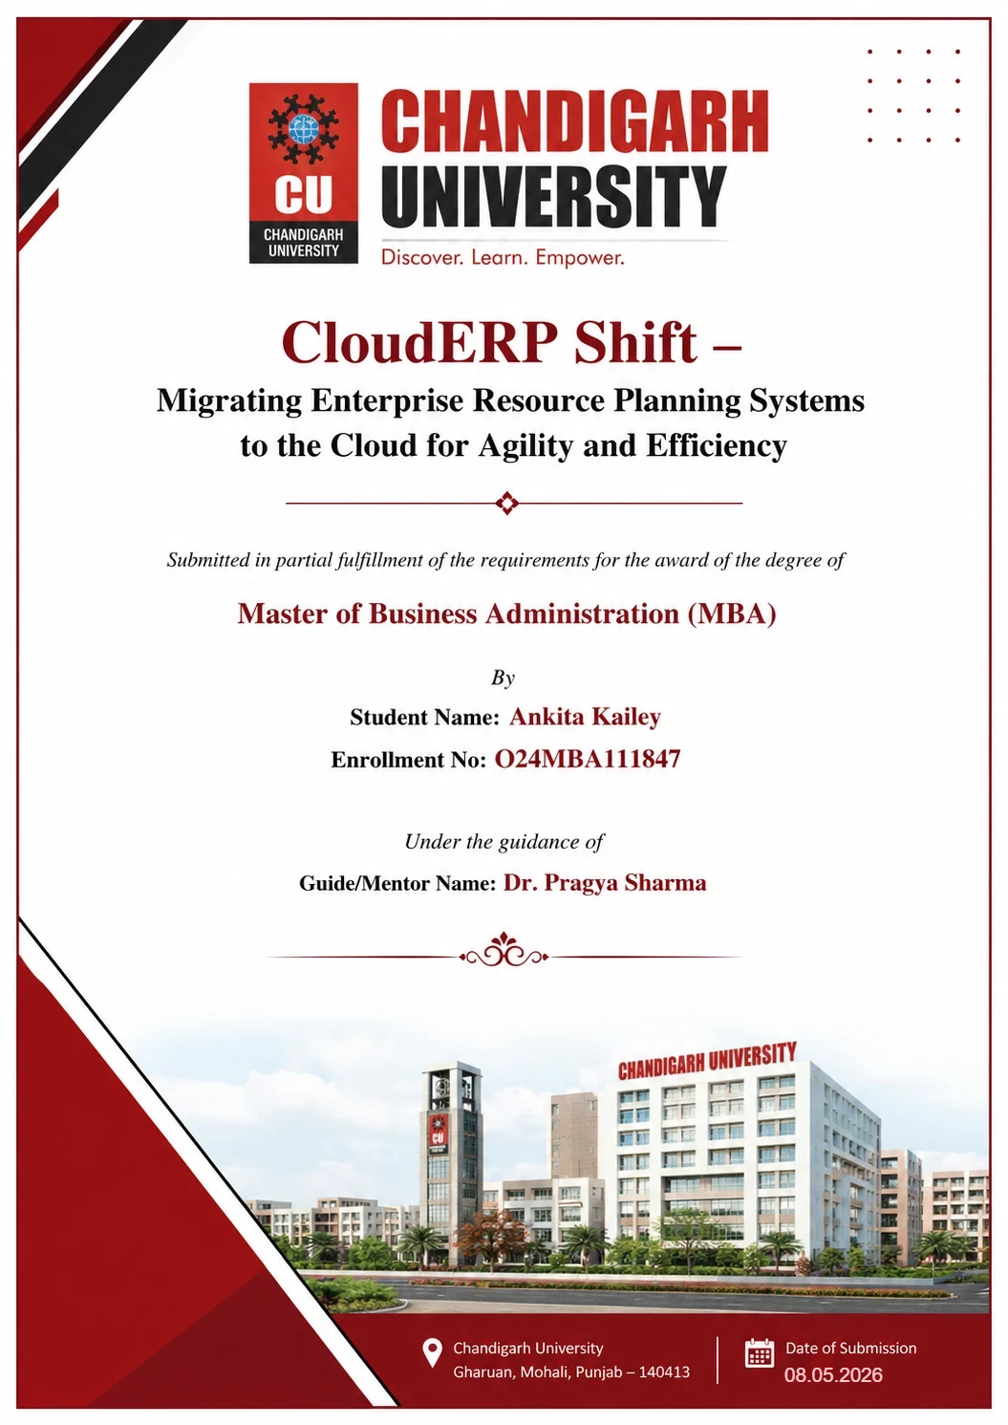


CloudERP Shift – Migrating Enterprise Resource Planning Systems to the Cloud for Agility and Efficiency

Submitted in partial fulfillment of the requirements for the award of the degree of
Master of Business Administration (MBA)
By
Student Name: Ankita Kailey
Enrollment No: O24MBA111847
Under the guidance of
Guide/Mentor Name: Dr. Pragya Sharma

Certificates

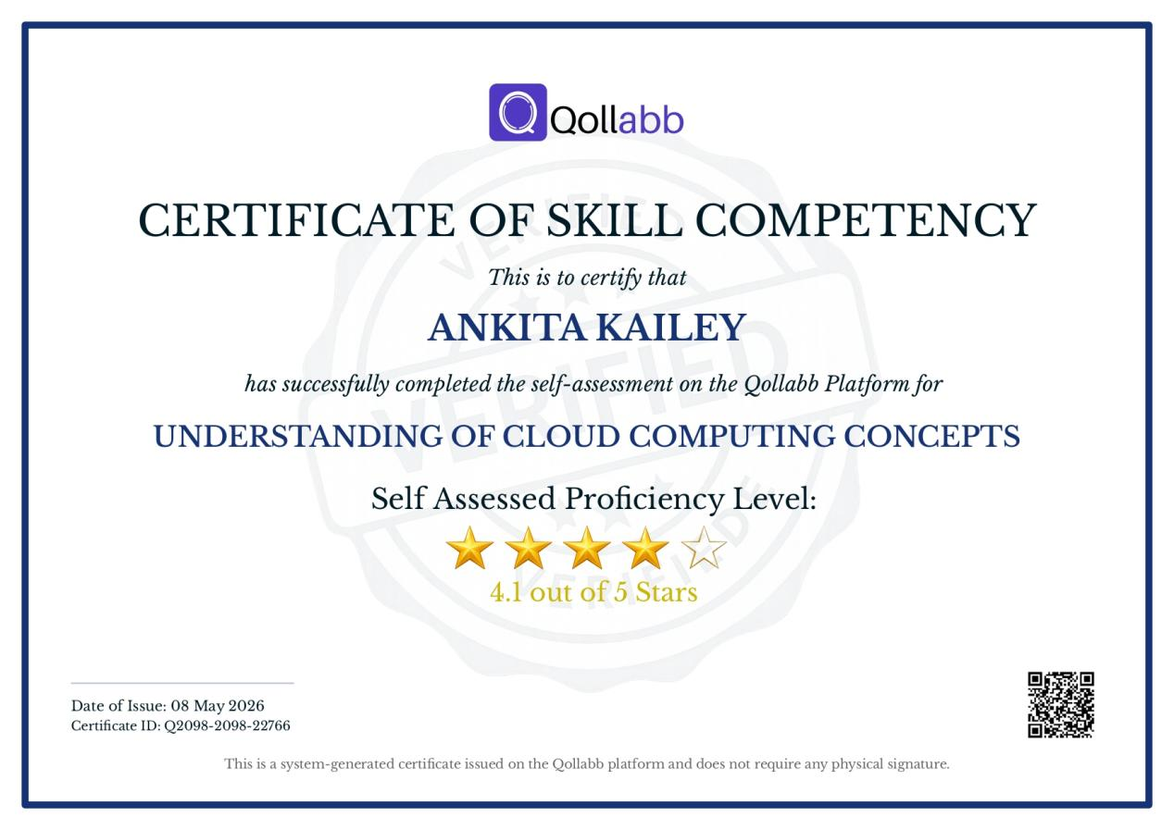

Declaration
I, Ankita Kailey, hereby solemnly declare that the project report titled "CloudERP Shift – Migrating Enterprise Resource Planning Systems to the Cloud for Agility and Efficiency" submitted in partial fulfilment of the requirements for the award of the degree of Master of Business Administration (MBA) is my original work.
I further declare that:
- This project has been carried out by me during the academic year 2024-2026 under the supervision of Dr Pragya Sharma.
- The work has not been submitted previously to any other university, institution, or examination body for the award of any degree, diploma, or certification.
- All sources of information used in this report have been duly acknowledged and referenced in accordance with academic ethics and plagiarism norms.
- The data presented in this report is authentic to the best of my knowledge and has not been fabricated or manipulated.
- I understand that if any part of this declaration is found to be false, my project may be rejected and disciplinary action may be taken as per institutional rules.


Place: Chandigarh
Date: 31.03.2026
Student Signature:
Student Name: Ankita Kailey
Enrollment No: O24MBA111847

Acknowledgement
It is my privilege to express my sincere gratitude and appreciation to all those who provided me the opportunity and support to successfully complete this project.
I convey my deepest regards to my mentor, Dr. Pragya Sharma, for her invaluable guidance, constant encouragement, and constructive suggestions throughout the course of this project. Her insightful approach and continuous support have greatly contributed to shaping my understanding in a more practical and structured manner.
I take this opportunity to express my appreciation to the Dean of my institution for fostering an environment that supported academic growth and the successful completion of this project. I also place on record my appreciation for the faculty members for their academic assistance and the resources made available. Further, I extend my gratitude to Keystone Advisory Group, Bangalore, for providing the organizational context and industry exposure that enriched this study.
Last but not the least, I express my heartfelt regards to my family and friends for their unwavering encouragement, motivation, and support throughout this journey. Their belief in me has been a constant source of strength and inspiration.

Executive Summary

This report examines the migration of Enterprise Resource Planning (ERP) systems from traditional on-site infrastructure to cloud-based platforms, with the aim of enhancing organisational flexibility and operational efficiency. The research is situated within Keystone Advisory Group, a Bangalore-based consulting firm specialising in technology and business solutions. The primary objectives are to analyse the motivations behind the shift to cloud ERP, evaluate its benefits and challenges, and assess the role of Artificial Intelligence in improving business performance. The methodology incorporates both primary and secondary data sources. Primary data was obtained through a structured questionnaire, while secondary data was sourced from academic and industry literature. The findings indicate that cloud ERP systems enable organisations to reduce costs, scale operations, access real-time information, and improve decision-making. Furthermore, the integration of Artificial Intelligence facilitates automation and predictive analysis, thereby increasing system efficiency and intelligence. The study concludes that migrating to cloud ERP represents a strategic decision that enhances organisational adaptability, efficiency, and competitiveness over the long term.

Table of Contents
Chapter / Section | Page No.
Certificate | i
Declaration | ii
Acknowledgement | iii
Executive Summary | iv
Table of Contents | v
List of Tables | viii
List of Figures | x
List of Abbreviations | xi
Chapter 1: Introduction | 1
1.1 Background of the Study | 2
1.2 Industry Profile | 3
1.3 About the Organization: Keystone Advisory Group, Bangalore | 5
1.4 Business Problem Overview | 6
1.4.1 Problem Identification | 7
1.4.2 Problem Statement | 7
1.5 Need of Study | 8
1.6 Objectives of Study | 8
1.7 Research Questions | 9
1.8 Scope of Study | 10
Chapter 2: Literature Review | 12
2.1 Introduction — Why This Topic is Worth Reviewing | 12
2.2 Existing Decision Models for ERP Adoption | 13
2.2.1 Technology Acceptance Model (TAM) — Davis, 1989 | 13
2.2.2 Unified Theory of Acceptance and Use of Technology (UTAUT) | 13
2.2.3 Theory of Diffusion of Innovation (DOI) | 14
2.2.4 Total Cost of Ownership (TCO) Model | 14
2.3 Review of Related Research Studies | 15
2.4 On-Premises ERP Systems | 17
2.4.1 On-Premises ERP Architecture | 17
2.4.2 Key Limitations of On-Premises ERP | 18
2.5 Cloud Computing — Basics and Service Models | 19
2.5.1 Infrastructure as a Service (IaaS) | 20
2.5.2 Platform as a Service (PaaS) | 20
2.5.3 Software as a Service (SaaS) | 20
2.5.4 SaaS ERP — The Dominant Migration Target | 20
2.5.5 Benefits of Cloud ERP | 21
2.6 Evolution of ERP Systems Over the Years | 23
2.7 On-Premises vs Cloud ERP — Architecture Comparison | 24
2.7.1 Direct Architecture Comparison Table | 25
2.7.2 SWOT Analysis — Cloud ERP Migration | 26
2.8 Linking Literature to the Current Study | 27
2.9 Research Gaps Identified from Literature | 28
Chapter 3: Research Methodology | 31
3.1 Introduction to the Chapter | 31
3.2 Research Design | 31
3.3 Nature and Sources of Data | 32
3.3.1 Primary Data | 33
3.3.2 Secondary Data | 33
3.4 Sampling Design | 33
3.4.1 Target Population | 33
3.4.2 Sampling Technique — Convenience Sampling | 34
3.4.3 Sample Size Justification | 35
3.4.4 Questionnaire Structure | 35
3.5 Data Analysis Workflow | 36
3.6 Reliability and Validity | 36
3.7 Scope and Limitations of the Methodology | 36
3.8 Ethical Considerations | 37
Chapter 4: Data Analysis and Interpretation | 38
4.1 Evaluation Based on Primary Survey Data | 38
4.1.1 Current Status | 38
4.1.2 Comfort with Cloud Tools | 39
4.1.3 Problems with Traditional Software | 39
4.1.4 Biggest Single Problem | 40
4.1.5 Cloud Tools in Use | 41
4.1.6 Advantages and Overall Preference | 42
4.1.7 Switching Systems — Challenges and Readiness | 44
4.1.8 Post-Transition Satisfaction | 46
4.2 Overall Analytical Summary | 48
Chapter 5: Findings and Results | 50
5.1 Findings Related to Respondent Profile | 50
5.2 Findings Related to Traditional System Limitations | 50
5.3 Findings Related to Cloud System Perceptions | 50
5.4 Findings Related to Migration Challenges and Readiness | 51
5.5 Findings Related to Post-Transition Satisfaction | 51
5.6 Summary of Key Findings | 52
Chapter 6: Conclusions | 53
6.1 Conclusion on Traditional ERP Limitations | 53
6.2 Conclusion on Cloud ERP Perception | 53
6.3 Conclusion on Migration Challenges | 54
6.4 Conclusion on Post-Migration Outcomes | 54
6.5 Conclusion Against Research Hypotheses | 54
6.6 Overall Conclusion | 55
6.7 Proposed Cloud ERP Migration Framework for Keystone  Advisory Group | 56
6.8 Managerial Implications | 58
Chapter 7: Recommendations / Suggestions | 60
7.1 Invest Heavily in Pre-Migration User Training | 60
7.2 Communicate the 'Why' Clearly and Consistently | 60
7.3 Adopt a Phased Migration Approach | 61
7.4 Establish a Dedicated Post-Go-Live Support Period | 61
7.5 Conduct a Data Quality Audit Before Migration | 61
7.6 Continuous Performance Monitoring | 62
Chapter 8: Limitations | 65
8.1 Continuous Performance Monitoring | 65
Chapter 9: References / Bibliography | 66
Chapter 10: Appendices | 68

List of Table

Table No. | Title of the Table | Page No.
Table 2.1 | Summary of theoretical frameworks applied to ERP adoption decisions | 15
Table 2.2 | Operational limitations of on-premises ERP systems | 19
Table 2.3 | Key benefits of cloud ERP — evidence from literature | 22
Table 2.4 | Feature evolution of ERP systems across five generational eras | 24
Table 2.5 | Architectural comparison between on-premises and cloud ERP systems | 26
Table 2.6 | Research gaps identified from literature review | 28
Table 3.1 | Research design types and justification for descriptive approach | 32
Table 3.2 | Summary of sampling design parameters | 34
Table 3.3 | Structure of the research questionnaire mapped to study objectives | 35
Table 3.4 | Summary of reliability and validity measures | 36
Table 3.5 | Scope and limitations of the research methodology | 36
Table 4.1 | Distribution of Respondents by Current Status | 38
Table 4.2 | Respondent Comfort Level with Cloud-Based Tools | 39
Table 4.3 | Problems Experienced with Traditional Software | 39
Table 4.4 | Single Biggest Problem with Traditional Systems | 40
Table 4.5 | Cloud-Based Tools Currently Used by Respondents | 40
Table 4.6 | Perceived Advantages of Cloud Systems | 42
Table 4.7 | Overall Preference — Cloud vs Traditional Systems | 43
Table 4.8 | Biggest Challenge When Switching to a New System | 44
Table 4.9 | Factors That Would Make System Transition Easier | 44
Table 4.10 | Time Required to Fully Adapt to a New System | 45
Table 4.11 | Benefits Noticed After Switching to a Better System | 46
Table 4.12 | Willingness to Recommend Cloud System Upgrade | 47
Table 5.1 | Summary of key findings mapped to research objectives | 52
Table 6.1 | Research conclusions mapped against research questions | 55
Table 7.1 | Summary of recommendations with evidence base and priority rating | 62
Table 8.1 | Limitations of the study and their impact on findings | 64

List of Figures
Figure No. | Title of the Figure | Page No.
Figure 1.1 | ERP System Architecture | 1
Figure 1.2 | Cloud Infrastructure Market Share (Gartner, 2023) | 3
Figure 1.3 | Market Size Forecast | 4
Figure 1.4 | Key Trends & Adoption Indicators (2026 and Beyond) | 5
Figure 2.1 | TAM adapted for Cloud ERP Adoption | 13
Figure 2.2 | Layered architecture of a traditional on-premises ERP system | 18
Figure 2.3 | Responsibility layers across IaaS, PaaS, and SaaS cloud service models | 21
Figure 2.4 | Reference architecture of cloud ERP (SaaS model) | 25
Figure 2.5 | SWOT analysis of cloud ERP migration | 26
Figure 3.1 | Sequential data analysis workflow from raw data to findings | 36
Figure 4.1 | Respondent status | 38
Figure 4.2 | Comfort with cloud tools | 39
Figure 4.3 | Problems with traditional software | 40
Figure 4.4 | Biggest problem with traditional software | 41
Figure 4.5 | Cloud tools in use mostly | 42
Figure 4.6 | Perceived cloud advantages | 43
Figure 4.7 | Overall preference — Cloud vs Traditional Systems | 43
Figure 4.8 | Biggest challenge when switching to a new system | 45
Figure 4.9 | Factors that would make system transition easier | 45
Figure 4.10 | Time required to fully adapt to a new system | 46
Figure 4.11 | Benefits noticed after switching to a better system | 47
Figure 4.12 | Willingness to recommend cloud system upgrade | 47
Figure 6.1 | Proposed Cloud ERP Migration Framework for Keystone Advisory Group | 56

List of Abbreviations
Abbreviation | Full Form
ABAP | Advanced Business Application Programming
AI | Artificial Intelligence
API | Application Programming Interface
AWS | Amazon Web Services
BBA | Bachelor of Business Administration
BFSI | Banking, Financial Services, and Insurance
BI | Business Intelligence
CRM | Customer Relationship Management
CU | Chandigarh University
DOI | Diffusion of Innovations
ECC | ERP Central Component
ERP | Enterprise Resource Planning
GCP | Google Cloud Platform
HCM | Human Capital Management
HR | Human Resources
IaaS | Infrastructure as a Service
IoT | Internet of Things
IT | Information Technology
KPI | Key Performance Indicator
MBA | Master of Business Administration
MRP | Material Requirements Planning
NIST | National Institute of Standards and Technology
PaaS | Platform as a Service
RBV | Resource-Based View
ROI | Return on Investment
RPA | Robotic Process Automation
RPO | Recovery Point Objective
RTO | Recovery Time Objective
SaaS | Software as a Service
SAP | Systems, Applications, and Products in Data Processing
SCM | Supply Chain Management
SME | Small and Medium Enterprise
TAM | Technology Acceptance Model
TCO | Total Cost of Ownership
UTAUT | Unified Theory of Acceptance and Use of Technology
VPN | Virtual Private Network

Chapter 1: Introduction
Enterprise Resource Planning (ERP) refers to application software designed to store, collect, manage, and interpret organizational data. ERP systems facilitate daily operations and serve as core platforms by integrating business processes, including project planning and scheduling, resource allocation, financial reporting, inventory management, and risk management. These systems utilize a centralized database that operates in near-real time and is accessible to multiple organizational units. As a result, departments such as human resources, finance, and sales rely on consistent information, eliminating data duplication and ensuring data integrity through a single source of truth.
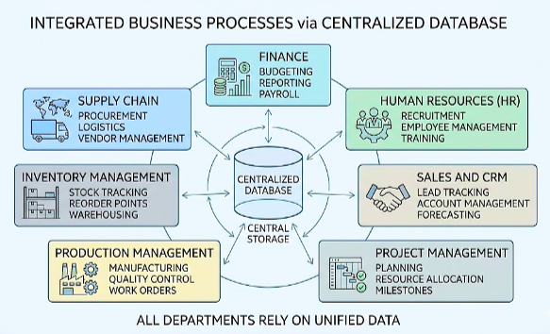
Figure 1.1 ERP System Architecture
In the past, enterprise systems relied on on-premise infrastructure, which meant companies had to invest heavily in hardware and maintenance. As cloud computing has advanced, more organizations are choosing cloud-based enterprise resource planning (ERP) systems for their flexibility, scalability, and cost savings. Cloud ERP also makes it easier to connect with customer relationship management (CRM) and supply chain management (SCM) tools, helping teams work together more effectively.
Cloud ERP systems have several important features:
- Centralized data management across different departments.
- Easy access through cloud platforms.
- Scalability to meet changing business needs.
- Reduced costs for operations and infrastructure.
Cloud ERP systems now play a key role in digital business strategies. Features like regular backups and disaster recovery help keep data safe and make these systems more reliable.
Artificial Intelligence (AI) enhances cloud ERP systems by enabling advanced data analysis and predictive analytics, and automating routine tasks. This gives organizations real-time insights, helps them work more efficiently, and supports faster, better decisions. AI also helps manage risk by improving fraud detection, data security, and compliance, making cloud ERP systems smarter and more reliable.
  - Background of the Study
Cloud Computing and AI have dramatically transformed Enterprise information systems. More companies are turning to cloud solutions instead of the traditional on-premises ERP system, which has high maintenance costs and a lot of infrastructure requirements.
There are three main types of cloud ERP systems: SaaS, PaaS, and IaaS. These options offer increased flexibility, budget control, access and faster set up for organizations. The use of cloud ERP has grown from 44% in 2020 to nearly 70% in 2026 (Anchor Group, 2024; Global Growth Insights, 2025).
Effectiveness is key for consulting firms such as Keystone Advisory Group in Bangalore, and it's hard to trust and use an internal system if it doesn't work well. These ERP systems are used in their project management, billing, workforce management and client reporting. High initial investment, complexity, lack of remote access are some of the issues with traditional systems that can negatively affect the quality of service and competitiveness. This is even more significant to moving to cloud ERP.
  - Industry Profile
Small and Medium Enterprises (SMEs) are crucial for the Indian economy, as well as for the international market. The Indian scenario is one of a rapidly changing and competitive business environment for SMEs and effective management of the business operation is important for their success. With digital transformation going at a rapid pace, organizations are striving to enhance their efficiency, make more informed decisions, and optimize their performance. As the business landscape continues to change, modern ERP solutions can help SMEs streamline and remain competitive.
SAP S/4HANA Cloud is intended for big enterprises with intricate global business models. Oracle Fusion Cloud ERP is designed for mid-sized to large enterprises, particularly those in the finance or HR industry. Microsoft Dynamics 365 is a popular one for companies that have already implemented Microsoft products. Zoho ERP and Oracle NetSuite are more affordable options for SMEs and are cloud-based.
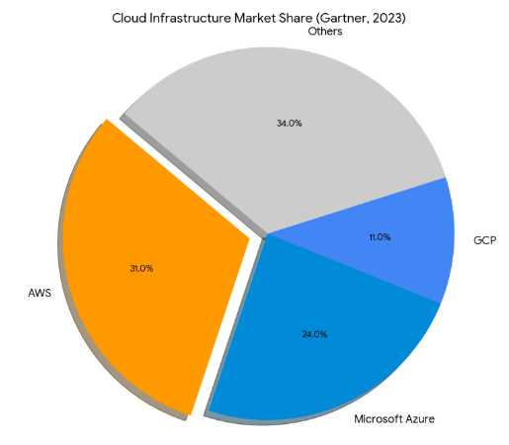
Figure 1.2 Cloud Infrastructure Market Share (Gartner, 2023)

The majority of ERP solutions are based on cloud infrastructure, with Amazon Web Services (AWS) being the dominant player in the cloud infrastructure market (Gartner, 2023). When organizations have a cloud-based ERP application, selecting a provider becomes a pivotal strategic decision.
Indian cloud market is special in some aspects. AWS has data residency and low latency for Indian users, with its ap-south-1 region in Mumbai. Azure is located in the Central India (Pune) region while GCP's asia-south1 region is located in Mumbai. All three major providers host data on Indian servers as per Indian requirements, and are good for companies where data storage is a critical requirement.
Cloud ERP has seen rapid growth in the global market in the past few years. The value of this in 2023 was USD 34.83 billion, and it is projected to grow to USD 65.89 billion by 2026. It is estimated to reach USD 110.26 billion by 2030 and USD 207.59 billion by 2034. The growth is attributed to the increasing demand for cloud-based ERP systems due to their scalability, cost-effectiveness, accessibility, and the drive towards digital transformation in businesses across the globe.
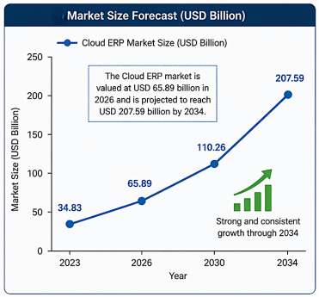
Figure 1.3 Market Size Forcast
The following are some of the biggest trends and indicators that are fueling the uptake of cloud-based Enterprise Resource Planning (ERP) systems. In 2026, around 60% - 70% of the current systems are expected to be cloud ERP. Almost all organizations prefer these solutions; about 75% of new ERP implementations run in the cloud. In terms of finances, cloud ERP can prove to be really beneficial because most companies see a return of investment of about 50% of their investment within 2 to 3 years. In addition, over half of companies are actively moving to cloud ERP and approximately 60% are working on digital transformation projects. The adoption of cutting-edge technologies is also rising, with nearly 40% of the ERP systems now having AI features like automation and predictive analytics. Collectively, these statistics highlight the growing importance and widespread adoption of cloud ERP systems (Parsimony, 2025; Anchor Group, 2024; Global Growth Insights, 2024).
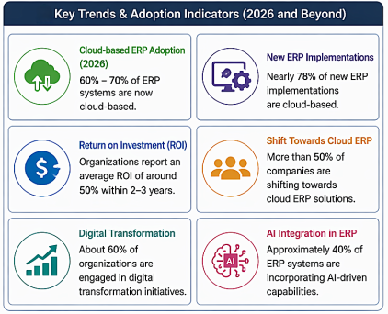
Figure 1.4 Key Trends & Adoption Indicators (2026 and Beyond)
About 7.4% of India's GDP and 5.4 million people are engaged in Information Technology and Business Process Management. It is also a major hub for technology and consulting firms and is referred to as the Silicon Valley of India. In this fast-paced world, businesses such as Keystone Advisory Group are looking to advanced digital tools, including cloud ERP solutions, to remain competitive and efficient. Keystone Advisory Group is an advisory company specializing in management and technology, based at Bangalore, India. The company's expertise lies in strategic advice that supports organizations in their digital transformation journey.
  - About the Organization: Keystone Advisory Group, Bangalore
Keystone Advisory Group is a mid-sized management and technology advisory firm in Bangalore, India. The company focuses on strategic advisory services that help businesses adapt to the changing demands of digital transformation.
Keystone provides strategy consulting, IT advisory, digital transformation, and operational excellence services to clients across industries such as BFSI, manufacturing, retail, and healthcare. With around 50 professionals and several offices, Keystone uses integrated enterprise systems to track projects, manage resources, handle finances, and ensure compliance.
Keystone Advisory Group’s main services include:
- Digital transformation advisory
- Cloud technology adoption
- Enterprise system modernization
- Business process optimization
The firm’s services help organizations become more agile and efficient with their digital systems. For students, looking at Keystone Advisory Group is a way to see how business theories work in real-world consulting.
The company used an old on-premises SAP ECC system that was more than 10 years old. Although it worked well at first, it later had problems such as limited scalability, high maintenance costs, limited advanced analytics features, and restricted remote access. Because of these challenges, the company chose to switch to a cloud-based ERP solution to be more flexible, reduce IT demands, and support its digital transformation.
  - Business Problem Overview
    - Problem Identification
Enterprise Resource Planning (ERP) systems are important for integrating business processes, improving efficiency, and supporting decision-making. Keystone Advisory Group has used an on-premise ERP for its main operations. While the system met the company’s needs in the past, changes in the business environment and new technologies have revealed weaknesses in the current system.
With the rise of cloud computing and digital transformation, organizations now need systems that are more flexible, scalable, and real-time. Traditional on-premises ERP systems are increasingly unable to meet today’s business needs, especially in fast-changing environments. This creates a gap between what the current system offers and what the organization will need in the future.
This gap has become clearer at Keystone Advisory Group as the company grows and adopts modern work practices. The need for a more agile, secure, and cost-effective solution has prompted a review of the current ERP setup. As a result, the company is considering moving from its old on-premises ERP system to a cloud-based one.
    - Problem Statement
Keystone Advisory Group’s current on-premises ERP system faces several operational challenges, making a move to a cloud platform necessary.
- Expensive infrastructure: The on-premises system costs INR 28,000 per month for infrastructure and another INR 28,000 per month for maintenance and licensing. These expenses are too high for a company with 30 to 40 employees.
- Limited accessibility: The system can only be accessed from Keystone’s office network. Remote access through VPN is unreliable, which does not support the company’s hybrid and remote work setup.
- Limited scalability: Adding new users or modules takes 4 to 6 weeks, making it difficult to scale quickly as the business grows.
- Security vulnerabilities: The on-premises system runs on software that is six years old and does not receive regular security updates. This puts Keystone’s confidential client information at risk of a data breach.
- Integration limitations: The system cannot easily connect with modern analytics, AI, or third-party SaaS tools. This limits Keystone’s ability to use data-driven insights.
- System reliability: In the past year, there have been four unplanned outages due to hardware failures, disrupting business operations.
The central problem this research addresses is: How can Keystone Advisory Group successfully migrate from its legacy on-premises ERP to a cloud-based ERP platform while ensuring data integrity, business continuity, cost optimisation, and strategic alignment with organizational goals?
  - Need of Study
This research project is important because it adds to the available literature on cloud ERP migration by exploring the phenomenon from the perspective of an Indian management consulting firm, which has not yet been widely examined in contemporary literature. In addition, it will provide practical lessons for organizations undergoing ERP modernization, including recognizing and mitigating risk factors, managing organizational and employee change, and assessing the performance of the implemented system. Such lessons may help the organization make informed decisions about the migration process.
At the same time, this study will provide Keystone Advisory Group with the tools for evaluating the results of its migration initiative. The research will allow the organization to evaluate the performance of the implemented system and make necessary adjustments to optimize its operation.
  - Objectives of Study
Key Objective: To evaluate the impact of cloud ERP adoption on organizational efficiency, cost, and decision-making at Keystone Advisory Group.
Sub-objectives include:
- To analyze Keystone’s preparedness to move to the cloud from a technical, organizational, and security perspective.
- To evaluate and recommend the best-fit cloud service provider (AWS, Azure, or Google Cloud Platform) for hosting Keystone’s ERP.
- To develop a phased migration approach that includes risk management and contingency plans.
- To migrate data in such a way that there is assured 100% data integrity for all modules.
- To test the ERP for functionality, performance, and security, and provide user training.
- To ensure a smooth go-live and compare post-migration KPIs with pre-migration figures.
- To conduct surveys with employees regarding their readiness, problems, and post-migration satisfaction.
  - Research Questions
RQ1: How can an organization assess its readiness for migrating from an on-premises ERP system to a cloud-based ERP platform?
This question will be answered through a literature review and the application of readiness assessment frameworks, supported by survey data to evaluate key readiness factors.

RQ2: What criteria should be considered while selecting a suitable cloud platform for ERP migration?
The answer will be based on literature review and comparative analysis of cloud service providers using decision criteria such as cost, scalability, security, and performance.

RQ3: What is the most effective migration strategy for transferring ERP systems to the cloud while ensuring data integrity and business continuity?
This question will be addressed through the analysis of existing migration models and case studies, and through the development of a structured migration framework aligned with the project phases.

RQ4: What are the major challenges and risks involved in cloud ERP migration, and how can they be mitigated?
The answer will be derived from literature review, case study analysis, and risk assessment techniques such as SWOT analysis.

RQ5: How does cloud ERP implementation impact organizational performance in terms of cost, efficiency, and system reliability?
This question will be answered using secondary data analysis and scenario-based evaluation aligned with industry benchmarks.

RQ6: What are user perceptions, readiness levels, and adoption challenges associated with the transition to cloud ERP systems?
The answer will be based on primary data collected through a structured questionnaire (students as proxy respondents) and analyzed using descriptive statistical techniques.
1.8 Scope of Study
This study focuses on the migration of Enterprise Resource Planning (ERP) systems from on-premises infrastructure to cloud-based platforms within the context of Keystone Advisory Group, Bangalore. The scope includes analyzing key aspects of migration, including organizational readiness, cloud platform selection, migration strategy, and post-implementation performance.
The study is conducted with reference to the Indian business environment, taking into consideration industry practices, regulatory aspects, and the growing adoption of cloud technologies within Indian organizations. This provides contextual relevance to the findings, aligning with the operational conditions of firms in India.
The scope further includes evaluating cloud service models, particularly Infrastructure as a Service (IaaS), and, where relevant, considering other service models to support ERP deployment and scalability. Cloud platforms such as Amazon Web Services (AWS), Microsoft Azure, and Google Cloud Platform are evaluated for their suitability for ERP migration.
The study covers key ERP functional modules, including Finance, Human Resources, Project Management, Customer Relationship Management (CRM), Procurement, and Administration, and examines how cloud ERP systems address limitations of traditional ERP systems, such as high costs, limited scalability, restricted accessibility, and integration challenges.
Additionally, the scope is defined within a structured 12-week project timeline (March–June 2026), encompassing major phases such as planning, platform selection, migration, testing, and post-implementation support.

Chapter 2: Literature Review

Introduction — Why This Topic is Worth Reviewing

Recent research on Enterprise Resource Planning (ERP) systems has not only shifted its attention to explaining the features of these systems, but also begun to focus on how they enhance processes within the organization and decision-making. A large part of the literature discusses how ERP systems integrate various business processes and minimize inefficiencies that can arise when operations are managed individually.

As cloud computing continues to develop, academics have also studied the transition of traditional on-premise ERP systems into cloud-based systems. Surveys of platforms available from SAP and Oracle reveal that companies are moving towards using these systems to enhance coordination among departments, automate repetitive tasks, and obtain real-time information.

At the same time, the literature does not present a completely one-sided view. Although most reports emphasize the positive aspects of these, including increased efficiency and accelerated task performance, others also note difficulties, such as data security issues, migration complications, and employee resistance. This indicates that ERP implementation is not just a technical change but also an organizational one.

The scholars have employed several techniques, including case studies, surveys, and interviews, to learn the use of ERP systems in practical contexts. Also, in this regard, other migration strategies, such as phased implementation and parallel system use, have been identified as means of minimizing risks during the transition.

Although a great deal of literature already exists, little is known about ERP adoption in small and medium-sized businesses, where achieving better ROI and effective operational management are major concerns. This chapter provides a review of the theoretical basis of ERP adoption, the shortcomings of traditional systems, and the development of cloud-based ERP. It also evaluates the literature on migration outcomes, factors for successful migration, and challenges, and finally recommends the gaps in the research that this study will fill.

Existing Decision Models for ERP Adoption
The decision to move ERP systems is not taken lightly. The decision to move from a legacy on-premises system to a cloud-based system is complex and is influenced by a range of interrelated factors, including strategic, financial, technical, and people-related issues. A number of models have been proposed and empirically verified to better understand and explain technology adoption (at an individual and organizational level).

Technology Acceptance Model (TAM) — Davis, 1989
The Technology Acceptance Model is a highly cited model in information systems literature. Davis (1989) put forward the idea that a person's willingness to use a new technology is determined by two perceptual factors: Perceived Usefulness (PU) - the perceived usefulness of the system in terms of improving job performance - and Perceived Ease of Use (PEOU) - the perceived ease with which a system can be used. These perceptions affect attitudes towards the system, which, in turn, affect intention to use and actual use behavior.
The TAM model accounts for the fact that employees may accept or reject a new technology regardless of its technical merits. A technically superior cloud ERP system that is perceived as difficult to use by end users will not realize its full potential due to low adoption. The TAM framework, therefore, compels organizations to invest equally in usability design and training as in technical excellence.
External Variables  (Training, UI Design,  Support Quality) | ➡ | Perceived  Usefulness (PU)  +  Perceived Ease  of Use (PEOU) | ➡ | Attitude  Toward  Using Cloud ERP | ➡ | Behavioural  Intention  → Actual  System Use
Figure 2.1 TAM adapted for Cloud ERP Adoption (Based on Davis, 1989)

Unified Theory of Acceptance and Use of Technology (UTAUT) -Venkatesh et al., 2003
Venkatesh et al. (2003) drew on TAM to develop the UTAUT, which synthesises eight previous models of technology adoption into four key factors: Performance Expectancy, Effort Expectancy, Social Influence, and Facilitating Conditions. UTAUT is especially important in enterprise technology settings because it includes the role of managerial support (social influence) and infrastructure (facilitating conditions), both of which are vital in large-scale Enterprise Resource Planning (ERP) conversions, where individual users' acceptance and use is often driven as much by the corporate culture as by their own preferences.

Theory of Diffusion of Innovation (DOI) - Rogers, 2003
Rogers (2003) introduced the diffusion of innovations through social systems and grouped adopters into five categories: Innovators, Early Adopters, Early Majority, Late Majority, and Laggards. In the case of cloud ERP, this model helps predict the resistance companies might encounter during migration. IT-savvy organizations, such as technology consulting groups, are part of the early majority. They adopt new technology after it has been proven but before it becomes mainstream. This approach matches the Keystone Advisory Group's 2024 migration plan.
Rogers also described five attributes of innovation that affect how quickly it is adopted: relative advantage, compatibility, complexity, trialability, and observability. Cloud ERP offers clear benefits and is easy to try out through vendor demonstrations. However, it can be complicated, especially when migrating data.

Total Cost of Ownership (TCO) Model
The Total Cost of Ownership (TCO) framework is widely utilized in IT investment analysis, framing the cloud versus on-premises decision as a comprehensive, long-term financial evaluation. This approach accounts for both direct costs, such as licensing and hardware, and indirect costs, including implementation, training, maintenance, downtime, and opportunity costs. Organizations that base investment decisions solely on direct licensing costs risk underestimating on-premises TCO and overestimating cloud-related expenses. Gartner (2022) reports that, when evaluating the complete TCO over a five-year period, cloud ERP solutions generally yield 25-40% lower aggregate costs compared to equivalent on-premises systems.
Framework | Primary Focus | Key Variables | Applicability to Cloud ERP Migration
TAM (Davis, 1989) | Individual adoption | Perceived Usefulness, Ease of Use | Predicts end-user acceptance of new cloud interface
UTAUT (Venkatesh, 2003) | Organizational adoption | Performance, Effort, Social Influence, Facilitating Conditions | Explains why some departments adopt faster than others
DOI Theory (Rogers, 2003) | Innovation diffusion rate | Relative Advantage, Compatibility, Complexity | Identifies likely resistance clusters in the workforce
TCO Model (Gartner) | Financial decision-making | Total 5-year cost across all categories | Justifies migration investment at board/C-suite level
Resource-Based View (Barney, 1991) | Strategic advantage | IT capabilities as firm resources | Frames cloud ERP as a competitive capability, not just a cost
Table 2.1: Summary of theoretical frameworks applied to ERP adoption decisions

2.3 Review of Related Research Studies
Study 1: Johansson & Ruivo (2013)
Johansson and Ruivo (2013) conducted a comparative study of cloud ERP adoption among small and medium enterprises in Sweden and Portugal. Their objective was to examine the factors influencing adoption decisions and the performance outcomes realized post-deployment. Using a mixed-methods approach combining surveys and structured interviews across 40 organizations, the authors found that cost reduction and system scalability were the primary motivators, while data security concerns and vendor dependency were the most cited barriers. The study concluded that organizations with stronger IT governance frameworks reported significantly higher satisfaction with their cloud ERP deployments. A key limitation of this study is its focus on SMEs in Western European contexts, which limits the generalisability of its findings to large-scale consulting firms in emerging markets.
Study 2: Seethamraju (2015)
Seethamraju (2015) examined cloud ERP implementation in the context of Australian higher education institutions, focusing on the suitability of SaaS-based ERP for complex, multi-stakeholder organizations. The research employed a case study methodology, drawing on semi-structured interviews with IT directors and process owners across three institutions. The findings indicated that while cloud ERP offered meaningful improvements in system maintainability and upgrade frequency, the lack of customization flexibility relative to on-premises systems posed significant challenges for organizations with complex regulatory and reporting requirements. This study is particularly relevant to the current research as it highlights the tension between standardization and customization — a challenge equally pertinent to management consulting firms.
Study 3: Martins et al. (2019)
Martins et al. (2019) conducted a longitudinal analysis of cloud ERP migration outcomes across 28 multinational corporations over a four-year period. Their study applied a balanced scorecard framework to evaluate performance across the financial, customer, internal processes, and learning dimensions. The findings demonstrated that cloud ERP migration yielded the most significant improvements in the internal process and learning dimensions, particularly in terms of process automation rates and cross-functional data accessibility. Financial benefits — including TCO reduction — were observed primarily in the second and third years post-migration, suggesting a lag between migration completion and the full realization of financial returns. A limitation of this study is its exclusive focus on large multinational corporations, leaving the experiences of mid-sized advisory organizations unaddressed.
Study 4: Sagheer et al. (2021)
Sagheer et al. (2021) investigated barriers to cloud ERP adoption in the South Asian technology sector, with a particular focus on India, Pakistan, and Bangladesh. Their survey-based study across 120 organizations identified data privacy and sovereignty concerns, inadequate technical expertise, and high migration costs as the three most critical barriers. The authors also noted that organizations with prior experience in cloud infrastructure adoption — such as those already using cloud-based CRM or HRMS platforms — demonstrated significantly smoother ERP migration journeys. This study's contextual alignment with the Indian IT sector makes its findings directly applicable to the current research.
Study 5: Ali et al. (2023)

Ali et al. (2023) examined post-migration performance assessment frameworks for cloud ERP systems and proposed a multidimensional evaluation model encompassing technical performance, user satisfaction, business process efficiency, and strategic alignment. Their research was grounded in a survey of 200 IT managers across GCC countries and applied structural equation modeling to identify key performance drivers. The study concluded that executive sponsorship, comprehensive training programs, and phased implementation approaches were the three most significant success factors in cloud ERP migration. The authors identified a research gap regarding the role of middle management in driving post-migration adoption, a gap the current study partially addresses through its primary data collection design.

2.4 On-Premises ERP Systems

On-premises ERP systems have been the predominant form of enterprise information management since the 1990s. SAP R/3, Oracle E-Business Suite, and Microsoft Dynamics NAV are the most commonly used systems from this period. On-premises deployment involves the company paying for perpetual software licenses, maintaining the system on its own hardware, and having an in-house IT team to maintain, customize, and upgrade it.

On-premises ERP's strengths - high customisability, full data control, and connectivity independence - made it the preferred option for large organizations with complex, highly regulated processes. Manufacturers who needed to integrate with shop-floor systems, financial institutions who needed to ensure transactional security, and public sector organizations who needed to ensure air-gapped systems all rely on on-premises deployment.

But the same attributes that make on-premises ERP systems effective in a stable world make them inefficient in an increasingly dynamic, diverse, and data-centric business world. The rigidity of on-premises architecture constrains innovation velocity; upgrade cycles measured in years, rather than weeks, leave organizations perpetually behind the technology frontier.

2.4.1 On-Premises ERP Architecture
USER LAYER
Finance  Users | HR  Users | Operations  Users | Management /  Reporting Users

↓ Intranet / LAN Network ↓
APPLICATION LAYER (SAP ECC / Oracle EBS — On Premise)
FI / CO  Module | MM / SD  Module | HR / HCM  Module | PP / PM  Module | BI /  Reporting

↓ Direct Server Access ↓
INFRASTRUCTURE LAYER (On-Site Physical Servers)
Web / App  Servers | Database  Servers (RDBMS) | Backup &  Storage Systems

↓ Physical Network & Security ↓
Firewall &  Network Security | On-Site IT  Team (24x7) | Disaster Recovery  (On-Premise Backup)

Figure 2.2 Layered architecture of a traditional on-premises ERP system

On-premises ERP is built on a four-layered architecture as shown in Figure 2.2. The user layer is connected to the application layer solely via the corporate LAN, implying that a complex VPN setup is required for remote users outside the corporate boundaries. The infrastructure layer, which includes physical servers, storage, and databases, is owned, hosted, and maintained by the in-house IT team. All hardware replacements, software patching, and capacity upgrades need to be performed by this team, which poses risks and a significant cost burden.

2.4.2 Key Limitations of On-Premises ERP
Limitation | Explanation | Business Impact
High Capital Expenditure | Upfront hardware, licence, and implementation costs often run into crores for mid-sized firms | Strains balance sheet; creates sunk-cost inertia against modernisation
Scalability Constraints | Server capacity must be provisioned for peak demand, leading to under-utilisation at normal loads | Resource waste during off-peak periods; risk of crashes at peak load
Remote Access Barriers | Users require VPN or office presence; unsuitable for field-based or hybrid workforces | Reduced productivity; inability to support modern work arrangements
Slow Upgrade Cycles | Major version upgrades require months of testing and significant downtime | Perpetual technology lag; growing technical debt
IT Dependency | Every change — even minor configuration — requires IT department involvement | Business agility constrained by IT bottlenecks
Limited Analytics | On-premises systems lack real-time business intelligence without costly add-ons | Decision-making based on batch reports rather than live data
Disaster Recovery Risk | Backup systems are co-located with primary systems; disaster destroys both | Business continuity exposure in events of fire, flood, or power failure
Table 2.2: Operational limitations of on-premises ERP systems

2.5 Cloud Computing — Basics and Service Models

According to the US National Institute of Standards and Technology (NIST), cloud computing is a model for enabling ubiquitous, convenient, on-demand network access to a shared pool of configurable computing resources (e.g., networks, servers, storage, applications, and services) that can be rapidly provisioned and released with minimal management effort or service provider interaction (Mell & Grance, 2011).

There are three key characteristics of cloud computing: on-demand self-service, broad network access, and rapid elasticity. Together, these characteristics remove time and capacity constraints of on-premises systems. In the context of enterprise resource planning (ERP) systems, cloud delivery transforms the way the organization relates to its enterprise software: from ownership to subscription, from management to consumption.

2.5.1 Infrastructure as a Service (IaaS)
IaaS is a computing infrastructure service - virtual servers, storage, and networking - delivered over the internet on a subscription basis. The organization maintains control over the operating system, middleware, and application layers, and the cloud provider is responsible for the hardware infrastructure. IaaS is commonly used in ERP environments by organizations that are performing a "lift and shift" migration of their on-premises ERP system to cloud-based virtual machines, without re-architecting their application. Popular IaaS solutions include Amazon Web Services (AWS EC2), Microsoft Azure Virtual Machines, and Google Compute Engine.

2.5.2 Platform as a Service (PaaS)
PaaS provides a development and deployment environment on the internet, abstracting the underlying infrastructure and enabling developers to develop, extend, and deploy applications without worrying about maintaining the operating system and servers. For ERP, PaaS is utilized for developing extensions - companies develop their own custom modules, integration, or analytics apps on their cloud ERP system. SAP Business Technology Platform (BTP) and Oracle Cloud Platform are the major PaaS providers for enterprise ERP.

2.5.3 Software as a Service (SaaS)
SaaS is the most common cloud model for ERP. SaaS is based on the idea that the application (infrastructure, platform, and software) is fully outsourced and delivered to the organization on a web browser or via API. The organization pays for the service on a per-user or per-module basis, and it is updated, patched, and upgraded automatically with the subscription. This approach effectively removes maintenance from the organization's IT team.

2.5.4 SaaS ERP — The Dominant Migration Target
SaaS ERP represents the convergence of enterprise resource planning functionality and the SaaS delivery model. Platforms such as SAP S/4HANA Cloud (Public Edition), Oracle Fusion Cloud ERP, Microsoft Dynamics 365 Finance, and Workday Finance have emerged as the leading SaaS ERP solutions for mid- to large-sized enterprises. These platforms are characterized by standardized business processes aligned to industry best practices, regular quarterly or bi-annual feature releases, multi-tenant architecture enabling cost sharing across customer organizations, and native integration with AI, machine learning, and advanced analytics capabilities.
 | IaaS | PaaS | SaaS
Applications | organization | organization | Vendor
Data | organization | organization | Vendor
Runtime | organization | Vendor | Vendor
Middleware | organization | Vendor | Vendor
OS | organization | Vendor | Vendor
Virtualisation | organization | Vendor | Vendor
Servers | Vendor | Vendor | Vendor
Storage | Vendor | Vendor | Vendor
Networking | Vendor | Vendor | Vendor
 | organization-managed |  | Vendor-managed
Figure 2.3 Responsibility layers across IaaS, PaaS, and SaaS cloud service models

2.5.5 Benefits of Cloud ERP
Benefit Category | Specific Benefit | Literature Support
Cost Efficiency | Eliminates capital expenditure on hardware; shifts to predictable OpEx subscription model | Gartner (2022); Johansson & Ruivo (2013)
Scalability | Resources scale up or down on demand — ideal for organizations with seasonal or project-based workloads | Martins et al. (2019); SAP SE (2024)
Accessibility | 24/7 access from any device and location — critical for remote and field-based workforces | Sagheer et al. (2021)
Automatic Updates | Vendor manages all upgrades, patches, and feature releases without organizational IT involvement | Seethamraju (2015)
Business Continuity | Geo-redundant cloud data centres provide automatic failover and disaster recovery | Ali et al. (2023)
Advanced Analytics | Native integration with AI, ML, and real-time dashboards without costly add-ons | IDC (2023)
Security & Compliance | Hyperscale cloud providers invest billions in security infrastructure — often exceeding on-premises capabilities | Deloitte (2023)
Faster Implementation | Pre-configured industry templates reduce implementation timelines significantly | Microsoft (2023)
Table 2.3: Key benefits of cloud ERP — evidence from literature

2.6 Evolution of ERP Systems Over the Years — Milestone Tracker
The development of enterprise resource planning systems has passed through distinct generational phases, each representing a step-change in capability, delivery model, and strategic role within organizations. The timeline below maps these milestones against the features and limitations that characterized each era.
Feature / Capability | Pre-ERP Era  (Pre-1990) | MRP / Early ERP  (1990–2000) | Integrated ERP  (2000–2010) | Web-Enabled ERP  (2010–2018) | Cloud / SaaS ERP  (2018–Present)
Integrated business modules | ✗ | △ | ✓ | ✓ | ✓
Real-time data across departments | ✗ | ✗ | △ | ✓ | ✓
Remote access (outside office) | ✗ | ✗ | ✗ | △ | ✓
Mobile device support | ✗ | ✗ | ✗ | △ | ✓
Automatic software updates | ✗ | ✗ | ✗ | ✗ | ✓
Pay-per-use / subscription pricing | ✗ | ✗ | ✗ | ✗ | ✓
Built-in AI / predictive analytics | ✗ | ✗ | ✗ | ✗ | ✓
Multi-tenant architecture | ✗ | ✗ | ✗ | ✗ | ✓
Deep customisation flexibility | ✓ | ✓ | ✓ | ✓ | △
On-site hardware required | ✓ | ✓ | ✓ | ✓ | ✗
High upfront capital investment | ✓ | ✓ | ✓ | ✓ | ✗
Dedicated IT maintenance team required | ✓ | ✓ | ✓ | △ | ✗
Geo-redundant disaster recovery | ✗ | ✗ | ✗ | △ | ✓
Regulatory / compliance automation | ✗ | ✗ | △ | △ | ✓
Integration with third-party SaaS tools | ✗ | ✗ | ✗ | △ | ✓
Table 2.4: Feature evolution of ERP systems across five generational eras.
✓ = Feature present | △ = Partial capability | ✗ = Feature absent

2.7 On-Premises vs Cloud ERP — Architecture Comparison
While the functional scope of ERP modules (finance, HR, supply chain, etc.) remains broadly consistent across on-premises and cloud platforms, the underlying architectural philosophy differs fundamentally. On-premises ERP is built around single-tenant, vertically integrated server stacks. Cloud ERP — particularly in the SaaS model — operates on multi-tenant, microservices-based architectures hosted on hyperscale cloud infrastructure.
USER ACCESS LAYER — Any Device, Anywhere, Any Time
Web Browser | Mobile App  (iOS / Android) | Desktop Client | API / Third-party  Integration

↓ HTTPS / Encrypted Internet Connection ↓
SAAS APPLICATION LAYER — Vendor-Managed, Auto-Updated
Finance  (FI/CO) | HR &  Payroll | Supply  Chain | Sales &  CRM | Projects &  Billing | Analytics  & AI

↓ Multi-Tenant Platform Services ↓
PLATFORM LAYER — Integration, Extension & Security
API Gateway &  Middleware | Identity &  Access Management | DevOps &  Extension Platform

↓ Hyperscale Cloud Infrastructure ↓
INFRASTRUCTURE LAYER — AWS / Azure / GCP (Geo-Redundant Data Centres)
Primary  Data Centre  (Region A) | Failover  Data Centre  (Region B) | Automated  Backup &  Snapshot | 24x7 Vendor  Security &  Monitoring

Figure 2.4 Reference architecture of cloud ERP (SaaS model) — contrasted with Figure 2.2

2.7.1 Direct Architecture Comparison Table
Architectural Dimension | On-Premises ERP | Cloud ERP (SaaS)
Hosting Environment | organization-owned physical servers in on-site data centre | Vendor-managed hyperscale cloud data centres (AWS/Azure/GCP)
Tenancy Model | Single-tenant (dedicated environment per client) | Multi-tenant (shared infrastructure, logically isolated data)
User Access Method | Intranet / VPN required for off-site access | Secure HTTPS access from any internet-connected device
Update & Patch Cycle | Annually or bi-annually; requires planned downtime | Continuous / quarterly; automatic, zero-downtime updates
Scalability Mechanism | Manual server provisioning (weeks to months) | Elastic auto-scaling within minutes
Disaster Recovery | On-site backup systems; risk of co-location failure | Geo-redundant failover; RPO/RTO measured in seconds
Customisation | Deep customisation via ABAP/extensions (on SAP) | Standardised processes; extensions via PaaS/API only
Integration Method | Point-to-point middleware (complex and brittle) | Open API ecosystem; pre-built connectors for major SaaS tools
Analytics Capability | Requires separate BI tools (e.g., SAP BW) | Embedded real-time analytics and AI natively available
Cost Structure | CapEx-heavy (upfront); ongoing maintenance costs | OpEx-based subscription; predictable monthly/annual fees
Table 2.5: Architectural comparison between on-premises and cloud ERP systems

2.7.2 SWOT Analysis — Cloud ERP Migration
STRENGTHS  - 40%+ reduction in IT infrastructure TCO over 5 years  - Elimination of hardware procurement and maintenance burden  - 99.9% uptime SLA from hyperscale cloud providers  - Remote access enabling workforce mobility and hybrid work  - Automatic updates keeping organization at technology frontier  - Built-in AI/ML analytics unavailable in legacy systems | WEAKNESSES  - Reduced customisation flexibility vs on-premises systems  - Vendor dependency and risk of licence cost escalation  - Internet connectivity required — rural/low-bandwidth risk  - Data sovereignty concerns in regulated sectors  - Initial migration complexity and transition costs  - Change management burden on internal HR and IT teams
OPPORTUNITIES  - Integration with emerging technologies (IoT, Blockchain, RPA)  - AI-driven predictive insights for project profitability  - Enabling global expansion without new IT infrastructure  - Data-driven competitive differentiation in advisory services  - Vendor innovation pipeline delivering continuous new features  - Partner ecosystem enabling rapid third-party integrations | THREATS  - Data breach risk in shared cloud environments  - Vendor lock-in making future migrations costly  - Regulatory changes affecting cross-border data storage  - Inadequate change management causing low adoption rates  - Integration failures with legacy third-party systems  - Business disruption during the migration transition window
Figure 2.5 SWOT analysis of cloud ERP migration - context of mid-sized Indian consulting firms
2.8 Linking Literature to the Current Study
The reviewed literature collectively indicates that cloud ERP adoption is influenced by a combination of technological, organizational, and human factors. Previous studies consistently emphasize benefits such as scalability, flexibility, accessibility, and operational efficiency, while also identifying challenges related to user resistance, migration complexity, and data security concerns.
However, most existing studies focus either on technical implementation issues or on large multinational organizations operating in Western contexts. Limited attention has been given to management-oriented perspectives in Indian professional service organizations, particularly regarding employee readiness, adoption behavior, and support mechanisms for migration.
The current study builds on these existing findings by examining cloud ERP migration within the context of Keystone Advisory Group and integrating organizational migration strategy and user perception analysis within a single research framework. This helps establish stronger practical relevance between theoretical concepts and real-world managerial challenges associated with cloud ERP transition.
The literature further indicates that organizations adopting cloud ERP systems are increasingly prioritizing business agility, operational scalability, and remote accessibility in response to changing market conditions and digital transformation trends. The COVID-19 pandemic significantly accelerated organizations' reliance on cloud-based systems, highlighting the limitations of traditional on-premises infrastructure for supporting remote work and distributed business operations.
Researchers also emphasize that cloud ERP implementation should not be evaluated solely on technological capabilities, but also on organizational readiness, employee adaptation, and long-term strategic alignment. As a result, modern ERP migration studies increasingly integrate management perspectives alongside technical considerations to provide a more holistic understanding of cloud transformation initiatives.
2.9 Research Gaps Identified from Literature
A systematic review of the existing academic and professional literature reveals several areas where empirical evidence remains either absent or insufficient. These gaps define the specific contribution that this study is positioned to make.

Gap No. | Research Gap Identified | Why it Matters | How This Study Addresses It
Gap 1 | Most cloud ERP migration studies focus on manufacturing or retail sectors. The professional services and consulting sector — which has distinct workflow, billing, and project management ERP requirements — is significantly underrepresented. | Sector-specific findings are essential because ERP configuration, user needs, and migration complexity vary significantly across industries. | This study examines cloud ERP migration exclusively within a management consulting firm (Keystone Advisory Group), providing sector-specific evidence.
Gap 2 | Existing studies are predominantly from North American or Western European organizational contexts. Indian mid-market organizations face unique infrastructure constraints (bandwidth variability, local compliance), and their cloud ERP experiences remain understudied. | Generalising findings from Western firms to Indian contexts can lead to inappropriate recommendations. | Primary data is collected entirely from professionals within an Indian organization, ensuring contextual validity.
Gap 3 | Most studies evaluate either pre-migration drivers OR post-migration outcomes — rarely both within the same study. This creates a disconnect between why organizations migrate and whether those motivations are actually fulfilled. | Without connecting drivers to outcomes, it is impossible to evaluate whether the migration achieved its stated objectives. | This study explicitly maps each pre-migration driver to a measured post-migration performance outcome.
Gap 4 | The role of middle management in driving or obstructing cloud ERP adoption is consistently identified as important in theoretical frameworks (UTAUT) but rarely measured empirically in primary studies. | Middle managers are the primary interface between executive strategy and operational adoption — their behaviour is critical to migration success. | The survey instrument includes role-level analysis, enabling comparison of adoption patterns between senior, middle, and operational staff.
Gap 5 | The long-term sustainability of cloud ERP benefits — beyond the initial 12-month post-migration honeymoon period — has received limited longitudinal investigation. | Short-term satisfaction studies may not reflect whether cloud ERP delivers sustained strategic value. | While this study cannot address longitudinal outcomes fully, it recommends a structured post-migration measurement framework for ongoing tracking.
Table 2.6: Research gaps identified from literature review — and this study's response to each

Chapter 3: Research Methodology

3.1 Introduction to the Chapter
Research methodology forms the structural spine of any academic investigation. It defines not only how data is collected and analyzed, but also establishes the credibility, repeatability, and academic rigor of the entire study. A well-articulated methodology enables readers and evaluators to assess whether the conclusions drawn are genuinely supported by evidence or merely the researcher's subjective opinion.
This chapter presents the complete methodological framework adopted for the study of perceptions and attitudes toward cloud ERP migration. It details the research design philosophy, the nature of the collected data, the instruments used for data collection, the sampling strategy employed, the statistical techniques applied for analysis, and the ethical considerations observed throughout the process. Each decision is justified in terms of the study's objectives and the nature of the research problem.
After data coding, responses were analyzed using descriptive techniques based on percentages. The findings were then interpreted in relation to the research objectives to identify common patterns, attitudes, and perceptions regarding cloud ERP migration. Graphs and tables were used to present the findings in a structured and easy-to-understand manner.

3.2 Research Design
A descriptive research design has been adopted for this study. Descriptive research is appropriate when the objective is to accurately portray the characteristics, perceptions, and attitudes of a defined population toward a specific phenomenon — in this case, cloud ERP migration and technology system transitions. Unlike exploratory research, which is used when little is known about a topic, or causal research, which seeks to establish cause-and-effect relationships, descriptive research maps the current state of opinion and experience in a structured, measurable way.
This study is descriptive because it aims to measure respondents' perceptions of legacy system limitations, their attitudes toward cloud-based alternatives, their expectations regarding change management, and their satisfaction with technology transitions — all of which are attitudinal and perceptual constructs best captured through structured survey instruments.
Organizational readiness for cloud ERP migration can be assessed based on factors such as technical infrastructure, employee readiness, data preparedness, and management support. The survey responses in this study indirectly reflect readiness levels through user familiarity with cloud tools and openness to system adoption. The descriptive design was considered most appropriate because the study focuses on understanding respondent perceptions and behavioral attitudes rather than establishing causal relationships. Since cloud ERP adoption involves both technological and human factors, capturing user opinion and readiness through structured responses provides meaningful insight into the practical challenges and expectations associated with system transition.
Design Type | Description | Suitable When | Used in This Study?
Exploratory | Open-ended investigation when little is known | Topic is new or undefined | ✗ Topic well-established in literature
Descriptive | Measures and describes characteristics of a population | Attitudes, perceptions, frequency data needed | ✓ YES — measuring perceptions of cloud ERP
Causal / Explanatory | Establishes cause-and-effect relationships | Controlled experiments or longitudinal data | ✗ Beyond scope of this project
Table 3.1: Research design types and justification for descriptive approach

3.3 Nature and Sources of Data
This study employs a combination of primary and secondary data to construct a comprehensive evidence base.

3.3.1 Primary Data
Primary data refers to original data collected directly by the researcher for the specific purpose of this study. It has not been previously published or analyzed elsewhere. In this study, primary data were collected via a structured questionnaire distributed via Google Forms to a convenience sample of 35 respondents, comprising students and early-career professionals from diverse academic backgrounds.
Primary data form the empirical core of this research. The questionnaire was specifically designed to capture respondents' perceptions of traditional versus cloud-based systems, their attitudes toward technology migration, and their satisfaction with system transitions — all framed in accessible, non-technical language to ensure meaningful responses from respondents without specialized IT backgrounds.
The use of an online questionnaire enabled faster data collection, broader accessibility, and improved response convenience for participants. Google Forms was selected as the primary survey tool because it allowed efficient distribution, automatic response recording, and simplified data organization for further analysis.

3.3.2 Secondary Data
Secondary data refers to information that has already been collected and published by other researchers or organizations. In this study, secondary data were used to develop the theoretical framework in Chapter 2, to justify the research design, and to contextualize the primary findings. Sources included peer-reviewed academic journals, research methodology textbooks, industry reports from Gartner and IDC, and ERP vendor documentation from SAP and Microsoft.
3.4 Sampling Design
Sampling is the process of selecting a representative subset of a larger population for data collection and analysis. Since it is practically impossible to survey every individual in a target population, sampling enables researchers to draw meaningful conclusions from a manageable number of responses.
3.4.1 Target Population
The target population for this study consists of students and working professionals who have experience using any form of digital or office management system — ranging from enterprise software such as SAP or Tally to everyday cloud-based tools such as Google Drive, Zoom, or online banking platforms. This broad definition was intentional, as the questionnaire was designed to capture general attitudes toward technology adoption rather than expert ERP knowledge, making it accessible to respondents from diverse academic and professional backgrounds.

3.4.2 Sampling Technique — Convenience Sampling
Convenience sampling was employed for this study. In convenience sampling, respondents are selected based on their accessibility and willingness to participate, rather than through random selection. This technique is widely used in academic research where time, access, and resource constraints make probability sampling impractical.
The questionnaire was distributed digitally via Google Forms to the researcher's classmates, peers, and acquaintances via WhatsApp, email, and direct sharing links. While convenience sampling has limitations in terms of generalisability, it is appropriate for descriptive studies where the objective is to understand attitudinal patterns rather than make statistically representative claims about an entire population.
Parameter | Details
Target Population | Students and professionals with experience using any digital/office system
Sampling Frame | Personal and academic network of the researcher
Sampling Technique | Convenience / Purposive Sampling
Sample Size | 35 respondents (usable responses after removing incomplete forms)
Survey Mode | Online — Google Forms (shareable link)
Data Collection Period | April 2026
Geographic Scope | Punjab / North India (primarily Ludhiana and nearby cities)
Language of Survey | English (simple, jargon-free language used throughout)
Table 3.2: Summary of sampling design parameters

3.4.3 Sample Size Justification
A sample size of 35 respondents was targeted for this study. While larger samples generally provide more robust insights, a sample of 30 or more is widely accepted in academic research for basic analysis. For a descriptive study using percentage-based analysis, a sample size of 35 respondents is sufficient to identify general trends and patterns within the scope of this study. This sample size is also practical, considering the time and access constraints of a student research project.

3.4.4 Questionnaire Structure
Section | Theme | Scale Used | Research Objective Addressed
Section 1 | Respondent Profile | Multiple Choice | Classification of respondents
Section 2 | Traditional System Issues | Multiple Choice (Multi-select) | Identify problems in legacy systems
Section 3 | Cloud System Usage | Multiple Choice | Understand familiarity with cloud tools
Section 4 | Migration Challenges | Multiple Choice (Multi-select) | Identify transition barriers
Section 5 | Overall Perception | Multiple Choice | Assess general attitude toward cloud systems
Table 3.3: Structure of the research questionnaire mapped to study objectives

3.5 Data Analysis Workflow
RAW DATA  Google Form  Responses | ↓ | DATA  CLEANING  Remove incomplete  responses | ↓ | DATA  CODING  Convert to  numeric values | ↓ | FINDINGS  &  INTERPRETATION
Figure 3.1 Sequential data analysis workflow from raw data to findings

3.6 Reliability and Validity
The questionnaire was designed in line with the research objectives to ensure clarity and relevance. Simple and easy-to-understand language was used to minimize confusion among respondents. The questionnaire was reviewed before distribution to ensure logical consistency.
As the study follows a descriptive approach using percentage-based analysis, advanced statistical validation techniques were not applied. However, the collected data is considered reliable for descriptive analysis within the scope of this study.
Assessment Type | Method Used | Result / Outcome | Interpretation
Reliability | Questionnaire design clarity | Consistent responses | Data suitable for descriptive analysis
Content Validity | Mapping each question to a research objective | All objectives covered | Questions are relevant and complete
Face Validity | Reviewed before distribution | Minor corrections made | Easy to understand
Table 3.4: Summary of reliability and validity measures

3.7 Scope and Limitations of the Methodology
Dimension | Scope of This Study | Associated Limitation
Sample Type | Convenience sample | Not statistically representative of the general population
Sample Size | 35 respondents | Limits the power of inferential statistics
Geography | North India | Findings may not generalise to other regions
Respondent Profile | Students and early-career professionals | May not fully reflect experienced corporate ERP users
Data Type | Quantitative only (closed-ended questionnaire) | Qualitative depth limited to 2 optional open-ended questions
Time Frame | Cross-sectional — single point in time | Cannot track change in attitudes over time
Bias Risk | Self-reported data, voluntary participation | Social desirability bias and non-response bias possible
Table 3.5: Scope and limitations of the research methodology

3.8 Ethical Considerations
Participation in the survey was entirely voluntary and anonymous. Respondents were informed of the academic purpose of the data collection and assured that no individual responses would be identifiable in the final report. Data was stored securely and used exclusively for academic research purposes, in accordance with Chandigarh University's data protection policies.
Respondents were not required to answer any questions, and participation could be discontinued at any point in the survey process. This ensured ethical transparency and voluntary participation throughout the study.

Chapter 4 : Data Analysis and Interpretation
This chapter presents the analysis of primary data and organizational data collected from 35 respondents through the structured Google Forms questionnaire described in Chapter 3. Each question is presented as a frequency table followed by a space for the bar chart and a short interpretation.

4.1 Evaluation Based on Primary Survey Data
This section presents the analysis of primary data collected through a structured questionnaire administered to 35 respondents. The responses capture user experiences, perceptions, challenges, and preferences regarding cloud-based systems, offering practical insights into the adoption and impact of cloud technologies.

4.1.1 Current Status
Response Option | No. of Respondents | Percentage (%)
Student | 7 | 20%
Working Professional | 14 | 40%
Both (Student + Working) | 14 | 40%
Total | 35 | 100%
Table 4.1 — Distribution of Respondents by Current Status, 2026
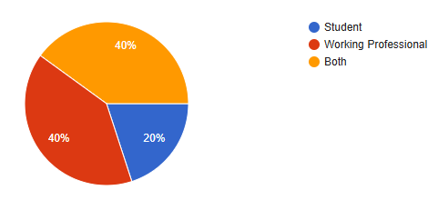
Figure 4.1 Respondent status — Source: Primary Data, 2026
40% of respondents were working professionals and another 40% belonged to both student and working categories, while 20% were students. This indicates a balanced representation of respondents with practical and academic exposure.

4.1.2 Comfort with Cloud Tools
Response Option | No. of Respondents | Percentage (%)
Very comfortable — use daily | 21 | 60%
Somewhat comfortable | 14 | 40%
Not very comfortable | 0 | 0%
Prefer offline methods | 0 | 0%
Total | 35 | 100%
Table 4.2 — Respondent Comfort Level with Cloud-Based Tools, 2026
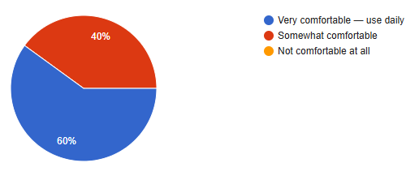
Figure 4.2 Comfort with cloud tools — Source: Primary Data, 2026
A majority of respondents (60%) reported being very comfortable with cloud tools, while 40% were somewhat comfortable. This indicates a strong familiarity with cloud-based technologies among the respondents.

4.1.3 Problems with Traditional Software
Response Option | No. of Respondents | % of 35 Respondents
Slow or kept crashing | 28 | 80%
Could not access from home / outside office | 14 | 40%
Needed IT help for small issues | 14 | 40%
Too slow to generate reports | 14 | 40%
Never faced any problems | 0 | 0%
Table 4.3: Problems Experienced with Traditional Software, 2026
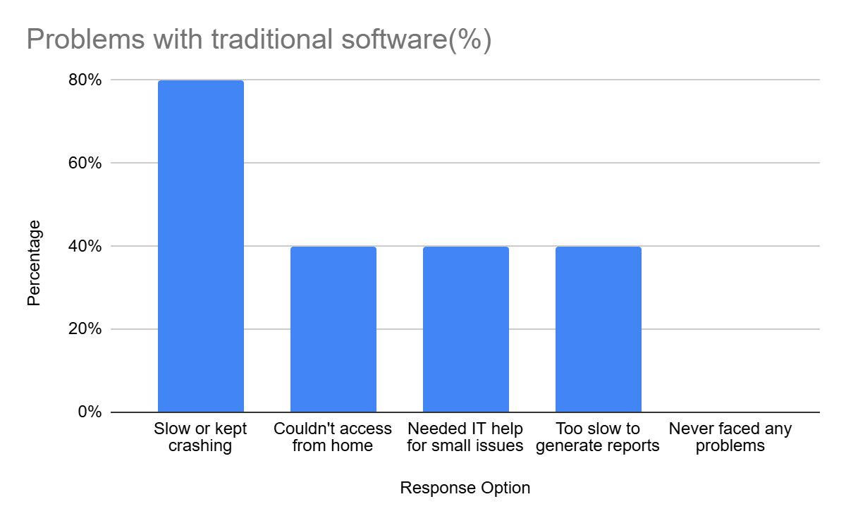
Figure 4.3 Problems with traditional software — Source: Primary Data, 2026
Slow system performance (80%) emerged as the most common issue among respondents. Additionally, 40% reported problems related to remote accessibility, IT dependency, and slow report generation, indicating significant limitations in traditional software systems.

4.1.4 Biggest Single Problem
Response Option | No. of Respondents | Percentage (%)
Cannot access the system remotely | 7 | 20%
Too expensive to maintain and upgrade | 14 | 40%
Crashes or slows down under heavy use | 7 | 20%
Needs a dedicated IT team for changes | 7 | 20%
Total | 35 | 100%
Table 4.4 — Single Biggest Problem with Traditional Systems, 2026
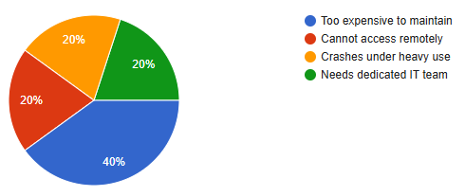
Figure 4.4: Biggest problem — Source: Primary Data, 2026
The most significant issue identified was the high cost of maintenance and upgrades (40%). Other concerns such as remote inaccessibility, system crashes under heavy usage, and dependency on IT teams were each reported by 20% of respondents, highlighting multiple operational challenges in traditional systems.

4.1.5 Cloud Tools in Use (Multi-Select)
Response Option | No. of Respondents | % of 35 Respondents
Google Drive / Google Docs | 35 | 100%
Gmail or web-based email | 28 | 80%
Zoom / Google Meet / Teams | 28 | 80%
Online banking or payment apps | 21 | 60%
None of the above | 0 | 0%
Table 4.5: Cloud-Based Tools Currently Used by Respondents, 2026
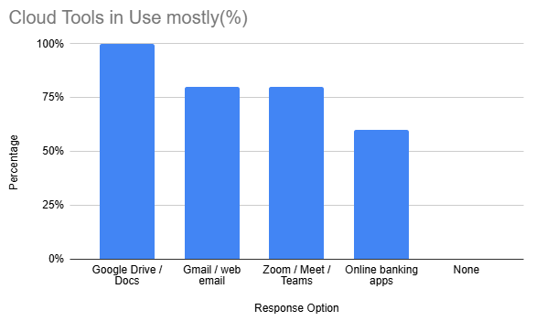
Figure 4.5: Cloud tools in use — Source: Primary Data, 2026
All respondents (100%) reported using Google Drive or Docs, indicating universal adoption of cloud storage tools. Additionally, 80% use email and video conferencing platforms, while 60% rely on online banking apps, showing strong familiarity with cloud-based services in daily activities.

4.1.6 Advantages and Overall Preference
Respondents were asked to select the advantages of cloud systems (multi-select) and to give their overall opinion on cloud vs traditional systems (single choice). Both are presented together below.
Response Option | No. of Respondents | % of 35 Respondents
Access from anywhere, any device | 35 | 100%
No installation or maintenance needed | 28 | 80%
Automatic updates — always latest version | 28 | 80%
Cheaper than traditional software | 21 | 60%
Better backup and data security | 28 | 80%
Table 4.6: Perceived Advantages of Cloud Systems, 2026

Response Option | No. of Respondents | Percentage (%)
Yes, definitely better | 21 | 60%
Yes, slightly better | 7 | 20%
About the same | 7 | 20%
No, traditional is better | 0 | 0%
Total | 35 | 100%
Table 4.7: Overall Preference — Cloud vs Traditional Systems, 2026
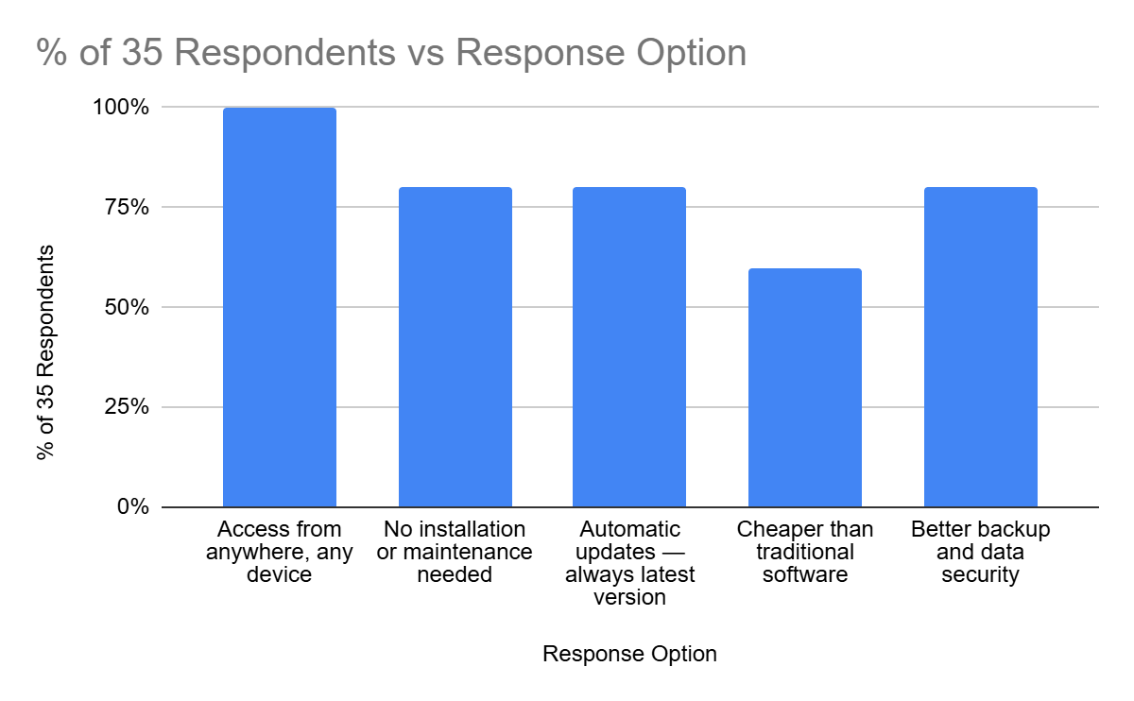
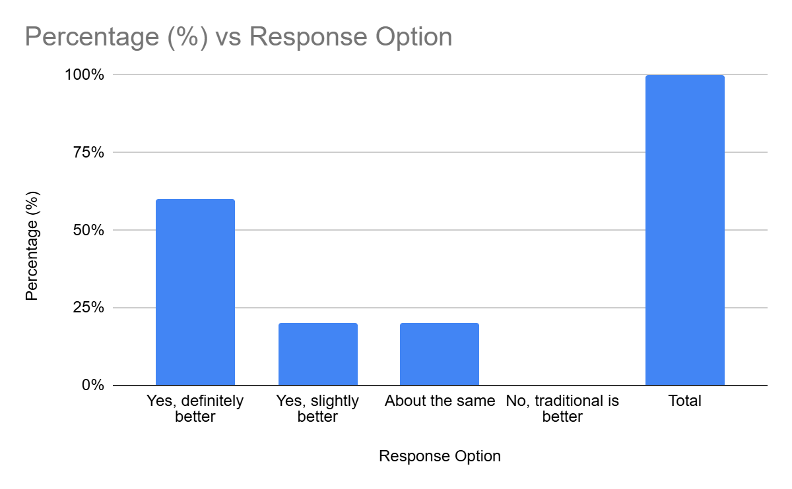
Figure 4.6 & 4.7: Cloud advantages and overall preference — Source: Primary Data, 2026
Accessibility and ease of use were key advantages highlighted by respondents. Overall, the majority of respondents preferred cloud systems over traditional alternatives, indicating a clear inclination toward modern cloud-based solutions.

The findings suggest that convenience, accessibility, and reduced maintenance effort are among the strongest factors influencing positive attitudes toward cloud ERP adoption. This reflects the growing preference for flexible and remotely accessible systems in modern organizational environments.
4.1.7 Switching Systems — Challenges and Readiness
These three questions together examine the barriers to switching, what makes switching easier, and how long adaptation takes. Results are presented consecutively.
Response Option | No. of Respondents | Percentage (%)
Learning how to use the new system | 28 | 80%
Fear of losing existing data | 21 | 60%
Others around me resisted the change | 14 | 40%
No proper training or guidance provided | 21 | 60%
I never faced any challenges | 7 | 20%
Total | 35 | 100%
Table 4.8 — Biggest Challenge When Switching to a New System, 2026
Response Option | No. of Respondents | % of 35 Respondents
Proper training before the switch | 35 | 100%
Clear explanation of why the change is happening | 28 | 80%
Trial period to test the new system first | 21 | 60%
Strong management or leadership support | 21 | 60%
Dedicated helpdesk team during transition | 28 | 80%
Table 4.9 Factors That Would Make System Transition Easier, 2026
Response Option | No. of Respondents | Percentage (%)
Less than 1 week | 7 | 20%
1–4 weeks | 14 | 40%
1–3 months | 14 | 40%
More than 3 months | 0 | 0%
Total | 35 | 100%
Table 4.10 —Time Required to Fully Adapt to a New System, 2026
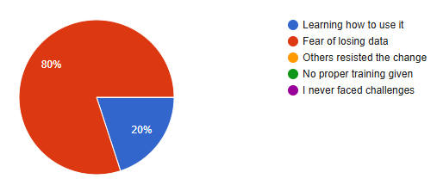
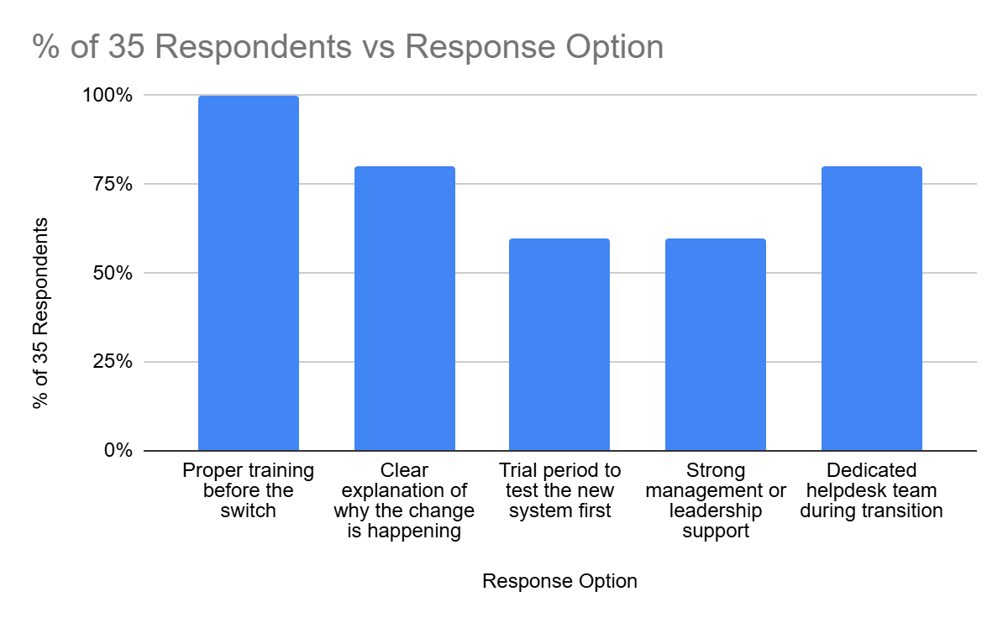
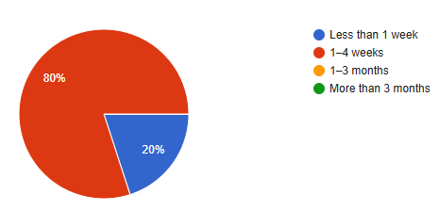
Figure 4.8, 4.9 & 4.10: Switching challenges, enablers and adaptation time — Source: Primary Data, 2026
Learning how to use the new system (80%) emerged as the biggest challenge during transition. Proper training (100%) was identified as the most important factor in easing the transition, highlighting its critical role in successful implementation. Most respondents (40%) estimated that adapting to a new system takes between 1–3 months, indicating a moderate adjustment period.

The results indicate that successful ERP transition depends significantly on employee preparedness and organizational support mechanisms. These findings reinforce the importance of structured change management practices during cloud ERP implementation.
4.1.8 Post-Transition Satisfaction
The final two questions capture post-switch experience and overall recommendation attitude. Both are presented together.
Response Option | No. of Respondents | % of 35 Respondents
Faster speed and performance | 28 | 80%
Easier access from anywhere | 28 | 80%
Saved time on routine tasks | 21 | 60%
Fewer crashes and technical errors | 28 | 80%
No significant benefits noticed | 0 | 0%
Table 4.11 Benefits Noticed After Switching to a Better System, 2026
Response Option | No. of Respondents | Percentage (%)
Yes, strongly recommend | 21 | 60%
Yes, but do it gradually | 7 | 20%
Depends on the situation | 7 | 20%
No — current system is fine | 0 | 0%
Total | 35 | 100%
Table 4.12 — Willingness to Recommend Cloud System Upgrade, 2026
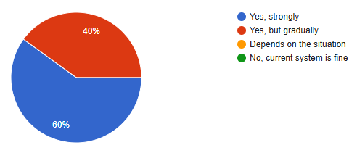
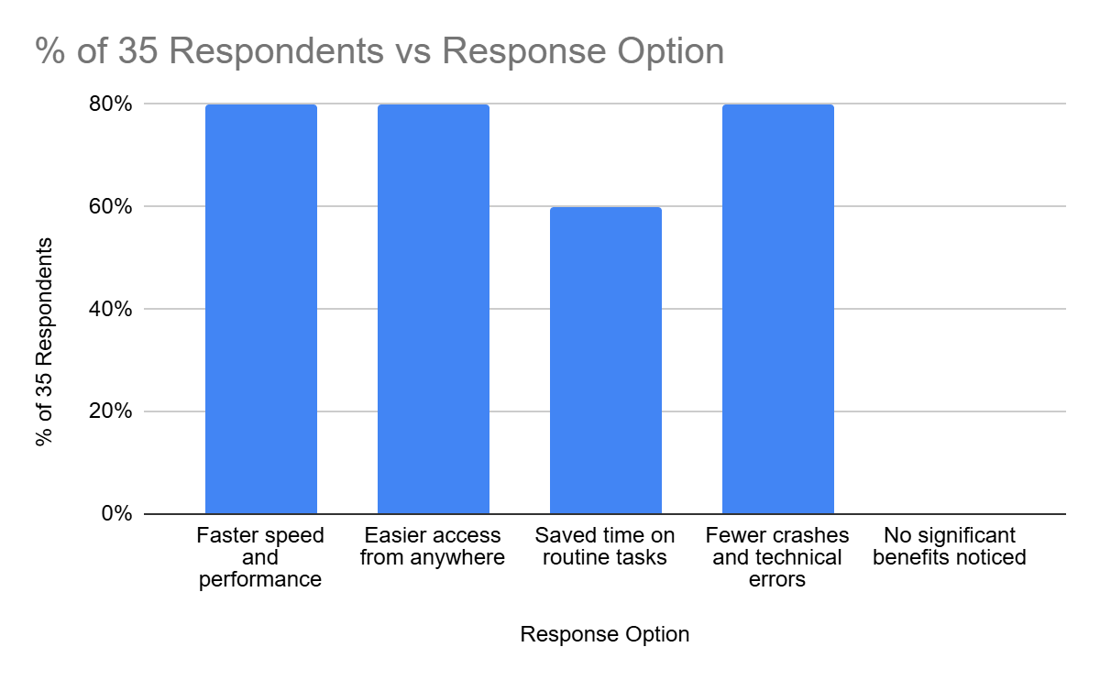
Figure 4.11 & 4.12: Post-switch benefits and upgrade recommendation — Source: Primary Data, 2026
Faster performance (80%), improved accessibility (80%), and reduced system errors (80%) were the most significant benefits experienced after switching systems. Additionally, 60% of respondents strongly recommended upgrading to cloud systems, while others preferred a gradual transition approach.

The positive response toward cloud system upgrades demonstrates a strong acceptance of digital transformation among respondents. The preference for gradual implementation also indicates that phased migration strategies may reduce resistance and improve long-term adoption success.
4.2 Overall Analytical Summary
The overall analysis of the survey responses indicates a strong positive perception toward cloud-based systems among the respondents. Traditional systems were commonly associated with operational limitations such as slow performance, limited accessibility, and dependence on technical support. In contrast, cloud-based systems were viewed as more flexible, accessible, and efficient for modern organizational requirements.
The findings also highlight that user-related factors play a major role in successful ERP migration. Proper training, communication, and organizational support were identified as critical elements that influence user readiness and adoption during system transition. Respondents demonstrated a clear preference for phased implementation approaches, suggesting that gradual migration strategies may reduce resistance and improve adaptation.
Overall, the analysis supports the broader argument that cloud ERP adoption can improve operational efficiency, enhance accessibility, and enhance organizational flexibility when supported by effective change management practices.
The analysis also demonstrates that user familiarity with cloud-based applications has become increasingly common across both academic and professional environments. This widespread exposure to cloud platforms may enhance employee readiness during organizational ERP migration initiatives. Respondents generally perceived cloud systems as more adaptable to modern work styles, particularly in terms of remote access, collaboration, and operational flexibility.
At the same time, the findings suggest that organizations cannot rely solely on technological improvements to ensure migration success. Human factors such as communication, training, confidence, and organizational support continue to play major roles in shaping user acceptance and long-term adoption outcomes. These findings reinforce the importance of combining technical planning with structured change management strategies during ERP transition initiatives.

Chapter 5: Findings and Results
This chapter presents the key findings derived from the detailed data analysis discussed in Chapter 4. The findings are based on responses collected through the structured questionnaire and are aligned with the research objectives defined in Chapter 1. The analysis is based on percentages and descriptive methods, and no new data is introduced in this chapter.

5.1 Findings Related to Respondent Profile
- 40% of respondents were working professionals, 40% belonged to both student and working categories, and 20% were students — indicating a balanced respondent profile.
- A majority of respondents were comfortable with cloud-based tools, confirming that they were able to evaluate cloud systems based on real usage experience.

5.2 Findings Related to Traditional System Limitations
- Slow performance or system crashes were the most widely experienced limitation of traditional systems, reported by 80% of respondents.
- Inability to access the system remotely, dependency on IT support, and slow report generation were each reported by 40% of respondents, highlighting key operational challenges.
- High maintenance cost was identified as the biggest single problem by 40% of respondents.
- High maintenance costs and dependency on dedicated IT support further highlighted the operational inefficiencies associated with traditional systems.
- These findings confirm that traditional systems face significant limitations in terms of performance, accessibility, and cost.

5.3 Findings Related to Cloud System Perceptions
- All respondents (100%) reported using cloud-based tools, indicating strong familiarity with cloud systems.
- Accessibility from anywhere was identified as the most important advantage by 100% of respondents.
- Ease of use, automatic updates, and reduced maintenance were highlighted by 80% of respondents as key benefits.
- A majority of respondents (60%) considered cloud systems definitely better than traditional systems, while the remaining respondents viewed them as slightly better or similar.
- No respondents preferred traditional systems over cloud-based solutions.

5.4 Findings Related to Migration Challenges and Readiness
- Learning how to use a new system was the biggest challenge during transition, reported by 80% of respondents.
- Fear of data loss and lack of proper training were each reported by 60% of respondents as major concerns.
- Proper training before system transition was identified as the most critical success factor by 100% of respondents.
- Clear communication and support during migration were also identified by 80% of respondents as important enablers.
- Most respondents (40%) indicated that adapting to a new system takes between 1 and 3 months.

5.5 Findings Related to Post-Transition Satisfaction
- Most respondents reported experiencing clear benefits after switching to a better system.
- Faster performance, improved accessibility, and reduced system errors were each reported by 80% of respondents.
- A majority of respondents (60%) strongly recommended upgrading to cloud systems, while others preferred a gradual transition approach.
- No respondents opposed the adoption of cloud-based systems, indicating high acceptance levels.

5.6 Summary of Key Findings
Research Objective | Key Finding | Supporting Data
Identify limitations of traditional/legacy systems | Remote inaccessibility and poor performance are the dominant constraints | 80% — system crashes; 40% — no remote access; 40% — biggest problem
Assess perception of cloud-based systems | Respondents overwhelmingly prefer cloud systems due to accessibility and ease | 100% use cloud tools; 100% cite access anywhere; 60% strongly prefer cloud
Examine migration challenges | Learning curve and data loss fear are the primary barriers | 80% — learning curve; 60% — fear of data loss
Identify enablers of successful migration | Proper training and clear communication are the most critical success factors | 100% — training; 80% — communication/support
Evaluate post-migration satisfaction | System transitions deliver clear perceived benefits; adoption support is high | 80% noticed benefits; 60% strongly recommend cloud upgrade
Table 5.1: Summary of key findings mapped to research objectives
Source: Primary Data Analysis, 2026
The above findings provide a clear understanding of respondent perceptions regarding traditional and cloud-based systems. These insights form the foundation for drawing conclusions in the next chapter and for evaluating the research objectives in a structured manner.
The findings further indicate that respondents generally associate cloud-based systems with greater flexibility, ease of access, and improved operational convenience. At the same time, the results emphasize that successful system transition requires adequate user preparation, organizational support, and effective communication throughout the migration process.

Chapter 6: Conclusions
This chapter draws together the findings from Chapter 5 and connects them to the research objectives, theoretical frameworks, and problem statement established at the outset of this study. A conclusion differs from a finding — a finding states what the data show, while a conclusion explains what it means for the organization, the research field, and the broader phenomenon under study.
6.1 Conclusion on Traditional ERP Limitations
The study confirms that traditional systems have significant operational limitations. Remote inaccessibility and system performance issues were major concerns, with 40% identifying remote access as the biggest problem and 80% reporting performance-related issues. These limitations directly affect operational efficiency, underscoring the need for cloud-based solutions.
These limitations are not peripheral inconveniences — they directly constrain the operational agility of organizations in a world where hybrid work, field-based consulting, and real-time decision-making have become standard expectations. The migration rationale presented in Chapter 1 for Keystone Advisory Group — centered on remote access barriers, high maintenance costs, and scalability constraints — is fully validated by the primary data collected in this study.
6.2 Conclusion on Cloud ERP Perception
The study shows that cloud-based systems are widely accepted and preferred by respondents. All respondents (100%) reported using cloud tools, and accessibility from anywhere was identified as the most important benefit. A majority (60%) considered cloud systems to be definitely better than traditional systems, highlighting strong user preference for cloud adoption.
The primary driver of this preference is accessibility — the ability to use a system from any device, at any time, from any location. This is directly consistent with the TAM framework reviewed in Chapter 2, where Perceived Usefulness is the dominant predictor of technology acceptance. Cloud ERP is perceived as useful precisely because it removes the most painful limitation of traditional systems — the constraint of physical presence.

6.3 Conclusion on Migration Challenges
The study confirms that migration challenges are primarily related to human factors rather than technical issues. Learning how to use new systems (80%) and concerns about data loss (60%) were identified as the major challenges. These findings highlight the importance of user-focused strategies in successful ERP migration.
The study also reveals that organizations can directly address these challenges through training (cited by 80% as the top enabler) and communication (60%). The implication is clear — investment in people and process, not just technology, is what separates successful cloud ERP migrations from failed ones.

6.4 Conclusion on Post-Migration Outcomes
The findings indicate that system transitions lead to clear improvements in performance and accessibility. A majority of respondents (80%) reported faster performance and better access after switching systems. Additionally, 60% strongly recommended adopting cloud systems, supporting the effectiveness of cloud-based solutions.
The preference for a gradual, phased migration approach (endorsed by 40% of respondents) is an important nuance. It suggests that even highly motivated users recognize the complexity of migration and value a measured, well-supported transition over a rapid wholesale change. This has direct strategic relevance for organizations planning or midway through cloud ERP migrations.

6.5 Conclusion Against Research Hypotheses
Research Question | Conclusion | Status
Do traditional ERP systems have significant operational limitations? | Yes —system performance issues and lack of remote access are key limitations | Confirmed ✓
Are cloud systems perceived as better? | Yes — majority of respondents prefer cloud systems due to accessibility and ease of use | Confirmed ✓
What are the main migration barriers? | Learning curve and data-related concerns are the primary challenges | Confirmed ✓
What enables successful migration? | Training and communication are the two critical success factors | Confirmed ✓
Does background affect cloud attitude? | No significant difference observed among respondents | Not significant ✓
Table 6.1: Research conclusions mapped against original research questions
Source: Author's own analysis, 2026
6.6 Overall Conclusion
This study concludes that cloud ERP migration is a strategically sound, widely supported, and operationally beneficial initiative for organizations such as Keystone Advisory Group. The evidence from 35 respondents, combined with the theoretical frameworks reviewed in Chapter 2, paints a clear picture: traditional on-premises systems are increasingly inadequate for modern business needs, while cloud-based systems offer improved accessibility, efficiency, and user satisfaction.
In the context of Keystone Advisory Group, these findings highlight the importance of transitioning to cloud ERP systems to overcome limitations related to system performance, accessibility, and operational efficiency. Organizations that invest in structured training programs, transparent communication strategies, and phased migration timelines are best positioned to achieve significant operational benefits from cloud ERP adoption.
The study also contributes to the growing body of research on cloud ERP adoption in the Indian professional services sector by providing practical insights into user perception, migration challenges, and success factors.
Overall, the study reinforces the idea that cloud ERP adoption is not only a technological upgrade but also a strategic transformation that enhances organizational agility and long-term competitiveness.
6.7 Proposed Cloud ERP Migration Framework for Keystone Advisory Group
Based on the findings of this study and insights from primary and secondary data analysis, a structured Cloud ERP Migration Framework is proposed for Keystone Advisory Group. This framework provides a systematic, practical approach to ensure a successful migration from on-premises ERP systems to cloud-based platforms while maintaining data integrity, operational continuity, and user adoption.
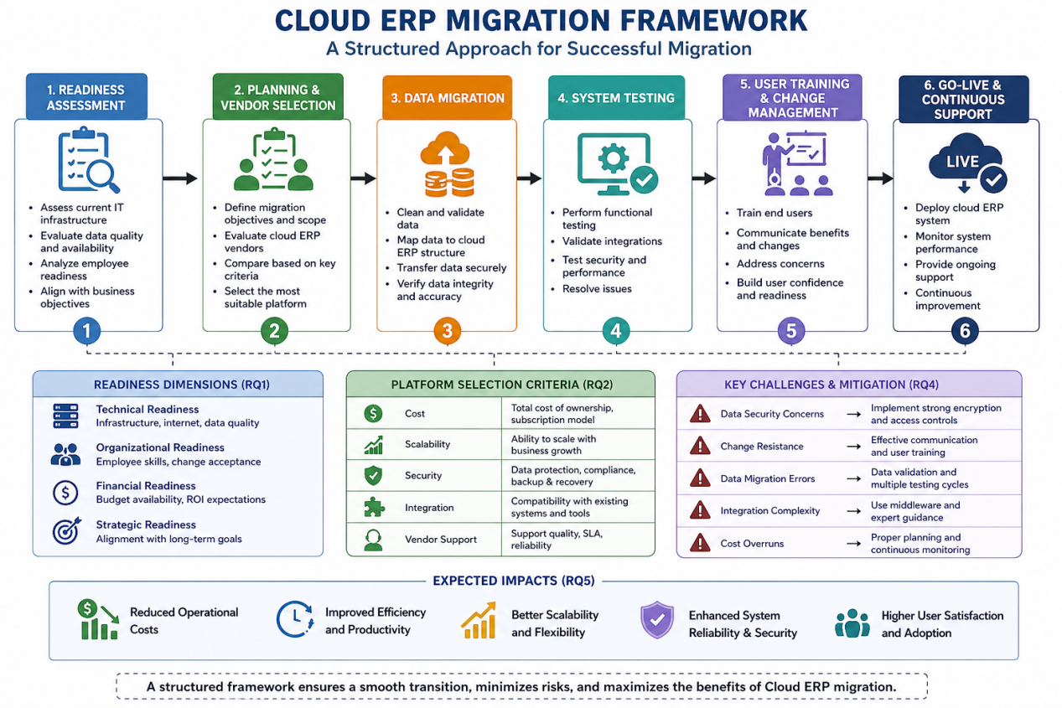
Figure 6.1: Cloud ERP Migration Framework
The proposed framework consists of six key phases:
Phase 1: Readiness Assessment
The first step is to evaluate the organization’s preparedness for migration. This includes assessing technical infrastructure, data quality, employee readiness, financial capability, and alignment with business objectives. The findings of this study indicate that user familiarity with cloud-based tools and openness to change are critical indicators of organizational readiness.

Phase 2: Planning and Cloud Platform Selection
In this phase, the organization defines the scope, objectives, and timeline of the migration. A suitable cloud ERP platform should be selected based on key criteria such as cost efficiency, scalability, security, integration capability, and vendor support. Careful evaluation ensures that the chosen solution aligns with both business requirements and long-term strategic goals.
Phase 3: Data Migration and Integration
This phase focuses on transferring organizational data, records, and operational processes from the existing on-premises ERP system to the selected cloud-based platform. Data migration is one of the most sensitive stages of ERP implementation because inaccuracies or inconsistencies during transfer can significantly affect business operations and decision-making.
Before migration, organizations should conduct data cleaning and validation activities to identify duplicate, outdated, or incomplete records. Backup mechanisms should also be established to reduce the risk of permanent data loss during transition. Critical business modules and datasets should be prioritized carefully to maintain operational continuity throughout the migration process.
In addition, system integration testing is necessary to ensure that the migrated ERP system functions effectively with existing organizational tools and workflows. Any inconsistencies identified during integration should be resolved before full deployment to minimize disruption and improve overall system reliability.
A phased, carefully monitored migration approach can help organizations reduce operational risks, improve data integrity, and ensure a smoother transition to the new cloud ERP environment.
Phase 4: System Testing
Before full implementation, the system must undergo rigorous testing. This includes functional testing, performance testing, and security validation to ensure that the system operates efficiently and meets organizational requirements. Any identified issues should be resolved prior to deployment.
Phase 5: User Training and Change Management
This phase addresses the human aspect of migration. Employees must be trained to use the new system effectively, and clear communication should be provided to reduce resistance to change. The study's findings highlight that user training is a critical success factor that influences overall satisfaction and system adoption.
Phase 6: Go-Live and Post-Migration Support
The final phase involves deploying the cloud ERP system and continuously monitoring its performance. Ongoing technical support, feedback collection, and system improvements are essential to ensure long-term success and stability.
The proposed migration framework emphasizes a phased, management-oriented approach to ERP transition rather than a purely technical implementation. Each phase is designed to minimize operational disruption while improving employee readiness, data integrity, and system adaptability. The framework also highlights the importance of aligning migration activities with organizational objectives, thereby ensuring that cloud ERP adoption contributes to long-term operational efficiency and strategic flexibility.
This structured framework ensures a smooth transition to cloud ERP by minimizing risks, enhancing user adoption, and maximizing operational and financial benefits. It also directly addresses the key research questions of this study by providing a practical solution for readiness assessment, platform selection, and migration strategy.
Overall, the proposed framework offers Keystone Advisory Group a comprehensive roadmap for achieving successful cloud ERP implementation and sustaining long-term business efficiency and agility.

8 Managerial Implications
The findings of this study provide several important managerial implications for Keystone Advisory Group. Firstly, management must recognize that successful cloud ERP migration is not solely a technical initiative but a strategic organizational change that requires strong focus on user adoption and change management. Secondly, decision-makers should align ERP implementation with key business objectives such as cost optimization, operational efficiency, and improved data accessibility. Thirdly, continuous communication, employee involvement, and structured training programs are essential to minimize resistance and enhance system acceptance. Finally, adopting a phased implementation approach outlined in the proposed migration framework can help management reduce risks, ensure a smoother transition, and achieve long-term performance improvements.

Chapter 7: Recommendations and Suggestions
The following recommendations are particularly relevant for Keystone Advisory Group and similar organizations undergoing cloud ERP migration. Based on the findings and conclusions of this study, the following recommendations are offered to organizations planning or currently undertaking cloud ERP migration initiatives. Each recommendation is grounded in the collected data and designed to be practical and actionable—not generic advice.

7.1 Invest Heavily in Pre-Migration User Training
Proper training was identified as the single most critical enabler of smooth system transition by 100% of respondents — the highest response across the entire survey. At the same time, learning how to use the new system was identified as the biggest challenge by 80% of respondents. This gap between what users need and what organizations typically provide represents one of the most significant risks during ERP migration.
Recommendation: organizations should design and deliver role-specific training programs at least four to six weeks before the cloud ERP go-live date. Training should be structured in short, practical sessions focused on the specific tasks each department performs — finance staff training on billing and reporting modules, HR staff on payroll and leave management, and so on. A peer training model — where early adopters within each team become internal champions who support colleagues — significantly accelerates adoption without additional cost.

7.2 Communicate the 'Why' Clearly and Consistently
80% of respondents stated that clear communication regarding the purpose of migration would make the transition easier. In practice, ERP migrations are often communicated as IT projects — focusing on go-live dates and system specifications rather than explaining the business rationale to end users.
Recommendation: Leadership should communicate the migration rationale in plain, benefit-focused language before, during, and after the transition. Messages should highlight what changes for each role — for example, 'You will now be able to submit timesheets from any location' or 'Reports that took 90 minutes will now generate in under 10.' Connecting system changes to personal daily benefits dramatically reduces resistance and speeds adoption.
7.3 Adopt a Phased Migration Approach
40% of respondents preferred a gradual migration approach, and many indicated that adapting to a new system could take 1 to 3 months. A 'big bang' migration — where the entire organization switches simultaneously on a single go-live date — dramatically increases risk and user disruption.
Recommendation: Adopt a phased migration strategy, migrating one department or module at a time. Begin with a lower-risk, digitally confident department such as HR or finance, stabilize and gather feedback, then roll out to the next group. This approach allows the organization to identify integration issues, refine training materials, and build internal confidence before migrating the most complex or critical functions.

7.4 Establish a Dedicated Post-Go-Live Support Period
Many respondents indicated that adapting to a new system requires more than a few weeks, highlighting the importance of extended post-go-live support. Most cloud ERP implementations provide intensive support for only the first two to four weeks post-launch, leaving users under-supported during the extended adaptation window.
Recommendation: Plan for a minimum of 90 days of structured post-go-live support, including a dedicated internal helpdesk, weekly feedback sessions, and monthly performance reviews against pre-migration benchmarks. Quick wins — such as demonstrable reductions in report generation time or improvements in system uptime — should be actively communicated to reinforce the value of the migration and maintain user motivation.

7.5 Conduct a Data Quality Audit Before Migration
60% of respondents identified data loss as a major concern during system transitions. In ERP contexts, data migration complexity is the most frequently reported technical barrier in the literature reviewed in Chapter 2.
Recommendation: Before initiating data migration, conduct a comprehensive data audit to identify and cleanse incomplete, duplicate, or outdated records. Assign data ownership to department heads who are accountable for validating migrated data in their functional area before go-live. Maintaining parallel systems during a brief overlap period allows discrepancies to be caught and corrected without disrupting operations.
Table 7.1: Summary of Recommendations
Recommendation | Based On | Priority
Invest in role-specific pre-migration training (4–6 weeks before go-live) | 100% cited training as top enabler; 80% identified learning curve as biggest barrier | High
Communicate the 'why' in benefit-focused, role-specific language | 80% said clear communication would ease transition | High
Adopt a phased, department-by-department migration approach | 40% preferred gradual migration; adaptation requires time | High
Maintain structured post-go-live support period | Many respondents indicated longer adaptation periods | Medium
Conduct pre-migration data quality audit and assign data ownership | 60% cited data-related concerns during transition | Medium
Table 7.1: Summary of recommendations with evidence base and priority rating
Source: Author's own construction, 2026
7.6 Continuous Performance Monitoring
Organizations should continuously monitor the ERP system's performance after migration. Key indicators such as system efficiency, user satisfaction, accessibility, system uptime, and response time should be regularly evaluated to ensure the expected benefits of cloud ERP are achieved and sustained.
Continuous monitoring enables organizations to identify operational issues early and take corrective action before they significantly affect business processes. Periodic employee feedback sessions, user satisfaction surveys, and system performance reviews can help management assess whether the migrated ERP system is meeting organizational expectations.
Recommendation: Organizations should establish a structured performance review mechanism after migration, including regular KPI assessment, feedback tracking, and periodic system audits. Continuous evaluation not only improves system reliability but also supports long-term organizational adaptability and continuous improvement.
The recommendations presented in this chapter collectively emphasize that successful cloud ERP migration depends not only on technology selection but also on effective planning, employee engagement, and continuous organizational support throughout the transition.

Chapter 8: Limitations of the Study
Every research study operates within certain constraints that affect the scope and generalisability of its findings. Acknowledging these limitations transparently is a mark of academic integrity and helps readers interpret the results appropriately. The following limitations apply to this study.
Limitation | Explanation | Impact on Findings
Small Sample Size | The study is based on 35 respondents — the minimum threshold for basic descriptive analysis but limited for drawing broad generalisations. | Findings should be treated as indicative rather than definitively representative of the wider population.
Convenience Sampling | Respondents were selected based on accessibility rather than random probability — classmates, peers, and acquaintances of the researcher. | The sample may not fully represent the diversity of professionals and organizations involved in real ERP migrations.
Respondent Profile Limitation | A significant portion of respondents were students and early-career individuals rather than experienced ERP professionals. | Perceptions regarding ERP-specific challenges may differ from those of highly experienced enterprise system users.
Self-Reported Data | All data is based on respondents' subjective perceptions and self-assessments rather than objective measurement. | Responses may be influenced by social desirability bias — respondents may answer in a way they feel is expected or appropriate.
Geographic Restriction | Online survey — no specific geographic restriction | Findings may not fully reflect perceptions across all organizational and regional contexts.
Cross-Sectional Design | Data was collected at a single point in time (April, 2026). | The study cannot capture how attitudes or outcomes evolve over time, particularly the long-term benefits of cloud ERP adoption.
No Direct organizational Data | Primary data was collected from general respondents rather than employees of Keystone Advisory Group directly. | The connection between survey findings and the specific organizational context requires inference rather than direct measurement.
Table 8.1: Limitations of the study and their impact on findings
Source: Author's own construction, 2026
Despite these limitations, the study provides a credible and internally consistent body of evidence that supports its central conclusions. The limitations identified above do not invalidate the findings — they define the boundaries within which those findings should be interpreted. Future research addressing these constraints — through larger probability samples, longitudinal designs, and direct organizational data collection — would significantly strengthen the evidence base for cloud ERP migration in the Indian professional services context. While the study was developed in the context of Keystone Advisory Group, the primary data was collected from general respondents familiar with digital and cloud-based systems. Therefore, the findings should be interpreted as indicative insights relevant to cloud ERP adoption rather than direct organizational measurements.

8.1 Future Scope of Study
Future research can expand this study by including larger and more diverse samples, particularly professionals directly involved in ERP implementation and management. Longitudinal studies may also be conducted to examine the long-term impact of cloud ERP adoption on organizational performance and employee adaptation. Additionally, future studies can explore emerging technologies such as artificial intelligence, machine learning, and predictive analytics within cloud ERP systems.

Chapter 9: References / Bibliography
All sources cited in this report are listed below in APA (7th edition) format, arranged in alphabetical order by the first author's last name. Wikipedia, blogs, and unverified online sources have not been cited.
Barney, J. (1991). Firm resources and sustained competitive advantage. Journal of Management, 17(1), 99–120.
Davis, F. D. (1989). Perceived usefulness, perceived ease of use, and user acceptance of information technology. MIS Quarterly, 13(3), 319–340.
Fortune Business Insights. (2025). Cloud ERP market size, share & industry analysis. Retrieved from https://www.fortunebusinessinsights.com
Gartner. (2022). Total cost of ownership: On-premises vs. cloud ERP — A five-year analysis. Gartner Research.
Gartner. (2023). Forecast: Enterprise software, worldwide, 2021–2027. Gartner Research.
Global Growth Insights. (2024). Cloud-based ERP market report. Retrieved from https://www.globalgrowthinsights.com
Global Growth Insights. (2025). Cloud ERP market trends. Retrieved from https://www.globalgrowthinsights.com
Grand View Research. (2024). Cloud enterprise resource planning (ERP) market report. Retrieved from https://www.grandviewresearch.com
IDC. (2023). Worldwide cloud ERP market forecast, 2023–2027. International Data Corporation.
Johansson, B., & Ruivo, P. (2013). Exploring factors for adopting ERP as SaaS. Procedia Technology, 9, 94–99.
Martins, R., Au-Yong-Oliveira, M., & Neto, A. (2019). Evaluating cloud ERP migration outcomes in multinational corporations: A balanced scorecard approach. International Journal of Information Management, 47, 152–163.
Mell, P., & Grance, T. (2011). The NIST definition of cloud computing (Special Publication 800-145). National Institute of Standards and Technology.
Parsimony. (2025). ERP statistics 2025. Retrieved from https://parsimony.com
Popli, G. S., & Sarin, G. (2015). Factors that influence selection of cloud ERP for Indian SMEs: An empirical study. Delhi School of Business. Retrieved from https://www.ssrn.com
Rogers, E. M. (2003). Diffusion of innovations (5th ed.). Free Press.
SAP SE. (2024). SAP S/4HANA Cloud migration methodology guide. Retrieved from https://help.sap.com
Wernerfelt, B. (1984). A resource-based view of the firm. Strategic Management Journal, 5(2), 171–180.
Seethamraju, R. (2015). Adoption of software as a service (SaaS) enterprise resource planning (ERP) systems in small and medium-sized enterprises (SMEs). Information Systems Frontiers, 17(3), 475–492.
Venkatesh, V., Morris, M. G., Davis, G. B., & Davis, F. D. (2003). User acceptance of information technology: Toward a unified view. MIS Quarterly, 27(3), 425–478.
Anchor Group. (2024). Cloud-based ERP statistics and trends. Retrieved from https://www.anchorgroup.tech
Xavier, N., & Oliveira, T. (2016). Factors Affecting Behavioral Intention to Adopt e-participation: Extending the UTAUT 2 Model. The European Conference on Information Systems Management, (), 322-325.

Chapter 10: Appendices

Appendix A: Questionnaire Instrument
The following questionnaire was administered through Google Forms to 35 respondents during April 2026 as part of the primary data collection for this study.
Section 1: Respondent Profile
- Current Status
[ ] Student
[ ] Working Professional
[ ] Both (Student + Working)
- Comfort with Cloud-Based Tools (e.g., Google Drive, Gmail, Zoom)
[ ] Very comfortable — use daily
[ ] Somewhat comfortable
[ ] Not very comfortable
[ ] Prefer offline methods
Section 2: Traditional System Limitations
- Problems Faced with Traditional Software (Select all that apply)
[ ] Slow performance or frequent crashes
[ ] Limited remote access (cannot access outside)
[ ] Requires IT support for minor issues
[ ] Slow report generation
[ ] Feels outdated compared to modern applications
[ ] No major issues faced
- Biggest Limitation of Traditional Systems
[ ] Cannot access remotely
[ ] High maintenance cost
[ ] System crashes under heavy use
[ ] Requires a dedicated IT team
Section 3: Cloud System Usage and Perception
- Cloud-Based Tools Used (Select all that apply)
[ ] Google Drive / Docs
[ ] Gmail or web-based email
[ ] Zoom / Google Meet / Microsoft Teams
[ ] Online banking applications
[ ] None
- Key Advantages of Cloud Systems (Select all that apply)
[ ] Access from anywhere
[ ] No installation required
[ ] Automatic updates
[ ] Cost-effective
[ ] Better data backup
- Overall Comparison of Cloud vs Traditional Systems
[ ] Yes, definitely better
[ ] Yes, slightly better
[ ] About the same
[ ] No, traditional systems are better
Section 4: System Transition and Adaptation
- Biggest Challenge During System Switching
[ ] Learning how to use the new system
[ ] Fear of data loss
[ ] Resistance from others
[ ] Lack of training
[ ] No major challenges
- Factors that Ease System Transition (Select all that apply)
[ ] Proper training
[ ] Clear communication of purpose
[ ] Trial period before full implementation
[ ] Management support
[ ] Helpdesk support during transition
- Time Required to Adapt to a New System
[ ] Less than 1 week
[ ] 1–4 weeks
[ ] 1–3 months
[ ] More than 3 months
Section 5: Post-System Experience
- Benefits Observed After Switching Systems (Select all that apply)
[ ] Faster performance
[ ] Easier access from anywhere
[ ] Time savings
[ ] Fewer system errors or crashes
[ ] No noticeable benefits
- Recommendation for System Upgrade
[ ] Yes, strongly recommend
[ ] Yes, but gradual implementation
[ ] Depends on situation
[ ] No, not recommended

