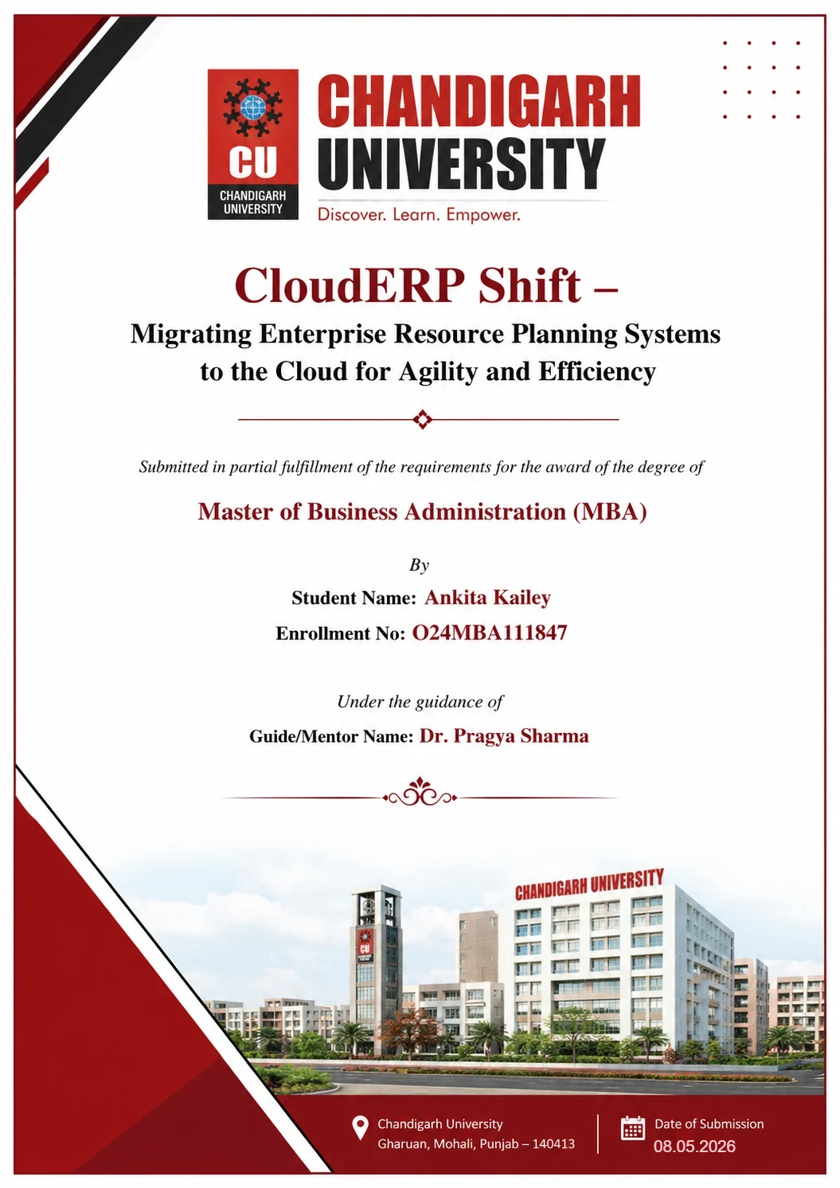


CloudERP Shift – Migrating Enterprise Resource Planning Systems to the Cloud for Agility and Efficiency

Submitted in partial fulfillment of the requirements for the award of the degree of
Master of Business Administration (MBA)
By
Student Name: Ankita Kailey
Enrollment No: O24MBA111847
Under the guidance of
Guide/Mentor Name: Dr. Pragya Sharma

Certificates
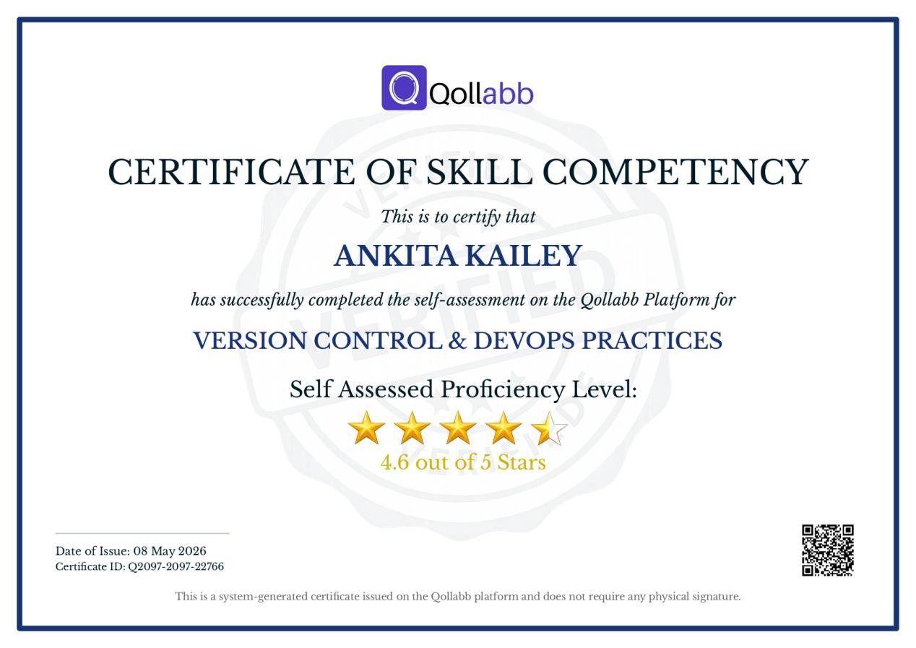
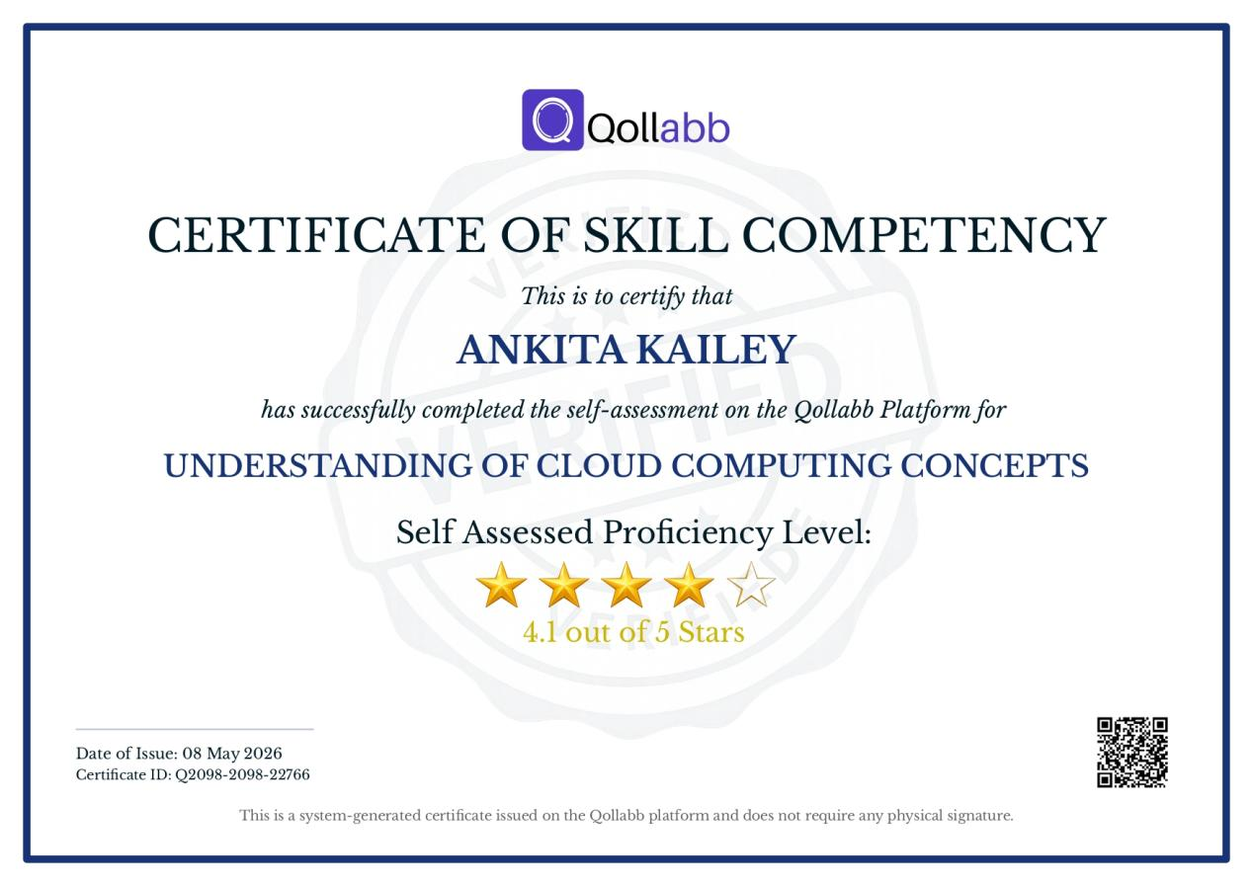

Declaration
I, Ankita Kailey, hereby solemnly declare that the project report titled "CloudERP Shift – Migrating Enterprise Resource Planning Systems to the Cloud for Agility and Efficiency" submitted in partial fulfilment of the requirements for the award of the degree of Master of Business Administration (MBA) is my original work.
I further declare that:
- This project has been carried out by me during the academic year 2024-2026 under the supervision of Dr Pragya Sharma.
- The work has not been submitted previously to any other university, institution, or examination body for the award of any degree, diploma, or certification.
- All sources of information used in this report have been duly acknowledged and referenced in accordance with academic ethics and plagiarism norms.
- The data presented in this report is authentic to the best of my knowledge and has not been fabricated or manipulated.
- I understand that if any part of this declaration is found to be false, my project may be rejected and disciplinary action may be taken as per institutional rules.


Place: Chandigarh
Date: 31.03.2026
Student Signature:
Student Name: Ankita Kailey
Enrollment No: O24MBA111847

Acknowledgement
It is my privilege to express my sincere gratitude and appreciation to all those who provided me the opportunity and support to successfully complete this project.
I convey my deepest regards to my mentor, Dr. Pragya Sharma, for her invaluable guidance, constant encouragement, and constructive suggestions throughout the course of this project. Her insightful approach and continuous support have greatly contributed to shaping my understanding in a more practical and structured manner.
I take this opportunity to express my appreciation to the Dean of my institution for fostering an environment that supported academic growth and the successful completion of this project. I also place on record my appreciation for the faculty members for their academic assistance and the resources made available. Further, I extend my gratitude to Keystone Advisory Group, Bangalore, for providing the organizational context and industry exposure that enriched this study.
Last but not the least, I express my heartfelt regards to my family and friends for their unwavering encouragement, motivation, and support throughout this journey. Their belief in me has been a constant source of strength and inspiration.

Executive Summary

This report examines the migration of Enterprise Resource Planning (ERP) systems from traditional on-site infrastructure to cloud-based platforms, with the aim of enhancing organisational flexibility and operational efficiency. The research is situated within Keystone Advisory Group, a Bangalore-based consulting firm specialising in technology and business solutions. The primary objectives are to analyse the motivations behind the shift to cloud ERP, evaluate its benefits and challenges, and assess the role of Artificial Intelligence in improving business performance. The methodology incorporates both primary and secondary data sources. Primary data was obtained through a structured questionnaire, while secondary data was sourced from academic and industry literature. The findings indicate that cloud ERP systems enable organisations to reduce costs, scale operations, access real-time information, and improve decision-making. Furthermore, the integration of Artificial Intelligence facilitates automation and predictive analysis, thereby increasing system efficiency and intelligence. The study concludes that migrating to cloud ERP represents a strategic decision that enhances organisational adaptability, efficiency, and competitiveness over the long term.

Table of Contents
Chapter / Section | Page No.
Certificate | i
Declaration | ii
Acknowledgement | iii
Executive Summary | iv
Table of Contents | v
List of Tables | viii
List of Figures | x
List of Abbreviations | xi
Chapter 1: Introduction | 1
1.1 Background of the Study | 2
1.2 Industry Profile | 3
1.3 About the Organization: Keystone Advisory Group, Bangalore | 5
1.4 Business Problem Overview | 6
1.4.1 Problem Identification | 7
1.4.2 Problem Statement | 7
1.5 Need of Study | 8
1.6 Objectives of Study | 8
1.7 Research Questions | 9
1.8 Scope of Study | 10
Chapter 2: Literature Review | 12
2.1 Introduction — Why This Topic is Worth Reviewing | 12
2.2 Existing Decision Models for ERP Adoption | 13
2.2.1 Technology Acceptance Model (TAM) — Davis, 1989 | 13
2.2.2 Unified Theory of Acceptance and Use of Technology (UTAUT) | 13
2.2.3 Theory of Diffusion of Innovation (DOI) | 14
2.2.4 Total Cost of Ownership (TCO) Model | 14
2.3 Review of Related Research Studies | 15
2.4 On-Premises ERP Systems | 17
2.4.1 On-Premises ERP Architecture | 17
2.4.2 Key Limitations of On-Premises ERP | 18
2.5 Cloud Computing — Basics and Service Models | 19
2.5.1 Infrastructure as a Service (IaaS) | 20
2.5.2 Platform as a Service (PaaS) | 20
2.5.3 Software as a Service (SaaS) | 20
2.5.4 SaaS ERP — The Dominant Migration Target | 20
2.5.5 Benefits of Cloud ERP | 21
2.6 Evolution of ERP Systems Over the Years | 23
2.7 On-Premises vs Cloud ERP — Architecture Comparison | 24
2.7.1 Direct Architecture Comparison Table | 25
2.7.2 SWOT Analysis — Cloud ERP Migration | 26
2.8 Linking Literature to the Current Study | 27
2.9 Research Gaps Identified from Literature | 28
Chapter 3: Research Methodology | 31
3.1 Introduction to the Chapter | 31
3.2 Research Design | 31
3.3 Nature and Sources of Data | 32
3.3.1 Primary Data | 33
3.3.2 Secondary Data | 33
3.4 Sampling Design | 33
3.4.1 Target Population | 33
3.4.2 Sampling Technique — Convenience Sampling | 34
3.4.3 Sample Size Justification | 35
3.4.4 Questionnaire Structure | 35
3.5 Data Analysis Workflow | 36
3.6 Reliability and Validity | 36
3.7 Scope and Limitations of the Methodology | 36
3.8 Ethical Considerations | 37
Chapter 4: Data Analysis and Interpretation | 38
4.1 Evaluation Based on Primary Survey Data | 38
4.1.1 Current Status | 38
4.1.2 Comfort with Cloud Tools | 39
4.1.3 Problems with Traditional Software | 39
4.1.4 Biggest Single Problem | 40
4.1.5 Cloud Tools in Use | 41
4.1.6 Advantages and Overall Preference | 42
4.1.7 Switching Systems — Challenges and Readiness | 44
4.1.8 Post-Transition Satisfaction | 46
4.2 Overall Analytical Summary | 48
Chapter 5: Findings and Results | 50
5.1 Findings Related to Respondent Profile | 50
5.2 Findings Related to Traditional System Limitations | 50
5.3 Findings Related to Cloud System Perceptions | 50
5.4 Findings Related to Migration Challenges and Readiness | 51
5.5 Findings Related to Post-Transition Satisfaction | 51
5.6 Summary of Key Findings | 52
Chapter 6: Conclusions | 53
6.1 Conclusion on Traditional ERP Limitations | 53
6.2 Conclusion on Cloud ERP Perception | 53
6.3 Conclusion on Migration Challenges | 54
6.4 Conclusion on Post-Migration Outcomes | 54
6.5 Conclusion Against Research Hypotheses | 54
6.6 Overall Conclusion | 55
6.7 Proposed Cloud ERP Migration Framework for Keystone  Advisory Group | 56
6.8 Managerial Implications | 58
Chapter 7: Recommendations / Suggestions | 60
7.1 Invest Heavily in Pre-Migration User Training | 60
7.2 Communicate the 'Why' Clearly and Consistently | 60
7.3 Adopt a Phased Migration Approach | 61
7.4 Establish a Dedicated Post-Go-Live Support Period | 61
7.5 Conduct a Data Quality Audit Before Migration | 61
7.6 Continuous Performance Monitoring | 62
Chapter 8: Limitations | 65
8.1 Continuous Performance Monitoring | 65
Chapter 9: References / Bibliography | 66
Chapter 10: Appendices | 68

List of Table

Table No. | Title of the Table | Page No.
Table 2.1 | Summary of theoretical frameworks applied to ERP adoption decisions | 15
Table 2.2 | Operational limitations of on-premises ERP systems | 19
Table 2.3 | Key benefits of cloud ERP — evidence from literature | 22
Table 2.4 | Feature evolution of ERP systems across five generational eras | 24
Table 2.5 | Architectural comparison between on-premises and cloud ERP systems | 26
Table 2.6 | Research gaps identified from literature review | 28
Table 3.1 | Research design types and justification for descriptive approach | 32
Table 3.2 | Summary of sampling design parameters | 34
Table 3.3 | Structure of the research questionnaire mapped to study objectives | 35
Table 3.4 | Summary of reliability and validity measures | 36
Table 3.5 | Scope and limitations of the research methodology | 36
Table 4.1 | Distribution of Respondents by Current Status | 38
Table 4.2 | Respondent Comfort Level with Cloud-Based Tools | 39
Table 4.3 | Problems Experienced with Traditional Software | 39
Table 4.4 | Single Biggest Problem with Traditional Systems | 40
Table 4.5 | Cloud-Based Tools Currently Used by Respondents | 40
Table 4.6 | Perceived Advantages of Cloud Systems | 42
Table 4.7 | Overall Preference — Cloud vs Traditional Systems | 43
Table 4.8 | Biggest Challenge When Switching to a New System | 44
Table 4.9 | Factors That Would Make System Transition Easier | 44
Table 4.10 | Time Required to Fully Adapt to a New System | 45
Table 4.11 | Benefits Noticed After Switching to a Better System | 46
Table 4.12 | Willingness to Recommend Cloud System Upgrade | 47
Table 5.1 | Summary of key findings mapped to research objectives | 52
Table 6.1 | Research conclusions mapped against research questions | 55
Table 7.1 | Summary of recommendations with evidence base and priority rating | 62
Table 8.1 | Limitations of the study and their impact on findings | 64

List of Figures
Figure No. | Title of the Figure | Page No.
Figure 1.1 | ERP System Architecture | 1
Figure 1.2 | Cloud Infrastructure Market Share (Gartner, 2023) | 3
Figure 1.3 | Market Size Forecast | 4
Figure 1.4 | Key Trends & Adoption Indicators (2026 and Beyond) | 5
Figure 2.1 | TAM adapted for Cloud ERP Adoption | 13
Figure 2.2 | Layered architecture of a traditional on-premises ERP system | 18
Figure 2.3 | Responsibility layers across IaaS, PaaS, and SaaS cloud service models | 21
Figure 2.4 | Reference architecture of cloud ERP (SaaS model) | 25
Figure 2.5 | SWOT analysis of cloud ERP migration | 26
Figure 3.1 | Sequential data analysis workflow from raw data to findings | 36
Figure 4.1 | Respondent status | 38
Figure 4.2 | Comfort with cloud tools | 39
Figure 4.3 | Problems with traditional software | 40
Figure 4.4 | Biggest problem with traditional software | 41
Figure 4.5 | Cloud tools in use mostly | 42
Figure 4.6 | Perceived cloud advantages | 43
Figure 4.7 | Overall preference — Cloud vs Traditional Systems | 43
Figure 4.8 | Biggest challenge when switching to a new system | 45
Figure 4.9 | Factors that would make system transition easier | 45
Figure 4.10 | Time required to fully adapt to a new system | 46
Figure 4.11 | Benefits noticed after switching to a better system | 47
Figure 4.12 | Willingness to recommend cloud system upgrade | 47
Figure 6.1 | Proposed Cloud ERP Migration Framework for Keystone Advisory Group | 56

List of Abbreviations
Abbreviation | Full Form
ABAP | Advanced Business Application Programming
AI | Artificial Intelligence
API | Application Programming Interface
AWS | Amazon Web Services
BBA | Bachelor of Business Administration
BFSI | Banking, Financial Services, and Insurance
BI | Business Intelligence
CRM | Customer Relationship Management
CU | Chandigarh University
DOI | Diffusion of Innovations
ECC | ERP Central Component
ERP | Enterprise Resource Planning
GCP | Google Cloud Platform
HCM | Human Capital Management
HR | Human Resources
IaaS | Infrastructure as a Service
IoT | Internet of Things
IT | Information Technology
KPI | Key Performance Indicator
MBA | Master of Business Administration
MRP | Material Requirements Planning
NIST | National Institute of Standards and Technology
PaaS | Platform as a Service
RBV | Resource-Based View
ROI | Return on Investment
RPA | Robotic Process Automation
RPO | Recovery Point Objective
RTO | Recovery Time Objective
SaaS | Software as a Service
SAP | Systems, Applications, and Products in Data Processing
SCM | Supply Chain Management
SME | Small and Medium Enterprise
TAM | Technology Acceptance Model
TCO | Total Cost of Ownership
UTAUT | Unified Theory of Acceptance and Use of Technology
VPN | Virtual Private Network

Chapter 1: Introduction
At its core, Enterprise Resource Planning (ERP) is software that pulls together an organization’s data—gathering it, organizing it, and turning it into something actionable. What makes these platforms so central to daily work is their ability to knit together functions that would otherwise run in silos: from scheduling projects and distributing resources to tracking inventory, managing finances, and flagging risks. Everything feeds into one shared database, updated in near-real time, so that the HR team, the finance department, and the sales floor are all looking at exactly the same numbers. That single-source architecture stamps out duplicate records and keeps data clean across the board.
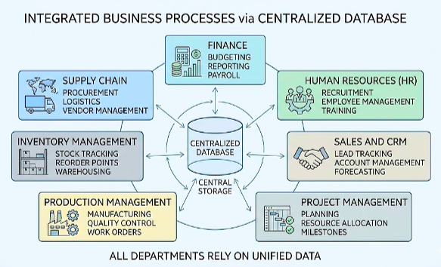
Figure 1.1 ERP System Architecture
For decades, running an enterprise system meant owning the servers, patching the hardware, and footing a hefty maintenance bill. That picture has shifted. Cloud computing opened the door to ERP platforms hosted off-site, and organizations jumped at the chance—drawn by the flexibility to scale up or down, the lighter financial burden, and the ease of plugging in complementary tools like CRM and SCM software. Cross-team collaboration, once hampered by disconnected systems, became far more natural.
What sets cloud ERP apart? A handful of defining traits:
- One place for data—shared across every department in the company.
- Log in from anywhere, on any device, through the cloud.
- Scale resources up or down as the business demands it.
- Drastically lower spending on hardware and day-to-day operations.
Today, cloud ERP sits at the heart of most digital business playbooks. Automated backups and built-in disaster recovery give organizations peace of mind that their data will survive even the worst outage, making the whole platform noticeably more dependable.
Artificial Intelligence (AI) takes cloud ERP a step further. Routine tasks get automated, predictive models surface patterns human analysts might miss, and decision-makers receive real-time dashboards instead of stale weekly reports. On the risk side, AI tightens fraud detection, hardens data security, and keeps compliance on track—turning the ERP into a smarter, more resilient backbone for the entire enterprise.
  - Background of the Study
Cloud Computing and AI have redrawn the map for enterprise information systems. Conventional on-premises ERP—with its heavy infrastructure bills and constant upkeep—is steadily losing ground to cloud alternatives that promise a lighter, more agile operating model.
Three service models dominate the cloud ERP landscape: SaaS, PaaS, and IaaS. Regardless of the model, the appeal is the same—faster deployment, tighter budget control, and access from virtually anywhere. The numbers back this up: cloud ERP usage climbed from 44% in 2020 to roughly 70% by 2026 (Anchor Group, 2024; Global Growth Insights, 2025).
A consulting firm like Keystone Advisory Group in Bangalore lives and dies by operational effectiveness. When the internal system stumbles—slow reports, remote-access headaches, expensive patches—client service quality takes the hit. Keystone depends on its ERP for project tracking, invoicing, workforce scheduling, and client deliverables. Legacy hurdles like steep capital costs, labyrinthine maintenance, and poor off-site access make the argument for migrating to cloud ERP hard to ignore.
  - Industry Profile
Small and Medium Enterprises (SMEs) power a significant share of both the Indian and the global economy. Inside India, the competitive landscape for SMEs shifts fast; those that cannot manage operations efficiently fall behind quickly. Digital transformation is no longer optional—firms need sharper analytics, leaner workflows, and faster decisions just to stay in the race. Modern ERP platforms give SMEs exactly that toolkit.
The vendor landscape is varied. SAP S/4HANA Cloud serves sprawling multinationals with intricate global operations. Oracle Fusion Cloud ERP leans toward mid-to-large companies, especially in financial services and HR. Firms already deep in the Microsoft stack gravitate toward Dynamics 365. Smaller enterprises on a tighter budget often look at Zoho ERP or Oracle NetSuite—both cloud-native, both priced for leaner organizations.
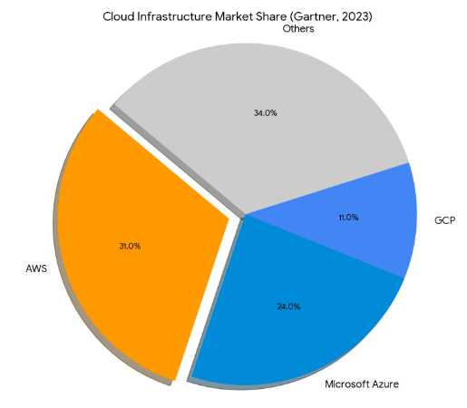
Figure 1.2 Cloud Infrastructure Market Share (Gartner, 2023)

Cloud infrastructure now underpins the vast majority of new ERP deployments. Amazon Web Services (AWS) holds the biggest slice of that infrastructure pie (Gartner, 2023), which means picking a provider is no small decision—it shapes cost structures, latency, and compliance posture for years to come.
India’s cloud market has its own dynamics. AWS runs its ap-south-1 region out of Mumbai, giving Indian clients low latency and local data residency. Azure operates from Pune through its Central India region; Google Cloud’s asia-south1 sits in Mumbai as well. All three keep data on Indian soil—a non-negotiable for companies that treat data sovereignty as a boardroom issue.
Globally, the cloud ERP market has been on a steep climb. It stood at USD 34.83 billion in 2023 and is on track to hit USD 65.89 billion by 2026. Projections push that further—USD 110.26 billion by 2030, USD 207.59 billion by 2034. What is fuelling this? Scalability, cost savings, anywhere-access, and the relentless corporate drive toward digital transformation.
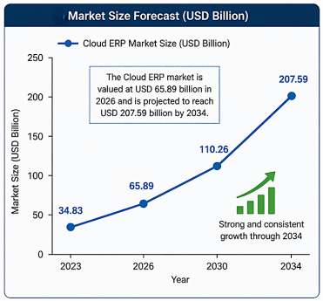
Figure 1.3 Market Size Forcast
Several signposts confirm just how fast cloud ERP is gaining traction. Between 60% and 70% of all ERP environments are expected to sit in the cloud by 2026. Roughly three out of four brand-new ERP implementations already run there. Financially, the payoff is tangible—most companies recoup about half their investment inside two to three years. Over half of enterprises are in the middle of migrating, and around 60% have active digital transformation programmes. Nearly 40% of ERP platforms now embed AI features such as automation and predictive analytics (Parsimony, 2025; Anchor Group, 2024; Global Growth Insights, 2024).
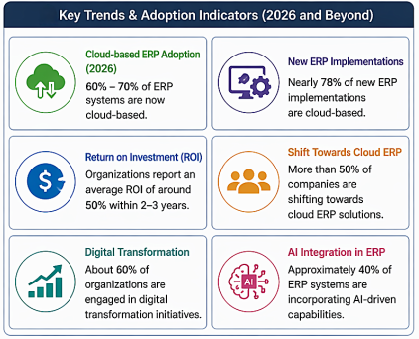
Figure 1.4 Key Trends & Adoption Indicators (2026 and Beyond)
India’s IT and Business Process Management sector accounts for about 7.4% of national GDP and employs roughly 5.4 million people. Bangalore—often called India’s Silicon Valley—is where much of the technology and consulting activity concentrates. In that high-speed environment, outfits like Keystone Advisory Group lean on digital tools, cloud ERP included, to stay sharp. Keystone is a management-and-technology advisory house headquartered in Bangalore, built around guiding companies through digital change.
  - About the Organization: Keystone Advisory Group, Bangalore
Operating out of Bangalore, Keystone Advisory Group is a mid-sized firm that blends management consulting with technology advisory. Its niche: helping businesses retool their operations for a digital-first world.
Clients come from BFSI, manufacturing, retail, and healthcare. The firm fields about 50 professionals across multiple offices and leans on integrated enterprise platforms for everything from tracking projects and managing talent to running the books and meeting compliance requirements. Strategy consulting, IT advisory, digital transformation, and operational excellence round out the service mix.
The firm’s service portfolio breaks down into four pillars:
- Guiding organizations through digital transformation
- Helping clients adopt cloud-based technologies
- Refreshing and modernizing legacy enterprise platforms
- Streamlining and optimizing business workflows
Each service line feeds the same goal: making client organizations quicker on their feet and more efficient in how they run digital operations. For students of business, Keystone doubles as a living case study—a place where textbook theories meet the messiness of real consulting engagements.
For more than ten years, Keystone ran on an on-premises SAP ECC system. It worked well enough at first, but cracks widened over time: the system could not scale easily, maintenance bills kept rising, analytics capabilities were basic at best, and staff outside the office had very limited access. Those pain points pushed leadership to explore a cloud ERP migration—seeking agility, lighter IT overhead, and a platform that fit the firm’s digital ambitions.
  - Business Problem Overview
    - Problem Identification
ERP systems sit at the junction of process integration, efficiency, and data-driven decision-making. Keystone Advisory Group built its core operations around an on-premise ERP for years. The system met needs once, but evolving business realities and newer technology stacks have laid bare its shortcomings.
Cloud computing and digital transformation have raised the bar. Organizations now need platforms that flex on demand, scale without friction, and deliver insights in real time. Traditional on-premises ERP struggles on all three fronts, especially in industries that move fast. The result is a growing mismatch between what legacy systems can deliver and what the business actually requires going forward.
That mismatch has become impossible to ignore at Keystone as the company grows and adopts hybrid work practices. Leadership recognized the need for something more agile, more secure, and easier on the budget—prompting a serious look at swapping the legacy on-premises ERP for a cloud-hosted replacement.
    - Problem Statement
Multiple operational headaches plague Keystone’s current on-premises ERP, making a cloud migration not just attractive but necessary.
- Costly infrastructure: Running the on-premises stack costs INR 28,000 monthly for infrastructure alone, plus another INR 28,000 for maintenance and licensing. For a team of 30–40 people, those numbers are hard to justify.
- Poor remote access: Only users on Keystone’s office LAN can reach the system reliably. VPN workarounds are patchy—a real problem for a firm that increasingly works in hybrid and remote setups.
- Sluggish scaling: Bringing on new users or spinning up additional modules takes four to six weeks—far too slow for a business that needs to adapt on shorter notice.
- Outdated security: The platform runs on six-year-old software with irregular patch cycles. That leaves sensitive client data exposed to breach risks that grow with every delayed update.
- Weak integration: Connecting the system to modern analytics engines, AI tools, or third-party SaaS products is cumbersome at best. Keystone’s ability to draw data-driven insights suffers as a result.
- Unreliable uptime: Four unplanned outages hit the firm in the past year, all traced to hardware failures, each one disrupting day-to-day operations.
All of this funnels into one core research question: How can Keystone Advisory Group pull off a successful migration from its legacy ERP to a cloud platform—without sacrificing data integrity, interrupting operations, blowing the budget, or losing sight of strategic goals?
  - Need of Study
Why does this study matter? First, it fills a gap. Most cloud ERP research focuses on large Western multinationals; very little examines Indian management consulting firms. Second, it produces practical takeaways: how to spot and neutralize migration risks, how to steer organizational change, and how to gauge whether the new system is actually performing. Those lessons can sharpen decision-making for any company walking the same path.
Beyond the academic contribution, the study hands Keystone Advisory Group a yardstick for measuring its own migration outcomes. Armed with these findings, leadership can benchmark the new system’s performance and fine-tune operations where the data says fine-tuning is needed.
  - Objectives of Study
Primary Objective: Gauge how moving to cloud ERP reshapes efficiency, cost dynamics, and the quality of decision-making at Keystone Advisory Group.
Several supporting objectives flow from this:
- Probe Keystone’s technical, organizational, and security readiness for a cloud migration.
- Weigh AWS, Azure, and Google Cloud Platform against each other and recommend the strongest fit for hosting Keystone’s ERP.
- Map out a phased migration roadmap complete with risk management protocols and fallback plans.
- Move data across to the new platform with a firm guarantee of 100% data integrity in every module.
- Put the cloud ERP through its paces—functionality, performance, security—and train users on the new workflows.
- Orchestrate a clean go-live and set up a framework that compares post-migration KPIs against pre-migration baselines.
- Survey staff on how prepared they felt, what problems they hit, and how satisfied they are after the switch.
  - Research Questions
RQ1: What steps should an organization take to gauge whether it is genuinely ready to move its ERP from on-premises servers to a cloud platform?
Answering this draws on published literature combined with readiness assessment frameworks; survey data add an empirical layer by spotlighting the readiness factors that matter most.

RQ2: On what grounds should a company pick one cloud platform over another when migrating its ERP?
A comparative look at the major cloud providers—filtered through criteria like cost, scalability, security, and raw performance—provides the answer, backed by existing literature.

RQ3: Which migration approach best safeguards data integrity and keeps the business running while the ERP shifts to the cloud?
Published migration models and case studies supply the foundation; a purpose-built migration framework, mapped to the project’s phases, ties the theory to practice.

RQ4: What are the biggest pitfalls and hazards in a cloud ERP migration, and how can an organization work around them?
Answers come from combing through academic sources, dissecting case studies, and applying structured risk tools—SWOT analysis chief among them.

RQ5: Once a cloud ERP goes live, how does it move the needle on cost, efficiency, and system uptime?
Secondary data analysis paired with scenario-based modelling, benchmarked against industry norms, tackles this question.

RQ6: How do end users perceive the shift to cloud ERP—what is their readiness level, and where do adoption hurdles show up?
Primary data from a structured questionnaire—fielded to students serving as proxy respondents—feeds into descriptive statistical analysis to answer this.
1.8 Scope of Study
This study zeroes in on migrating ERP systems from local servers to cloud platforms, viewed through the lens of Keystone Advisory Group in Bangalore. The analysis covers readiness, cloud vendor selection, the migration strategy itself, and how the new system performs once it is up and running.
Everything is framed within the Indian business context—taking into account domestic industry norms, regulatory guardrails, and the fast-rising adoption of cloud technologies by Indian firms. That grounding keeps the findings relevant to the conditions companies actually face on the ground.
Cloud service models fall within the study’s lens as well, particularly Infrastructure as a Service (IaaS), though other models receive attention where they bear on ERP deployment and growth. AWS, Microsoft Azure, and Google Cloud Platform are each appraised for their suitability as an ERP migration target.
On the functional side, the study spans Finance, Human Resources, Project Management, CRM, Procurement, and Administration modules. It examines how a cloud-based ERP tackles the chronic weaknesses of legacy systems—excessive costs, poor scalability, restricted access, and cumbersome integrations.
A 12-week project window (March–June 2026) bounds the work, covering planning, vendor selection, migration execution, testing, and post-go-live support.

Chapter 2: Literature Review

Introduction — Why This Topic is Worth Reviewing

Scholarship on ERP systems has moved well beyond cataloguing features. The conversation now centres on measurable outcomes—how these platforms reshape workflows, sharpen decisions, and cut waste. A thick strand of the literature digs into the way ERP unifies processes that used to run on separate tracks, trimming the inefficiencies that creep in when departments operate in isolation.

Cloud computing’s rise has added a new chapter. Academics are probing what happens when companies lift their ERP off local servers and drop it into platforms from SAP, Oracle, and others. The verdict so far: cloud delivery strengthens coordination between departments, automates grunt work, and puts live data at everyone’s fingertips.

That said, the literature is not all rosy. Plenty of studies flag real downsides—security worries, messy migrations, and employees who simply refuse to change how they work. The takeaway? Adopting ERP is never just a technology project; it is an organizational shakeup that touches culture, habits, and power structures.

Methodologically, the field is diverse. Researchers have leaned on case studies, large-scale surveys, and in-depth interviews to understand ERP in practice. On the migration front, strategies like phased rollouts and parallel-run periods surface repeatedly as ways to keep risk in check while the old system hands off to the new one.

Even with all this work, blind spots remain—particularly around SMEs, where tight budgets make ROI a do-or-die metric and operational efficiency is not a luxury but a survival requirement. This chapter walks through the theoretical bedrock of ERP adoption, catalogues the weak points of legacy systems, traces the arc of cloud ERP’s emergence, and sizes up what existing research says about migration results, success levers, and stumbling blocks. It closes by mapping the gaps this study sets out to fill.

Existing Decision Models for ERP Adoption
Nobody migrates an ERP system on a whim. The decision to abandon a legacy on-premises setup for a cloud alternative is tangled, touching strategy, finance, technology, and people in roughly equal measure. Scholars have proposed—and tested—several models to make sense of how organizations and individuals adopt new technology.

Technology Acceptance Model (TAM) — Davis, 1989
Few frameworks in information systems carry as much weight as the Technology Acceptance Model. Davis (1989) boiled adoption down to two beliefs: Perceived Usefulness (PU)—“Will this make my job better?”—and Perceived Ease of Use (PEOU)—“Can I figure this out without a headache?” Those two beliefs feed attitudes, which feed intentions, which feed actual use. Simple chain, powerful explanation.
The model’s punch line is sobering for IT leaders: a technically brilliant cloud ERP that feels clunky to end users will sit idle. People reject systems they find hard to use, no matter how many features the spec sheet lists. TAM therefore pushes organizations to pour as much effort into interface design and hands-on training as they do into server provisioning.
External Variables  (Training, UI Design,  Support Quality) | ➡ | Perceived  Usefulness (PU)  +  Perceived Ease  of Use (PEOU) | ➡ | Attitude  Toward  Using Cloud ERP | ➡ | Behavioural  Intention  → Actual  System Use
Figure 2.1 TAM adapted for Cloud ERP Adoption (Based on Davis, 1989)

Unified Theory of Acceptance and Use of Technology (UTAUT) -Venkatesh et al., 2003
Venkatesh et al. (2003) folded eight earlier adoption models into one unified framework—UTAUT—and distilled them down to four drivers: Performance Expectancy, Effort Expectancy, Social Influence, and Facilitating Conditions. For large-scale ERP conversions, UTAUT is especially relevant because it captures the weight of managerial endorsement and infrastructure readiness—forces that often matter more than any single user’s personal preference.

Theory of Diffusion of Innovation (DOI) - Rogers, 2003
Rogers (2003) mapped how new ideas spread through a population, slotting people into five buckets: Innovators, Early Adopters, Early Majority, Late Majority, and Laggards. For cloud ERP, the model is a useful predictor of internal resistance. Tech-savvy consulting firms tend to land in the early-majority camp—they wait for proof of concept but move before the mainstream catches up. Keystone Advisory Group’s 2024 migration timeline fits that pattern neatly.
Rogers also pinpointed five innovation attributes that speed or slow adoption: relative advantage, compatibility, complexity, trialability, and observability. Cloud ERP scores well on advantage and trialability—vendors happily demo their platforms. Complexity, though, remains a sticking point, especially when migrating years of accumulated data.

Total Cost of Ownership (TCO) Model
TCO analysis frames the cloud-versus-on-premises debate as a long-haul financial exercise. It goes beyond sticker prices—licensing, hardware—and folds in implementation, training, maintenance, downtime, and opportunity costs. Companies that look only at license fees tend to undercount what on-premises really costs them while overstating what the cloud will. Gartner (2022) puts numbers to it: over a five-year horizon, cloud ERP typically runs 25–40% cheaper in aggregate than its on-premises equivalent.
Framework | Primary Focus | Key Variables | Applicability to Cloud ERP Migration
TAM (Davis, 1989) | Individual adoption | Perceived Usefulness, Ease of Use | Predicts end-user acceptance of new cloud interface
UTAUT (Venkatesh, 2003) | Organizational adoption | Performance, Effort, Social Influence, Facilitating Conditions | Explains why some departments adopt faster than others
DOI Theory (Rogers, 2003) | Innovation diffusion rate | Relative Advantage, Compatibility, Complexity | Identifies likely resistance clusters in the workforce
TCO Model (Gartner) | Financial decision-making | Total 5-year cost across all categories | Justifies migration investment at board/C-suite level
Resource-Based View (Barney, 1991) | Strategic advantage | IT capabilities as firm resources | Frames cloud ERP as a competitive capability, not just a cost
Table 2.1: Summary of theoretical frameworks applied to ERP adoption decisions

2.3 Review of Related Research Studies
Johansson & Ruivo (2013)
Johansson and Ruivo (2013) compared cloud ERP uptake among SMEs in Sweden and Portugal. Forty organizations took part in surveys and structured interviews. Cost savings and scalability topped the list of motivators; data security fears and vendor lock-in topped the list of worries. A striking finding: firms with mature IT governance reported noticeably higher satisfaction. The catch? A Western-European-SME sample limits how far the results travel—particularly to consulting firms in emerging markets.
Seethamraju (2015)
Seethamraju (2015) looked at SaaS ERP inside Australian universities—complex, multi-stakeholder organizations by nature. Semi-structured interviews with IT directors and process owners across three institutions revealed genuine gains in maintainability and upgrade frequency, but exposed a tension: cloud platforms offer less room for bespoke customization than on-premises installations. For entities tangled in regulatory and reporting obligations, that trade-off bites. The finding resonates directly with consulting firms, which face their own version of the standardization-versus-customization tug-of-war.
Martins et al. (2019)
Martins et al. (2019) tracked cloud ERP migration outcomes at 28 multinationals over four years, scoring performance against a balanced scorecard. Internal processes and organizational learning showed the biggest lifts—process automation jumped, cross-functional data sharing improved markedly. Financial payoffs, including TCO reduction, materialized mainly in years two and three, hinting at a lag between go-live and full ROI realization. Because the study only covered large multinationals, mid-sized advisory firms remain off the radar.
Sagheer et al. (2021)
Sagheer et al. (2021) surveyed 120 organizations in India, Pakistan, and Bangladesh to catalogue barriers to cloud ERP in South Asia’s tech sector. Data-privacy worries, skill gaps, and migration costs topped the list. An encouraging pattern also emerged: companies that had already dabbled in cloud—via a hosted CRM or HRMS, for instance—navigated ERP migration with significantly less turbulence. Given its South-Asian focus, the work maps closely onto the present study’s context.
Ali et al. (2023)

Ali et al. (2023) surveyed 200 IT managers across the Gulf Cooperation Council region and built a multidimensional model for judging post-migration ERP performance—technical health, user satisfaction, process efficiency, and strategic fit. Structural equation modelling identified three standout success drivers: executive sponsorship, thorough training, and phased rollout. The authors flagged a gap around middle management’s role in post-migration adoption—a gap the present study starts to close through its own survey design.

2.4 On-Premises ERP Systems

On-premises ERP dominated enterprise information management from the 1990s onward. SAP R/3, Oracle E-Business Suite, and Microsoft Dynamics NAV were the heavyweights of that era. Running these systems meant buying perpetual licenses, maintaining physical servers in-house, and keeping an IT team on standby for customization, patching, and major upgrades.

Deep customisability, total data control, and no reliance on an internet connection—these strengths cemented on-premises ERP as the go-to choice for large, heavily regulated organizations. Manufacturers needing shop-floor hooks, banks guarding transactional security, and government bodies requiring air-gapped networks all built their operations around locally hosted systems.

Ironically, the very qualities that made on-premises ERP effective in a slower-moving era now hobble it. Rigid architecture chokes the pace of innovation; upgrade cycles stretching into years guarantee that the organization is always a step behind the technology curve.

2.4.1 On-Premises ERP Architecture
USER LAYER
Finance  Users | HR  Users | Operations  Users | Management /  Reporting Users

↓ Intranet / LAN Network ↓
APPLICATION LAYER (SAP ECC / Oracle EBS — On Premise)
FI / CO  Module | MM / SD  Module | HR / HCM  Module | PP / PM  Module | BI /  Reporting

↓ Direct Server Access ↓
INFRASTRUCTURE LAYER (On-Site Physical Servers)
Web / App  Servers | Database  Servers (RDBMS) | Backup &  Storage Systems

↓ Physical Network & Security ↓
Firewall &  Network Security | On-Site IT  Team (24x7) | Disaster Recovery  (On-Premise Backup)

Architecturally, on-premises ERP stacks four layers (see Figure 2.2). The user layer talks to the application layer only through the corporate LAN—anyone working off-site needs a VPN, often an unreliable one. Underneath, the infrastructure layer (physical servers, storage arrays, databases) is wholly owned and managed by the in-house IT team. Hardware swaps, software patches, and capacity upgrades all land on that team’s desk, piling up both risk and cost.

On-premises ERP is built on a four-layered architecture as shown in Figure 2.2. The user layer is connected to the application layer solely via the corporate LAN, implying that a complex VPN setup is required for remote users outside the corporate boundaries. The infrastructure layer, which includes physical servers, storage, and databases, is owned, hosted, and maintained by the in-house IT team. All hardware replacements, software patching, and capacity upgrades need to be performed by this team, which poses risks and a significant cost burden.

2.4.2 Key Limitations of On-Premises ERP
Limitation | Explanation | Business Impact
High Capital Expenditure | Upfront hardware, licence, and implementation costs often run into crores for mid-sized firms | Strains balance sheet; creates sunk-cost inertia against modernisation
Scalability Constraints | Server capacity must be provisioned for peak demand, leading to under-utilisation at normal loads | Resource waste during off-peak periods; risk of crashes at peak load
Remote Access Barriers | Users require VPN or office presence; unsuitable for field-based or hybrid workforces | Reduced productivity; inability to support modern work arrangements
Slow Upgrade Cycles | Major version upgrades require months of testing and significant downtime | Perpetual technology lag; growing technical debt
IT Dependency | Every change — even minor configuration — requires IT department involvement | Business agility constrained by IT bottlenecks
Limited Analytics | On-premises systems lack real-time business intelligence without costly add-ons | Decision-making based on batch reports rather than live data
Disaster Recovery Risk | Backup systems are co-located with primary systems; disaster destroys both | Business continuity exposure in events of fire, flood, or power failure
Table 2.2: Operational limitations of on-premises ERP systems

2.5 Cloud Computing — Basics and Service Models

NIST offers the canonical definition: cloud computing is a model for on-demand network access to a shared pool of configurable computing resources—networks, servers, storage, applications, and services—that can be spun up or torn down quickly with minimal hands-on management (Mell & Grance, 2011).

Three properties make cloud computing tick: self-service on demand, broad network reach, and rapid elasticity. Together they shatter the time and capacity ceilings of on-premises setups. For ERP specifically, the cloud rewrites the relationship between an organization and its software—swapping ownership for subscription, hands-on management for consumption.

2.5.1 Infrastructure as a Service (IaaS)
IaaS hands over virtual servers, storage, and networking on a pay-as-you-go basis. The cloud vendor looks after the hardware; the customer keeps control of the OS, middleware, and applications. In ERP land, IaaS is the go-to for “lift and shift” moves—taking the existing on-premises application and dropping it onto cloud-hosted VMs without rearchitecting anything. AWS EC2, Azure Virtual Machines, and Google Compute Engine are the big names here.

2.5.2 Platform as a Service (PaaS)
PaaS gives developers an internet-based environment for building and deploying applications, hiding the infrastructure plumbing beneath an abstraction layer. In ERP ecosystems, PaaS is where organizations craft custom modules, build integrations, or develop analytics apps that sit on top of their cloud ERP. SAP Business Technology Platform (BTP) and Oracle Cloud Platform lead this space.

2.5.3 Software as a Service (SaaS)
SaaS is the dominant delivery vehicle for cloud ERP. Infrastructure, platform, and application—the entire stack—lives with the vendor. Customers access it through a browser or API, pay per user or per module, and get patches, updates, and feature releases automatically. The IT team’s maintenance burden drops to nearly zero.

2.5.4 SaaS ERP — The Dominant Migration Target
SaaS ERP is where enterprise functionality meets cloud-native delivery. SAP S/4HANA Cloud (Public Edition), Oracle Fusion Cloud ERP, Microsoft Dynamics 365 Finance, and Workday Finance lead the pack. Common traits: standardized processes drawn from industry best practices, quarterly or half-yearly feature drops, multi-tenant architecture that shares costs across customers, and built-in hooks for AI, machine learning, and advanced analytics.
 | IaaS | PaaS | SaaS
Applications | organization | organization | Vendor
Data | organization | organization | Vendor
Runtime | organization | Vendor | Vendor
Middleware | organization | Vendor | Vendor
OS | organization | Vendor | Vendor
Virtualisation | organization | Vendor | Vendor
Servers | Vendor | Vendor | Vendor
Storage | Vendor | Vendor | Vendor
Networking | Vendor | Vendor | Vendor
 | organization-managed |  | Vendor-managed
Figure 2.3 Responsibility layers across IaaS, PaaS, and SaaS cloud service models

2.5.5 Benefits of Cloud ERP
Benefit Category | Specific Benefit | Literature Support
Cost Efficiency | Eliminates capital expenditure on hardware; shifts to predictable OpEx subscription model | Gartner (2022); Johansson & Ruivo (2013)
Scalability | Resources scale up or down on demand — ideal for organizations with seasonal or project-based workloads | Martins et al. (2019); SAP SE (2024)
Accessibility | 24/7 access from any device and location — critical for remote and field-based workforces | Sagheer et al. (2021)
Automatic Updates | Vendor manages all upgrades, patches, and feature releases without organizational IT involvement | Seethamraju (2015)
Business Continuity | Geo-redundant cloud data centres provide automatic failover and disaster recovery | Ali et al. (2023)
Advanced Analytics | Native integration with AI, ML, and real-time dashboards without costly add-ons | IDC (2023)
Security & Compliance | Hyperscale cloud providers invest billions in security infrastructure — often exceeding on-premises capabilities | Deloitte (2023)
Faster Implementation | Pre-configured industry templates reduce implementation timelines significantly | Microsoft (2023)
Table 2.3: Key benefits of cloud ERP — evidence from literature

2.6 Evolution of ERP Systems Over the Years — Milestone Tracker
ERP has moved through clearly distinct generational phases, each one pushing capability, delivery method, and strategic importance to a new level. The timeline below maps those milestones to the features—and the constraints—that defined each era.
Feature / Capability | Pre-ERP Era  (Pre-1990) | MRP / Early ERP  (1990–2000) | Integrated ERP  (2000–2010) | Web-Enabled ERP  (2010–2018) | Cloud / SaaS ERP  (2018–Present)
Integrated business modules | ✗ | △ | ✓ | ✓ | ✓
Real-time data across departments | ✗ | ✗ | △ | ✓ | ✓
Remote access (outside office) | ✗ | ✗ | ✗ | △ | ✓
Mobile device support | ✗ | ✗ | ✗ | △ | ✓
Automatic software updates | ✗ | ✗ | ✗ | ✗ | ✓
Pay-per-use / subscription pricing | ✗ | ✗ | ✗ | ✗ | ✓
Built-in AI / predictive analytics | ✗ | ✗ | ✗ | ✗ | ✓
Multi-tenant architecture | ✗ | ✗ | ✗ | ✗ | ✓
Deep customisation flexibility | ✓ | ✓ | ✓ | ✓ | △
On-site hardware required | ✓ | ✓ | ✓ | ✓ | ✗
High upfront capital investment | ✓ | ✓ | ✓ | ✓ | ✗
Dedicated IT maintenance team required | ✓ | ✓ | ✓ | △ | ✗
Geo-redundant disaster recovery | ✗ | ✗ | ✗ | △ | ✓
Regulatory / compliance automation | ✗ | ✗ | △ | △ | ✓
Integration with third-party SaaS tools | ✗ | ✗ | ✗ | △ | ✓
Table 2.4: Feature evolution of ERP systems across five generational eras.
✓ = Feature present | △ = Partial capability | ✗ = Feature absent

2.7 On-Premises vs Cloud ERP — Architecture Comparison
Functionally, on-premises and cloud ERP cover much the same ground—finance, HR, supply chain, and so on. Architecturally, however, they are worlds apart. On-premises ERP is monolithic: single-tenant, vertically integrated server stacks. Cloud ERP, particularly in SaaS form, is distributed: multi-tenant, microservices-based, hosted on hyperscale infrastructure.
USER ACCESS LAYER — Any Device, Anywhere, Any Time
Web Browser | Mobile App  (iOS / Android) | Desktop Client | API / Third-party  Integration

↓ HTTPS / Encrypted Internet Connection ↓
SAAS APPLICATION LAYER — Vendor-Managed, Auto-Updated
Finance  (FI/CO) | HR &  Payroll | Supply  Chain | Sales &  CRM | Projects &  Billing | Analytics  & AI

↓ Multi-Tenant Platform Services ↓
PLATFORM LAYER — Integration, Extension & Security
API Gateway &  Middleware | Identity &  Access Management | DevOps &  Extension Platform

↓ Hyperscale Cloud Infrastructure ↓
INFRASTRUCTURE LAYER — AWS / Azure / GCP (Geo-Redundant Data Centres)
Primary  Data Centre  (Region A) | Failover  Data Centre  (Region B) | Automated  Backup &  Snapshot | 24x7 Vendor  Security &  Monitoring

Figure 2.4 Reference architecture of cloud ERP (SaaS model) — contrasted with Figure 2.2

2.7.1 Direct Architecture Comparison Table
Architectural Dimension | On-Premises ERP | Cloud ERP (SaaS)
Hosting Environment | organization-owned physical servers in on-site data centre | Vendor-managed hyperscale cloud data centres (AWS/Azure/GCP)
Tenancy Model | Single-tenant (dedicated environment per client) | Multi-tenant (shared infrastructure, logically isolated data)
User Access Method | Intranet / VPN required for off-site access | Secure HTTPS access from any internet-connected device
Update & Patch Cycle | Annually or bi-annually; requires planned downtime | Continuous / quarterly; automatic, zero-downtime updates
Scalability Mechanism | Manual server provisioning (weeks to months) | Elastic auto-scaling within minutes
Disaster Recovery | On-site backup systems; risk of co-location failure | Geo-redundant failover; RPO/RTO measured in seconds
Customisation | Deep customisation via ABAP/extensions (on SAP) | Standardised processes; extensions via PaaS/API only
Integration Method | Point-to-point middleware (complex and brittle) | Open API ecosystem; pre-built connectors for major SaaS tools
Analytics Capability | Requires separate BI tools (e.g., SAP BW) | Embedded real-time analytics and AI natively available
Cost Structure | CapEx-heavy (upfront); ongoing maintenance costs | OpEx-based subscription; predictable monthly/annual fees
Table 2.5: Architectural comparison between on-premises and cloud ERP systems

2.7.2 SWOT Analysis — Cloud ERP Migration
STRENGTHS  - 40%+ reduction in IT infrastructure TCO over 5 years  - Elimination of hardware procurement and maintenance burden  - 99.9% uptime SLA from hyperscale cloud providers  - Remote access enabling workforce mobility and hybrid work  - Automatic updates keeping organization at technology frontier  - Built-in AI/ML analytics unavailable in legacy systems | WEAKNESSES  - Reduced customisation flexibility vs on-premises systems  - Vendor dependency and risk of licence cost escalation  - Internet connectivity required — rural/low-bandwidth risk  - Data sovereignty concerns in regulated sectors  - Initial migration complexity and transition costs  - Change management burden on internal HR and IT teams
OPPORTUNITIES  - Integration with emerging technologies (IoT, Blockchain, RPA)  - AI-driven predictive insights for project profitability  - Enabling global expansion without new IT infrastructure  - Data-driven competitive differentiation in advisory services  - Vendor innovation pipeline delivering continuous new features  - Partner ecosystem enabling rapid third-party integrations | THREATS  - Data breach risk in shared cloud environments  - Vendor lock-in making future migrations costly  - Regulatory changes affecting cross-border data storage  - Inadequate change management causing low adoption rates  - Integration failures with legacy third-party systems  - Business disruption during the migration transition window
Figure 2.5 SWOT analysis of cloud ERP migration - context of mid-sized Indian consulting firms
2.8 Linking Literature to the Current Study
Pull the threads together and a clear picture forms: cloud ERP adoption is driven by a cocktail of technology, organizational culture, and human behavior. Prior research consistently touts scalability, flexibility, accessibility, and efficiency gains while simultaneously waving red flags around user resistance, messy migrations, and data-security worries.
A gap stands out, though. Most studies either zoom in on technical plumbing or examine large Western multinationals. Management-level perspectives from Indian professional service firms—particularly around employee readiness, adoption patterns, and the support structures that smooth a migration—have received remarkably little scholarly attention.
This study picks up where the existing work leaves off. By investigating cloud ERP migration at Keystone Advisory Group and weaving together organizational strategy with user-perception data inside a single research framework, it tightens the link between academic theory and the messy realities managers face on the ground.
Another thread in the literature: organizations going cloud-first on ERP increasingly prize agility, elastic scaling, and remote access—responses to fast-moving markets and the digital transformation imperative. COVID-19 was a powerful accelerant; the pandemic exposed just how brittle on-premises infrastructure is when offices empty out and distributed operations become the norm.
Scholars also stress that judging a cloud ERP rollout purely on its technology is a mistake. Organizational readiness, how well employees adapt, and whether the migration fits long-term strategy matter just as much. As a result, modern migration research increasingly blends management and technical viewpoints to paint a fuller picture of what cloud transformation really entails.
2.9 Research Gaps Identified from Literature
Combing methodically through the academic and practitioner literature turns up several zones where hard evidence is either thin or absent altogether. Those gaps define the exact niche this study occupies.

Gap No. | Research Gap Identified | Why it Matters | How This Study Addresses It
Gap 1 | Most cloud ERP migration studies focus on manufacturing or retail sectors. The professional services and consulting sector — which has distinct workflow, billing, and project management ERP requirements — is significantly underrepresented. | Sector-specific findings are essential because ERP configuration, user needs, and migration complexity vary significantly across industries. | This study examines cloud ERP migration exclusively within a management consulting firm (Keystone Advisory Group), providing sector-specific evidence.
Gap 2 | Existing studies are predominantly from North American or Western European organizational contexts. Indian mid-market organizations face unique infrastructure constraints (bandwidth variability, local compliance), and their cloud ERP experiences remain understudied. | Generalising findings from Western firms to Indian contexts can lead to inappropriate recommendations. | Primary data is collected entirely from professionals within an Indian organization, ensuring contextual validity.
Gap 3 | Most studies evaluate either pre-migration drivers OR post-migration outcomes — rarely both within the same study. This creates a disconnect between why organizations migrate and whether those motivations are actually fulfilled. | Without connecting drivers to outcomes, it is impossible to evaluate whether the migration achieved its stated objectives. | This study explicitly maps each pre-migration driver to a measured post-migration performance outcome.
Gap 4 | The role of middle management in driving or obstructing cloud ERP adoption is consistently identified as important in theoretical frameworks (UTAUT) but rarely measured empirically in primary studies. | Middle managers are the primary interface between executive strategy and operational adoption — their behaviour is critical to migration success. | The survey instrument includes role-level analysis, enabling comparison of adoption patterns between senior, middle, and operational staff.
Gap 5 | The long-term sustainability of cloud ERP benefits — beyond the initial 12-month post-migration honeymoon period — has received limited longitudinal investigation. | Short-term satisfaction studies may not reflect whether cloud ERP delivers sustained strategic value. | While this study cannot address longitudinal outcomes fully, it recommends a structured post-migration measurement framework for ongoing tracking.
Table 2.6: Research gaps identified from literature review — and this study's response to each

Chapter 3: Research Methodology

3.1 Introduction to the Chapter
Methodology is the spine of any scholarly investigation. It pins down how data gets collected and scrutinized, and it sets the bar for credibility, reproducibility, and academic rigour. A transparent methodology lets evaluators decide for themselves whether the conclusions genuinely follow from the evidence or merely reflect the researcher’s hunches.
What follows is the full methodological blueprint for this study of attitudes and perceptions toward cloud ERP migration. It lays out the research design, the character of the data, the instruments behind data collection, the sampling game plan, the analytical techniques applied, and the ethical guardrails observed throughout. Every methodological choice is tied back to the study’s objectives and the nature of the problem at hand.
Once responses were coded, analysis proceeded through descriptive techniques anchored in percentages. Results were then read against the research objectives to tease out recurring patterns, prevailing attitudes, and shared perceptions around cloud ERP migration. Tables and charts translate those results into a format that is both structured and straightforward to follow.

3.2 Research Design
The study sits on a descriptive research foundation. Descriptive research fits when the goal is to capture—accurately and measurably—the characteristics, opinions, and attitudes a defined group holds toward a given phenomenon. Here, that phenomenon is cloud ERP migration. Unlike exploratory work (used when a topic is barely charted) or causal research (used to prove X causes Y), descriptive research maps the landscape of opinion and experience in a structured, quantifiable way.
Why descriptive? Because the study seeks to capture how respondents view legacy-system weaknesses, what they expect from cloud alternatives, how they feel about organizational change management, and whether they are satisfied with past technology switches. All of these are perceptual constructs, and structured surveys are the natural instrument for measuring them.
Readiness for cloud ERP migration can be appraised along several dimensions: technical infrastructure, staff preparedness, data quality, and leadership backing. Survey responses here capture readiness indirectly—through how familiar respondents are with cloud tools and how open they are to trying new systems. The descriptive approach was judged the best fit because the study aims to map perceptions and tendencies, not to establish causal chains. Given that cloud ERP adoption straddles both technology and human behavior, structured opinion data shed genuine light on the real-world challenges and expectations around system transition.
Design Type | Description | Suitable When | Used in This Study?
Exploratory | Open-ended investigation when little is known | Topic is new or undefined | ✗ Topic well-established in literature
Descriptive | Measures and describes characteristics of a population | Attitudes, perceptions, frequency data needed | ✓ YES — measuring perceptions of cloud ERP
Causal / Explanatory | Establishes cause-and-effect relationships | Controlled experiments or longitudinal data | ✗ Beyond scope of this project
Table 3.1: Research design types and justification for descriptive approach

3.3 Nature and Sources of Data
Two streams of data feed this study: primary and secondary, combined to build as complete an evidence base as possible.

3.3.1 Primary Data
Primary data—collected first-hand by the researcher expressly for this project—has not appeared in any earlier publication. A structured questionnaire went out via Google Forms to a convenience sample of 35 individuals: students and early-career professionals drawn from a range of academic disciplines.
This primary data sits at the empirical heart of the research. The questionnaire was built to probe how respondents view traditional versus cloud-based systems, how they feel about switching technologies, and whether they came away satisfied from past transitions. Language was kept simple and jargon-free so that participants without IT specializations could still give meaningful answers.
Going digital with the survey—Google Forms, specifically—sped up collection, widened the reach, and made responding more convenient. Automatic logging and built-in data export smoothed the path from raw responses to organized datasets.

3.3.2 Secondary Data
Secondary data—information already published by other researchers or institutions—served three roles: building the theoretical frame in Chapter 2, justifying the chosen research design, and providing context for interpreting the primary results. Sources spanned peer-reviewed journals, methodology textbooks, Gartner and IDC industry reports, and vendor documentation from SAP and Microsoft.
3.4 Sampling Design
No researcher can survey an entire population, so sampling steps in. By selecting a manageable subset, the study can still draw meaningful conclusions without the logistical impossibility of reaching everyone.
3.4.1 Target Population
The target population includes students and working professionals who have used any kind of digital or office-management tool—anything from SAP or Tally to Google Drive, Zoom, or an online banking app. Casting the net this wide was intentional. The questionnaire probes general attitudes toward technology adoption, not specialist ERP knowledge, so a diverse respondent base strengthens rather than weakens the data.

3.4.2 Sampling Technique — Convenience Sampling
Convenience sampling drove respondent selection. Participants were picked on the basis of availability and willingness, not through random draw. This is standard practice in student-led academic projects where time, budget, and access rule out probability-based sampling.
Distribution happened digitally—Google Forms links shared via WhatsApp, email, and direct messages to classmates, peers, and acquaintances. The trade-off is familiar: convenience sampling limits generalisability, but for a descriptive study aiming to spot attitudinal patterns rather than make population-level claims, it is a defensible choice.
Parameter | Details
Target Population | Students and professionals with experience using any digital/office system
Sampling Frame | Personal and academic network of the researcher
Sampling Technique | Convenience / Purposive Sampling
Sample Size | 35 respondents (usable responses after removing incomplete forms)
Survey Mode | Online — Google Forms (shareable link)
Data Collection Period | April 2026
Geographic Scope | Punjab / North India (primarily Ludhiana and nearby cities)
Language of Survey | English (simple, jargon-free language used throughout)
Table 3.2: Summary of sampling design parameters

3.4.3 Sample Size Justification
Thirty-five respondents were the target. Bigger samples are always nicer, but academic convention accepts 30-plus as a workable threshold for basic analysis. For a percentage-based descriptive study, 35 is enough to surface meaningful trends—and realistic given the time and access constraints a student researcher faces.

3.4.4 Questionnaire Structure
Section | Theme | Scale Used | Research Objective Addressed
Section 1 | Respondent Profile | Multiple Choice | Classification of respondents
Section 2 | Traditional System Issues | Multiple Choice (Multi-select) | Identify problems in legacy systems
Section 3 | Cloud System Usage | Multiple Choice | Understand familiarity with cloud tools
Section 4 | Migration Challenges | Multiple Choice (Multi-select) | Identify transition barriers
Section 5 | Overall Perception | Multiple Choice | Assess general attitude toward cloud systems
Table 3.3: Structure of the research questionnaire mapped to study objectives

3.5 Data Analysis Workflow
RAW DATA  Google Form  Responses | ↓ | DATA  CLEANING  Remove incomplete  responses | ↓ | DATA  CODING  Convert to  numeric values | ↓ | FINDINGS  &  INTERPRETATION
Figure 3.1 Sequential data analysis workflow from raw data to findings

3.6 Reliability and Validity
Questions were aligned with the research objectives; wording was kept plain to cut down on respondent confusion. Before the form went live, it was reviewed end-to-end for logical flow and consistency.
Because the analysis stays within descriptive, percentage-based territory, heavy-duty statistical validation was not applied. That said, the data hold up for descriptive purposes within the study’s defined scope.
Assessment Type | Method Used | Result / Outcome | Interpretation
Reliability | Questionnaire design clarity | Consistent responses | Data suitable for descriptive analysis
Content Validity | Mapping each question to a research objective | All objectives covered | Questions are relevant and complete
Face Validity | Reviewed before distribution | Minor corrections made | Easy to understand
Table 3.4: Summary of reliability and validity measures

3.7 Scope and Limitations of the Methodology
Dimension | Scope of This Study | Associated Limitation
Sample Type | Convenience sample | Not statistically representative of the general population
Sample Size | 35 respondents | Limits the power of inferential statistics
Geography | North India | Findings may not generalise to other regions
Respondent Profile | Students and early-career professionals | May not fully reflect experienced corporate ERP users
Data Type | Quantitative only (closed-ended questionnaire) | Qualitative depth limited to 2 optional open-ended questions
Time Frame | Cross-sectional — single point in time | Cannot track change in attitudes over time
Bias Risk | Self-reported data, voluntary participation | Social desirability bias and non-response bias possible
Table 3.5: Scope and limitations of the research methodology

3.8 Ethical Considerations
Nobody was forced to participate. Every respondent knew the data was for academic use and that their individual answers would stay anonymous in the final report. Responses were stored securely, used solely for research, and handled in line with Chandigarh University’s data-protection policies.
No question was compulsory, and respondents could walk away from the survey at any point. That combination—voluntary, anonymous, discontinuable—ensured ethical transparency from start to finish.

Chapter 4 : Data Analysis and Interpretation
Here, the primary and organizational data gathered from 35 respondents through the Chapter 3 Google Forms questionnaire are broken down question by question. Each question appears as a frequency table, followed by space for a bar chart and a brief read of what the numbers say.

4.1 Evaluation Based on Primary Survey Data
What follows is a question-by-question walkthrough of the primary survey data. Thirty-five respondents shared their experiences, opinions, pain points, and preferences around cloud-based systems—yielding a practical snapshot of how cloud technologies land with real users.

4.1.1 Current Status
Response Option | No. of Respondents | Percentage (%)
Student | 7 | 20%
Working Professional | 14 | 40%
Both (Student + Working) | 14 | 40%
Total | 35 | 100%
Table 4.1 — Distribution of Respondents by Current Status, 2026
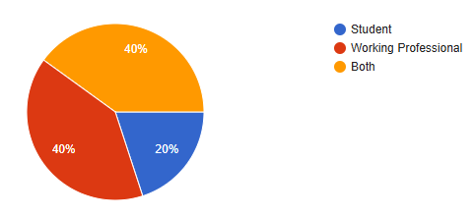
Figure 4.1 Respondent status — Source: Primary Data, 2026
Working professionals made up two-fifths of the sample; another two-fifths wore both student and professional hats. Pure students accounted for the remaining fifth. That three-way split keeps the data grounded in a blend of academic and on-the-job perspectives, adding practical weight to the survey outcomes.

4.1.2 Comfort with Cloud Tools
Response Option | No. of Respondents | Percentage (%)
Very comfortable — use daily | 21 | 60%
Somewhat comfortable | 14 | 40%
Not very comfortable | 0 | 0%
Prefer offline methods | 0 | 0%
Total | 35 | 100%
Table 4.2 — Respondent Comfort Level with Cloud-Based Tools, 2026
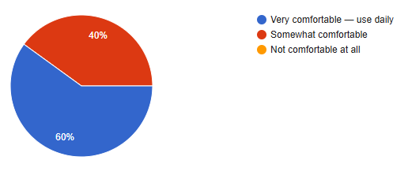
Figure 4.2 Comfort with cloud tools — Source: Primary Data, 2026
Three in five respondents (60%) described themselves as very comfortable with cloud tools—a solid foundation. When people already use cloud applications daily, their comparison of legacy and cloud systems carries genuine experiential credibility.

4.1.3 Problems with Traditional Software
Response Option | No. of Respondents | % of 35 Respondents
Slow or kept crashing | 28 | 80%
Could not access from home / outside office | 14 | 40%
Needed IT help for small issues | 14 | 40%
Too slow to generate reports | 14 | 40%
Never faced any problems | 0 | 0%
Table 4.3: Problems Experienced with Traditional Software, 2026
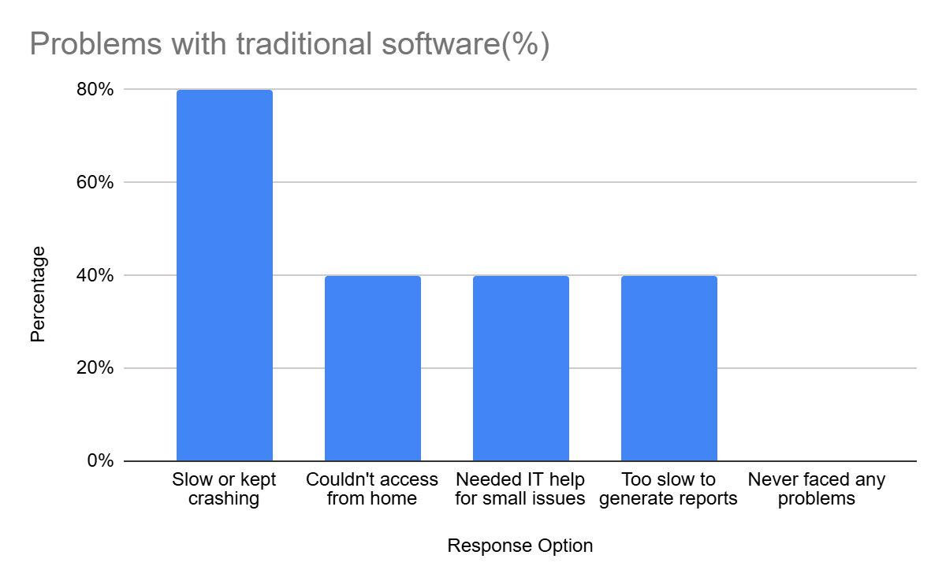
Figure 4.3 Problems with traditional software — Source: Primary Data, 2026
Sluggish performance topped the complaint list at 80%. Poor remote access and over-reliance on IT help also featured prominently. The message: traditional platforms create tangible, day-to-day friction that users feel acutely.

4.1.4 Biggest Single Problem
Response Option | No. of Respondents | Percentage (%)
Cannot access the system remotely | 7 | 20%
Too expensive to maintain and upgrade | 14 | 40%
Crashes or slows down under heavy use | 7 | 20%
Needs a dedicated IT team for changes | 7 | 20%
Total | 35 | 100%
Table 4.4 — Single Biggest Problem with Traditional Systems, 2026
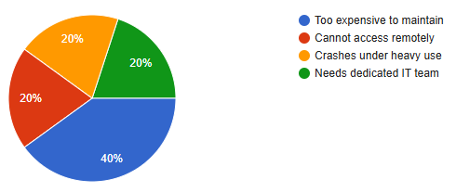
Figure 4.4: Biggest problem — Source: Primary Data, 2026
Maintenance and upgrade costs drew the sharpest criticism, with two in five respondents calling it the worst single issue. Remote-access restrictions followed. Together, these responses validate the financial and accessibility burdens that legacy systems impose.

4.1.5 Cloud Tools in Use (Multi-Select)
Response Option | No. of Respondents | % of 35 Respondents
Google Drive / Google Docs | 35 | 100%
Gmail or web-based email | 28 | 80%
Zoom / Google Meet / Teams | 28 | 80%
Online banking or payment apps | 21 | 60%
None of the above | 0 | 0%
Table 4.5: Cloud-Based Tools Currently Used by Respondents, 2026
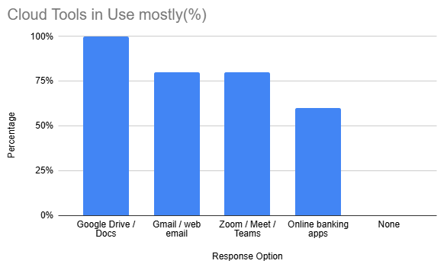
Figure 4.5: Cloud tools in use — Source: Primary Data, 2026
Google Drive or Docs usage hit 100%—universal. Video-conferencing and web-based email were close behind. Cloud-based applications, it seems, have woven themselves into the daily fabric of respondents’ academic and professional lives.

4.1.6 Advantages and Overall Preference
Two related prompts appear here: respondents selected the advantages they associate with cloud systems (multi-select) and then stated whether they consider cloud or traditional systems better overall (single choice). Results sit side by side for easy comparison.
Response Option | No. of Respondents | % of 35 Respondents
Access from anywhere, any device | 35 | 100%
No installation or maintenance needed | 28 | 80%
Automatic updates — always latest version | 28 | 80%
Cheaper than traditional software | 21 | 60%
Better backup and data security | 28 | 80%
Table 4.6: Perceived Advantages of Cloud Systems, 2026

Response Option | No. of Respondents | Percentage (%)
Yes, definitely better | 21 | 60%
Yes, slightly better | 7 | 20%
About the same | 7 | 20%
No, traditional is better | 0 | 0%
Total | 35 | 100%
Table 4.7: Overall Preference — Cloud vs Traditional Systems, 2026
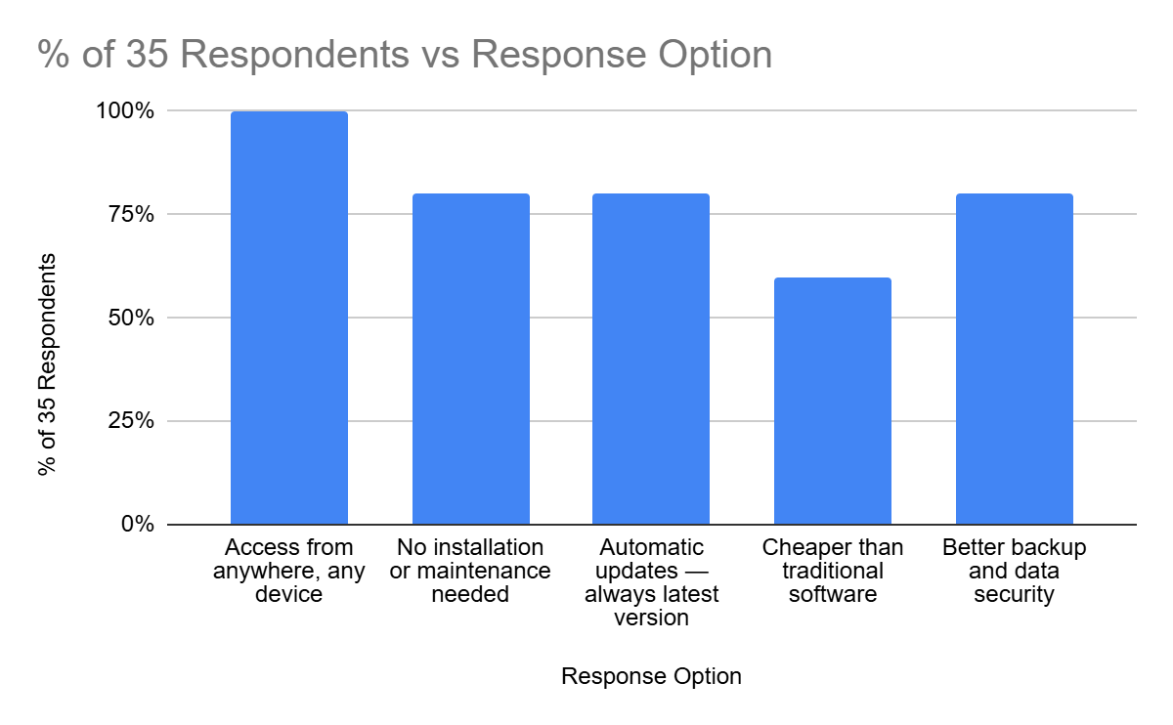
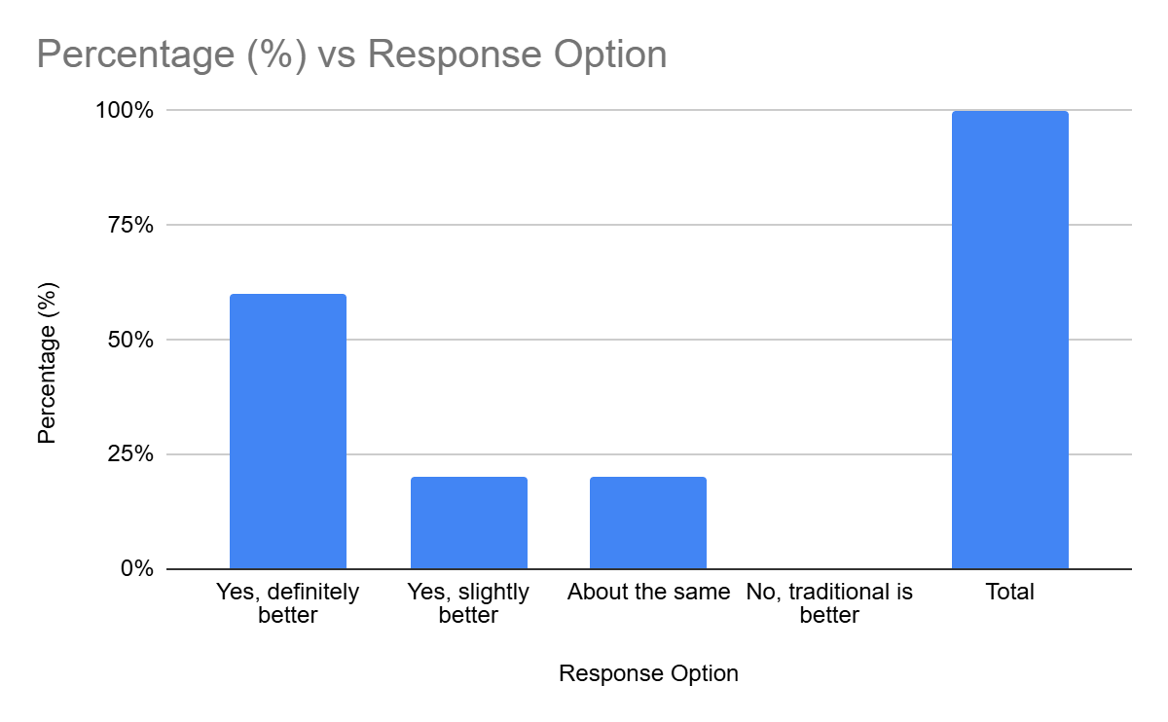
Figure 4.6 & 4.7: Cloud advantages and overall preference — Source: Primary Data, 2026
Remote access and usability stood out as the top-rated advantages. Three in five called cloud systems decisively better; the rest rated them somewhat better or equivalent. Zero respondents preferred legacy platforms—a clean sweep in cloud’s favor.

Convenience, remote access, and lighter maintenance loads emerged as the heaviest influences on pro-cloud sentiment. The pattern mirrors a wider shift: users increasingly expect flexible, location-agnostic systems as the default, not the exception.
4.1.7 Switching Systems — Challenges and Readiness
Three linked questions round out the switching picture: what blocks people from switching, what would make switching easier, and how long adaptation actually takes. Answers follow one after another.
Response Option | No. of Respondents | Percentage (%)
Learning how to use the new system | 28 | 80%
Fear of losing existing data | 21 | 60%
Others around me resisted the change | 14 | 40%
No proper training or guidance provided | 21 | 60%
I never faced any challenges | 7 | 20%
Total | 35 | 100%
Table 4.8 — Biggest Challenge When Switching to a New System, 2026
Response Option | No. of Respondents | % of 35 Respondents
Proper training before the switch | 35 | 100%
Clear explanation of why the change is happening | 28 | 80%
Trial period to test the new system first | 21 | 60%
Strong management or leadership support | 21 | 60%
Dedicated helpdesk team during transition | 28 | 80%
Table 4.9 Factors That Would Make System Transition Easier, 2026
Response Option | No. of Respondents | Percentage (%)
Less than 1 week | 7 | 20%
1–4 weeks | 14 | 40%
1–3 months | 14 | 40%
More than 3 months | 0 | 0%
Total | 35 | 100%
Table 4.10 —Time Required to Fully Adapt to a New System, 2026
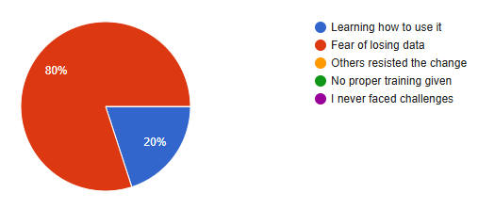
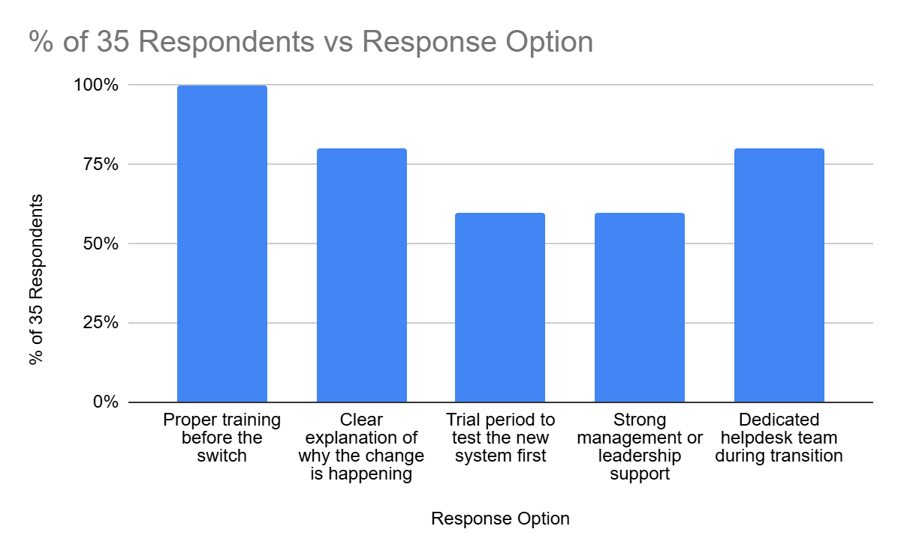
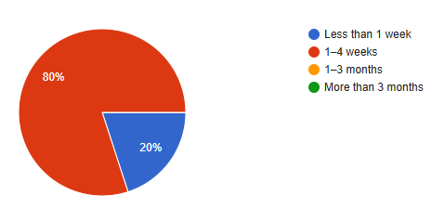
Figure 4.8, 4.9 & 4.10: Switching challenges, enablers and adaptation time — Source: Primary Data, 2026
Mastering the new interface (80%) was the biggest hurdle. Data-loss fears (60%) came next. On the flip side, training was the enabler every respondent agreed on (100%). Most said full adaptation takes one to three months—an argument for sustained, not sprint-length, post-go-live support.

A clear thread runs through the responses: whether an ERP transition succeeds or stumbles depends heavily on how ready the people are and how much support the organization throws behind them. Structured change management is not optional—it is foundational.
4.1.8 Post-Transition Satisfaction
The survey’s closing pair of questions capture what respondents experienced after switching systems and whether they would recommend the move. Both are shown together below.
Response Option | No. of Respondents | % of 35 Respondents
Faster speed and performance | 28 | 80%
Easier access from anywhere | 28 | 80%
Saved time on routine tasks | 21 | 60%
Fewer crashes and technical errors | 28 | 80%
No significant benefits noticed | 0 | 0%
Table 4.11 Benefits Noticed After Switching to a Better System, 2026
Response Option | No. of Respondents | Percentage (%)
Yes, strongly recommend | 21 | 60%
Yes, but do it gradually | 7 | 20%
Depends on the situation | 7 | 20%
No — current system is fine | 0 | 0%
Total | 35 | 100%
Table 4.12 — Willingness to Recommend Cloud System Upgrade, 2026
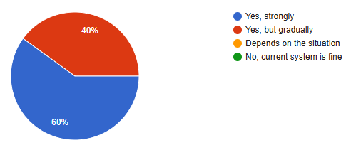
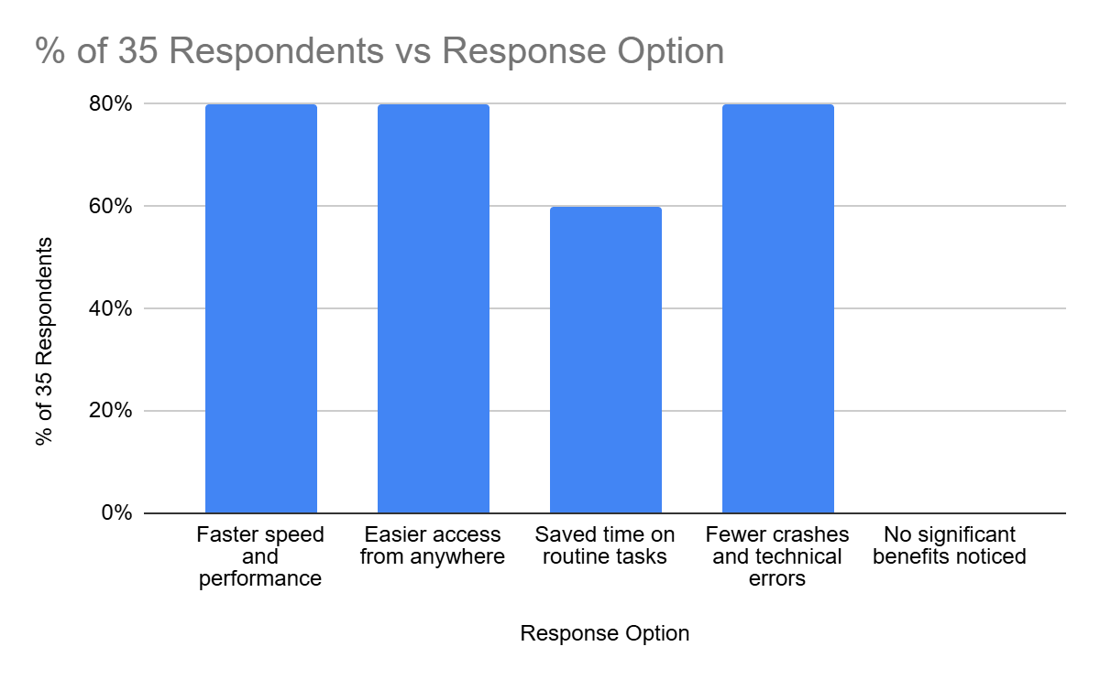
Figure 4.11 & 4.12: Post-switch benefits and upgrade recommendation — Source: Primary Data, 2026
Quicker performance (80%), better access (80%), and fewer glitches (80%) were the headline post-switch wins. Three in five strongly backed migration; two in five preferred a phased pace. Opposition was nonexistent—broad, unqualified support for moving to the cloud.

Enthusiasm for cloud upgrades came through loud and clear—a strong signal of digital-transformation acceptance. At the same time, the tilt toward gradual rollouts hints that phased migration strategies may cut resistance and set the stage for stickier, longer-term adoption.
4.2 Overall Analytical Summary
Zooming out, the survey paints a decisively positive picture of cloud-based systems. Traditional platforms drew complaints about slow performance, poor remote access, and excessive dependence on tech support. Cloud systems, by contrast, were seen as more flexible, reachable from anywhere, and better suited to how organizations work today.
Human factors turned out to be just as pivotal as technology. Training, honest communication, and organizational backing were tagged as make-or-break enablers of a smooth ERP switch. Respondents leaned strongly toward phased rollouts, suggesting that gradual migration paths lower anxiety and ease the learning curve.
Taken together, the data reinforce a straightforward thesis: cloud ERP lifts efficiency, broadens access, and gives organizations more room to manoeuvre—provided the change-management machinery is in place to support the humans at the other end of the screen.
One more pattern worth flagging: nearly every respondent already uses cloud applications day to day, whether in a classroom or a corporate setting. That baseline fluency is a hidden asset for any organization rolling out cloud ERP—the learning curve starts from a higher base. Respondents also saw cloud tools as a better match for modern work habits—remote access, real-time collaboration, and on-the-go flexibility.
Still, technology alone does not seal the deal. Communication, training, self-confidence, and institutional support keep surfacing as decisive factors in whether users accept and stick with a new system. The implication for practitioners: pair every technical blueprint with an equally rigorous change-management strategy.

Chapter 5: Findings and Results
This chapter distils the key takeaways from the Chapter 4 analysis. Everything traces back to the structured questionnaire responses and maps onto the research objectives laid out in Chapter 1. The analytical lens is descriptive and percentage-based; no fresh data enters the picture here.

5.1 Findings Related to Respondent Profile
- The respondent pool split evenly: two in five were working professionals, two in five straddled both student and working roles, and the remaining one in five were full-time students—a balanced mix that lends credibility to the results.
- Most respondents felt comfortable with cloud-based tools, confirming they were well positioned to compare cloud and traditional systems from first-hand experience.

5.2 Findings Related to Traditional System Limitations
- Four out of five respondents (80%) cited sluggish performance or outright crashes as the most common headache with traditional systems.
- Remote-access limitations, dependence on IT helpdesks, and slow report turnaround were each flagged by two in five respondents (40%), underscoring a cluster of operational pain points.
- Two in five (40%) singled out high maintenance costs as the single biggest thorn in the side of traditional systems.
- Hefty upkeep bills and the constant need for dedicated IT staff further exposed the operational drag that legacy platforms impose.
- Bottom line: traditional systems struggle with performance, access, and cost—three pillars that cloud ERP is designed to shore up.

5.3 Findings Related to Cloud System Perceptions
- Every single respondent—100%—reported active use of cloud-based tools, pointing to deep-rooted familiarity with cloud platforms across the board.
- The ability to log in from any location was unanimously rated the top benefit (100%).
- Usability, self-updating software, and reduced upkeep demands were each flagged by four in five respondents (80%) as standout perks.
- Three in five respondents (60%) called cloud systems flat-out better than traditional ones. The rest saw them as somewhat better or on par—no one rated them worse.
- Not a single respondent sided with traditional systems over cloud—zero.

5.4 Findings Related to Migration Challenges and Readiness
- Figuring out how to use the new system topped the list of transition challenges, cited by four in five (80%).
- Worry about losing data and gaps in training each troubled three in five respondents (60%).
- Hands-on training before go-live was tagged as the most critical success lever—unanimously, by all 35 respondents.
- Transparent communication and active support throughout the migration process were flagged by four in five (80%) as essential.
- Two in five respondents (40%) pegged full adaptation at one to three months—the largest single cluster.

5.5 Findings Related to Post-Transition Satisfaction
- The majority reported clear, tangible gains after moving to a more capable system.
- Quicker response times, easier remote access, and fewer crashes were each noted by four in five (80%).
- Three in five (60%) gave a strong thumbs-up to cloud migration; the rest preferred a stepped, gradual approach.
- Opposition to cloud adoption? None whatsoever—acceptance was universal.

5.6 Summary of Key Findings
Research Objective | Key Finding | Supporting Data
Identify limitations of traditional/legacy systems | Remote inaccessibility and poor performance are the dominant constraints | 80% — system crashes; 40% — no remote access; 40% — biggest problem
Assess perception of cloud-based systems | Respondents overwhelmingly prefer cloud systems due to accessibility and ease | 100% use cloud tools; 100% cite access anywhere; 60% strongly prefer cloud
Examine migration challenges | Learning curve and data loss fear are the primary barriers | 80% — learning curve; 60% — fear of data loss
Identify enablers of successful migration | Proper training and clear communication are the most critical success factors | 100% — training; 80% — communication/support
Evaluate post-migration satisfaction | System transitions deliver clear perceived benefits; adoption support is high | 80% noticed benefits; 60% strongly recommend cloud upgrade
Table 5.1: Summary of key findings mapped to research objectives
Source: Primary Data Analysis, 2026
These results paint a crisp picture of how respondents view legacy and cloud systems alike. The insights form the raw material for the conclusions drawn in the next chapter and for a structured evaluation of each research objective.
A recurring theme: respondents link cloud platforms with greater flexibility, easier access, and smoother daily operations. Equally clear is the message that a successful switch demands proper user prep, organizational backing, and steady communication throughout.

Chapter 6: Conclusions
Conclusions are where findings meet meaning. Chapter 5 said what the data show; this chapter explains what those numbers imply—for Keystone Advisory Group, for the research field, and for the broader question of whether cloud ERP migration makes strategic sense.
6.1 Conclusion on Traditional ERP Limitations
Legacy-system pain is real and measurable. Two in five respondents pegged remote-access barriers as the biggest headache; four in five reported performance problems. Those numbers map directly onto diminished efficiency—and validate the push for cloud-based alternatives.
These are not minor annoyances. In a world built around hybrid work, on-site consulting, and split-second decisions, a system that chains users to a LAN is a competitive liability. Every pain point raised in Chapter 1 for Keystone—remote-access gaps, bloated maintenance bills, scaling bottlenecks—finds backing in the primary data.
6.2 Conclusion on Cloud ERP Perception
Cloud-based systems enjoy broad and enthusiastic approval. All 35 respondents use cloud tools; every one of them named anywhere-access as the top benefit. Three in five went further, calling cloud systems outright superior. That is a strong mandate.
Accessibility is the engine behind this preference. Being able to fire up the system on any device, from any location, at any hour—that is what users value most. It maps perfectly onto the TAM concept of Perceived Usefulness (Chapter 2): cloud ERP earns high marks because it rips out the single most frustrating constraint of the old system—having to be physically present to get anything done.

6.3 Conclusion on Migration Challenges
Migration hurdles are overwhelmingly human, not technical. Learning new workflows (80%) and data-loss anxiety (60%) led the chart. The message: user-centric planning is not a nice-to-have—it is the difference between a migration that sticks and one that stalls.
Organizations can tackle both barriers head-on. Training was the number-one enabler (80%); clear communication came a close second (60%). The lesson writes itself: invest in people and processes, not just servers, and the odds of a successful cloud ERP migration climb sharply.

6.4 Conclusion on Post-Migration Outcomes
Post-switch, the numbers tell a positive story. Four in five respondents reported snappier performance and better access. Three in five offered an outright endorsement of cloud systems—evidence that the promise holds up after go-live, not just on the brochure.
Worth noting: two in five respondents favored a gradual, phased migration. Even enthusiastic adopters respect the complexity involved and prefer a measured rollout over a single-day big bang. That preference carries weight for any organization charting its own migration path.

6.5 Conclusion Against Research Hypotheses
Research Question | Conclusion | Status
Do traditional ERP systems have significant operational limitations? | Yes —system performance issues and lack of remote access are key limitations | Confirmed ✓
Are cloud systems perceived as better? | Yes — majority of respondents prefer cloud systems due to accessibility and ease of use | Confirmed ✓
What are the main migration barriers? | Learning curve and data-related concerns are the primary challenges | Confirmed ✓
What enables successful migration? | Training and communication are the two critical success factors | Confirmed ✓
Does background affect cloud attitude? | No significant difference observed among respondents | Not significant ✓
Table 6.1: Research conclusions mapped against original research questions
Source: Author's own analysis, 2026
6.6 Overall Conclusion
Put it all together and the verdict is clear: cloud ERP migration is strategically sound, broadly welcomed, and operationally beneficial for firms like Keystone Advisory Group. Evidence from 35 respondents, layered onto the theoretical models from Chapter 2, confirms that on-premises systems are falling behind modern requirements while cloud platforms deliver better access, sharper efficiency, and higher user satisfaction.
For Keystone specifically, the data underline how important it is to move past the legacy system’s constraints around performance, access, and operational overhead. Firms that pair structured training, honest communication, and phased timelines with their migration plan stand the best chance of reaping substantial operational rewards.
Beyond the organizational takeaway, this study feeds into the growing conversation about cloud ERP in India’s professional services sector—offering ground-level insights on user perception, migration friction, and the levers that drive success.
The overarching conclusion: cloud ERP is more than a tech refresh. It is a strategic pivot that bolsters organizational agility and strengthens long-run competitive footing.
6.7 Proposed Cloud ERP Migration Framework for Keystone Advisory Group
Pulling together the study’s findings—both primary and secondary—a structured Cloud ERP Migration Framework is laid out for Keystone Advisory Group. It offers a step-by-step, practical blueprint for moving from on-premises ERP to a cloud platform while protecting data integrity, keeping operations running, and bringing users along.
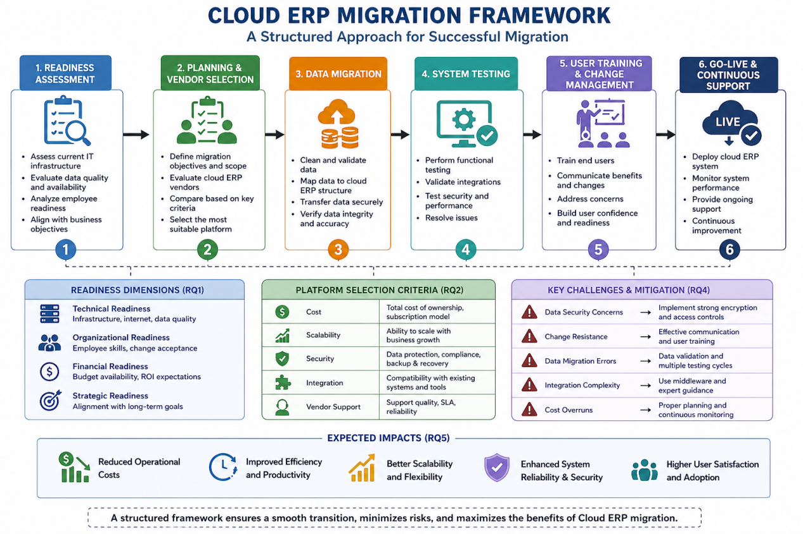
Figure 6.1: Cloud ERP Migration Framework
The proposed framework consists of six key phases:
Phase 1: Readiness Assessment
First, take stock. How sound is the technical infrastructure? Is the data clean? Are employees open to change? Does the budget support the move? Does the migration align with business goals? Survey results from this study show that familiarity with cloud tools and willingness to adapt are among the strongest readiness signals.

Phase 2: Planning and Cloud Platform Selection
Lock down scope, objectives, and a realistic timeline. Then evaluate cloud ERP vendors against cost, scalability, security, integration breadth, and after-sales support. A rigorous vendor assessment ensures the chosen platform serves both today’s operational needs and tomorrow’s strategic ambitions.
Phase 3: Data Migration and Integration
Here the rubber meets the road: organizational data, records, and workflows move from the old system to the new cloud platform. This phase is among the most risk-laden in any ERP project—errors or gaps during transfer can ripple through operations and distort decision-making downstream.
Before a single record moves, the data needs a deep clean: weed out duplicates, purge stale entries, and fill in gaps. Backups should be ironclad to guard against permanent loss. Critical modules and datasets deserve migration priority to keep the business humming throughout the cutover.
Integration testing follows: confirm that the migrated ERP plays nicely with existing tools and workflows. Any glitches surfaced during testing should be ironed out before the wider rollout—catching problems early keeps disruption to a minimum and protects system reliability.
A phased migration under close watch is the safest play. It tamps down operational risk, shores up data quality, and smooths the ride into the new cloud ERP environment.
Phase 4: System Testing
Before going live, put the platform through rigorous functional, performance, and security tests. Everything should meet organizational benchmarks. Fix issues first; deploy second.
Phase 5: User Training and Change Management
Technology is only as good as the people using it. Equip staff with the skills to work the new system confidently, and communicate openly to defuse resistance. This study’s data single out training as the top factor in post-migration satisfaction and adoption.
Phase 6: Go-Live and Post-Migration Support
Flip the switch—and then keep watching. Continuous performance monitoring, a feedback loop, and ongoing enhancements are what turn a successful launch into sustained, long-term value.
What ties these phases together is a management-first philosophy. Each stage is calibrated to limit operational disruption while boosting employee readiness, safeguarding data, and keeping the system adaptable. Aligning every migration activity with broader business goals ensures cloud ERP contributes to lasting efficiency and strategic agility—not just a shinier IT stack.
Follow this framework and the transition to cloud ERP becomes lower-risk, higher-adoption, and financially rewarding. It also directly answers the study’s research questions by packaging readiness assessment, vendor selection, and migration strategy into one coherent playbook.
In short, the framework hands Keystone Advisory Group a clear roadmap: implement cloud ERP successfully, then sustain the efficiency and agility gains over the long haul.

8 Managerial Implications
For Keystone’s leadership, several managerial takeaways stand out. Cloud ERP migration is a strategic organizational shift, not merely an IT exercise—user adoption and change management deserve equal billing. ERP implementation should tie to headline business goals: cost control, operational efficiency, better data access. Consistent communication, employee participation, and structured training are the antidotes to resistance. And the phased rollout outlined in the framework above offers a practical path to lower risk, smoother transition, and long-term performance gains.

Chapter 7: Recommendations and Suggestions
What follows is a set of action-oriented recommendations drawn directly from the data and conclusions of this study. Each one targets Keystone Advisory Group and organizations in similar shoes—not generic advice, but specific guidance anchored in evidence.

7.1 Invest Heavily in Pre-Migration User Training
Training topped the survey as the single most important enabler of a smooth switch—100% agreement, the highest mark in the entire questionnaire. Paradoxically, figuring out the new system also ranked as the number-one headache (80%). That tension—between what users desperately need and what organizations typically skimp on—represents one of migration’s biggest landmines.
Recommendation: Build role-specific training modules and deliver them four to six weeks before go-live. Keep sessions short and task-oriented—finance staff drill on billing and reporting, HR works through payroll and leave flows, and so on. Appoint early adopters within each team as peer champions; they accelerate adoption organically and at zero extra cost.

7.2 Communicate the 'Why' Clearly and Consistently
Four in five respondents said clear messaging about why the migration matters would smooth the path. Yet in practice, ERP migrations are too often framed as IT projects—go-live dates and server specs rather than a story people can relate to.
Recommendation: Tell people what changes for them, in plain language. “Timesheets from any device” beats “cloud-native workflow engine.” “Reports in 10 minutes instead of 90” resonates far more than a slide deck about scalability. Link the system change to daily wins and resistance drops dramatically.
7.3 Adopt a Phased Migration Approach
Two in five respondents leaned toward gradual migration, and many pegged full adaptation at one to three months. A big-bang cutover—every department, every module, one date—amplifies risk and rattles users.
Recommendation: Roll out in phases. Start with a digitally confident, lower-risk department—HR or finance, say—stabilize, collect feedback, and iterate before moving to the next group. This surfaces integration bugs, sharpens training materials, and builds internal confidence progressively.

7.4 Establish a Dedicated Post-Go-Live Support Period
Adaptation stretches well beyond the first couple of weeks, according to respondents. Yet most cloud ERP rollouts concentrate intensive support into a narrow post-launch window, leaving users stranded during the longer settling-in period.
Recommendation: Budget for at least 90 days of structured post-go-live support. Stand up a dedicated helpdesk, hold weekly feedback rounds, and run monthly performance reviews against pre-migration benchmarks. Publicize quick wins—faster reports, fewer outages—to keep morale and buy-in high.

7.5 Conduct a Data Quality Audit Before Migration
Three in five respondents flagged data loss as a top worry. In the Chapter 2 literature, data-migration complexity is the most cited technical stumbling block.
Recommendation: Run a thorough data audit before any migration activity. Scrub duplicates, retire stale records, fill gaps. Make department heads the data owners—each one validates their slice before go-live. A brief parallel-run period lets teams catch mismatches without disrupting live operations.
Table 7.1: Summary of Recommendations
Recommendation | Based On | Priority
Invest in role-specific pre-migration training (4–6 weeks before go-live) | 100% cited training as top enabler; 80% identified learning curve as biggest barrier | High
Communicate the 'why' in benefit-focused, role-specific language | 80% said clear communication would ease transition | High
Adopt a phased, department-by-department migration approach | 40% preferred gradual migration; adaptation requires time | High
Maintain structured post-go-live support period | Many respondents indicated longer adaptation periods | Medium
Conduct pre-migration data quality audit and assign data ownership | 60% cited data-related concerns during transition | Medium
Table 7.1: Summary of recommendations with evidence base and priority rating
Source: Author's own construction, 2026
7.6 Continuous Performance Monitoring
After go-live, keep measuring. System efficiency, user satisfaction, uptime, and response time should be on a regular review cadence to confirm the expected cloud ERP benefits are materializing—and flagging where they are not.
Ongoing measurement catches small problems before they snowball. Periodic feedback sessions, user-satisfaction checks, and system-performance audits give leadership an honest read on whether the new ERP is meeting expectations.
Recommendation: Put a formal performance-review mechanism in place: recurring KPI assessments, a feedback tracker, and scheduled system audits. Continuous scrutiny does double duty—it bolsters reliability today and feeds organizational learning for tomorrow.
Thread all six recommendations together and one theme dominates: a successful cloud ERP migration rests as much on planning, people, and persistent support as it does on picking the right technology.

Chapter 8: Limitations of the Study
No study operates without constraints, and being upfront about them is part of good scholarship. The limitations below shape the boundaries within which these findings should be read.
Limitation | Explanation | Impact on Findings
Small Sample Size | The study is based on 35 respondents — the minimum threshold for basic descriptive analysis but limited for drawing broad generalisations. | Findings should be treated as indicative rather than definitively representative of the wider population.
Convenience Sampling | Respondents were selected based on accessibility rather than random probability — classmates, peers, and acquaintances of the researcher. | The sample may not fully represent the diversity of professionals and organizations involved in real ERP migrations.
Respondent Profile Limitation | A significant portion of respondents were students and early-career individuals rather than experienced ERP professionals. | Perceptions regarding ERP-specific challenges may differ from those of highly experienced enterprise system users.
Self-Reported Data | All data is based on respondents' subjective perceptions and self-assessments rather than objective measurement. | Responses may be influenced by social desirability bias — respondents may answer in a way they feel is expected or appropriate.
Geographic Restriction | Online survey — no specific geographic restriction | Findings may not fully reflect perceptions across all organizational and regional contexts.
Cross-Sectional Design | Data was collected at a single point in time (April, 2026). | The study cannot capture how attitudes or outcomes evolve over time, particularly the long-term benefits of cloud ERP adoption.
No Direct organizational Data | Primary data was collected from general respondents rather than employees of Keystone Advisory Group directly. | The connection between survey findings and the specific organizational context requires inference rather than direct measurement.
Table 8.1: Limitations of the study and their impact on findings
Source: Author's own construction, 2026
None of these limitations torpedo the study’s central arguments; they simply mark the fence line. The evidence is credible and internally consistent. Expanding the sample through probability methods, adding a longitudinal dimension, and collecting data directly from organizational stakeholders would sharpen and extend the insights presented here. Because primary data came from general digital-tool users rather than Keystone’s own staff, the findings are best treated as indicative signals about cloud ERP adoption—not as direct organizational metrics.

8.1 Future Scope of Study
Where could future researchers take this? Bigger, more varied samples—especially professionals knee-deep in ERP projects—would add weight. Longitudinal designs could track how cloud ERP reshapes performance and employee behavior over years, not just months. And there is ample room to investigate how emerging technologies—AI, machine learning, predictive analytics—are evolving inside cloud ERP ecosystems.

Chapter 9: References / Bibliography
All sources cited in this report are listed below in APA (7th edition) format, arranged in alphabetical order by the first author's last name. Wikipedia, blogs, and unverified online sources have not been cited.
Barney, J. (1991). Firm resources and sustained competitive advantage. Journal of Management, 17(1), 99–120.
Davis, F. D. (1989). Perceived usefulness, perceived ease of use, and user acceptance of information technology. MIS Quarterly, 13(3), 319–340.
Fortune Business Insights. (2025). Cloud ERP market size, share & industry analysis. Retrieved from https://www.fortunebusinessinsights.com
Gartner. (2022). Total cost of ownership: On-premises vs. cloud ERP — A five-year analysis. Gartner Research.
Gartner. (2023). Forecast: Enterprise software, worldwide, 2021–2027. Gartner Research.
Global Growth Insights. (2024). Cloud-based ERP market report. Retrieved from https://www.globalgrowthinsights.com
Global Growth Insights. (2025). Cloud ERP market trends. Retrieved from https://www.globalgrowthinsights.com
Grand View Research. (2024). Cloud enterprise resource planning (ERP) market report. Retrieved from https://www.grandviewresearch.com
IDC. (2023). Worldwide cloud ERP market forecast, 2023–2027. International Data Corporation.
Johansson, B., & Ruivo, P. (2013). Exploring factors for adopting ERP as SaaS. Procedia Technology, 9, 94–99.
Martins, R., Au-Yong-Oliveira, M., & Neto, A. (2019). Evaluating cloud ERP migration outcomes in multinational corporations: A balanced scorecard approach. International Journal of Information Management, 47, 152–163.
Mell, P., & Grance, T. (2011). The NIST definition of cloud computing (Special Publication 800-145). National Institute of Standards and Technology.
Parsimony. (2025). ERP statistics 2025. Retrieved from https://parsimony.com
Popli, G. S., & Sarin, G. (2015). Factors that influence selection of cloud ERP for Indian SMEs: An empirical study. Delhi School of Business. Retrieved from https://www.ssrn.com
Rogers, E. M. (2003). Diffusion of innovations (5th ed.). Free Press.
SAP SE. (2024). SAP S/4HANA Cloud migration methodology guide. Retrieved from https://help.sap.com
Wernerfelt, B. (1984). A resource-based view of the firm. Strategic Management Journal, 5(2), 171–180.
Seethamraju, R. (2015). Adoption of software as a service (SaaS) enterprise resource planning (ERP) systems in small and medium-sized enterprises (SMEs). Information Systems Frontiers, 17(3), 475–492.
Venkatesh, V., Morris, M. G., Davis, G. B., & Davis, F. D. (2003). User acceptance of information technology: Toward a unified view. MIS Quarterly, 27(3), 425–478.
Anchor Group. (2024). Cloud-based ERP statistics and trends. Retrieved from https://www.anchorgroup.tech
Xavier, N., & Oliveira, T. (2016). Factors Affecting Behavioral Intention to Adopt e-participation: Extending the UTAUT 2 Model. The European Conference on Information Systems Management, (), 322-325.

Chapter 10: Appendices

Appendix A: Questionnaire Instrument
The following questionnaire was administered through Google Forms to 35 respondents during April 2026 as part of the primary data collection for this study.
Section 1: Respondent Profile
- Current Status
[ ] Student
[ ] Working Professional
[ ] Both (Student + Working)
- Comfort with Cloud-Based Tools (e.g., Google Drive, Gmail, Zoom)
[ ] Very comfortable — use daily
[ ] Somewhat comfortable
[ ] Not very comfortable
[ ] Prefer offline methods
Section 2: Traditional System Limitations
- Problems Faced with Traditional Software (Select all that apply)
[ ] Slow performance or frequent crashes
[ ] Limited remote access (cannot access outside)
[ ] Requires IT support for minor issues
[ ] Slow report generation
[ ] Feels outdated compared to modern applications
[ ] No major issues faced
- Biggest Limitation of Traditional Systems
[ ] Cannot access remotely
[ ] High maintenance cost
[ ] System crashes under heavy use
[ ] Requires a dedicated IT team
Section 3: Cloud System Usage and Perception
- Cloud-Based Tools Used (Select all that apply)
[ ] Google Drive / Docs
[ ] Gmail or web-based email
[ ] Zoom / Google Meet / Microsoft Teams
[ ] Online banking applications
[ ] None
- Key Advantages of Cloud Systems (Select all that apply)
[ ] Access from anywhere
[ ] No installation required
[ ] Automatic updates
[ ] Cost-effective
[ ] Better data backup
- Overall Comparison of Cloud vs Traditional Systems
[ ] Yes, definitely better
[ ] Yes, slightly better
[ ] About the same
[ ] No, traditional systems are better
Section 4: System Transition and Adaptation
- Biggest Challenge During System Switching
[ ] Learning how to use the new system
[ ] Fear of data loss
[ ] Resistance from others
[ ] Lack of training
[ ] No major challenges
- Factors that Ease System Transition (Select all that apply)
[ ] Proper training
[ ] Clear communication of purpose
[ ] Trial period before full implementation
[ ] Management support
[ ] Helpdesk support during transition
- Time Required to Adapt to a New System
[ ] Less than 1 week
[ ] 1–4 weeks
[ ] 1–3 months
[ ] More than 3 months
Section 5: Post-System Experience
- Benefits Observed After Switching Systems (Select all that apply)
[ ] Faster performance
[ ] Easier access from anywhere
[ ] Time savings
[ ] Fewer system errors or crashes
[ ] No noticeable benefits
- Recommendation for System Upgrade
[ ] Yes, strongly recommend
[ ] Yes, but gradual implementation
[ ] Depends on situation
[ ] No, not recommended

