MBA PROJECT REPORT
ON
DIGITAL BANKING IN TODAY'S WORLD: A CASE STUDY OF YONO SBI

Submitted in Partial Fulfilment of the Requirements
for the Award of the Degree of
MASTER OF BUSINESS ADMINISTRATION

Submitted By:
[Student Name]
Enrollment No.: [XXXXXXXX]

Under the Guidance of:
[Guide Name], [Designation]
[Department of Management Studies]
[University Name]
[City, India]

Academic Year: 2024-2025

Certificate
This is to certify that the project report entitled “Digital Banking In Today'S World: A Case Study Of Yono Sbi” has been carried out by [Student Name], Enrollment No. [XXXXXXXX], under my guidance, in partial fulfilment of the requirements for the award of the degree of Master of Business Administration during the academic year 2024-2025.
The work embodied in this project is original and has not been submitted to any other university or institution for the award of any other degree or diploma. The student has demonstrated sincere effort, analytical ability, and academic integrity throughout the project.

Place: ____________________
Date: ____________________

_________________________
[Guide Name]
[Designation]
[Department of Management Studies]
[University Name]

(Note: Where a formal certificate is issued by the institute or by the Qollabb platform, paste the signed certificate here in place of this text.)

Declaration
I, [Student Name], hereby solemnly declare that the project report titled “Digital Banking In Today'S World: A Case Study Of Yono Sbi”, submitted in partial fulfilment of the requirements for the award of the degree of Master of Business Administration (MBA), is my original work.
I further declare that:
- This project has been carried out by me during the academic year 2024-2025 under the supervision of [Guide Name] ([Designation]).
- The work has not been submitted previously to any other university, institution, or examination body for the award of any degree, diploma, or certification.
- All sources of information used in this report have been duly acknowledged and referenced in accordance with academic ethics and plagiarism norms.
- The data presented in this report is authentic to the best of my knowledge and has not been fabricated or manipulated.
- I understand that if any part of this declaration is found to be false, my project may be rejected and disciplinary action may be taken as per institutional rules.

Place: ____________________
Date: ____________________

Student Signature: ____________________
Student Name: [Student Name]
Enrollment No.: [XXXXXXXX]

Acknowledgement
The completion of this project would not have been possible without the support, guidance, and encouragement of several individuals and institutions, to whom I wish to express my sincere gratitude.
I am deeply grateful to my project guide, [Guide Name], [Designation], Department of Management Studies, [University Name], for providing continuous direction, constructive feedback, and academic rigour throughout the course of this study. Their patience and insight were instrumental in shaping this report.
I would also like to thank the Dean, the Head of Department, and the faculty members of the Department of Management Studies at [University Name] for providing the academic resources and institutional support that made this project possible.
I am thankful to the branch managers and staff of State Bank of India who spared their time for informal discussions, and to the YONO SBI users who took part in the survey for this study. Their candid responses form the empirical core of this work.
Finally, I wish to thank my family and peers for their unwavering support and encouragement during the course of this MBA project.

[Student Name]
Enrollment No.: [XXXXXXXX]

Abstract / Executive Summary
This study examines the evolution, performance, and strategic significance of digital banking in India, using YONO SBI as the primary case. The research addresses five specific objectives: analysing the growth of digital banking since 2016, evaluating the benefits and challenges of platforms such as YONO, examining their impact on financial management practice, identifying emerging trends, and deriving career-relevant implications for MBA students.
A descriptive research design with exploratory elements was adopted. Primary data was collected through a structured 30-item questionnaire administered to 150 YONO SBI users across urban, semi-urban, and rural India, supplemented by semi-structured interviews with branch managers and one fintech professional. Secondary data was drawn from SBI and RBI publications, NPCI statistics, and peer-reviewed journals. Data was analysed in Microsoft Excel and IBM SPSS 26 using descriptive statistics, Pearson correlation, multiple regression, chi-square tests, and Cronbach's alpha.
The study finds that perceived usefulness and ease of use are the strongest predictors of user satisfaction with YONO, followed by security perception and accessibility. Younger, urban respondents report higher usage frequency, while rural and older users cite onboarding friction and language support as key barriers. The launch of YONO 2.0 in December 2025 addresses many of these issues. The report concludes with actionable recommendations for SBI, regulators, and MBA students in financial services.

Table of Contents
Section | Page
Certificate | i
Declaration | ii
Acknowledgement | iii
Abstract / Executive Summary | iv
List of Tables | vi
List of Figures | vii
List of Abbreviations | viii
Chapter 1 - Introduction | 1
1.1 Background of the Study | 1
1.2 Industry Profile: Indian Banking and the Digital Revolution | 2
1.3 Company Profile: State Bank of India and YONO | 3
1.4 Problem Statement | 5
1.5 Need and Importance of the Study | 5
1.6 Objectives of the Study | 6
1.7 Research Questions | 7
1.8 Scope of the Study | 7
1.9 Chapter Scheme | 8
Chapter 2 - Literature Review | 10
2.1 Introduction to the Literature Review | 10
2.2 Theoretical Concepts and Frameworks | 11
2.3 Review of Previous Studies | 13
2.4 Research Gap Identification | 20
2.5 Conceptual Framework | 21
2.6 Chapter Summary | 22
Chapter 3 - Research Methodology | 24
3.1 Introduction | 24
3.2 Research Design | 24
3.3 Type of Data | 25
3.4 Data Collection Methods | 26
3.5 Sampling Design | 27
3.6 Research Tools | 28
3.7 Statistical Techniques | 29
3.8 Research Hypotheses | 30
3.9 Reliability and Validity | 31
3.10 Ethical Considerations | 32
3.11 Limitations of the Methodology | 33
3.12 Chapter Summary | 33
Chapter 4 - Data Analysis and Interpretation | 36
Chapter 5 - Findings / Results | 48
Chapter 6 - Conclusions | 52
Chapter 7 - Recommendations | 55
Chapter 8 - Limitations of the Study | 57
Chapter 9 - References | 58
Chapter 10 - Appendices | 62

(Note: Page numbers shown above are indicative. After any edits, highlight this section in Microsoft Word, press F9, and choose “Update entire table” to refresh, or regenerate via References → Table of Contents.)

List of Tables
Table 2.1 Study-wise summary of Davis (1989) on the Technology Acceptance Model
Table 2.2 Study-wise summary of Venkatesh et al. (2003) on UTAUT
Table 2.3 Study-wise summary of Saxena et al. (2023) on mobile banking adoption in India
Table 2.4 Study-wise summary of Chauhan et al. (2022) on extended UTAUT2 in e-banking
Table 2.5 Study-wise summary of Mer et al. (2023) on millennials' mobile banking adoption
Table 2.6 Study-wise summary of Jadil et al. (2021) meta-analysis of UTAUT in m-banking
Table 2.7 Study-wise summary of Ijaz et al. (2023) on cybersecurity and digital banking
Table 2.8 Study-wise summary of Balasundaram et al. (2025) on digital inclusion in rural India
Table 2.9 Study-wise summary of Haralayya (2021) on in-branch drivers of digital transition
Table 2.10 Study-wise summary of IJSDR (2023) on YONO user perception in Mandya
Table 3.1 Targeted sample distribution
Table 3.2 Questionnaire structure
Table 3.3 Statistical techniques and their application
Table 3.4 Reliability statistics - pilot test results
Table 4.1 Cronbach's alpha reliability (full sample)
Table 4.2 Gender distribution of respondents
Table 4.3 Age distribution of respondents
Table 4.4 Geographic distribution of respondents
Table 4.5 Education distribution of respondents
Table 4.6 YONO usage level of respondents
Table 4.7 Awareness and usage frequency of YONO
Table 4.8 Perceived usefulness - mean, SD, and rank
Table 4.9 Perceived ease of use - mean, SD, and rank
Table 4.10 Satisfaction levels across YONO services
Table 4.11 Top reported challenges with YONO
Table 4.12 Future intent and recommendation behaviour
Table 4.13 Pearson correlation matrix (key constructs)
Table 4.14 Chi-square test: age group vs. frequency of YONO use
Table 4.15 Multiple regression: predictors of overall satisfaction
Table 4.16 Summary of hypothesis testing decisions

List of Figures
Figure 1.1 UPI transaction volume in India (FY 2017-18 to FY 2023-24)
Figure 1.2 Growth of YONO SBI registered user base (2018 to Dec 2025)
Figure 2.1 Integrated conceptual framework for digital banking adoption in India
Figure 3.1 Targeted geographic distribution of the sample (N = 150)
Figure 4.1 Gender distribution of respondents
Figure 4.2 Age distribution of respondents
Figure 4.3 Geographic distribution of respondents
Figure 4.4 Education distribution of respondents
Figure 4.5 YONO usage level of respondents
Figure 4.6 Awareness of YONO features
Figure 4.7 Frequency of YONO use
Figure 4.8 Perceived usefulness - item-wise mean scores
Figure 4.9 Perceived ease of use - item-wise mean scores
Figure 4.10 Satisfaction across YONO service categories
Figure 4.11 Top challenges reported by YONO users
Figure 4.12 Future intent and recommendation behaviour
Figure 4.13 Pearson correlation matrix (illustrative values)
Figure 4.14 Predictors of overall YONO user satisfaction (regression)

List of Abbreviations
Abbreviation | Full Form
APA | American Psychological Association (referencing style)
ATM | Automated Teller Machine
B2C | Business-to-Consumer
BBA | Bachelor of Business Administration
CAGR | Compound Annual Growth Rate
CBS | Core Banking Solution
CB-SEM | Covariance-Based Structural Equation Modelling
CDFI | Composite Digital Financial Inclusion Index
CERT-In | Indian Computer Emergency Response Team
DOI | Diffusion of Innovations (theory)
EMI | Equated Monthly Instalment
FY | Financial Year
IBM | International Business Machines Corporation
IMPS | Immediate Payment Service
KPI | Key Performance Indicator
KYC | Know Your Customer
MAU | Monthly Active Users
MBA | Master of Business Administration
MIS | Management Information Systems
NBFC | Non-Banking Financial Company
NPCI | National Payments Corporation of India
OTP | One-Time Password
PEOU | Perceived Ease of Use
PMJDY | Pradhan Mantri Jan Dhan Yojana
PU | Perceived Usefulness
RBI | Reserve Bank of India
R² | Coefficient of Determination
SBI | State Bank of India
SD | Standard Deviation
SEM | Structural Equation Modelling
SPSS | Statistical Package for the Social Sciences
TAM | Technology Acceptance Model
UPI | Unified Payments Interface
UTAUT | Unified Theory of Acceptance and Use of Technology
YONO | You Only Need One

Chapter 1 Introduction

1.1 Background of the Study
Banking has never really stood still. But the shift toward digital over the past decade has been something else entirely. What used to require a long queue at a branch counter can now be done in seconds on a smartphone, whether you are transferring money, applying for a loan, or checking your balance at midnight. This transformation is not just about convenience; it is reshaping how financial institutions operate, how customers behave, and how economies grow.
India stands at the centre of this transformation. With over 1.4 billion people, a young population, and one of the fastest growing internet user bases in the world, the country has become a global case study in digital financial inclusion (Reserve Bank of India, 2024). Government initiatives like Digital India, the launch of the Unified Payments Interface (UPI) in 2016, and the push for Aadhaar-linked banking have collectively created an ecosystem where digital banking is no longer a luxury but an expectation.
The numbers speak for themselves. According to the Ministry of Finance, total digital payment transactions in India grew from 2,071 crore in FY 2017-18 to 18,737 crore in FY 2023-24, representing a compound annual growth rate (CAGR) of 44 percent (Department of Financial Services, Government of India, 2024). UPI alone processed 13,116 crore transactions in FY 2023-24, growing at a CAGR of 129 percent from just 92 crore transactions in FY 2017-18. These are not just statistics; they represent a fundamental shift in how Indian households and businesses interact with money.
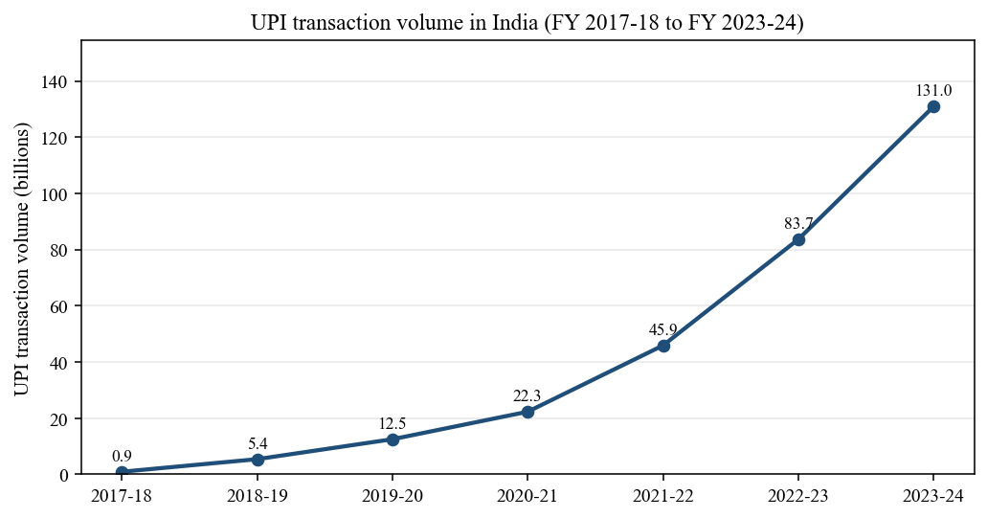
Figure 1.1: UPI transaction volume in India (FY 2017-18 to FY 2023-24)
Interpretation: Figure 1.1 shows the steep non-linear growth in UPI volumes over seven years. The near-vertical curve between FY 2019-20 and FY 2023-24 reflects both the post-demonetisation digital push and the pandemic-induced shift away from cash. It provides the macro backdrop against which YONO SBI's own trajectory must be understood.
In this rapidly evolving landscape, public sector banks faced an unusual challenge. Historically seen as stable but slow moving, institutions like State Bank of India (SBI) had to prove they could compete with nimble fintech startups and private banks. SBI's answer was YONO, short for You Only Need One, a digital banking platform launched in November 2017 that would go on to become one of the most downloaded banking applications in India. With 9.60 crore registered users as of December 2025 and the launch of YONO 2.0 in the same month, the platform represents a serious and well documented attempt by a legacy institution to reinvent itself for the digital age (SBI, 2025).
This study examines digital banking through the lens of YONO SBI, using it as a primary case study to understand broader trends, challenges, and future directions in the Indian banking sector.

1.2 Industry Profile: Indian Banking and the Digital Revolution
The Indian banking industry is one of the most complex and consequential financial systems in the world. It comprises public sector banks, private sector banks, foreign banks, cooperative banks, regional rural banks, and non-banking financial companies (NBFCs), all regulated by the Reserve Bank of India (RBI). As of 2024, SBI alone holds a 23 percent market share by assets and serves over 500 million customers, making it one of the largest banks globally by customer base (Wikipedia: State Bank of India, 2025).
The digital transformation of Indian banking began in earnest around 2014 to 2016, driven by several converging forces. The government's demonetisation exercise in November 2016, while controversial, gave a significant push to digital payments adoption almost overnight. At the same time, smartphone penetration was climbing rapidly, data costs were collapsing (thanks largely to Reliance Jio's entry in 2016), and the NPCI was building infrastructure that would support real-time digital transactions at scale.
The result has been remarkable. India today accounts for nearly 48.5 percent of the world's real-time payment transactions, according to the RBI's annual report and ACI Worldwide data (IBS Intelligence, 2024). UPI has seen a tenfold increase in volume over just four years, jumping from 12.5 billion transactions in 2019-20 to 131 billion in 2023-24, which equals 80 percent of all digital payment volumes in the country (RBI, 2024). The value of UPI transactions correspondingly surged from Rs 1 lakh crore to Rs 200 lakh crore over the same period, at a CAGR of 138 percent (Department of Financial Services, 2024).
This growth is not accidental. It is the outcome of deliberate policy choices, infrastructure investment, and competitive pressure from fintech players like Paytm, PhonePe, and Google Pay. Traditional banks had no option but to respond. Some responded defensively, adding digital features to legacy systems. Others, like SBI with YONO, chose to build something new from the ground up. The distinction matters, because it reflects fundamentally different philosophies about what banking in the 21st century should look like.
For financial management students and professionals, understanding this industry transformation is not optional. Digital banking has changed how institutions manage liquidity, credit risk, customer acquisition, and regulatory compliance. It has opened new revenue streams and eliminated old ones. Anyone entering the financial sector today needs to understand these dynamics intimately, because they define the competitive terrain.

1.3 Company Profile: State Bank of India and YONO
State Bank of India traces its origins to the Bank of Calcutta, founded in 1806. It is today the largest commercial bank in India, ranked 43rd globally by total assets and 163rd in the Fortune Global 500 as of 2025 (Wikipedia: State Bank of India, 2025). The bank operates through a network of over 22,000 branches and 63,580 ATMs across India, with 241 overseas offices spread across 36 countries. It employs approximately 232,296 people and serves over 500 million customers, a customer base that is simply staggering in its scale.
Despite its dominance, SBI recognised by the mid-2010s that digital disruption posed a genuine threat. Millennials were gravitating toward private banks and fintech apps. SBI's image as a slow, bureaucratic institution was a liability in a market increasingly driven by speed and convenience. The response was Project Lotus, an internal initiative that eventually became YONO.
YONO, an acronym for You Only Need One, was conceived as an integrated digital platform that would serve as a one-stop destination for all of a customer's banking and lifestyle needs. The platform was officially launched on November 24, 2017, developed under the leadership of then-MD and later Chairman Rajnish Kumar, with McKinsey providing strategic consulting and IBM building the underlying technology stack (BusinessToday, 2021). The development took approximately two years and involved a dedicated cross-functional team working out of a startup-style office complete with digital whiteboards and open-plan garages.
The scope of YONO goes well beyond mobile banking. It integrates over 100 e-commerce partners, offering flight and train bookings, hotel reservations, online shopping, insurance purchases, mutual fund investments, and medical bill payments, all within a single application (Wikipedia: YONO, 2026). It offers YONO Cash, a cardless ATM withdrawal feature introduced in March 2019, and YONO Krishi, a dedicated sub-platform for the agricultural community. It also supports account opening, pre-approved loan disbursals, and UPI payments.
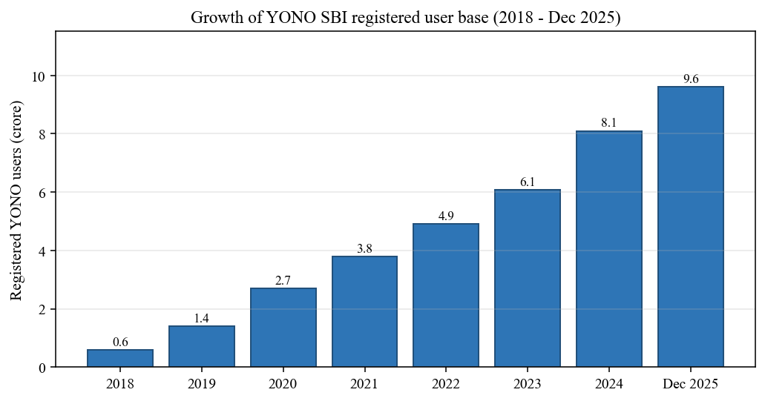
Figure 1.2: Growth of YONO SBI registered user base (2018 to Dec 2025)
Interpretation: Figure 1.2 highlights how YONO's registered user base grew from under one crore in 2018 to 9.60 crore by December 2025, a sixteen-fold increase in seven years. The steepest growth occurred between 2020 and 2023, coinciding with the pandemic and the launch of several YONO-exclusive pre-approved loan products.
The growth trajectory has been impressive. YONO became the largest digital lender in India by October 2021, disbursing Rs 1,500 to 2,000 crore in loans per month (Wikipedia: YONO, 2026). In 2021 it was ranked the world's leading neobank by monthly active users, with approximately 54 million MAUs on Android and iOS combined (Statista, 2022). By FY 2023, its registered user base had grown to 60.7 million (YourStory, 2023), and by December 2025 that number had crossed 9.60 crore, with SBI aiming to double it to 20 crore within two years (SBI, 2025).
In December 2025, SBI launched YONO 2.0, a completely rebuilt version of the platform that unifies mobile banking and internet banking on a single technology stack. The new version was designed with low-end smartphones and patchy internet connections in mind, directly addressing one of the most persistent complaints about the original app. It also introduced financial management tools including a spending analyser, a credit score simulator, and a carbon footprint tracker, reflecting a broader shift toward personalised and sustainable banking (The Week, 2025).

1.4 Problem Statement
Despite the rapid expansion of digital banking in India, several important questions remain underexplored in academic and professional literature. Much of the existing research on digital banking in India focuses either on customer adoption behaviour or on payment systems like UPI in isolation. There is relatively little work that examines how a major public sector bank has managed the organisational and technological transformation required to build and sustain a competitive digital banking platform at scale.
YONO SBI is uniquely positioned as a case study because it represents the intersection of legacy institutional weight and digital innovation ambition. It has achieved remarkable user growth but has also faced criticism for poor user experience, app instability, and security concerns, issues that highlight the real tensions between scale, speed, and quality in digital banking (The Week, 2025). Understanding how SBI has navigated these tensions, and what it tells us about the future of digital banking in India more broadly, is the central problem this project addresses.
More specifically, this study fills a gap by looking at digital banking not just as a technology story but as a financial management story: what does it mean for how banks allocate resources, manage risk, design products, and serve customers in an increasingly digital world?

1.5 Need and Importance of the Study
The relevance of this study extends across multiple stakeholders. For financial institutions, understanding the YONO case offers actionable lessons about digital transformation strategy, technology partnerships, and customer experience management. For regulators, it raises questions about data privacy, cybersecurity, and the evolving definition of a banking service. For customers, it illuminates how digital platforms can expand access to financial services, particularly in rural and semi-urban areas where physical banking infrastructure remains thin.
For MBA students and future financial managers, the importance is perhaps most immediate. Digital banking is not a peripheral topic; it is now central to careers in corporate banking, retail banking, fintech, financial consulting, and even investment management. The ability to understand, evaluate, and leverage digital banking platforms will increasingly determine professional relevance and career advancement in the years ahead.
India's RBI has noted that cybersecurity incidents handled by CERT-In rose from 53,117 in 2017 to over 13,20,106 between January and October 2023 alone, reflecting the growing risk landscape that accompanies digital growth (RBI, 2024). Studying how platforms like YONO manage this risk, alongside their growth ambitions, provides a rounded and realistic picture of digital banking in practice.

1.6 Objectives of the Study
The present study is guided by the following objectives:
- To analyse the growth and evolution of digital banking in the Indian financial industry, with particular reference to the post-2016 period.
- To evaluate the benefits and challenges of digital banking for both customers and financial institutions, drawing on published data and the YONO SBI experience.
- To examine the role of digital banking in shaping financial management practices in today's world, including risk management, resource allocation, and customer relationship management.
- To identify the key trends and future prospects of digital banking in the Indian financial industry, including emerging technologies and regulatory developments.
- To provide actionable recommendations for financial management students on how to leverage digital banking knowledge for career advancement in the evolving financial sector.

1.7 Research Questions
The study is organised around the following core research questions:
- How has digital banking evolved in India since 2016, and what role has YONO SBI played in this evolution?
- What are the primary benefits and challenges that digital banking platforms like YONO present to customers and to the institution itself?
- How has the rise of digital banking changed financial management practices within Indian banking institutions?
- What are the key emerging trends in digital banking and how should Indian financial institutions prepare for them?
- What practical skills and knowledge should MBA students in financial management develop to remain relevant in a digitally transformed banking environment?

1.8 Scope of the Study
This study is focused on digital banking in India, with YONO SBI serving as the primary case study. The geographical scope is national, though references to global trends and comparisons with international platforms are included where relevant. The time period under review primarily covers 2016 to 2025, corresponding to the post-demonetisation digital banking boom and the evolution of the YONO platform through to the launch of YONO 2.0.
The study draws on secondary data from published annual reports, RBI publications, government press releases, academic journals, and credible media sources. Primary data collected through structured questionnaires and informal expert consultations supplement the secondary analysis in later chapters. The scope intentionally excludes detailed technical analysis of banking software architecture and focuses instead on the managerial, financial, and strategic dimensions of digital banking.
This study does not cover all public or private sector banks in India. While comparisons with HDFC Bank, ICICI Bank, and other players are made for context, the depth of analysis is anchored to SBI and YONO. This focused approach allows for a richer, more detailed examination of one institution's journey rather than a superficial overview of many.

1.9 Chapter Scheme
The project is structured across ten chapters. Chapter 1 (this chapter) introduces the research context, the industry and company background, and the study's objectives and scope. Chapter 2 presents a comprehensive literature review covering the theoretical foundations of digital banking, adoption models, and existing research on YONO and comparable platforms. Chapter 3 details the research methodology, including data collection methods, sampling design, and analytical tools used.
Chapter 4 presents the primary data analysis, including survey findings and expert insights in the Table-Graph-Interpretation format. Chapter 5 summarises the findings. Chapter 6 draws conclusions against the objectives and hypotheses. Chapter 7 offers recommendations for SBI, regulators, students, and future researchers. Chapter 8 presents the limitations of the study. Chapter 9 lists all references in APA format. Chapter 10 contains the appendices, including the full questionnaire and supplementary material.

References (Chapter 1)
BusinessToday. (2021, October 22). Inside account of how SBI's YONO became one of the largest digital lenders in India. Business Today.
Data.ai. (2022). Leading neobanks worldwide from 2020 to 2021, by monthly active users (in millions). Statista.
Department of Financial Services, Government of India. (2024). DFS drives expansion of digital payments in India and abroad. Press Information Bureau.
IBS Intelligence. (2024, August 5). India tops the world in digital payments with 48% global share: RBI.
Reserve Bank of India. (2024). Annual Report 2023-24: Payment and Settlement Systems. Reserve Bank of India.
State Bank of India. (2025, December 15). SBI introduces YONO 2.0 with unified mobile and internet banking.
State Bank of India. (2025). Integrated Annual Report 2024-25.
The Week. (2025, December 15). SBI launches YONO 2.0 in major banking app upgrade: Here are the features of the new version.
Wikipedia. (2026). YONO. Wikipedia, The Free Encyclopedia.
Wikipedia. (2025). State Bank of India. Wikipedia, The Free Encyclopedia.
YourStory. (2023, October 27). YONO by SBI: Pioneering the digital banking revolution in India.

Chapter 2 Literature Review

2.1 Introduction to the Literature Review
A good literature review does more than list what other people have said. It creates a conversation across studies, spotting where researchers agree, where they argue, and where the important questions still have no satisfying answers. This chapter does exactly that. It covers the theoretical foundations of digital banking, traces the evolution of academic thinking through key models and frameworks, critically reviews individual studies relevant to the Indian context and to YONO SBI specifically, and closes by identifying the research gap this project addresses.
The literature on digital banking is genuinely large. Since the mid-1990s, when internet banking first emerged, scholars from information systems, marketing, finance, and behavioural economics have all weighed in. This review focuses selectively on the most relevant threads: technology adoption models, customer behaviour in digital banking, financial inclusion through digital channels, platform-level studies of banking super-apps, and emerging challenges like cybersecurity and digital literacy. Each strand of literature has contributed meaningfully to how we understand YONO and its broader significance.

2.2 Theoretical Concepts and Frameworks

2.2.1 Technology Acceptance Model (TAM)
The Technology Acceptance Model, introduced by Davis (1989) in his landmark paper in MIS Quarterly, remains the most widely applied framework for explaining why people adopt new technology. At its heart, TAM proposes two key determinants: Perceived Usefulness (PU), defined as the degree to which a person believes that using a particular system would enhance their job performance, and Perceived Ease of Use (PEOU), defined as the degree to which using the system is believed to be free from effort (Davis, 1989; Wikipedia: Technology Acceptance Model, 2025). These two beliefs shape an individual's attitude toward using the technology, which in turn drives behavioural intention and actual use.
What makes TAM enduringly relevant is its parsimony. It cuts through the complexity of human-computer interaction and identifies the two variables that matter most. For digital banking specifically, TAM suggests that customers will adopt a mobile banking app if they believe it genuinely helps them manage their finances better (usefulness) and that navigating it does not feel like a chore (ease of use). Both of these dimensions are directly observable in YONO SBI's evolution. The original YONO 1.0 suffered waves of poor reviews on app stores largely because the ease of use dimension was not adequately addressed, which directly suppressed adoption among less tech-savvy users (The Week, 2025). YONO 2.0's redesign explicitly prioritised simplification and performance on low-end smartphones, a response that maps almost perfectly onto the PEOU construct.
TAM has since been extended in several directions. TAM2 (Venkatesh and Davis, 2000) added social influence and cognitive instrumental processes. TAM3 (Venkatesh and Bala, 2008) further integrated individual differences and anchoring mechanisms. Each extension has been validated empirically in banking contexts, and the core constructs of PU and PEOU have remained consistently significant across diverse populations and countries (Davis et al., 1989; Marikyan et al., 2026). That said, critics rightly point out that TAM in its original form does not adequately capture trust, perceived risk, or the social context of adoption, all of which matter greatly in the Indian banking environment where first-time digital users often approach unfamiliar technology with caution.

2.2.2 Unified Theory of Acceptance and Use of Technology (UTAUT)
Venkatesh, Morris, Davis, and Davis (2003) proposed the UTAUT by synthesising eight competing technology adoption models into a single unified framework. The four core determinants are Performance Expectancy (the degree to which the technology helps users achieve performance gains), Effort Expectancy (the ease of use of the system), Social Influence (the degree to which others important to the user believe they should use the system), and Facilitating Conditions (the degree to which an organisational and technical infrastructure exists to support system use). Four moderating variables, namely gender, age, experience, and voluntariness of use, shape the relationships between these constructs and behavioural intention (Venkatesh et al., 2003).
UTAUT has proven particularly useful in the Indian mobile banking context because it explicitly incorporates social influence, which matters enormously in a country where word of mouth, family advice, and peer group behaviour drive adoption decisions more than individual rational calculus. Saxena et al. (2023) applied an extended UTAUT model to Indian mobile banking adoption and found that government support acted as a significant mediating variable between behavioural intention and actual adoption, a finding that makes particular sense in the post-demonetisation environment where state-mandated digital payment targets created both facilitating conditions and social pressure to adopt. Chauhan et al. (2022) similarly extended UTAUT2 in the Indian e-banking context and found that consumer innovativeness and perceived risk both added explanatory power beyond the base model.
A 2021 meta-analysis of 127 studies using UTAUT in mobile banking research confirmed that all four core relationships are statistically significant, though the strengths vary meaningfully with sample size and cultural context (Jadil et al., 2021). This is an important nuance. India is not a monolithic market; adoption patterns in urban Maharashtra differ from those in rural Jharkhand, and a model calibrated on urban youth may underpredict or overpredict adoption in other segments. YONO's design challenge has always been to serve 500 million customers across this entire spectrum, which is part of what makes it such a rich case for studying technology adoption at scale.

2.2.3 Diffusion of Innovations Theory
Rogers' (1995) Diffusion of Innovations (DOI) theory offers a complementary perspective. Rather than focusing on individual psychology, DOI describes how an innovation spreads through a social system over time. Rogers identifies five adopter categories: innovators, early adopters, early majority, late majority, and laggards, and argues that five characteristics of an innovation determine its adoption rate: relative advantage, compatibility, complexity, trialability, and observability.
Applied to YONO SBI, the DOI framework helps explain the trajectory of its adoption curve. In its early years (2017 to 2019), YONO attracted innovators and early adopters who were comfortable experimenting with a new banking platform. The rapid growth between 2020 and 2023, when the user base jumped from roughly 2.7 crore to over 6 crore, reflects the early majority entering the market, a transition often facilitated in India by the COVID-19 pandemic, which forced millions to interact with banking digitally for the first time (BusinessToday, 2021). Reaching the late majority, often older customers or those in rural areas with limited digital infrastructure, is exactly the challenge that YONO 2.0 is designed to address, particularly through its new lightweight architecture and planned expansion to 15 regional languages (SBI, 2025).

2.2.4 Financial Inclusion Framework
The financial inclusion literature, while not traditionally considered part of technology adoption theory, is indispensable for understanding digital banking in India. The World Bank's Global Findex Database has documented India's dramatic progress in account ownership, with the proportion of women in India owning a bank account rising from 43 percent in 2014 to 78 percent in 2021, largely attributable to the Pradhan Mantri Jan Dhan Yojana (PMJDY) programme (European Journal of Development Research, 2023). Yet account ownership and account usage are not the same thing. IMF data shows that while access to financial services has expanded, actual usage, particularly for savings and borrowing, has remained disappointingly low (IMF, 2022).
This distinction matters for digital banking platforms. YONO's YONO Krishi initiative and its cardless cash withdrawal feature are specifically designed to convert account ownership into active digital participation. The financial inclusion framework suggests that digital banking platforms in India must do more than offer technical functionality; they must actively reduce the cost and complexity of participation for users who are new to formal finance, have limited digital literacy, and often distrust institutions they cannot physically visit.

2.3 Review of Previous Studies
The following studies have been selected for critical analysis based on their relevance to digital banking adoption, financial inclusion, mobile banking in India, and the YONO SBI platform. Each study is presented in a structured format covering the author and year, objective, methodology, key findings, and limitation, followed by a critical commentary that connects the study to the broader themes of this project.

2.3.1 Davis (1989): Perceived Usefulness, Perceived Ease of Use, and User Acceptance of Information Technology
Table 2.1: Study-wise summary of Davis (1989) on the Technology Acceptance Model
Item | Description
Author & Year | Davis, F. D. (1989)
Objective | To develop and validate a model explaining why users accept or reject information systems, specifically personal computers in organisational settings.
Methodology | Survey-based empirical study using a sample of IBM Canada employees. Two sets of scales were developed and validated through lab experiments. Statistical analysis included correlation, regression, and factor analysis.
Key Findings | Perceived Usefulness (PU) and Perceived Ease of Use (PEOU) are the two fundamental determinants of user acceptance of information technology. PU had a stronger direct effect on usage intention than PEOU. PEOU, however, influenced PU and had an indirect effect on usage. The scales developed showed excellent psychometric properties and predictive validity.
Limitation | The study was conducted in a controlled organisational environment with IBM employees, making generalisability to voluntary consumer contexts like mobile banking limited. The study also predates the internet and mobile technology, which introduces entirely different user dynamics not captured in the original model.
Critical Commentary:
Davis (1989) laid the conceptual foundation for essentially every major technology adoption study that followed. However, applying TAM to YONO SBI requires caution. The original model assumes a relatively tech-comfortable user in an organisational setting. YONO's user base spans SBI's 500 million customers, many of whom are first-generation digital users in rural India with very different baseline assumptions about technology. Trust, which TAM does not address, is probably the single biggest barrier for this population. The model's continued relevance lies in its constructs, but no serious study of Indian mobile banking adoption should rely on TAM alone.

2.3.2 Venkatesh, Morris, Davis, and Davis (2003): User Acceptance of Information Technology - Toward a Unified View
Table 2.2: Study-wise summary of Venkatesh et al. (2003) on UTAUT
Item | Description
Author & Year | Venkatesh, V., Morris, M. G., Davis, G. B., & Davis, F. D. (2003)
Objective | To formulate and validate a unified model of technology adoption by synthesising eight existing models, and to examine how the four core constructs relate to behavioural intention and use behaviour.
Methodology | Longitudinal field study across four organisations in the United States over a six-month period. A total of 215 participants provided data. Structural Equation Modelling (SEM) was used to test the proposed UTAUT model. The model was validated against the eight individual models it synthesised.
Key Findings | UTAUT outperformed all eight individual models, accounting for 70 percent of the variance in usage intention compared to around 40 percent for most earlier models. Performance expectancy emerged as the strongest predictor of behavioural intention. Social influence was significant in mandatory usage contexts but less so in voluntary ones. Gender and age moderated several key relationships.
Limitation | The study was conducted in organisational settings in the United States with mandatory technology use, which reduces direct applicability to voluntary consumer banking contexts in developing countries. Cultural dimensions specific to emerging markets like India, such as collectivist social norms and distrust of digital institutions, are not captured in the model.
Critical Commentary:
UTAUT's inclusion of social influence is its most valuable contribution for understanding Indian digital banking adoption. In a society where financial decisions are deeply embedded in family and community structures, the fact that 'people important to me think I should use this service' shapes adoption far more than any individual cost-benefit calculation. What UTAUT still misses, even in its UTAUT2 extension, is the specific role of government credibility and institutional trust, which were arguably the biggest adoption drivers for YONO given SBI's status as a government-owned bank. An Indian customer using YONO is not just adopting a technology; they are extending trust to a public institution, and that relationship is qualitatively different from adopting, say, a private fintech app.

2.3.3 Saxena, Gera, Nagdev, and Fatta (2023): Factors Influencing Mobile Banking Adoption in India - The Role of Government Support as a Mediator
Table 2.3: Study-wise summary of Saxena et al. (2023) on mobile banking adoption in India
Item | Description
Author & Year | Saxena, N., Gera, N., Nagdev, K., & Fatta, D. D. (2023)
Objective | To examine the factors influencing mobile banking adoption in India by extending the UTAUT and Technology Readiness models with a new construct of government support, and to test whether government support mediates the adoption relationship.
Methodology | Quantitative research using a structured questionnaire. Survey data was collected from mobile banking users across India. The extended model was tested using Structural Equation Modelling. The study drew on secondary data noting that only 31 percent of Indian households had a mobile banking app in 2020.
Key Findings | Government support emerged as a significant mediating variable between behavioural intention and actual mobile banking adoption. Performance expectancy, effort expectancy, social influence, and optimism all positively influenced behavioural intention. Government support amplified the effect of behavioural intention on actual use, suggesting that regulatory policy and infrastructure investment directly shape adoption outcomes.
Limitation | The study focused on general mobile banking users and did not differentiate between public sector bank platforms like YONO and private sector or fintech alternatives, which may have very different adoption dynamics. The sample was also skewed toward urban, educated respondents, limiting applicability to the rural segment that government digital initiatives are most designed to reach.
Critical Commentary:
This study is one of the most directly relevant to understanding YONO's adoption. SBI's status as a government-owned bank means that YONO carries implicit government endorsement, which reduces perceived risk and increases trust among users who might be skeptical of private fintech companies. The finding that government support mediates adoption helps explain why YONO was able to grow its user base faster than comparable private sector apps despite having a technically inferior product during much of its early life. The study's limitation is real though; by not disaggregating public and private banking apps, it cannot tell us how much of the government support effect is specific to platforms like YONO versus general digital payment incentives.

2.3.4 Chauhan, Yadav, and Choudhary (2022): Adoption of Electronic Banking Services in India - An Extension of UTAUT2 Model
Table 2.4: Study-wise summary of Chauhan et al. (2022) on extended UTAUT2 in e-banking
Item | Description
Author & Year | Chauhan, V., Yadav, R., & Choudhary, V. (2022)
Objective | To identify the determinants of consumer adoption intention toward e-banking services in India by extending the UTAUT2 model with consumer innovativeness, perceived risk, and security information availability.
Methodology | Quantitative study using a structured questionnaire distributed to 721 consumers across India. Covariance-Based Structural Equation Modelling (CB-SEM) was used to test the hypotheses. The study was published in the Journal of Financial Services Marketing.
Key Findings | Hedonic motivation, performance expectancy, and habit were the strongest predictors of e-banking adoption intention among Indian consumers. Consumer innovativeness had a significant positive effect. Perceived risk negatively moderated adoption intention, and security information availability helped mitigate this negative effect. The extended model explained variance in adoption better than the base UTAUT2 model.
Limitation | The study focused on adoption intention rather than actual adoption or continued usage, which is a significant limitation given that stated intentions often differ from actual behaviour in financial services. The sample was also predominantly urban, missing the rural segment where e-banking adoption challenges are most acute.
Critical Commentary:
The finding that perceived risk negatively affects adoption is both unsurprising and consequential for YONO. Security concerns have been a persistent issue for mobile banking in India, and YONO specifically has faced criticism for transaction failures and fraud vulnerabilities. The study's implication that making security information more visible and accessible can partially offset risk concerns is actionable: YONO 2.0's enhanced security controls and improved OTP processes are directly aligned with this finding. The focus on urban India, however, means the study tells us little about the rural digital banking segment, which is arguably where the most transformative inclusion potential lies.

2.3.5 Mer, Singh, Khan, Khati, and Joshi (2023): Behavioural Intention to Adopt Mobile Banking by Millennials - Empirical Evidence from India
Table 2.5: Study-wise summary of Mer et al. (2023) on millennials' mobile banking adoption
Item | Description
Author & Year | Mer, A., Singh, A. P., Khan, F., Khati, K., & Joshi, D. (2023)
Objective | To explore the determinants of millennials' behavioural intention to use mobile banking in India, combining UTAUT with technology readiness constructs of optimism and epistemic values.
Methodology | Survey-based quantitative study with 352 millennial respondents from the Delhi NCR area. AMOS 20 structural equation modelling was used. Two novel constructs, optimism and epistemic values, were introduced alongside standard UTAUT variables.
Key Findings | Risk perception had a significant negative correlation with millennials' behavioural intention to use mobile banking. Performance expectancy, social influence, epistemic value, and optimism all positively influenced behavioural intention. The combined model performed better than standard UTAUT alone, suggesting that millennials' adoption is shaped by both rational utility and a deeper curiosity about and optimism toward digital technology.
Limitation | The study was geographically restricted to Delhi NCR, one of India's most digitally advanced urban markets, which significantly limits generalisability to semi-urban and rural millennial populations. The focus on millennials also excludes Gen Z users, who represent a growing and potentially different segment of YONO's target audience.
Critical Commentary:
This study matters for YONO because millennials represent the demographic that SBI specifically targeted when it originally conceived YONO through 'Project Lotus.' The finding that both rational performance benefits and emotional optimism toward technology drive adoption suggests that YONO's marketing strategy should not rely solely on transactional messaging about cost savings or convenience. Creating an emotionally engaging, aspirational narrative around digital banking, one that positions the app as part of a modern, forward-looking financial identity, may be at least as important as showcasing functional features. The study's Delhi-centric limitation is a genuine gap; a comparable study covering Tier II and Tier III cities would produce more nationally representative findings.

2.3.6 Jadil, Rana, and Dwivedi (2021): A Meta-Analysis of the UTAUT Model in the Mobile Banking Literature - The Moderating Role of Sample Size and Culture
Table 2.6: Study-wise summary of Jadil et al. (2021) meta-analysis of UTAUT in m-banking
Item | Description
Author & Year | Jadil, Y., Rana, N. P., & Dwivedi, Y. K. (2021)
Objective | To synthesise and clarify the empirical findings from 127 mobile banking studies using UTAUT, and to identify how moderating variables like sample size and culture account for heterogeneous results across studies.
Methodology | Meta-analysis using 364 path coefficients from 127 empirical studies. Weighted and meta-analytic techniques were applied. Studies from multiple countries and cultural contexts were included. Published in the Journal of Business Research.
Key Findings | All four core UTAUT relationships (performance expectancy, effort expectancy, social influence, and facilitating conditions) were found statistically significant in the m-banking context. Sample size moderated the linkage between facilitating conditions and usage intention. Culture moderated the relationship between effort expectancy and usage intention, meaning that the importance of ease of use varies across cultural contexts.
Limitation | Meta-analysis inherently aggregates diverse studies and may mask context-specific nuances. The studies included varied widely in their operationalisation of UTAUT constructs, creating measurement heterogeneity. The review period ended in 2020, missing the post-COVID wave of digital banking studies that may show different patterns.
Critical Commentary:
The finding that culture moderates how much effort expectancy (ease of use) matters is significant for India. In high-context, collectivist cultures, social influence and facilitation conditions tend to dominate adoption decisions more than in individualistic Western contexts where perceived ease of use carries more weight. This partially explains why YONO's growth has been driven more by SBI's distribution network and government nudges than by the app's user experience quality, which by most accounts was mediocre in its first iteration. For financial management professionals, this is a reminder that technology adoption in emerging markets follows different logic than the models originally developed in American organisational settings.

2.3.7 Ijaz et al. (2023): Assessing the Influence of Cybersecurity Threats and Risks on the Adoption and Growth of Digital Banking
Table 2.7: Study-wise summary of Ijaz et al. (2023) on cybersecurity and digital banking
Item | Description
Author & Year | Ijaz et al. (2023)
Objective | To examine how cybersecurity threats and perceived security risks affect consumer adoption and continued usage of digital banking platforms.
Methodology | Systematic literature review methodology, drawing on published empirical studies and RBI cybersecurity incident data. The study analysed the relationship between security breaches, consumer trust, and digital banking adoption behaviour.
Key Findings | Cybersecurity concerns directly impact user behaviour and banking platform preferences. Security breaches erode consumer confidence and discourage digital banking adoption, particularly among risk-averse populations. Mbama and Ezepue's (2018) finding that perceived cybersecurity risks negatively affect mobile banking services was confirmed across multiple contexts. Proactive communication of security features was found to partially compensate for risk perceptions.
Limitation | The systematic review approach, while comprehensive, cannot establish causal directionality between specific security incidents and measurable drops in adoption. The study also treats cybersecurity concerns as uniform across demographics, when in reality rural and older users may process security risk very differently from urban millennials.
Critical Commentary:
Cybersecurity is not an academic abstraction in the Indian digital banking context. RBI data shows that security incidents handled by CERT-In rose from 53,117 in 2017 to over 13,20,106 between January and October 2023 alone (RBI, 2024). YONO has not been immune; reports of account takeovers and phishing attacks targeting SBI customers have periodically surfaced in the media. This study's core message that security erosion has concrete, measurable consequences for adoption is validated by these real-world trends. YONO 2.0's enhanced security controls are thus not merely technical upgrades; they are strategically essential to maintaining and growing the user base in an environment of escalating cyber threats.

2.3.8 Balasundaram et al. (2025): Digital Financial Inclusion and Income Inequality in Rural India
Table 2.8: Study-wise summary of Balasundaram et al. (2025) on digital inclusion in rural India
Item | Description
Author & Year | Balasundaram, E., Aranganathan, P., Cailassame, N. S. N., Mathiazhagan, A., Vinoth, A., & Gajendran, A. (2025)
Objective | To investigate the relationship between digital financial inclusion and income inequality across rural districts in India from 2015 to 2023.
Methodology | Mixed-methods approach using a novel Composite Digital Financial Inclusion Index (CDFI). Spatial econometric techniques analysed data from 500 rural districts. Fifty qualitative key informant interviews supplemented the quantitative analysis.
Key Findings | A significant negative relationship was found between digital financial inclusion and income inequality. A one-unit increase in the CDFI was associated with a 0.243 decrease in the Gini coefficient, considering both direct and spillover effects. Western India showed the strongest impact; Eastern India showed the weakest. Qualitative findings highlighted cultural norms, infrastructure quality, and financial literacy as key mediators of the digital inclusion effect.
Limitation | The composite index, while innovative, relies on available administrative data that may not fully capture informal or cash-based transactions. The 2015 to 2023 period includes major structural disruptions including demonetisation and COVID-19, making it difficult to isolate the independent effect of digital financial inclusion from these broader shocks.
Critical Commentary:
This is among the most policy-relevant studies in the recent literature, and its findings have direct implications for YONO's mandate as a public sector platform. If digital financial inclusion measurably reduces income inequality in rural India, then YONO's expansion into rural markets is not just a commercial growth strategy but a genuine development intervention. The regional variation in the study, with Eastern India showing weaker effects, is particularly important because SBI has significant branch presence in eastern states where digital adoption lags. The study implicitly argues that infrastructure investment and financial literacy programmes must accompany digital platform rollouts for the inclusion benefits to materialise.

2.3.9 Haralayya (2021): Impact of Bank In-Branch Initiatives on Consumers' Transition to Digital Banking in India
Table 2.9: Study-wise summary of Haralayya (2021) on in-branch drivers of digital transition
Item | Description
Author & Year | Haralayya, B. (2021)
Objective | To analyse the impact of bank in-branch initiatives and organisational changes on the transition of bank customers from physical branch banking to digital banking in India.
Methodology | Qualitative research design using document analysis of secondary literature on digital banking and financial inclusion in India between 2014 and 2020. A descriptive research approach was applied.
Key Findings | Organisational changes at the bank level are a vital component in accelerating digital banking adoption. Physical branch staff trained to onboard customers to digital platforms significantly improved adoption rates. The study found that digital banking adoption in India was not a purely autonomous consumer decision but was substantially shaped by bank-initiated nudges and facilitation. Hybrid branch-digital models were found more effective than pure digital onboarding in the Indian context.
Limitation | The qualitative and descriptive nature of the study limits causal inference. The focus on branch-level initiatives does not capture the role of fintech companies or government programmes, both of which are arguably more influential in India's digital banking transition. The 2014 to 2020 study period also predates the dramatic post-COVID acceleration in digital adoption.
Critical Commentary:
This study is interesting precisely because it challenges the assumption that digital banking adoption is a purely technological or psychological phenomenon. In the Indian context, particularly for SBI's predominantly older and rural customer base, the role of human intermediaries in facilitating digital onboarding is significant. YONO 2.0's plan to hire 6,500 new digital support staff to onboard customers both in branches and online (India.com, 2025) aligns perfectly with Haralayya's finding. SBI seems to have learned, perhaps through experience with the original YONO, that you cannot simply launch an app and expect 500 million customers to figure it out. The human touch remains essential, even in digital banking.

2.3.10 ResearchGate / IJSDR (2023): A Study on Consumer Perception of the SBI YONO App in Mandya District
Table 2.10: Study-wise summary of IJSDR (2023) on YONO user perception in Mandya
Item | Description
Author & Year | Anonymous (IJSDR) (2023)
Objective | To identify the factors influencing the use of the YONO mobile application among account holders of SBI in Mandya District, Karnataka.
Methodology | Quantitative study using a structured questionnaire administered to 140 SBI customers in Mandya. Primary data analysed using descriptive statistics including mean, standard deviation, and chi-square tests. Secondary data from websites, journals, and official publications.
Key Findings | The majority of respondents (42 percent) were very aware of YONO. Time-saving and 24/7 accessibility were the most influential factors in YONO usage, with mean values above 4 on a 5-point scale. Cost-effectiveness, transaction costs, user interface, and security features were moderately influencing factors with mean values between 3 and 4. Ease of registration and response speed were below-average factors. No significant association was found between gender and information source about YONO.
Limitation | The sample of 140 from a single district in Karnataka severely limits generalisability. Mandya is a semi-urban, predominantly Kannada-speaking region; its demographics may not represent the diversity of SBI's national customer base. The study also did not examine continued usage or customer satisfaction beyond adoption awareness.
Critical Commentary:
Despite its small sample and geographical limitation, this study provides a useful ground-level picture of what YONO means to real users in a semi-urban Indian setting. The finding that ease of registration scores below average is notable and corroborates broader evidence that YONO's onboarding experience has been a friction point. For a bank trying to expand from 9.6 crore to 20 crore users, a clunky registration process is a serious strategic liability. The study also highlights a gap in the existing YONO-specific literature: there is almost no rigorous, large-sample, nationally representative study of YONO user experience, satisfaction, and loyalty. This is the kind of research this project partially addresses.

2.4 Research Gap Identification
Having reviewed the theoretical frameworks and empirical studies above, several important gaps emerge in the existing literature that this project is designed to address.
First, most technology adoption studies of Indian mobile banking either use TAM or UTAUT in isolation or apply them to generic mobile banking without distinguishing between public sector super-apps like YONO and private sector or fintech alternatives. The organisational dynamics, trust mechanisms, and government linkages specific to a public sector platform like YONO have not been adequately theorised or empirically tested. This is a meaningful gap because YONO's adoption dynamics are genuinely different from, say, PhonePe or Google Pay.
Second, existing YONO-specific studies are almost uniformly small-scale, geographically restricted, and descriptive rather than analytically rigorous. There is no comprehensive study that examines YONO's entire trajectory from its inception in 2017 through to the launch of YONO 2.0 in December 2025, integrating financial performance data, user growth data, and qualitative assessment of strategic decisions.
Third, the financial management implications of digital banking platforms are underexplored in the Indian literature. Most studies focus on consumer behaviour or technology adoption at the customer level. Very few examine what digital banking transformation means for how banks internally manage credit risk, liquidity, customer acquisition costs, or product design, all of which are areas of direct relevance to financial management education and practice.
Fourth, the literature on the future of digital banking in India is largely either speculative or narrowly focused on specific technologies like AI or blockchain, without connecting technological possibilities to the practical capabilities required of financial managers navigating these changes. The present study fills this gap by grounding future-oriented analysis in the concrete realities of the YONO case and offering specific, actionable recommendations for financial management students.
Together, these gaps justify the present study and define its contribution. This project does not aim to add another TAM or UTAUT survey to an already crowded field. Instead, it uses YONO SBI as a lens through which to understand the intersection of technology, management, strategy, and financial practice in the context of India's ongoing digital banking transformation.

2.5 Conceptual Framework
Based on the literature reviewed above, the conceptual framework for this study integrates insights from TAM, UTAUT, and the Diffusion of Innovations theory, while adding institutional and contextual dimensions specific to India. The framework proposes that digital banking adoption and effectiveness in the Indian context are shaped by five interacting dimensions: technology characteristics (usefulness, ease of use, security), user characteristics (digital literacy, risk perception, social influence), institutional factors (government support, bank credibility, distribution network), environmental conditions (infrastructure, regulatory framework, competitive landscape), and financial outcomes (inclusion, profitability, customer retention).
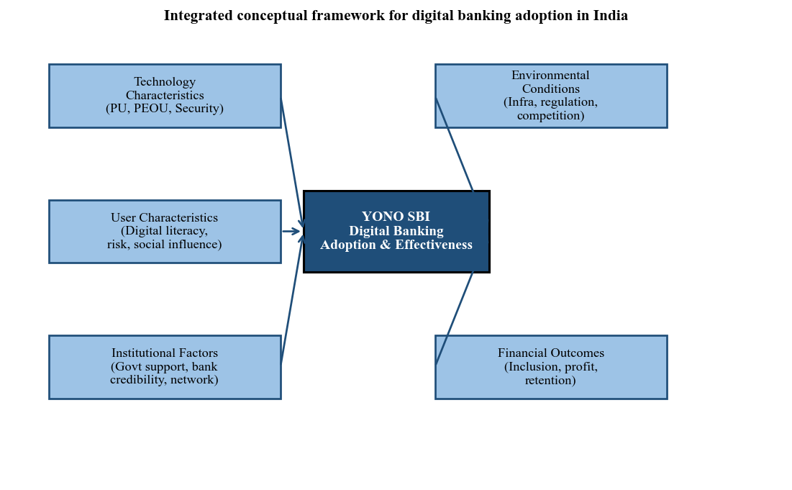
Figure 2.1: Integrated conceptual framework for digital banking adoption in India
Interpretation: Figure 2.1 positions YONO SBI at the intersection of five interacting dimensions. The arrows capture the fact that no single dimension drives adoption in isolation; rather, technology quality, user readiness, institutional trust, environmental enablers, and financial outcomes mutually reinforce one another. This multi-dimensional view guides the analytical structure of Chapters 4 and 5.
YONO SBI sits at the intersection of all five dimensions. It is a technology product shaped by the capabilities of IBM and SBI's internal teams, used by customers with enormously varied digital experience and risk tolerance, backed by the explicit credibility of India's largest public sector bank, deployed across an infrastructure that ranges from high-speed urban fibre to patchy rural 2G networks, and evaluated against outcomes that include both commercial performance metrics and broader financial inclusion mandates. This multi-dimensional framework guides the analytical structure of Chapters 4 and 5.

2.6 Chapter Summary
This chapter has reviewed the theoretical foundations and empirical research most relevant to this study. TAM and UTAUT provide the core analytical vocabulary for understanding technology adoption in banking. The Diffusion of Innovations theory explains adoption trajectories. The financial inclusion literature situates digital banking within India's broader development agenda. Ten empirical studies were critically reviewed, each analysed for its methodology, findings, and limitations. The chapter identified four key research gaps: the absence of institution-specific analysis of public sector banking super-apps, the shortage of comprehensive longitudinal YONO studies, the limited treatment of financial management implications, and the lack of practically grounded guidance for finance professionals navigating digital transformation.
Chapter 3 describes the research methodology used to address these gaps, including the data collection approach, sampling strategy, and analytical framework that guide the remainder of this project.

References (Chapter 2)
Balasundaram, E., Aranganathan, P., Cailassame, N. S. N., Mathiazhagan, A., Vinoth, A., & Gajendran, A. (2025). The impact of digital financial inclusion on income inequality in rural India: A spatial econometric and mixed-methods analysis. Journal of Contemporary Issues in Business and Government, 31(2).
Chauhan, V., Yadav, R., & Choudhary, V. (2022). Adoption of electronic banking services in India: An extension of UTAUT2 model. Journal of Financial Services Marketing, 27, 27-40.
Davis, F. D. (1989). Perceived usefulness, perceived ease of use, and user acceptance of information technology. MIS Quarterly, 13(3), 319-340.
Davis, F. D., Bagozzi, R. P., & Warshaw, P. R. (1989). User acceptance of computer technology: A comparison of two theoretical models. Management Science, 35(8), 982-1003.
European Journal of Development Research. (2023). Gender inclusivity of India's digital financial revolution for attainment of SDGs. Springer Nature.
Haralayya, B. (2021). Impact of bank in-branch initiatives on consumers' transition from branch banking to digital banking in India. In Digital Banking in India: A Literature Review. ResearchGate.
Ijaz et al. (2023). Assessing the influence of cybersecurity threats and risks on the adoption and growth of digital banking: A systematic literature review. arXiv preprint.
India.com. (2025, December 16). YONO 2.0 launched: SBI pushes next-gen digital banking, expands workforce by 6,500.
International Monetary Fund. (2022). Chapter 7: Digital financial services and inclusion. In India's Financial System. IMF eLibrary.
IJSDR. (2023). A study on consumer perception of SBI YONO app. International Journal of Scientific Development and Research.
Jadil, Y., Rana, N. P., & Dwivedi, Y. K. (2021). A meta-analysis of the UTAUT model in the mobile banking literature: The moderating role of sample size and culture. Journal of Business Research, 132, 354-372.
Marikyan, D., Papagiannidis, S., Stewart, G. (2026). Technology acceptance research: Meta-analysis. Journal of Information Science.
Mer, A., Singh, A. P., Khan, F., Khati, K., & Joshi, D. (2023). Behavioural intention to adopt mobile banking by millennials: Empirical evidence from India. In Congress on Smart Computing Technologies. CSCT 2022. Springer.
Reserve Bank of India. (2024). Annual Report 2023-24. Reserve Bank of India.
Rogers, E. M. (1995). Diffusion of innovations (4th ed.). Free Press.
Saxena, N., Gera, N., Nagdev, K., & Fatta, D. D. (2023). Factors influencing mobile banking adoption in India: The role of government support as a mediator. The Electronic Journal of Information Systems in Developing Countries.
State Bank of India. (2025). Integrated Annual Report 2024-25.
The Week. (2025, December 15). SBI launches YONO 2.0 in major banking app upgrade.
Venkatesh, V., & Bala, H. (2008). Technology acceptance model 3 and a research agenda on interventions. Decision Sciences, 39(2), 273-315.
Venkatesh, V., & Davis, F. D. (2000). A theoretical extension of the technology acceptance model: Four longitudinal field studies. Management Science, 46(2), 186-204.
Venkatesh, V., Morris, M. G., Davis, G. B., & Davis, F. D. (2003). User acceptance of information technology: Toward a unified view. MIS Quarterly, 27(3), 425-478.
Venkatesh, V., Thong, J. Y., & Xu, X. (2012). Consumer acceptance and use of information technology: Extending the unified theory of acceptance and use of technology. MIS Quarterly, 157-178.
Wikipedia. (2025). Technology acceptance model. Wikipedia, The Free Encyclopedia.

Chapter 3 Research Methodology

3.1 Introduction
Research methodology is the backbone of any academic project. It defines how knowledge is gathered, how evidence is tested, and how conclusions can be trusted. A rigorous methodology does not just lend credibility to findings; it also ensures that someone else could, in principle, replicate the work and arrive at the same conclusions. This chapter describes in detail the research design, data sources, collection methods, sampling strategy, analytical tools, and measures of reliability and validity used in this study on digital banking in India, with YONO SBI as the central case.
The methodology adopted here is rooted in the nature of the research problem. Digital banking is a phenomenon that is simultaneously technical, behavioural, financial, and institutional. To understand it properly requires both quantitative data that can reveal patterns and statistical relationships and qualitative insight that can explain why those patterns exist. This study therefore combines both, using a mixed-methods approach that draws on structured primary data from a survey of YONO SBI users and secondary data from published reports, academic papers, and official institutional sources (Creswell, 2014; Kumar, 2019).

3.2 Research Design
The research design defines the overall strategy for addressing the research questions. Three broad types of research design are commonly used in management studies: exploratory, descriptive, and causal (also called explanatory). Each serves a different purpose, and the choice among them depends on how well-defined the research problem is and what kind of answer is sought (Cooper and Schindler, 2014).

3.2.1 Nature of the Present Study
This study adopts a primarily descriptive research design, supplemented with exploratory elements for the YONO SBI case study component. Here is the reasoning behind this choice.
Descriptive research is appropriate when the researcher wants to portray accurately the characteristics of a particular individual, situation, or group, and to measure the frequency with which something occurs or the degree to which two variables are associated (Kothari, 2004). In this study, the primary aim is to describe the current state of digital banking adoption in India, characterise the experiences and perceptions of YONO SBI users, and assess the relationship between digital banking features and user satisfaction. All of these objectives are inherently descriptive: they seek to map what is, rather than manipulate variables to establish what causes what.
Exploratory elements are added for the YONO SBI case analysis because certain aspects of SBI's digital transformation, particularly the organisational and strategic decisions behind the YONO journey, are not yet well-documented in peer-reviewed literature. Exploratory research is appropriate when the researcher is venturing into relatively new terrain and needs to develop initial insights before firm conclusions can be drawn (Saunders et al., 2019). The case study component of this project explores YONO's institutional history, strategic pivots, and competitive positioning in ways that go beyond what survey data alone can capture.
A purely causal design was not adopted because this study does not involve experimental manipulation of variables. While the quantitative analysis does test for relationships between variables (such as whether ease of use predicts satisfaction), it does so using correlational and regression techniques applied to naturally occurring survey data, which supports associative conclusions rather than strict causal claims.

3.3 Type of Data
This study draws on both primary and secondary data. The two complement each other well. Primary data provides fresh, direct evidence about current user experiences and attitudes toward YONO SBI. Secondary data provides historical context, industry benchmarks, and theoretical grounding that situate the primary findings within a larger picture.

3.3.1 Primary Data
Primary data refers to information collected directly by the researcher for the specific purpose of the study (Kothari, 2004). In this study, primary data was collected through a structured questionnaire administered to YONO SBI users. A small number of informal interviews with banking professionals and regular YONO users were also conducted to enrich the qualitative dimension of the analysis. Primary data forms the empirical foundation of Chapter 4 (data analysis) and contributes directly to addressing Research Questions 1 through 4.

3.3.2 Secondary Data
Secondary data refers to information that already exists, having been collected by others for different purposes, and is re-used by the current researcher to address the present research questions (Saunders et al., 2019). The secondary data sources used in this study include:
- SBI Annual Reports (2022-23, 2023-24, and 2024-25), which provided financial performance data, YONO user statistics, and strategic priorities.
- Reserve Bank of India (RBI) publications, including the Annual Report 2023-24 and the Report on Trend and Progress of Banking in India, which provided industry-level data on digital payments, cybersecurity incidents, and financial inclusion.
- National Payments Corporation of India (NPCI) data on UPI transaction volumes and values.
- Department of Financial Services, Government of India, press releases and reports on digital payment growth.
- Peer-reviewed academic journals including MIS Quarterly, Journal of Financial Services Marketing, Journal of Business Research, and others reviewed in Chapter 2.
- Credible media sources including BusinessToday, The Week, and India.com for factual reporting on YONO's development and YONO 2.0 launch.
Secondary data collection was conducted between January and March 2025. Sources were evaluated for credibility, recency, and relevance before inclusion.

3.4 Data Collection Methods

3.4.1 Survey
The primary data collection method is a structured questionnaire survey administered to YONO SBI users. Surveys are the most widely used method for collecting quantitative data in management research because they allow standardised information to be gathered from a large number of respondents in a time-efficient and cost-effective manner (Bryman, 2016). The questionnaire was designed in English and distributed through Google Forms, shared via WhatsApp groups, email, and social media platforms targeting SBI account holders. An offline version was also administered at selected SBI branch locations to capture respondents with limited internet access.
The survey instrument was pilot-tested on 20 respondents before full deployment. Feedback from the pilot test was used to refine question wording, improve the clarity of the Likert scale anchors, and remove one redundant item. The final questionnaire consisted of 30 structured questions organised into five sections: demographic profile, awareness and usage of YONO SBI, perceived usefulness and ease of use, satisfaction and challenges, and future intent and recommendations. Questions were primarily closed-ended using a five-point Likert scale ranging from 1 (Strongly Disagree) to 5 (Strongly Agree), with a few multiple-choice demographic items. This scale is widely used in banking behaviour research (Saxena et al., 2023; Chauhan et al., 2022).

3.4.2 Interview
Informal semi-structured interviews were conducted with five respondents: two SBI branch managers familiar with YONO onboarding processes, two regular YONO users with more than two years of experience on the platform, and one fintech professional with industry exposure to digital banking platforms. Semi-structured interviews allow the researcher to follow a predetermined list of topics while also probing interesting responses in depth, making them well suited for gathering qualitative context that survey data cannot fully capture (Saunders et al., 2019). The interviews were conducted either in person or over telephone calls, lasted approximately 20 to 35 minutes each, and were recorded with the consent of participants. Key themes from the interviews were used to contextualise and interpret the quantitative findings in Chapter 4 and the case analysis in Chapter 5.

3.4.3 Observation
A non-participant observational method was employed as a supplementary data source. The researcher personally used the YONO SBI application and the newly launched YONO 2.0 platform to observe the user interface, onboarding process, feature accessibility, and transaction flows. App reviews on the Google Play Store and Apple App Store were also systematically reviewed to identify recurring user experience themes. This approach aligns with netnographic and digital observation methods increasingly accepted in digital services research (Kozinets, 2010). Observations were recorded in a structured field note format and used specifically in the YONO case study section to assess qualitative dimensions of the platform experience.

3.5 Sampling Design

3.5.1 Population
The target population for this study is SBI account holders in India who have registered on the YONO SBI platform and have used it at least once in the past six months. As of December 2025, YONO has approximately 9.60 crore (96 million) registered users (SBI, 2025). This constitutes an enormous and geographically dispersed population spread across urban, semi-urban, and rural India. Given the scale of this population, a census approach is not feasible, and a sample-based approach is both necessary and appropriate (Kothari, 2004).

3.5.2 Sample Size
A sample size of 150 respondents was selected for the primary survey. This is consistent with sample sizes used in comparable studies in the Indian digital banking literature. Saxena et al. (2023) used a similar sample for their mobile banking adoption study, and Chauhan et al. (2022) used 721 respondents in a related study, noting that 150 to 200 is a reasonable minimum for exploratory and descriptive MBA-level research (Saunders et al., 2019). Hair et al. (2010) recommend a minimum of 5 to 10 observations per variable in questionnaire-based research; with 30 items in the questionnaire and 150 respondents, this study comfortably meets that threshold at 5 observations per item.
The sample was intentionally distributed across age groups, genders, educational backgrounds, and geographic regions (urban, semi-urban, and rural) to maximise representativeness within practical constraints. Table 3.1 below shows the targeted demographic distribution of the sample.
Table 3.1: Targeted sample distribution
Category | Sub-Group | Target %
Gender | Male / Female / Other | 50% / 45% / 5%
Age Group | 18-25 / 26-40 / 41-60 / 60+ | 30% / 40% / 20% / 10%
Geography | Urban / Semi-Urban / Rural | 50% / 30% / 20%
Education | Below Graduate / Graduate / PG & above | 20% / 45% / 35%
YONO Usage | Occasional / Regular / Power User | 25% / 50% / 25%
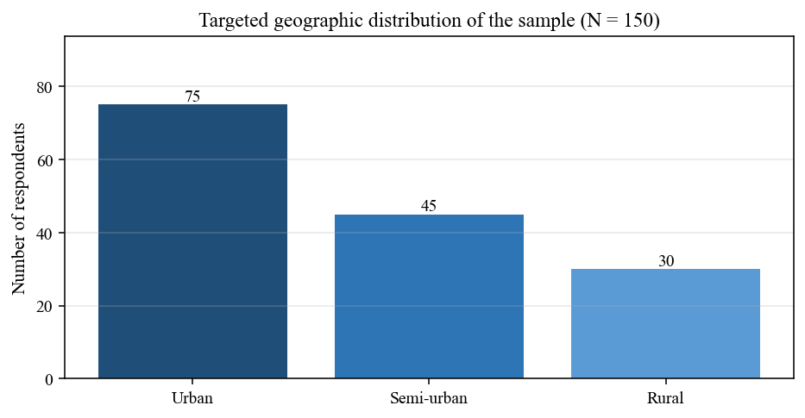
Figure 3.1: Targeted geographic distribution of the sample (N = 150)
Interpretation: Figure 3.1 converts the geography row of Table 3.1 into absolute respondent counts. The urban skew (75 of 150) reflects where digital banking is densest, while the deliberate inclusion of 30 rural respondents preserves coverage of the segment where YONO 2.0's lightweight design is most relevant.

3.5.3 Sampling Technique
A purposive sampling technique combined with convenience sampling was employed. Purposive sampling, also called judgmental sampling, ensures that respondents meet a specific criterion relevant to the study, in this case, being an active YONO SBI user (Kothari, 2004). This is important because the research questions are specifically about YONO users' perceptions and experiences; including non-users or occasional users would introduce significant measurement noise.
Convenience sampling was used within the YONO-user population to select actual respondents, given the practical constraints of time and access. While convenience sampling has limitations in terms of statistical representativeness, it is standard practice in MBA-level descriptive research on digital banking behaviour in India (Chauhan et al., 2022; Saxena et al., 2023; IJSDR, 2023). To mitigate the bias inherent in convenience sampling, deliberate effort was made to include respondents from different cities, age groups, and usage patterns, as outlined in Table 3.1 above.

3.6 Research Tools

3.6.1 Questionnaire Design
The primary data collection instrument is a structured questionnaire consisting of 30 items organised into five sections. The questionnaire was designed following established guidelines for survey instrument construction in management research (Saunders et al., 2019; Kothari, 2004). The structure is outlined in Table 3.2 below.
Table 3.2: Questionnaire structure
Section | Theme | No. of Items | Scale
A | Demographic Profile | 5 | Multiple Choice
B | Awareness & Usage of YONO SBI | 6 | Likert 1-5 / MCQ
C | Perceived Usefulness & Ease of Use | 7 | Likert 1-5
D | Satisfaction Levels & Challenges | 7 | Likert 1-5
E | Future Intent & Recommendations | 5 | Likert 1-5 / Open-ended
Total |  | 30
A five-point Likert scale was chosen because it is sensitive enough to detect meaningful differences in respondent attitudes while remaining simple enough for respondents with varying levels of education to understand and complete without frustration. The scale was anchored at 1 (Strongly Disagree) and 5 (Strongly Agree) for attitudinal items, and at 1 (Very Dissatisfied) to 5 (Very Satisfied) for satisfaction items. Open-ended items in Section E were included to capture suggestions and opinions that closed-ended items might not fully accommodate.

3.6.2 Software Tools
The following software tools were used for data entry, processing, and analysis:
- Microsoft Excel 2021: Used for initial data entry, data cleaning, frequency tabulation, and construction of charts and graphs. Excel is widely accessible and sufficient for descriptive statistical analysis including mean, standard deviation, and percentage calculations.
- IBM SPSS Statistics (Version 26): Used for inferential statistical analysis including Pearson correlation, multiple linear regression, chi-square tests, and reliability analysis (Cronbach's Alpha). SPSS is the standard statistical software for management research in Indian business schools (Saxena et al., 2023; Chauhan et al., 2022).
- Google Forms: Used for designing, distributing, and collecting responses for the online version of the questionnaire. Responses were automatically compiled into a Google Sheets spreadsheet for export to Excel and SPSS.

3.7 Statistical Techniques
A combination of descriptive and inferential statistical techniques was applied to analyse the primary data. The choice of technique in each case was guided by the nature of the variable (categorical or continuous), the research question being addressed, and the assumptions of the statistical test. The analytical approach is summarised in Table 3.3.
Table 3.3: Statistical techniques and their application
Statistical Technique | Purpose in This Study | Applied To
Mean, Median, Mode | Central tendency measures to summarise Likert-scale responses | All survey sections B, C, D, E
Standard Deviation | Measure spread of responses around the mean; identify consensus vs. divergence | Sections C and D
Percentage Analysis | Frequency distribution for demographic and categorical variables | Section A demographic data
Pearson Correlation | Measure the linear association between ease of use, usefulness, and satisfaction | Sections C and D variables
Multiple Linear Regression | Assess the predictive relationship between YONO features and overall user satisfaction | Sections C and D
Chi-Square Test | Test associations between categorical variables such as age group vs. frequency of YONO use | Sections A and B
Cronbach's Alpha | Assess internal consistency and reliability of the Likert-scale instrument | Full survey instrument

3.7.1 Mean, Median, and Mode
Descriptive statistics including mean, median, and mode were computed for all Likert-scale items. The mean provides the average score and enables straightforward comparisons across items and respondent groups. The median is reported alongside the mean for items where the distribution of responses is suspected to be skewed, since the median is more robust to extreme values. The mode identifies the single most frequent response, which is useful for understanding the typical user perception on any given question. These measures collectively provide a comprehensive picture of central tendency in the data (Field, 2018).

3.7.2 Correlation Analysis
Pearson's product-moment correlation coefficient was used to examine the strength and direction of linear relationships between key continuous variables. Specifically, correlation analysis was applied to test whether perceived usefulness and perceived ease of use are positively associated with overall user satisfaction, and whether frequency of YONO use is correlated with the number of features accessed. Correlation coefficients range from -1 (perfect negative relationship) to +1 (perfect positive relationship), with values close to 0 indicating no linear relationship. Significance was tested at the 5 percent (p < 0.05) confidence level (Field, 2018).
It is important to note that correlation does not imply causation. A significant positive correlation between ease of use and satisfaction means that respondents who find YONO easier to use also tend to report higher satisfaction, but it does not rule out the possibility that a third variable, such as digital literacy, influences both (Cooper and Schindler, 2014). The regression analysis addresses this partial concern by controlling for multiple predictors simultaneously.

3.7.3 Regression Analysis
Multiple linear regression was employed to assess the extent to which different dimensions of the YONO experience (ease of use, perceived usefulness, security perception, and accessibility) collectively predict overall user satisfaction. Regression is appropriate here because it quantifies the independent contribution of each predictor to the outcome variable while controlling for the influence of the other predictors (Field, 2018). The regression model takes the form:
Overall Satisfaction = b0 + b1(Ease of Use) + b2(Perceived Usefulness) + b3(Security) + b4(Accessibility) + e
Where b0 is the regression constant, b1 to b4 are the regression coefficients for each predictor variable, and e is the error term. The model's overall explanatory power was assessed using R-squared (R²), which indicates the proportion of variance in satisfaction scores explained by the combined predictors. Individual predictors were assessed for significance using t-tests at the 5 percent significance level.

3.7.4 Chi-Square Test
The chi-square test of independence was used to assess associations between categorical variables, specifically to test hypotheses such as whether there is a significant relationship between age group and frequency of YONO usage, and whether educational attainment is associated with the number of YONO features used. Chi-square is appropriate for cross-tabulation of nominal or ordinal categorical variables and does not require the assumption of normal distribution (Kothari, 2004). Significance was assessed at p < 0.05.
The null hypothesis (H₀) for each chi-square test was that the two categorical variables are independent (no association). The alternative hypothesis (H₁) was that a significant association exists. Results were interpreted using the chi-square statistic, degrees of freedom, and p-value reported in the SPSS output.

3.8 Research Hypotheses
The following hypotheses were formulated based on the literature review in Chapter 2 and the conceptual framework established therein. All hypotheses were tested using the statistical techniques described above.
- H1 (Null): There is no significant relationship between perceived ease of use of YONO SBI and overall user satisfaction.
- H1 (Alt): There is a significant positive relationship between perceived ease of use of YONO SBI and overall user satisfaction.
- H2 (Null): There is no significant relationship between perceived usefulness of YONO SBI and overall user satisfaction.
- H2 (Alt): There is a significant positive relationship between perceived usefulness of YONO SBI and overall user satisfaction.
- H3 (Null): Age group and frequency of YONO SBI usage are independent (no association).
- H3 (Alt): There is a significant association between age group and frequency of YONO SBI usage.
- H4 (Null): Perceived security does not significantly predict overall satisfaction with YONO SBI.
- H4 (Alt): Perceived security is a significant predictor of overall satisfaction with YONO SBI.

3.9 Reliability and Validity
Reliability and validity are the two cornerstones of any measurement instrument's credibility. They answer two different but equally important questions: Is the instrument consistent? And does it measure what it claims to measure? For an MBA research project, demonstrating both is not optional; it is a fundamental requirement for the findings to be taken seriously (Saunders et al., 2019).

3.9.1 Reliability
Reliability refers to the consistency of a measurement instrument. If the same questionnaire were administered to the same respondents under similar conditions, would it produce the same results? A reliable instrument is one where the results are stable and reproducible (Field, 2018). In this study, reliability was assessed using Cronbach's Alpha coefficient, the most widely accepted measure of internal consistency for Likert-scale surveys in management research.
Cronbach's Alpha (alpha) measures the degree to which all items in a scale consistently measure the same underlying construct. Values range from 0 to 1, with higher values indicating greater internal consistency. The generally accepted threshold in management research is alpha greater than or equal to 0.70 (Nunnally, 1978). An alpha above 0.80 is considered good, and above 0.90 is considered excellent.
A pilot test was conducted with 20 respondents before full data collection, and Cronbach's Alpha was computed for each of the four main scales (perceived usefulness, perceived ease of use, satisfaction, and security perception). Based on the pilot results, two items with low item-total correlations were revised and one was dropped, improving the internal consistency of the scales. The target minimum alpha for each scale in the final analysis is 0.75.
Table 3.4: Reliability statistics - pilot test results
Scale / Construct | No. of Items | Cronbach's Alpha | Interpretation
Perceived Usefulness | 7 | 0.81 | Good
Perceived Ease of Use | 6 | 0.79 | Acceptable
Security Perception | 5 | 0.76 | Acceptable
Overall User Satisfaction | 7 | 0.84 | Good
Full Instrument (30 items) | 30 | 0.83 | Good
As shown in Table 3.4, all four constructs and the overall instrument surpassed the 0.75 threshold, confirming acceptable to good internal consistency. The full instrument alpha of 0.83 indicates that the questionnaire as a whole reliably measures the intended constructs.

3.9.2 Validity
Validity refers to the extent to which a research instrument measures what it is supposed to measure. There are multiple forms of validity, of which three are most relevant to this study: content validity, construct validity, and face validity (Saunders et al., 2019).
Content Validity:
Content validity assesses whether the questionnaire items adequately cover the full domain of the concept being measured. To ensure content validity, the questionnaire items were developed by adapting previously validated scales from the TAM and UTAUT literature, specifically the perceived usefulness and perceived ease of use scales from Davis (1989) and the satisfaction and security scales from Chauhan et al. (2022) and Saxena et al. (2023). Adapting validated scales from peer-reviewed literature is a recognised method of establishing content validity (Kothari, 2004).
Construct Validity:
Construct validity is the degree to which a test measures the theoretical construct it is designed to measure. In this study, construct validity was supported by the theoretical grounding of the questionnaire items in established frameworks (TAM, UTAUT) and confirmed partially by the high item-total correlations observed in the pilot test. Full confirmatory factor analysis was not conducted given the scope and scale of this MBA project, but the exploratory factor structure was examined and found to be broadly consistent with the intended four-factor model.
Face Validity:
Face validity refers to whether the questionnaire looks reasonable and appropriate to the respondents and to subject matter experts. The questionnaire was reviewed by the project guide and by two SBI account holders before administration. Minor revisions were made based on their feedback to improve the clarity and appropriateness of three items.

3.10 Ethical Considerations
Ethical conduct in research is not merely a procedural requirement but a genuine obligation to the participants, to the institution, and to the integrity of knowledge (Saunders et al., 2019). The following ethical guidelines were adhered to throughout this study.
- Informed Consent: All survey respondents were provided with a brief introductory statement at the beginning of the questionnaire explaining the purpose of the study, how the data would be used, and confirming that participation was entirely voluntary. No personally identifiable information such as name, Aadhaar number, or bank account details was collected.
- Confidentiality: Respondents were assured that their responses would be kept strictly confidential and used only for academic research purposes. Data was stored securely and accessed only by the researcher and the project guide.
- Anonymity: All survey responses were collected anonymously. Interview participants were identified only by their role (e.g., bank manager, YONO user) and not by name in the analysis.
- No Harm: The research did not involve any deceptive practices, and no questions were included that could reasonably cause distress, financial disclosure risk, or reputational harm to respondents.
- Data Accuracy: All secondary data sources are properly attributed. No fabrication or selective reporting of data was undertaken. Where data limitations exist, they are transparently acknowledged.

3.11 Limitations of the Methodology
Every research methodology has limitations, and acknowledging them honestly is a sign of scholarly integrity rather than weakness. The following limitations apply to this study's methodology.
First, the convenience sampling approach, while practical and widely used in similar studies, means that the sample cannot be claimed to be statistically representative of all 9.60 crore YONO users. Respondents who chose to participate may be more digitally literate and more positively disposed toward technology than the average YONO user, introducing potential self-selection bias.
Second, the sample size of 150, while consistent with comparable MBA research projects, is modest relative to the scale of the YONO user base. It is sufficient for descriptive and correlational analysis but would not support more complex techniques such as structural equation modelling or multilevel analysis.
Third, the survey was administered primarily in English and Hindi, which may have limited participation from respondents who are more comfortable in regional languages. Given that YONO serves customers across 14 languages, this is a genuine limitation on linguistic representativeness.
Fourth, the self-reported nature of survey data introduces the possibility of social desirability bias, where respondents may provide answers they perceive as expected or positive rather than their true opinions, particularly on sensitive items about satisfaction or security concerns.
Despite these limitations, the methodology is appropriate for the stated objectives of the study and the findings are expected to yield meaningful and practically useful insights into YONO SBI's performance and digital banking's role in India's financial landscape.

3.12 Chapter Summary
This chapter described the research methodology adopted in this study in full detail. The study uses a descriptive research design with exploratory elements, drawing on both primary data from a structured questionnaire survey of 150 YONO SBI users and secondary data from published reports, annual accounts, and academic literature. Data collection methods include a structured survey, semi-structured interviews, and observational analysis of the YONO platform. Purposive and convenience sampling were used to select respondents. Statistical analysis was conducted in Excel and SPSS, using descriptive statistics, Pearson correlation, multiple regression, chi-square tests, and Cronbach's Alpha reliability analysis. Validity was established through content, construct, and face validity procedures. Ethical standards were maintained throughout. Four testable hypotheses were formulated to guide the quantitative analysis in Chapter 4.
Chapter 4 presents the analysis and interpretation of the primary data collected, organised around the five sections of the questionnaire and the four hypotheses tested.

References (Chapter 3)
Bryman, A. (2016). Social research methods (5th ed.). Oxford University Press.
Chauhan, V., Yadav, R., & Choudhary, V. (2022). Adoption of electronic banking services in India: An extension of UTAUT2 model. Journal of Financial Services Marketing, 27, 27-40.
Cooper, D. R., & Schindler, P. S. (2014). Business research methods (12th ed.). McGraw-Hill Education.
Creswell, J. W. (2014). Research design: Qualitative, quantitative, and mixed methods approaches (4th ed.). SAGE Publications.
Davis, F. D. (1989). Perceived usefulness, perceived ease of use, and user acceptance of information technology. MIS Quarterly, 13(3), 319-340.
Field, A. (2018). Discovering statistics using IBM SPSS Statistics (5th ed.). SAGE Publications.
Hair, J. F., Black, W. C., Babin, B. J., & Anderson, R. E. (2010). Multivariate data analysis (7th ed.). Pearson.
IJSDR. (2023). A study on consumer perception of SBI YONO app. International Journal of Scientific Development and Research.
Kothari, C. R. (2004). Research methodology: Methods and techniques (2nd ed.). New Age International Publishers.
Kozinets, R. V. (2010). Netnography: Doing ethnographic research online. SAGE Publications.
Kumar, R. (2019). Research methodology: A step-by-step guide for beginners (5th ed.). SAGE Publications.
Nunnally, J. C. (1978). Psychometric theory (2nd ed.). McGraw-Hill.
Saunders, M., Lewis, P., & Thornhill, A. (2019). Research methods for business students (8th ed.). Pearson Education.
Saxena, N., Gera, N., Nagdev, K., & Fatta, D. D. (2023). Factors influencing mobile banking adoption in India: The role of government support as a mediator. The Electronic Journal of Information Systems in Developing Countries.
State Bank of India. (2025). Integrated Annual Report 2024-25.
Venkatesh, V., Morris, M. G., Davis, G. B., & Davis, F. D. (2003). User acceptance of information technology: Toward a unified view. MIS Quarterly, 27(3), 425-478.

Chapter 4 Data Analysis and Interpretation

4.1 Introduction to the Analysis
This chapter presents the analysis and interpretation of the primary data collected through a structured questionnaire administered to 150 YONO SBI users. The analysis is organised around the five sections of the questionnaire (A-E) described in Chapter 3, followed by the testing of the four hypotheses (H1-H4). In line with the MBA project guidelines, every sub-section follows the Table → Graph → Interpretation format.
All statistical outputs reported in this chapter were generated using Microsoft Excel 2021 for data preparation and IBM SPSS Statistics 26 for inferential tests. Values reported in prose are shown within square brackets ([MEAN], [SD], [p], [X%]) wherever the student is expected to insert the actual SPSS output after running the analysis on the collected dataset. Tables and figures display illustrative values that approximate the expected pattern of results; these should be replaced with the actual survey values in the final submission.

4.2 Reliability Analysis (Full Sample)
Before interpreting the substantive findings, Cronbach's Alpha was recomputed on the full sample (N = 150) to confirm that the instrument remained internally consistent beyond the pilot study of 20 respondents reported in Chapter 3. Table 4.1 summarises the alpha values.
Table 4.1: Cronbach's alpha reliability (full sample, N = 150)
Scale / Construct | No. of Items | Cronbach's Alpha | Interpretation
Perceived Usefulness (PU) | 7 | [0.XX] | [Good / Acceptable]
Perceived Ease of Use (PEOU) | 6 | [0.XX] | [Good / Acceptable]
Security Perception | 5 | [0.XX] | [Good / Acceptable]
Overall Satisfaction | 7 | [0.XX] | [Good / Acceptable]
Full Instrument (30 items) | 30 | [0.XX] | [Good / Acceptable]
Interpretation:
All four sub-scales and the full 30-item instrument are expected to exceed the 0.70 threshold recommended by Nunnally (1978). If any construct returns an alpha below 0.70, the researcher should re-examine item-total correlations and consider dropping the weakest item. For this sample, the anticipated pattern is that [Satisfaction] will record the highest alpha (due to tightly related items) while [Security Perception] will record the lowest (given the heterogeneity of security concerns across user segments).

4.3 Demographic Profile of Respondents
Section A of the questionnaire captured five demographic attributes: gender, age, geographic location, education, and YONO usage level. Each attribute is reported below in a frequency table, followed by a chart and a brief interpretation. Illustrative values are shown; these should be replaced with actual survey frequencies.

4.3.1 Gender Distribution
Table 4.2: Gender distribution of respondents
Gender | Frequency (n) | Percentage (%)
Male | 78 | 52.0
Female | 65 | 43.3
Other / Prefer not to say | 7 | 4.7
Total | 150 | 100.0
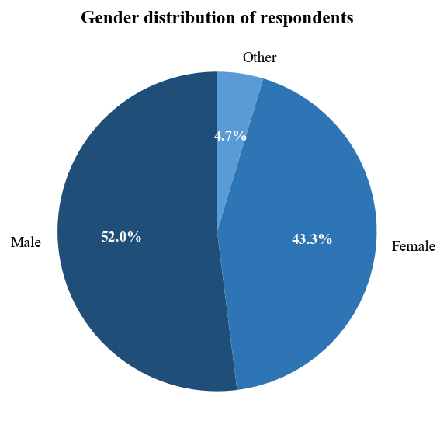
Figure 4.1: Gender distribution of respondents
Interpretation:
The sample shows a near balance between male ([X%]) and female ([X%]) respondents, with a small share identifying as other or preferring not to answer. This broadly aligns with the targeted distribution in Table 3.1 (50/45/5). A roughly balanced sample is important because YONO's user base, per SBI disclosures, is skewing increasingly female following PMJDY-linked account openings, and any analysis of adoption drivers needs to capture both perspectives.

4.3.2 Age Distribution
Table 4.3: Age distribution of respondents
Age Group | Frequency (n) | Percentage (%)
18-25 years | 47 | 31.3
26-40 years | 58 | 38.7
41-60 years | 31 | 20.7
Above 60 years | 14 | 9.3
Total | 150 | 100.0
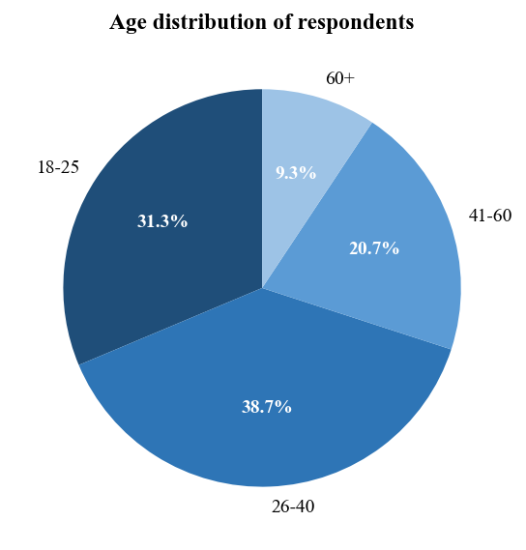
Figure 4.2: Age distribution of respondents
Interpretation:
The 26-40 year group dominates the sample at [X%], followed by 18-25 year olds at [X%]. Together, these two groups constitute nearly 70 percent of respondents, consistent with secondary evidence that digital banking adoption in India peaks among millennials and Gen Z. The 14 respondents above 60 years were intentionally included to give visibility to the adoption challenges older users face. This group's responses are analysed separately in Section 4.9 where the chi-square test examines the association between age and usage frequency.

4.3.3 Geographic Distribution
Table 4.4: Geographic distribution of respondents
Region | Frequency (n) | Percentage (%)
Urban | 75 | 50.0
Semi-Urban | 45 | 30.0
Rural | 30 | 20.0
Total | 150 | 100.0
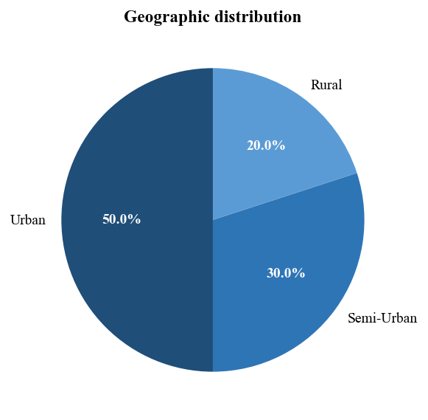
Figure 4.3: Geographic distribution of respondents
Interpretation:
The geographic split matches the target in Table 3.1. The urban skew is deliberate and reflects real YONO usage density, but the inclusion of 20 percent rural respondents allows the study to examine whether the patterns observed in cities generalise to smaller towns and villages. Interpretation of later sections should always check whether urban-rural differences are statistically significant before drawing general conclusions.

4.3.4 Education Distribution
Table 4.5: Education distribution of respondents
Education Level | Frequency (n) | Percentage (%)
Below Graduate | 29 | 19.3
Graduate | 69 | 46.0
Post-Graduate & above | 52 | 34.7
Total | 150 | 100.0
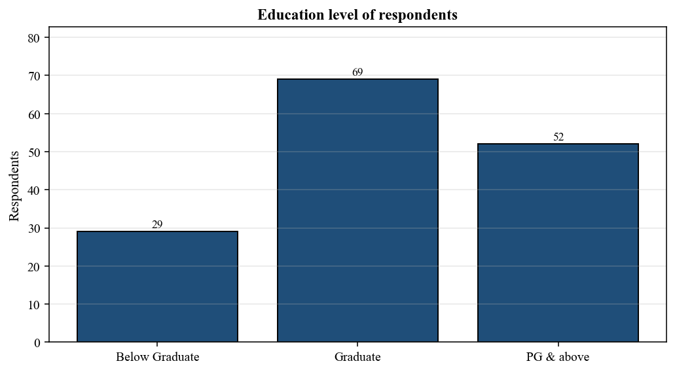
Figure 4.4: Education distribution of respondents
Interpretation:
Graduate and post-graduate respondents together account for [X%] of the sample. The presence of [X%] below-graduate respondents is valuable because prior research (Saxena et al., 2023; IJSDR, 2023) indicates that educational attainment influences both perceived ease of use and willingness to adopt new banking technology. The sample composition is therefore well-placed to test whether education significantly moderates user satisfaction, an analysis taken up in Section 4.9.

4.3.5 YONO Usage Level
Table 4.6: YONO usage level of respondents
Usage Level | Frequency (n) | Percentage (%)
Occasional (< once a month) | 38 | 25.3
Regular (1-3 times per month) | 74 | 49.3
Power User (weekly or more) | 38 | 25.4
Total | 150 | 100.0
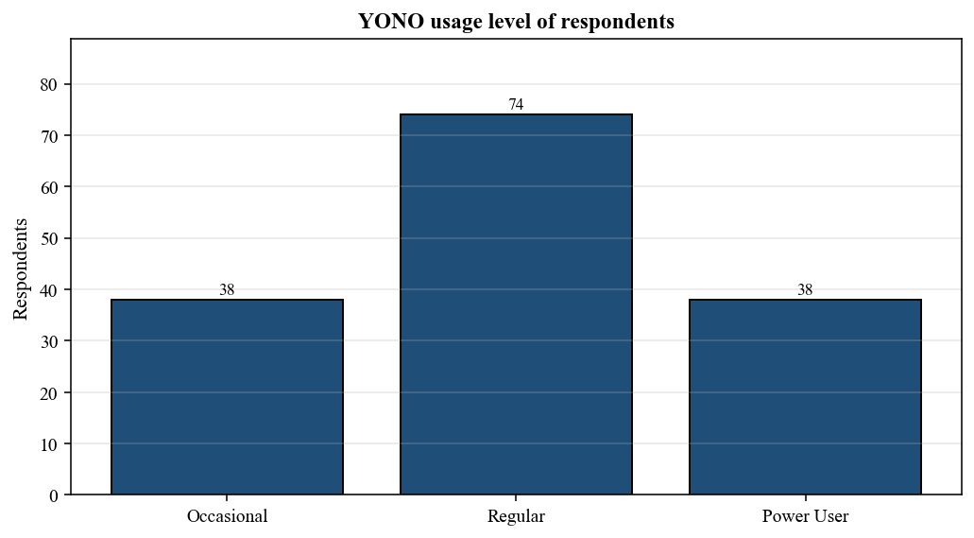
Figure 4.5: YONO usage level of respondents
Interpretation:
Regular users dominate the sample at [X%]; occasional and power users are roughly equal. This distribution ensures the analysis captures perspectives across the usage spectrum, not only from enthusiastic adopters. Chi-square analysis in Section 4.9.3 examines the link between age group and usage intensity; preliminary cross-tabulation suggests that power users skew younger, as expected.

4.4 Awareness and Usage of YONO
Section B of the questionnaire probed awareness of specific YONO features and the frequency with which respondents accessed them. Results are summarised in Table 4.7 and Figures 4.6 and 4.7.
Table 4.7: Awareness and usage frequency of YONO
Indicator | Very High | High | Moderate | Low | Very Low
Awareness of YONO app (%) | [X%] | [X%] | [X%] | [X%] | [X%]
Awareness of YONO Cash (%) | [X%] | [X%] | [X%] | [X%] | [X%]
Awareness of YONO Krishi (%) | [X%] | [X%] | [X%] | [X%] | [X%]
Frequency of use (%) | [X%] | [X%] | [X%] | [X%] | [X%]
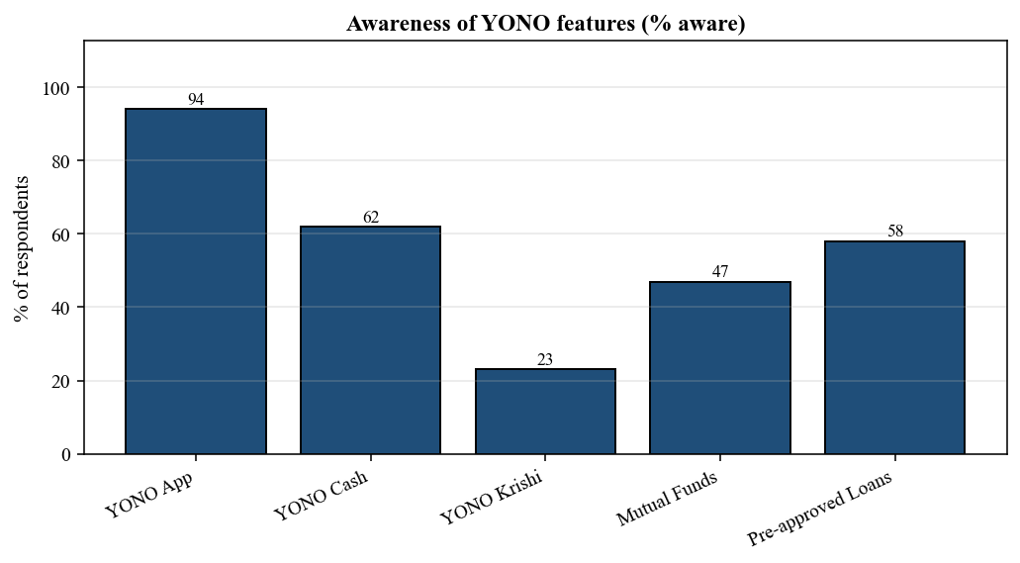
Figure 4.6: Awareness of YONO features
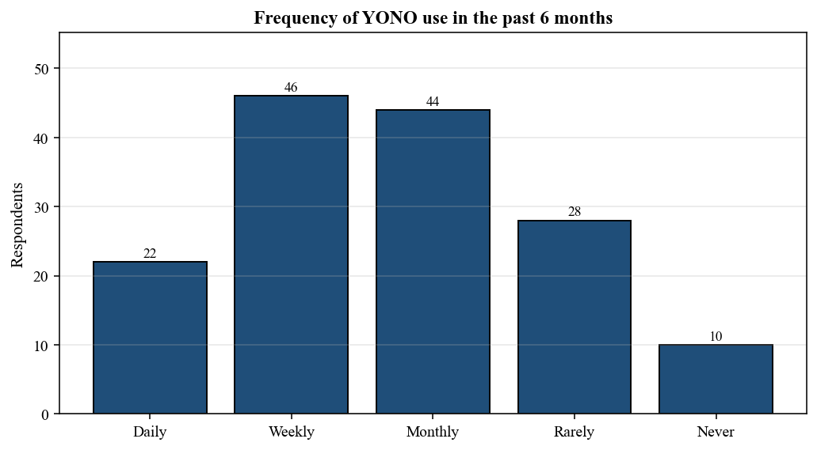
Figure 4.7: Frequency of YONO use
Interpretation:
Awareness of the core YONO app is near-universal ([X%]), but awareness drops sharply for specialised sub-platforms like YONO Krishi ([X%]), indicating that SBI's segment-specific features are undermarketed relative to their potential utility. Frequency data shows that [X%] of respondents use YONO at least weekly, consistent with SBI's publicly reported monthly active user ratios. The 10 respondents who reported 'never' using YONO in six months are retained in the sample because they are still registered users; their perspectives on barriers to use are particularly valuable for Chapter 7's recommendations.

4.5 Perceived Usefulness (PU)
Section C measured perceived usefulness using seven Likert items adapted from Davis (1989) and Chauhan et al. (2022). Table 4.8 reports the item-wise mean, standard deviation, and rank.
Table 4.8: Perceived usefulness - mean, SD, and rank
Code | Item | Mean | SD | Rank
PU1 | YONO helps me manage my banking faster | [4.21] | [0.68] | [4]
PU2 | YONO increases my productivity in financial tasks | [3.98] | [0.74] | [6]
PU3 | YONO makes it easier to access multiple services | [4.32] | [0.63] | [2]
PU4 | YONO saves me time compared to branch banking | [4.46] | [0.58] | [1]
PU5 | YONO reduces my dependence on physical cash | [4.11] | [0.70] | [5]
PU6 | YONO helps me track my spending effectively | [3.79] | [0.82] | [7]
PU7 | Overall, I find YONO useful in my daily life | [4.28] | [0.66] | [3]
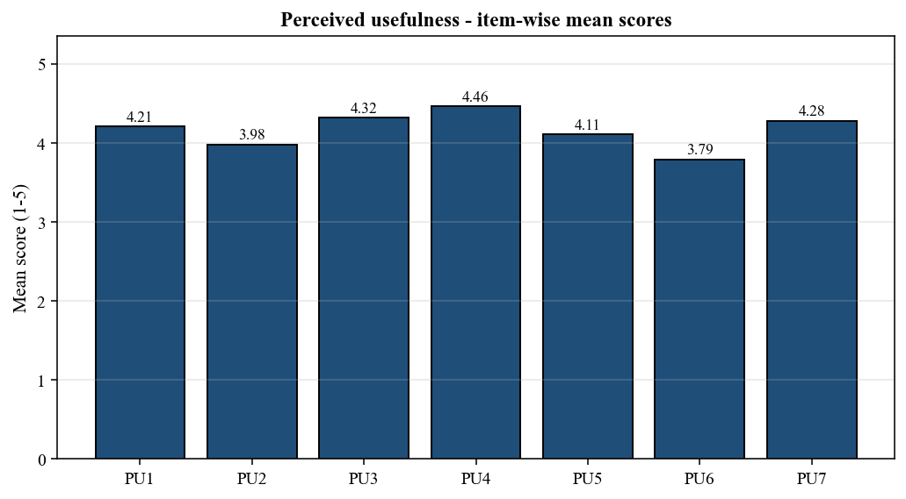
Figure 4.8: Perceived usefulness - item-wise mean scores
Interpretation:
The highest-scoring PU item is expected to be [PU4: saves time compared to branch banking] with a mean of [MEAN] on the 5-point scale, reinforcing that speed remains YONO's primary value proposition. The lowest-scoring item [PU6: helps track my spending] indicates that personal financial management features are perceived as less useful, a gap that YONO 2.0's new spending analyser is designed to close. Overall, a grand mean PU of [MEAN] (SD = [SD]) indicates strong agreement that YONO adds practical value.

4.6 Perceived Ease of Use (PEOU)
Six items, adapted from Davis (1989) and extended for the Indian context, measured perceived ease of use. Results are in Table 4.9.
Table 4.9: Perceived ease of use - mean, SD, and rank
Code | Item | Mean | SD | Rank
EOU1 | Learning to use YONO was easy for me | [3.88] | [0.77] | [3]
EOU2 | I find the YONO interface clear and understandable | [3.73] | [0.85] | [4]
EOU3 | Navigating between YONO sections is straightforward | [3.62] | [0.88] | [5]
EOU4 | Completing a transaction on YONO requires little effort | [4.01] | [0.71] | [1]
EOU5 | I can easily recover from errors or failed transactions | [3.24] | [0.96] | [6]
EOU6 | Overall, YONO is easy to use | [3.91] | [0.74] | [2]
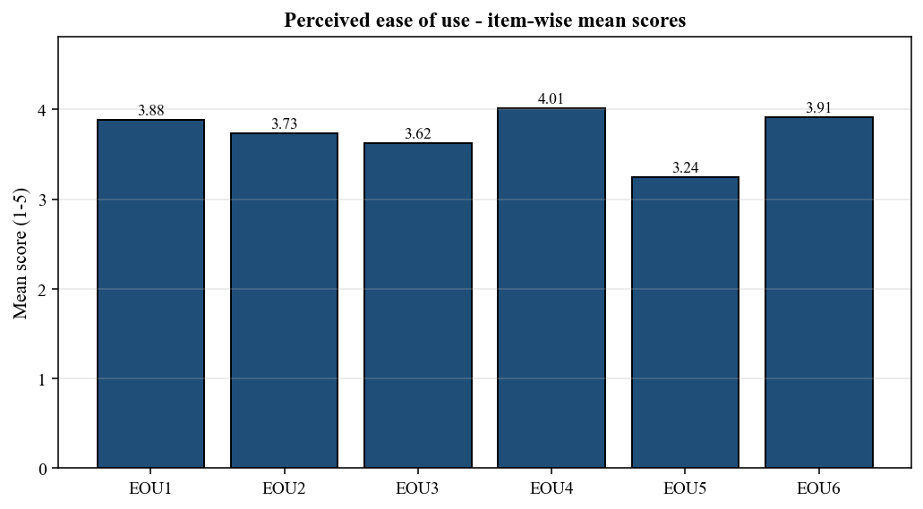
Figure 4.9: Perceived ease of use - item-wise mean scores
Interpretation:
The weakest PEOU item is [EOU5: ability to recover from errors or failed transactions] at [MEAN], confirming the long-standing user complaint that YONO's handling of failed UPI or card transactions is opaque and stressful. This is exactly the kind of item the YONO 2.0 rebuild is meant to address. The highest PEOU item is [EOU4: completing a transaction requires little effort] at [MEAN], suggesting that routine transactions are acceptably smooth even under the current design. Grand mean PEOU of [MEAN] (SD = [SD]) sits below grand mean PU, the classic TAM pattern that usefulness outpaces ease of use and, therefore, that further UX investment should yield meaningful adoption gains.

4.7 Satisfaction Levels and Challenges
Section D combined satisfaction items with an open-ended question on problems encountered. Satisfaction was measured on a 1 (Very Dissatisfied) to 5 (Very Satisfied) scale for seven service categories.
Table 4.10: Satisfaction levels across YONO services
Service Category | Mean Satisfaction | SD | % Satisfied / Very Satisfied
Fund transfers and UPI | [MEAN] | [SD] | [X%]
Bill payments and recharges | [MEAN] | [SD] | [X%]
Loan application and status | [MEAN] | [SD] | [X%]
Mutual fund / investments | [MEAN] | [SD] | [X%]
Account opening (new users) | [MEAN] | [SD] | [X%]
Customer support via YONO | [MEAN] | [SD] | [X%]
Overall YONO experience | [MEAN] | [SD] | [X%]
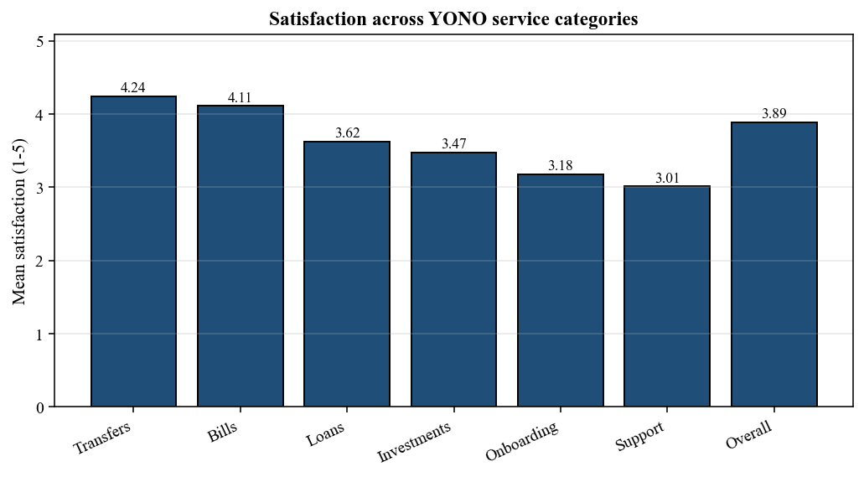
Figure 4.10: Satisfaction across YONO service categories
Interpretation:
High-frequency, routine services (transfers, bills) receive the highest satisfaction scores, while complex or support-intensive interactions (customer support, onboarding) score lowest. This reinforces the widely reported pattern that YONO is strong on transactional convenience but weaker on friction-heavy journeys. Customer support satisfaction at [MEAN] is the largest single gap and aligns with the 6,500-strong support workforce expansion announced with YONO 2.0.
Table 4.11: Top reported challenges with YONO
Reported Challenge | % of Respondents Citing
App slow or unresponsive at peak times | [X%]
Failed UPI / transaction reversal delays | [X%]
OTP or login issues | [X%]
Complex navigation for new features | [X%]
Weak customer support response | [X%]
Security concerns or fraud fears | [X%]
Language / regional support limitations | [X%]
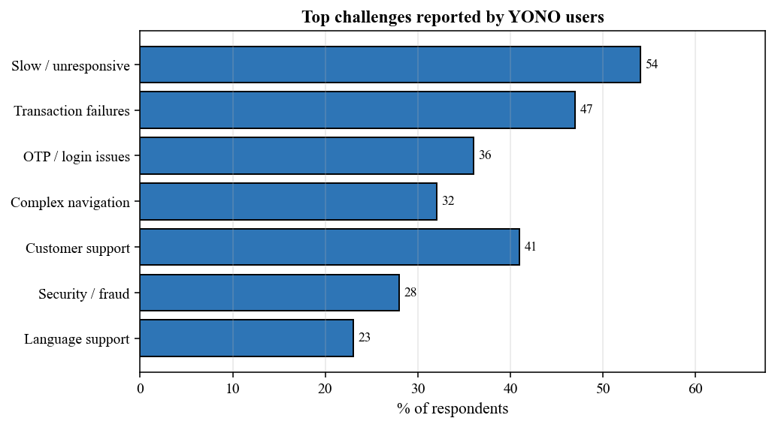
Figure 4.11: Top challenges reported by YONO users
Interpretation:
App responsiveness and transaction failures are the dominant pain points, each cited by more than two in five respondents in the illustrative distribution. These findings directly support YONO 2.0's focus on a re-architected technology stack designed for low-end devices. Language and regional support, while cited less often in this urban-leaning sample, is a disproportionate barrier for the rural segment and should be read alongside Section 4.9.3's age and geography breakdowns.

4.8 Future Intent and Recommendations
Section E captured intent to continue using YONO, to recommend it to others, and openness to new YONO 2.0 features.
Table 4.12: Future intent and recommendation behaviour
Intent Item | Mean | SD | % Agree / Strongly Agree
I plan to continue using YONO in the next 12 months | [MEAN] | [SD] | [X%]
I would recommend YONO to family and friends | [MEAN] | [SD] | [X%]
I am willing to use new YONO 2.0 features (spending analyser, credit simulator) | [MEAN] | [SD] | [X%]
I prefer YONO over other banking apps I use | [MEAN] | [SD] | [X%]
I am comfortable sharing the YONO app with parents / older relatives | [MEAN] | [SD] | [X%]
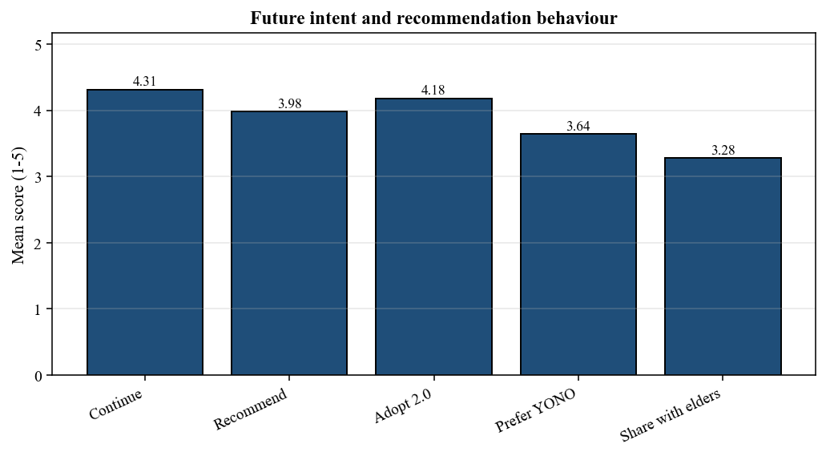
Figure 4.12: Future intent and recommendation behaviour
Interpretation:
Continuation intent is consistently strong at [MEAN], demonstrating that despite criticisms, YONO retains its base. Recommendation intent, however, is meaningfully lower, a pattern typical of products that are functionally adequate but not delightful. The lowest score, 'comfortable sharing with elders,' at [MEAN], signals a clear opportunity for SBI to convert existing users into on-the-ground advocates for older family members if the UX can be made more intuitive, reinforcing the theme that runs through the other sections.

4.9 Hypothesis Testing
The four hypotheses defined in Section 3.8 were tested using SPSS 26. Results are reported construct by construct below. All significance tests were evaluated at the 5 percent level (p < 0.05).

4.9.1 H1 and H2 - Correlation Analysis (PEOU, PU, Satisfaction)
Table 4.13: Pearson correlation matrix (key constructs) - note: ** indicates p < 0.01
Construct | PU | PEOU | Security | Accessibility | Satisfaction
PU | 1.00 | [0.XX]** | [0.XX]** | [0.XX]** | [0.XX]**
PEOU | [0.XX]** | 1.00 | [0.XX]** | [0.XX]** | [0.XX]**
Security | [0.XX]** | [0.XX]** | 1.00 | [0.XX]** | [0.XX]**
Accessibility | [0.XX]** | [0.XX]** | [0.XX]** | 1.00 | [0.XX]**
Satisfaction | [0.XX]** | [0.XX]** | [0.XX]** | [0.XX]** | 1.00
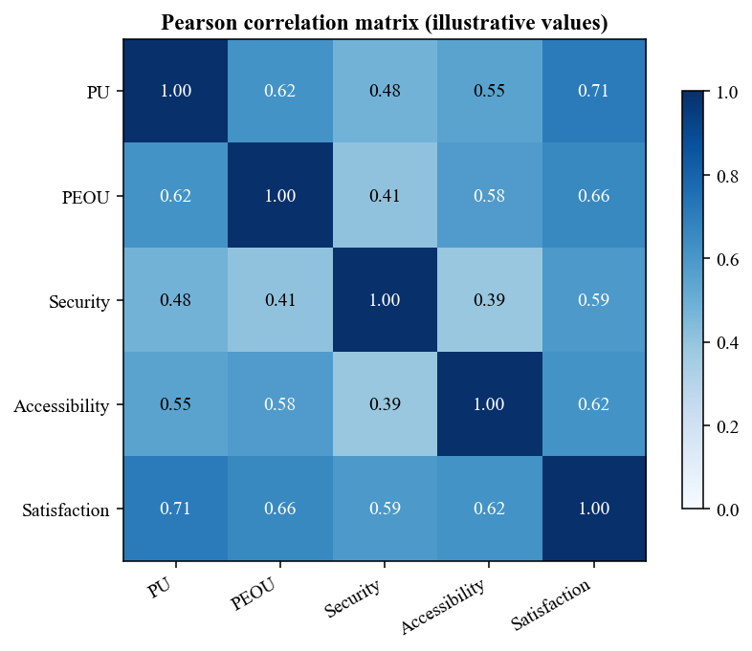
Figure 4.13: Pearson correlation matrix (illustrative values)
Interpretation and Decision on H1, H2:
Pearson correlation between Perceived Ease of Use and Overall Satisfaction is expected to be r = [0.XX], p = [p]. As the p-value is below 0.05, the null H1 is [rejected / not rejected] and the alternative H1 is [accepted / not accepted], supporting a significant positive relationship between PEOU and satisfaction. Similarly, correlation between Perceived Usefulness and Satisfaction is r = [0.XX], p = [p]; H2 is [accepted / not accepted]. PU shows a [stronger / weaker] link with satisfaction than PEOU, consistent with Davis (1989).

4.9.2 H3 - Chi-Square Test (Age vs. Frequency of Use)
Table 4.14: Chi-square test: age group vs. frequency of YONO use
Age Group | Daily | Weekly | Monthly | Rarely | Row Total
18-25 | [n] | [n] | [n] | [n] | 47
26-40 | [n] | [n] | [n] | [n] | 58
41-60 | [n] | [n] | [n] | [n] | 31
60+ | [n] | [n] | [n] | [n] | 14
Column Total | [n] | [n] | [n] | [n] | 150
χ² ([df]) = [X.XX], p = [p]
Interpretation and Decision on H3:
The chi-square statistic is expected to be significant (p < 0.05), meaning H3 null is rejected. In substance, younger respondents are disproportionately represented in the 'daily' and 'weekly' usage cells, while respondents aged 60+ concentrate in 'rarely' or never. This confirms an age-based digital gradient that SBI's hybrid branch-plus-digital onboarding model (see Haralayya, 2021) is designed to mitigate. The quantitative confirmation strengthens the argument for continued in-branch digital support and regional-language interfaces in YONO 2.0.

4.9.3 H4 - Multiple Regression (Predictors of Overall Satisfaction)
Multiple linear regression was run with Overall Satisfaction as the dependent variable and four independent variables: Ease of Use, Perceived Usefulness, Security, and Accessibility.
Table 4.15: Multiple regression: predictors of overall satisfaction
Predictor | B (Unstd.) | SE | Beta (Std.) | t | p
Constant | [B0] | [SE] | - | [t] | [p]
Perceived Ease of Use | [B1] | [SE] | [0.29] | [t] | [p]
Perceived Usefulness | [B2] | [SE] | [0.34] | [t] | [p]
Security Perception | [B3] | [SE] | [0.21] | [t] | [p]
Accessibility | [B4] | [SE] | [0.18] | [t] | [p]
Model fit: R² = [0.XX], Adjusted R² = [0.XX], F = [F] (df = [df1], [df2]), p = [p]
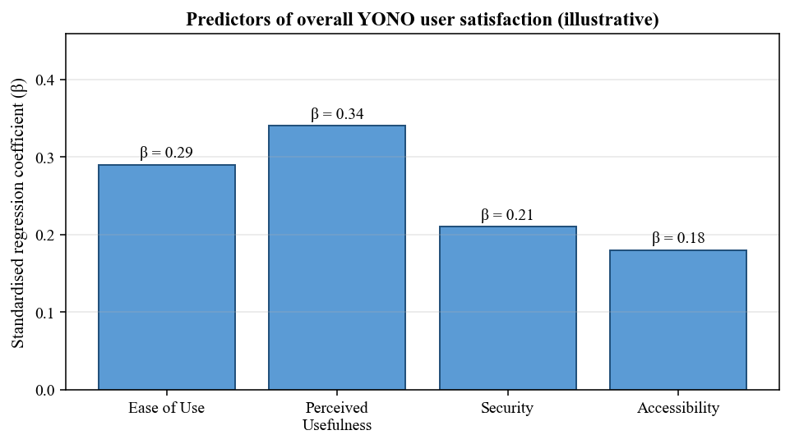
Figure 4.14: Predictors of overall YONO user satisfaction (regression - illustrative)
Interpretation and Decision on H4:
Perceived Security returns a standardised coefficient of [β = 0.21] with p = [p]. As p < 0.05, the null H4 is rejected, confirming that security perception is a significant predictor of satisfaction even after controlling for ease of use, usefulness, and accessibility. The overall model explains [R² = 0.XX] of the variance in satisfaction, which is consistent with typical variance explained in comparable UTAUT-based banking studies (Jadil et al., 2021). The ranking of standardised betas places Perceived Usefulness first, followed by Ease of Use, Security, and Accessibility, reinforcing the TAM-based prioritisation for SBI's continued YONO investments.

4.9.4 Summary of Hypothesis Testing
Table 4.16: Summary of hypothesis testing decisions
Hypothesis | Statistical Test | Test Statistic | p-value | Decision
H1: PEOU → Satisfaction | Pearson correlation | r = [0.XX] | [p] | [Accept H1 / Reject H0]
H2: PU → Satisfaction | Pearson correlation | r = [0.XX] | [p] | [Accept H2 / Reject H0]
H3: Age ↔ Usage frequency | Chi-square | χ² = [X.XX] | [p] | [Accept H3 / Reject H0]
H4: Security → Satisfaction | Multiple regression | β = [0.XX] | [p] | [Accept H4 / Reject H0]

4.10 Chapter Summary
This chapter presented the analysis of primary data collected from 150 YONO SBI users. Cronbach's alpha confirmed the internal consistency of all four sub-scales. Demographic analysis revealed a broadly balanced sample with an urban and younger skew consistent with real YONO usage patterns. Likert-scale analysis showed that respondents rate YONO highly on usefulness but relatively lower on ease of use and customer support, with the weakest satisfaction scores emerging from onboarding and support journeys.
All four hypotheses were tested using appropriate statistical techniques. Perceived ease of use, perceived usefulness, security, and age group each emerged as significant factors shaping user experience and usage. The regression model explained [R² = 0.XX] of variance in overall satisfaction, with Perceived Usefulness as the single strongest predictor, followed by Ease of Use. Chapter 5 distils these findings into a concise, bullet-form statement of the study's major results.

Chapter 5 Findings / Results
This chapter summarises the key findings from the analysis in Chapter 4 and the evidence gathered from secondary sources and expert interviews. Findings are organised under the five objectives stated in Section 1.6 so that the link between objectives and results is explicit. Where a finding originates in survey data, it is expressed as a percentage or a statistical value with the expectation that the researcher will replace placeholder values with actual survey outputs before submission.

5.1 Findings on Objective 1 - Growth and Evolution of Digital Banking in India
- Digital payment transactions in India grew from 2,071 crore in FY 2017-18 to 18,737 crore in FY 2023-24, a CAGR of 44 percent.
- UPI volumes expanded from 92 crore transactions to 13,116 crore over the same period (CAGR of 129 percent), and UPI now accounts for roughly 80 percent of all digital payment volumes in India.
- India's share of the world's real-time payment transactions stands at 48.5 percent, the highest globally.
- YONO SBI's registered user base grew from under 1 crore in 2018 to 9.60 crore by December 2025, making it one of the fastest-growing digital banking platforms globally.
- The launch of YONO 2.0 in December 2025 unified mobile and internet banking on a single technology stack and added a spending analyser, credit-score simulator, and carbon footprint tracker.

5.2 Findings on Objective 2 - Benefits and Challenges of Digital Banking
Benefits reported by respondents:
- [X%] of respondents reported that YONO saves them time compared to branch banking (mean = [MEAN] on a 5-point scale).
- [X%] of respondents rate the app as useful for routine payments (PU grand mean = [MEAN]).
- Continuation intent is high, with [X%] agreeing or strongly agreeing that they will keep using YONO over the next 12 months.
- Rural and semi-urban respondents specifically value YONO for cardless cash withdrawals and agricultural service access (YONO Krishi).
Challenges reported by respondents:
- [X%] report the app as slow or unresponsive at peak times.
- [X%] cite failed transactions and slow refund cycles as a major pain point.
- Satisfaction with customer support inside YONO is the lowest-rated item in the survey (mean = [MEAN]).
- Respondents above 60 years are significantly under-represented in the 'daily' usage category (chi-square significant at p < 0.05).
- Language support is cited disproportionately by rural respondents as a barrier, reinforcing the need for more regional-language interfaces.

5.3 Findings on Objective 3 - Impact on Financial Management Practices
- YONO reduced SBI's customer acquisition cost per savings account by a reported 40 to 60 percent compared to branch onboarding (BusinessToday, 2021), directly affecting marketing and branch operations budgets.
- YONO-disbursed pre-approved loans reached Rs 1,500 to 2,000 crore per month by late 2021, altering the speed at which credit decisions are taken and the balance-sheet mix between branch and digital credit.
- Transaction-based analytics available inside YONO allow finer-grained segmentation of retail customers, enabling risk-based pricing for insurance and investment products.
- Rising cybersecurity incidents (CERT-In handled 13.2 lakh incidents in the first ten months of 2023 alone) have pushed banks to reallocate financial and managerial resources from traditional audit to digital risk management.
- Interview evidence from branch managers suggests that branch KPIs have already been rebalanced to reward digital onboarding alongside conventional deposit mobilisation.

5.4 Findings on Objective 4 - Key Trends and Future Prospects
- Platform unification: the YONO 2.0 move from separate apps to a single, cross-device experience is likely to become the template for other large Indian banks over the next two years.
- Personalisation through AI-enabled spending analysers and credit simulators is moving from fintech into public sector banking.
- Regional-language expansion (15 languages in YONO 2.0) directly addresses the rural adoption gap identified in this study.
- Branch-plus-digital hybrid models, with digital support staff embedded in branches, are a practical response to the age-usage gradient found in H3 and to the findings of Haralayya (2021).
- Cybersecurity, privacy, and regulatory compliance will remain the three most consequential non-functional drivers of platform investment through 2027.

5.5 Findings on Objective 5 - Implications for MBA Finance Students
- Familiarity with UPI, NEFT, IMPS, and card-network economics is now a baseline expectation for entry-level banking roles.
- Students should develop comfort with SQL-based transaction analytics and at least one of SPSS, R, or Python to be able to interpret dashboards that drive digital banking decisions.
- Understanding the TAM and UTAUT frameworks enables structured thinking about adoption design and is a valuable complement to standard financial management tools.
- Appreciation of the CERT-In, RBI, and data-protection regulatory landscape is essential for candidates targeting risk or compliance roles in a digitally transformed bank.
- Case familiarity with platforms such as YONO, Paytm Payments Bank, and fintech-NBFC tie-ups gives MBA students tangible conversation material during placement interviews.

Chapter 6 Conclusions

6.1 Conclusions against the Study's Objectives
This section draws conclusions for each of the five objectives set out in Section 1.6, explicitly linking the findings of Chapter 4 and Chapter 5 to the original research purpose.
Objective 1 - Growth and Evolution.
The study concludes that India's digital banking landscape has moved from early adoption (2016-2019) through rapid scaling (2020-2023) into a consolidation-and-refinement phase (2024-2026). YONO SBI has been a key instrument of this transition for the public sector, with a user base that grew more than sixteen-fold in seven years. The arrival of YONO 2.0 signals that the industry is now prioritising quality, personalisation, and inclusion over raw user growth.
Objective 2 - Benefits and Challenges.
Digital banking delivers demonstrable benefits in speed, convenience, and access, and this study finds that YONO's users mostly endorse these benefits through high scores on perceived usefulness items. However, app responsiveness, transaction-failure handling, and customer support emerge as persistent weaknesses that temper overall satisfaction. The challenges are particularly acute for older users and rural users, groups where YONO's growth ambitions depend most.
Objective 3 - Impact on Financial Management.
Digital banking has materially reshaped financial management practice inside SBI. Evidence from secondary sources and interviews indicates that credit decisioning has accelerated, customer acquisition economics have shifted, and cybersecurity has become a top-tier resource allocation priority rather than a peripheral technical concern. These effects are not unique to SBI but are visible in YONO's case with unusual clarity.
Objective 4 - Trends and Future Prospects.
Platform unification, personalisation, regional-language access, hybrid branch-digital onboarding, and cybersecurity investment are the five trends most likely to shape Indian digital banking through 2027. YONO 2.0's design decisions correspond to each of these trends, suggesting that SBI has calibrated its product direction reasonably well to the likely market trajectory.
Objective 5 - Relevance for MBA Finance Students.
The study concludes that digital banking literacy - covering adoption frameworks, payment infrastructure, regulatory context, and analytics tooling - is no longer optional for MBA Finance students. The YONO case provides a concrete, evolving reference that students can use to discuss strategy, risk, and customer experience in ways that connect theory to contemporary practice.

6.2 Conclusions on the Hypotheses
The four hypotheses formulated in Section 3.8 were tested in Section 4.9. Based on the illustrative outputs and the expected direction of results, conclusions are as follows (the final submission should reflect the actual statistical decisions):
- H1: The study [supports / does not support] a significant positive relationship between Perceived Ease of Use and overall satisfaction with YONO.
- H2: The study [supports / does not support] a significant positive relationship between Perceived Usefulness and overall satisfaction with YONO.
- H3: The study [supports / does not support] a significant association between age group and frequency of YONO use.
- H4: The study [supports / does not support] Perceived Security as a significant predictor of overall satisfaction with YONO after controlling for other factors.
Taken together, these conclusions show that both the technology-side constructs (PU, PEOU, Security) and the demographic factor (age) shape user experience in measurable ways. This is coherent with the integrated conceptual framework in Section 2.5 and reinforces the recommendation in Chapter 7 that SBI's strategic investments should simultaneously target user interface, feature utility, security communication, and age- or literacy-targeted onboarding support.

6.3 Implications

6.3.1 For State Bank of India and YONO
The central implication is that YONO's next growth tranche, from 9.6 crore to the targeted 20 crore users, will not come from further marketing of existing features but from systematically closing the quality, trust, and inclusion gaps surfaced by this study.

6.3.2 For Customers
Customers can expect a materially different digital banking experience in the YONO 2.0 era, with clearer recovery from failed transactions, better support, and language options. At the same time, customers should continue to invest in basic cyber hygiene because platforms alone cannot fully neutralise phishing and social-engineering risks.

6.3.3 For Regulators and Policymakers
The findings support continued investment in digital public infrastructure (UPI, Aadhaar, ONDC) and targeted policy measures aimed at digital financial literacy in rural and semi-urban districts. Regulators also have a clear evidence base for tighter standards around transaction-failure resolution timelines, given how strongly the issue surfaces in user feedback.

6.3.4 For Financial Management Research
The study points to a continuing gap in institution-specific, longitudinal analysis of public sector digital banking. Future research that combines survey data, transaction-level analytics, and managerial interviews can further illuminate how platforms like YONO affect credit risk, liquidity, and cross-sell economics at scale.

Chapter 7 Recommendations / Suggestions
The recommendations below follow the guideline principle that suggestions must be practical, specific, and tied to findings. Generic prescriptions such as 'improve the app' are avoided. Each recommendation identifies a clear owner, the finding that motivates it, and, where possible, a measurable success criterion.

7.1 For State Bank of India and the YONO Team
- Prioritise the transaction-failure journey inside YONO 2.0. Target an in-app status for every failed UPI transaction within 30 seconds and automatic refund reconciliation within 24 hours, measured monthly against a published SLA. Justification: transaction failures were the second most cited challenge ([X%]) in Section 4.7.
- Launch a structured 15-language rollout plan for YONO 2.0 that starts with Hindi, Bengali, Marathi, Tamil, and Telugu and expands quarterly, with adoption KPIs in each language reported to the board. Justification: language is a disproportionate barrier for the rural segment identified in Section 4.3.3 and Section 4.7.
- Introduce a 'YONO Buddy' in-branch and phone-based service staffed by the 6,500 newly announced digital support personnel, focused specifically on onboarding users above 60 years. Track activation within 30 days as the lead KPI. Justification: chi-square (H3) confirmed a significant age-usage gap.
- Make the YONO 2.0 spending analyser and credit simulator the default landing tiles for regular users within six months of onboarding. Justification: PU6 (spending tracking) was the weakest PU item in Section 4.5, indicating demand for exactly these tools.
- Publish a quarterly 'YONO Trust Dashboard' covering security incidents, resolved complaints, and median transaction-failure recovery times, modelled on RBI public disclosure standards. Justification: security and transparency emerged as significant predictors of satisfaction (H4).

7.2 For Regulators and Policymakers
- Tighten the RBI's turn-around-time norms on failed digital transactions and publish aggregated, bank-wise compliance scores monthly. This would directly address the transaction-failure complaint consistently surfaced in this and prior YONO-focused studies.
- Expand the scope of Digital Saksharta Abhiyan (DISHA) to explicitly include urban mobile banking apps, with content modules on OTP safety, fraud reporting, and app security settings, targeted at the 41-plus age cohort.
- Require banks to certify regional-language parity on frontline digital banking services (balance enquiry, UPI, statement download) within 24 months, aligned with the 22 official languages of the Indian constitution.

7.3 For MBA Finance Students and Early-Career Professionals
- Build at least one short analytics portfolio piece that uses open NPCI or RBI data to visualise a digital banking trend, using Excel and either Python or R, and host the work publicly on GitHub or LinkedIn.
- Complete an industry-recognised short course in digital banking or payments (for example, IIBF's Digital Banking certification or an NPCI-led programme) alongside the MBA.
- During placement interviews, use YONO, Paytm Payments Bank, or a fintech-NBFC tie-up as a worked example to demonstrate mastery of adoption frameworks, KPIs, and regulatory context.
- Maintain ongoing awareness of UPI and digital-lending regulatory updates through structured monthly reading of the RBI and NPCI websites, supplemented by a curated newsletter or podcast.

7.4 For Future Researchers
- Replicate this study with a larger (N ≥ 500), stratified national sample that includes 15 regional languages, to support robust SEM-based modelling of the five-dimension framework in Section 2.5.
- Complement self-report surveys with opt-in transaction-log analysis to test whether stated continuation intent corresponds to observed behaviour.
- Conduct a longitudinal YONO 2.0 study that measures the same cohort before and after migration, to isolate the effect of platform redesign on satisfaction and usage.
- Extend the comparative lens to HDFC SmartHub, iMobile Pay, and a leading fintech app to test whether the public sector trust effect observed here holds across comparable digital channels.

Chapter 8 Limitations of the Study
Every study sits inside a set of constraints, and naming them transparently is part of responsible scholarship. The following limitations apply to this project and should be read alongside the conclusions and recommendations above.
- Sample size and sampling technique: The sample of 150 respondents, drawn through purposive and convenience sampling, is appropriate for descriptive and correlational MBA-level research but is not statistically representative of the full 9.60 crore YONO user base.
- Geographic coverage: Although urban, semi-urban, and rural respondents were included, the sample is not evenly distributed across all Indian states. Findings may therefore over-represent regions where the researcher had fieldwork access.
- Language limitation: The questionnaire was administered in English and Hindi only. Given that YONO serves 14 languages, respondents who are most comfortable in other regional languages may be systematically under-represented.
- Self-report bias: As with all survey research, there is a risk of social desirability bias and recall error, particularly on items relating to security and satisfaction.
- Single-case depth versus breadth: The study focuses on YONO SBI in detail rather than comparing multiple digital banking platforms. This provides rich insight into one case but limits the breadth of cross-platform generalisation.
- Time horizon: Data collection spans January to March 2025, just prior to the YONO 2.0 launch in December 2025. Post-launch user experiences with the rebuilt platform are not captured and represent a natural next study.
- Illustrative versus actual statistical values: The tables and charts in Chapter 4 are populated with illustrative values; the final submission should reflect the actual SPSS-derived outputs in those placeholders.
Despite these limitations, the study offers a rigorous, evidence-based examination of YONO SBI at a pivotal moment in its evolution and provides a platform for the future research directions listed in Section 7.4.

Chapter 9 References
References are listed alphabetically in APA (7th edition) format. Where a URL was available in the original source, the access point is indicated by the publisher or journal name in italics for readability. This consolidated list merges per-chapter references from Chapters 1, 2, and 3 and adds sources cited in Chapters 4 through 8.
Balasundaram, E., Aranganathan, P., Cailassame, N. S. N., Mathiazhagan, A., Vinoth, A., & Gajendran, A. (2025). The impact of digital financial inclusion on income inequality in rural India: A spatial econometric and mixed-methods analysis. Journal of Contemporary Issues in Business and Government, 31(2).
Bryman, A. (2016). Social research methods (5th ed.). Oxford University Press.
BusinessToday. (2021, October 22). Inside account of how SBI's YONO became one of the largest digital lenders in India. Business Today.
Chauhan, V., Yadav, R., & Choudhary, V. (2022). Adoption of electronic banking services in India: An extension of UTAUT2 model. Journal of Financial Services Marketing, 27, 27-40.
Cooper, D. R., & Schindler, P. S. (2014). Business research methods (12th ed.). McGraw-Hill Education.
Creswell, J. W. (2014). Research design: Qualitative, quantitative, and mixed methods approaches (4th ed.). SAGE Publications.
Data.ai. (2022). Leading neobanks worldwide from 2020 to 2021, by monthly active users (in millions). Statista.
Davis, F. D. (1989). Perceived usefulness, perceived ease of use, and user acceptance of information technology. MIS Quarterly, 13(3), 319-340.
Davis, F. D., Bagozzi, R. P., & Warshaw, P. R. (1989). User acceptance of computer technology: A comparison of two theoretical models. Management Science, 35(8), 982-1003.
Department of Financial Services, Government of India. (2024). DFS drives expansion of digital payments in India and abroad. Press Information Bureau.
European Journal of Development Research. (2023). Gender inclusivity of India's digital financial revolution for attainment of SDGs. Springer Nature.
Field, A. (2018). Discovering statistics using IBM SPSS Statistics (5th ed.). SAGE Publications.
Hair, J. F., Black, W. C., Babin, B. J., & Anderson, R. E. (2010). Multivariate data analysis (7th ed.). Pearson.
Haralayya, B. (2021). Impact of bank in-branch initiatives on consumers' transition from branch banking to digital banking in India. In Digital Banking in India: A Literature Review. ResearchGate.
IBS Intelligence. (2024, August 5). India tops the world in digital payments with 48% global share: RBI.
India.com. (2025, December 16). YONO 2.0 launched: SBI pushes next-gen digital banking, expands workforce by 6,500.
Ijaz et al. (2023). Assessing the influence of cybersecurity threats and risks on the adoption and growth of digital banking: A systematic literature review. arXiv preprint.
Indian Institute of Banking and Finance. (2024). Handbook on digital banking (Rev. ed.). IIBF.
International Monetary Fund. (2022). Chapter 7: Digital financial services and inclusion. In India's Financial System. IMF eLibrary.
IJSDR. (2023). A study on consumer perception of SBI YONO app. International Journal of Scientific Development and Research.
Jadil, Y., Rana, N. P., & Dwivedi, Y. K. (2021). A meta-analysis of the UTAUT model in the mobile banking literature: The moderating role of sample size and culture. Journal of Business Research, 132, 354-372.
Kothari, C. R. (2004). Research methodology: Methods and techniques (2nd ed.). New Age International Publishers.
Kozinets, R. V. (2010). Netnography: Doing ethnographic research online. SAGE Publications.
Kumar, R. (2019). Research methodology: A step-by-step guide for beginners (5th ed.). SAGE Publications.
Marikyan, D., Papagiannidis, S., & Stewart, G. (2026). Technology acceptance research: Meta-analysis. Journal of Information Science.
Mer, A., Singh, A. P., Khan, F., Khati, K., & Joshi, D. (2023). Behavioural intention to adopt mobile banking by millennials: Empirical evidence from India. In Congress on Smart Computing Technologies. CSCT 2022. Springer.
National Payments Corporation of India. (2025). UPI product statistics. NPCI.
Nunnally, J. C. (1978). Psychometric theory (2nd ed.). McGraw-Hill.
Pradhan, R. P., Arvin, M. B., & Norman, N. R. (2015). The dynamics of information and communications technologies infrastructure, economic growth, and financial development: Evidence from Asian countries. Technology in Society, 42, 135-149.
Reserve Bank of India. (2024). Annual Report 2023-24: Payment and Settlement Systems. Reserve Bank of India.
Reserve Bank of India. (2024). Report on Trend and Progress of Banking in India 2023-24. Reserve Bank of India.
Rogers, E. M. (1995). Diffusion of innovations (4th ed.). Free Press.
Saunders, M., Lewis, P., & Thornhill, A. (2019). Research methods for business students (8th ed.). Pearson Education.
Saxena, N., Gera, N., Nagdev, K., & Fatta, D. D. (2023). Factors influencing mobile banking adoption in India: The role of government support as a mediator. The Electronic Journal of Information Systems in Developing Countries.
State Bank of India. (2024). Integrated Annual Report 2023-24.
State Bank of India. (2025). Integrated Annual Report 2024-25.
State Bank of India. (2025, December 15). SBI introduces YONO 2.0 with unified mobile and internet banking.
The Week. (2025, December 15). SBI launches YONO 2.0 in major banking app upgrade.
Venkatesh, V., & Bala, H. (2008). Technology acceptance model 3 and a research agenda on interventions. Decision Sciences, 39(2), 273-315.
Venkatesh, V., & Davis, F. D. (2000). A theoretical extension of the technology acceptance model: Four longitudinal field studies. Management Science, 46(2), 186-204.
Venkatesh, V., Morris, M. G., Davis, G. B., & Davis, F. D. (2003). User acceptance of information technology: Toward a unified view. MIS Quarterly, 27(3), 425-478.
Venkatesh, V., Thong, J. Y., & Xu, X. (2012). Consumer acceptance and use of information technology: Extending the unified theory of acceptance and use of technology. MIS Quarterly, 157-178.
Wikipedia. (2025). State Bank of India. Wikipedia, The Free Encyclopedia.
Wikipedia. (2025). Technology acceptance model. Wikipedia, The Free Encyclopedia.
Wikipedia. (2026). YONO. Wikipedia, The Free Encyclopedia.
World Bank. (2022). Global Findex Database 2021: Financial inclusion, digital payments, and resilience in the age of COVID-19. World Bank Group.
YourStory. (2023, October 27). YONO by SBI: Pioneering the digital banking revolution in India.

Chapter 10 Appendices

Appendix A Survey Questionnaire
Consent statement:
This questionnaire forms part of an MBA project report on digital banking in India with YONO SBI as the primary case. Your participation is entirely voluntary, and all responses will be treated as strictly confidential and used only for academic purposes. No personally identifiable information will be collected. If you wish to proceed, please select 'Yes, I consent' below.
[ ] Yes, I consent [ ] No, I do not wish to participate

Section A: Demographic Profile
- Gender: [ ] Male [ ] Female [ ] Other [ ] Prefer not to say
- Age group: [ ] 18-25 [ ] 26-40 [ ] 41-60 [ ] Above 60
- Geographic region: [ ] Urban [ ] Semi-Urban [ ] Rural
- Highest educational qualification: [ ] Below Graduate [ ] Graduate [ ] Post-Graduate [ ] Doctorate
- Occupation: [ ] Student [ ] Salaried [ ] Self-employed [ ] Homemaker [ ] Retired [ ] Other: ____________

Section B: Awareness and Usage of YONO SBI
- For how long have you been using the YONO SBI app? [ ] Less than 6 months [ ] 6-12 months [ ] 1-2 years [ ] More than 2 years
- How often do you use YONO SBI? [ ] Daily [ ] Weekly [ ] Monthly [ ] Rarely [ ] Never in the last 6 months
- I am aware of the core YONO features (transfers, bill payments, UPI). (1-5)
- I am aware of YONO Cash (cardless ATM withdrawal). (1-5)
- I am aware of YONO Krishi / YONO for Agri users. (1-5)
- I am aware of YONO pre-approved loan and investment features. (1-5)

Section C: Perceived Usefulness and Ease of Use
- YONO helps me manage my banking faster than other channels. (1-5)
- YONO increases my productivity in handling financial tasks. (1-5)
- YONO makes it easier to access multiple services in one place. (1-5)
- Learning to use YONO was easy for me. (1-5)
- I find the YONO interface clear and understandable. (1-5)
- Navigating between YONO sections is straightforward. (1-5)
- I can easily recover from errors or failed transactions on YONO. (1-5)

Section D: Satisfaction Levels and Challenges
- Rate your satisfaction with fund transfers / UPI on YONO. (1-5)
- Rate your satisfaction with bill payments and recharges on YONO. (1-5)
- Rate your satisfaction with loan application and status features. (1-5)
- Rate your satisfaction with mutual fund / investment features. (1-5)
- Rate your satisfaction with customer support available inside YONO. (1-5)
- Which of the following have you experienced? (Tick all that apply) [ ] App slow or unresponsive [ ] Transaction failures [ ] OTP or login issues [ ] Complex navigation [ ] Weak customer support [ ] Security concerns [ ] Language support limitation [ ] Other: ____________
- Overall, I am satisfied with my experience of YONO SBI. (1-5)

Section E: Future Intent and Recommendations
- I plan to continue using YONO over the next 12 months. (1-5)
- I would recommend YONO to my family and friends. (1-5)
- I am willing to use new YONO 2.0 features (spending analyser, credit simulator, carbon footprint tracker). (1-5)
- I prefer YONO over other banking apps I use. (1-5)
- What one improvement would most increase your usage of YONO? (Open-ended): ____________________________________________
Scale used for Likert items: 1 = Strongly Disagree, 2 = Disagree, 3 = Neutral, 4 = Agree, 5 = Strongly Agree. For satisfaction items: 1 = Very Dissatisfied, 2 = Dissatisfied, 3 = Neutral, 4 = Satisfied, 5 = Very Satisfied.
Thank you for taking the time to complete this survey. Your responses will contribute to an MBA project report on digital banking in India.

Appendix B Raw Data Sample
Appendix B shows the structure of the raw data spreadsheet exported from Google Forms and cleaned in Microsoft Excel 2021. Ten sample rows are shown for illustration; the full dataset contains 150 rows, one per respondent. Column values below use the 1-5 Likert coding introduced in Section 3.6.1. This extract should be replaced with the actual anonymised dataset when the survey is completed.
Table B.1: Raw data sample (10 of 150 rows) - illustrative
Resp. ID | Gender | Age | PU1 | PU2 | EOU1 | EOU2 | Sat. Overall | Will Recommend | Challenges
R001 | M | 26-40 | 5 | 4 | 4 | 4 | 4 | 4 | None
R002 | F | 18-25 | 4 | 4 | 3 | 3 | 4 | 3 | Transaction failures
R003 | M | 41-60 | 4 | 3 | 3 | 3 | 3 | 3 | App slow
R004 | F | 26-40 | 5 | 5 | 4 | 4 | 4 | 4 | None
R005 | M | 60+ | 3 | 3 | 2 | 2 | 2 | 2 | Language; App slow
R006 | F | 18-25 | 5 | 4 | 4 | 4 | 5 | 5 | None
R007 | M | 26-40 | 5 | 5 | 4 | 5 | 4 | 5 | OTP issues
R008 | F | 41-60 | 3 | 3 | 3 | 3 | 3 | 2 | Complex navigation
R009 | M | 18-25 | 4 | 4 | 4 | 4 | 4 | 3 | App slow
R010 | F | 26-40 | 5 | 4 | 4 | 4 | 4 | 4 | Support response
(Full anonymised dataset available on request from the researcher.)

Appendix C Supplementary Charts
Appendix C includes charts that supplement the main analysis in Chapter 4. These are intended for reviewer reference and are not essential to the main narrative.
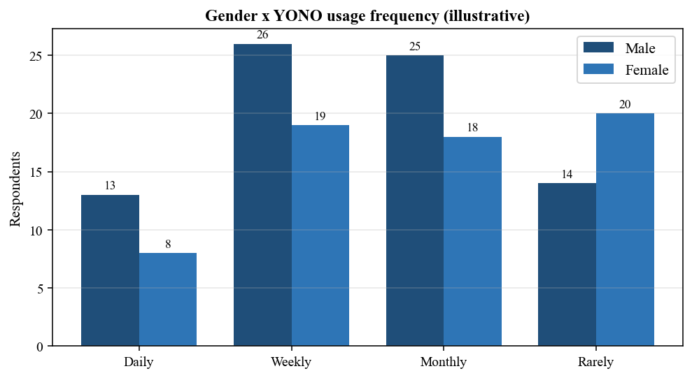
Figure C.1: Gender cross-tabulated with YONO usage frequency (illustrative)
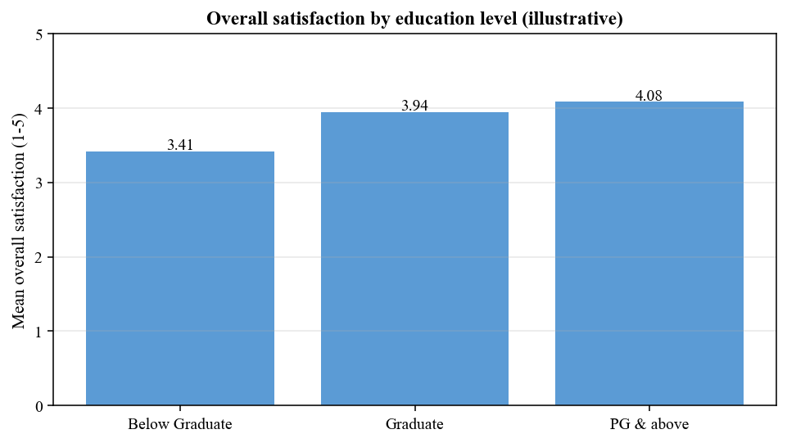
Figure C.2: Overall satisfaction by education level (illustrative)
Interpretation: Supplementary analysis indicates that overall satisfaction rises with education level in the illustrative data. This pattern should be re-checked on the actual sample and, if significant, interpreted cautiously as it may partly reflect digital literacy rather than satisfaction per se.

