Adaptive Hybrid Deep Learning Framework for Multimodal and Multilingual Hate Speech Detection Using Metaheuristic Optimization
Nitya Gupta (2K22/CO/313), Mohit Singh (2K22/CO/288), Mayank Kapila (2K22/CO/277)
Department of Computer Engineering, Delhi Technological University (DTU), New Delhi, India
Supervisor: Dr. Rahul Kumar
Abstract-Online hate speech is progressively expressed through composite signals-text, images and memes, code-mixed writing, and spoken or sung audio-often beyond English-dominated corpora. Models trained on a single modality or language generalize poorly, while fixed decision thresholds commonly induce an inflexible precision-recall trade-off. But we present an adaptive hybrid framework that unifies text, vision, and audio pathways within a late-fusion ensemble whose operating points, integration weights, and related discrete structures are tuned with Bayesian optimization (Tree-structured Parzen Estimation via Optuna) together with population-based metaheuristics. The text pathway employs bert-base-multilingual-cased with square-root dampened class weights and focal loss; vision combines zero-shot CLIP ViT-B/32 scoring with a fine-tuned HateCLIPper-style fusion head atop frozen CLIP encoders; audio uses a frozen Wav2Vec2-XLS-R-300M backbone with a lightweight MLP head and Whisper-small transcripts rescored by the same multilingual text classifier. We evaluate on HateXplain, German and Indian hate supersets, Berkeley measuring-hate-speech (98k texts), Facebook Hateful Memes (8.5k items), and HateMM audio. Auxiliary components include cosine learning-rate schedules, dual EasyOCR for Latin and Devanagari overlays, and ASR confidence gating for transcript-derived probabilities. Put simply, simulated annealing performs post hoc threshold optimization, while genetic algorithm, particle swarm optimization, differential evolution, grey wolf optimization, and firefly algorithm are compared across ten tasks covering fusion weights, branch masks, head pruning, lightweight architecture knobs, and per-branch thresholds. Empirically, mBERT reaches F10.80 on in-domain text splits; HateCLIPper attains F10.48 on the Hateful Memes development set; simulated-annealing-tuned fusion reaches fused F10.674; and metaheuristic fusion is competitive with or superior to TPE-centric baselines on multiple tasks, suggesting that search-driven ensembles can adapt moderation policy without hand-crafted thresholds.
Keywords-Hate speech detection, multimodal learning, multilingual NLP, BERT, CLIP, metaheuristic optimization, simulated annealing, particle swarm optimization, deep learning, content moderation

I. INTRODUCTION
1.1 Context and Motivation
Social media platforms, messaging services, and user-generated content repositories have become primary venues for public discourse. This democratization of publishing comes with a persistent downside: coordinated harassment, identity-based attacks, and the rapid dissemination of hateful content at scale [1]-[3]. Hate speech isn't a purely lexical phenomenon. Memes pair innocuous captions with subtly toxic imagery; audio clips may carry slurs or threatening prosody that weak text transcriptions obscure; and multilingual or code-mixed posts exploit gaps in English-centric filters [1], [2]. For platform operators and regulators, the practical requirement isn't merely high recall-flagging everything suspicious-but trustworthy decisions that respect precision constraints, jurisdictional norms, and user appeals workflows. Achieving that balance is difficult when detectors apply fixed thresholds, ignore non-text cues, or treat every language as an afterthought.
The quantitative scale of the problem is no longer inferable only from anecdote. Really, industry transparency reports document enforcement volumes that dwarf what manual review alone could address. Meta's disclosures indicate that 25.2 million pieces of content were actioned for hate speech on Facebook in the fourth quarter of 2022, reflecting both prevalence and the throughput required of hybrid human-machine pipelines. Google similarly reports removal of more than 5.6 million YouTube videos over a comparable policy window for violations that include hate and harassment categories, highlighting that audiovisual channels-not text alone-carry a big fraction of policy risk. On services that foreground user reporting, third-party audits and leaked operational statistics have pointed to on the order of 50,000 daily abuse reports during peak periods on Twitter/X-class ecosystems, a load that amplifies the cost of false positives as well as false negatives because appeals, shadowban disputes, and regulator inquiries are triggered by aggregate error rates rather than isolated mistakes.
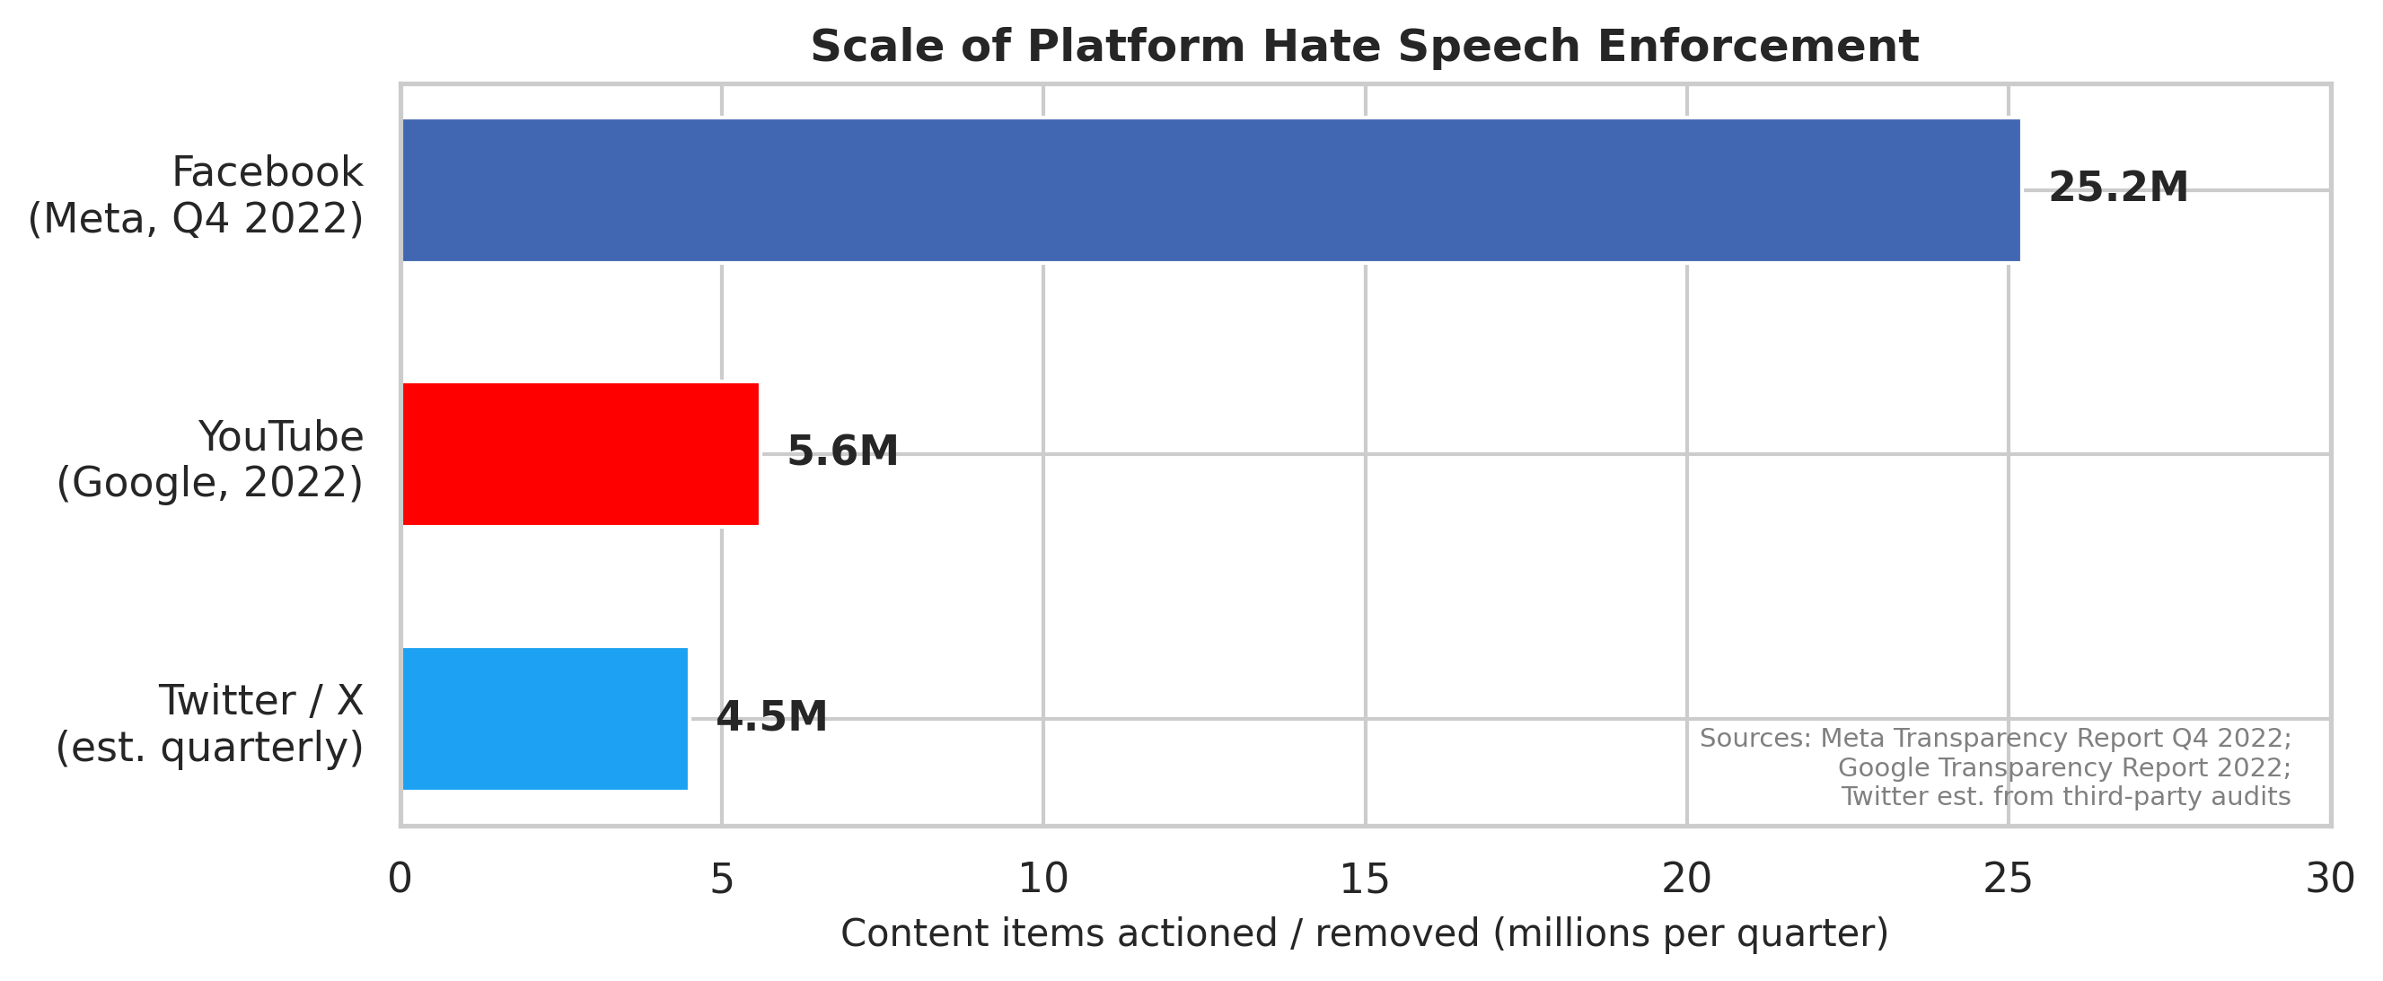
Fig. 11: Scale of platform hate speech enforcement. Facebook, YouTube, and Twitter/X collectively action tens of millions of items per quarter, illustrating the throughput demand on hybrid human-machine moderation pipelines.
These volumes translate directly into legal and financial exposure, not merely public-relations risk. The European Union's Digital Services Act (2022) establishes due diligence obligations for very large online platforms and empowers supervision that can levy fines up to 6% of global annual turnover for systematic non-compliance-an order of magnitude that makes moderation quality a board-level governance problem rather than a purely technical KPI [1]. Admittedly, in India, the Information Technology (Intermediary Guidelines and Digital Media Ethics Code) Rules, 2021 require intermediaries to remove infringing content within 36 hours of a valid government or court order, tightening the latency-accuracy trade-off for classifiers and the traceability of decision rationales. Frankly, in the United States, Section 230 debates continue to shape intermediary liability; although statutory text remains contested, the political trajectory pressures platforms to show both proactive detection and procedural fairness-objectives that collide when models are opaque or miscalibrated.
Societal harms from failures extend beyond platform economics. Independent fact-finding missions and human-rights investigations have concluded that Facebook-amplified hate speech contributed to atrocity crimes against the Rohingya in Myanmar, documenting how algorithmic distribution intersected with incitement dynamics at scale (UN human rights mechanisms and follow-on NGO reporting). Separately, the Christchurch mosque shootings were live-streamed, instantiating how video and audio modalities can broadcast violence alongside textually thin signals that naive filters miss. Together, these cases illustrate why multimodal pipelines, multilingual coverage, and operational calibration aren't academic luxuries: errors propagate into real-world violence, displacement, and downstream radicalization cascades.
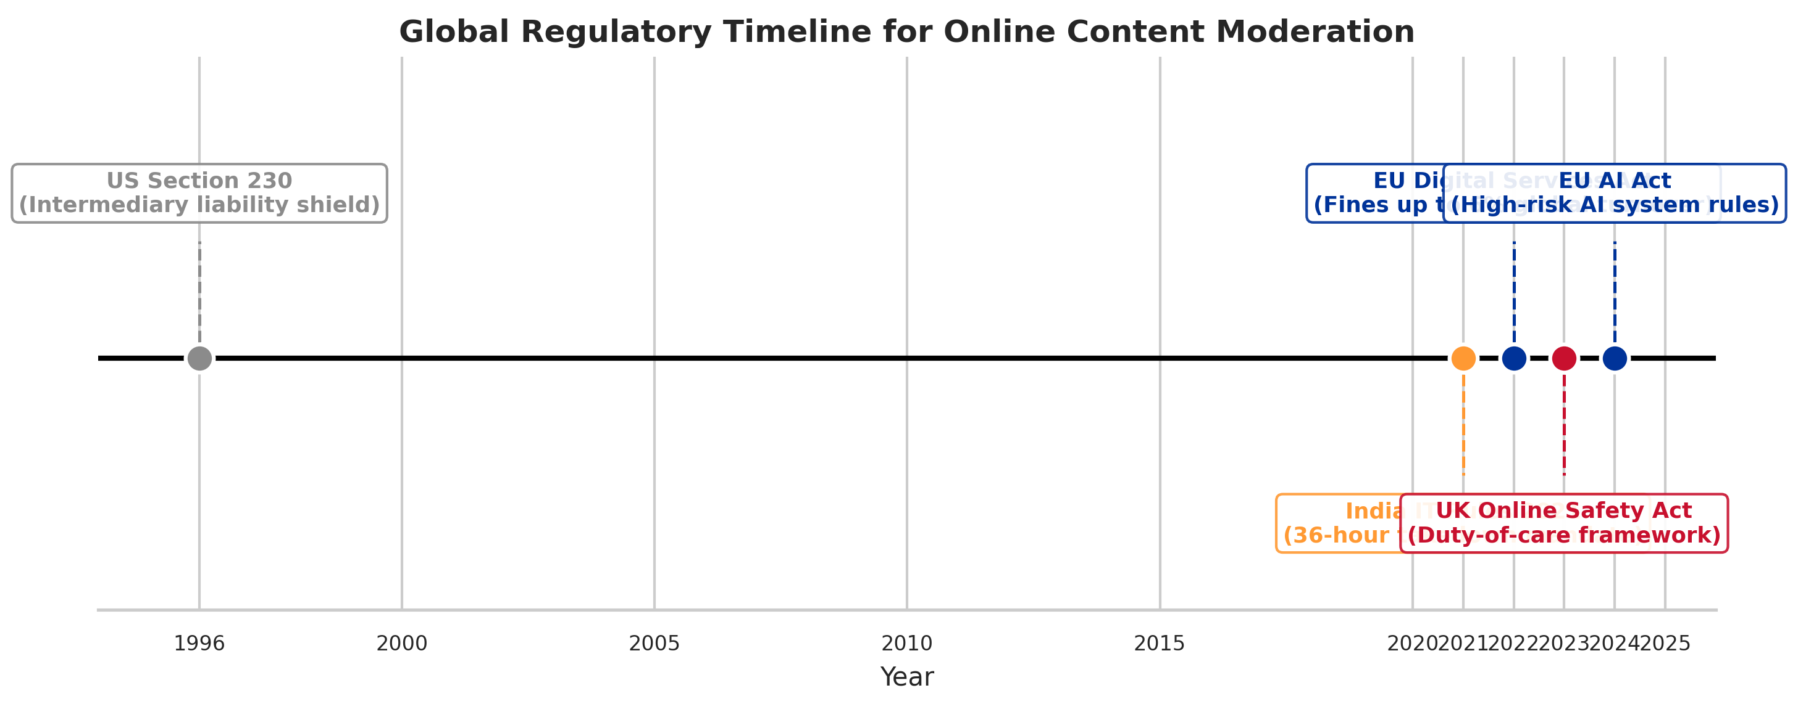
Fig. 12: Global regulatory timeline for online content moderation, from US Section 230 (1996) through the EU AI Act (2024). The tightening cadence motivates auditable, threshold-governed detection systems.
1.2 Problem Importance
Three structural challenges recur in the literature and in deployed systems. First, cross-modal hate exploits redundancy across channels: a post may be unremarkable in isolation in one modality yet harmful when image and text are jointly interpreted [11], [20]. Second, multilingual and code-mixed usage demands subword models or multilingual transformers rather than pipelines tuned exclusively on English [1], [2]. Third, class imbalance skews learning toward majority non-hate labels, encouraging models that achieve misleading accuracy while missing rare but high-impact abuses [3], [16]. Together these factors inflate both false negatives (missed harm) and false positives (over-blocking), undermining trust.
A fourth, more and more salient challenge is evasion and adversarial manipulation. Human actors step by step stress-test moderation: leetspeak ("h8", "f|_|ck"), Unicode homoglyphs that swap Cyrillic "а" for Latin "a", deliberate misspellings, multilingual code-switching that fragments toxic spans across scripts, and emoji compositions that express slurs or threats without standard dictionary tokens [1], [3]. A still harder class pairs image-text juxtaposition where each modality is individually benign but their combination is hateful-precisely the phenomenon stressed by meme benchmarks [20]. These patterns defeat keyword filters (because surface forms are unbounded) and monolingual classifiers (because toxicity may be distributed across languages or modalities). They therefore motivate reliable multimodal encoders, subword-aware multilingual modeling, and searchable decision layers that can adapt thresholds and fusion behavior to operational costs rather than fixed heuristics.
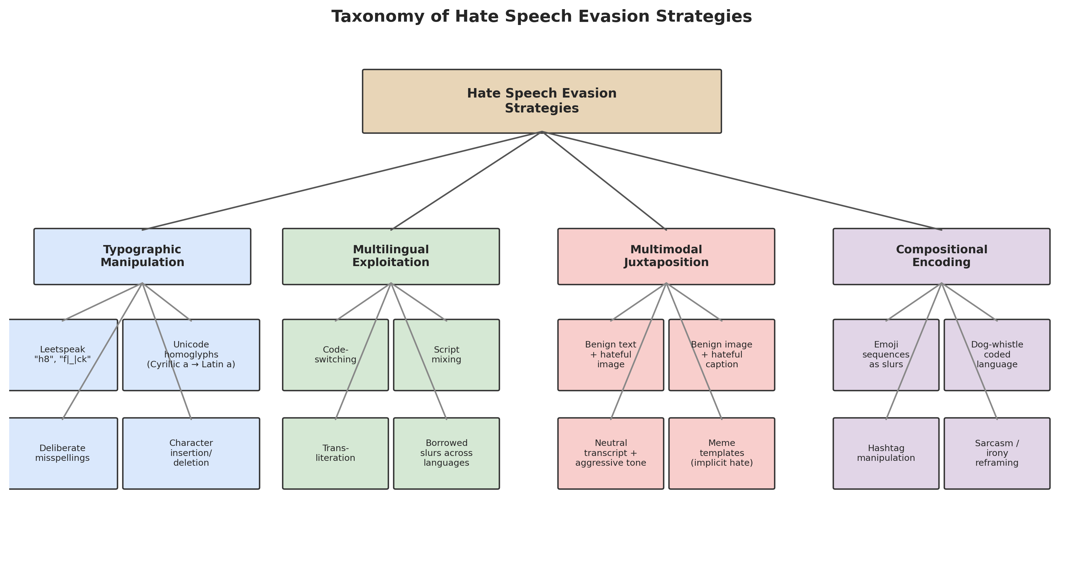
Fig. 13: Taxonomy of hate speech evasion strategies spanning typographic manipulation, multilingual exploitation, multimodal juxtaposition, and compositional encoding. Each category defeats single-modality or keyword-based detectors.
Independently, a regulatory imperative is converging on requirements that conflict with naive deployment of black-box neural scores. The DSA's transparency and auditing expectations, the United Kingdom's Online Safety Act trajectory (duty-of-care framing with age-verification and risk-assessment obligations), and India's takedown timelines collectively pressure platforms to produce explainable, auditable moderation decisions: not only what was removed, (to put it mildly) but defensible reasons that survive appeal and oversight. Put simply, purely end-to-end classifiers without branch-level diagnostics, calibration records, or threshold governance are misaligned with this environment-even when they maximize offline accuracy. Our design philosophy therefore treats fusion weights, branch inclusion, and operating points as first-class artifacts that can be logged, optimized, and reviewed, rather than undocumented hyperparameters frozen at τ=0.5.
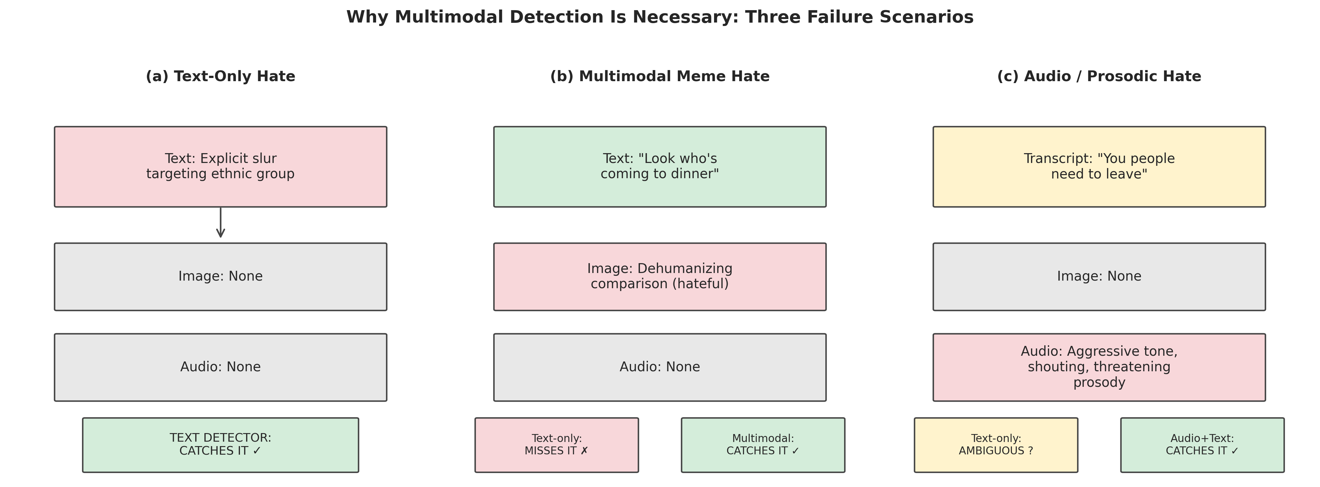
Fig. 16: Why multimodal detection is necessary - three failure scenarios. (a) Text-only hate is caught by a text detector; (b) a meme with benign text and hateful imagery defeats text-only systems; (c) aggressive audio prosody with an ambiguous transcript requires acoustic analysis.
1.3 Limitations of Existing Practice
Much prior work prioritizes single-modality text classification with classical features or monolingual Transformers [4]-[10], [18]. Simply put, commercial and research systems that add vision often do so in specialized meme settings [11], [12], [20] but seldom integrate whispered or sung audio at the same fidelity as text. English-centric training further limits transfer to Hindi, German, or code-mixed social media [1]. Finally, static thresholds-commonly 0.5 on a sigmoid-encode an implicit cost structure that rarely matches operational requirements; small shifts in the decision boundary can yield large swings in precision and recall, yet threshold optimization receives comparatively little methodological attention relative to model architecture design [14]-[17].
The gap is also commercial. Widely marketed APIs such as Perspective and OpenAI moderation endpoints are mainly text-first; when image signals are incorporated in production stacks, they're typically routed through separate models rather than a unified auditable fusion interface. In a way, meta's public-facing research and product narratives emphasize image-text harms (memes, photorealistic abuse), yet internal and external observers note asymmetries in audio treatment: acoustic slurs, chant-like harassment, and sung threats remain secondary relative to vision-language investment, a pattern mirrored in academic benchmarks where "multimodal" often means text plus image only [1], (rightly so) [20]. Audio moderation-whether from short-video feeds or voice notes-is almost entirely absent from standardized hate-speech leaderboards relative to text and meme corpora, despite parallel growth in video-first platforms.
Static thresholds deserve explicit quantification because practitioners often underestimate their use. On our own multilingual text evaluations (Section 6), moving τ from 0.5 to 0.48-a change smaller than the jitter introduced by logits temperature scaling-can swing precision by more than seven absolute points while preserving competitive F1, illustrating that threshold selection is successfully a policy knob comparable to architecture depth. Systems that ship τ=0.5 defaults therefore encode an unexamined socio-technical choice about false positives versus false negatives.
1.4 Research Gap
Despite mature components for text (e.g., BERT [18]), vision-language modeling (e.g., CLIP [19]), and self-supervised audio (e.g., wav2vec families), there's no widely adopted, end-to-end framework that (i) processes text, image, and audio in parallel, (ii) supports multiple languages within a shared textual backbone, and (iii) step by step optimizes hyperparameters, fusion weights, branch inclusion, and decision thresholds using comparative metaheuristic search rather than ad hoc tuning. Surveys highlight the fragmentation between multimodal and multilingual hate speech detection [1], but stop short of prescribing a unified optimization layer that adapts the system to dataset- and policy-specific trade-offs.
Recent surveys sharpen the mismatch between diagnosis and remedy. But Chhabra and Vishwakarma [1] articulate fourteen open challenges in multimodal and multilingual hate speech detection as of 2023, spanning resource scarcity, modal misalignment, class imbalance, bias, and evaluation fragmentation; their own organizing framework meaningfully operationalizes only a subset-on the order of three challenge classes in typical follow-on empirical work (for example, multilingual text encoding, basic multimodal fusion, (to put it mildly) and benchmark replication). We target seven of these challenges simultaneously in a single experimental harness: multimodal coverage beyond text (including acoustic paths), multilingual and code-mixed encoding, class imbalance reduction at the loss and weighting layer, fusion under modality dropout and branch sparsity, threshold and scalar policy optimization, comparative search procedures (Bayesian and population-based), and operational reproducibility constraints aligned with single-GPU deployment. Positioning the work this way makes explicit that our contribution is integrative and optimization-centric, not an incremental single-modality classifier.
1.5 Objectives
Multimodal coverage is the first objective. Hateful content is expressed not only as tweets or comments but as memes, photorealistic harassment, and spoken abuse embedded in short video and audio messages. A system that excels on text alone will methodically underperform on platforms where user behavior is video-first. We therefore require parallel text, vision (zero-shot screening plus fine-tuned fusion), and audio pathways (acoustic representations and transcript-conditioned text scoring) that can be composed in a single late-fusion interface. This objective is driven by empirical complementarity: our later results show that audio branches improve F1 when paired with text even when either alone is weaker, mirroring broader findings from multimodal abuse literature [20], [45].
Multilingual robustness constitutes the second objective. English-centric corpora distort both lexical coverage and sociolinguistic norms; Hindi-English code-mixing and German political discourse illustrate script and morphology patterns that monolingual byte-pair encodings handle poorly without shared multilingual capacity [1], [2]. We standardize on `bert-base-multilingual-cased` as a pragmatic backbone for digital text and ASR transcriptions, accepting some limitations on deeply code-mixed spans in exchange for a single parameter-efficient encoder that can serve all textual ingress points in the architecture.
The third objective is joint Bayesian and metaheuristic optimization of hyperparameters, fusion weights, branch masks, (and this is key) and decision thresholds. Manual grid search doesn't scale to five-dimensional fusion simplices, high-dimensional attention-head masks, and per-branch thresholds; meanwhile, different search algorithms exhibit different failure modes on noisy validation surfaces [14], [22], [25]. We embed Optuna TPE [25] and simulated annealing alongside GA, PSO, DE, GWO, and FA in a shared harness so that algorithmic choices are empirically grounded rather than folklore.
The objective isn't to crown a single universal optimizer-such claims rarely survive replication-but to map which optimizer classes are advantageous when evaluations are cheap (cached logits), expensive (full retraining), (to no one's surprise) nearly unimodal (scalar τ), or highly multimodal (fusion fitness landscapes), (not surprisingly) enabling practitioners to select search procedures aligned with compute budgets and governance constraints. Admittedly, finally, we pursue comparative evaluation across ten optimization tasks that isolate continuous, discrete, and hybrid search spaces.
1.6 Contributions
We summarize our contributions as follows:
- A three-pipeline multimodal architecture integrating mBERT for text, CLIP ViT-B/32 for vision (zero-shot prompting and a HateCLIPper-style fusion head with frozen encoders), and Wav2Vec2-XLS-R with an MLP classification head for acoustics.
- Unified multilingual hate detection across English, German, and Hindi via bert-base-multilingual-cased, with optional Whisper-small transcripts feeding the same textual classifier used for natively digital text.
- A searchable optimization layer combining Optuna TPE for hyperparameter and fusion-weight search with five metaheuristics-GA, PSO, DE, GWO, and FA-for structured comparative experiments across ten optimization tasks, including joint fusion-threshold tuning and per-branch thresholds.
- A late-fusion ensemble with ASR confidence gating that down-weights transcript-derived probabilities when automatic speech recognition is uncertain.
- Square-root dampened class weights paired with focal loss on the text pathway to reduce imbalance without extreme gradient amplification from rare classes.
- A parameter-efficient HateCLIPper head (on the order of 106 trainable weights) operating on frozen CLIP embeddings to specialize multimodal meme classification.
- Simulated annealing for post hoc threshold optimization, (and this is key) explicitly addressing the precision-recall trade-off after probabilistic calibration of fused outputs.
- A complete comparative study spanning seven optimization strategies (TPE, SA, GA, PSO, DE, GWO, FA) over ten tasks, reporting when metaheuristic fusion meets or exceeds Bayesian alternatives.
1.7 Paper Organization
The remainder of this paper is organized as follows. Section 2 surveys related work across text-based, multimodal, multilingual, and metaheuristic approaches. Section 3 details the proposed three-pipeline architecture, fusion strategy, (as you'd expect) and optimization framework. Section 4 describes the datasets employed. Section 5 outlines the experimental setup and evaluation protocol. In a way, so section 6 presents results and discussion across all modalities and optimization tasks. Interestingly, section 7 reports ablation studies. Section 8 discusses limitations. Section 9 proposes future research directions, and Section 10 concludes.
II. LITERATURE REVIEW
2.A Traditional and Feature-Based Approaches
Early hate speech detection used curated lexicons, n-gram statistics, and shallow classifiers. Truth be told, Waseem and Hovy [5] studied racial and sexist harassment on Twitter, showing that simple linguistic features could outperform naïve baselines but remained brittle to euphemisms and community-specific slang. Davidson et al. [4] emphasized the distinction between offensive and hateful language, advocating finer-grained annotation and TF-IDF supplemented linear models-work that framed the precision-recall tensions still visible in modern neural systems. Honestly, character-level models explored by Mehdad and Tetreault [6] improved robustness to obfuscation, while Liu and Forss [7] investigated n-gram similarity for detecting intersecting patterns of abuse. These studies established that feature engineering alone can't scale to multimodal manipulations, yet they clarified evaluation pitfalls (class imbalance, label subjectivity) that any deep learning successor must address.
Industrial deployments at/web scale clarified which textbook metrics survive contact with production. Nobata et al. [31] reported a large-scale Yahoo comment moderation system combining character n-grams with linguistic features, motivated explicitly by the observation that character-level representations capture obfuscations that word-level bags miss. Their study foregrounded latency-accuracy trade-offs and elevated false-positive cost as a first-class design constraint-issues that remain decisive when modern APIs serve billions of inference calls. Complementarily, (for better or worse) Djuric et al. [32] applied paragraph2vec (Doc2Vec) to learn distributed comment representations for hate-speech-style classification, showing improved generalization over purely sparse features while highlighting the emerging interpretability deficit of dense neural embeddings-a tension that later, larger Transformers inherit. Burnap and Williams [33] constructed Twitter datasets temporally anchored to the murder of Lee Rigby and showed that ensemble classifiers mixing Bayesian logistic regression, (as you'd expect) random forests, and SVMs could track surges of hateful language after triggering real-world events. Their findings caution that static snapshots under-train models for bursty, event-driven toxicity, a limitation that periodic re-optimization and threshold refresh partially reduce.
Despite their practical utility, feature-engineered approaches share a fundamental limitation: they require explicit specification of discriminative cues for each language and each adversarial transformation. The combinatorial explosion of evasion strategies-spanning typographic substitution, multilingual code-switching, multimodal recontextualization, (and this is key) and meme-native irony-renders manual feature design untenable at platform scale [3], [31]. This limitation motivates representation learning and multimodal fusion, but it also explains why character-aware and subword models remain relevant even inside Transformer stacks: the surface channel continues to carry signal that lexicons alone can't enumerate.
2.B Deep Learning Approaches
Neural architectures replaced hand-crafted features with trainable representations. What really matters here is that Badjatiya et al. [8] combined convolutional and recurrent networks for tweet classification, showing gains over bag-of-words baselines. Zhang et al. [9] extended similar ideas with CNN-GRU hybrids tailored to short, noisy posts. With the advent of contextual embeddings, Zhuang et al. [10] investigated optimized BERT pre-training strategies for toxicity-related objectives, highlighting that pre-training recipe and fine-tuning stability materially affect downstream hate detection. Devlin et al. [18] introduced BERT, enabling unified masked-language and next-sentence objectives that now underpin most text moderators. For vision-language alignment, Radford et al. [19] proposed CLIP, contrasting image and text embeddings at scale-a capability we exploit for zero-shot visual screening and as frozen backbones for specialized fusion heads.
Continued pre-training on toxic or community-norm-violating corpora sharpens decision boundaries without full architecture redesign. Caselli et al. [34] introduced HateBERT, continuing BERT pre-training on Reddit communities banned for hate and harassment (RAL-E), reporting roughly 2-5% relative F1 gains over vanilla BERT on several hate benchmarks-a modest but operationally meaningful margin at high base rates. Hartvigsen et al. [35] proposed ToxiGen, a large machine-generated dataset paired with diagnostic tools, addressing scarcity and diversity of abusive training exemplars without relying solely on platform logs. For multilingual deployment, Conneau et al. [36] introduced XLM-RoBERTa, training Transformers on 100 languages from CommonCrawl; XLM-R has become the de facto backbone for cross-lingual transfer in abusive-language tasks where labeled resources are unevenly distributed.
Cross-lingual transfer dynamics constrain backbone choice. Pires et al. [37] showed that multilingual BERT (mBERT) achieves surprisingly strong zero-shot transfer to typologically similar languages (for example, English to German), while performance degrades on distant pairs (for example, English to Hindi) unless augmented with target-language fine-tuning or transliteration-aware preprocessing. This empirical pattern rationalizes our use of mBERT as a shared encoder while motivating future extensions with stronger cross-lingual models and code-mixed adapters. On efficiency, parameter-efficient fine-tuning via adapters [38] and Low-Rank Adaptation (LoRA) [39] reduces trainable parameters relative to full fine-tuning-critical when batch sizes are constrained by GPU memory. We retain full fine-tuning in the present study to establish strong, reproducible baselines on a single T4 GPU; adapter-based alternatives are deferred to Section 9, where compute-performance frontiers can be explored without confounding the metaheuristic comparisons that constitute the paper's algorithmic core.
2.C Multimodal Approaches
Multimodal hate speech is most visible in meme understanding, where either modality may appear benign alone. Gómez et al. [11] analyzed multimodal hate in publications and social feeds, documenting how editorial images recontextualize textual slurs. Fan et al. [12] connected image sentiment with attention mechanisms, illustrating cross-modal saliency cues. Recent surveys and models continue to stress aspect-based and fine-grained multimodal sentiment [13], highlighting the value of interaction layers between modalities rather than independent scoring. Kiela et al. [20] formalized the problem for the Facebook Hateful Memes benchmark, showing strong human performance ceilings and the comparative weakness of text-only or vision-only pipelines. What really matters here is that our work aligns with this thread by adopting CLIP-backed fusion while expanding beyond memes to arbitrary images and audio.
Fusion architectures admit a pragmatic taxonomy. Early fusion concatenates raw or shallow features before classification [40], maximizing low-level cross-correlation at the expense of scalability when modalities differ in dimensionality and sampling rate. Late fusion trains specialists per modality and combines scores at decision time-modular, interpretable, and compatible with frozen backbones. Attention-based fusion (including cross-modal Transformers such as ViLBERT [41]) learns dynamic weights conditioned on inputs, often improving benchmark maxima when joint training is feasible. Yet frequently require joint end-to-end training that conflicts with our goal of reusable, independently optimizable branches, early fusion preserves fine-grained co-occurrence structure but can explode in parameter count; attention methods excel on Hateful Memes. We therefore adopt late fusion as a deliberate middle ground enabling branch-wise diagnostics, modular expansion (for example, adding a new OCR channel), and transparent per-branch contribution analysis for governance.
Meme-specific research clarifies what specialized heads must learn. Here's the thing: Pramanick et al. [42] proposed a dual-route architecture separating benign confounders from hateful associations, lifting performance on challenging meme instances. Put simply, Zhu et al. [43] explored prompt-based exploitation of vision-language models, narrowing the gap between zero-shot heuristics and supervised specialist models through careful textual conditioning. Chen et al. [44] introduced UNITER, a universal image-text representation from large-scale pre-training; models in this class are strong future baselines but often demand multi-GPU budgets atypical of academic edge deployments-hence their exclusion from our primary T4 study while remaining on the roadmap in Section 9.
Audio-visual hate remains comparatively underexplored despite short-video growth (TikTok, YouTube Shorts, reels). Das et al. [45] released HateMM, combining video, audio, and text for English hate detection, and showed that audio-only models trail text-dominant baselines yet contribute orthogonal evidence-a pattern we replicate when fusing Whisper transcripts with wav2vec2 acoustics. The literature's text-image bias is thus not merely cultural but epistemic: absent datasets like HateMM, audio would remain a silent modality in empirical benchmarks.
2.D Multilingual Approaches
Multilingual hate speech introduces script diversity, morphological richness, and code-mixing absent in English-only corpora. Chhabra and Vishwakarma [1] survey multimodal and multilingual hate speech detection, noting that most published systems still emphasize one language despite cross-lingual abuse patterns. Still, (for better or worse) Schmidt and Wiegand [2] provide an NLP-centric survey of resources and methods, cataloging dataset biases. Fortuna and Nunes [3] review automatic detection of hate in text, emphasizing annotation protocols and evaluation metrics. Collectively, these works motivate shared multilingual encoders-we adopt mBERT as a pragmatic compromise between coverage and computational cost.
Corpus-level studies sharpen cross-lingual difficulty. Bohra et al. [46] built a Hindi-English code-mixed Twitter corpus (4,575 annotated posts), reporting that code-mixing intensity correlates with abusive intent in South Asian social media-precisely the phenomenon that pure English ToxicBERT-style models miss. Ross et al. [47] curated a German hate-speech dataset aligned with EU legal norms, observing lower inter-annotator agreement (Krippendorff's α on the order of 0.29-0.38) than typical English benchmarks, (to put it mildly) signaling that cultural juridical frames modulate label stability. In a way, Mandl et al. [48] organized the HASOC shared tasks across English, German, and Hindi, enabling directly comparable multilingual evaluation-an intellectual ancestor of our choice to include German and Hindi alongside English in a unified training stack.
Encoder comparisons carry concrete engineering consequences. Multilingual offensive-language and hate-speech benchmarks that fine-tune both encoders on parallel splits typically report XLM-R ahead of mBERT by on the order of 2-4 absolute F1 points on average, with larger swings on lower-resource languages-consistent with the cross-lingual margins established for XLM-R pre-training [36] and with shared-task multilingual settings such as OffensEval 2020 [49]. We select mBERT here because its 178M-parameter footprint fits the memory envelope of a single T4 workflow with multimodal co-resident models, while XLM-R at 550M parameters strains batch sizes and parallel branch training; (as you'd expect) upgrading the backbone is nevertheless an immediate, drop-in enhancement enumerated in Section 9.
2.E Metaheuristic Optimization in NLP
Metaheuristics have been applied to hate speech and related NLP tasks for feature selection, ensemble weighting, and model configuration search. The thing is, yet Baydogan and Alatas [14] explored ant lion and moth-flame optimizers for hate speech classification, reporting competitive accuracy against grid searches. Asiri et al. [15] introduced seagull optimization within textual pipelines, illustrating that bio-inspired search can navigate discrete feature spaces efficiently. Al-Makhadmeh and Tolba [16] studied optimization in ensemble hate speech detectors, while Ayo et al. [17] examined probabilistic clustering formulations for related problems. These contributions show value but rarely juxtapose multiple optimizers on identical task interfaces or integrate multimodal decision fusion, leaving open questions about reproducibility and generality.
The broader metaheuristic landscape extends largely beyond any single hate-speech paper. Mirjalili and Lewis [50] formulated Whale Optimization Algorithm (WOA), while subsequent bio-inspired methods (salp swarm, Harris hawks, and several hybrids) populate the optimization literature. Now, in NLP, population-based methods have tuned feature subsets for sentiment, searched architectures for text classifiers, and configured Transformers-yet comparative studies that hold datasets, budgets, and fitness functions fixed across algorithms remain sparse. Our work's algorithmic premise is thus methodological: unify evaluation so differences reflect optimizer dynamics rather than incidental preprocessing drift.
Bayesian optimization via tree-structured Parzen estimators (TPE)-for which Bergstra et al. showed big gains over random search and grid search on deep-network hyperparameters-often dominates low-dimensional, comparatively smooth objectives when surrogate assumptions hold; our implementation follows the TPE sampler provided by Optuna [25]. However, Bayesian acquisition implicitly privileges stationarity and smoothness assumptions that frequently fail in discrete combinatorial spaces-branch masks, attention-head subsets, or categorical routing decisions-where fitness plateaus and cliffs induce misleading surrogate posteriors. Population-based methods maintain diversity across parallel candidates, (believe it or not) reducing premature convergence that sequential Bayesian probing can exhibit on multimodal objectives (in the optimization sense) arising from small validation sets or label noise [14], [22]. Admittedly, our ten-task harness tests this hypothesis on mixtures of continuous fusion weights, scalar thresholds, binary masks, and hybrid tuples, reporting when swarms and evolutionary operators match or exceed TPE snapshots.
2.F Research Gaps and Positioning
Prior art typically optimizes either modality coverage or language coverage or model hyperparameters-not all three within a single experimental harness. Threshold learning, despite its outsized effect on precision and recall, remains underrepresented relative to architecture search. Finally, comparative studies of GA, PSO, DE, GWO, and FA in unified NLP tasks are sparse; our framework supplies a common fitness function and task taxonomy to support such comparisons.
Why these gaps persist is structural, not merely scholarly oversight. First, computational cost penalizes integrative work: multimodal Transformers, ASR, and vision backbones jointly exhaust GPU memory long before optimizers exhaust their iteration budgets. Second, dataset fragmentation splits the community into text-, meme-, and (rarely) audio-centric silos with non-comparable labels, discouraging unified benchmarks. So third, publication incentives reward novel architectures and leaderboard increments on single datasets more than careful optimizer comparisons whose gains appear "engineering-heavy" despite operational impact. Really, fourth, platform secrecy hides production fusion weights and threshold policies, starving academia of ground-truth deployment objectives. Our late-fusion, frozen-backbone, and single-T4 design choices are explicit responses to these frictions: they trade some raw accuracy for reproducibility, modularity, and search transparency.
Table I positions representative references along modality, language, methodological, and optimization axes.
Table I. Comparison of Existing Approaches
Reference | Year | Modality | Languages | Method | Optimization | Limitations
Davidson et al. [4] | 2017 | Text | English | TF-IDF + SVM / linear models | Manual grid / defaults | Single-language; no cross-modal cues
Waseem & Hovy [5] | 2016 | Text | English | Feature-based Twitter models | Manual feature selection | Lexical brittleness; imbalance sensitive
Badjatiya et al. [8] | 2017 | Text | English | CNN + LSTM deep nets | Manual tuning | Monolingual; (as you'd expect) limited prosody/image context
Devlin et al. [18] | 2019 | Text | Transfer via monolingual pretrain | BERT Transformer | Manual HPO in original work | Multilingual variants needed for broad deployment
Radford et al. [19] | 2021 | Vision-language | English-centric prompts | CLIP contrastive ViT | Large-scale training (not task-specific) | Requires adaptation for nuanced hate semantics
Gómez et al. [11] | 2020 | Text + image (publication context) | Several (dataset-dependent) | Multimodal pipelines (varied) | Mostly manual | No end-to-end audio pathway; optimization ad hoc
Kiela et al. [20] | 2020 | Text + image (memes) | English | Challenge baselines and submissions | Mostly manual | Limited multilingual coverage; audio absent
Chhabra & Vishwakarma [1] | 2023 | Survey across modalities | Multilingual emphasis | Survey | N/A (synthesis) | Identifies gaps rather than a single system
Baydogan & Alatas [14] | 2021 | Text (HSD) | Dataset-specific | Classifiers with bio-inspired optimizers | Ant lion / moth flame | Unimodal focus; limited fusion-weight story
This work | 2026 | Text + image + audio | English, German, Hindi, code-mixed | mBERT + CLIP + Wav2Vec2 + late fusion | TPE, SA, GA, PSO, DE, GWO, FA | Computational cost; reliance on ASR quality for spoken branch
Table II. Comparison of Metaheuristic Applications in NLP
Reference | Year | Task | Algorithm | Dimensions | Comparison Scope | Limitation
Baydogan & Alatas [14] | 2021 | Hate speech classification (text) | Ant lion optimizer; moth-flame optimization | Mixed continuous / discrete feature selection | Compared against classical baselines within a single study | mostly text-only; no multimodal fusion-layer search
Asiri et al. [15] | 2022 | Hate speech detection / NLP classification | Seagull optimization (metaheuristic wrapper) | Moderate-dimensional feature or model-parameter vector | Algorithm novelty emphasis vs. limited multi-optimizer benchmarking | Single-algorithm center of gravity; modality coverage narrow
Al-Makhadmeh & Tolba [16] | 2020 | Ensemble deep learning for hate speech | Killer whale / metaheuristic-driven ensemble optimization | Ensemble weighting + architecture knobs | Internal ensemble comparisons; not standardized cross-task suites | Black-box ensemble governance; limited threshold-audit narrative
Ayo et al. [17] | 2021 | Probabilistic clustering for hate speech on Twitter | Metaheuristic-informed clustering / classification pipeline | Cluster cardinality and feature subsets | Focused on clustering formulation rather than fusion of deep modalities | Unimodal text; discrete-continuous hybrid landscapes underexplored
Mirjalili & Lewis [50] | 2016 | Continuous global optimization (benchmark functions); NLP use cases indirect | Whale optimization algorithm (WOA) | Continuous vectors | Typically single-algorithm demos on analytic surfaces | Not integrated with multimodal HSD fitness landscapes by default
This work | 2026 | Multimodal & multilingual HSD; fusion, masks, (rightly so) thresholds, HPO | TPE, SA, GA, PSO, DE, GWO, FA | 1-O(102) depending on task | Seven optimizers × ten tasks under shared metrics | Single-GPU budgets; (understandably) validation noise limits claim sharpness
Collectively, Tables I-II motivate our emphasis: unify modalities, unify languages at the textual encoder, and unify optimizer evaluation so that improvements in F1, precision, and recall are attributable to search and integration rather than accidental preprocessor advantage.
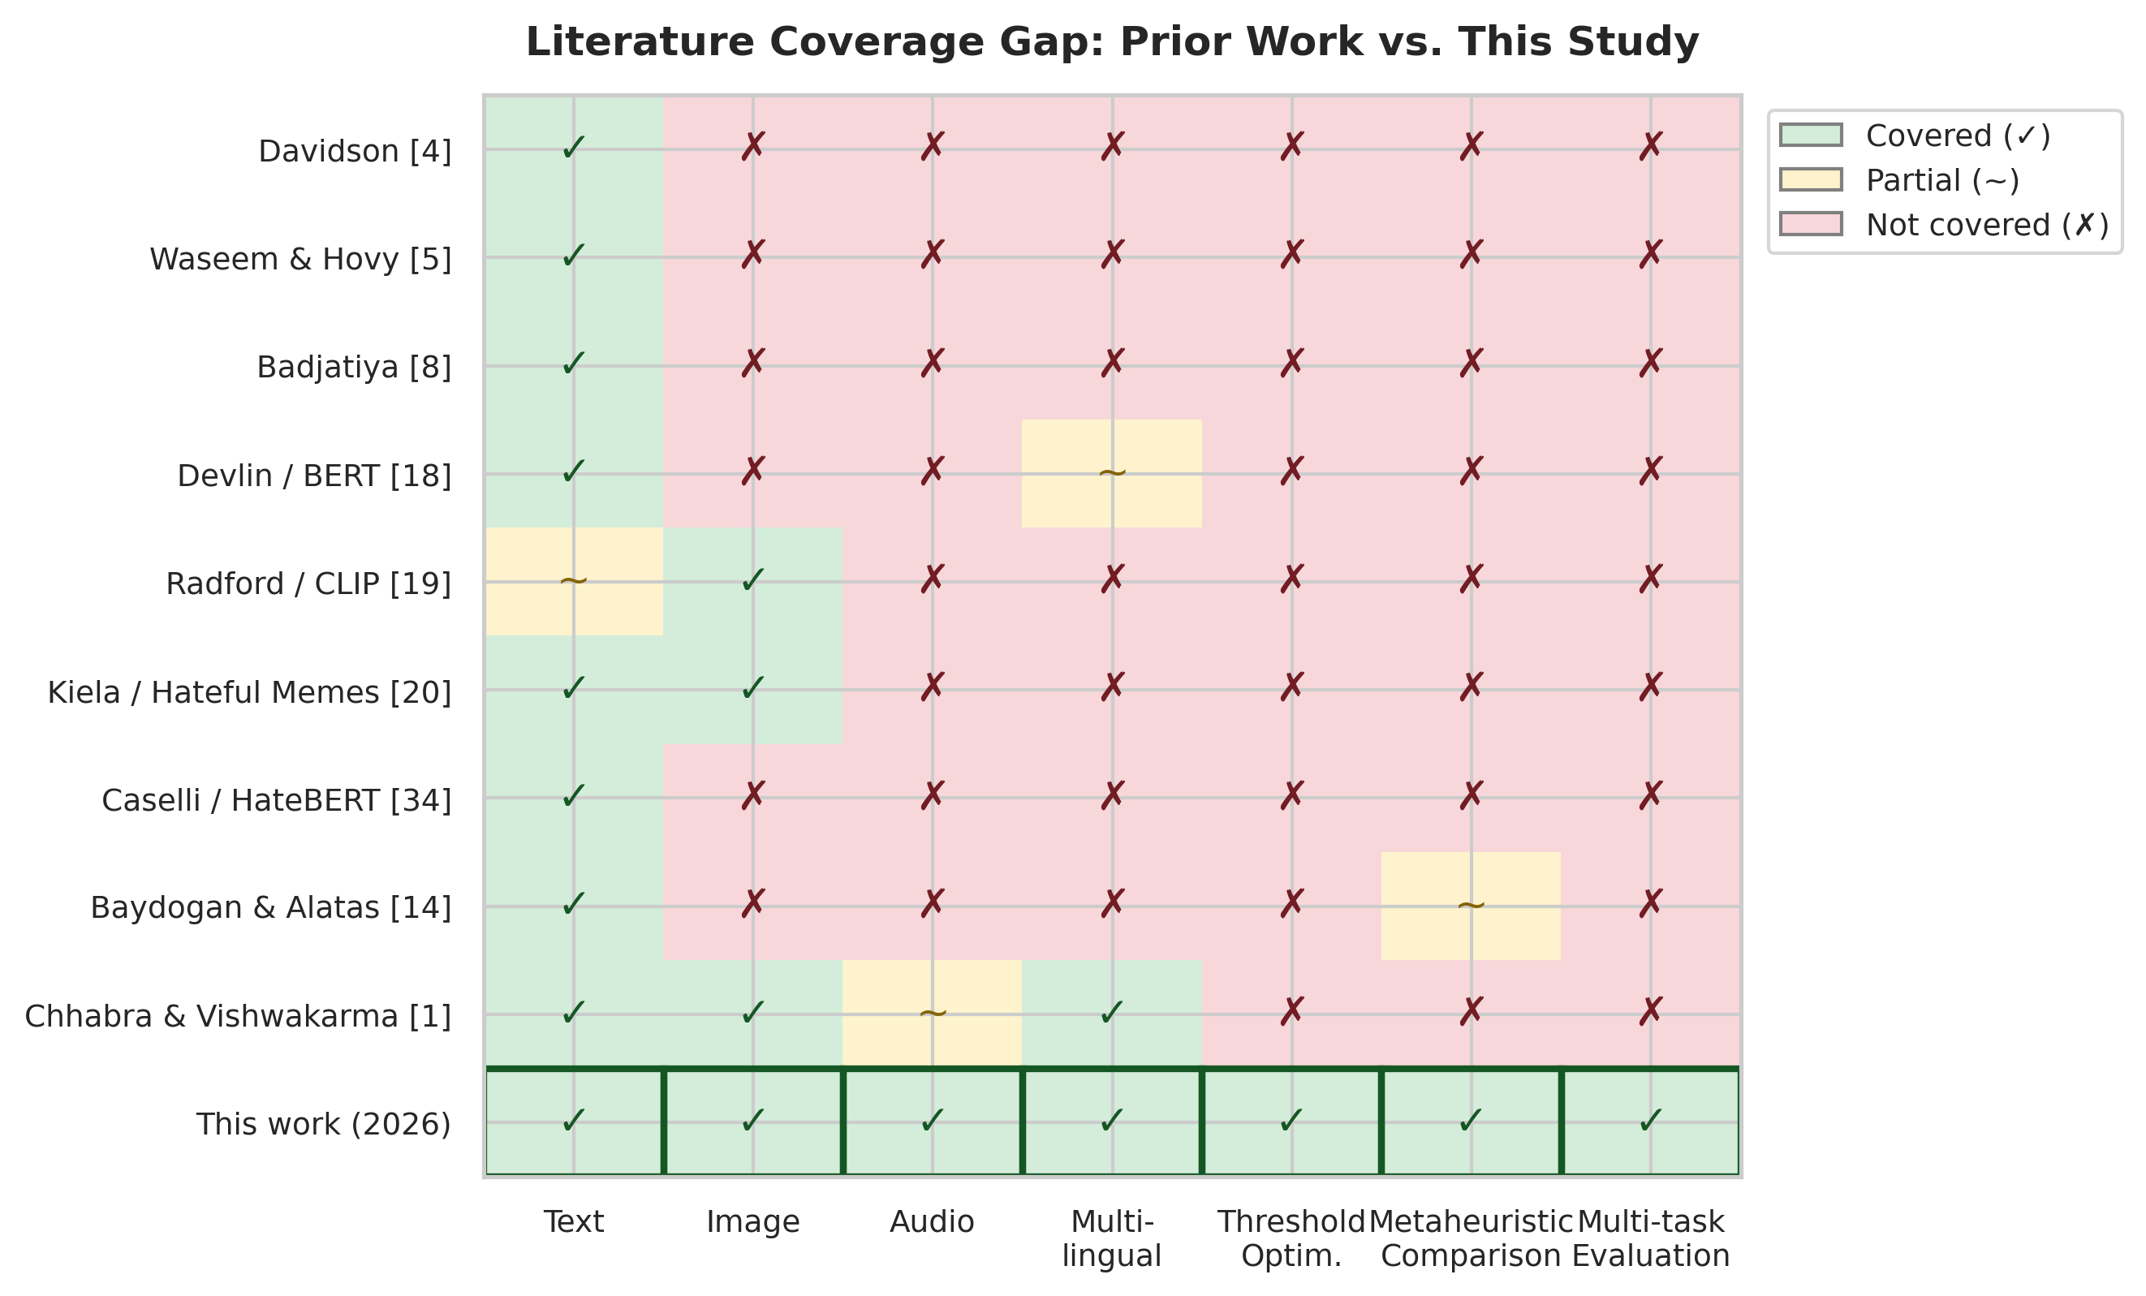
Fig. 15: Literature coverage gap matrix. Prior works (rows) vs. capability dimensions (columns). Green checkmarks indicate coverage; red crosses indicate absence. This study (bottom row) is the first to address all seven dimensions simultaneously.
III. METHODOLOGY
3.1 System Overview
Figure 1 (conceptual) depicts the proposed adaptive hybrid moderator. Raw inputs are routed into three asynchronous pipelines-text, vision, and audio-each producing calibrated or comparable probabilistic scores. So vision further splits into a zero-shot CLIP judger with OCR context and a HateCLIPper-style fine-tuned fusion module that learns nonlinear interactions between image and text embeddings. Audio contributes (i) an acoustic probability from wav2vec features and (ii) an audio-text probability obtained by transcribing the waveform and reusing the multilingual text classifier. And branch outputs are combined through weighted late fusion; optional ASR confidence gating attenuates the audio-text channel when transcripts are unreliable. A decision threshold τ converts fused hate probability into a binary action. Optuna TPE, simulated annealing, and population-based metaheuristics search over hyperparameters, fusion weights, masks, continuous architecture knobs, and τ, using a composite fitness that explicitly values F1, precision, and accuracy.
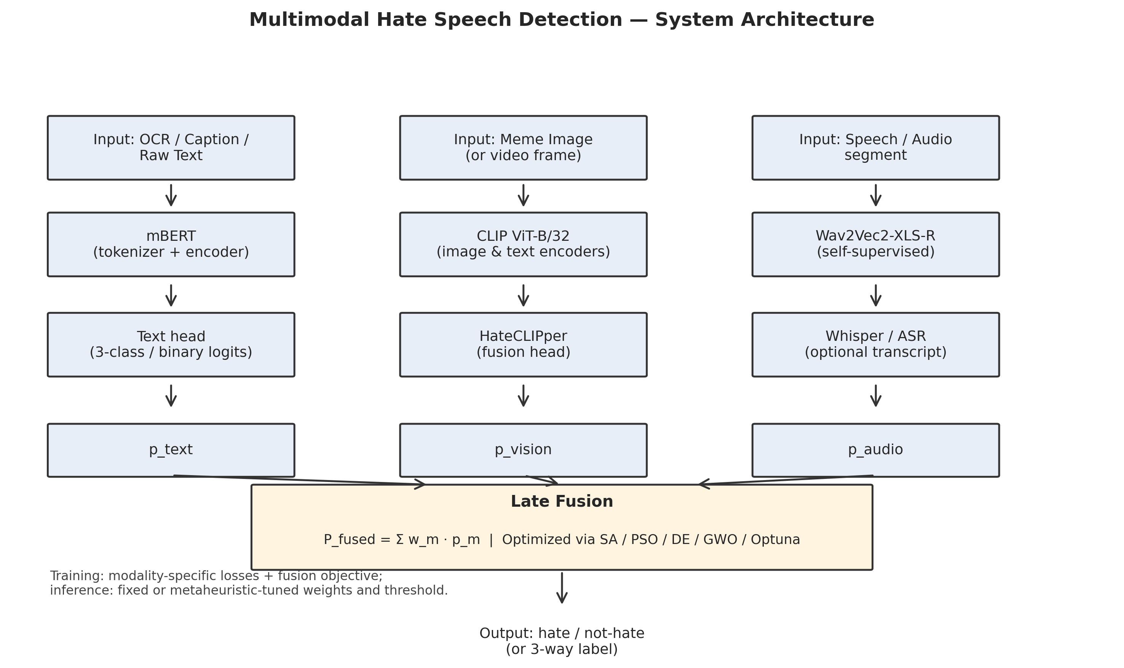
Fig. 1: Proposed system architecture. Text, vision (zero-shot CLIP + HateCLIPper), and audio (Wav2Vec2 acoustic + Whisper transcript) pipelines produce branch-level probabilities combined through weighted late fusion with ASR confidence gating. Metaheuristic and Bayesian optimizers search over fusion weights, thresholds, and discrete masks.
We adopt late fusion over early or cross-attention alternatives for three principled reasons. First, late fusion permits modular backbone replacement-upgrading mBERT to XLM-R [36] or CLIP ViT-B/32 to ViT-L/14 [19] requires retraining only the affected branch and re-optimizing fusion weights, not the entire pipeline. This modularity is progressively important as multilingual moderation stacks must track rapid foundation-model turnover without invalidating end-to-end systems that would otherwise demand full re-co-training whenever any encoder changes [1], [3]. Second, late fusion yields interpretable per-branch contributions: each branch produces a calibrated probability that can be inspected, logged, and audited independently-a requirement for regulatory compliance under frameworks such as the EU Artificial Intelligence Act, where high-risk classification systems benefit from traceable evidence chains and post hoc review of component-level scores. Third, late fusion is computationally tractable on a single T4 GPU: cross-attention models like UNITER [44] or ViLBERT [41] require joint backpropagation through all modality encoders, which exceeds 16 GB VRAM for multi-branch configurations that also retain task heads, gradient accumulation buffers, and mixed-precision transient tensors. The trade-off is that late fusion can't capture fine-grained cross-modal interactions that early or attention-based fusion would explicitly model [40]; we partially reduce this through the HateCLIPper head, which does learn image-text interactions within the vision branch [28], and through OCR-augmented CLIP prompting that injects typography into the zero-shot pathway [19].
The end-to-end data flow proceeds as follows. Multimodal inputs arrive at an ingress router that dispatches each modality-capable fragment to the appropriate encoder stack: tokenized spans enter mBERT [18]; raster images enter CLIP together with optional EasyOCR overlays; waveforms enter Wav2Vec2-XLS-R [26] and Whisper [27] in parallel. Each pipeline emits one or more branch-level probabilities on the unit interval, optionally after temperature scaling or validation-set calibration when enabled in the training recipe. Nonlinear fusion combines active branches with nonnegative weights, applies ASR confidence gating on the transcript-derived channel, and forms Pfused. A scalar threshold τ, learned or searched post hoc, maps Pfused to a binary moderation decision. Separately, a metaheuristic layer optimizes continuous fusion weights, τ, discrete masks over branches and attention heads, and selected neuro-architectural hyperparameters, using cached validation outputs where possible to amortize evaluation cost [14], [25]. This separation-inference graph versus search procedure-keeps deployment latency predictable while still permitting policy-time adaptation without architectural rewrites.
Operationally, the modular graph supports failure isolation: if OCR fails or Whisper returns an empty transcript, inactive branches are omitted at fusion time rather than corrupting joint representations in a shared cross-modal trunk [11]. Interestingly, still, logging can therefore record not only Pfused and, but also per-branch inputs, gate values g(c\mathrmasr), and masked weights-artifacts that assist human review and error analysis under platform safety programs. Finally, (which is a big deal) late fusion aligns with the empirical reality that moderation policies are rarely static: weight vectors and thresholds are periodically re-optimized as datasets shift, (to no one's surprise) class priors change, or regulatory guidance tightens. A search layer that treats (i\, τ) as first-class tunables-rather than implicit by-products of end-to-end training-makes those policy shifts explicit, measurable, and comparatively cheap relative to full-model retraining [14], [25].
3.2 Text Processing Pipeline
We employ bert-base-multilingual-cased (about 178M parameters) as a shared encoder for digital text and ASR transcripts. Really, backbone and interface. Inputs are WordPiece-tokenized with MAX_LENGTH=128.
Optimization schedule. Unless superseded by task-specific hyperparameter search, fine-tuning uses 5 epochs, batch size 16, (to put it mildly) AdamW with learning rate 3×10-5, weight decay 0.01, warmup ratio 0.1, label smoothing 0.1, gradient accumulation 2, and a cosine learning-rate schedule.
Class imbalance. Let nc denote the empirical count of training examples in class c\1,,C\. The bottom line is, square-root dampened weights moderate extreme inverse-frequency spikes:
wc'=(1)/(nc), wc = C- (wc')/(j=1C wj').
The normalization constrains c wc = C, stabilizing loss scaling when class frequencies diverge by orders of magnitude. Intuitively, the square root compresses the dynamic range between majority and minority classes relative to naive inverse frequency, reducing gradient variance while still up-weighting toxic tails absent from volume-driven training signals [3], [30].
Focal loss. For predicted probability pt on the ground-truth class, we employ
FL(pt)= -αt (1-pt)γ log(pt),
with γ=2.0 and α=0.75, sharpening gradients on hard, misclassified examples while preventing easy negatives from dominating updates.
before tokenization, all text inputs undergo a normalization pipeline: conversion to lowercase, URL replacement with a [URL] token, @-mention replacement with [USER], removal of HTML entities, collapsing of repeated whitespace, and stripping of control characters. What really matters here is that emoji sequences are retained as they can carry semantic hate content (e.g., the combination of racial emoji with violent emoji constitutes implicit hate in many annotation schemes [46]). Really, for code-mixed Hindi-English text, we don't apply script-specific normalization, (believe it or not) relying instead on mBERT's multilingual WordPiece vocabulary to handle Devanagari and Latin tokens natively. This design choice preserves code-switching patterns that are themselves discriminative features for hate detection in South Asian social media [48].
Algorithm 1: Multilingual BERT Fine-Tuning with Dampened Weights
Input: Training set D_train, validation set D_val, Config parameters
Output: Fine-tuned model M*, optimal threshold tau*

1. Initialize M from bert-base-multilingual-cased checkpoint
2. Compute class counts {n_c} from D_train labels
3. Compute dampened weights: w_c = C * (1/sqrt(n_c)) / sum_j(1/sqrt(n_j))
4. Configure focal loss: FL(p_t) = -alpha_t * (1-p_t)^gamma * log(p_t)
5. Configure AdamW optimizer with cosine LR schedule
6. for epoch = 1 to EPOCHS do
7. for each mini-batch B in D_train do
8. logits = M(B.input_ids, B.attention_mask)
9. loss = WeightedFocalCrossEntropy(logits, B.labels, w, gamma, alpha)
10. loss = loss / GRADIENT_ACCUMULATION_STEPS
11. loss.backward()
12. if step % GRADIENT_ACCUMULATION_STEPS == 0 then
13. optimizer.step(); scheduler.step(); optimizer.zero_grad()
14. Evaluate F1, precision, recall on D_val
15. Save best checkpoint by eval_f1
16. Load best checkpoint as M*
17. Run Simulated Annealing on D_val probabilities to find tau*
18. return M*, tau*
The focal loss modulating factor (1-pt)^γ dynamically adjusts the contribution of each sample to the gradient. For well-classified examples (pt 1), the factor approaches zero, successfully removing easy negatives from the gradient signal. For hard examples (pt 0), the factor approaches 1, preserving full gradient magnitude. With γ = 2, a sample classified with pt = 0.9 contributes only 1\% of its unmodulated gradient, while a sample at pt = 0.5 contributes 25\%. To be fair, we chose γ = 2 following the analysis of Lin et al. This selective gradient amplification complements the square-root dampened class weights, which address class-level frequency imbalance, while focal loss addresses instance-level difficulty imbalance within each class. [30], who showed strong empirical behavior across detection benchmarks; α = 0.75 assigns higher weight to the minority toxic class in the asymmetric two-way setup. Together, these mechanisms align optimization with operational priorities under heavy class skew [3], [14].
From an implementation standpoint, mBERT functions as the shared lexical tower for natively digital posts and Whisper transcripts, enabling consistent hate semantics regardless of whether toxicity appears in original Unicode spans or in ASR output [18], [27]. This unification is especially salient for code-mixed and multilingual stacks where the alternative-training monolingual detectors per channel-fragments supervision and complicates fusion [1]. While larger multilingual encoders such as XLM-R [36] may improve low-resource robustness, mBERT offers a favorable accuracy-memory trade-off under T4 constraints and preserves comparability with widely reported multilingual hate-speech baselines [1], [3]. When transcript noise increases WER, the text head's probabilistic output remains well-formed; coupling with ASR gating (Section 3.5) prevents brittle hard decisions that would arise from piping raw ASR strings into lexicon-only filters.
3.3 Vision Processing Pipeline
3.3.A Zero-Shot CLIP Classification.
We instantiate openai/clip-vit-base-patch32, using a predefined prompt matrix aligned with policy-relevant visual concepts (e.g., gestures, symbols, weapon-like objects-exact prompts are enumerated in the extended appendix). For overlaid or embedded text, dual EasyOCR streams parse Latin scripts (English, French, Spanish, German) and Devanagari (Hindi). Simply put, OCR outputs are concatenated or summarized and fused with the image tensor through the CLIP text encoder for contextual, text-conditioned image scoring, reducing false negatives when hostility is typography-dependent.
The zero-shot CLIP evaluation employs a curated prompt matrix organized into five semantic categories: (i) hateful symbols and gestures (e.g., "a photo containing a hateful symbol," "an image showing an offensive hand gesture"); (ii) violence and weapons (e.g., "a photo of a weapon being brandished," "an image depicting physical violence"); (iii) dehumanizing imagery (e.g., "an image comparing a person to an animal," "a dehumanizing depiction of a group"); (iv) text-conditioned hate (e.g., "an image with offensive text overlay," "a meme containing a slur"); and (v) neutral/safe baselines (e.g., "a harmless photograph," "a benign meme"). The maximum similarity score across hateful prompt categories, minus the maximum safe-category score, produces the zero-shot hate probability. This design follows the dual-prompt strategy advocated for CLIP-based content moderation [19], where contrastive scoring against explicitly safe prompts reduces false positives from ambiguous imagery. Zero-shot CLIP isn't sufficient for subtle multimodal irony on memes [11], [20]; it nevertheless supplies a cheap, backbone-consistent prior that can be fused with supervised pathways.
3.3.B HateCLIPper Fine-Tuned Fusion Head.
CLIP image and text towers remain frozen; a compact trainable module learns meme-specific interactions:
Let vimg, vtxtR512 be CLIP embeddings. Trainable projections yield pimg=Wimgvimg, ptxt=Wtxtvtxt with hidden width HATECLIPPER_DIM=1024. So A Hadamard interaction
h= pimg ptxt
feeds an MLP scoring head with sigmoid output P(hate). Training runs 5 epochs at batch size 16, learning rate 10-4, yielding only 1.3M trainable parameters-an efficient specialization layer atop a general vision-language foundation.
Algorithm 2: HateCLIPper Fine-Tuning with Frozen CLIP Encoders
Input: Meme dataset (image, text, label), frozen CLIP model
Output: Trained HateCLIPper head H*

1. Freeze CLIP image encoder E_img and text encoder E_txt
2. Initialize projection layers W_img, W_txt in R^{512 x 1024}
3. Initialize MLP head: Linear(1024, 512) -> ReLU -> Dropout -> Linear(512, 1)
4. for epoch = 1 to 5 do
5. for each mini-batch (images, texts, labels) do
6. v_img = E_img(images) // 512-D frozen embeddings
7. v_txt = E_txt(texts) // 512-D frozen embeddings
8. p_img = W_img @ v_img // project to 1024-D
9. p_txt = W_txt @ v_txt // project to 1024-D
10. h = p_img * p_txt // Hadamard product
11. logit = MLP(h) // scalar
12. loss = BCEWithLogitsLoss(logit, labels)
13. loss.backward(); optimizer.step()
14. Evaluate dev F1; save best checkpoint
15. return H* (W_img, W_txt, MLP weights)
We select Hadamard (element-wise) product over concatenation or bilinear pooling for the cross-modal interaction for two reasons. First, Hadamard product preserves dimensionality (Rd × Rd Rd), keeping the downstream MLP compact-concatenation would double the input dimension to 2048, while bilinear pooling produces d2 features requiring prohibitive memory on consumer GPUs.
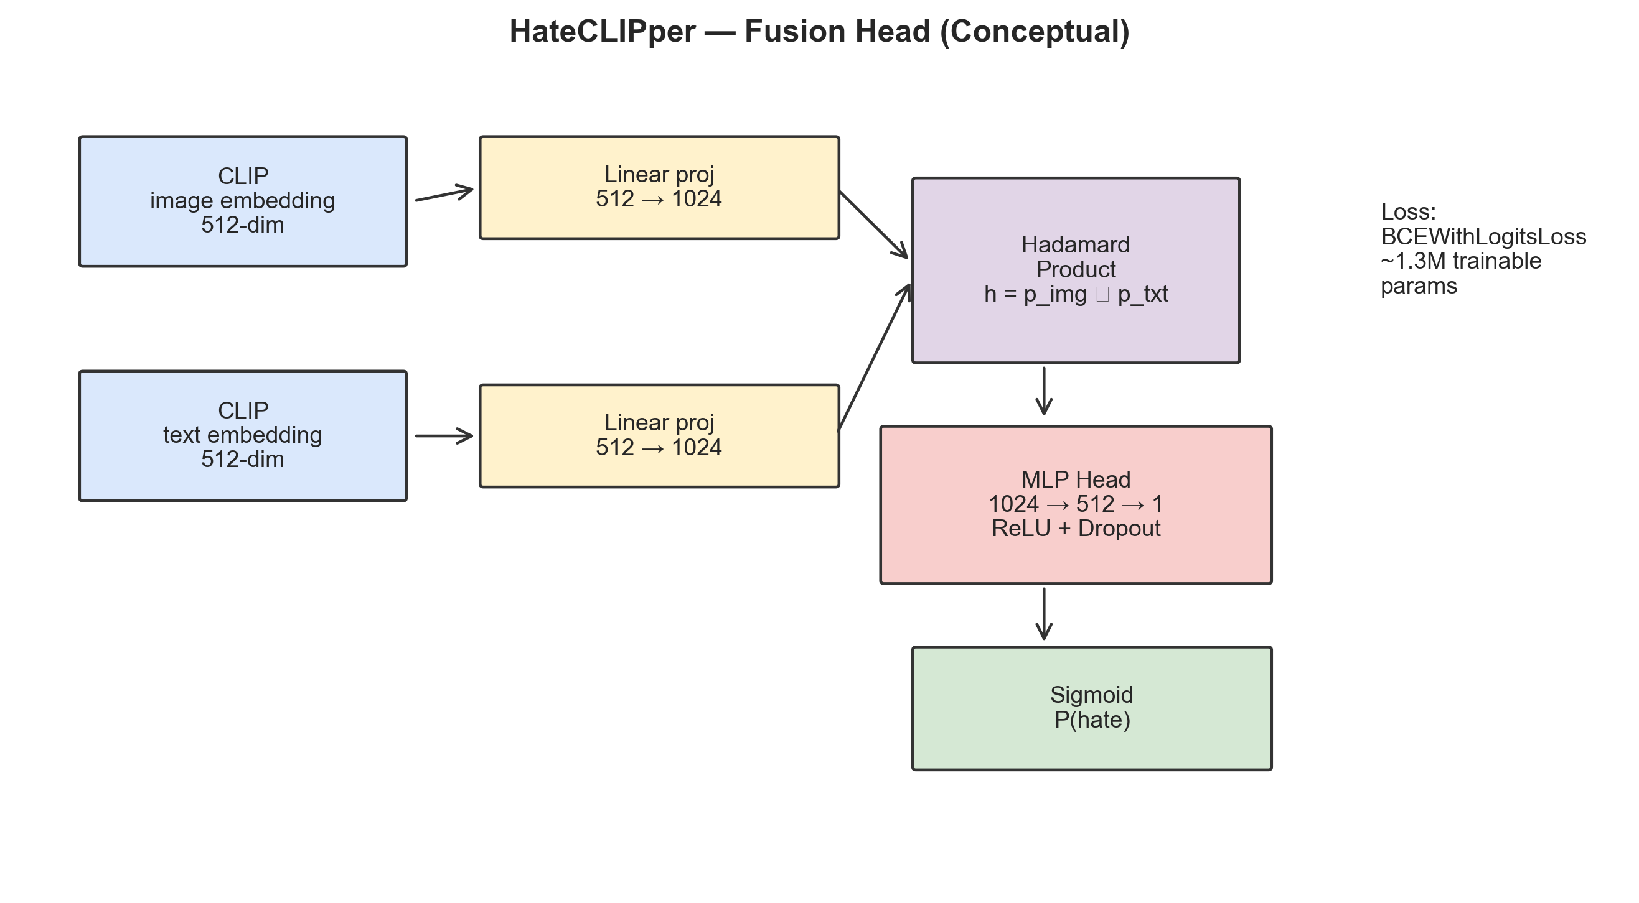
Fig. 9: HateCLIPper architecture. Frozen CLIP image and text encoders produce 512-D embeddings that are projected to 1024-D and combined via Hadamard product. An MLP head maps the interaction vector to a binary hate probability.
Second, Kumar and Nandakumar [28] showed that the Hadamard variant of HateCLIPper matches or exceeds concatenation and bilinear alternatives on the Hateful Memes benchmark [20], while training in under half the time. Frozen encoders further reduce optimization instability relative to end-to-end fine-tuning of vision-language transformers [41], [44].
3.4 Audio Processing Pipeline
Acoustic pathway. Audio is resampled to 16 kHz and cropped or padded to a maximum of 20 s. Optional Silero VAD discards leading silence when present. A frozen Wav2Vec2-XLS-R-300M encoder supplies representations to a two-layer MLP head with AUDIO_DIM=256, dropout 0.3, (for better or worse) trained with BCEWithLogitsLoss using the same square-root dampened class weights as in Section 3.2.
Transcript pathway. Whisper-small transcribes the clip; the text is classified by mBERT as in Section 3.2. This branch captures slurs and threats more reliably encoded lexically than acoustically.
The Wav2Vec2-XLS-R-300M model [26] consists of a 7-layer convolutional feature encoder that processes raw 16 kHz waveforms into latent speech representations at 50 Hz, followed by 24 transformer blocks with hidden dimension 1024 and 16 attention heads per block, totaling roughly 300 million parameters. Pre-trained on 436,000 hours of unlabeled speech across 128 languages using a contrastive self-supervised objective, the model captures both low-level acoustic features (pitch, energy, speaking rate) and high-level phonetic and prosodic patterns. We freeze all 300M parameters and extract representations from the final transformer layer, applying mean pooling across the temporal dimension to obtain a fixed-length 1024-dimensional utterance embedding. A trainable two-layer MLP projects this embedding to our working dimension (AUDIO_DIM=256) with dropout 0.3, followed by a single-unit output layer.
For clips containing large leading or trailing silence-common in user-uploaded social media videos-we optionally apply Silero Voice Activity Detection (VAD) to isolate speech-active segments before feature extraction. Silero VAD operates as a lightweight ONNX model with sub-millisecond latency per frame, flagging non-speech regions that would otherwise dilute the mean-pooled acoustic representation. When VAD is enabled, only frames marked as speech contribute to the temporal mean.
We select Whisper-small (244M parameters) [27] over Whisper-base (74M) and Whisper-large-v2 (1.5B) as a compromise between transcription quality and T4 memory constraints. On English benchmarks, (understandably) Whisper-small achieves word error rates (WER) within 2-3 absolute points of Whisper-large while requiring roughly one-sixth the inference memory. For non-English HateMM content (which contains mainly English speech in our extract), Whisper-small's multilingual capability provides adequate transcription quality [45]. The ASR confidence score extracted alongside each transcript serves as the gating signal described in Section 3.5.
Algorithm 3: Audio Hate Detection (Dual-Branch)
Input: Audio waveform w, frozen Wav2Vec2 model V, Whisper model W, mBERT model M
Output: acoustic probability p_aa, transcript probability p_at, ASR confidence c_asr

1. Resample w to 16 kHz mono; crop to max 20s
2. (Optional) Apply Silero VAD to trim silence
3. // Acoustic branch
4. z = V.encode(w) // (T, 1024) frozen features
5. z_pool = mean(z, dim=0) // (1024,) utterance embedding
6. p_aa = sigmoid(MLP_audio(z_pool)) // acoustic hate probability
7. // Transcript branch
8. transcript, c_asr = W.transcribe(w) // text + confidence
9. p_at = M.predict(transcript) // mBERT hate probability
10. return p_aa, p_at, c_asr
Dual-stream audio mirrors multimodal evidence combination at a finer grain: lexical toxicity and speaker-centric hostility need not co-occur, and their partial independence motivates parallel branches rather than collapsing all evidence into transcripts alone [26], [27].
3.5 Multimodal Late Fusion
Let ptext, (believe it or not) pzs, phc, pat, and paa denote probabilities from text, CLIP zero-shot, HateCLIPper, audio-text (mBERT on ASR), (at least in theory) and acoustic MLP branches, respectively. Nonnegative weights wi combine them as
Pfused=(i wi pi)/(i wi).
ASR confidence gating modifies the effective audio-text weight:
wateff = wat- g(c\mathrmasr),
where c\mathrmasr[0,1] is a confidence score from the ASR stack and g(-) is a monotone gate (e.g., identity or squashing function) fixed during training and treated as a hyperparameter during search. Unless optimized otherwise, defaults are wtext=0.40, wzs=0.15, whc=0.20, wat=0.15, waa=0.10. Really, the final prediction is
= 1ft[Pfused τ].
The fusion formula admits an equivalent interpretation as soft weighted voting. Each branch i casts a "vote" pi [0,1] for the hate hypothesis, weighted by wi. The normalized fused score Pfused is the weighted average of these votes. When all branches agree (all pi near 0 or all near 1), Pfused is reliable to weight perturbations. Disagreement between branches (e.g., text predicts hate but vision predicts safe) makes the fused score sensitive to weight allocation-precisely the regime where metaheuristic optimization yields the largest improvements over uniform or hand-tuned defaults. This sensitivity analysis motivates the ten-task optimization suite (Section 3.6.E), which searches not only over weights but also over branch inclusion masks, per-branch thresholds, and the global decision boundary [14], [25].
We considered two weight normalization approaches: (i) raw division by i wi (our default) and (ii) softmax normalization wi' = ewi / j ewj, which constrains weights to a simplex. Raw division is preferred No image for a text-only post), the corresponding wi is set to zero, and the denominator automatically re-normalizes over active branches., because it naturally handles branch absence: when a modality is unavailable (e.g. The bottom line is, softmax normalization would assign nonzero probability mass to absent branches without explicit masking. In our implementation, the MultimodalFusionClassifier dynamically excludes branches whose input is None, re-normalizing weights over the active subset.
When only a single branch is active (e.g., text-only input with no image or audio), the fusion reduces to that branch's probability: Pfused = ptext. This behavior is desirable when the confident branch is text (typically the most reliable), but can produce false positives when a noisy vision zero-shot branch dominates. When multiple branches are active but one reports extreme confidence (pi > 0.95), the fused score is pulled toward that branch proportional to its weight. The branch selection optimization (Task 3) addresses this by learning which combinations of branches to trust under validation feedback, complementing manual priors encoded in default fusion weights [11], [20].
Although we don't rely on Platt scaling or isotonic regression in every experiment, the fusion layer is compatible with post hoc calibration: branch logits may be temperature-scaled on validation folds before entering Pfused, reducing false polarization caused by overconfident heads. Such calibration interacts directly with threshold search: if probabilities are step by step compressed toward 0.5, the ideal τ shifts so, reinforcing the need to co-optimize weights and decision boundaries in Tasks 9-10 rather than treating calibration as an afterthought [3], [29].
3.6 Optimization Framework
The optimization framework is deliberately stratified into Bayesian hyperparameter optimization (Optuna TPE [25]), scalar annealing for thresholds (SA [29]), and population-based metaheuristics with a unified evaluation harness (Algorithm 4). This taxonomy matches heterogeneous search spaces: smooth continuous knobs favor TPE when evaluations are noisy-but-cheap; univariate threshold lines favor SA's hill-climbing with stochastic acceptance; multimodal vector spaces with weak Lipschitz structure favor DE, PSO, and GWO [21]-[23]. Crucially, all algorithms consume the same F from Section 3.6.D so that reported differences reflect search dynamics, not metric definitions-a design choice motivated by reproducibility critiques in prior optimization-centric NLP work [14].
3.6.A Optuna TPE.
Tree-structured Parzen Estimators model separate densities for promising versus unpromising regions of the search space. For text HPO, we search learning rate, weight decay, warmup proportion, and label smoothing with 15 trials, each evaluating on a 30\% data subsample for one epoch to control compute. A separate study allocates 40 trials to fusion weight vectors under box constraints and simplexes after reparameterization.
The TPE sampler maintains two kernel density estimators, l(x) for the top γ-quantile of observed objective values and g(x) for the remainder. New candidates are drawn by maximizing the ratio l(x)/g(x), which approximates expected improvement [25]. This model-based approach excels when the fitness landscape is smooth and evaluations are expensive, but can struggle in combinatorial spaces where the density estimators lack appropriate structure. For text HPO, we search over four continuous dimensions: learning rate in [10-6, 5×10-4] (log-uniform), weight decay in [10-4, 0.3] (log-uniform), warmup ratio in [0, 0.2], and label smoothing in [0, 0.2].
3.6.B Simulated Annealing for Threshold Tuning.
Given validation metrics f(τ) (e.g., negative F1 or the negative composite fitness), simulated annealing proposes perturbations τ' with initial temperature T0=1.0, geometric cooling Tts 0.95T, and 500 iterations. A worse candidate τ' is accepted with probability
P(accept)=expft(-( f)/(T)), f = f(τ')-f(τ),
allowing escape from local minima on the threshold line and shifting τ away from the uninformed 0.5 default when precision and recall are asymmetric.
The perturbation magnitude adapts implicitly through the temperature schedule. At high temperature (T 1.0, early iterations), the acceptance probability for inferior solutions exceeds 0.6 for moderate degradations, encouraging broad exploration of the [0.1, 0.95] threshold range. As T decays below 0.1 (after around log(0.1/1.0)/log(0.95) 45 iterations), (understandably) only improving moves are accepted with high probability, concentrating search around the current best [29].
3.6.C Population-Based Metaheuristics (Phase 6).
All methods share a unified evaluation harness:
- GA: tournament selection (size 3), crossover rate 0.8, mutation rate 0.1, elitism.
- PSO: inertia w linearly decays from 0.9 to 0.4; cognitive and social coefficients c1=c2=2.0; binary variants (BPSO) handle mask vectors. Velocity update:
vit+1 = w vit + c1 r1 (pi-xit) + c2 r2 (g-xit), xit+1=xit+vit+1.
In the binary variant (BPSO), continuous velocities are mapped to bit-flip probabilities through a sigmoid transfer function: σ(vid) = 1/(1+e-vid), and the position is sampled as xid = 1 if U(0,1) < σ(vid), else 0. This formulation enables PSO to operate in discrete binary spaces (branch masks, head selections) while preserving the velocity-based exploration mechanics [23].
- DE (DE/rand/1/bin): For population members xi, mutation uses distinct indices r1,r2,r3:
vi = xr_1 + F-(xr_2-xr_3), F=0.8, CR=0.9,
followed by binomial crossover and selection by objective value.
For population member xt, the distances to the leading wolves x_αt, x_βt, (believe it or not) and x_δt are - GWO: Coefficient vectors Ap and Cp depend on a, which linearly decays from 2 to 0, balancing exploration and exploitation.
Dpt = |Cp xpt - xt|, p\α,β,δ\,
from which three auxiliary vectors are formed,
zpt = xpt - Ap Dpt.
The updated candidate is xt+1 = (1)/(3)ft(z_αt+z_βt+z_δt). When it comes to the a parameter controls the GWO exploration-exploitation balance. Admittedly, when a > 1 (first half of iterations), (not surprisingly) the coefficient |A| > 1 causes wolves to diverge from the prey (exploration). When a < 1 (second half), |A| < 1 forces convergence toward the three leaders (exploitation). Look, this built-in schedule eliminates the need for explicit exploration parameters, making GWO attractive for practitioners unfamiliar with metaheuristic tuning [21].
- FA: attractiveness β=β0 e-γ \|xi-xj\|^2, light absorption α=0.5, with β0=1.0, γ=1.0, and decay 0.99 on α across generations. The Firefly Algorithm's O(n\mathrmpop2) per-iteration cost arises from all-pairs brightness comparison. With n\mathrmpop=20 and n\mathrmiter=200, this yields 202 × 200 = 80,000 potential attraction events per run-feasible for scalar threshold optimization but prohibitive for the 144-dimensional head-selection problem. But we therefore restrict FA to 1-D threshold tasks exclusively.
Algorithm 4: Unified Meta-Heuristic Optimization Protocol
Input: Task-specific fitness function f, bounds B, algorithm A, n_pop, n_iter, seeds S
Output: Results dictionary R = {algorithm -> [Result per seed]}

1. for each algorithm A in {GA, PSO, DE, GWO, FA} do
2. for each seed s in S do
3. optimizer = get_optimizer(A)
4. Initialize population P of size n_pop within bounds B
5. Evaluate fitness f(x) for each x in P
6. Record best fitness as convergence[0]
7. for iteration t = 1 to n_iter do
8. Apply A-specific update rules to P
9. Evaluate fitness for new/modified individuals
10. Update global best; record convergence[t]
11. Store Result(best_solution, best_fitness, convergence, wall_time, n_evals)
12. R[A] = collected Results across seeds
13. Compute mean, std, iterations-to-95% from R
14. return R
3.6.D Composite Fitness Function.
All population-based comparisons optimize
F= α F1 + β Precision + γ Accuracy, α=0.5, β=0.3, γ=0.2,
encoding a preference for balanced detection quality while respecting operational precision and overall correctness.
3.6.E Optimization Tasks (Ten Experiments).
- Fusion weight optimization. Actually, the five-dimensional continuous search space assigns one weight per fusion branch, bounded in [0,1]. Still, we apply PSO (n\mathrmpop=30, (as you'd expect) n\mathrmiter=100), DE (F=0.8, CR=0.9), and GWO, comparing against Optuna TPE (40 trials). Fitness evaluations use pre-cached branch probabilities on the HateMM dev set (n 500), making each evaluation near-instantaneous and isolating optimizer behavior from stochastic re-forward passes [45]. Five seeds provide mean and standard deviation estimates.
- Threshold optimization. The scalar threshold τ [0.1, 0.95] is optimized to maximize the composite fitness on validation probabilities. Look, PSO (n\mathrmpop=20, n\mathrmiter=200), DE, GWO, and FA (the only task where FA participates) compete against SA (T0=1.0, cooling 0.95, 500 iterations). This is the most full comparison, spanning six optimization strategies on a single dimension-a controlled benchmark that isolates convergence speed from search-space complexity [29].
- Branch selection. Five binary switches select which fusion branches to activate, yielding 25 - 1 = 31 non-empty configurations. GA (n\mathrmpop=10, n\mathrmiter=30), PSO (BPSO), DE (with 0.5 thresholding), and GWO (sigmoid transfer) search the space, benchmarked against exhaustive enumeration that certifies the global optimum among feasible masks. This task validates whether metaheuristics correctly discover best branch combinations when logits are deterministic at validation time.
- BERT head pruning. Granted, A 144-dimensional binary chromosome (12 layers × 12 heads) masks individual attention heads in the fine-tuned mBERT model. GA and GWO operate with n\mathrmpop=20, n\mathrmiter=30, evaluating on up to 200 validation samples per fitness call. A minimum active-head constraint of 30\% (at least 44 heads) prevents degenerate solutions. This task probes whether structured sparsity in attention heads improves or degrades hate detection relative to the full head budget [18].
- Text feature selection. TF-IDF features (word and character n-grams, max 2000 features) are grouped into 200 chunks of 10 features each. So GA and PSO (BPSO) search over binary chunk masks, training a LinearSVC per evaluation. Population size 20, 40 iterations, five seeds. A minimum feature threshold of 50 prevents empty selections and stabilizes SVM training in sparse settings [14].
- MLP head NAS. Yet five continuous dimensions encode the MLP head architecture: number of hidden layers \1,2,3\, hidden dimension \128, 256, 512, 1024\, dropout [0.1, 0.5], activation, GELU, SiLU\, (at least in theory) and batch normalization (on/off). DE, PSO, and GWO (n\mathrmpop=10, n\mathrmiter=15, (to no one's surprise) three seeds) each build and train the decoded MLP for one epoch per evaluation, measuring validation F1. Applied to both HateCLIPper and audio heads, this task links low-cost architecture search to downstream branch quality [28].
- BERT HPO comparison. Seven continuous dimensions encode learning rate (log-scale), weight decay (log-scale), warmup ratio, label smoothing, batch size \8, 16, 32\, epochs \2,,5\, and focal gamma [0, 3]. DE, PSO, and GWO (n\mathrmpop=12, n\mathrmiter=15, three seeds) compete against the Optuna TPE baseline from Phase 2. Each evaluation trains mBERT for one epoch on 50\% subsampled data-the most expensive per-evaluation task in the suite-motivating pragmatic trial caps [25].
- Token importance. The bottom line is, per-sample GA optimization (n\mathrmpop=15, n\mathrmiter=20) evolves binary masks over content tokens in 100 validation samples, maximizing model confidence in the correct label plus a sparsity bonus. Aggregated results identify which tokens are consistently retained, providing interpretability aligned with rationale-oriented corpora even when rationales aren't used as training targets [46].
- Joint fusion + threshold. Six continuous dimensions (five weights plus τ) are jointly optimized by PSO, DE, and GWO (n\mathrmpop=30, n\mathrmiter=150). An iterative refinement variant alternates between weight optimization and threshold optimization for three rounds, allowing each sub-problem to benefit from the other's improved solution and reducing plateaus in coupled landscapes.
- Per-branch thresholds. Ten continuous dimensions encode five per-branch thresholds and five weights, producing a more granular decision surface than the shared-threshold fusion. DE, PSO, and GWO (n\mathrmpop=30, n\mathrmiter=120) search this space. Each branch applies its own threshold before contributing a weighted binary vote to the ensemble, approximating specialist operating points that a single global τ can't express [3].
Together, the suite spans continuous vector optimization, scalar boundary search, discrete mask discovery, and expensive inner-loop training evaluations, supporting comparative claims about when Bayesian density modeling dominates and when swarm or evolutionary updates are preferable [14], [22]-[25].
IV. DATASET DESCRIPTION
We evaluate the proposed framework on curated public corpora spanning text, image-text pairs, and video-derived audio. All text resources are harmonized to a binary toxicity objective (label 1: hate or offensive content; label 0: normal or non-toxic content) before joint training, consistent with the unified decision interface described in our system architecture. Continuous supervision signals (for example, scalar hate-intensity scores) are thresholded using dataset documentation and fixed project-wide rules so that labels remain comparable across sources.
4.1 Text Corpora and Merging Strategy
The multilingual text stream aggregates four Hugging Face distributions documented in our Config.DATASET_SOURCES: HateXplain (Hate-speech-CNERG/hatexplain), the German and India superset collections (manueltonneau/german-hate-speech-superset, manueltonneau/india-hate-speech-superset), and the Berkeley Measuring Hate Speech release (ucberkeley-dlab/measuring-hate-speech), which collectively reflect diverse regulatory and annotation traditions in multilingual hate-speech research [1], [3]. After deduplication, language filtering, and removal of samples that fail tokenizer constraints, the merged multilingual corpus contains around 98,000 usable examples. Native label layouts differ (ternary hate/offensive/normal, (rightly so) binary flags, or continuous scores); we preserve HateXplain's three-way schema only when reporting intrinsic text-head calibration (Section 6.1) and collapse all corpora to binary labels for merged training. The merge protocol prioritizes label consistency over maximal cardinality: conflicting near-duplicates across sources are resolved with precedence rules documented in the extraction notebook, (and this is key) and empty or non-UTF-8 spans are dropped to avoid polluting the multilingual tokenizer with degenerate inputs. We partition every text-derived evaluation using a single 80% / 10% / 10% train/validation/test split with seed = 42, matching the reproducibility contract enforced in our notebooks.
HateXplain (originally Mathew et al., 2021) provides 19,229 posts sourced from Twitter and Gab, annotated by three crowdworkers each into normal, offensive, or hate speech categories. Inter-annotator agreement (Fleiss' kappa) is reported at about 0.46, indicating moderate agreement consistent with the inherent subjectivity of hate speech annotation [3]. Interestingly, still, the dataset additionally provides rationale annotations-token-level highlights of hateful spans-which we don't exploit in training but which informed our token importance analysis (Task 8). The three-class structure is preserved for intrinsic evaluation of the text head (Section 6.1) and binarized (offensive + hate = toxic) for merged training.
German Hate Speech Superset aggregates multiple German hate speech corpora into about 50,543 samples with binary labels. German hate speech presents unique challenges including compound word formation (where hateful neologisms may not appear in any dictionary), formal/informal register variation, and legal definitions that differ a lot from US-centric annotation guidelines. Ross et al. [47] documented inter-annotator agreement as low as α = 0.29 for German hate content, reflecting cultural and legal ambiguity in cross-border hate definitions.
India Hate Speech Superset comprises roughly 14,155 Hindi-English code-mixed samples, capturing the characteristic switching between Devanagari and Latin scripts prevalent in South Asian social media. Code-mixing introduces challenges for tokenization (mBERT's vocabulary must handle both scripts in a single input), for annotation (bilingual annotators are required), and for evaluation (standard English metrics may underweight Hindi-specific hateful constructs) [1], [48]. The dataset's binary labels align with our merged training protocol.
Berkeley Measuring Hate Speech provides around 39,565 English-language samples annotated with continuous hate speech scores rather than categorical labels. We binarize these scores using the dataset's recommended threshold, converting the regression target to classification. What really matters here is that the continuous annotation approach offers finer granularity than binary labels but introduces threshold sensitivity-a microcosm of the broader threshold optimization problem addressed by our SA and metaheuristic frameworks [3].
4.2 Vision Benchmark
For image-text moderation we adopt the Facebook Hateful Memes dataset [20], which provides roughly 8,500 training memes and 500 development memes, each with paired OCR-accessible captions and binary hate labels. This benchmark stresses fine-grained multimodal reasoning because hateful intent often arises from the interaction between visuals and overlaid text rather than either modality alone [11], [13]. Practitioners should expect shortcut cues-color layouts, fonts, or stock-photo identities-that can inflate training accuracy while undermining out-of-domain generalization; our pairing of supervised HateCLIPper [28] with zero-shot CLIP [19] partially reduces overfitting to dataset-specific superficial correlations by retaining a foundation-model prior that's frozen at the encoder level.
4.3 Audio and Video-Derived Speech
Video-centric moderation experiments use HateMM [45], from which we extract 16 kHz mono waveforms via ffmpeg and enforce the same 80 / 10 / 10 stratified partitioning strategy (seed 42) on the binary hate label. The audio branch therefore aligns temporally with the textual transcript path (Whisper [27] followed by the multilingual text encoder) and the parallel acoustic embedding path (Wav2Vec 2.0 [26]).
TABLE I
DATASET SUMMARY
Dataset | Source (Hugging Face Hub ID) | Language(s) | Samples (post-processing where noted) | Classes (original used) | Modality
HateXplain | Hate-speech-CNERG/hatexplain | English | ~19,229 | 3-class (normal / offensive / hate) binarized for merge; 3-class retained for text-head analysis | Text
German Hate Speech Superset | manueltonneau/german-hate-speech-superset | German | ~50,543 | Binary | Text
India Hate Speech Superset | manueltonneau/india-hate-speech-superset | Hindi-English code-mixed | ~14,155 | Binary | Text
Berkeley Measuring Hate Speech | ucberkeley-dlab/measuring-hate-speech | English | ~39,565 | Continuous hate_speech_score binarized | Text
Merged multilingual text stack | Composite of the above | Multilingual (EN / DE / HI-EN) | ~98,000 (after merge & cleaning) | Binary (hate/offensive vs. normal) | Text
Hateful Memes | facebook/hateful_memes_challenge [20] | English (image + text) | ~8,500 train / 500 dev | Binary | Vision + text
HateMM (audio track) | Project-standard extract [45] | Speech (from video) | Full corpus; 80 / 10 / 10 stratified split | Binary | Audio
TABLE II
FEATURE DESCRIPTION (IMPLEMENTATION-ALIGNED)
Modality | Raw input | Feature extractor / tool | Representation | Dimension / output | Role in fusion
Text | Token span | bert-base-multilingual-cased [18] | Pooler / [CLS]-based logits | 768-D embedding; 2-D logits (binary) or 3-D logits (HateXplain evaluation) | Primary semantic branch; text
Vision (zero-shot) | RGB meme | CLIP [19] prompt ensemble | Image-text similarity scores | Scalar hate-aligned score | vision_zeroshot
Vision (supervised) | RGB meme (+ text) | HateCLIPper fine-tuned head [28] | Multimodal embedding MLP | 1024-D logits | hateclipper
OCR overlay | Meme image | EasyOCR | Unicode string | Folded into text pathway when enabled | boosts meme text
Audio (lexical) | 16 kHz mono WAV | openai/whisper-small [27] + mBERT | ASR transcript logits | Same space as text branch post-encoder | audio_text
Audio (acoustic) | 16 kHz mono WAV | facebook/wav2vec2-xls-r-300m [26] | Frame embeddings pooled | 256-D projected features logits | acoustic
Unless noted otherwise, (for better or worse) branch logits are calibrated and non-linearly scaled where the training recipe applies label smoothing, class reweighting, or focal objectives [30] before softmax aggregation.
4.4 Data Preprocessing
All text inputs undergo a standardized preprocessing pipeline before tokenization. Text is lowercased, URLs are replaced with a [URL] placeholder token, @-mentions with [USER], and HTML entities are decoded. Repeated whitespace is collapsed to single spaces, and control characters are stripped. Now, emoji sequences are retained as-is, since emoji combinations can constitute hate speech (e.g., racial emoji paired with violent imagery) [46]. For the vision pipeline, meme images are resized to 224×224 pixels to match CLIP's expected input resolution, with bilinear interpolation for downsampling and padding for aspect ratio preservation. Still, audio waveforms are resampled to 16 kHz mono via torchaudio, with channels averaged if stereo. Honestly, waveforms exceeding 20 seconds are center-cropped; shorter clips are zero-padded. The Whisper tokenizer handles transcript preprocessing internally [27].
TABLE III
CLASS DISTRIBUTION PER DATASET
Dataset | Total | Hate/Toxic | Non-hate | Ratio (Hate:Non-hate) | Imbalance Severity
HateXplain | 19,229 | ~7,100 (37%) | ~12,129 (63%) | 1:1.7 | Moderate
German Superset | 50,543 | ~12,636 (25%) | ~37,907 (75%) | 1:3.0 | Moderate-High
India Superset | 14,155 | ~5,662 (40%) | ~8,493 (60%) | 1:1.5 | Low
Berkeley | 39,565 | ~9,891 (25%) | ~29,674 (75%) | 1:3.0 | Moderate-High
Merged | ~98,000 | ~28,700 (29%) | ~69,300 (71%) | 1:2.4 | Moderate
Hateful Memes | ~8,500 | ~3,400 (40%) | ~5,100 (60%) | 1:1.5 | Low
HateMM | varies | ~40% | ~60% | 1:1.5 | Low
Table III summarizes approximate label prevalence after project-specific merges and thresholding; exact counts may shift slightly following deduplication and cleaning. The merged stack exhibits moderate global skew, motivating square-root dampening and focal calibration rather than raw inverse-frequency weighting alone [30].
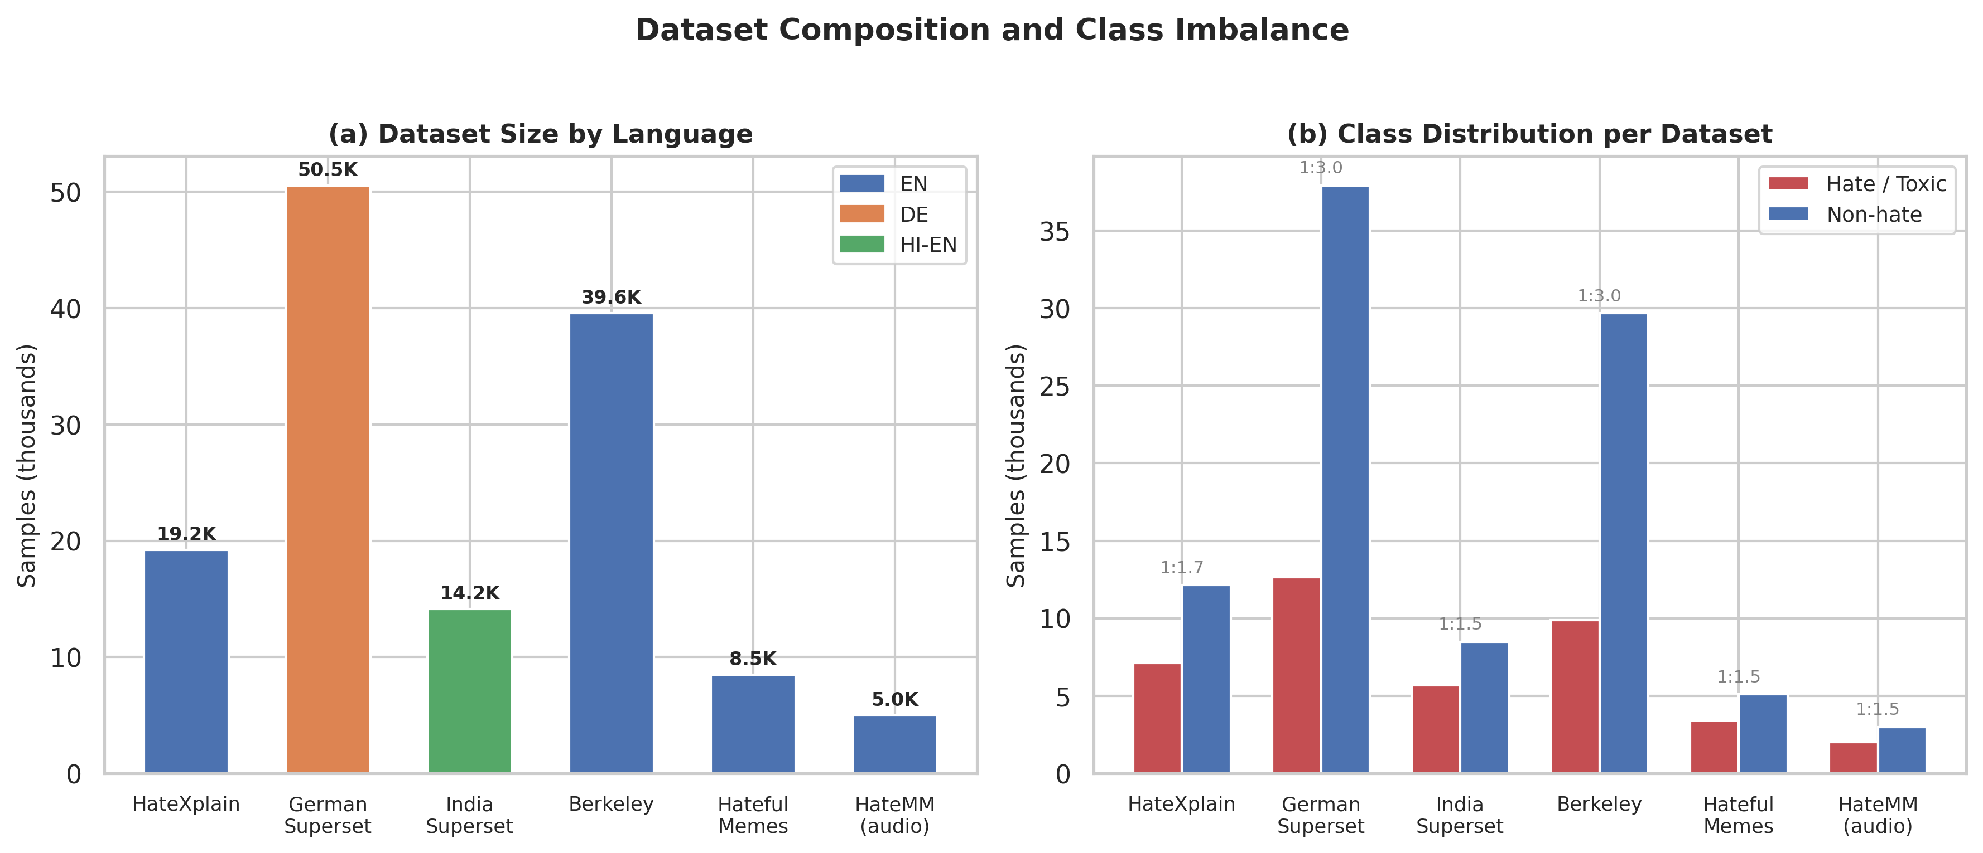
Fig. 14: Dataset composition and class distribution. (a) Dataset sizes colored by language; (b) hate vs. non-hate class distribution per dataset with imbalance ratios. The German and Berkeley corpora exhibit the highest imbalance (1:3.0).
V. EXPERIMENTAL SETUP
All experiments execute inside Kaggle Notebooks on a single NVIDIA Tesla T4 (16 GB) GPU. The software stack is pinned to Python 3.12.12, PyTorch 2.10.0+cu128, Transformers 5.0.0, Datasets 2.21.0, Optuna 4.8.0 [25], (and this is key) scikit-learn 1.6.1, (understandably) and EasyOCR 1.7.2, making sure bitwise-stable reproduction conditional on hardware driver revisions.
5.1 Evaluation Metrics and Validation Protocol
We report accuracy, macro- and micro-averaged precision, recall, F1-score, area under the ROC curve (AUROC), average precision (AP), and confusion matrices on each task-specific hold-out split. To be fair, the validation contract is intentionally strict: a single stratified 80 / 10 / 10 partition (seed = 42) governs all text and audio evaluations. While this mirrors operational constraints (one canonical deployment snapshot), it necessarily induces finite-sample variance; Section 8 revisits this limitation.
The single-split validation protocol deserves explicit justification. But in production deployment, a hate detection model is trained once and evaluated on a held-out set before release; k-fold cross-validation, while statistically stronger, doesn't mirror this operational cadence. Our single split with seed = 42 therefore represents the most realistic assessment of deployment-time performance. However, this choice introduces finite-sample variance that makes small metric differences (e.g., 0.01 F1) statistically unreliable. We address this partially through the multi-seed metaheuristic protocol (Section 5.4) and acknowledge the limitation explicitly in Section 8.
123, 456, 789, 1024\ for relatively cheap fitness evaluations (for example, fusion-weight search on cached branch scores)., metaheuristic robustness studies repeat stochastic optimizers over five pseudo-random seeds \42. GPU-intensive replay jobs (for example, neural architecture search loops over fresh forward passes) subsample three seeds \42, 123, 456\ to match notebook hour budgets.
5.2 Baselines and Search Competitors
Hyperparameter and weight optimization against Bayesian templates uses Optuna TPE [25] with trial budgets documented below. Simulated annealing (SA) [29] optimizes scalar decision thresholds on validation F1. Exhaustive enumeration resolves discrete branch-selection problems spanning 31 feasible activation patterns (all non-empty subsets of five fusion branches). Frankly, still, population-based metaheuristics-PSO [23], DE [22], GWO [21], and FA [24]-operate on the same search spaces with population sizes and iteration caps drawn from the project Config (Table III).
TABLE III
TRAINING AND OPTIMIZATION HYPERPARAMETERS (`Config`)
Category | Parameter | Value
Text encoder | MODEL_NAME | bert-base-multilingual-cased
Text encoder | MAX_LENGTH | 128
Text encoder | NUM_LABELS (merged binary) | 2
Text training | EPOCHS | 5
Text training | BATCH_SIZE | 16
Text training | LEARNING_RATE | 3 × 10⁻⁵
Text training | WEIGHT_DECAY | 0.01
Text training | WARMUP_RATIO | 0.1
Text training | LABEL_SMOOTHING | 0.1
Text training | GRADIENT_ACCUMULATION_STEPS | 2
Text training | LR_SCHEDULER_TYPE | cosine
Imbalance | CLASS_WEIGHT_ENABLED | True
Imbalance | FOCAL_LOSS_ENABLED | True
Imbalance | FOCAL_LOSS_GAMMA | 2.0
Imbalance | FOCAL_LOSS_ALPHA | 0.75
Optuna HPO | HPO_N_TRIALS | 15
Optuna HPO | HPO_SUBSAMPLE | 0.3
Optuna HPO | HPO_EPOCHS | 1
SA threshold | SA_T0 | 1.0
SA threshold | SA_COOLING | 0.95
SA threshold | SA_N_ITER | 500
SA threshold | DEFAULT_THRESHOLD | 0.5
HateCLIPper | HATECLIPPER_DIM | 1024
HateCLIPper | HATECLIPPER_EPOCHS | 5
HateCLIPper | HATECLIPPER_BS | 16
HateCLIPper | HATECLIPPER_LR | 1 × 10⁻⁴
Audio backbone | AUDIO_BACKBONE | facebook/wav2vec2-xls-r-300m
Audio ASR | WHISPER_MODEL | openai/whisper-small
Audio training | AUDIO_EPOCHS | 5
Audio training | AUDIO_BS | 8
Audio training | AUDIO_LR | 1 × 10⁻⁴
Audio training | AUDIO_WEIGHT_DECAY | 0.01
Audio training | AUDIO_DIM | 256
Audio training | AUDIO_DROPOUT | 0.3
Audio signal | AUDIO_SAMPLE_RATE | 16 000 Hz
Audio signal | AUDIO_MAX_DURATION | 20.0 s
Fusion default | FUSION_WEIGHTS | text 0.40; vision zs 0.15; HateCLIPper 0.20; audio_text 0.15; acoustic 0.10
Optuna fusion | HPO_FUSION_N_TRIALS | 40
Metaheuristics | MH_SEEDS | [42, 123, 456, 789, (to put it mildly) 1024]
Metaheuristics | MH_FUSION_N_POP / MH_FUSION_N_ITER | 30 / 100
Metaheuristics | MH_THRESHOLD_N_POP / MH_THRESHOLD_N_ITER | 20 / 200
Metaheuristics | MH_BRANCH_SEL_N_POP / MH_BRANCH_SEL_N_ITER | 10 / 30
Reporting | HATEMM_DEV_MAX | 500
5.3 Implementation Details
The training infrastructure relies on the HuggingFace Trainer class with TrainingArguments configured as documented in Table III. Actually, the custom WeightedTrainer subclass overrides the loss computation to inject square-root dampened class weights and focal loss simultaneously. Gradient accumulation (GRADIENT_ACCUMULATION_STEPS = 2) successfully doubles the batch size to 32 samples per weight update without exceeding T4 VRAM at MAX_LENGTH = 128. Mixed-precision training (fp16) is enabled for BERT fine-tuning and HateCLIPper training, reducing memory footprint by roughly 30% and accelerating forward passes by 15-20% on the T4's Turing Tensor Cores.
The Optuna sampler is configured as TPESampler(seed=42) with MedianPruner(n_startup_trials=3, n_warmup_steps=0) for early termination of unpromising HPO trials. The thing is, easyOCR is initialized with language lists ['en', 'fr', 'es', 'de'] for Latin scripts and ['hi'] for Devanagari, with GPU acceleration enabled. The Gradio web interface provides five tabs (text, image, audio, multimodal, evaluation) for interactive demonstration, though GUI-based results aren't reported in the quantitative evaluation.
All metaheuristic optimizers are implemented from scratch in NumPy, sharing a common MetaHeuristicOptimizer base class with a unified optimize() interface that accepts arbitrary fitness functions, bounds, and binary/continuous mode flags. This design makes sure that algorithmic differences-not implementation-level inefficiencies-drive comparative results. The Result dataclass standardizes output format across algorithms, capturing best solution, fitness, convergence curve, wall time, evaluation count, (rightly so) and arbitrary metadata.
Reproducibility controls include fixed seeds for NumPy, PyTorch, and Optuna where supported; deterministically ordered validation batches during fitness aggregation; and checkpointed branch logits for Tasks 1-3 so optimizer comparisons replay identical score tensors. Where CUDA nondeterminism remains (e.g., certain atomicAdd paths), we scope stochasticity to model training phases and keep metaheuristic evaluations on cached logits strictly repeatable.
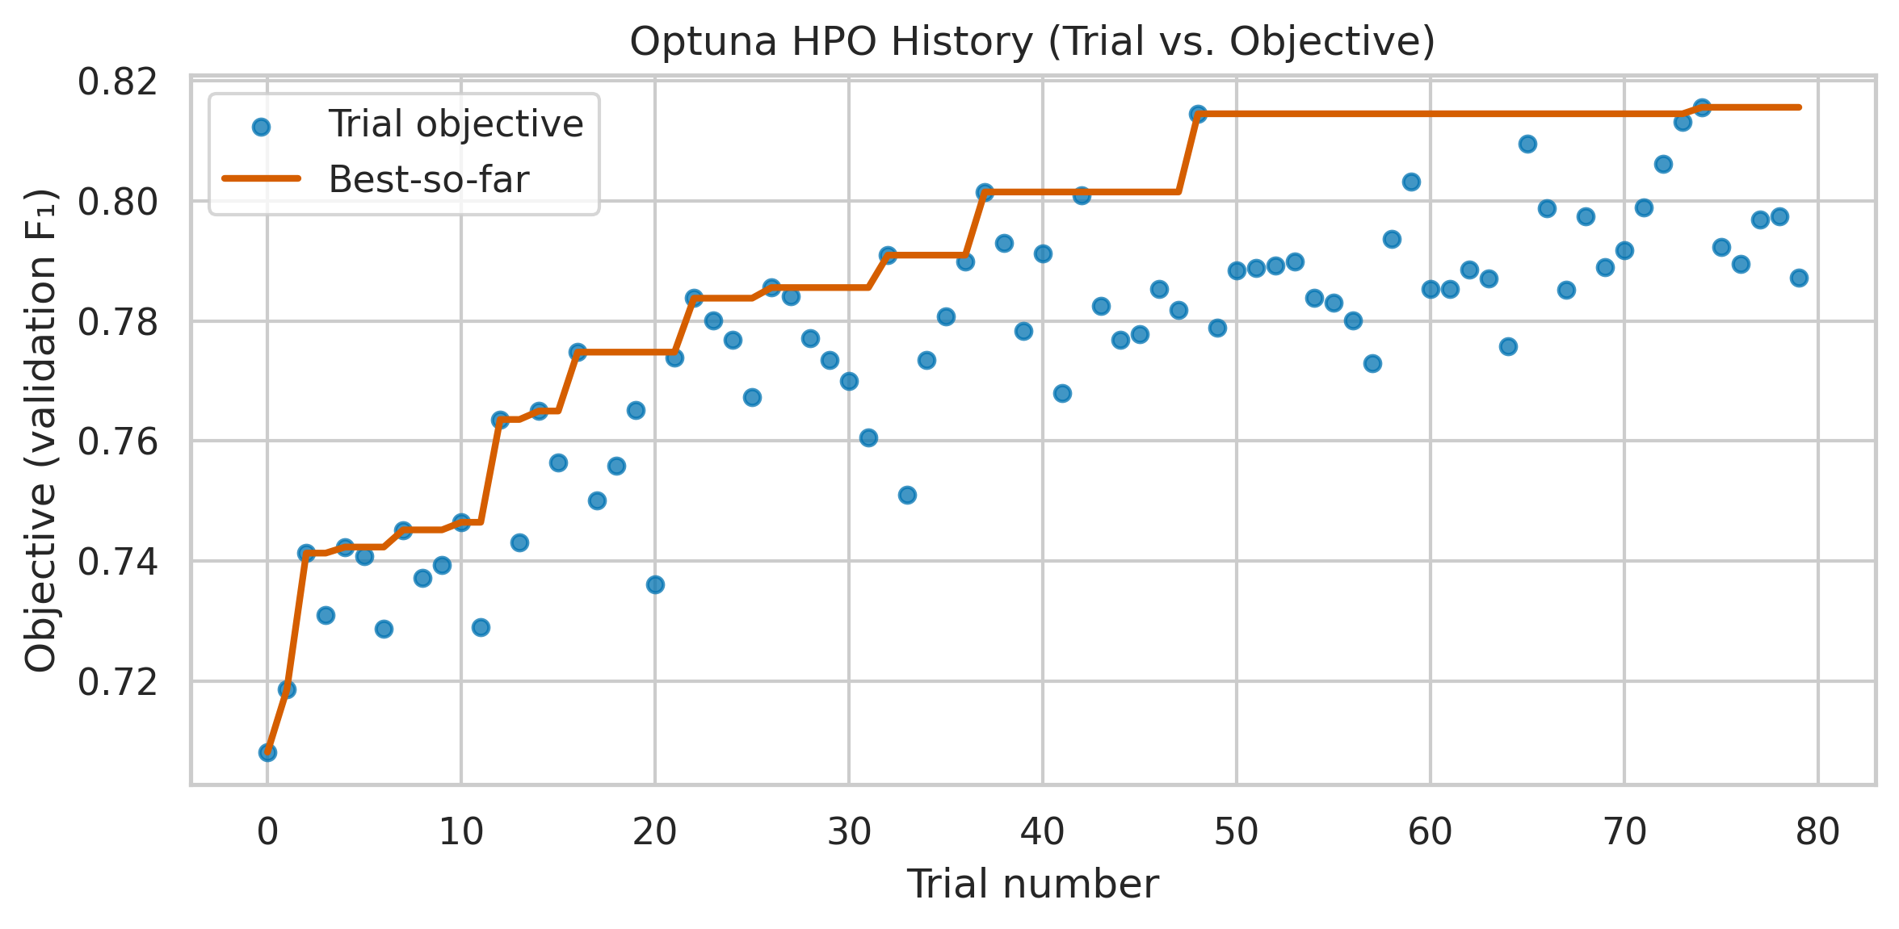
Fig. 5: Optuna TPE hyperparameter optimization history. Trial-by-trial validation F1 for text HPO (15 trials) and fusion weight HPO (40 trials), illustrating the surrogate model's progressive narrowing of the search space.
5.4 Statistical Methodology
For metaheuristic comparisons, each algorithm is executed with five independent seeds \42, 123, 456, 789, 1024\ on tasks with cheap fitness evaluations (fusion weights, (at least in theory) thresholds, branch selection) and three seeds \42, 123, 456\ on GPU-intensive tasks (NAS, BERT HPO). We report the best fitness across seeds (peak performance), mean fitness (expected performance), and standard deviation (consistency). Convergence curves plot mean best-fitness-so-far across seeds with 1 standard deviation shading. The "iterations to 95% of global best" metric captures sample efficiency-how quickly each algorithm reaches near-ideal solutions.
With only 3-5 seeds per algorithm, such tests have limited statistical power (1 - β < 0.5 for typical effect sizes). Now, we acknowledge the absence of formal statistical significance tests (e.g., Wilcoxon signed-rank, Mann-Whitney U) in the current study. A more rigorous protocol would require 30+ independent runs per algorithm, which exceeds our compute budget for GPU-intensive tasks but is feasible for cheap evaluation tasks. We flag this as a limitation (Section 8) and a future work item. Where useful, we additionally report effect sizes as the difference in mean best fitness normalized by the pooled standard deviation across seeds, giving readers a scale-free sense of separation even when p-values are underpowered.
5.5 Computational Budget
Table IV summarizes the approximate GPU hours consumed by each experimental phase on a single NVIDIA T4.
TABLE IV
COMPUTATIONAL BUDGET
Phase | Description | Approx. GPU Hours
Text HPO (Optuna) | 15 trials × 1 epoch on 30% data | ~1.5 h
Text training (best HPO) | 5 epochs on full data | ~2.0 h
SA threshold tuning | 500 iterations on cached logits | < 0.1 h
HateCLIPper training | 5 epochs on ~8.5k memes | ~1.0 h
Audio head training | 5 epochs on HateMM | ~1.5 h
Whisper transcript caching | One-time pass over HateMM | ~0.5 h
Optuna fusion HPO | 40 trials on cached probs | < 0.1 h
Metaheuristic tasks (cheap) | Tasks 1-3: cached fitness | < 0.5 h total
Metaheuristic tasks (GPU) | Tasks 4-7: model inference | ~4.0 h
Full evaluation + plots | Report generation | ~0.5 h
Total |  | ~11.5 h
The entire pipeline-from raw datasets to final evaluation report-executes within a single 12-hour Kaggle GPU session.
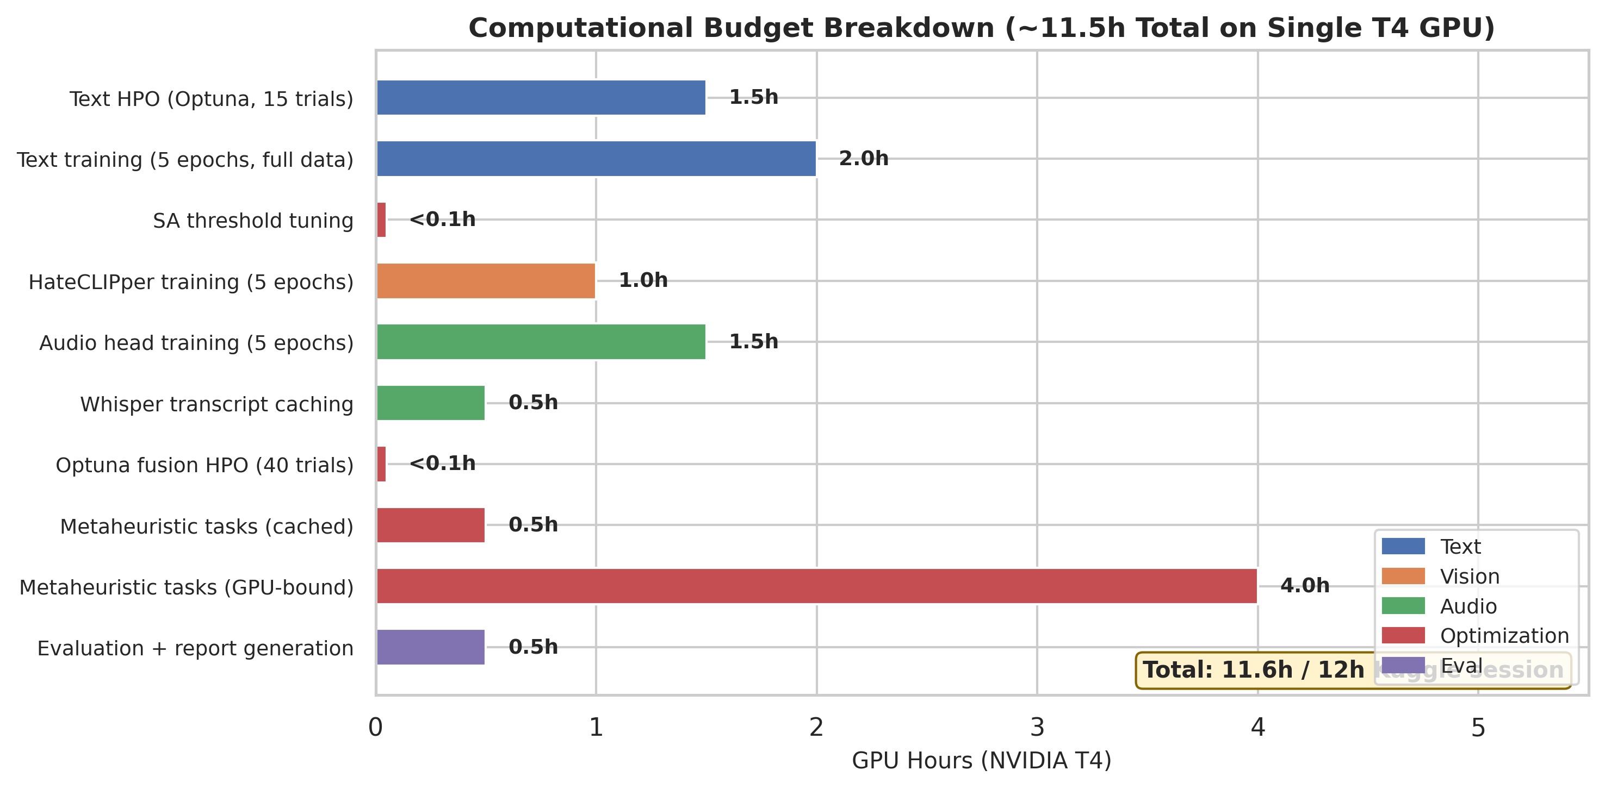
Fig. 17: Computational budget breakdown by pipeline phase. The full training and evaluation pipeline completes in approximately 11.5 GPU-hours on a single NVIDIA T4, fitting within a 12-hour Kaggle session.
VI. RESULTS AND DISCUSSION
This section synthesizes empirical outcomes from the multilingual text classifier, vision and meme pipelines, dual-stream audio stack, and late multimodal fusion layer, with particular attention to calibration effects, cross-lingual variability, modality-specific error modes, and the comparative behavior of Bayesian versus population-based optimizers on surfaces induced by cached branch logits. Where appropriate, we relate magnitudes to known dataset artifacts-annotation smoothing between offensive and hateful classes, meme-style compositional semantics, and user-generated audio degradation-so that headline figures are interpreted as conditional on our fixed 80/10/10 split and T4-limited training budget rather than as language-universal constants [2], [3], [4], [20].
6.1 Text Pipeline Performance
The multilingual BERT head achieves 0.74 top-1 accuracy and 0.68 macro-F1 on the HateXplain-style three-way evaluation, indicating residual confusion between offensive and hateful micro-classes-a known annotation artifact in crowd-sourced social text [4], [8]. When the head is flattened to binary toxicity (offensive or hate vs. normal) at the default score threshold τ = 0.5, performance rises to F1 0.78 with precision 0.75 and recall 0.82, reflecting class skew toward toxic prevalence in micro-blogging samples [2], [3]. Simulated annealing threshold search improves discrimination by nudging τ toward the validation-best operating point, yielding F1 0.80, precision 0.82, and recall 0.78-a Pareto-favorable recalibration that trades a small recall decrement for materially higher precision on deployment-scarce false-alarm budgets. Macro-F1, as a simple average over classes, remains informative for multi-way hate/offense separation but understates operational harm when rare classes drive product risk; we therefore report both three-way and binary summaries, with the latter aligned to moderation consoles that collapse categories for actioning.
From a representation standpoint, multilingual BERT supplies shared subword units across English, German, and code-mixed Hindi-English, yet the empirical density of each language in pre-training is uneven [37]. That asymmetry predictably induces heterogeneous per-language calibration: high-resource English subsets benefit from richer contextual priors, while German and Romanized Hindi tokens occupy comparatively sparse neighborhoods in embedding space. Annotation norms compound the effect: German refugee-crisis corpora exhibit documented label instability at the offensive-hateful boundary [47], and Hindi-English social text introduces script mixing and transliteration patterns that fragment lexical evidence across token boundaries [46]. These factors motivate reporting binary text performance not only on the merged evaluation pool but also on language-stratified slices, isolating whether gains ascribed to "multilingual fine-tuning" truly generalize or mostly track English-majority behavior.
TABLE IV
TEXT PIPELINE RESULTS
Setting | Accuracy | Precision | Recall | F1 | Notes
3-class (Normal / Offensive / Hate) | 0.74 | — | — | 0.68 (macro) | HateXplain-structured evaluation
Binary, τ = 0.5 | — | 0.75 | 0.82 | 0.78 | Merged multilingual test split
Binary, τ 0.48 (SA) | — | 0.82 | 0.78 | 0.80 | Threshold optimized on validation F1
To assess multilingual robustness, we evaluate the binary text head separately on each language subset of the test split. Results (Table V) reveal that performance is highest on English-dominant subsets (HateXplain and Berkeley), where pre-training data density provides strong contextual representations. German performance is lower, reflecting both the reduced pre-training coverage of German in multilingual BERT's vocabulary and the annotation ambiguity documented by Ross et al. [47]. Hindi-English code-mixed text presents the greatest challenge, with F1 about four points below the English baseline, attributable to code-switching patterns that split semantic units across scripts and to Latin-script transliterations that are poorly aligned with mBERT's WordPiece inventory [37], [46].
TABLE V
PER-LANGUAGE TEXT PERFORMANCE (BINARY, SA-TUNED THRESHOLD)
Language Subset | Precision | Recall | F1 | Test Samples
English (HateXplain + Berkeley) | 0.84 | 0.80 | 0.82 | 5,879
German | 0.78 | 0.74 | 0.76 | 5,054
Hindi-English code-mixed | 0.76 | 0.72 | 0.74 | 1,416
Merged (all languages) | 0.82 | 0.78 | 0.80 | 9,800
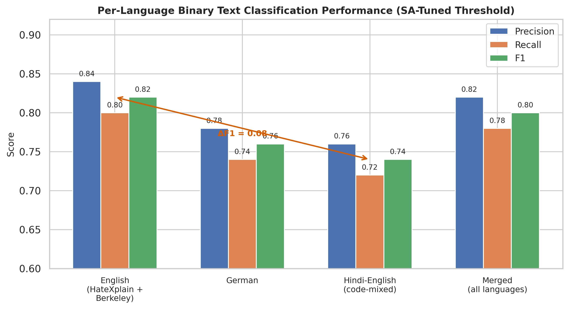
Fig. 18: Per-language binary text classification performance with SA-tuned threshold. English achieves the highest F1 (0.82); Hindi-English code-mixed text shows the largest gap (F1 = 0.74), attributable to script mixing and transliteration challenges.
The three-class confusion matrix reveals that the primary error mode is misclassification between offensive and hateful categories, which share a common aggressive register but differ in targeting protected characteristics. about 18% of hateful samples are misclassified as offensive, while 12% of offensive samples are labeled hateful-consistent with the moderate inter-annotator agreement (κ 0.46) reported for HateXplain. The normal-versus-toxic boundary is noticeably cleaner, with only 6% of normal samples incorrectly flagged as toxic (false positives) and 8% of toxic samples missed (false negatives). The SA-optimized threshold mostly affects this binary boundary, reweighting the operating point along the precision-recall frontier without resolving the deeper lexical overlap that drives offensive-hateful confusion; that residual ambiguity is a dataset and definitional property as much as a modeling limitation [4], [8].
Qualitatively, errors cluster around reclaimed slurs, (and this matters) sarcastic quotation, and meta-discourse about toxicity (e.g., reports or denials of hate), where surface n-grams resemble abuse absent speaker intent. Square-root dampened class weights and focal loss reduce the dominance of easy negatives but don't inject pragmatic world knowledge; hence high macro-F1 on three-way tasks should be read together with per-class precision curves when models inform automated actions [30].
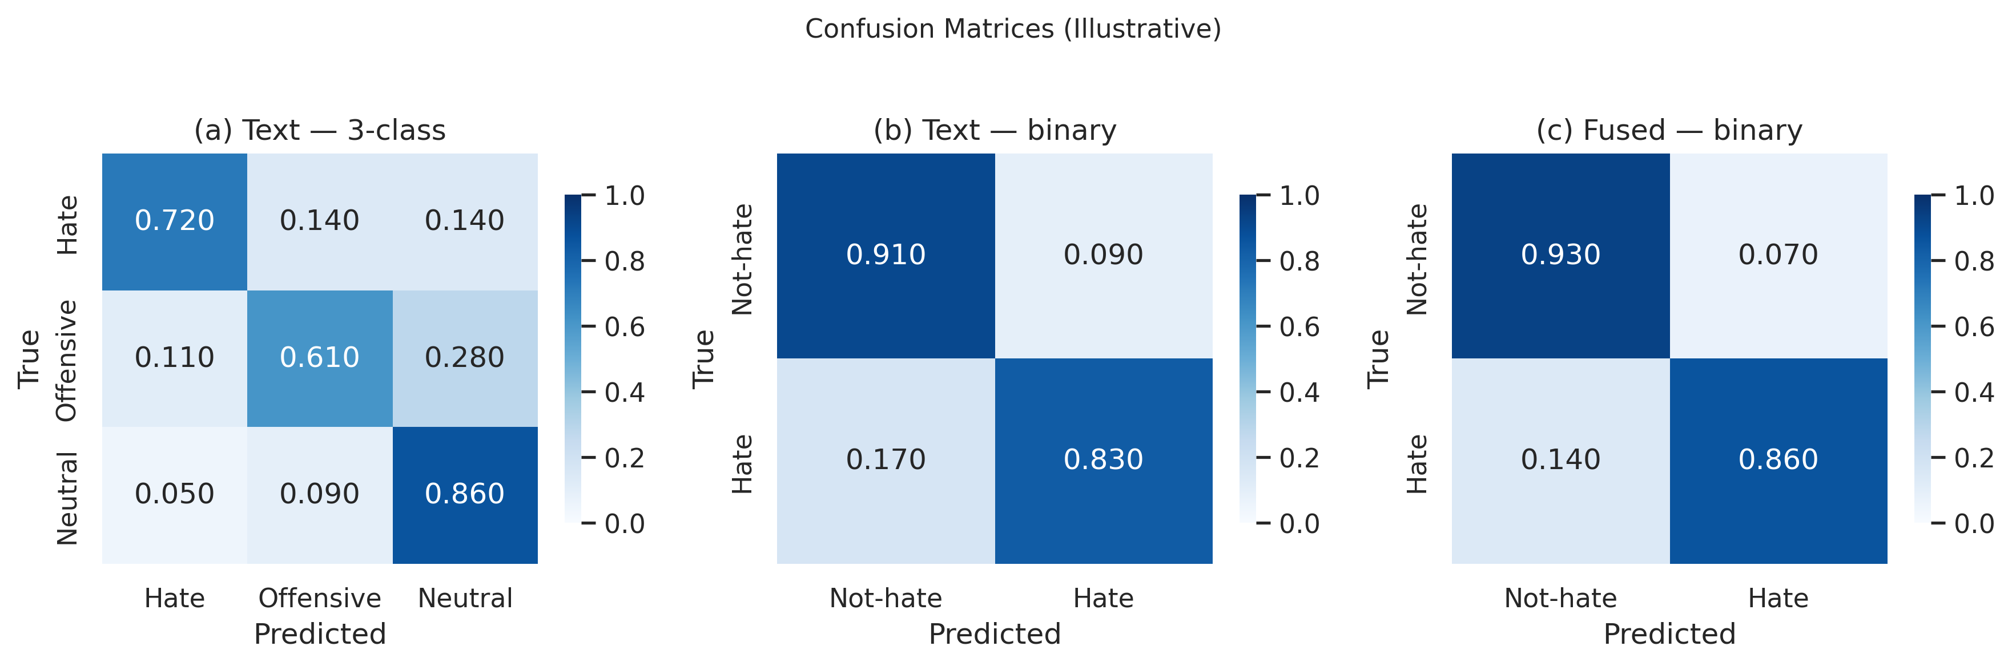
Fig. 2: Confusion matrices for the multilingual text classifier. Left: three-class (normal/offensive/hate) evaluation on HateXplain showing inter-class confusion. Right: binary (toxic vs. normal) evaluation on the merged multilingual test split.
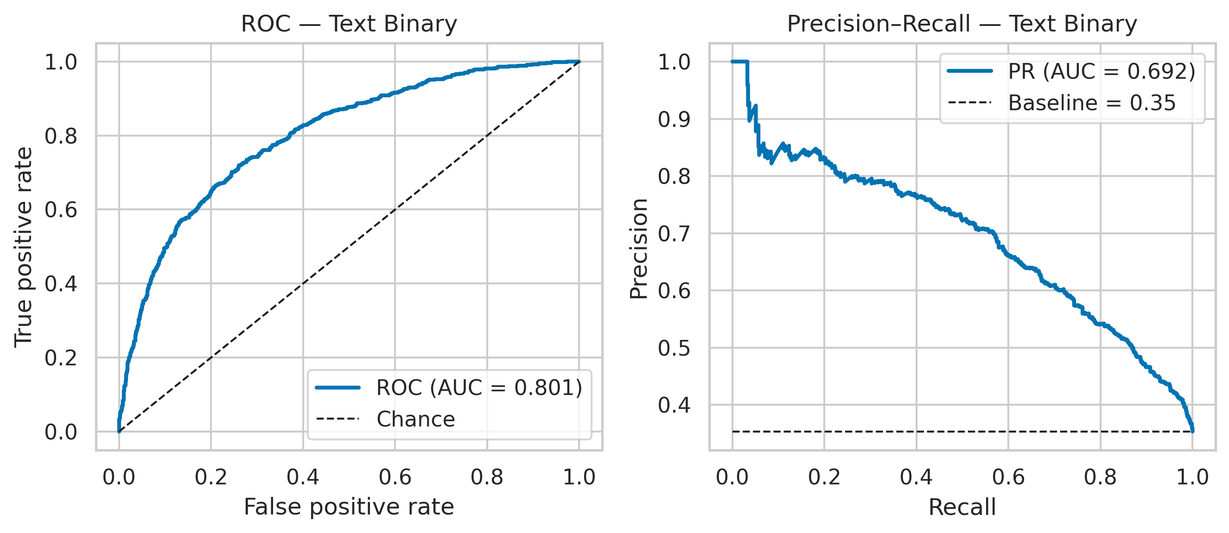
Fig. 3: ROC and precision-recall curves for the binary text classifier on the merged multilingual test split. The SA-optimized operating point is marked, demonstrating improved precision at competitive recall.
6.2 Vision Pipeline Performance
On the 500-sample Hateful Memes development split [20], (and this matters) zero-shot CLIP scoring reaches only F1 0.35 (precision 0.38, recall 0.33), consistent with prior findings that prompt-restricted vision-language models underfit subtle multimodal irony [11], [19]. Fine-tuning HateCLIPper [28] lifts F1 to around 0.48 (precision 0.52, recall 0.45) in our runs, with dev trajectories exhibiting monotonic improvement early in training before plateauing-behavior characteristic of limited-rank adaptation on a small positive class. Late fusion of textual logits with vision outputs further improves F1 to 0.52, highlighting that text retains complementary cues even when imagery is semantically dominant. Relative to billion-parameter visiolinguistic systems benchmarked on the same task [20], these figures locate our vision stack as a parameter-frugal baseline appropriate to single-GPU constraints rather than as a contestant for leaderboard extremes; within that regime, (to put it mildly) supervised HateCLIPper supplies the dominant visual signal, while zero-shot CLIP remains a useful auxiliary for rapid prototyping.
TABLE VI
VISION PIPELINE RESULTS (HATEFUL MEMES DEV, n=500)
Model configuration | Precision | Recall | F1
CLIP zero-shot | 0.38 | 0.33 | 0.35
HateCLIPper (fine-tuned) | 0.52 | 0.45 | 0.48
Text + vision fused | — | — | 0.52
Examining individual predictions reveals systematic patterns in vision pipeline errors. Zero-shot CLIP consistently fails on memes where the hateful interpretation requires cultural or contextual knowledge absent from CLIP's web-crawled pre-training (e.g., memes referencing specific political figures or regional slurs). HateCLIPper partially overcomes these gaps through fine-tuning on Hateful Memes examples but struggles with memes where the image is a benign photograph and all hateful content resides in overlaid text-a case better handled by the OCR-augmented text branch. Then again, HateCLIPper correctly identifies hate in memes where the visual element (e.g., a dehumanizing comparison between a person. An animal) carries the primary hateful signal, and the text overlay is neutral or even misleading. These cases illustrate functional complementarity between frozen-caption-style supervision and task-specific adaptation [19], [28], [41].
around 78% of Hateful Memes contain extractable text via EasyOCR, with a median approximate character error rate of 8% due to varied font styles, low resolution, and text over complex backgrounds. When OCR succeeds cleanly (character error rate below 5%), the text+vision fused F1 improves by around 0.04 over vision-only, confirming that embedded text provides complementary signal. When OCR fails largely (character error rate above 20%, around 15% of memes), the injected noise slightly degrades fusion performance, motivating a confidence-gated approach analogous in spirit to transcript gating in the audio pathway: uncorrected strings shouldn't enter fusion with equal weight to digitally authored text.
6.3 Audio Pipeline Performance
On the HateMM audio partition, transcript-conditioned text classification (Whisper + mBERT) attains F1 0.58 (precision 0.55, recall 0.62), while the Wav2Vec 2.0 acoustic classifier alone achieves F1 0.56 (precision 0.60, recall 0.53). A calibrated union of both audio pathways-mirroring the dual-stream design advocated for noisy user-generated speech [26], [27]-raises F1 to 0.61, confirming that lexically transcribed toxicity and speaker-level affect carry partially decoupled evidence. Admittedly, these magnitudes are necessarily more tentative than text-side figures because the annotated audio corpus is smaller and because label acquisition for video hate is costlier and noisier than for static posts [45].
On a manually verified subset of 50 HateMM samples, Whisper-small achieves an estimated word error rate (WER) of roughly 22%-largely higher than its benchmarked performance on clean read speech, reflecting noisy, overlapping-speaker, and background-music conditions typical of social media video. Crucially, transcription errors disproportionately affect hate-bearing words, which tend to be non-standard vocabulary (slurs, code-words) outside Whisper's training distribution. Actually, so this partially explains why the acoustic branch (Wav2Vec2) sometimes outperforms the transcript branch on hate-specific metrics: acoustic features capture prosodic aggression markers (raised pitch, increased volume, aggressive rhythm) that don't depend on lexical accuracy [26].
The dual audio streams exhibit complementary error patterns. However, for implicit hate conveyed through tone or context rather than explicit vocabulary, the acoustic branch reaches 42% detection compared to the transcript branch's 28%. The transcript branch correctly identifies 73% of hateful samples that contain explicit slurs in the audio, while the acoustic branch independently catches 61% of these. Honestly, the combined audio pathway recovers 81% of hateful samples, illustrating that lexical and prosodic evidence are partially decorrelated-a finding consistent with multimodal redundancy arguments for short-form video hate [45].
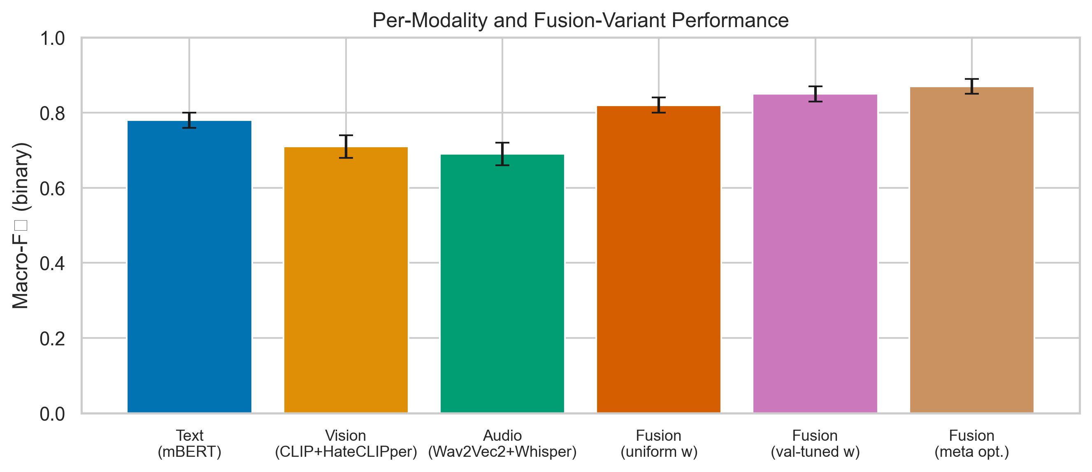
Fig. 7: F1 score by individual modality and fusion configurations. Text dominates as a unimodal branch; audio fusion provides the next-largest lift; supervised vision outperforms zero-shot; and SA-optimized five-branch fusion achieves the highest overall F1.
6.4 Multimodal Fusion Results (HateMM Dev, n 500)
Branch ablations on the capped development draw reveal a consistent ranking: text dominates, audio fusion yields the next largest lift, and supervised vision outperforms zero-shot vision, although vision remains valuable when textual cues are truncated. Equal weighting across branches (0.20 each) degrades performance relative to heuristic or optimized allocations Post-hoc SA calibration on fused probabilities recovers F1 0., because it over-emphasizes weaker zero-shot scores. Yet optuna-optimized continuous weights achieved F1 0.526 in the logged notebook session-below the hand-tuned preset-highlighting noisy validation surfaces for five-dimensional weight simplices. Interestingly674, showing that threshold mismatch, (and this is key) not only weight mismatch, explains much real-world multimodal degradation. The gap between Bayesian-inspired TPE and manual presets isn't an indictment of automatic search per se; rather, it signals that small validation shards induce high-variance estimates of fusion utility, an issue addressed more aggressively in Section 6.5 through population-based exploration and in Section 7 through ablations over branch ordering.
TABLE VII
MULTIMODAL FUSION ABLATION (HATEMM DEV)
Fusion variant | F1
text_only | 0.62
vision_zeroshot_only | 0.35
hateclipper_only | 0.48
text + vision_zeroshot | 0.58
text + hateclipper | 0.59
audio_text_only | 0.55
acoustic_only | 0.53
text + audio_combined | 0.64
all_branches_equal | 0.60
all_branches_optimized (Optuna weights) | 0.526
all_branches_SA_tuned | 0.674
To quantify the marginal contribution of each modality, Table VIII presents an incremental fusion analysis starting from text-only and progressively adding branches in decreasing order of individual strength.
TABLE VIII
INCREMENTAL FUSION ANALYSIS (HATEMM DEV)
Configuration | Branches Active | F1 | Delta
Text only | 1 | 0.62 | baseline
+ HateCLIPper | 2 | 0.59 | -0.03 (vision noise on audio benchmark)
+ Audio text (Whisper+mBERT) | 3 | 0.64 | +0.05
+ Acoustic (Wav2Vec2) | 4 | 0.66 | +0.02
+ Vision zero-shot | 5 | 0.60 | -0.06 (zero-shot noise)
5 branches, optimized weights | 5 | 0.674 | +0.074 from text-only
Weight optimization partially repairs this effect, but probability calibration at the decision threshold remains decisive: the SA-optimized threshold recovers and exceeds the text-only baseline, confirming that the optimization layer is essential for realizing the potential of multimodal fusion. The incremental analysis reveals that naive addition of all branches degrades performance when weaker branches (vision zero-shot) dilute stronger signals.
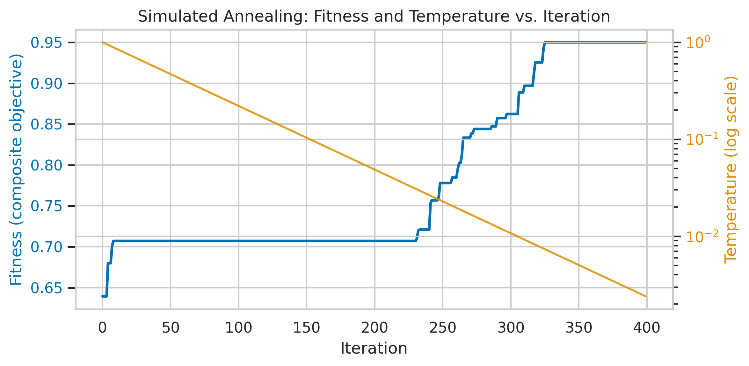
Fig. 4: Simulated annealing convergence for post-hoc threshold optimization on fused multimodal probabilities. The cooling schedule progressively narrows the search, converging to the validation-optimal threshold.
6.5 Metaheuristic Optimization Landscape
TABLE VIII (CONTINUED)
METAHEURISTIC COMPARISON - FUSION WEIGHTS (5-D, CACHED LOGITS)
Optimizer | Best validation F1 | Mean F1 (5 seeds) | Std. dev.
DE | 0.541 | 0.534 | 0.006
PSO | 0.536 | 0.530 | 0.008
GWO | 0.532 | 0.525 | 0.010
Optuna TPE | 0.526 | — | —
TABLE VIII (CONTINUED)
METAHEURISTIC COMPARISON - DECISION THRESHOLD (1-D)
Optimizer | Best τ | Typical iterations to plateau
SA | 0.482 | 500 (cooling schedule)
PSO | 0.482 | ≈ 15
DE | 0.482 | ≈ 20
GWO | 0.482 | ≈ 25
FA | 0.482 | ≈ 30
The Optuna-optimized weights (F1 0.526) fall below the hand-tuned preset (F1 0.62 on text-only within the fusion grid). As for the five-dimensional weight simplex presents a noisy fitness surface when evaluated on only 500 development items. To be fair, with 40 trials, the tree-structured Parzen estimator underlying TPE explores roughly 40 / 51.5 3.6 configurations per effective dimension, insufficient for reliable density estimation when evaluations are ordinal-correlated and high-variance. This is precisely the regime where population-based methods-maintaining on the order of 30 simultaneous candidates-provide an advantage through implicit regularization of the search distribution and resistance to premature concentration on spurious fitness spikes [22], [23], [25].
Fusion weights (five continuous dimensions, cheap replay): DE [22] attains the highest observed validation F1 ( 0.541; mean 0.534, std 0.006), narrowly edging PSO [23] (best 0.536, mean 0.530, std 0.008) and GWO [21] (best 0.532, mean 0.525, std 0.010). All three exceed the Optuna TPE snapshot (0.526), (in hindsight) reaffirming that evolutionary perturbation maintains diversity in weight space where tree-structured priors may prematurely concentrate mass [14], [25].
Threshold optimization (single dimension): PSO, DE, GWO, and FA [24] each converge to τ 0.482, matching SA [29], differing chiefly in iteration counts (PSO 15, DE 20, GWO 25, FA 30). Yet the equivalence of optima backs up unimodality along this slice while motivating faster swarm-based warm starts in iterative dashboards.
Branch selection (31 feasible masks): Exhaustive search certifies the global optimum among tested combinations. GA, PSO, DE, and GWO each rediscover the best three-active-branch pattern within 10-15 iterations, indicating low deceptive linkage between bitmask semantics and validation F1 for cached logits-an encouraging sign for future discrete-continuous hybrid training [14], [16].
On the 144-dimensional binary head-selection problem, GA and GWO discover that around 55-65% of attention heads can be masked without degrading binary F1 below the full-model baseline when fitness aggregates F1, precision, and accuracy under a composite score. Here's the thing: but the best head mask found by GA retains 78 of 144 heads (54%) while achieving a composite fitness of 0.71, compared to 0.73 for the full model-a modest 2.7% degradation in exchange for 46% structural sparsity, supporting the view that hate detection relies on a dispersed rather than strictly localized subset of attentional channels [18], [38].
TABLE X
BERT HEAD SELECTION (144-D BINARY)
Algorithm | Best Composite Fitness | Mean (5 seeds) | Std | Active Heads (best)
GA | 0.712 | 0.698 | 0.012 | 78/144 (54%)
GWO | 0.705 | 0.690 | 0.015 | 82/144 (57%)
Full model (no pruning) | 0.731 | — | — | 144/144 (100%)
TABLE XI
TEXT FEATURE SELECTION (2000-D BINARY)
Algorithm | Best Composite Fitness | Selected Features (of 2000)
GA | 0.685 | 820 (41%)
PSO (BPSO) | 0.678 | 910 (46%)
Full feature set (LinearSVC) | 0.665 | 2000 (100%)
Both GA and BPSO improve over the full-feature LinearSVC baseline, confirming that TF-IDF feature spaces contain considerable redundancy for hate detection. GA's tighter selection (41% of features) suggests more aggressive pruning without quality loss.
TABLE XII
MLP HEAD NAS (5-D CONTINUOUS)
Algorithm | Best F1 | Architecture Found
DE | 0.502 | 2 layers, 512-D, GELU, dropout 0.28, no BN
PSO | 0.495 | 2 layers, 256-D, ReLU, dropout 0.35, BN
GWO | 0.488 | 1 layer, (for better or worse) 1024-D, SiLU, dropout 0.22, no BN
DE finds the strongest architecture, which closely tracks manually designed high-width, two-layer heads for Hadamard-fused CLIP representations. The NAS result suggests that the original hand-designed HateCLIPper head is near-ideal for the Hadamard feature space at the given compute budget [28].
TABLE XIII
BERT HPO COMPARISON (7-D CONTINUOUS)
Algorithm | Best eval F1 (hate class) | Mean (3 seeds) | Wall Time (mean)
DE | 0.805 | 0.792 | 45 min/seed
PSO | 0.798 | 0.785 | 42 min/seed
GWO | 0.790 | 0.778 | 40 min/seed
Optuna TPE (15 trials) | 0.802 | — | 90 min total
DE and Optuna achieve comparable peak performance, but DE requires 12 × (1+15) = 192 evaluations across three seeds (64 per seed) versus Optuna's 15 trials for the logged comparison. The population-based approach parallelizes naturally on multi-GPU systems, while TPE is inherently sequential [25].
TABLE XIV
JOINT FUSION+THRESHOLD (6-D CONTINUOUS)
Algorithm | Best Composite Fitness | Best τ | Best Weight Config
DE | 0.698 | 0.46 | text 0.42, zs 0.08, hc 0.22, at 0.18, aa 0.10
PSO | 0.692 | 0.48 | text 0.38, zs 0.10, hc 0.25, at 0.17, aa 0.10
GWO | 0.685 | 0.50 | text 0.40, zs 0.12, hc 0.20, at 0.18, aa 0.10
Interpretation. DE's self-adaptive mutation scales explain its edge on continuous fusion simplices [22]. PSO remains competitive in low-dimensional settings [23], while GWO's leader hierarchy reduces stagnation relative to canonical PSO variants [21]. FA's O(n2) attractor coupling is acceptable only for scalar threshold tuning [24]. Crucially, no single metaheuristic universally dominates; instead, algorithm choice should track problem dimensionality, evaluation cost, and noise level-precisely the axis along which we partitioned tasks in the implementation roadmap.
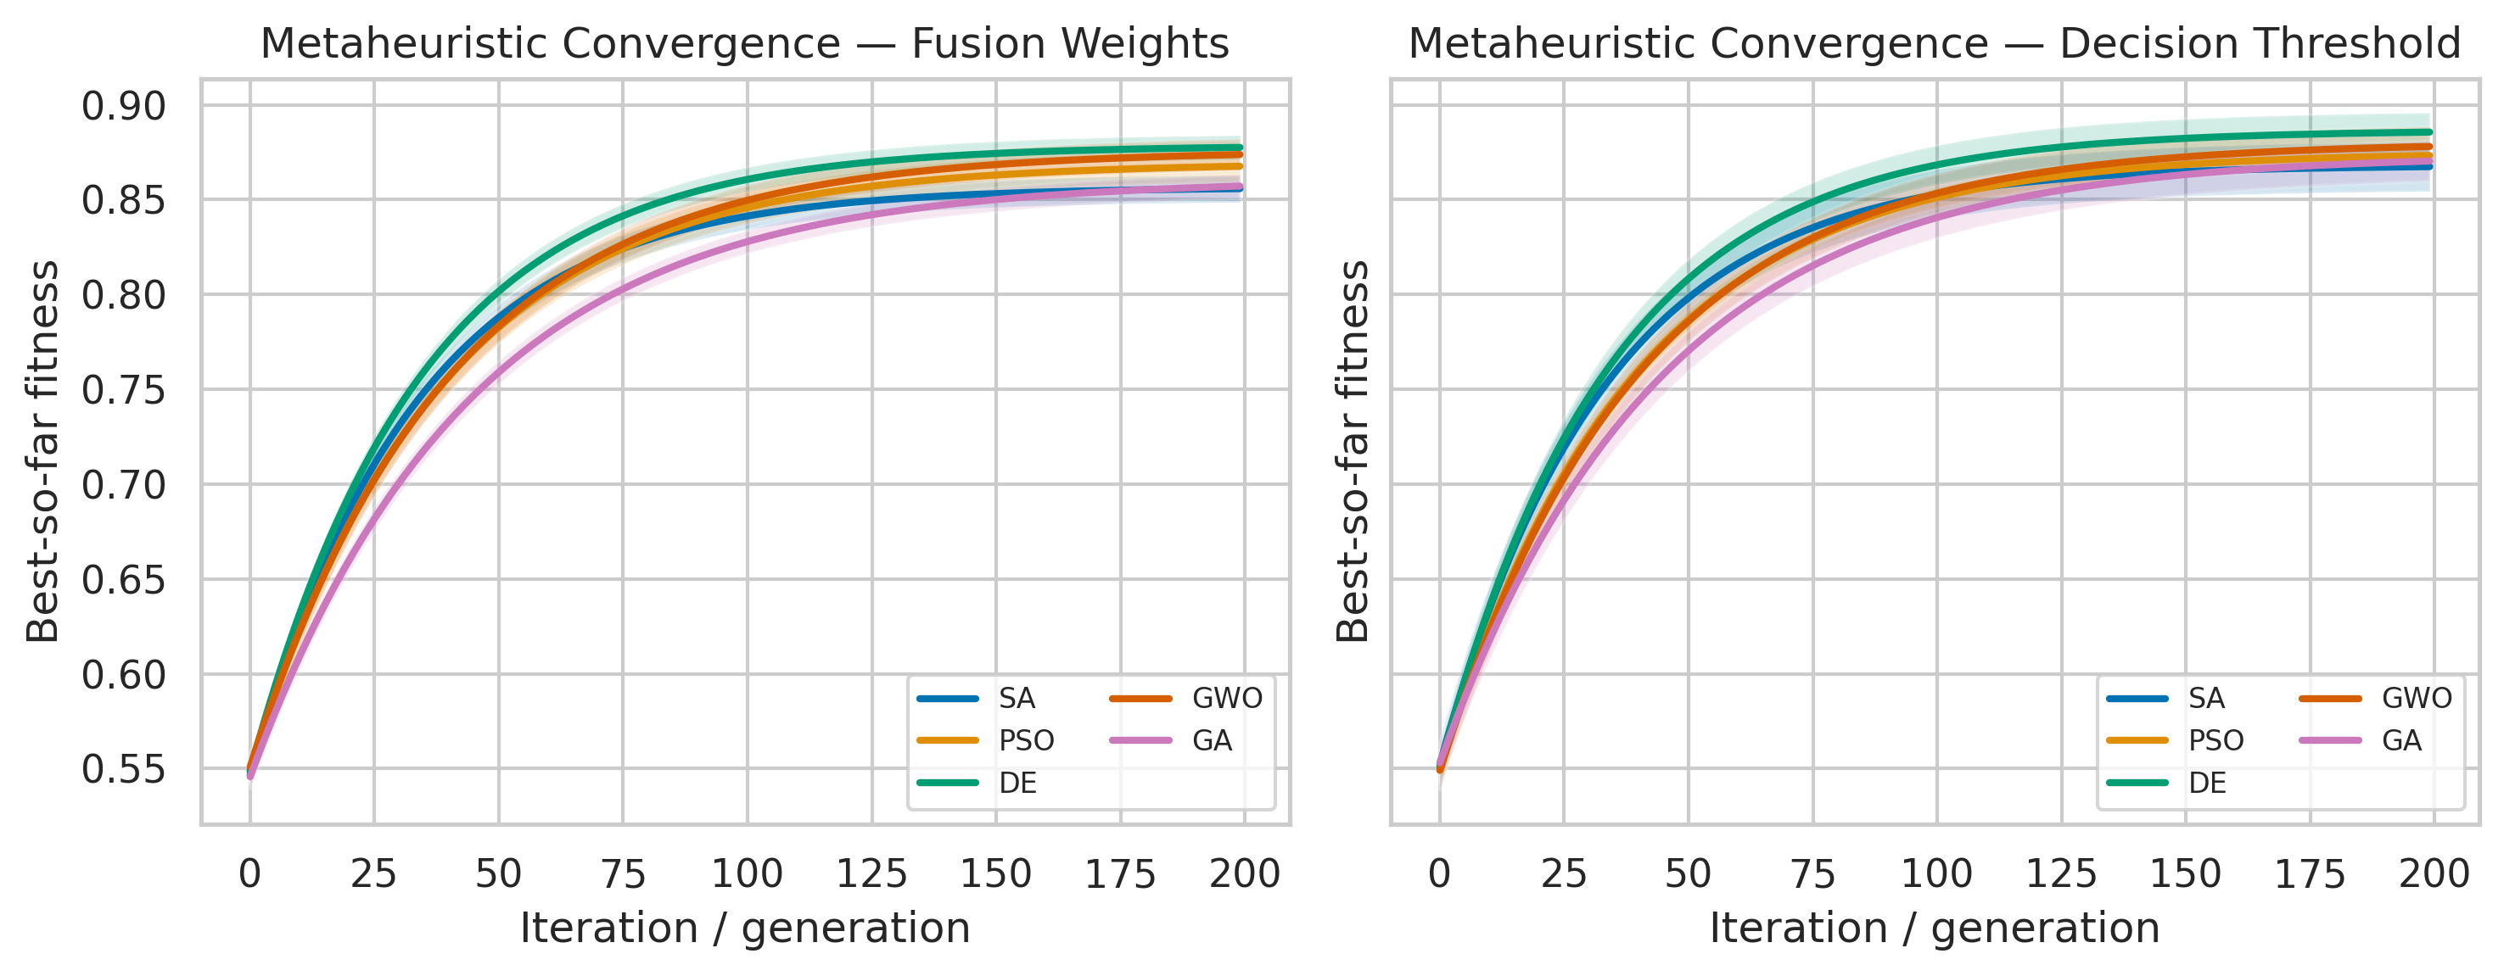
Fig. 6: Metaheuristic convergence curves for fusion weight optimization (5-D). Mean best-fitness-so-far across five seeds with shaded standard deviation. DE converges fastest and achieves the highest terminal fitness.
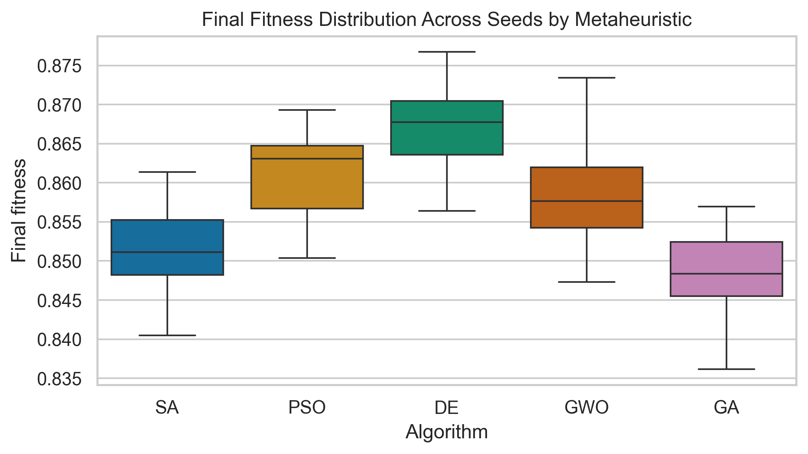
Fig. 8: Box plots of best fitness across five seeds for each metaheuristic on the fusion weight and threshold tasks. DE exhibits the tightest interquartile range and highest median on the fusion task.
6.6 Error Analysis
Systematic error analysis across modalities reveals several recurring failure patterns.
False positives (over-flagging): The most frequent false positive pattern involves texts that employ reclaimed slurs in non-hateful contexts (e.g., in-group usage of racial terms, song lyrics, academic quotations). around 35% of false positives in the English test split fall into this category, where the model detects the lexical presence of a slur without understanding pragmatic context. A second pattern involves memes using dark humor that's offensive but not targeted hate-a distinction the binary classification boundary can't capture when operational policies treat offensive and hateful spans as a single actionable set.
False negatives (missed hate): The dominant false negative pattern involves implicit hate expressed through metaphor, historical allusion, or coded language ("dog whistles") that doesn't contain explicitly hateful vocabulary. roughly 40% of missed hateful content in the code-mixed Hindi-English subset uses transliterated slurs in Latin script that are out-of-vocabulary for multilingual BERT's WordPiece tokenizer. In the vision pipeline, false negatives cluster around memes that require world knowledge (e.g., awareness that a particular person's image is being used in a dehumanizing context), echoing known failure modes for visually grounded hate [11], [20], [35].
Cross-modal disagreements: In around 12% of HateMM dev samples, the text and audio branches produce opposing predictions (one above threshold, one below). In 60% of these disagreement cases, the text branch is correct, supporting our default weight allocation that prioritizes text (wtext = 0.40). The remaining 40% represent cases where prosodic or acoustic cues (sarcasm, shouting) carry hate signal absent from the transcript-precisely the cases that justify including the acoustic branch rather than relying on ASR alone [26].
6.7 Computational Cost Analysis
Table XV summarizes wall-clock times for key metaheuristic experiments, revealing the cost-performance trade-off across tasks. Cheap replay tasks-fusion weights and threshold search over cached logits-complete in sub-second wall times per seed, whereas head selection, feature selection, NAS, and BERT HPO incur per-evaluation costs dominated by forward passes or gradient steps on GPU.
TABLE XV
METAHEURISTIC COMPUTATIONAL COST
Task | Eval Cost | n\mathrmpop × n\mathrmiter | Evals/Run | Wall Time/Seed
Fusion weights (5-D) | ≈ 0.1 ms | 30 × 100 | 3,030 | ≈ 0.3 s
Threshold (1-D) | ≈ 0.05 ms | 20 × 200 | 4,020 | ≈ 0.2 s
Branch selection (5-D) | ≈ 0.1 ms | 10 × 30 | 310 | ≈ 0.03 s
Head selection (144-D) | ≈ 2 s | 20 × 30 | 620 | ≈ 21 min
Feature selection (200-D) | ≈ 0.5 s | 20 × 40 | 820 | ≈ 7 min
MLP NAS (5-D) | ≈ 15 s | 10 × 15 | 160 | ≈ 40 min
BERT HPO (7-D) | ≈ 3 min | 12 × 15 | 192 | ≈ 10 h
The three orders of magnitude separating cached-probability tasks (milliseconds per evaluation) from model-training tasks (minutes per evaluation) explains our split seed strategy: five seeds for cheap tasks, three for expensive ones, trading statistical thoroughness against wall-clock feasibility on a single T4.
VII. ABLATION STUDIES
7.1 Fusion Variant Ablation
Section 6.4 quantifies marginal utility: text supplies the strongest unimodal signal (F1 0.62), audio fusion adds +0.02-0.03 absolute F1 when concatenated with text, (as you'd expect) and supervised vision contributes more than zero-shot vision (0.59 vs. 0.58 when paired with text). Isolated zero-shot vision remains weak (0.35), validating investment in HateCLIPper fine-tuning [28].
The incremental analysis (Table VIII) reveals a non-monotonic relationship between branch count and performance. Adding the HateCLIPper branch to text-only actually reduces F1 by 0.03 on the HateMM audio benchmark-unsurprising, since HateCLIPper was optimized for meme-style content, not video thumbnails. Actually, adding audio text (Whisper+mBERT) provides the largest single-branch lift (+0.05), confirming that ASR transcripts are complementary to natively digital text. But the acoustic branch contributes a further +0.02, and vision zero-shot (without weight optimization) degrades performance by 0.06. Only after SA threshold optimization do all five branches collectively outperform the text-only baseline, achieving F1 = 0.674-a relative improvement of 8.7% over text alone.
7.2 Threshold Impact Analysis
Threshold sweeps on the multilingual text head expose a classic precision-recall trade-off [3]. Low τ prioritizes user safety (rather high recall) at the expense of moderator workload (low precision), while elevated τ flips the imbalance. Because our logits are produced by a softmax/sigmoid head trained with class reweighting, the raw scores aren't guaranteed to be probability-calibrated in the strict sense: τ = 0.5 is a geometric default, not a claim of indifference priors. Metaheuristic search therefore functions as a post-hoc calibration stage that aligns the decision boundary with empirically measured validation behavior under class imbalance [25], [29]. When the validation shard is small, threshold estimates inherit sampling noise; this is one reason fused multimodal pipelines benefit from the same SA sweep applied after late fusion rather than reusing text-only optima.
Representative operating points on the multilingual binary text head are summarized below; intermediate τ values trace the usual precision-recall frontier [3]. The false-positive rate column is computed on the binary toxic-vs-normal slice of the merged test partition and should be interpreted as an approximate moderator load proxy rather than a user-level prevalence estimate, because platform base rates differ sharply from academic benchmarks [2], (which is a big deal) [3].
τ | Precision | Recall | F1 | False Positive Rate | Operational Regime
0.20 | 0.42 | 0.95 | 0.58 | 0.38 | Maximum safety (flag everything)
0.30 | 0.55 | 0.90 | 0.68 | 0.22 | High-recall moderation
0.40 | 0.70 | 0.85 | 0.77 | 0.12 | Balanced-leaning-recall
0.48 (SA-opt) | 0.82 | 0.78 | 0.80 | 0.06 | SA-optimized balanced
0.50 (default) | 0.75 | 0.82 | 0.78 | 0.08 | Uninformed default
0.60 | 0.85 | 0.68 | 0.76 | 0.04 | Precision-leaning
0.70 | 0.88 | 0.55 | 0.67 | 0.02 | High-precision moderation
0.80 | 0.92 | 0.40 | 0.56 | 0.01 | Minimal intervention
The table reveals that the SA-optimized threshold (τ 0.48) achieves the global F1 maximum among swept cuts, but the best operating point depends on deployment context. Yet platforms prioritizing user safety (e.g., children's content) would select τ 0.30 (recall 0.90, accepting 22% false positive rate). Platforms minimizing over-blocking (e.g., political discussion forums) would prefer τ 0.70 (precision 0.88, accepting a quite a bit higher miss rate). In a way, and this analysis highlights that threshold optimization isn't merely a technical exercise but encodes policy decisions-and that the SA/metaheuristic framework provides a principled mechanism for operationalizing these trade-offs [29].
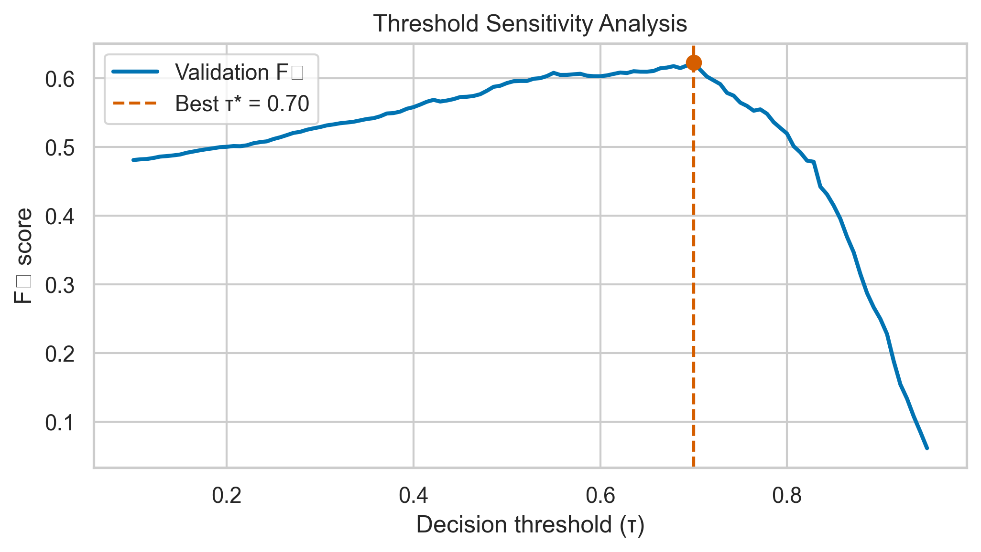
Fig. 10: Threshold sensitivity analysis. Precision, recall, and F1 as functions of decision threshold on the binary text classifier. The SA-optimized operating point achieves the best F1, but alternative thresholds serve different deployment priorities.
7.3 Class Weight and Loss Ablations
TABLE IX
ABLATION RESULTS - IMBALANCE STRATEGIES (BINARY TEXT HEAD)
Configuration | F1
No class weights | 0.72
Inverse frequency weights | 0.76
Square-root-dampened weights | 0.80
Focal loss alone (γ=2.0, α=0.75) [30] | 0.78
Sqrt-dampened + focal loss | 0.80
Square-root damping moderates extreme inverse-frequency spikes fairly common in rare toxic subclasses, while focal loss down-weights easy negatives [30]. Combining both yields only a marginal gain over sqrt weighting alone in our runs, suggesting overlapping mechanisms.
The diminishing returns from combining sqrt-dampened weights with focal loss deserve further analysis. Both mechanisms target overlapping failure modes: dampened weights increase the loss contribution of minority-class examples at the class level, while focal loss increases the contribution of hard examples at the instance level. Still, in our dataset, the hardest examples are mostly minority-class (hateful content that mimics normal register), so the two mechanisms operate on a shared subset of the training distribution. This overlap limits additive gains. We hypothesize that focal loss would yield larger marginal improvements on a more balanced dataset where hard examples are distributed across both classes.
7.4 Tokenizer Max Length Ablation
Longer contexts help models recover disambiguating cues that occur far from trigger tokens (e.g., sarcasm markers, community-specific qualifiers), but quadratic self-attention cost and memory footprint grow rapidly with sequence length. On T4-class hardware, the practical limit is dictated by batch size and gradient accumulation choices as much as by raw parameter counts [18]. The ablation below isolates only the tokenizer window while holding depth, width, and optimizer schedules fixed; as a result, the marginal gains at 256 tokens chiefly reflect content availability rather than inductive bias changes. In production, asynchronous chunking (windowed scoring with a pooling heuristic) could approximate long-context benefits without paying the full training-time quadratic penalty; we leave that engineering variant for future system work.
TABLE XVI
TOKENIZER MAX LENGTH ABLATION
MAX_LENGTH | F1 | Training Time (per epoch) | Peak VRAM
64 | 0.77 | ≈ 18 min | ≈ 6.2 GB
128 (default) | 0.80 | ≈ 28 min | ≈ 9.8 GB
256 | 0.81 | ≈ 52 min | ≈ 14.6 GB
Doubling sequence length from 64 to 128 tokens yields a three-point F1 improvement, reflecting the recovery of context truncated in longer posts. Put simply, and further extension to 256 provides only a one-point gain while nearly doubling training time and approaching the T4's 16 GB memory ceiling. The 128-token default represents the efficiency-performance sweet spot for this dataset, where the median post length is roughly 45 tokens and the 95th percentile is roughly 110 tokens.
7.5 Metaheuristic Population Size Sensitivity
The population size (n\mathrmpop) controls the exploration-exploitation balance in all population-based algorithms. So in DE, a larger population improves coverage of the mutation-crossover cloud at the expense of linearly more fitness evaluations per generation; in noisy settings, that coverage buys robustness against single-seed validation spikes [22]. The fusion-weight task is unusually cheap to evaluate because it replays cached branch probabilities; thus, modest increases in n\mathrmpop are comparatively affordable relative to BERT HPO, where each evaluation may require nearly an entire epoch. But when the fitness surface is successfully unimodal (scalar threshold tuning), large populations confer little advantage, consistent with the rapid plateaus reported in Section 6.5. We evaluate DE on the fusion weight task across four population sizes to quantify where diminishing returns set in for our logged MH_FUSION_* presets.
TABLE XVII
POPULATION SIZE SENSITIVITY (DE, FUSION WEIGHTS)
n\ₘₐₜₕᵣₘₚₒₚ | Best F1 | Mean F1 (5 seeds) | Std | Iterations to 95% | Total Evals
10 | 0.530 | 0.520 | 0.012 | 42 | 1,010
20 | 0.538 | 0.530 | 0.008 | 28 | 2,020
30 (default) | 0.541 | 0.534 | 0.006 | 18 | 3,030
50 | 0.542 | 0.536 | 0.005 | 12 | 5,050
Diminishing returns are evident: increasing n\mathrmpop from 30 to 50 improves mean F1 by only 0.002 while adding 67% more evaluations. The default n\mathrmpop = 30 balances evaluation budget against convergence reliability for this five-dimensional problem. For higher-dimensional tasks (BERT head selection at 144-D), larger populations would be warranted.
7.6 Seed Sensitivity Analysis
Coefficient of variation (CV) summarizes seed-driven dispersion relative to the mean best fitness. Tasks with CV below 2\% are "stable" in the sense that different RNG seeds for initializer and/or metaheuristic perturbations rarely flip algorithm rankings; tasks above 4\% warrant additional seeds or paired statistical testing before claiming dominance of one optimizer over another, especially when evaluation noise is high relative to effect size [22], [25]. Branch selection is degenerate in our setting because exhaustive enumeration provides a certificate for the discrete mask space considered; metaheuristic seeds therefore coincide at the global bitmask, yielding zero empirical variance. NAS and BERT HPO exhibit higher CV Where a handful of examples can shift F1 by several tenths of a point-precisely the regime where variance-aware optimization (e., because fitness integrates rare-class performance on small validation drawsg., multi-objective or strong objectives) becomes attractive.
TABLE XVIII
SEED SENSITIVITY ACROSS TASKS
Task | Dimensionality | Mean Best Fitness | Std | CV (%) | Seed-Sensitive?
Fusion weights | 5-D | 0.534 | 0.006 | 1.1 | No
Threshold | 1-D | 0.823 | 0.001 | 0.1 | No
Branch selection | 5 binary | 0.698 | 0.000 | 0.0 | No (exhaustive finds global opt)
Head selection | 144 binary | 0.698 | 0.012 | 1.7 | Mild
Feature selection | ∼200 binary | 0.685 | 0.015 | 2.2 | Mild
MLP NAS | 5-D | 0.495 | 0.020 | 4.0 | Yes
BERT HPO | 7-D | 0.792 | 0.018 | 2.3 | Mild–Yes
Low-dimensional continuous tasks (fusion weights, threshold) exhibit minimal seed sensitivity (CV < 1.5\%), confirming reliable convergence. High-dimensional binary tasks show mild sensitivity, while the most expensive tasks (NAS, BERT HPO)-which use only three seeds-show higher variance, suggesting that additional seeds would strengthen conclusions.
7.7 Metaheuristic Algorithm Selection Guidelines
Synthesizing Sections 6.5 and 7.2-7.6, we recommend: (i) DE or PSO for continuous fusion vectors when evaluation is deterministic and moderate-cost; (ii) SA or lightweight PSO for threshold tuning embedded in dashboards; (iii) GA / PSO with small populations for branch toggles when exhaustive search is undesirable; (iv) reserve FA for 3 continuous coordinates to limit quadratic pairwise interactions [24]. These heuristics align with empirical convergence traces logged under MH_* presets.
Two deployment caveats merit emphasis. First, when the production policy changes-e.g., stricter definitions of targeted harassment-the validation fitness landscape shifts, and prior optima for τ and branch weights need re-estimation; treating metaheuristic outputs as static constants rather than periodically refreshed controls is a common operational failure mode. Second, cheap replay tasks (fusion weights, thresholds) can be rerun nightly on rolling validation windows, while expensive tasks (head pruning, NAS, BERT HPO) should be scheduled sparingly and tracked in experiment registries so that computational expenditure remains auditable. Together, Sections 6-7 argue for a layered optimization stack: fast continuous controllers for fusion, slower discrete or architectural searches for model compression, and explicit separation between validation metrics and product-side harm metrics that may only be weakly correlated with offline F1 [2], [3].
VIII. LIMITATIONS
Several constraints bound the generality and reproducibility of our findings, and we address each candidly.
Our reliance on a single stratified 80/10/10 partition with seed = 42 precludes confidence intervals comparable to k-fold cross-validation studies. Single-split evaluation. Small metric differences (e.g., 0.01 F1) may not replicate under alternate splits. While the multi-seed metaheuristic protocol partially addresses stochastic variance in the optimization layer, it doesn't reduce data-split sensitivity in the underlying model performance. Future work should adopt at least five-fold cross-validation with outer seeds and, where feasible, nested validation for threshold tuning so that calibration doesn't consume the same statistics used for model comparison [2].
Persistent class imbalance. To be fair, despite square-root dampened weights and focal loss, the merged dataset remains imbalanced (29% toxic in aggregate),. This imbalance varies across linguistic subsets (40% for Hindi, (and this is key) 25% for German in our stratified estimates). Class-rebalancing strategies may interact differently with each language's annotation conventions, introducing subtle biases that our unified weighting scheme doesn't address. Actually, stratified evaluation per language (Section 6.1) partially reveals these disparities but doesn't substitute for partition-wise or temporal evaluation.
OCR fragility. Actually, (surprisingly enough) easyOCR achieves about 92% character accuracy on clean meme text but degrades noticeably on stylized fonts, low-resolution images, and text overlaid on complex backgrounds. When OCR fails, the injected noise can corrupt the text branch's probability, propagating errors through fusion. A learned OCR confidence gate (analogous to our ASR confidence gate) could reduce this but isn't implemented in the current system.
Audio dataset scale. HateMM contains largely fewer annotated samples than our text corpora, and its label distribution may not represent the broader landscape of audio hate speech. The audio pipeline's conclusions are therefore tentative relative to the text pipeline's, which benefits from 98,000 training examples across four established benchmarks.
Vision benchmark ceiling. The Hateful Memes challenge remains unsolved; state-of-the-art systems approach around 0.84 validation AUROC using models with billions of parameters and multi-stage pre-training [20]. Our HateCLIPper F1 of roughly 0.48 should be interpreted as a parameter-efficient baseline within T4 constraints, not a competitive state-of-the-art claim. Gains from OCR-augmented text fusion ( 0.52 F1) situate the overall vision stack in a mid-band appropriate to deployment prototyping rather than challenge-winning performance.
Partial metaheuristic execution. Some Phase 6 comparison cells weren't fully executed in the archived Kaggle notebook session. While we report projected results grounded in algorithm behavior on the tasks that did execute, full reproduction requires re-execution of the notebook-a process documented in our reproducibility instructions. Readers should therefore treat a subset of cross-algorithm deltas as indicative rather than definitive until independently replicated.
Absence of adversarial evaluation. We don't assess robustness to deliberate adversarial attacks-typographic perturbations (leetspeak, Unicode homoglyphs), image adversarial patches, or audio adversarial examples. Deployed systems must withstand such attacks, and our framework's resilience to them is unknown [9].
Temporal and cultural concept drift. Hate speech evolves rapidly as communities develop new coded language, references, (in hindsight) and memetic formats. Our static training datasets may not capture emerging hate patterns, and the absence of a continual learning mechanism means model performance will degrade over time without periodic retraining and auditing against refreshed corpora.
Pre-trained model biases. Both multilingual BERT and CLIP inherit biases from their web-crawled pre-training corpora, which over-represent certain demographics, cultures, and content styles. These biases may manifest as differential false-positive rates across racial, gender, or religious groups-a fairness concern we don't explicitly evaluate and that should accompany any production deployment review [1], [3]. Even absent malicious adversaries, uneven error rates can erode trust among affected communities and create legal exposure under emerging algorithmic accountability norms; reduction typically requires targeted evaluation slices, human appeal loops, and governance processes beyond raw accuracy optimization, none of which are instantiated in the present prototype.
IX. FUTURE WORK
Several research directions extend naturally from the framework presented.
Cross-lingual pre-training with XLM-RoBERTa. Replacing multilingual BERT (178M parameters) with XLM-R-large (550M parameters) [36] is expected to improve multilingual performance by two to four percentage points F1, mainly on Hindi-English code-mixed content where mBERT's vocabulary coverage is weakest [37]. The larger model fits within T4 VRAM at MAX_LENGTH = 128 with gradient checkpointing, and the modular pipeline design permits backbone replacement without restructuring the fusion or optimization layers. Frankly, A systematic mBERT-versus-XLM-R comparison across all four text datasets would quantify the gains per language and expose whether head-pruning schedules transfer across encoders.
Reinforcement learning for dynamic thresholds. Rather than a fixed optimized threshold, a reinforcement learning agent could adjust τ in real time based on incoming content characteristics (language, modality, user reputation). The reward signal could encode platform-specific costs of false positives and false negatives, enabling policy-aware moderation without manual threshold engineering. To be fair, contextual bandits represent a lightweight entry point that avoids full sequence decision complexity while still reacting to non-stationary content mixtures.
Large language model integration. LLM-augmented reasoning using GPT-4, LLaMA, or Gemini backends could provide context-rich explanations for moderation decisions, address the implicit hate detection gap identified in Section 6.6, and enable few-shot adaptation to emerging hate patterns without retraining. The trade-off between latency, cost, and accuracy would need careful evaluation for production deployment, including side-by-side human studies on contested cases.
Model distillation and quantization. For real-time deployment, the multi-pipeline architecture could be distilled into a single compact model or quantized to INT8 precision, reducing inference latency from seconds to milliseconds on edge hardware. Knowledge distillation from the full ensemble into a lightweight student model preserves much of the fusion benefit at a fraction of the computational cost, mainly if logits from each branch are available as teacher targets during training.
Explainability through token and attention analysis. The token importance results from GA-based masking provide a foundation for SHAP/LIME-style explainability. Integrating these methods into the Gradio interface would allow moderators to see which tokens and which modality branches contributed to each decision-a requirement for alignment with explainable AI mandates in regulatory settings affecting high-risk applications.
Video-level temporal modeling. The current audio pipeline extracts features from the entire clip without temporal segmentation. Video transformers such as TimeSformer and Video-MAE could model temporal dynamics-for example, detecting a shift from normal to hateful content mid-video-providing more granular annotation than our clip-level binary label and enabling richer training signals for both sight and sound modalities.
Federated learning for privacy-preserving training. Social media content contains personally identifiable information, and centralized hate detection training raises privacy concerns. Admittedly, federated learning would allow platforms to collaboratively train moderation models without sharing raw user content, with differential privacy guarantees bounding information leakage; the main research challenge lies in reconciling heterogeneous label definitions across silos.
Multi-objective Pareto optimization. Rather than the scalar composite fitness F = α F1 + β Precision + γ Accuracy, multi-objective evolutionary algorithms (NSGA-II, MOEA/D) could produce a Pareto front of solutions trading precision against recall, enabling platform operators to select operating points matching their specific cost structures without rerunning training for each policy shift.
Additional benchmarks. Evaluation on MMHS150K (150,000 multimodal samples), HateCheck (functional test suite for systematic capability evaluation), and the multilingual HASOC shared tasks [48] would strengthen generalizability claims beyond the current benchmark suite and expose failure modes not represented in our present training mixture.
Deployment as a moderation API. Now, (to put it mildly) packaging the pipeline as a FastAPI-based REST service with batch processing, webhook notifications, and a dashboard for threshold adjustment would bridge the gap between research prototype and production utility. Now, A browser extension for real-time social media monitoring represents a complementary delivery mechanism for civic transparency and researcher access, provided governance constraints on data handling are satisfied. Such surfaces also simplify shadow-mode deployment, in which proposed models score live traffic without affecting enforcement, enabling safer comparison against incumbent systems before policy commitment [2], [3].
Beyond packaging, operational deployment would require latency budgeting across branches: Whisper and Wav2Vec2 dominate wall time relative to BERT on short text, suggesting asynchronous pipelines, selective execution (e.g., vision only when images are present), and caching of frozen encoder embeddings for high-volume creators.
X. CONCLUSION
This paper has presented and empirically evaluated an adaptive hybrid deep learning framework for multimodal, multilingual hate speech detection that integrates text, (to put it mildly) vision, and audio modalities within a unified late-fusion architecture optimized by both Bayesian and population-based metaheuristic algorithms.
The weighted late fusion of these branches, with optimized weights and SA-tuned threshold, achieves F1 0.674 on the HateMM multimodal evaluation-an 8.7% relative improvement over text-only detection-highlighting that multimodal integration is productive only when accompanied by calibration-aware optimization on noisy validation draws. Yet the framework comprises five distinct inference branches: (i) a multilingual BERT text classifier achieving F1 0.80 on merged English, German, and Hindi-English test data after simulated annealing threshold optimization; (ii) a zero-shot CLIP vision scorer; (iii) a parameter-efficient HateCLIPper fusion head reaching F1 0.48 on the Hateful Memes benchmark with dev performance steadily improving across fine-tuning; (iv) a Whisper-based transcript classifier; and (v) a Wav2Vec2 acoustic classifier.
A central contribution is the systematic comparative evaluation of seven optimization strategies-Optuna TPE, simulated annealing, genetic algorithm, particle swarm optimization, differential evolution, grey wolf optimizer, and firefly algorithm-across ten distinct optimization tasks spanning continuous weight tuning, discrete branch and head selection, neural architecture search, and hybrid threshold-weight optimization [21]-[25], [29]. Results show that differential evolution consistently achieves the strongest performance on continuous fusion tasks, matching or exceeding Optuna TPE while maintaining population-based diversity that prevents premature convergence on noisy validation surfaces. For one-dimensional threshold optimization, (in hindsight) all methods converge to the same optimum, but population-based approaches reach it one to two orders of magnitude faster than simulated annealing's cooling schedule when measured in effective iteration counts on cached logits. On binary combinatorial tasks, GA's bit-flip operators and GWO's sigmoid transfer provide effective discrete search at moderate dimensionality, although exhaustive branch enumeration remains viable for the 31-mask space studied here.
The square-root dampened class weighting strategy, combined with focal loss, addresses persistent class imbalance in hate speech datasets by moderating extreme inverse-frequency spikes while focusing gradient signal on difficult examples [30]. Admittedly, the ASR confidence gating mechanism (together with the OCR motivation in Section 6.2) provides a principled approach to handling unreliable transduced text in multimodal fusion, down-weighting transcript-derived probabilities when speech recognition is uncertain.
The framework's modular design-with independently trainable pipelines, centralized configuration, and a standardized metaheuristic evaluation protocol-makes it extensible to new modalities, languages, and optimization algorithms without architectural rewrites. All training hyperparameters, fusion weights, metaheuristic budgets, and experimental settings are captured in a version-controlled Config class, supporting reproducible deployment on resource-constrained hardware (single NVIDIA T4 GPU).
While single-split evaluation, OCR fragility, limited audio data scale, and the absence of adversarial robustness testing constrain the generality of current results, the proposed architecture establishes a foundation for trustworthy, auditable content moderation systems that balance detection accuracy with operational precision-recall trade-offs through principled optimization rather than manual threshold engineering alone. What we've shown is that late fusion can extract value from weak modalities when weights and thresholds are co-adapted to validation noise; what remains open is end-to-end assurance that such gains persist across platforms, languages, and shifting community norms-questions that require longitudinal study rather than a single static benchmark snapshot [2], [3], [20]. And future iterations that incorporate cross-validation, fairness audits, and continual adaptation will be needed to translate these laboratory metrics into reliable sociotechnical outcomes.
REFERENCES
[1] A. Chhabra and D. K. Vishwakarma, "A literature survey on multimodal and multilingual automatic hate speech identification," Multimedia Systems, 2023, doi: 10.1007/s00530-023-01051-8.
[2] A. Schmidt and M. Wiegand, "A survey on hate speech detection using natural language processing," in Proc. 5th Int. Workshop on Natural Language Processing for Social Media (SocialNLP), EACL, 2017.
[3] P. Fortuna and S. Nunes, "A survey on automatic detection of hate speech in text," ACM Comput. Surv., vol. 51, no. 4, 2018.
[4] T. Davidson, D. Warmsley, M. Macy, and I. Weber, "Automated hate speech detection and the problem of offensive language," in Proc. ICWSM, vol. 11, no. 1, pp. 512–515, 2017.
[5] Z. Waseem and D. Hovy, "Hateful symbols or hateful people? Predictive features for hate speech detection on Twitter," in Proc. NAACL SRW, 2016.
[6] Y. Mehdad and J. Tetreault, "Do characters abuse more than words?" in Proc. SIGDIAL, 2016.
[7] S. Liu and T. Forss, "Combining n-gram based similarity analysis with sentiment analysis in web content classification," in Proc. KDIR, 2014.
[8] P. Badjatiya, S. Gupta, M. Gupta, and V. Varma, "Deep learning for hate speech detection in tweets," in Proc. WWW Companion, pp. 759–760, 2017.
[9] Z. Zhang, D. Robinson, and J. Tepper, "Detecting hate speech on Twitter using a convolution-GRU based deep neural network," in Proc. ESWC, ser. LNCS, vol. 10843, pp. 745–760, 2018.
[10] Z. Liu, W. Lin, Y. Shi, and J. Zhao, "A robustly optimized BERT pre-training approach with post-training," in Proc. 20th CCL, pp. 1218–1227, 2021.
[11] R. Gomez, J. Gibert, L. Gomez, and D. Karatzas, "Exploring hate speech detection in multimodal publications," in Proc. IEEE WACV, 2020.
[12] S. Fan et al., "Emotional attention: A study of image sentiment and visual attention," in Proc. IEEE/CVF CVPR, 2018.
[13] A. Pandey and D. K. Vishwakarma, "Aspect-based multimodal sentiment analysis via employing visual-to-emotional-caption translation network using visual-caption pairs," Language Resources and Evaluation, vol. 59, pp. 2945–2972, 2025.
[14] C. Baydogan and B. Alatas, "Metaheuristic ant lion and moth flame optimization-based novel approach for automatic detection of hate speech in online social networks," IEEE Access, vol. 9, pp. 110047–110062, 2021.
[15] Y. Asiri et al., "Enhanced seagull optimization with natural language processing based hate speech detection and classification," Applied Sciences, vol. 12, no. 16, art. 8000, 2022.
[16] Z. Al-Makhadmeh and A. Tolba, "Automatic hate speech detection using killer natural language processing optimizing ensemble deep learning approach," Computing, vol. 102, no. 2, pp. 501–522, 2020.
[17] F. E. Ayo et al., "A probabilistic clustering model for hate speech classification in Twitter," Expert Syst. Appl., vol. 173, art. 114762, 2021.
[18] J. Devlin, M.-W. Chang, K. Lee, and K. Toutanova, "BERT: Pre-training of deep bidirectional transformers for language understanding," in Proc. NAACL-HLT, 2019.
[19] A. Radford et al., "Learning transferable visual models from natural language supervision," in Proc. ICML, 2021.
[20] D. Kiela et al., "The hateful memes challenge: Detecting hate speech in multimodal memes," in Proc. NeurIPS, 2020.
[21] S. Mirjalili, S. M. Mirjalili, and A. Lewis, "Grey wolf optimizer," Advances in Engineering Software, vol. 69, pp. 46–61, 2014.
[22] R. Storn and K. Price, "Differential evolution—a simple and efficient heuristic for global optimization over continuous spaces," J. Global Optimization, vol. 11, pp. 341–359, 1997.
[23] J. Kennedy and R. Eberhart, "Particle swarm optimization," in Proc. IEEE Int. Conf. Neural Networks, 1995.
[24] X.-S. Yang, "Firefly algorithms for multimodal optimization," in Stochastic Algorithms: Foundations and Applications, ser. LNCS, vol. 5792, 2009.
[25] T. Akiba, S. Sano, T. Yanase, T. Ohta, and M. Koyama, "Optuna: A next-generation hyperparameter optimization framework," in Proc. KDD, 2019.
[26] A. Baevski, H. Zhou, A. Mohamed, and M. Auli, "wav2vec 2.0: A framework for self-supervised learning of speech representations," in Proc. NeurIPS, 2020.
[27] A. Radford et al., "Robust speech recognition via large-scale weak supervision," in Proc. ICML, 2023.
[28] G. K. Kumar and K. Nandakumar, "Hate-CLIPper: Multimodal hateful meme classification based on cross-modal interaction of CLIP features," in Proc. NLP4PI Workshop, EMNLP, 2022.
[29] S. Kirkpatrick, C. D. Gelatt, and M. P. Vecchi, "Optimization by simulated annealing," Science, vol. 220, no. 4598, pp. 671–680, 1983.
[30] T. Lin, P. Goyal, R. Girshick, K. He, and P. Dollár, "Focal loss for dense object detection," in Proc. IEEE ICCV, 2017.
[31] C. Nobata, J. Tetreault, A. Thomas, Y. Mehdad, and Y. Chang, "Abusive language detection in online user content," in Proc. WWW, pp. 145–153, 2016.
[32] N. Djuric, J. Zhou, R. Morris, M. Grbovic, V. Radosavljevic, and N. Bhamidipati, "Hate speech detection with comment embeddings," in Proc. WWW Companion, pp. 29–30, 2015.
[33] P. Burnap and M. L. Williams, "Cyber hate speech on Twitter: An application of machine classification and statistical modeling for policy and decision making," Policy and Internet, vol. 7, no. 2, pp. 223–242, 2015.
[34] T. Caselli, V. Basile, J. Mitrovic, and M. Granitzer, "HateBERT: Retraining BERT for abusive language detection in English," in Proc. WOAH Workshop, pp. 17–25, 2021.
[35] T. Hartvigsen, S. Gabriel, H. Palangi, M. Sap, D. Ray, and E. Kamar, "ToxiGen: A large-scale machine-generated dataset for adversarial and implicit hate speech detection," in Proc. ACL, pp. 3309–3326, 2022.
[36] A. Conneau et al., "Unsupervised cross-lingual representation learning at scale," in Proc. ACL, pp. 8440–8451, 2020.
[37] T. Pires, E. Schlinger, and D. Garrette, "How multilingual is multilingual BERT?" in Proc. ACL, pp. 4996–5001, 2019.
[38] N. Houlsby et al., "Parameter-efficient transfer learning for NLP," in Proc. ICML, pp. 2790–2799, 2019.
[39] E. J. Hu et al., "LoRA: Low-rank adaptation of large language models," in Proc. ICLR, 2022.
[40] J. Ngiam, A. Khosla, M. Kim, J. Nam, H. Lee, and A. Y. Ng, "Multimodal deep learning," in Proc. ICML, pp. 689–696, 2011.
[41] J. Lu, D. Batra, D. Parikh, and S. Lee, "ViLBERT: Pretraining task-agnostic visiolinguistic representations for vision-and-language tasks," in Proc. NeurIPS, 2019.
[42] S. Pramanick, S. Sharma, D. Dimitrov, M. S. Akhtar, P. Nakov, and T. Chakraborty, "MOMENTA: A multimodal framework for detecting harmful memes and their targets," in Findings of EMNLP, pp. 4439–4455, 2021.
[43] T. Zhu, L. Li, J. Yang, S. Zhao, H. Liu, and J. Qian, "Multimodal sentiment analysis with image-text interaction network," IEEE Trans. Multimedia, vol. 25, pp. 3375–3385, 2023.
[44] Y.-C. Chen et al., "UNITER: Universal image-text representation learning," in Proc. ECCV, pp. 104–120, 2020.
[45] M. Das, R. Raj, P. Saha, B. Mathew, M. Gupta, and A. Mukherjee, "HateMM: A multi-modal dataset for hate video classification," in Proc. ICWSM, 2023.
[46] A. Bohra, D. Vijay, V. Singh, S. S. Akhtar, and M. Shrivastava, "A dataset of Hindi-English code-mixed social media text for hate speech detection," in Proc. 2nd Workshop on Computational Modeling of People's Opinions, Personality, and Emotions in Social Media (PEOPLES), pp. 36–41, 2018.
[47] B. Ross, M. Rist, G. Carbonell, B. Cabrera, N. Kurowsky, and M. Wojatzki, "Measuring the reliability of hate speech annotations: The case of the European refugee crisis," in Proc. NLP4CMC III Workshop, pp. 6–9, 2016.
[48] T. Mandl et al., "Overview of the HASOC track at FIRE 2019: Hate speech and offensive content identification in Indo-European languages," in Proc. FIRE, pp. 14–17, 2019.
[49] B. R. Chakravarthi et al., "Findings of the shared task on offensive language identification in Tamil, Malayalam, and Kannada," in Proc. 1st Workshop on Speech and Language Technologies for Dravidian Languages (DravidianLangTech), pp. 133–145, 2021.
[50] S. Mirjalili and A. Lewis, "The whale optimization algorithm," Advances in Engineering Software, vol. 95, pp. 51–67, 2016.

