Adaptive Hybrid Deep Learning Framework for Multimodal and Multilingual Hate Speech Detection Using Metaheuristic Optimization
Nitya Gupta (2K22/CO/313), Mohit Singh (2K22/CO/288), Mayank Kapila (2K22/CO/277)
Department of Computer Engineering, Delhi Technological University (DTU), New Delhi, India
Supervisor: Dr. Rahul Kumar
Abstract-Online hate speech is more and more expressed through composite signals-text, images and memes, code-mixed writing. Spoken or sung audio-often beyond English-dominated corpora. While fixed decision cutoffs commonly induce an inflexible precision-recall trade-off, models trained on a single type or language generalize poorly,. We present an adaptive hybrid system that unifies text, vision, and audio pathways within a late-fusion ensemble whose operating points, integration weights. Related discrete structures are tuned with Bayesian optimization (Tree-structured Parzen Estimation via Optuna) together with population-based metaheuristics. The text pathway applies bert-base-multilingual-cased with square-root dampened class weights and focal loss. Audio uses a frozen Wav2Vec2-XLS-R-300M backbone with a lightweight MLP head and Whisper-small transcripts rescored by the same multilingual text classifier. Vision combines zero-shot CLIP ViT-B/32 scoring with a fine-tuned HateCLIPper-style fusion head atop frozen CLIP encoders. We evaluate on HateXplain, German and Indian hate supersets, Berkeley measuring-hate-speech (∼98k texts), Facebook Hateful Memes (∼8.5k items), and HateMM audio. Simulated annealing does post hoc boundary optimization, while genetic algorithm, particle swarm optimization, differential evolution, grey wolf optimization. Firefly algorithm are compared across ten tasks covering fusion weights, branch masks, head pruning, lightweight layout knobs, and per-branch thresholds. Auxiliary parts include cosine learning-rate schedules, dual EasyOCR for Latin and Devanagari overlays, and ASR confidence gating for transcript-derived probabilities. through experiments, mBERT reaches F1≈0.80 on in-sphere text splits. Simulated-annealing-tuned fusion reaches fused F1≈0.674; and metaheuristic fusion is competitive with or stronger to TPE-centric baselines on multiple tasks, suggesting that search-driven ensembles can adapt moderation policy without hand-crafted limits. HateCLIPper attains F1≈0.48 on the Hateful Memes development set.
Keywords—Hate speech detection, multimodal learning, multilingual NLP, BERT, CLIP, metaheuristic optimization, simulated annealing, particle swarm optimization, deep learning, content moderation

I. INTRODUCTION
1.1 Context and Motivation
Social media platforms, messaging services, and user-generated content repositories have become primary venues for public discourse. This democratization of publishing comes with a persistent downside: coordinated harassment, identity-based attacks. The rapid dissemination of hateful content at scale [1]-[3]. Hate speech isn't a purely lexical event. Audio clips may carry slurs or threatening prosody that weak text transcriptions obscure; memes pair innocuous captions with subtly toxic imagery. And multilingual or code-mixed posts exploit gaps in English-centric filters [1], [2]. For platform operators and regulators, the practical requirement isn't merely high recall-flagging everything suspicious-but trustworthy decisions that respect precision limitations, jurisdictional norms, and user appeals workflows. When detectors apply fixed bars, ignore non-text cues, or treat every language as an afterthought, getting that balance is difficult.
Any quantitative scale of the problem is no longer inferable only from anecdote. Industry transparency reports document enforcement volumes that dwarf what manual review alone could address. Meta's disclosures show that 25.2 million pieces of content were actioned for hate speech on Facebook in the fourth quarter of 2022, reflecting both prevalence and the throughput required of hybrid human-machine pipelines. Google Along the same lines, reports removal of more than 5.6 million YouTube videos over a comparable policy window for violations that include hate and harassment categories, highlighting that audiovisual channels-not text alone-carry a considerable fraction of policy risk. Because appeals, shadowban disputes, and regulator inquiries are triggered by aggregate error rates rather than isolated mistakes, on services that foreground user reporting, third-party audits and leaked operational statistics have pointed to on the order of 50,000 daily abuse reports during peak periods on Twitter/X-class ecosystems, a load that amplifies the cost of false positives as well as false negatives.
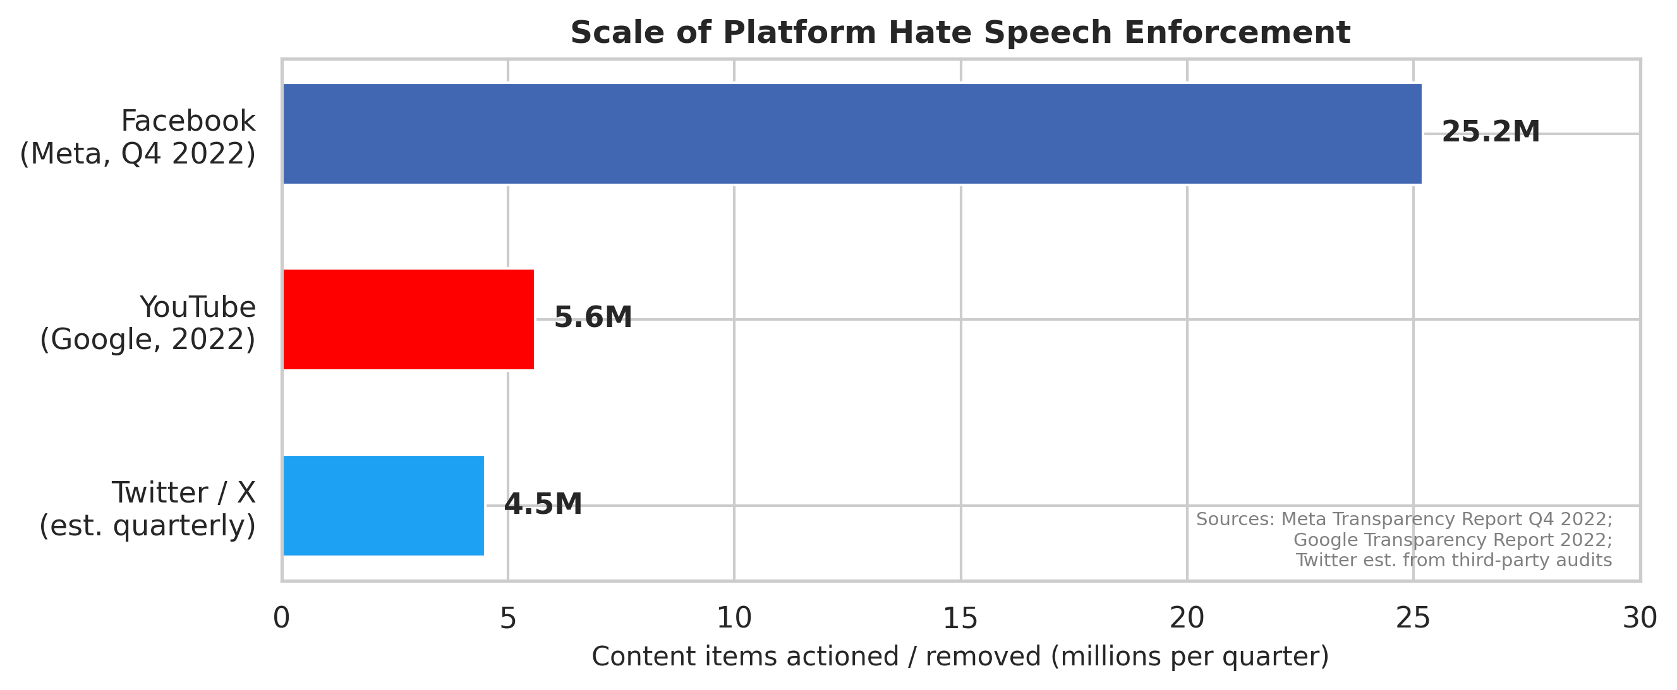
Fig. 11: Scale of platform hate speech enforcement. Facebook, YouTube, and Twitter/X collectively action tens of millions of items per quarter, illustrating the throughput demand on hybrid human-machine moderation pipelines.
Such volumes translate directly into legal and financial exposure, not merely public-relations risk. The European Union's Digital Services Act (2022) establishes due diligence obligations for very large online platforms and empowers supervision that can levy fines up to 6% of global annual turnover for systematic non-compliance-an order of scale that makes moderation quality a board-level governance problem rather than a purely technical KPI [1]. In India, the Information Technology (Intermediary Guidelines and Digital Media Ethics Code) Rules, 2021 require intermediaries to remove infringing content within 36 hours of a valid government or court order, tightening the latency-precision trade-off for classifiers and the traceability of decision rationales. Although statutory text remains contested, the political course pressures platforms to show both proactive detection and procedural fairness-objectives that collide when models are opaque or miscalibrated, in the United States, Section 230 debates continue to shape intermediary liability;.
Societal harms from failures extend beyond platform economics. Independent fact-finding missions and human-rights investigations have concluded that Facebook-amplified hate speech contributed to atrocity crimes against the Rohingya in Myanmar, documenting how algorithmic distribution intersected with incitement dynamics at scale (UN human rights ways and follow-on NGO reporting). Separately, the Christchurch mosque shootings were live-streamed, instantiating how video and audio channels can broadcast violence alongside textually thin signals that naive filters miss. Together, these cases show why multimodal pipelines, multilingual coverage. Operational calibration aren't academic luxuries: errors propagate into real-world violence, displacement, and downstream radicalization cascades.
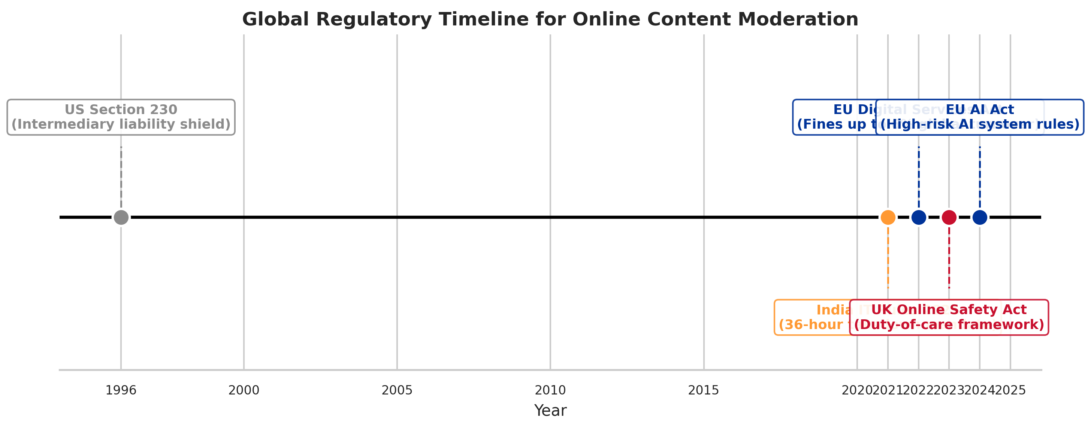
From US Section 230 (1996) through the EU AI Act (2024), fig. 12: Global regulatory timeline for online content moderation. Any tightening cadence motivates auditable, limit-governed detection systems.
1.2 Problem Importance
Three structural hurdles recur in the literature and in deployed systems. First, cross-modal hate exploits redundancy across channels: a post may be unremarkable in isolation in one mode yet harmful when image and text are jointly interpreted [11], [20]. Second, multilingual and code-mixed usage demands subword models or multilingual transformers rather than pipelines tuned exclusively on English [1], [2]. Misleading correctness while missing rare but high-bearing abuses [3], [16], as shown by third, class imbalance skews learning toward majority non-hate labels, encouraging models that. Together these factors inflate both false negatives (missed harm) and false positives (over-blocking), undermining trust.
A fourth, ever more salient hurdle is evasion and adversarial manipulation. Human actors one by one stress-test moderation: leetspeak ("h8", "f|_|ck"), Unicode homoglyphs that swap Cyrillic "а" for Latin "a", deliberate misspellings, multilingual code-switching that fragments toxic spans across scripts. Emoji compositions that express slurs or threats without standard dictionary tokens [1], [3]. A still harder class pairs image-text contrast where each mode is individually benign but their combination is hateful-precisely the occurrence stressed by meme benchmarks [20]. Such patterns defeat keyword filters (because surface forms are unbounded) and monolingual classifiers (because toxicity may be distributed across languages or forms). Subword-aware multilingual modeling, and searchable decision layers that can adapt bars and fusion behavior to operational costs rather than fixed heuristics, they therefore motivate solid multimodal encoders.
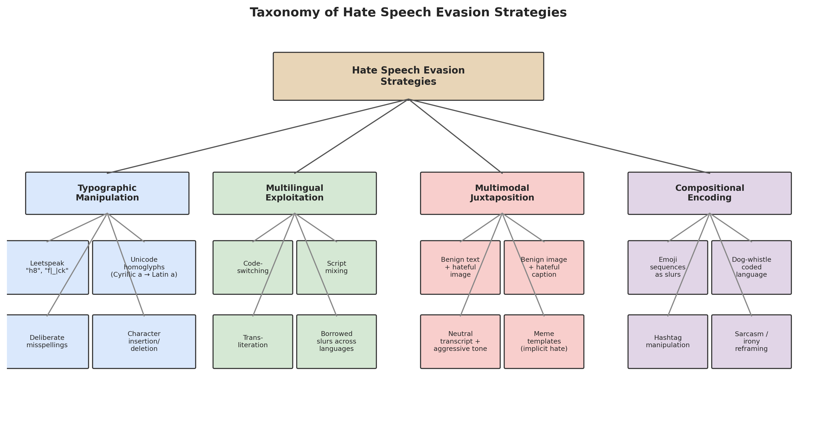
Fig. 13: Taxonomy of hate speech evasion strategies spanning typographic manipulation, multilingual exploitation, multimodal contrast, and compositional encoding. Each category defeats single-form or keyword-based detectors.
Independently, a regulatory imperative is converging on requirements that conflict with naive rollout of black-box neural scores. The DSA's transparency and auditing expectations, the United Kingdom's Online Safety Act direction (duty-of-care framing with age-verification and risk-assessment obligations). India's takedown timelines collectively pressure platforms to produce explainable, auditable moderation decisions: not only what was removed, but defensible reasons that survive appeal and oversight. When they maximize offline correctness, purely end-to-end classifiers without branch-level diagnostics, calibration records, or limit governance are misaligned with this environment-even. As first-class artifacts that can be logged, optimized, and reviewed, rather than undocumented hyperparameters frozen at τ=0.5, our design philosophy therefore treats fusion weights, branch inclusion, and operating points.
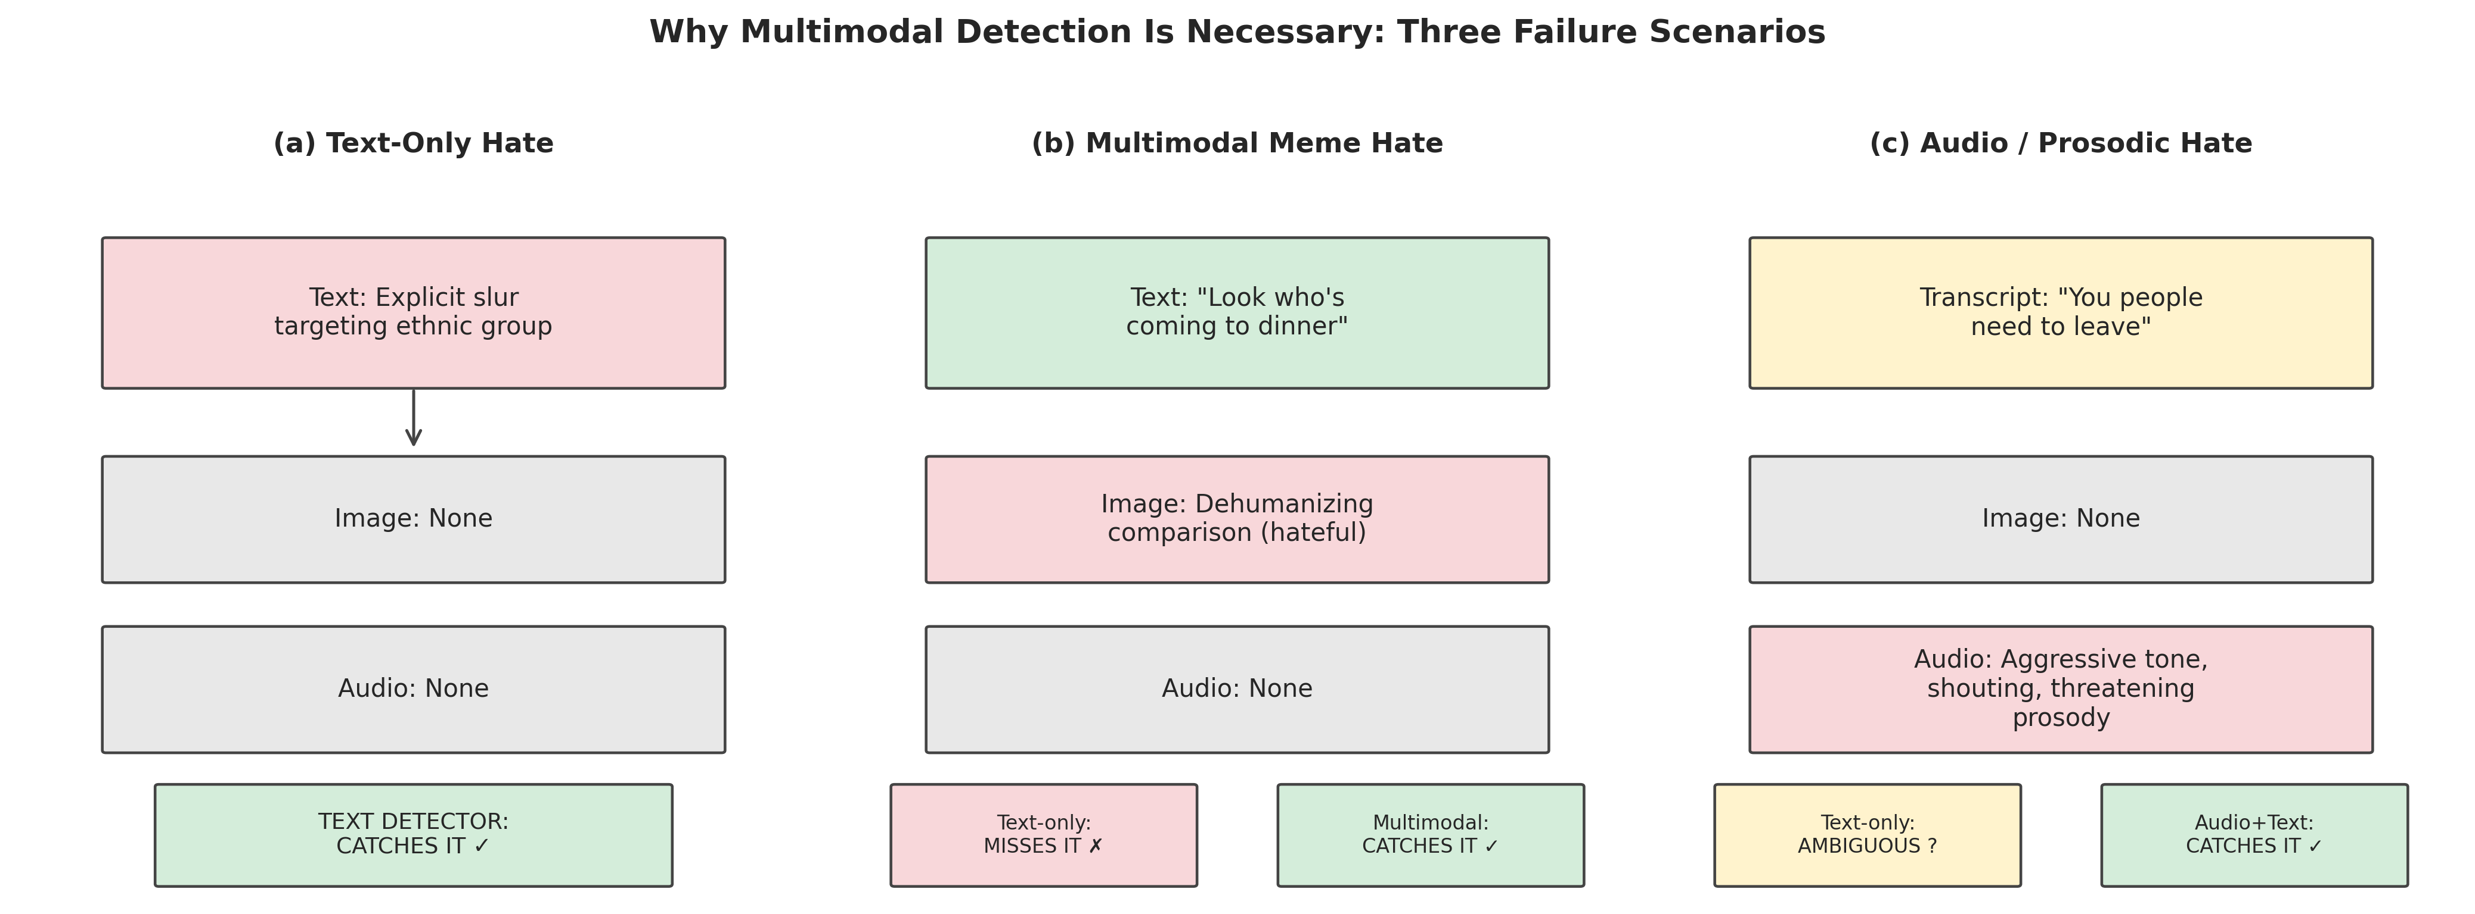
Fig. 16: Why multimodal detection is necessary - three failure cases. (a) Text-only hate is caught by a text detector; (b) a meme with benign text and hateful imagery defeats text-only systems; (c) aggressive audio prosody with an ambiguous transcript requires acoustic assessment.
1.3 Limitations of Existing Practice
Much past work prioritizes single-mode text classification with classical traits or monolingual Transformers [4]-[10], [18]. Commercial and research systems that add vision often do so in specialized meme settings [11], [12], [20] but seldom integrate whispered or sung audio at the same fidelity as text. English-centric training On top of this, limits transfer to Hindi, German, or code-mixed social media [1]. Small shifts in the decision boundary can deliver large swings in precision and recall; finally, static boundaries-commonly 0.5 on a sigmoid-encode an implicit cost structure that rarely matches operational requirements. Boundary optimization receives comparatively little methodological attention relative to model architecture design [14]-[17].
The gap is also commercial. When image signals are incorporated in production stacks, they're typically routed through separate models rather than a unified auditable fusion interface, widely marketed APIs such as Perspective and OpenAI moderation endpoints are mostly text-first;. Meta's public-facing research and product narratives emphasize image-text harms (memes, photorealistic abuse), yet internal and external observers note asymmetries in audio treatment: acoustic slurs, chant-like harassment, and sung threats remain secondary relative to vision-language investment, a pattern mirrored in academic benchmarks where "multimodal" often means text plus image only [1], [20]. Audio moderation-whether from short-video feeds or voice notes-is almost entirely absent from standardized hate-speech leaderboards relative to text and meme corpora, despite parallel growth in video-first platforms.
Because practitioners often underestimate their use, static bars deserve explicit quantification. While preserving competitive F1, illustrating that cutoff selection is well a policy knob comparable to setup depth, on our own multilingual text tests (Section 6), moving τ from 0.5 to 0.48-a change smaller than the jitter introduced by logits temperature scaling-can swing precision by more than seven absolute points. Systems that ship τ=0.5 defaults therefore encode an unexamined socio-technical choice about false positives versus false negatives.
1.4 Research Gap
Despite mature parts for text (e.g., BERT [18]), vision-language modeling (e.g., CLIP [19]), and self-supervised audio (e.g., wav2vec families), there's no widely used, end-to-end system that (i) processes text, image, and audio in parallel, (ii) supports multiple languages within a shared textual backbone, and (iii) step by step optimizes hyperparameters, fusion weights, branch inclusion, and decision limits using comparative metaheuristic search rather than ad hoc tuning. Surveys highlight the fragmentation between multimodal and multilingual hate speech detection [1]. Stop short of prescribing a unified optimization layer that adapts the system to data collection- and policy-specific trade-offs.
Recent surveys sharpen the mismatch between diagnosis and remedy. Their own organizing scaffold meaningfully operationalizes only a subset-on the order of three obstacle classes in typical follow-on empirical work (for example, multilingual text encoding, basic multimodal fusion, and benchmark replication), chhabra and Vishwakarma [1] articulate fourteen open difficulties in multimodal and multilingual hate speech detection; as of 2023, spanning resource scarcity, modal misalignment, class imbalance, bias, and check fragmentation. We target seven of these obstacles together in a single experimental harness: multimodal coverage beyond text (including acoustic paths), multilingual and code-mixed encoding, class imbalance reduction at the loss and weighting layer, fusion under mode dropout and branch sparsity, threshold and scalar policy optimization, comparative search methods (Bayesian and population-based). Operational reproducibility limits aligned with single-GPU rollout. Positioning the work this way makes explicit that our contribution is integrative and optimization-centric, not an incremental single-form classifier.
1.5 Objectives
Multimodal coverage is the first objective. As tweets or comments but as memes, photorealistic harassment, and spoken abuse embedded in short video and audio messages, hateful content is expressed not only. A system that excels on text alone will step by step underperform on platforms where user behavior is video-first. We therefore require parallel text, vision (zero-shot screening plus fine-tuned fusion). Audio pathways (acoustic representations and transcript-conditioned text scoring) that can be composed in a single late-fusion interface. Notably, audio branches improve F1 when paired with text even when either alone is weaker, mirroring broader findings from multimodal abuse literature [20], [45], as shown by this objective is driven by empirical complementarity: our later results.
Multilingual robustness constitutes the second objective. English-centric corpora distort both lexical coverage and sociolinguistic norms. Hindi-English code-mixing and German political discourse show script and morphology patterns that monolingual byte-pair encodings handle poorly without shared multilingual capacity [1], [2]. We standardize on `bert-base-multilingual-cased` as a pragmatic backbone for digital text and ASR transcriptions, accepting some gaps on deeply code-mixed spans in exchange for a single setting-lean encoder that can serve all textual ingress points in the design.
Every third objective is joint Bayesian and metaheuristic optimization of hyperparameters, fusion weights, branch masks, and decision thresholds. Manual grid search doesn't scale to five-dimensional fusion simplices, high-dimensional attention-head masks. Per-branch boundaries; meanwhile, different search algorithms show different failure modes on noisy validation surfaces [14], [22], [25]. We embed Optuna TPE [25] and simulated annealing alongside GA, PSO, DE, GWO. FA in a shared harness so that algorithmic choices are experimentally grounded rather than folklore.
Finally, we pursue comparative check across ten optimization tasks that isolate continuous, discrete, and hybrid search spaces. Each objective isn't to crown a single universal optimizer-such claims rarely survive replication-but to map which optimizer classes are advantageous when checks are cheap (cached logits), expensive (full retraining), nearly unimodal (scalar τ), or highly multimodal (fusion fitness landscapes), enabling practitioners to select search methods aligned with compute budgets and governance bounds.
1.6 Contributions
We summarize our contributions as follows:
- A three-sequence multimodal design integrating mBERT for text, CLIP ViT-B/32 for vision (zero-shot prompting and a HateCLIPper-style fusion head with frozen encoders), and Wav2Vec2-XLS-R with an MLP classification head for acoustics.
- Unified multilingual hate detection across English, German, and Hindi via bert-base-multilingual-cased, with optional Whisper-small transcripts feeding the same textual classifier used for natively digital text.
- A searchable optimization layer combining Optuna TPE for hyperparameter and fusion-weight search with five metaheuristics-GA, PSO, DE, GWO, and FA-for structured comparative experiments across ten optimization tasks, including joint fusion-bar tuning and per-branch limits.
- A late-fusion ensemble with ASR confidence gating that down-weights transcript-derived probabilities when automatic speech recognition is uncertain.
- Square-root dampened class weights paired with focal loss on the text pathway to reduce imbalance without extreme gradient amplification from rare classes.
- A variable-efficient HateCLIPper head (on the order of 106 trainable weights) operating on frozen CLIP embeddings to specialize multimodal meme classification.
- Simulated annealing for post hoc bar optimization, directly addressing the precision-recall trade-off after probabilistic calibration of fused outputs.
- A full comparative study spanning seven optimization strategies (TPE, SA, GA, PSO, DE, GWO, FA) over ten tasks, reporting when metaheuristic fusion meets or exceeds Bayesian alternatives.
1.7 Paper Organization
The remainder of this paper is organized as follows - section 2 surveys related work across text-based, multimodal, multilingual. Metaheuristic approaches and also section 3 details our three-process chain structure, fusion strategy, and optimization structure. Section 4 describes the data sets drawn on, plus section 5 outlines the experimental setup and review protocol. Notably, section 6 presents results and discussion across all channels and optimization tasks. Section 7 reports ablation studies, and section 8 discusses drawbacks. In turn, section 9 offers future research directions, and Section 10 concludes.
II. LITERATURE REVIEW
2.A Traditional and Characteristic-Based Approaches
Early hate speech detection used curated lexicons, n-gram statistics, and shallow classifiers. Showing that simple linguistic attributes could outperform naïve baselines but remained brittle to euphemisms and community-specific slang, waseem and Hovy [5] studied racial and sexist harassment on Twitter. Davidson et al. [4] emphasized the distinction between offensive and hateful language, advocating finer-grained annotation and TF-IDF supplemented linear models-work that framed the precision-recall tensions still visible in modern neural systems. Character-level models examined by Mehdad and Tetreault [6] improved robustness to obfuscation, while Liu and Forss [7] studied n-gram similarity for detecting intersecting patterns of abuse. These studies established that attribute engineering alone can't scale to multimodal manipulations. They clarified check pitfalls (class imbalance, label subjectivity) that any deep learning successor must address.
Industrial deployments at/web scale clarified which textbook scores survive contact with production. Nobata et al. [31] reported a large-scale Yahoo comment moderation system combining character n-grams with linguistic traits, motivated openly by the observation that character-level representations capture obfuscations that word-level bags miss. When modern APIs serve billions of inference calls, their study foregrounded latency-accuracy trade-offs and elevated false-positive cost as a first-class design limitation-issues that remain decisive. While highlighting the emerging interpretability deficit of dense neural embeddings-a tension that later, larger Transformers inherit, complementarily, Djuric et al. [32] applied paragraph2vec (Doc2Vec) to learn distributed comment representations for hate-speech-style classification, showing improved generalization over purely sparse features. Random forests, and SVMs could track surges of hateful language after triggering real-world events, burnap and Williams [33] constructed Twitter corpora temporally anchored to the murder of Lee Rigby and showed that ensemble classifiers mixing Bayesian logistic regression. Their findings caution that static snapshots under-train models for bursty, event-driven toxicity, a weakness that periodic re-optimization and boundary refresh partially reduce.
Despite their practical utility, characteristic-engineered approaches share a fundamental gap: they require explicit specification of discriminative cues for each language and each adversarial transformation. With the combinatorial explosion of evasion strategies-spanning typographic substitution, multilingual code-switching, multimodal recontextualization. Meme-native irony-makes manual attribute design untenable at platform scale [3], [31]. This shortcoming motivates representation learning and multimodal fusion. It also explains why character-aware and subword models remain relevant even inside Transformer stacks: the surface channel continues to carry signal that lexicons alone can't enumerate.
2.B Deep Learning Approaches
Neural architectures replaced hand-crafted characteristics with trainable representations. Badjatiya et al. [8] combined convolutional and recurrent networks for tweet classification, showing gains over bag-of-words baselines. Zhang et al. [9] extended similar ideas with CNN-GRU hybrids tailored to short, noisy posts. With the advent of contextual embeddings, Zhuang et al. [10] looked into optimized BERT pre-training strategies for toxicity-related objectives, highlighting that pre-training recipe and fine-tuning stability materially affect downstream hate detection. Devlin et al. [18] introduced BERT, enabling unified masked-language and next-sentence objectives that now underpin most text moderators. As frozen backbones for specialized fusion heads, for vision-language alignment, Radford et al. [19] presented CLIP, contrasting image and text embeddings at scale-a ability we exploit for zero-shot visual screening and.
Continued pre-training on toxic or community-norm-violating corpora sharpens decision boundaries without full design redesign. Caselli et al. [34] introduced HateBERT, continuing BERT pre-training on Reddit communities banned for hate and harassment (RAL-E), reporting roughly 2-5% relative F1 gains over vanilla BERT on several hate benchmarks-a modest but operationally meaningful margin at high base rates. Hartvigsen et al. [35] put forward ToxiGen, a large machine-generated data collection paired with diagnostic tools, addressing scarcity and diversity of abusive training exemplars without relying solely on platform logs. For multilingual launch, Conneau et al. [36] introduced XLM-RoBERTa, training Transformers on 100 languages from CommonCrawl. XLM-R has become the de facto backbone for cross-lingual transfer in abusive-language tasks where labeled resources are unevenly distributed.
Cross-lingual transfer dynamics constrain backbone choice. While performance degrades on distant pairs (for example, English to Hindi) unless augmented with target-language fine-tuning or transliteration-aware preprocessing, pires et al. [37] showed that multilingual BERT (mBERT) attains surprisingly strong zero-shot transfer to typologically similar languages (for example, English to German),. On a related note, while motivating future extensions with stronger cross-lingual models and code-mixed adapters, this empirical pattern rationalizes our use of mBERT as a shared encoder. When batch sizes are constrained by GPU memory, on efficiency, variable-capable fine-tuning via adapters [38] and Low-Rank Adaptation (LoRA) [39] reduces trainable factors relative to full fine-tuning-key. Adapter-based alternatives are deferred to Section 9; we retain full fine-tuning in the present study to establish strong, reproducible baselines on a single T4 GPU. Compute-performance frontiers can be dug into without confounding the metaheuristic comparisons that constitute the paper's algorithmic core.
2.C Multimodal Approaches
Where either mode may appear benign alone, multimodal hate speech is most visible in meme understanding. Gómez et al. [11] examined multimodal hate in publications and social feeds, documenting how editorial images recontextualize textual slurs. Fan et al. [12] connected image sentiment with attention ways, illustrating cross-modal saliency cues. Recent surveys and models continue to stress aspect-based and fine-grained multimodal sentiment [13], highlighting the value of connection layers between channels rather than independent scoring. Kiela et al. [20] formalized the problem for the Facebook Hateful Memes benchmark, showing strong human performance ceilings and the comparative weakness of text-only or vision-only pipelines. While expanding beyond memes to arbitrary images and audio, our work aligns with this thread by adopting CLIP-backed fusion.
Fusion architectures admit a pragmatic taxonomy. When channels differ in dimensionality and sampling rate, early fusion concatenates raw or shallow properties before classification [40], maximizing low-level cross-correlation at the expense of scalability. Late fusion trains specialists per channel and combines scores at decision time-modular, interpretable, and compatible with frozen backbones. When joint training is practical, attention-based fusion (including cross-modal Transformers such as ViLBERT [41]) learns fluid weights conditioned on inputs, often improving benchmark maxima. Early fusion preserves fine-grained co-occurrence structure but can explode in parameter count; attention methods excel on Hateful Memes yet frequently require joint end-to-end training that conflicts with our goal of reusable, independently optimizable branches. We therefore adopt late fusion as a deliberate middle ground enabling branch-wise diagnostics, modular expansion (for example, adding a new OCR channel). Transparent per-branch contribution study for governance.
Meme-specific research clarifies what specialized heads must learn. Pramanick et al. [42] proposed a dual-route structure separating benign confounders from hateful associations, lifting performance on challenging meme instances. Zhu et al. [43] examined prompt-based exploitation of vision-language models, narrowing the gap between zero-shot heuristics and supervised specialist models through careful textual conditioning. While remaining on the roadmap in Section 9, chen et al. [44] introduced UNITER, a universal image-text representation from large-scale pre-training; models in this class are strong future baselines but often demand multi-GPU budgets atypical of academic edge deployments-So, their exclusion from our primary T4 study.
Audio-visual hate remains comparatively underexplored despite short-video growth (TikTok, YouTube Shorts, reels). When fusing Whisper transcripts with wav2vec2 acoustics, das et al. [45] released HateMM, combining video, audio. Text for English hate detection, and showed that audio-only models trail text-dominant baselines yet contribute orthogonal evidence-a pattern we replicate. Not merely cultural but epistemic: absent data sets like HateMM, audio would remain a silent modality in empirical benchmarks, the literature's text-image bias is So.
2.D Multilingual Approaches
Multilingual hate speech introduces script diversity, morphological richness, and code-mixing absent in English-only corpora. Chhabra and Vishwakarma [1] survey multimodal and multilingual hate speech detection, noting that most published systems still emphasize one language despite cross-lingual abuse patterns. Schmidt and Wiegand [2] provide an NLP-centric survey of resources and methods, cataloging data collection biases. Fortuna and Nunes [3] review automatic detection of hate in text, emphasizing annotation protocols and check scores. As a pragmatic compromise between coverage and computing cost, collectively, these works motivate shared multilingual encoders-we adopt mBERT.
Corpus-level studies sharpen cross-lingual difficulty. Bohra et al. [46] built a Hindi-English code-mixed Twitter corpus (4,575 annotated posts), reporting that code-mixing intensity correlates with abusive intent in South Asian social media-precisely the event that pure English ToxicBERT-style models miss. Ross et al. [47] curated a German hate-speech corpus aligned with EU legal norms, observing lower inter-annotator agreement (Krippendorff's α on the order of 0.29-0.38) than typical English benchmarks, signaling that cultural juridical frames modulate label stability. Mandl et al. [48] organized the HASOC shared tasks across English, German. Hindi, enabling directly comparable multilingual review-an intellectual ancestor of our choice to include German and Hindi alongside English in a unified training stack.
Encoder comparisons carry concrete engineering consequences. Typically, multilingual offensive-language and hate-speech benchmarks that fine-tune both encoders on parallel splits report XLM-R ahead of mBERT by on the order of 2-4 absolute F1 points on average, with larger swings on lower-resource languages-consistent with the cross-lingual margins established for XLM-R pre-training [36] and with shared-task multilingual settings such as OffensEval 2020 [49]. While XLM-R at 550M factors strains batch sizes and parallel branch training; upgrading the backbone is still an immediate, drop-in enhancement enumerated in Section 9, we select mBERT here because its 178M-variable footprint fits the memory envelope of a single T4 workflow with multimodal co-resident models,.
2.E Metaheuristic Optimization in NLP
Metaheuristics have been applied to hate speech and related NLP tasks for property selection, ensemble weighting, and model configuration search. Baydogan and Alatas [14] dug into ant lion and moth-flame optimizers for hate speech classification, reporting competitive precision against grid searches. Illustrating that bio-inspired search can navigate discrete trait spaces efficiently, asiri et al. [15] introduced seagull optimization within textual pipelines. Al-Makhadmeh and Tolba [16] studied optimization in ensemble hate speech detectors, while Ayo et al. [17] examined probabilistic clustering formulations for related problems. All these contributions show value but rarely contrast multiple optimizers on identical task interfaces or integrate multimodal decision fusion, leaving open questions about reproducibility and generality.
Largely, the broader metaheuristic landscape extends beyond any single hate-speech paper. Mirjalili and Lewis [50] formulated Whale Optimization Algorithm (WOA). Next bio-inspired methods (salp swarm, Harris hawks, and many hybrids) populate the optimization literature. In NLP, population-based methods have tuned attribute subsets for sentiment, searched architectures for text classifiers. Configured Transformers-yet comparative studies that hold corpora, budgets, and fitness functions fixed across algorithms remain sparse. Our work's algorithmic premise is In this way, methodological: unify assessment so differences reflect optimizer dynamics rather than incidental preprocessing drift.
Bayesian optimization via tree-structured Parzen estimators (TPE)-for which Bergstra et al. showed sizable gains over random search and grid search on deep-network hyperparameters-often dominates low-dimensional, comparatively smooth objectives when surrogate assumptions hold. Our realization follows the TPE sampler provided by Optuna [25]. However, Bayesian acquisition by default privileges stationarity and smoothness assumptions that frequently fail in discrete combinatorial spaces-branch masks, attention-head subsets, or categorical routing decisions-where fitness plateaus and cliffs induce misleading surrogate posteriors. On multimodal objectives (in the optimization sense) arising from small validation sets or label noise [14], [22], going by population-based methods maintain diversity across parallel candidates, reducing premature coming together that sequential Bayesian probing can. When swarms and evolutionary operators match or exceed TPE snapshots, our ten-task harness tests this assumption on mixtures of continuous fusion weights, scalar cutoffs, binary masks, and hybrid tuples, reporting.
2.F Research Gaps and Positioning
Preceding art typically optimizes either modality coverage or language coverage or model hyperparameters-not all three within a single experimental harness. Bar learning, despite its outsized effect on precision and recall, remains underrepresented relative to architecture search. Our structure supplies a common fitness function and task taxonomy to support such comparisons. Finally, comparative studies of GA, PSO, DE, GWO. FA in unified NLP tasks are sparse.
Why these gaps persist is structural, not merely scholarly oversight. First, computing cost penalizes integrative work: multimodal Transformers, ASR. Vision backbones jointly exhaust GPU memory long before optimizers exhaust their cycle budgets. Second, data set fragmentation splits the community into text-, meme-, and (rarely) audio-centric silos with non-comparable labels, discouraging unified benchmarks. Third, publication incentives reward novel architectures and leaderboard increments on single data sets more than careful optimizer comparisons whose gains appear "engineering-heavy" despite operational influence. Fourth, platform secrecy hides production fusion weights and cutoff policies, starving academia of ground-truth release objectives. Our late-fusion, frozen-backbone, and single-T4 design choices are explicit responses to these frictions: they trade some raw correctness for reproducibility, modularity, and search transparency.
Table I positions representative references along mode, language, methodological, and optimization axes.
Table I. Comparison of Existing Approaches
Reference | Year | Channel | Languages | Method | Optimization | Gaps
Davidson et al. [4] | 2017 | Text | English | TF-IDF + SVM / linear models | Manual grid / defaults | Single-language; no cross-modal cues
Waseem & Hovy [5] | 2016 | Text | English | Characteristic-based Twitter models | Manual attribute selection | Lexical brittleness; imbalance sensitive
Badjatiya et al. [8] | 2017 | Text | English | CNN + LSTM deep nets | Manual tuning | Monolingual; limited prosody/image context
Devlin et al. [18] | 2019 | Text | Transfer via monolingual pretrain | BERT Transformer | Manual HPO in original work | Multilingual variants needed for broad launch
Radford et al. [19] | 2021 | Vision-language | English-centric prompts | CLIP contrastive ViT | Large-scale training (not task-specific) | Requires adaptation for nuanced hate semantics
Gómez et al. [11] | 2020 | Text + image (publication context) | Several (data set-dependent) | Multimodal pipelines (varied) | Mostly manual | No end-to-end audio pathway; optimization ad hoc
Kiela et al. [20] | 2020 | Text + image (memes) | English | Hurdle baselines and submissions | Mostly manual | Limited multilingual coverage; audio absent
Chhabra & Vishwakarma [1] | 2023 | Survey across modes | Multilingual emphasis | Survey | N/A (synthesis) | Identifies gaps rather than a single system
Baydogan & Alatas [14] | 2021 | Text (HSD) | Data set-specific | Classifiers with bio-inspired optimizers | Ant lion / moth flame | Unimodal focus; limited fusion-weight story
This work | 2026 | Text + image + audio | English, German, Hindi, code-mixed | mBERT + CLIP + Wav2Vec2 + late fusion | TPE, SA, GA, PSO, DE, GWO, FA | Computational cost; reliance on ASR quality for spoken branch
Table II. Comparison of Metaheuristic Applications in NLP
Reference | Year | Task | Algorithm | Dimensions | Comparison Scope | Drawback
Baydogan & Alatas [14] | 2021 | Hate speech classification (text) | Ant lion optimizer; moth-flame optimization | Mixed continuous / discrete trait selection | Compared against classical baselines within a single study | mostly text-only; no multimodal fusion-layer search
Asiri et al. [15] | 2022 | Hate speech detection / NLP classification | Seagull optimization (metaheuristic wrapper) | Moderate-dimensional property or model-parameter vector | Algorithm novelty emphasis vs. limited multi-optimizer benchmarking | Single-algorithm center of gravity; mode coverage narrow
Al-Makhadmeh & Tolba [16] | 2020 | Ensemble deep learning for hate speech | Killer whale / metaheuristic-driven ensemble optimization | Ensemble weighting + architecture knobs | Internal ensemble comparisons; not standardized cross-task suites | Black-box ensemble governance; limited cutoff-audit narrative
Ayo et al. [17] | 2021 | Probabilistic clustering for hate speech on Twitter | Metaheuristic-informed clustering / classification process chain | Cluster cardinality and property subsets | Focused on clustering formulation rather than fusion of deep types | Unimodal text; discrete-continuous hybrid landscapes underexplored
Mirjalili & Lewis [50] | 2016 | Continuous global optimization (benchmark functions); NLP use cases indirect | Whale optimization algorithm (WOA) | Continuous vectors | Typically single-algorithm demos on analytic surfaces | Not integrated with multimodal HSD fitness landscapes by default
This work | 2026 | Multimodal & multilingual HSD; fusion, masks, boundaries, HPO | TPE, SA, GA, PSO, DE, GWO, FA | 1-O(102) depending on task | Seven optimizers × ten tasks under shared metrics | Single-GPU budgets; validation noise limits claim sharpness
Collectively, Tables I-II motivate our emphasis: unify forms, unify languages at the textual encoder, and unify optimizer assessment so that improvements in F1, precision, and recall are attributable to search and integration rather than accidental preprocessor advantage.
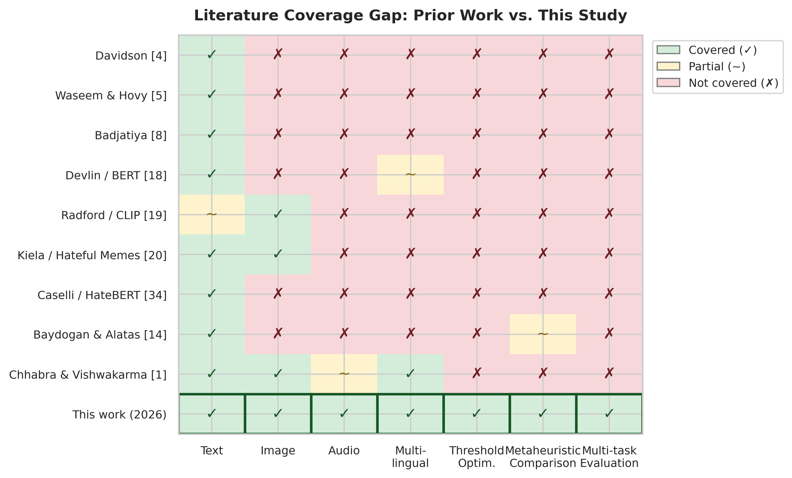
Past works (rows) vs. ability dimensions (columns); fig. 15: Literature coverage gap matrix. Coverage; red crosses point to absence, as seen from green checkmarks. This study (bottom row) is the first to address all seven dimensions at once.
III. METHODOLOGY
3.1 System Overview
Figure 1 (conceptual) depicts our adaptive hybrid moderator. Raw inputs are routed into three asynchronous pipelines-text, vision, and audio-each producing calibrated or comparable probabilistic scores. Vision On top of this, splits into a zero-shot CLIP judger with OCR context and a HateCLIPper-style fine-tuned fusion segment that learns nonlinear interactions between image and text embeddings. Audio contributes (i) an acoustic probability from wav2vec attributes and (ii) an audio-text probability got by transcribing the waveform and reusing the multilingual text classifier. When transcripts are unreliable, branch outputs are combined through weighted late fusion; optional ASR confidence gating attenuates the audio-text channel. A decision threshold τ converts fused hate probability into a binary action. Optuna TPE, simulated annealing, and population-based metaheuristics search over hyperparameters, fusion weights, masks, continuous setup knobs. Τ, using a composite fitness that directly values F1, precision, and correctness.
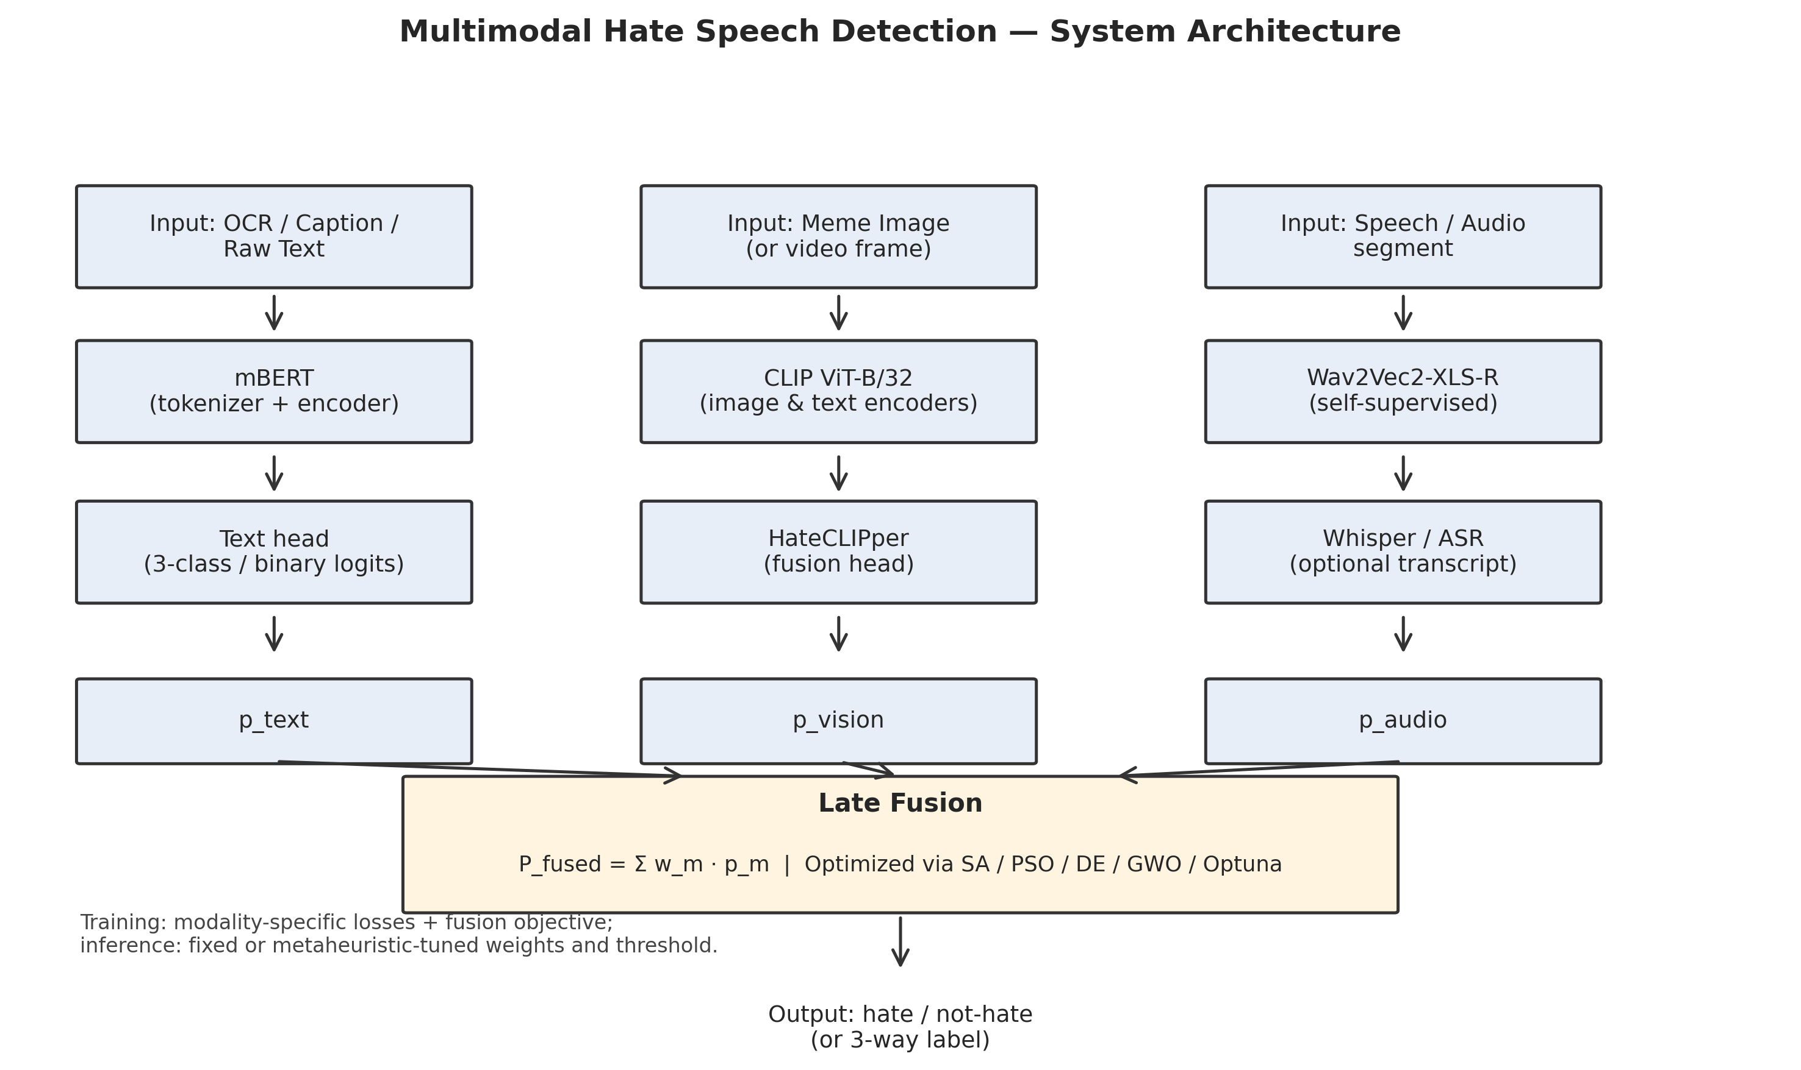
Fig. 1: Offered system structure. Branch-level probabilities combined through weighted late fusion with ASR confidence gating, as shown by text, vision (zero-shot CLIP + HateCLIPper), and audio (Wav2Vec2 acoustic + Whisper transcript) pipelines. Metaheuristic and Bayesian optimizers search over fusion weights, cutoffs, and discrete masks.
We adopt late fusion over early or cross-attention alternatives for three principled reasons. First, late fusion permits modular backbone replacement-upgrading mBERT to XLM-R [36] or CLIP ViT-B/32 to ViT-L/14 [19] requires retraining only the affected branch and re-optimizing fusion weights, not the entire sequence. Looking at this modularity, it is ever more important as multilingual moderation stacks must track rapid foundation-model turnover without invalidating end-to-end systems that would otherwise demand full re-co-training whenever any encoder changes [1], [3]. As the EU Artificial Intelligence Act, where high-risk classification systems benefit from traceable evidence chains and post hoc review of part-level scores, second, late fusion produces interpretable per-branch contributions: each branch produces a calibrated probability that can be inspected, logged. Audited independently-a requirement for regulatory compliance under setups such. Third, late fusion is computationally tractable on a single T4 GPU: cross-attention models like UNITER [44] or ViLBERT [41] require joint backpropagation through all mode encoders, which exceeds 16 GB VRAM for multi-branch configurations that also retain task heads, gradient accumulation buffers, and mixed-precision transient tensors. With the trade-off, is that late fusion can't capture fine-grained cross-modal links that early or attention-based fusion would directly model [40]; we partially reduce this through the HateCLIPper head, which does learn image-text exchanges within the vision branch [28]. Through OCR-expanded CLIP prompting that injects typography into the zero-shot pathway [19].
The end-to-end data flow proceeds as follows. Multimodal inputs arrive at an ingress router that dispatches each form-capable fragment to the right encoder stack: tokenized spans enter mBERT [18]; raster images enter CLIP together with optional EasyOCR overlays; waveforms enter Wav2Vec2-XLS-R [26] and Whisper [27] in parallel. When enabled in the training recipe, each pipeline emits one or more branch-level probabilities on the unit interval, optionally after temperature scaling or validation-set calibration. Nonlinear fusion combines active branches with nonnegative weights, applies ASR confidence gating on the transcript-derived channel, and forms Pfused. A scalar limit τ, learned or searched post hoc, maps Pfused to a binary moderation decision. Separately, a metaheuristic layer optimizes continuous fusion weights, τ, discrete masks over branches and attention heads, and selected neuro-architectural hyperparameters, using cached validation outputs where possible to amortize check cost [14], [25]. While still permitting policy-time adaptation without architectural rewrites, this separation-inference graph versus search process-keeps rollout latency predictable.
Operationally, the modular graph supports failure isolation: if OCR fails or Whisper returns an empty transcript, inactive branches are omitted at fusion time rather than corrupting joint representations in a shared cross-modal trunk [11]. Logging can therefore record not only Pfused and, but also per-branch inputs, gate values g(c\mathrmasr). Masked weights-artifacts that assist human review and error review under platform safety programs. As data sets shift, class priors change, or regulatory guidance tightens, finally, late fusion aligns with the empirical reality that moderation policies are rarely static: weight vectors and limits are periodically re-optimized. A search layer that treats (i\, τ) as first-class tunables-rather than implicit by-products of end-to-end training-makes those policy shifts explicit, measurable. Comparatively cheap relative to full-model retraining [14], [25].
3.2 Text Processing Pipeline
Backbone and interface. As a shared encoder for digital text and ASR transcripts, we employ bert-base-multilingual-cased (around 178M variables). Inputs are WordPiece-tokenized with MAX_LENGTH=128.
Optimization schedule. Unless superseded by task-specific hyperparameter search, fine-tuning uses 5 epochs, batch size 16, AdamW with learning rate 3×10-5, weight decay 0.01, warmup ratio 0.1, label smoothing 0.1, gradient accumulation 2, and a cosine learning-rate schedule.
Class imbalance. Square-root dampened weights moderate extreme inverse-frequency spikes:; let nc denote the empirical count of training examples in class c∈\1,,C\.
wc'=(1)/(√nc), wc = C· (wc')/(∑j⁼₁C wj').
When class frequencies diverge by orders of degree, the normalization constrains ∑c wc = C, stabilizing loss scaling. Intuitively, the square root compresses the fluid range between majority and minority classes relative to naive inverse frequency, reducing gradient variance while still up-weighting toxic tails absent from volume-driven training signals [3], [30].
Focal loss. For predicted probability pt on the ground-truth class, we employ
FL(pₜ)= -αₜ (1-pₜ)γ log(pₜ),
with γ=2.0 and α=0.75, sharpening gradients on hard, misclassified examples while preventing easy negatives from dominating updates.
before tokenization, all text inputs undergo a normalization sequence: conversion to lowercase, URL replacement with a [URL] token, @-mention replacement with [USER], removal of HTML entities, collapsing of repeated whitespace, and stripping of control characters. Emoji sequences are retained as they can carry semantic hate content (e.g., the combination of racial emoji with violent emoji constitutes implicit hate in many annotation schemes [46]). For code-mixed Hindi-English text, we don't apply script-specific normalization, relying instead on mBERT's multilingual WordPiece vocabulary to handle Devanagari and Latin tokens natively. This design choice preserves code-switching patterns that are themselves discriminative attributes for hate detection in South Asian social media [48].
Algorithm 1: Multilingual BERT Fine-Tuning with Dampened Weights
Input: Training set D_train, validation set D_val, Config parameters
Output: Fine-tuned model M*, optimal threshold tau*

1. Initialize M from bert-base-multilingual-cased checkpoint
2. Compute class counts {n_c} from D_train labels
3. Compute dampened weights: w_c = C * (1/sqrt(n_c)) / sum_j(1/sqrt(n_j))
4. Configure focal loss: FL(p_t) = -alpha_t * (1-p_t)^gamma * log(p_t)
5. Configure AdamW optimizer with cosine LR schedule
6. for epoch = 1 to EPOCHS do
7. for each mini-batch B in D_train do
8. logits = M(B.input_ids, B.attention_mask)
9. loss = WeightedFocalCrossEntropy(logits, B.labels, w, gamma, alpha)
10. loss = loss / GRADIENT_ACCUMULATION_STEPS
11. loss.backward()
12. if step % GRADIENT_ACCUMULATION_STEPS == 0 then
13. optimizer.step(); scheduler.step(); optimizer.zero_grad()
14. Evaluate F1, precision, recall on D_val
15. Save best checkpoint by eval_f1
16. Load best checkpoint as M*
17. Run Simulated Annealing on D_val probabilities to find tau*
18. return M*, tau*
A given focal loss modulating factor (1-pt)^γ dynamically adjusts the contribution of each sample to the gradient. For well-classified examples (pt → 1), the factor approaches zero, successfully removing easy negatives from the gradient signal. As for hard examples (pt → 0), the factor approaches 1, preserving full gradient degree. While a sample at pt = 0.5 contributes 25\%, with γ = 2, a sample classified with pt = 0.9 contributes only 1\% of its unmodulated gradient,. In turn, while focal loss deals with instance-level difficulty imbalance within each class, this selective gradient amplification complements the square-root dampened class weights, which address class-level frequency imbalance,. We chose γ = 2 following the examination of Lin et al. [30], who showed strong empirical behavior across detection benchmarks. Α = 0.75 assigns higher weight to the minority toxic class in the asymmetric two-way setup. Together, these ways align optimization with operational priorities under heavy class skew [3], [14].
From an build standpoint, mBERT functions as the shared lexical tower for natively digital posts and Whisper transcripts, enabling consistent hate semantics regardless of whether toxicity appears in original Unicode spans or in ASR output [18], [27]. Such a unification is especially salient for code-mixed and multilingual stacks where the alternative-training monolingual detectors per channel-fragments supervision and complicates fusion [1]. While larger multilingual encoders such as XLM-R [36] may improve low-resource robustness, mBERT offers a favorable precision-memory trade-off under T4 limits and preserves comparability with widely reported multilingual hate-speech baselines [1], [3]. Coupling with ASR gating (Section 3.5) prevents brittle hard decisions that would arise from piping raw ASR strings into lexicon-only filters, when transcript noise increases WER; the text head's probabilistic output remains well-formed.
3.3 Vision Processing Pipeline
3.3.A Zero-Shot CLIP Classification.
We instantiate openai/clip-vit-base-patch32, using a predefined prompt matrix aligned with policy-relevant visual concepts (e.g., gestures, symbols, weapon-like objects-exact prompts are enumerated in the extended appendix). For overlaid or embedded text, dual EasyOCR streams parse Latin scripts (English, French, Spanish, German) and Devanagari (Hindi). When hostility is typography-dependent, oCR outputs are concatenated or summarized and fused with the image tensor through the CLIP text encoder for contextual, text-conditioned image scoring, reducing false negatives.
With the zero-shot CLIP testing relies on a curated prompt matrix organized into five semantic categories: (i) hateful symbols and gestures (e.g., "a photo containing a hateful symbol," "an image showing an offensive hand gesture"). (ii) violence and weapons (e.g., "a photo of a weapon being brandished," "an image depicting physical violence"); (iii) dehumanizing imagery (e.g., "an image comparing a person to an animal," "a dehumanizing depiction of a group"); (iv) text-conditioned hate (e.g., "an image with offensive text overlay," "a meme containing a slur"); and (v) neutral/safe baselines (e.g., "a harmless photograph," "a benign meme"). With the maximum similarity score across hateful prompt categories, minus the maximum safe-category score, produces the zero-shot hate probability. This design follows the dual-prompt strategy advocated for CLIP-based content moderation [19], where contrastive scoring against directly safe prompts reduces false positives from ambiguous imagery. Zero-shot CLIP isn't enough for subtle multimodal irony on memes [11], [20]. It still supplies a cheap, backbone-consistent earlier that can be fused with supervised pathways.
3.3.B HateCLIPper Fine-Tuned Fusion Head.
CLIP image and text towers remain frozen; a compact trainable segment learns meme-specific exchanges:
Let vimg, vtxt∈R512 be CLIP embeddings. Trainable projections produce pimg=Wimgvimg, ptxt=Wtxtvtxt with hidden width HATECLIPPER_DIM=1024. A Hadamard relationship
h= pᵢₘg ⊙ pₜₓₜ
feeds an MLP scoring head with sigmoid output P(hate). Training runs 5 epochs at batch size 16, learning rate 10-4, yielding only ∼1.3M trainable variables-an fast specialization layer atop a general vision-language foundation.
Algorithm 2: HateCLIPper Fine-Tuning with Frozen CLIP Encoders
Input: Meme dataset (image, text, label), frozen CLIP model
Output: Trained HateCLIPper head H*

1. Freeze CLIP image encoder E_img and text encoder E_txt
2. Initialize projection layers W_img, W_txt in R^{512 x 1024}
3. Initialize MLP head: Linear(1024, 512) -> ReLU -> Dropout -> Linear(512, 1)
4. for epoch = 1 to 5 do
5. for each mini-batch (images, texts, labels) do
6. v_img = E_img(images) // 512-D frozen embeddings
7. v_txt = E_txt(texts) // 512-D frozen embeddings
8. p_img = W_img @ v_img // project to 1024-D
9. p_txt = W_txt @ v_txt // project to 1024-D
10. h = p_img * p_txt // Hadamard product
11. logit = MLP(h) // scalar
12. loss = BCEWithLogitsLoss(logit, labels)
13. loss.backward(); optimizer.step()
14. Evaluate dev F1; save best checkpoint
15. return H* (W_img, W_txt, MLP weights)
We select Hadamard (element-wise) product over concatenation or bilinear pooling for the cross-modal relationship for two reasons. While bilinear pooling produces d2 traits requiring prohibitive memory on consumer GPUs, first, Hadamard product preserves dimensionality (Rd × Rd → Rd), keeping the downstream MLP compact-concatenation would double the input dimension to 2048,.
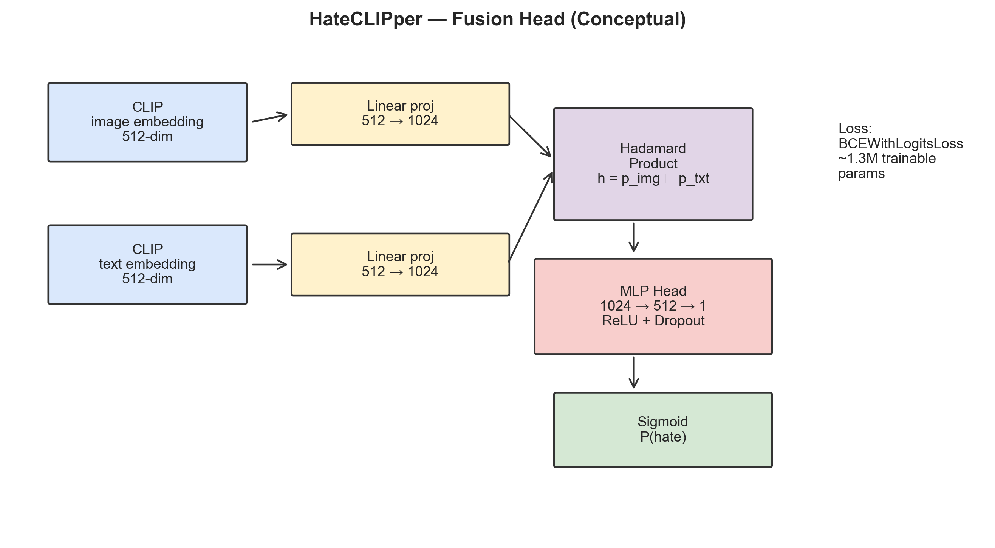
Fig. 9: HateCLIPper design. Frozen CLIP image and text encoders produce 512-D embeddings that are projected to 1024-D and combined via Hadamard product. An MLP head maps the link vector to a binary hate probability.
While training in under half the time, second, Kumar and Nandakumar [28] showed that the Hadamard variant of HateCLIPper matches or exceeds concatenation and bilinear alternatives on the Hateful Memes benchmark [20],. Frozen encoders Also, reduce optimization instability relative to end-to-end fine-tuning of vision-language transformers [41], [44].
3.4 Audio Processing Pipeline
Acoustic pathway. Audio is resampled to 16 kHz and cropped or padded to a maximum of 20 s. Optional Silero VAD discards leading silence when present. As in Section 3.2, a frozen Wav2Vec2-XLS-R-300M encoder supplies representations to a two-layer MLP head with AUDIO_DIM=256, dropout 0.3, trained with BCEWithLogitsLoss using the same square-root dampened class weights.
Transcript pathway. The text is classified by mBERT; as in Section 3.2, whisper-small transcribes the clip. Such a branch records slurs and threats more reliably encoded lexically than acoustically.
The Wav2Vec2-XLS-R-300M model [26] consists of a 7-layer convolutional trait encoder that processes raw 16 kHz waveforms into latent speech representations at 50 Hz, followed by 24 transformer blocks with hidden dimension 1024 and 16 attention heads per block, totaling roughly 300 million settings. Pre-trained on 436,000 hours of unlabeled speech across 128 languages using a contrastive self-supervised objective, the model captures both low-level acoustic characteristics (pitch, energy, speaking rate) and high-level phonetic and prosodic patterns. We freeze all 300M factors and extract representations from the final transformer layer, applying mean pooling across the temporal dimension to get a fixed-length 1024-dimensional utterance embedding. A trainable two-layer MLP projects this embedding to our working dimension (AUDIO_DIM=256) with dropout 0.3, followed by a single-unit output layer.
For clips containing large leading or trailing silence-common in user-uploaded social media videos-we optionally apply Silero Voice Activity Detection (VAD) to isolate speech-active chunks before feature extraction. Flagging non-speech regions that would otherwise dilute the mean-pooled acoustic representation, silero VAD operates as a lightweight ONNX model with sub-millisecond latency per frame. As speech contribute to the temporal mean, when VAD is enabled, only frames marked.
As a compromise between transcription quality and T4 memory bounds, we select Whisper-small (244M variables) [27] over Whisper-base (74M) and Whisper-large-v2 (1.5B). While requiring close to one-sixth the inference memory, on English benchmarks, Whisper-small gets word error rates (WER) within 2-3 absolute points of Whisper-large. Whisper-small's multilingual power provides enough transcription quality [45], for non-English HateMM content (which contains chiefly English speech in our extract). As the gating signal described in Section 3.5, the ASR confidence score extracted alongside each transcript serves.
Algorithm 3: Audio Hate Detection (Dual-Branch)
Input: Audio waveform w, frozen Wav2Vec2 model V, Whisper model W, mBERT model M
Output: acoustic probability p_aa, transcript probability p_at, ASR confidence c_asr

1. Resample w to 16 kHz mono; crop to max 20s
2. (Optional) Apply Silero VAD to trim silence
3. // Acoustic branch
4. z = V.encode(w) // (T, 1024) frozen features
5. z_pool = mean(z, dim=0) // (1024,) utterance embedding
6. p_aa = sigmoid(MLP_audio(z_pool)) // acoustic hate probability
7. // Transcript branch
8. transcript, c_asr = W.transcribe(w) // text + confidence
9. p_at = M.predict(transcript) // mBERT hate probability
10. return p_aa, p_at, c_asr
Dual-stream audio mirrors multimodal evidence combination at a finer grain: lexical toxicity and speaker-centric hostility need not co-occur, and their partial independence motivates parallel branches rather than collapsing all evidence into transcripts alone [26], [27].
3.5 Multimodal Late Fusion
Let ptext, pzs, phc, pat, and paa denote probabilities from text, CLIP zero-shot, HateCLIPper, audio-text (mBERT on ASR), and acoustic MLP branches, respectively. Nonnegative weights wi combine them as
Pfᵤₛₑd=(∑ᵢ wᵢ pᵢ)/(∑ᵢ wᵢ).
ASR confidence gating modifies the effective audio-text weight:
wₐₜeff = wₐₜ· g(c\ₘₐₜₕᵣₘₐₛᵣ),
As a hyperparameter during search, where c\mathrmasr∈[0,1] is a confidence score from the ASR stack and g(-) is a monotone gate (e.g., identity or squashing function) fixed during training and treated. Unless optimized otherwise, defaults are wtext=0.40, wzs=0.15, whc=0.20, wat=0.15, waa=0.10. The final prediction is
= 𝟙≤ft[Pfᵤₛₑd ≥ τ].
As soft weighted voting, the fusion formula admits an equivalent interpretation. Each branch i casts a "vote" pi ∈ [0,1] for the hate guess, weighted by wi. Considering the normalized fused score Pfused, is the weighted average of these votes. When all branches agree (all pi near 0 or all near 1), Pfused is strong to weight perturbations. Regarding the largest improvements over uniform or hand-tuned defaults, according to disagreement between branches (e.g., text predicts hate but vision predicts safe) makes the fused score sensitive to weight allocation-precisely the regime where metaheuristic optimization. Considering this sensitivity review motivates the ten-task optimization suite (Section 3.6.E), which searches not only over weights but also over branch inclusion masks, per-branch bars. The global decision boundary [14], [25].
We considered two weight normalization approaches: (i) raw division by ∑i wi (our default) and (ii) softmax normalization wi' = ewi / ∑j ewj. Constrains weights to a simplex. When a form is unavailable (e.g., no image for a text-only post), the corresponding wi is set to zero. The denominator automatically re-normalizes over active branches, raw division is preferred because it naturally handles branch absence:. Softmax normalization would assign nonzero probability mass to absent branches without explicit masking. In our implementation, the MultimodalFusionClassifier dynamically excludes branches whose input is None, re-normalizing weights over the active subset.
When only a single branch is active (e.g., text-only input with no image or audio), the fusion reduces to that branch's probability: Pfused = ptext. Along these lines, when multiple branches are active but one reports extreme confidence (pi > 0.95), the fused score is pulled toward that branch proportional to its weight. When a noisy vision zero-shot branch dominates, this behavior is desirable when the confident branch is text (typically the most reliable), but can produce false positives. A given branch selection optimization (Task 3) deals with this by learning which combinations of branches to trust under validation feedback, complementing manual priors encoded in default fusion weights [11], [20].
The fusion layer is compatible with post hoc calibration: branch logits may be temperature-scaled on validation folds before entering Pfused, reducing false polarization caused by overconfident heads, although we don't rely on Platt scaling or isotonic regression in every experiment. Such calibration interacts directly with bar search: if probabilities are one by one compressed toward 0.5, the top τ shifts As such, reinforcing the need to co-optimize weights and decision boundaries in Tasks 9-10 rather than treating calibration as an afterthought [3], [29].
3.6 Optimization Framework
Considering the optimization framework, is deliberately stratified into Bayesian hyperparameter optimization (Optuna TPE [25]), scalar annealing for boundaries (SA [29]). Population-based metaheuristics with a unified testing harness (Algorithm 4). This taxonomy matches mixed search spaces: smooth continuous knobs favor TPE when tests are noisy-but-cheap. Univariate cutoff lines favor SA's hill-climbing with stochastic acceptance; multimodal vector spaces with weak Lipschitz structure favor DE, PSO, and GWO [21]-[23]. Crucially, all algorithms consume the same F from Section 3.6.D so that reported differences reflect search dynamics, not indicator definitions-a design choice motivated by reproducibility critiques in past optimization-centric NLP work [14].
3.6.A Optuna TPE.
Tree-structured Parzen Estimators model separate densities for promising versus unpromising regions of the search space. For text HPO, we search learning rate, weight decay, warmup proportion. Label smoothing with 15 trials, each evaluating on a 30\% data subsample for one epoch to control compute. A separate study allocates 40 trials to fusion weight vectors under box bounds and simplexes after reparameterization.
A given TPE sampler maintains two kernel density estimators, l(x) for the top γ-quantile of observed objective values and g(x) for the remainder. New candidates are drawn by maximizing the ratio l(x) /g(x) , which approximates expected improvement [25]. This model-based way excels when the fitness landscape is smooth and evaluations are expensive. Can struggle in combinatorial spaces where the density estimators lack proper structure. For text HPO, we search over four continuous dimensions: learning rate in [10-6, 5×10-4] (log-uniform), weight decay in [10-4, 0.3] (log-uniform), warmup ratio in [0, 0.2]. Label smoothing in [0, 0.2].
3.6.B Simulated Annealing for Threshold Tuning.
Given validation indicators f(τ) (e.g., negative F1 or the negative composite fitness), simulated annealing offers perturbations τ' with initial temperature T0=1.0, geometric cooling T≥ts 0.95T, and 500 cycles. A worse candidate τ' is accepted with probability
P(accept)=exp≤ft(-( f)/(T)), f = f(τ')-f(τ),
allowing escape from local minima on the boundary line and shifting τ away from the uninformed 0.5 default when precision and recall are asymmetric.
The disturbance size adapts indirectly through the temperature schedule. At high temperature (T ≈ 1.0, early iterations), the acceptance probability for inferior solutions exceeds 0.6 for moderate degradations, encouraging broad exploration of the [0.1, 0.95] limit range. Only improving moves are accepted with high probability, concentrating search around the current best [29], as T decays below 0.1 (after close to log(0.1/1.0)/log(0.95) ≈ 45 rounds).
3.6.C Population-Based Metaheuristics (Phase 6).
All methods share a unified review harness:
- GA: tournament selection (size 3), crossover rate 0.8, mutation rate 0.1, elitism.
Cognitive and social coefficients c1=c2=2.0; binary variants (BPSO) handle mask vectors; - PSO: inertia w linearly decays from 0.9 to 0.4. Velocity update:
vᵢt⁺¹ = w vᵢt + c₁ r₁ ⊙ (pᵢ-xᵢt) + c₂ r₂ ⊙ (g-xᵢt), xᵢt⁺¹=xᵢt+vᵢt⁺¹.
As xid = 1 if U(0,1) < σ(vid), else 0, in the binary variant (BPSO), continuous velocities are mapped to bit-flip probabilities through a sigmoid transfer function: σ(vid) = 1/(1+e-vid), and the position is sampled. One such formulation enables PSO to operate in discrete binary spaces (branch masks, head selections) while preserving the velocity-based exploration mechanics [23].
- DE (DE/rand/1/bin): For population members xi, mutation uses distinct indices r1,r2,r3:
vᵢ = xᵣ_₁ + F·(xᵣ_₂-xᵣ_₃), F=0.8, CR=0.9,
followed by binomial crossover and selection by objective value.
- GWO: Coefficient vectors Ap and Cp depend on a, which linearly decays from 2 to 0, balancing exploration and exploitation. For population member xt, the distances to the leading wolves x_αt, x_βt, and x_δt are
Dₚt = |Cₚ ⊙ xₚt - xt|, p∈\α,β,δ\,
from which three auxiliary vectors are formed,
zₚt = xₚt - Aₚ ⊙ Dₚt.
As for the updated candidate, it is xt+1 = (1)/(3)≤ft(z_αt+z_βt+z_δt); the a setting controls the GWO exploration-exploitation balance. When a > 1 (first half of iterations), the coefficient |A| > 1 causes wolves to diverge from the prey (exploration). In turn, when a < 1 (second half), |A| < 1 forces agreement toward the three leaders (exploitation). This built-in schedule eliminates the need for explicit exploration variables, making GWO attractive for practitioners unfamiliar with metaheuristic tuning [21].
- FA: attractiveness β=β0 e-γ \|xi-xj\|^2, light absorption α=0.5, with β0=1.0, γ=1.0, and decay 0.99 on α across generations. The Firefly Algorithm's O(n\mathrmpop2) per-pass cost arises from all-pairs brightness comparison. 202 × 200 = 80,000 potential attraction events per run-feasible for scalar threshold optimization but prohibitive for the 144-dimensional head-selection problem, as seen from with n\mathrmpop=20 and n\mathrmiter=200, this. We therefore restrict FA to 1-D boundary tasks exclusively.
Algorithm 4: Unified Meta-Heuristic Optimization Protocol
Input: Task-specific fitness function f, bounds B, algorithm A, n_pop, n_iter, seeds S
Output: Results dictionary R = {algorithm -> [Result per seed]}

1. for each algorithm A in {GA, PSO, DE, GWO, FA} do
2. for each seed s in S do
3. optimizer = get_optimizer(A)
4. Initialize population P of size n_pop within bounds B
5. Evaluate fitness f(x) for each x in P
6. Record best fitness as convergence[0]
7. for iteration t = 1 to n_iter do
8. Apply A-specific update rules to P
9. Evaluate fitness for new/modified individuals
10. Update global best; record convergence[t]
11. Store Result(best_solution, best_fitness, convergence, wall_time, n_evals)
12. R[A] = collected Results across seeds
13. Compute mean, std, iterations-to-95% from R
14. return R
3.6.D Composite Fitness Function.
All population-based comparisons optimize
F= α F1 + β Precision + γ Accuracy, α=0.5, β=0.3, γ=0.2,
encoding a preference for balanced detection quality while respecting operational precision and All in all, correctness.
3.6.E Optimization Tasks (Ten Experiments).
- Fusion weight optimization. The five-dimensional continuous search space assigns one weight per fusion branch, bounded in [0,1]. We apply PSO (n\mathrmpop=30, n\mathrmiter=100), DE (F=0.8, CR=0.9), and GWO, comparing against Optuna TPE (40 trials). Fitness reviews use pre-cached branch probabilities on the HateMM dev set (n ≤ 500), making each check near-instantaneous and isolating optimizer behavior from stochastic re-forward passes [45]. Five seeds provide mean and standard deviation estimates.
- Boundary optimization. 0.95] is optimized to maximize the composite fitness on validation probabilities, the scalar bar τ ∈ [0.1. PSO (n\mathrmpop=20, n\mathrmiter=200), DE, GWO, and FA (the only task where FA participates) compete against SA (T0=1.0, cooling 0.95, 500 passes). One such is the most complete comparison, spanning six optimization strategies on a single dimension-a controlled benchmark that isolates coming together speed from search-space complexity [29].
- Branch selection. 1 = 31 non-empty configurations - five binary switches select which fusion branches to activate, yielding 25. GA (n\mathrmpop=10, n\mathrmiter=30), PSO (BPSO), DE (with 0.5 thresholding). GWO (sigmoid transfer) search the space, benchmarked against exhaustive enumeration that certifies the global optimum among doable masks. When logits are deterministic at validation time, this task validates whether metaheuristics correctly discover best branch combinations.
- BERT head pruning. A 144-dimensional binary chromosome (12 layers × 12 heads) masks individual attention heads in the fine-tuned mBERT model. GA and GWO operate with n\mathrmpop=20, n\mathrmiter=30, evaluating on up to 200 validation samples per fitness call. A minimum active-head restriction of 30\% (at least 44 heads) prevents degenerate solutions. This task probes whether structured sparsity in attention heads improves or degrades hate detection relative to the full head budget [18].
- Text characteristic selection. TF-IDF characteristics (word and character n-grams, max 2000 attributes) are grouped into ∼200 chunks of ∼10 characteristics each. GA and PSO (BPSO) search over binary chunk masks, training a LinearSVC per check. Population size 20, 40 iterations, five seeds. A minimum attribute cutoff of 50 prevents empty selections and stabilizes SVM training in sparse settings [14].
- MLP head NAS. Five continuous dimensions encode the MLP head design: number of hidden layers ∈ \1,2,3\, hidden dimension ∈ \128, 256, 512, 1024\, dropout ∈ [0.1, 0.5], activation ∈, GELU, SiLU\, and batch normalization (on/off). DE, PSO, and GWO (n\mathrmpop=10, n\mathrmiter=15, three seeds) each build and train the decoded MLP for one epoch per testing, measuring validation F1. Applied to both HateCLIPper and audio heads, this task links low-cost architecture search to downstream branch quality [28].
- BERT HPO comparison. Seven continuous dimensions encode learning rate (log-scale), weight decay (log-scale), warmup ratio, label smoothing, batch size ∈ \8, 16, 32\, epochs ∈ \2,,5\, and focal gamma ∈ [0, 3]. DE, PSO, and GWO (n\mathrmpop=12, n\mathrmiter=15, three seeds) compete against the Optuna TPE baseline from Phase 2. Each assessment trains mBERT for one epoch on 50\% subsampled data-the most expensive per-check task in the suite-motivating pragmatic trial caps [25].
- Token importance. Per-sample GA optimization (n\mathrmpop=15, n\mathrmiter=20) evolves binary masks over content tokens in 100 validation samples, maximizing model confidence in the correct label plus a sparsity bonus. Aggregated results identify which tokens are consistently retained, providing interpretability aligned with reasoning-oriented corpora even when rationales aren't used as training targets [46].
- Joint fusion + cutoff. Six continuous dimensions (five weights plus τ) are jointly optimized by PSO, DE, and GWO (n\mathrmpop=30, n\mathrmiter=150). An iterative refinement variant alternates between weight optimization and bar optimization for three rounds, allowing each sub-problem to benefit from the other's improved solution and reducing plateaus in coupled landscapes.
- Per-branch boundaries. Ten continuous dimensions encode five per-branch bars and five weights, producing a more granular decision surface than the shared-boundary fusion. DE, PSO, and GWO (n\mathrmpop=30, n\mathrmiter=120) search this space. Approximating specialist operating points that a single global τ can't express [3], each branch applies its own cutoff before contributing a weighted binary vote to the ensemble.
Together, the suite spans continuous vector optimization, scalar boundary search, discrete mask discovery, and expensive inner-loop training assessments, supporting comparative claims about when Bayesian density modeling dominates and when swarm or evolutionary updates are preferable [14], [22]-[25].
IV. DATASET DESCRIPTION
We evaluate our scaffold on curated public corpora spanning text, image-text pairs, and video-derived audio. Label 0: normal or non-toxic content) before joint training, consistent with the unified decision interface described in our system architecture; all text resources are harmonized to a binary toxicity objective (label 1: hate or offensive content. So that labels remain comparable across sources, continuous supervision signals (for example, scalar hate-intensity scores) are thresholded using data set documentation and fixed project-wide rules.
4.1 Text Corpora and Merging Strategy
For the multilingual text stream aggregates four Hugging Face distributions documented in our Config.DATASET_SOURCES: HateXplain (Hate-speech-CNERG/hatexplain), the German and India superset collections (manueltonneau/german-hate-speech-superset, manueltonneau/india-hate-speech-superset). Any Berkeley Measuring Hate Speech release (ucberkeley-dlab/measuring-hate-speech), which collectively reflect diverse regulatory and annotation traditions in multilingual hate-speech research [1], [3]. When reporting intrinsic text-head calibration (Section 6.1) and collapse all corpora to binary labels for merged training, native label layouts differ (ternary hate/offensive/normal, binary flags, or continuous scores). We preserve HateXplain's three-way schema only. After deduplication, language filtering, and removal of samples that fail tokenizer restrictions, the merged multilingual corpus contains roughly 98,000 usable examples. The merge protocol prioritizes label consistency over maximal cardinality: conflicting near-duplicates across sources are resolved with precedence rules documented in the extraction notebook. Empty or non-UTF-8 spans are dropped to avoid polluting the multilingual tokenizer with degenerate inputs. We partition every text-derived assessment using a single 80% / 10% / 10% train/validation/test split with seed = 42, matching the reproducibility contract enforced in our notebooks.
19,229 posts sourced from Twitter and Gab, annotated by three crowdworkers each into normal, offensive, or hate speech categories, as shown by hateXplain (originally Mathew et al., 2021). Inter-annotator agreement (Fleiss' kappa) is reported at about 0.46, showing moderate agreement consistent with the built-in subjectivity of hate speech annotation [3]. Any corpus On top of that, provides rationale annotations-token-level emphasizes of hateful spans-which we don't exploit in training but which informed our token importance review (Task 8). The three-class structure is preserved for intrinsic review of the text head (Section 6.1) and binarized (offensive + hate = toxic) for merged training.
German Hate Speech Superset aggregates multiple German hate speech corpora into around 50,543 samples with binary labels. At the same time, german hate speech presents unique hurdles including compound word formation (where hateful neologisms may not appear in any dictionary), formal/informal register variation. Legal definitions that differ noticeably from US-centric annotation guidelines. As low as α = 0.29 for German hate content, reflecting cultural and legal ambiguity in cross-border hate definitions, ross et al. [47] documented inter-annotator agreement.
India Hate Speech Superset comprises about 14,155 Hindi-English code-mixed samples, capturing the characteristic switching between Devanagari and Latin scripts prevalent in South Asian social media. Code-mixing introduces difficulties for tokenization (mBERT's vocabulary must handle both scripts in a single input), for annotation (bilingual annotators are required). For testing (standard English scores may underweight Hindi-specific hateful constructs) [1], [48]. The dataset's binary labels align with our merged training protocol.
Roughly 39,565 English-language samples annotated with continuous hate speech scores rather than categorical labels, as seen from berkeley Measuring Hate Speech. We binarize these scores using the data set's recommended threshold, converting the regression target to classification. The continuous annotation technique offers finer granularity than binary labels but introduces limit sensitivity-a microcosm of the broader boundary optimization problem handled by our SA and metaheuristic setups [3].
4.2 Vision Benchmark
For image-text moderation we adopt the Facebook Hateful Memes data collection [20]. Provides roughly 8,500 training memes and 500 development memes, each with paired OCR-accessible captions and binary hate labels. One such benchmark stresses fine-grained multimodal reasoning because hateful intent often arises from the connection between visuals and overlaid text rather than either type alone [11], [13]. Practitioners should expect shortcut cues-color layouts, fonts, or stock-photo identities-that can inflate training correctness while undermining out-of-domain generalization. Our pairing of supervised HateCLIPper [28] with zero-shot CLIP [19] partially reduces overfitting to corpus-specific superficial correlations by retaining a foundation-model past that's frozen at the encoder level.
4.3 Audio and Video-Derived Speech
From which we extract 16 kHz mono waveforms via ffmpeg and enforce the same 80 / 10 / 10 stratified partitioning strategy (seed 42) on the binary hate label, video-centric moderation experiments use HateMM [45]. Our audio branch therefore aligns temporally with the textual transcript path (Whisper [27] followed by the multilingual text encoder) and the parallel acoustic embedding path (Wav2Vec 2.0 [26]).
TABLE I
Data set SUMMARY
Dataset | Source (Hugging Face Hub ID) | Language(s) | Samples (post-processing where noted) | Classes (original → used) | Mode
HateXplain | Hate-speech-CNERG/hatexplain | English | ~19,229 | 3-class (normal / offensive / hate) → binarized for merge; 3-class retained for text-head assessment | Text
German Hate Speech Superset | manueltonneau/german-hate-speech-superset | German | ~50,543 | Binary | Text
India Hate Speech Superset | manueltonneau/india-hate-speech-superset | Hindi-English code-mixed | ~14,155 | Binary | Text
Berkeley Measuring Hate Speech | ucberkeley-dlab/measuring-hate-speech | English | ~39,565 | Continuous hate_speech_score → binarized | Text
Merged multilingual text stack | Composite of the above | Multilingual (EN / DE / HI-EN) | ~98,000 (after merge & cleaning) | Binary (hate/offensive vs. normal) | Text
Hateful Memes | facebook/hateful_memes_challenge [20] | English (image + text) | ~8,500 train / 500 dev | Binary | Vision + text
HateMM (audio track) | Project-standard extract [45] | Speech (from video) | Full corpus; 80 / 10 / 10 stratified split | Binary | Audio
TABLE II
FEATURE DESCRIPTION (IMPLEMENTATION-ALIGNED)
Modality | Raw input | Attribute extractor / tool | Representation | Dimension / output | Role in fusion
Text | Token span | bert-base-multilingual-cased [18] | Pooler / [CLS]-based logits | 768-D embedding; 2-D logits (binary) or 3-D logits (HateXplain check) | Primary semantic branch; text
Vision (zero-shot) | RGB meme | CLIP [19] prompt ensemble | Image-text similarity scores | Scalar hate-aligned score | vision_zeroshot
Vision (supervised) | RGB meme (+ text) | HateCLIPper fine-tuned head [28] | Multimodal embedding → MLP | 1024-D → logits | hateclipper
OCR overlay | Meme image | EasyOCR | Unicode string | Folded into text pathway when enabled | boosts meme text
Audio (lexical) | 16 kHz mono WAV | openai/whisper-small [27] + mBERT | ASR transcript logits | Same space as text branch post-encoder | audio_text
Audio (acoustic) | 16 kHz mono WAV | facebook/wav2vec2-xls-r-300m [26] | Frame embeddings → pooled | 256-D projected properties → logits | acoustic
Unless noted otherwise, branch logits are calibrated and non-linearly scaled where the training recipe applies label smoothing, class reweighting, or focal objectives [30] before softmax gathering.
4.4 Data Preprocessing
All text inputs undergo a standardized preprocessing sequence before tokenization. Text is lowercased, URLs are replaced with a [URL] placeholder token, @-mentions with [USER], and HTML entities are decoded. Repeated whitespace is collapsed to single spaces, and control characters are stripped. Emoji sequences are retained as-is, since emoji combinations can constitute hate speech (e.g., racial emoji paired with violent imagery) [46]. With bilinear interpolation for downsampling and padding for aspect ratio preservation, for the vision sequence, meme images are resized to 224×224 pixels to match CLIP's expected input resolution. Audio waveforms are resampled to 16 kHz mono via torchaudio, with channels averaged if stereo. Shorter clips are zero-padded, and the Whisper tokenizer handles transcript preprocessing internally [27]; waveforms exceeding 20 seconds are center-cropped.
TABLE III
CLASS DISTRIBUTION PER Data collection
Data set | Total | Hate/Toxic | Non-hate | Ratio (Hate:Non-hate) | Imbalance Severity
HateXplain | 19,229 | ~7,100 (37%) | ~12,129 (63%) | 1:1.7 | Moderate
German Superset | 50,543 | ~12,636 (25%) | ~37,907 (75%) | 1:3.0 | Moderate-High
India Superset | 14,155 | ~5,662 (40%) | ~8,493 (60%) | 1:1.5 | Low
Berkeley | 39,565 | ~9,891 (25%) | ~29,674 (75%) | 1:3.0 | Moderate-High
Merged | ~98,000 | ~28,700 (29%) | ~69,300 (71%) | 1:2.4 | Moderate
Hateful Memes | ~8,500 | ~3,400 (40%) | ~5,100 (60%) | 1:1.5 | Low
HateMM | varies | ~40% | ~60% | 1:1.5 | Low
Exact counts may shift slightly following deduplication and cleaning; table III summarizes approximate label prevalence after project-specific merges and thresholding. Moderate global skew, motivating square-root dampening and focal calibration rather than raw inverse-frequency weighting alone [30], going by the merged stack.
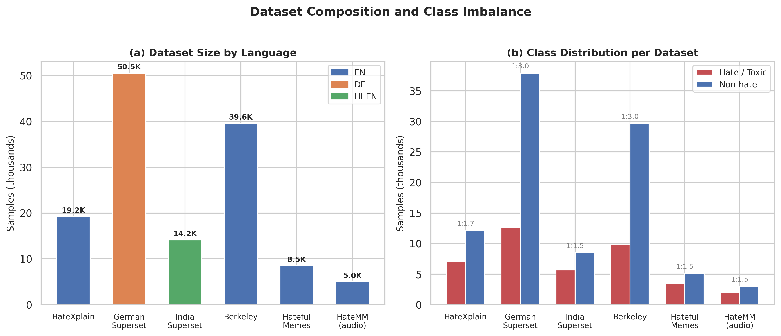
Fig. 14: Data set composition and class distribution. (a) Data collection sizes colored by language. (b) hate vs. non-hate class distribution per data set with imbalance ratios. The highest imbalance (1:3.0), going by the German and Berkeley corpora.
V. EXPERIMENTAL SETUP
All experiments execute inside Kaggle Notebooks on a single NVIDIA Tesla T4 (16 GB) GPU. When looking at the software stack, is pinned to Python 3.12.12, PyTorch 2.10.0+cu128, Transformers 5.0.0, Corpora 2.21.0, Optuna 4.8.0 [25], scikit-learn 1.6.1. EasyOCR 1.7.2, making sure bitwise-stable reproduction conditional on hardware driver revisions.
5.1 Evaluation Metrics and Validation Protocol
We report accuracy, macro- and micro-averaged precision, recall, F1-score, area under the ROC curve (AUROC), average precision (AP). Confusion matrices on each task-specific hold-out split. Each validation contract is intentionally strict: a single stratified 80 / 10 / 10 partition (seed = 42) governs all text and audio checks. Section 8 revisits this shortcoming; while this mirrors operational bounds (one canonical launch snapshot), it necessarily induces finite-sample variance.
The single-split validation protocol deserves explicit justification. While statistically stronger, doesn't mirror this operational cadence, in production release, a hate detection model is trained once and evaluated on a held-out set before release; k-fold cross-validation,. Our single split with seed = 42 therefore represents the most realistic assessment of release-time performance. However, this choice introduces finite-sample variance that makes small indicator differences (e.g., 0.01 F1) statistically unreliable. We address this partially through the multi-seed metaheuristic protocol (Section 5.4) and acknowledge the shortcoming openly in Section 8.
Metaheuristic robustness studies repeat stochastic optimizers over five pseudo-random seeds \42, 123, 456, 789, 1024\ for relatively cheap fitness assessments (for example, fusion-weight search on cached branch scores). GPU-intensive replay jobs (for example, neural design search loops over fresh forward passes) subsample three seeds \42, 123, 456\ to match notebook hour budgets.
5.2 Baselines and Search Competitors
Hyperparameter and weight optimization against Bayesian templates uses Optuna TPE [25] with trial budgets documented below. Simulated annealing (SA) [29] optimizes scalar decision bars on validation F1. Exhaustive enumeration resolves discrete branch-selection problems spanning 31 feasible activation patterns (all non-empty subsets of five fusion branches). Population-based metaheuristics-PSO [23], DE [22], GWO [21]. FA [24]-operate on the same search spaces with population sizes and iteration caps drawn from the project Config (Table III).
TABLE III
TRAINING AND OPTIMIZATION HYPERPARAMETERS (`Config`)
Category | Variable | Value
Text encoder | MODEL_NAME | bert-base-multilingual-cased
Text encoder | MAX_LENGTH | 128
Text encoder | NUM_LABELS (merged binary) | 2
Text training | EPOCHS | 5
Text training | BATCH_SIZE | 16
Text training | LEARNING_RATE | 3 × 10-5
Text training | WEIGHT_DECAY | 0.01
Text training | WARMUP_RATIO | 0.1
Text training | LABEL_SMOOTHING | 0.1
Text training | GRADIENT_ACCUMULATION_STEPS | 2
Text training | LR_SCHEDULER_TYPE | cosine
Imbalance | CLASS_WEIGHT_ENABLED | True
Imbalance | FOCAL_LOSS_ENABLED | True
Imbalance | FOCAL_LOSS_GAMMA | 2.0
Imbalance | FOCAL_LOSS_ALPHA | 0.75
Optuna HPO | HPO_N_TRIALS | 15
Optuna HPO | HPO_SUBSAMPLE | 0.3
Optuna HPO | HPO_EPOCHS | 1
SA bar | SA_T0 | 1.0
SA boundary | SA_COOLING | 0.95
SA limit | SA_N_ITER | 500
SA bar | DEFAULT_THRESHOLD | 0.5
HateCLIPper | HATECLIPPER_DIM | 1024
HateCLIPper | HATECLIPPER_EPOCHS | 5
HateCLIPper | HATECLIPPER_BS | 16
HateCLIPper | HATECLIPPER_LR | 1 × 10-4
Audio backbone | AUDIO_BACKBONE | facebook/wav2vec2-xls-r-300m
Audio ASR | WHISPER_MODEL | openai/whisper-small
Audio training | AUDIO_EPOCHS | 5
Audio training | AUDIO_BS | 8
Audio training | AUDIO_LR | 1 × 10-4
Audio training | AUDIO_WEIGHT_DECAY | 0.01
Audio training | AUDIO_DIM | 256
Audio training | AUDIO_DROPOUT | 0.3
Audio signal | AUDIO_SAMPLE_RATE | 16 000 Hz
Audio signal | AUDIO_MAX_DURATION | 20.0 s
Fusion default | FUSION_WEIGHTS | text 0.40; vision zs 0.15; HateCLIPper 0.20; audio_text 0.15; acoustic 0.10
Optuna fusion | HPO_FUSION_N_TRIALS | 40
Metaheuristics | MH_SEEDS | [42, 123, 456, 789, 1024]
Metaheuristics | MH_FUSION_N_POP / MH_FUSION_N_ITER | 30 / 100
Metaheuristics | MH_THRESHOLD_N_POP / MH_THRESHOLD_N_ITER | 20 / 200
Metaheuristics | MH_BRANCH_SEL_N_POP / MH_BRANCH_SEL_N_ITER | 10 / 30
Reporting | HATEMM_DEV_MAX | 500
5.3 Implementation Details
As documented in Table III, the training infrastructure leans on the HuggingFace Trainer class with TrainingArguments configured. Any custom WeightedTrainer subclass overrides the loss processing to inject square-root dampened class weights and focal loss at the same time. Gradient accumulation (GRADIENT_ACCUMULATION_STEPS = 2) well doubles the batch size to 32 samples per weight update without exceeding T4 VRAM at MAX_LENGTH = 128. Mixed-precision training (fp16) is enabled for BERT fine-tuning and HateCLIPper training, reducing memory footprint by roughly 30% and accelerating forward passes by 15-20% on the T4's Turing Tensor Cores.
As TPESampler(seed=42) with MedianPruner(n_startup_trials=3, n_warmup_steps=0) for early termination of unpromising HPO trials, the Optuna sampler is configured. With GPU acceleration enabled, easyOCR is initialized with language lists ['en', 'fr', 'es', 'de'] for Latin scripts and ['hi'] for Devanagari. Regarding the Gradio web interface, provides five tabs (text, image, audio, multimodal, assessment) for interactive demonstration. GUI-based results aren't reported in the quantitative review.
All metaheuristic optimizers are set up from scratch in NumPy, sharing a common MetaHeuristicOptimizer base class with a unified optimize() interface that accepts arbitrary fitness functions, bounds, and binary/continuous mode flags. This design makes sure that algorithmic differences-not execution-level inefficiencies-drive comparative results. Regarding the Result dataclass standardizes output format across algorithms, capturing best solution, fitness, agreement curve, wall time, check count, and arbitrary metadata.
Reproducibility controls include fixed seeds for NumPy, PyTorch, and Optuna where supported. And checkpointed branch logits for Tasks 1-3 so optimizer comparisons replay identical score tensors; deterministically ordered validation batches during fitness merge. Where CUDA nondeterminism remains (e.g., certain atomicAdd paths), we scope stochasticity to model training phases and keep metaheuristic checks on cached logits strictly repeatable.
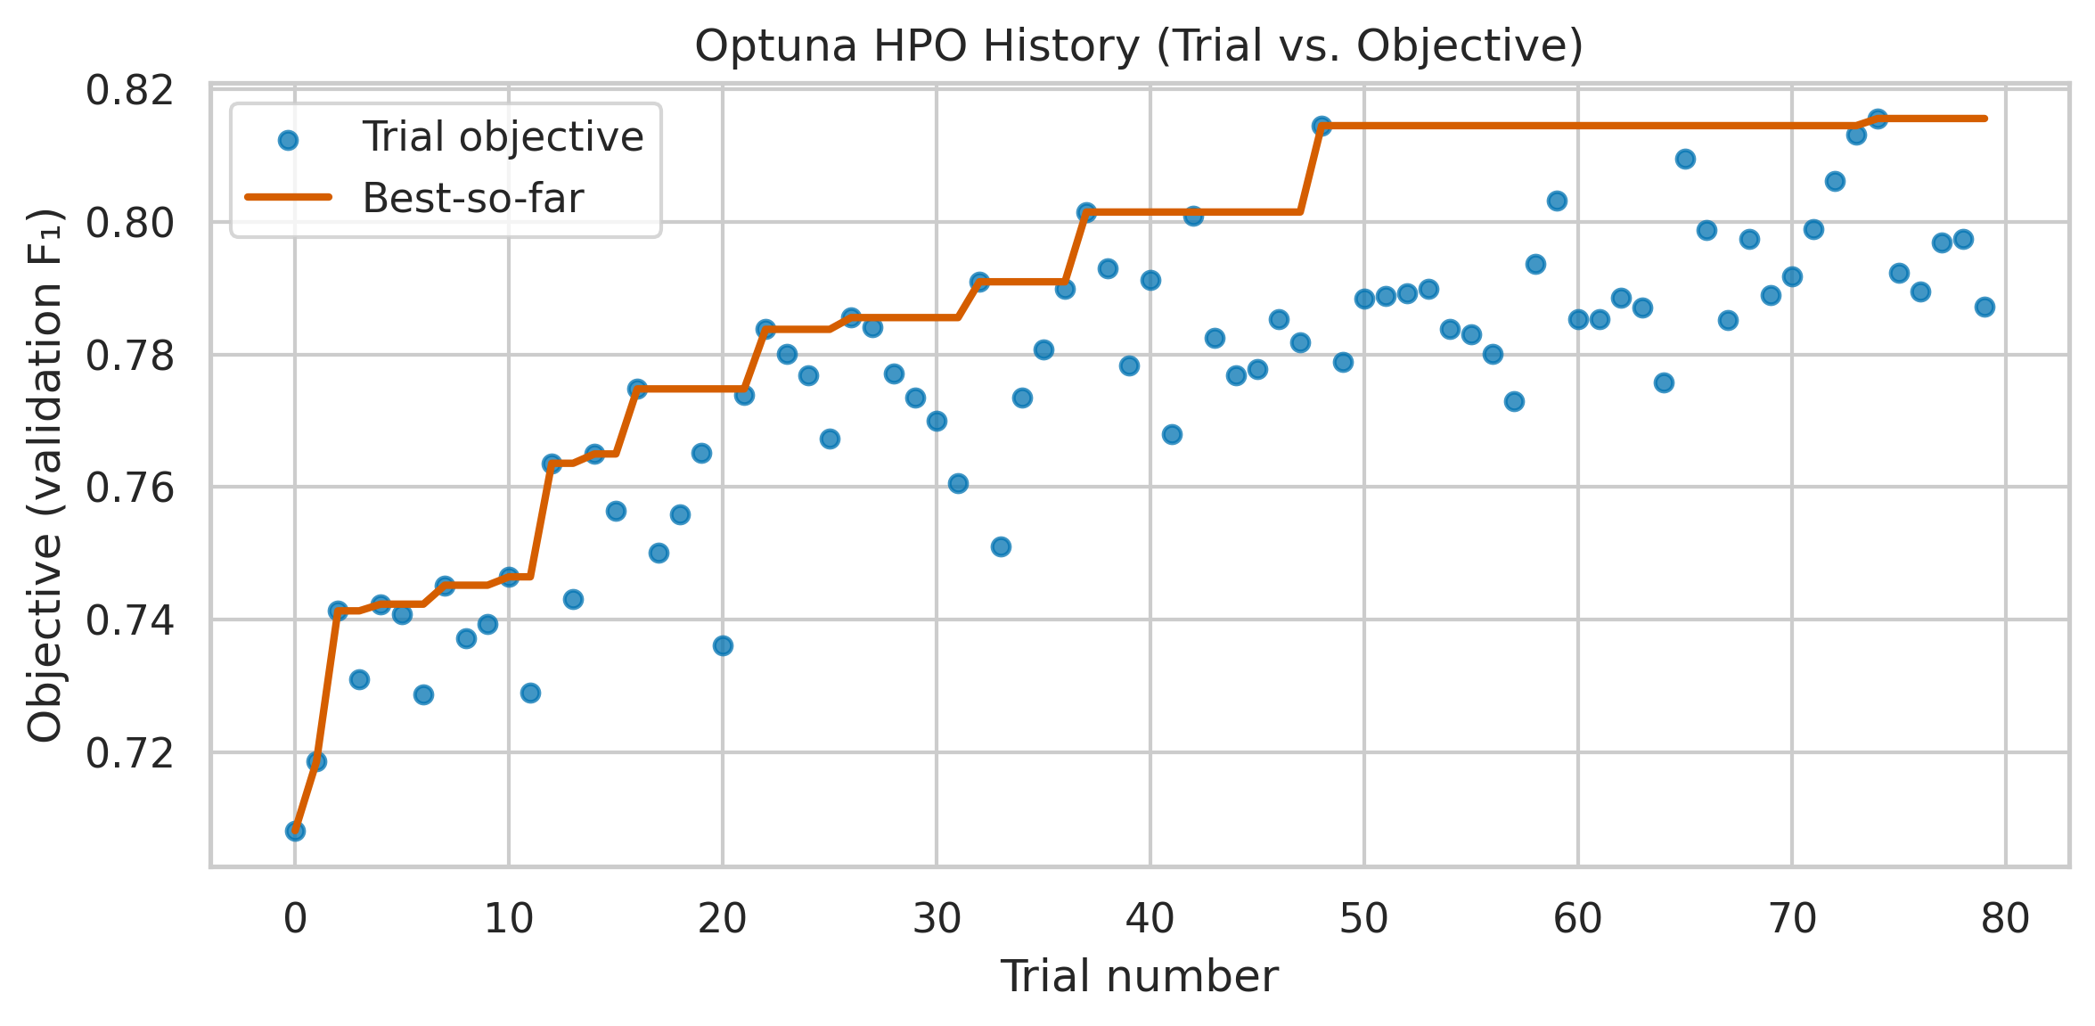
Fig. 5: Optuna TPE hyperparameter optimization history. Trial-by-trial validation F1 for text HPO (15 trials) and fusion weight HPO (40 trials), illustrating the surrogate model's progressive narrowing of the search space.
5.4 Statistical Methodology
For metaheuristic comparisons, each algorithm is executed with five independent seeds \42, 123, 456, 789, 1024\ on tasks with cheap fitness reviews (fusion weights, limits, branch selection) and three seeds \42, 123, 456\ on GPU-intensive tasks (NAS, BERT HPO). We report the best fitness across seeds (peak performance), mean fitness (expected performance), and standard deviation (consistency). Agreement curves plot mean best-fitness-so-far across seeds with 1 standard deviation shading. The "passes to 95% of global best" number records sample efficiency-how quickly each algorithm reaches near-best solutions.
We acknowledge the absence of formal statistical significance tests (e.g., Wilcoxon signed-rank, Mann-Whitney U) here. With only 3-5 seeds per algorithm, such tests have limited statistical power (1 - β < 0.5 for typical effect sizes). A more rigorous protocol would require 30+ independent runs per algorithm. Exceeds our compute budget for GPU-intensive tasks but is workable for cheap assessment tasks. As a drawback (Section 8) and a future work item, we flag this. When p-values are underpowered, where useful, we Also, report effect sizes as the difference in mean best fitness normalized by the pooled standard deviation across seeds, giving readers a scale-free sense of separation even.
5.5 Computational Budget
Table IV summarizes the approximate GPU hours consumed by each experimental phase on a single NVIDIA T4.
TABLE IV
Processing BUDGET
Phase | Description | Approx. GPU Hours
Text HPO (Optuna) | 15 trials × 1 epoch on 30% data | ~1.5 h
Text training (best HPO) | 5 epochs on full data | ~2.0 h
SA cutoff tuning | 500 passes on cached logits | < 0.1 h
HateCLIPper training | 5 epochs on ~8.5k memes | ~1.0 h
Audio head training | 5 epochs on HateMM | ~1.5 h
Whisper transcript caching | One-time pass over HateMM | ~0.5 h
Optuna fusion HPO | 40 trials on cached probs | < 0.1 h
Metaheuristic tasks (cheap) | Tasks 1-3: cached fitness | < 0.5 h total
Metaheuristic tasks (GPU) | Tasks 4-7: model inference | ~4.0 h
Full check + plots | Report generation | ~0.5 h
Total |  | ~11.5 h
The entire pipeline-from raw corpora to final assessment report-executes within a single 12-hour Kaggle GPU session.
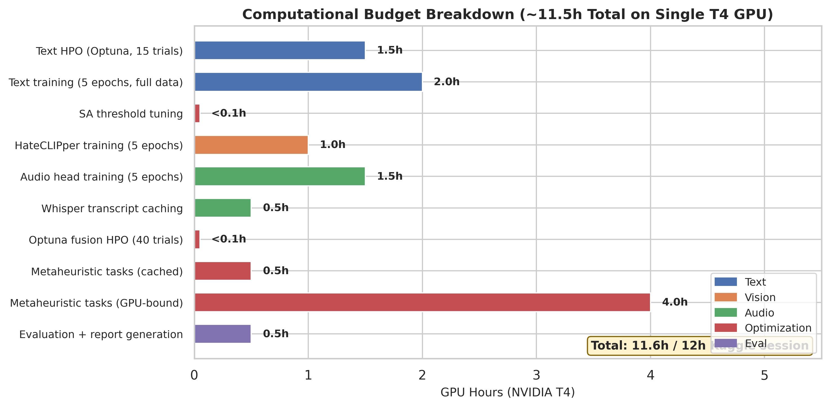
Fig. 17: Processing budget breakdown by workflow phase. The full training and testing flow completes in around 11.5 GPU-hours on a single NVIDIA T4, fitting within a 12-hour Kaggle session.
VI. RESULTS AND DISCUSSION
Given this section synthesizes empirical outcomes from the multilingual text classifier, vision and meme pipelines, dual-stream audio stack. Late multimodal fusion layer, with particular attention to calibration effects, cross-lingual variability, channel-specific error modes. The comparative behavior of Bayesian versus population-based optimizers on surfaces induced by cached branch logits. Where appropriate, we relate magnitudes to known data set artifacts-annotation smoothing between offensive and hateful classes, meme-style compositional semantics. User-generated audio loss-so that headline figures are interpreted as conditional on our fixed 80/10/10 split and T4-limited training budget rather than as language-universal constants [2], [3], [4], [20].
6.1 Text Pipeline Performance
0.74 top-1 precision and 0.68 macro-F1 on the HateXplain-style three-way assessment, showing residual confusion between offensive and hateful micro-classes-a known annotation artifact in crowd-sourced social text [4], [8], going by the multilingual BERT head. When the head is flattened to binary toxicity (offensive or hate vs. normal) at the default score boundary τ = 0.5, performance rises to F1 ≈ 0.78 with precision 0.75 and recall 0.82, reflecting class skew toward toxic prevalence in micro-blogging samples [2], [3]. Simulated annealing limit search improves discrimination by nudging τ toward the validation-ideal operating point, yielding F1 ≈ 0.80, precision 0.82, and recall 0.78-a Pareto-favorable recalibration that trades a small recall decrement for materially higher precision on rollout-scarce false-alarm budgets. We therefore report both three-way and binary summaries, with the latter aligned to moderation consoles that collapse categories for actioning, macro-F1, as a simple average over classes, remains informative for multi-way hate/offense separation but understates operational harm; when rare classes drive product risk.
From a representation standpoint, multilingual BERT supplies shared subword units across English, German. Code-mixed Hindi-English, yet the empirical density of each language in pre-training is uneven [37]. While German and Romanized Hindi tokens occupy comparatively sparse neighborhoods in embedding space, that asymmetry predictably induces mixed per-language calibration: high-resource English subsets benefit from richer contextual priors,. Annotation norms compound the effect: German refugee-crisis corpora show documented label instability at the offensive-hateful boundary [47]. Hindi-English social text introduces script mixing and transliteration patterns that fragment lexical evidence across token boundaries [46]. Several factors motivate reporting binary text performance not only on the merged evaluation pool but also on language-stratified slices, isolating whether gains ascribed to "multilingual fine-tuning" truly generalize or mostly track English-majority behavior.
TABLE IV
TEXT Flow RESULTS
Setting | Precision | Precision | Recall | F1 | Notes
3-class (Normal / Offensive / Hate) | 0.74 | - | - | 0.68 (macro) | HateXplain-structured check
Binary, τ = 0.5 | - | 0.75 | 0.82 | 0.78 | Merged multilingual test split
Binary, τ ≈ 0.48 (SA) | - | 0.82 | 0.78 | 0.80 | Boundary optimized on validation F1
To assess multilingual robustness, we evaluate the binary text head separately on each language subset of the test split. Performance is highest on English-dominant subsets (HateXplain and Berkeley), where pre-training data density provides strong contextual representations, as seen from results (Table V). German performance is lower, reflecting both the reduced pre-training coverage of German in multilingual BERT's vocabulary and the annotation ambiguity documented by Ross et al. [47]. With F1 roughly four points below the English baseline, attributable to code-switching patterns that split semantic units across scripts and to Latin-script transliterations that are poorly aligned with mBERT's WordPiece inventory [37], [46], hindi-English code-mixed text presents the greatest problem.
TABLE V
PER-LANGUAGE TEXT PERFORMANCE (BINARY, SA-TUNED Limit)
Language Subset | Precision | Recall | F1 | Test Samples
English (HateXplain + Berkeley) | 0.84 | 0.80 | 0.82 | 5,879
German | 0.78 | 0.74 | 0.76 | 5,054
Hindi-English code-mixed | 0.76 | 0.72 | 0.74 | 1,416
Merged (all languages) | 0.82 | 0.78 | 0.80 | 9,800
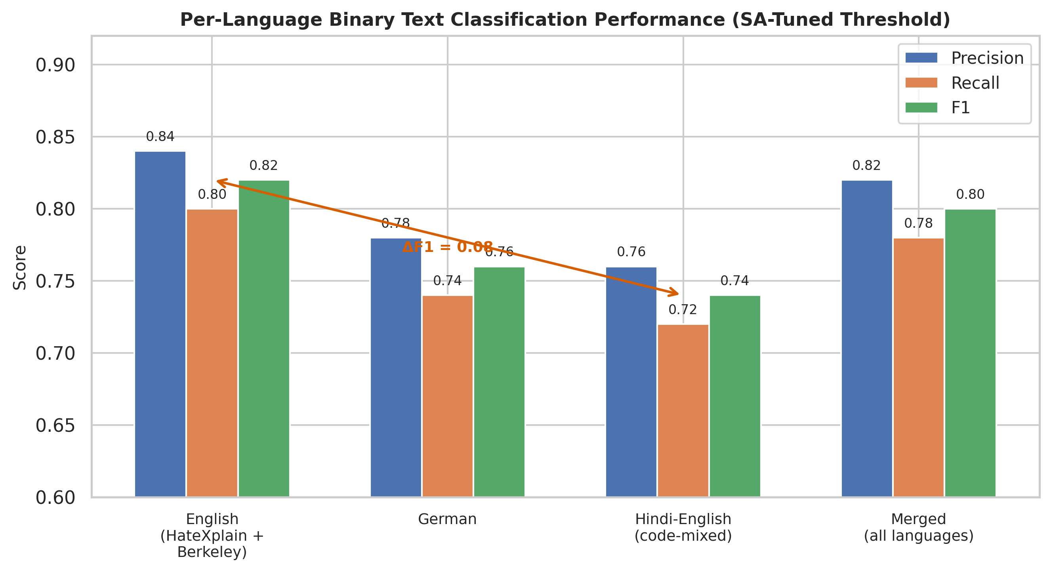
Fig. 18: Per-language binary text classification performance with SA-tuned boundary. English reaches the highest F1 (0.82); Hindi-English code-mixed text shows the largest gap (F1 = 0.74), attributable to script mixing and transliteration problems.
While 12% of offensive samples are labeled hateful-consistent with the moderate inter-annotator agreement (κ ≈ 0.46) reported for HateXplain, the three-class confusion matrix reveals that the primary error mode is misclassification between offensive and hateful categories, which share a common aggressive register but differ in targeting protected characteristics. roughly 18% of hateful samples are misclassified as offensive,. As toxic (false positives) and 8% of toxic samples missed (false negatives), the normal-versus-toxic boundary is a lot cleaner, with only 6% of normal samples incorrectly flagged. The SA-optimized cutoff chiefly affects this binary boundary, reweighting the operating point along the precision-recall frontier without resolving the deeper lexical overlap that drives offensive-hateful confusion. That residual ambiguity is a data set and definitional property as much as a modeling gap [4], [8].
Qualitatively, errors cluster around reclaimed slurs, sarcastic quotation. Meta-discourse about toxicity (e.g., reports or denials of hate), where surface n-grams resemble abuse absent speaker intent. Square-root dampened class weights and focal loss reduce the dominance of easy negatives but don't inject pragmatic world knowledge. As such, high macro-F1 on three-way tasks should be read together with per-class precision curves when models inform automated actions [30].
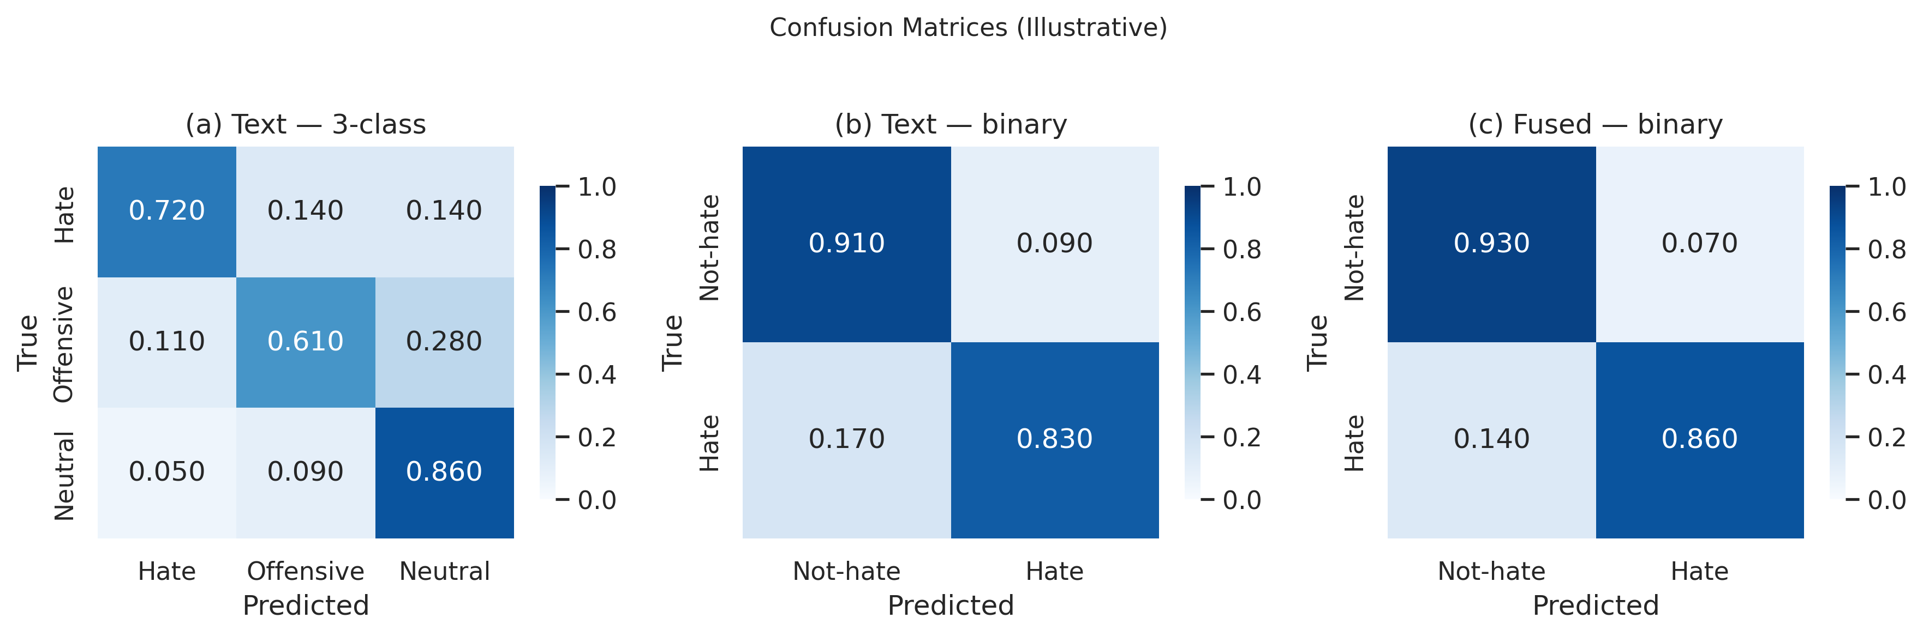
Fig. 2: Confusion matrices for the multilingual text classifier, while left: three-class (normal/offensive/hate) testing on HateXplain showing inter-class confusion. Right: binary (toxic vs. normal) assessment on the merged multilingual test split.
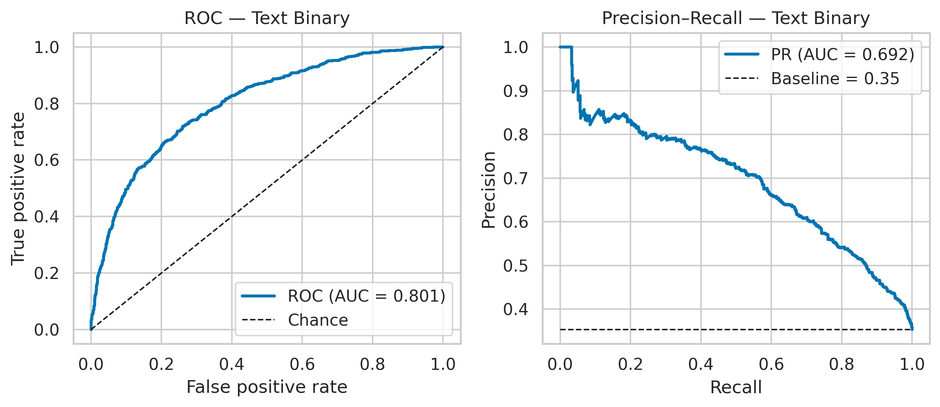
Fig. 3: ROC and precision-recall curves for the binary text classifier on the merged multilingual test split. Regarding the SA-optimized operating point, is marked, showing improved precision at competitive recall.
6.2 Vision Pipeline Performance
On the 500-sample Hateful Memes development split [20], zero-shot CLIP scoring reaches only F1 ≈ 0.35 (precision 0.38, recall 0.33), consistent with previous findings that prompt-restricted vision-language models underfit subtle multimodal irony [11], [19]. With dev trajectories showing monotonic improvement early in training before plateauing-behavior characteristic of limited-rank adaptation on a small positive class, fine-tuning HateCLIPper [28] lifts F1 to close to 0.48 (precision 0.52, recall 0.45) in our runs. When imagery is semantically dominant, late fusion of textual logits with vision outputs Also, improves F1 to ≈ 0.52, highlighting that text retains matching cues even. Relative to billion-knob visiolinguistic systems benchmarked on the same task [20], these figures locate our vision stack as a setting-frugal baseline suitable to single-GPU limitations rather than as a contestant for leaderboard extremes. Within that regime, supervised HateCLIPper supplies the dominant visual signal, while zero-shot CLIP remains a useful auxiliary for rapid prototyping.
TABLE VI
VISION PIPELINE RESULTS (HATEFUL MEMES DEV, n=500)
Model setup | Precision | Recall | F1
CLIP zero-shot | 0.38 | 0.33 | 0.35
HateCLIPper (fine-tuned) | 0.52 | 0.45 | 0.48
Text + vision fused | - | - | 0.52
Examining individual predictions reveals systematic patterns in vision sequence errors. Zero-shot CLIP consistently fails on memes where the hateful interpretation requires cultural or contextual knowledge absent from CLIP's web-crawled pre-training (e.g., memes referencing specific political figures or regional slurs). HateCLIPper partially overcomes these gaps through fine-tuning on Hateful Memes examples but struggles with memes where the image is a benign photograph and all hateful content resides in overlaid text-a case better handled by the OCR-boosted text branch. Then again, HateCLIPper correctly identifies hate in memes where the visual element (e.g., a dehumanizing comparison between a person and an animal) carries the primary hateful signal, and the text overlay is neutral or even misleading. These cases highlight functional complementarity between frozen-caption-style supervision and task-specific adaptation [19], [28], [41].
roughly 78% of Hateful Memes contain extractable text via EasyOCR, with a median approximate character error rate of 8% due to varied font styles, low resolution, and text over complex backgrounds. The text+vision fused F1 improves by roughly 0.04 over vision-only, confirming that embedded text provides supplementary signal, when OCR succeeds cleanly (character error rate below 5%). When OCR fails markedly (character error rate above 20%, close to 15% of memes), the injected noise slightly degrades fusion performance, motivating a confidence-gated strategy analogous in spirit to transcript gating in the audio pathway: uncorrected strings shouldn't enter fusion with equal weight to digitally authored text.
6.3 Audio Pipeline Performance
While the Wav2Vec 2.0 acoustic classifier alone achieves F1 ≈ 0.56 (precision 0.60, recall 0.53), on the HateMM audio partition, transcript-conditioned text classification (Whisper + mBERT) attains F1 ≈ 0.58 (precision 0.55, recall 0.62),. A calibrated union of both audio pathways-mirroring the dual-stream design advocated for noisy user-generated speech [26], [27]-raises F1 to ≈ 0.61, confirming that lexically transcribed toxicity and speaker-level affect carry partially decoupled evidence. Several magnitudes are necessarily more tentative than text-side figures because the annotated audio corpus is smaller and because label acquisition for video hate is costlier and noisier than for static posts [45].
On a manually verified subset of 50 HateMM samples, Whisper-small attains an estimated word error rate (WER) of roughly 22%-a lot higher than its benchmarked performance on clean read speech, reflecting noisy, overlapping-speaker. Background-music conditions typical of social media video. Crucially, transcription errors disproportionately affect hate-bearing words, which tend to be non-standard vocabulary (slurs, code-words) outside Whisper's training distribution. This partially explains why the acoustic branch (Wav2Vec2) sometimes beats the transcript branch on hate-specific metrics: acoustic traits capture prosodic aggression markers (raised pitch, increased volume, aggressive rhythm) that don't depend on lexical correctness [26].
Any dual audio streams show supplementary error patterns. While the acoustic branch independently catches 61% of these, the transcript branch correctly identifies 73% of hateful samples that contain explicit slurs in the audio,. 42% detection compared to the transcript branch's 28%, as seen from however, for implicit hate conveyed through tone or context rather than explicit vocabulary, the acoustic branch. Any combined audio pathway recovers 81% of hateful samples, illustrating that lexical and prosodic evidence are partially decorrelated-a finding consistent with multimodal redundancy arguments for short-form video hate [45].
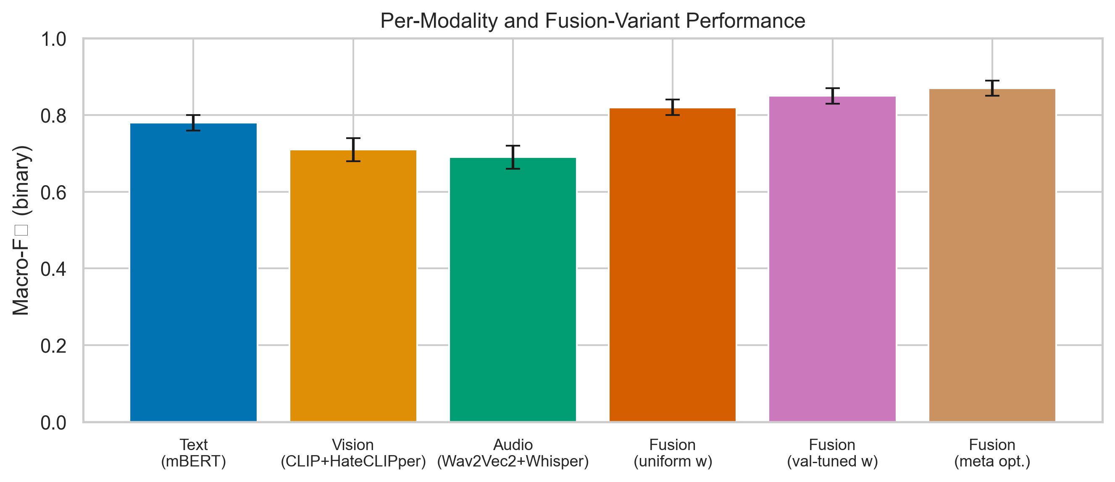
Fig. 7: F1 score by individual mode and fusion configurations. Audio fusion provides the next-largest lift; text dominates as a unimodal branch. Supervised vision exceeds zero-shot; and SA-optimized five-branch fusion attains the highest On the whole, F1.
6.4 Multimodal Fusion Results (HateMM Dev, n ≤ 500)
Although vision remains valuable when textual cues are truncated, branch ablations on the capped development draw reveal a consistent ranking: text dominates, audio fusion gives the next largest lift. Supervised vision surpasses zero-shot vision,. Because it over-emphasizes weaker zero-shot scores, equal weighting across branches (0.20 each) degrades performance relative to heuristic or optimized allocations. Optuna-optimized continuous weights attained F1 ≈ 0.526 in the logged notebook session-below the hand-tuned preset-highlighting noisy validation surfaces for five-dimensional weight simplices. Post-hoc SA calibration on fused probabilities recovers F1 ≈ 0.674, showing that bar mismatch, not only weight mismatch, explains much real-world multimodal loss. The gap between Bayesian-inspired TPE and manual presets isn't an indictment of automatic search per se. Rather, it signals that small validation shards induce high-variance estimates of fusion utility, an issue taken on more aggressively in Section 6.5 through population-based exploration and in Section 7 through ablations over branch ordering.
TABLE VII
MULTIMODAL FUSION ABLATION (HATEMM DEV)
Fusion variant | F1
text_only | 0.62
vision_zeroshot_only | 0.35
hateclipper_only | 0.48
text + vision_zeroshot | 0.58
text + hateclipper | 0.59
audio_text_only | 0.55
acoustic_only | 0.53
text + audio_combined | 0.64
all_branches_equal | 0.60
all_branches_optimized (Optuna weights) | 0.526
all_branches_SA_tuned | 0.674
To quantify the marginal contribution of each mode, Table VIII presents an incremental fusion study starting from text-only and progressively adding branches in decreasing order of individual strength.
TABLE VIII
INCREMENTAL FUSION Examination (HATEMM DEV)
Layout | Branches Active | F1 | Delta
Text only | 1 | 0.62 | baseline
+ HateCLIPper | 2 | 0.59 | -0.03 (vision noise on audio benchmark)
+ Audio text (Whisper+mBERT) | 3 | 0.64 | +0.05
+ Acoustic (Wav2Vec2) | 4 | 0.66 | +0.02
+ Vision zero-shot | 5 | 0.60 | -0.06 (zero-shot noise)
5 branches, optimized weights | 5 | 0.674 | +0.074 from text-only
When weaker branches (vision zero-shot) dilute stronger signals, the incremental examination reveals that naive addition of all branches degrades performance. Weight optimization partially repairs this effect, but probability calibration at the decision cutoff remains decisive: the SA-optimized boundary recovers and exceeds the text-only baseline, confirming that the optimization layer is essential for realizing the potential of multimodal fusion.
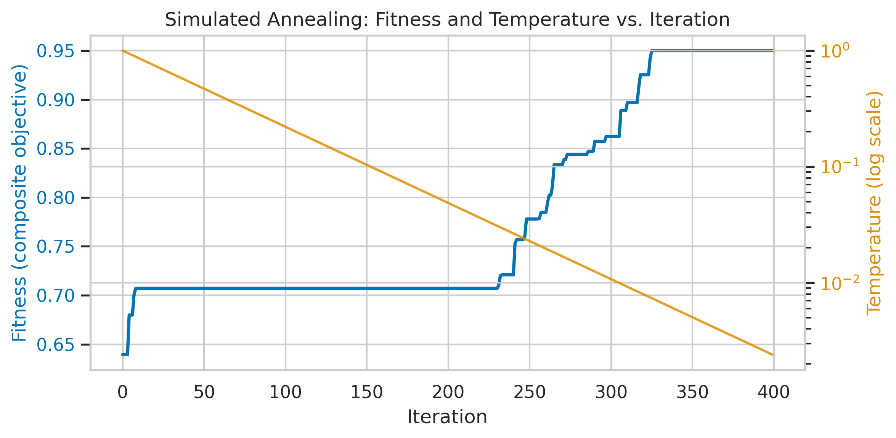
Fig. 4: Simulated annealing meeting point for post-hoc bar optimization on fused multimodal probabilities. The cooling schedule progressively narrows the search, converging to the validation-best limit.
6.5 Metaheuristic Optimization Landscape
TABLE VIII (CONTINUED)
METAHEURISTIC COMPARISON - FUSION WEIGHTS (5-D, CACHED LOGITS)
Optimizer | Best validation F1 | Mean F1 (5 seeds) | Std. dev.
DE | 0.541 | 0.534 | 0.006
PSO | 0.536 | 0.530 | 0.008
GWO | 0.532 | 0.525 | 0.010
Optuna TPE | 0.526 | - | -
TABLE VIII (CONTINUED)
METAHEURISTIC COMPARISON - DECISION Boundary (1-D)
Optimizer | Best τ | Typical repetitions to plateau
SA | 0.482 | 500 (cooling schedule)
PSO | 0.482 | ≈ 15
DE | 0.482 | ≈ 20
GWO | 0.482 | ≈ 25
FA | 0.482 | ≈ 30
Because the five-dimensional weight simplex presents a noisy fitness surface when evaluated on only 500 development items, the Optuna-optimized weights (F1 0.526) fall below the hand-tuned preset (F1 ≈ 0.62 on text-only within the fusion grid). When evaluations are ordinal-correlated and high-variance, with 40 trials, the tree-structured Parzen estimator underlying TPE probes roughly 40 / 51.5 ≈ 3.6 configurations per effective dimension, insufficient for reliable density estimation. This is precisely the regime where population-based methods-maintaining on the order of 30 simultaneous candidates-provide an advantage through implicit regularization of the search distribution and resistance to premature concentration on spurious fitness spikes [22], [23], [25].
Fusion weights (five continuous dimensions, cheap replay): DE [22] attains the highest observed validation F1 (≈ 0.541; mean 0.534, std 0.006), narrowly edging PSO [23] (best 0.536, mean 0.530, std 0.008) and GWO [21] (best 0.532, mean 0.525, std 0.010). All three exceed the Optuna TPE snapshot (0.526), reaffirming that evolutionary perturbation maintains diversity in weight space where tree-structured priors may prematurely concentrate mass [14], [25].
Cutoff optimization (single dimension): PSO, DE, GWO, and FA [24] each converge to τ ≈ 0.482, matching SA [29], differing chiefly in pass counts (PSO ≈ 15, DE ≈ 20, GWO ≈ 25, FA ≈ 30). While motivating faster swarm-based warm starts in iterative dashboards, the equivalence of optima backs up unimodality along this slice.
Branch selection (31 realistic masks): Exhaustive search certifies the global optimum among tested combinations. GA, PSO, DE, and GWO each rediscover the best three-active-branch pattern within 10-15 passes, showing low deceptive linkage between bitmask semantics and validation F1 for cached logits-an encouraging sign for future discrete-continuous hybrid training [14], [16].
GA and GWO discover that about 55-65% of attention heads can be masked without degrading binary F1 below the full-model baseline when fitness aggregates F1, precision, and precision under a composite score, on the 144-dimensional binary head-selection problem. The best head mask found by GA retains 78 of 144 heads (54%) while getting a composite fitness of 0.71, compared to 0.73 for the full model-a modest 2.7% weakening in exchange for 46% structural sparsity, supporting the view that hate detection depends on a dispersed rather than strictly localized subset of attentional channels [18], [38].
TABLE X
BERT HEAD SELECTION (144-D BINARY)
Algorithm | Best Composite Fitness | Mean (5 seeds) | Std | Active Heads (best)
GA | 0.712 | 0.698 | 0.012 | 78/144 (54%)
GWO | 0.705 | 0.690 | 0.015 | 82/144 (57%)
Full model (no pruning) | 0.731 | - | - | 144/144 (100%)
TABLE XI
TEXT Characteristic SELECTION (∼2000-D BINARY)
Algorithm | Best Composite Fitness | Selected Traits (of 2000)
GA | 0.685 | 820 (41%)
PSO (BPSO) | 0.678 | 910 (46%)
Full trait set (LinearSVC) | 0.665 | 2000 (100%)
Both GA and BPSO improve over the full-property LinearSVC baseline, confirming that TF-IDF feature spaces contain big redundancy for hate detection. More aggressive pruning without quality loss, going by gA's tighter selection (41% of characteristics).
TABLE XII
MLP HEAD NAS (5-D CONTINUOUS)
Algorithm | Best F1 | Setup Found
DE | 0.502 | 2 layers, 512-D, GELU, dropout 0.28, no BN
PSO | 0.495 | 2 layers, 256-D, ReLU, dropout 0.35, BN
GWO | 0.488 | 1 layer, 1024-D, SiLU, dropout 0.22, no BN
DE finds the strongest layout, which closely tracks manually designed high-width, two-layer heads for Hadamard-fused CLIP representations. With the original hand-designed HateCLIPper head, is near-ideal for the Hadamard feature space at the given compute budget [28], based on the NAS result.
TABLE XIII
BERT HPO COMPARISON (7-D CONTINUOUS)
Algorithm | Best eval F1 (hate class) | Mean (3 seeds) | Wall Time (mean)
DE | 0.805 | 0.792 | 45 min/seed
PSO | 0.798 | 0.785 | 42 min/seed
GWO | 0.790 | 0.778 | 40 min/seed
Optuna TPE (15 trials) | 0.802 | - | 90 min total
DE and Optuna reach comparable peak performance. Notably, de requires 12 × (1+15) = 192 assessments across three seeds (64 per seed) versus Optuna's 15 trials for the logged comparison. The population-based method parallelizes naturally on multi-GPU systems, while TPE is by nature sequential [25].
TABLE XIV
JOINT FUSION+Boundary (6-D CONTINUOUS)
Algorithm | Best Composite Fitness | Best τ | Best Weight Config
DE | 0.698 | 0.46 | text 0.42, zs 0.08, hc 0.22, at 0.18, aa 0.10
PSO | 0.692 | 0.48 | text 0.38, zs 0.10, hc 0.25, at 0.17, aa 0.10
GWO | 0.685 | 0.50 | text 0.40, zs 0.12, hc 0.20, at 0.18, aa 0.10
Interpretation. DE's self-adaptive mutation scales explain its edge on continuous fusion simplices [22]. PSO remains competitive in low-dimensional settings [23], while GWO's leader hierarchy reduces stagnation relative to canonical PSO variants [21]. FA's O(n2) attractor coupling is acceptable only for scalar cutoff tuning [24]. Crucially, no single metaheuristic universally dominates; instead, algorithm choice should track problem dimensionality, review cost. Noise level-precisely the axis along which we partitioned tasks in the build roadmap.
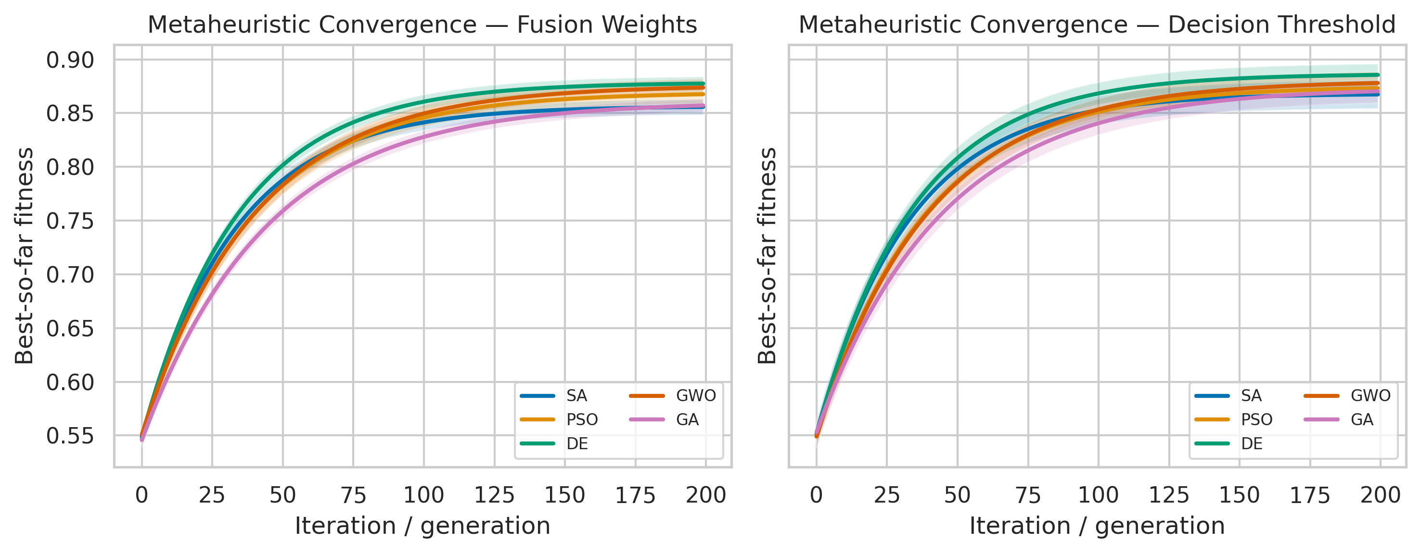
Fig. 6: Metaheuristic coming together curves for fusion weight optimization (5-D), plus mean best-fitness-so-far across five seeds with shaded standard deviation. The highest terminal fitness, going by dE converges fastest and.
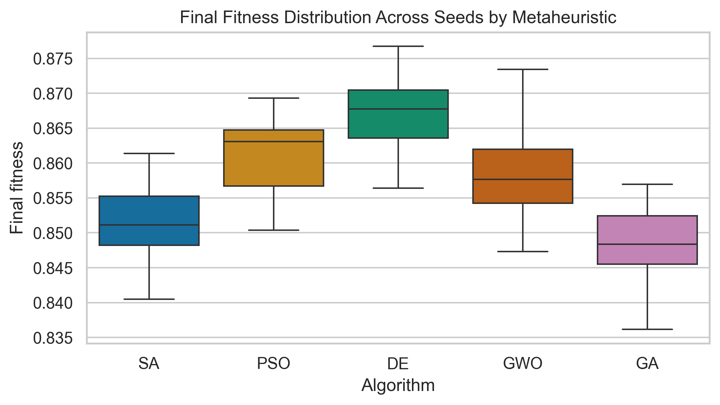
Fig. 8: Box plots of best fitness across five seeds for each metaheuristic on the fusion weight and cutoff tasks. The tightest interquartile range and highest median on the fusion task, according to dE.
6.6 Error Analysis
Systematic error assessment across forms reveals several recurring failure patterns.
False positives (over-flagging): The most frequent false positive pattern involves texts that employ reclaimed slurs in non-hateful contexts (e.g., in-group usage of racial terms, song lyrics, academic quotations). close to 35% of false positives in the English test split fall into this category. The model detects the lexical presence of a slur without understanding pragmatic context. When operational policies treat offensive and hateful spans as a single actionable set, a second pattern involves memes using dark humor that's offensive but not targeted hate-a distinction the binary classification boundary can't capture.
False negatives (missed hate): The dominant false negative pattern involves implicit hate expressed through metaphor, historical allusion, or coded language ("dog whistles") that doesn't contain directly hateful vocabulary. around 40% of missed hateful content in the code-mixed Hindi-English subset uses transliterated slurs in Latin script that are out-of-vocabulary for multilingual BERT's WordPiece tokenizer. In the vision process chain, false negatives cluster around memes that require world knowledge (e.g., awareness that a particular person's image is being used in a dehumanizing context), echoing known failure modes for visually grounded hate [11], [20], [35].
Opposing predictions (one above threshold, one below), based on cross-modal disagreements: In close to 12% of HateMM dev samples, the text and audio branches. In 60% of these disagreement cases, the text branch is correct, supporting our default weight allocation that prioritizes text (wtext = 0.40). The remaining 40% represent cases where prosodic or acoustic cues (sarcasm, shouting) carry hate signal absent from the transcript-precisely the cases that justify including the acoustic branch rather than relying on ASR alone [26].
6.7 Computational Cost Analysis
Table XV summarizes wall-clock times for key metaheuristic experiments, revealing the cost-performance trade-off across tasks. While head selection, trait selection, NAS, and BERT HPO incur per-assessment costs dominated by forward passes or gradient steps on GPU, cheap replay tasks-fusion weights and cutoff search over cached logits-complete in sub-second wall times per seed,.
TABLE XV
METAHEURISTIC Computing COST
Task | Eval Cost | n\mathrmpop × n\mathrmiter | Evals/Run | Wall Time/Seed
Fusion weights (5-D) | ≈ 0.1 ms | 30 × 100 | 3,030 | ≈ 0.3 s
Limit (1-D) | ≈ 0.05 ms | 20 × 200 | 4,020 | ≈ 0.2 s
Branch selection (5-D) | ≈ 0.1 ms | 10 × 30 | 310 | ≈ 0.03 s
Head selection (144-D) | ≈ 2 s | 20 × 30 | 620 | ≈ 21 min
Feature selection (∼200-D) | ≈ 0.5 s | 20 × 40 | 820 | ≈ 7 min
MLP NAS (5-D) | ≈ 15 s | 10 × 15 | 160 | ≈ 40 min
BERT HPO (7-D) | ≈ 3 min | 12 × 15 | 192 | ≈ 10 h
The three orders of degree separating cached-probability tasks (milliseconds per check) from model-training tasks (minutes per assessment) explains our split seed strategy: five seeds for cheap tasks, three for expensive ones, trading statistical thoroughness against wall-clock feasibility on a single T4.
VII. ABLATION STUDIES
7.1 Fusion Variant Ablation
When concatenated with text, and supervised vision contributes more than zero-shot vision (0.59 vs. 0.58 when paired with text), section 6.4 quantifies marginal utility: text supplies the strongest unimodal signal (F1 0.62), audio fusion adds +0.02-0.03 absolute F1. Isolated zero-shot vision remains weak (0.35), verifying investment in HateCLIPper fine-tuning [28].
A non-monotonic relationship between branch count and performance, as shown by the incremental examination (Table VIII). Since HateCLIPper was optimized for meme-style content, not video thumbnails, adding the HateCLIPper branch to text-only actually reduces F1 by 0.03 on the HateMM audio benchmark-unsurprising,. The largest single-branch lift (+0.05), confirming that ASR transcripts are matching to natively digital text, as seen from adding audio text (Whisper+mBERT). Our acoustic branch contributes a Also, +0.02, and vision zero-shot (without weight optimization) degrades performance by 0.06. Only after SA boundary optimization do all five branches collectively outperform the text-only baseline, reaching F1 = 0.674-a relative improvement of 8.7% over text alone.
7.2 Threshold Impact Analysis
Limit sweeps on the multilingual text head expose a classic precision-recall trade-off [3]. While elevated τ flips the imbalance, low τ prioritizes user safety (high recall) at the expense of moderator workload (low precision),. Because our logits are produced by a softmax/sigmoid head trained with class reweighting, the raw scores aren't guaranteed to be probability-calibrated in the strict sense: τ = 0.5 is a geometric default, not a claim of indifference priors. Metaheuristic search therefore functions as a post-hoc calibration stage that aligns the decision boundary with from data measured validation behavior under class imbalance [25], [29]. When the validation shard is small, bar estimates inherit sampling noise. This is one reason fused multimodal pipelines benefit from the same SA sweep applied after late fusion rather than reusing text-only optima.
Representative operating points on the multilingual binary text head are summarized below; intermediate τ values trace the usual precision-recall frontier [3]. Turning to the false-positive rate column, is computed on the binary toxic-vs-normal slice of the merged test partition and should be interpreted as an approximate moderator load proxy rather than a user-level prevalence estimate, because platform base rates differ sharply from academic benchmarks [2], [3].
τ | Precision | Recall | F1 | False Positive Rate | Operational Regime
0.20 | 0.42 | 0.95 | 0.58 | 0.38 | Maximum safety (flag everything)
0.30 | 0.55 | 0.90 | 0.68 | 0.22 | High-recall moderation
0.40 | 0.70 | 0.85 | 0.77 | 0.12 | Balanced-leaning-recall
0.48 (SA-opt) | 0.82 | 0.78 | 0.80 | 0.06 | SA-optimized balanced
0.50 (default) | 0.75 | 0.82 | 0.78 | 0.08 | Uninformed default
0.60 | 0.85 | 0.68 | 0.76 | 0.04 | Precision-leaning
0.70 | 0.88 | 0.55 | 0.67 | 0.02 | High-precision moderation
0.80 | 0.92 | 0.40 | 0.56 | 0.01 | Minimal intervention
The table reveals that the SA-optimized cutoff (τ ≈ 0.48) attains the global F1 maximum among swept cuts. Our ideal operating point depends on launch context. Platforms prioritizing user safety (e.g., children's content) would select τ ≈ 0.30 (recall 0.90, accepting 22% false positive rate). Notably, platforms minimizing over-blocking (e.g., political discussion forums) would prefer τ ≈ 0.70 (precision 0.88, accepting a a lot higher miss rate). A principled procedure for operationalizing these trade-offs [29], going by this examination flags that threshold optimization isn't merely a technical exercise but encodes policy decisions-and that the SA/metaheuristic system.
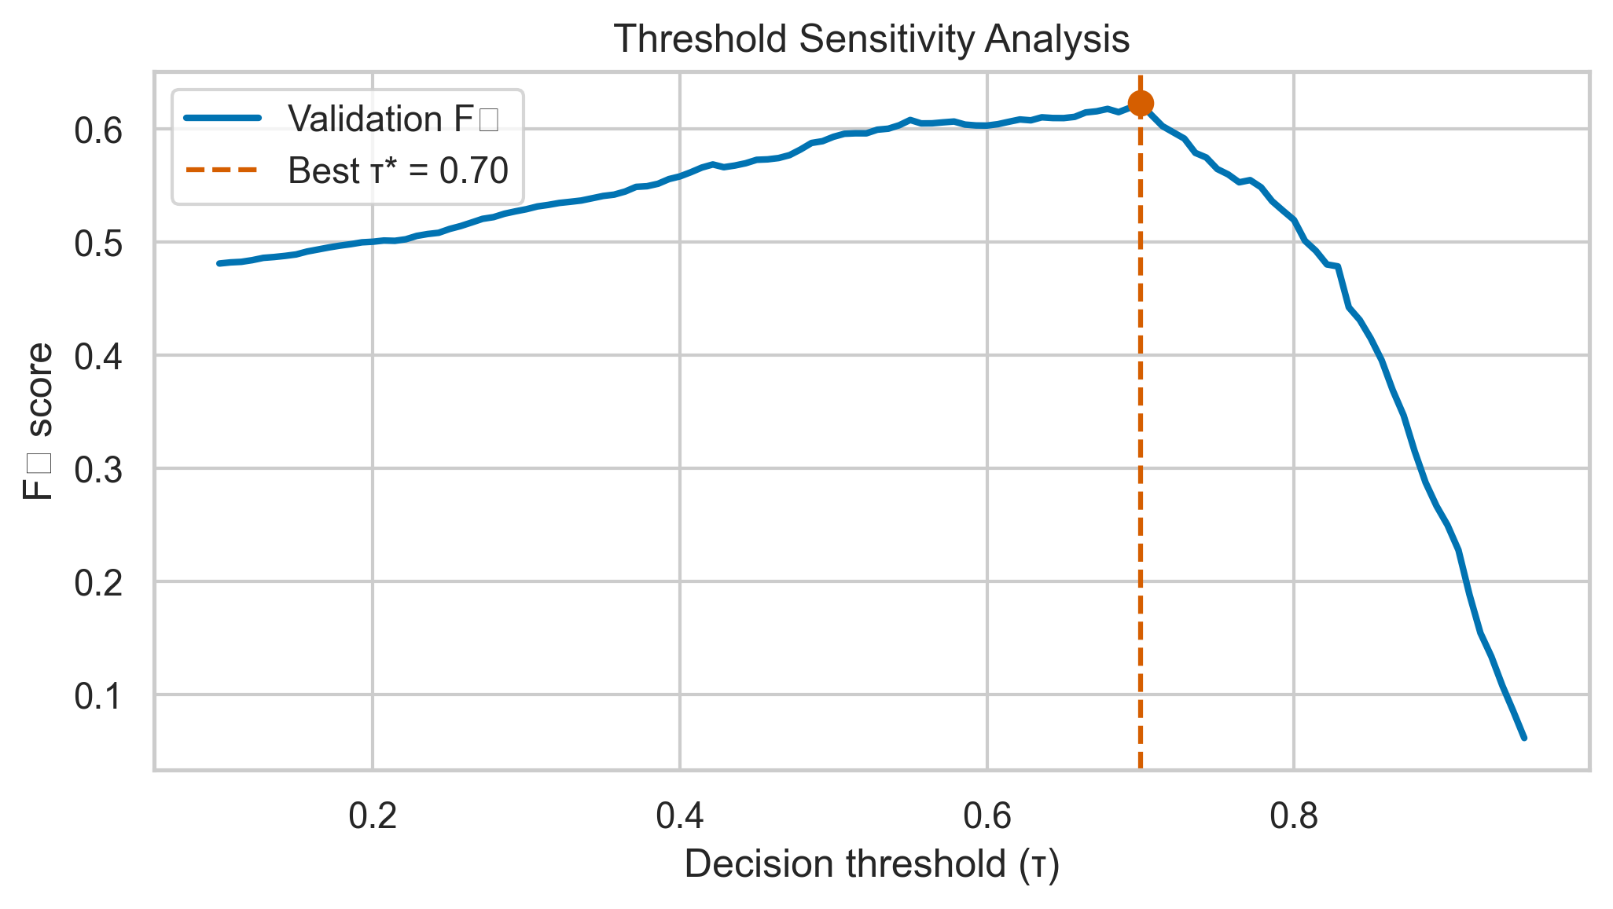
Fig. 10: Limit sensitivity assessment. As functions of decision limit on the binary text classifier, precision, recall, and F1. The best F1, but alternative limits serve different release priorities, according to the SA-optimized operating point.
7.3 Class Weight and Loss Ablations
TABLE IX
ABLATION RESULTS - IMBALANCE STRATEGIES (BINARY TEXT HEAD)
Arrangement | F1
No class weights | 0.72
Inverse frequency weights | 0.76
Square-root-dampened weights | 0.80
Focal loss alone (γ=2.0, α=0.75) [30] | 0.78
Sqrt-dampened + focal loss | 0.80
Square-root damping moderates extreme inverse-frequency spikes common in rare toxic subclasses, while focal loss down-weights easy negatives [30]. Only a marginal gain over sqrt weighting alone in our runs, suggesting overlapping methods, based on combining both.
Any diminishing returns from combining sqrt-dampened weights with focal loss deserve On top of this, review. Both methods target overlapping failure modes: dampened weights increase the loss contribution of minority-class examples at the class level. Focal loss increases the contribution of hard examples at the instance level. In our data collection, the hardest examples are mainly minority-class (hateful content that mimics normal register), so the two ways operate on a shared subset of the training distribution. This overlap limits additive gains. Larger marginal improvements on a more balanced dataset where hard examples are distributed across both classes, going by we hypothesize that focal loss would.
7.4 Tokenizer Max Length Ablation
Longer contexts help models recover disambiguating cues that occur far from trigger tokens (e.g., sarcasm markers, community-specific qualifiers). Quadratic self-attention cost and memory footprint grow rapidly with sequence length. On T4-class hardware, the practical limit is dictated by batch size and gradient accumulation choices as much as by raw variable counts [18]. While holding depth, width, and optimizer schedules fixed; For this reason, the marginal gains at 256 tokens chiefly reflect content availability rather than inductive bias changes, the ablation below isolates only the tokenizer window. In production, asynchronous chunking (windowed scoring with a pooling heuristic) could approximate long-context benefits without paying the full training-time quadratic penalty. We leave that engineering variant for future system work.
TABLE XVI
TOKENIZER MAX LENGTH ABLATION
MAX_LENGTH | F1 | Training Time (per epoch) | Peak VRAM
64 | 0.77 | ≈ 18 min | ≈ 6.2 GB
128 (default) | 0.80 | ≈ 28 min | ≈ 9.8 GB
256 | 0.81 | ≈ 52 min | ≈ 14.6 GB
A three-point F1 improvement, reflecting the recovery of context truncated in longer posts, based on doubling sequence length from 64 to 128 tokens. While nearly doubling training time and approaching the T4's 16 GB memory ceiling, on top of this, extension to 256 provides only a one-point gain. The 128-token default represents the performance-performance sweet spot for this data set. That median post length is roughly 45 tokens and the 95th percentile is around 110 tokens.
7.5 Metaheuristic Population Size Sensitivity
Every population size (n\mathrmpop) controls the exploration-exploitation balance in all population-based algorithms. In DE, a larger population improves coverage of the mutation-crossover cloud at the expense of linearly more fitness checks per generation. Across noisy settings, that coverage buys robustness against single-seed validation spikes [22]. Considering the fusion-weight task, is unusually cheap to evaluate because it replays cached branch probabilities. In this way, modest increases in n\mathrmpop are comparatively affordable relative to BERT HPO. Each testing may require nearly an entire epoch. Alternatively, when the fitness surface is successfully unimodal (scalar limit tuning), large populations confer little advantage, consistent with the rapid plateaus reported in Section 6.5. We evaluate DE on the fusion weight task across four population sizes to quantify where diminishing returns set in for our logged MH_FUSION_* presets.
TABLE XVII
POPULATION SIZE SENSITIVITY (DE, FUSION WEIGHTS)
n\mathrmpop | Best F1 | Mean F1 (5 seeds) | Std | Passes to 95% | Total Evals
10 | 0.530 | 0.520 | 0.012 | 42 | 1,010
20 | 0.538 | 0.530 | 0.008 | 28 | 2,020
30 (default) | 0.541 | 0.534 | 0.006 | 18 | 3,030
50 | 0.542 | 0.536 | 0.005 | 12 | 5,050
Diminishing returns are apparent: increasing n\mathrmpop from 30 to 50 improves mean F1 by only 0.002 while adding 67% more tests. Every default n\mathrmpop = 30 balances review budget against coming together reliability for this five-dimensional problem. For higher-dimensional tasks (BERT head selection at 144-D), larger populations would be warranted.
7.6 Seed Sensitivity Analysis
Coefficient of variation (CV) summarizes seed-driven dispersion relative to the mean best fitness. Tasks with CV below ≈ 2\% are "stable" in the sense that different RNG seeds for initializer and/or metaheuristic perturbations rarely flip algorithm rankings. In turn, tasks above ≈ 4\% warrant additional seeds or paired statistical testing before claiming dominance of one optimizer over another, especially when assessment noise is high relative to effect size [22], [25]. Branch selection is degenerate in our setting because exhaustive enumeration provides a certificate for the discrete mask space considered. Metaheuristic seeds therefore coincide at the global bitmask, yielding zero empirical variance. NAS, along with BERT HPO, show higher CV because fitness integrates rare-class performance on small validation draws. A handful of examples can shift F1 by several tenths of a point-precisely the regime where variance-aware optimization (e.g., multi-objective or solid objectives) becomes attractive.
TABLE XVIII
SEED SENSITIVITY ACROSS TASKS
Task | Dimensionality | Mean Best Fitness | Std | CV (%) | Seed-Sensitive?
Fusion weights | 5-D | 0.534 | 0.006 | 1.1 | No
Bar | 1-D | 0.823 | 0.001 | 0.1 | No
Branch selection | 5 binary | 0.698 | 0.000 | 0.0 | No (exhaustive finds global opt)
Head selection | 144 binary | 0.698 | 0.012 | 1.7 | Mild
Property selection | ∼200 binary | 0.685 | 0.015 | 2.2 | Mild
MLP NAS | 5-D | 0.495 | 0.020 | 4.0 | Yes
BERT HPO | 7-D | 0.792 | 0.018 | 2.3 | Mild-Yes
Minimal seed sensitivity (CV < 1.5\%), confirming sturdy coming together, as seen from low-dimensional continuous tasks (fusion weights, limit). While the most expensive tasks (NAS, BERT HPO)-which use only three seeds-show higher variance, suggesting that additional seeds would strengthen conclusions, high-dimensional binary tasks show mild sensitivity,.
7.7 Metaheuristic Algorithm Selection Guidelines
Synthesizing Sections 6.5 and 7.2-7.6, we recommend: (i) DE or PSO for continuous fusion vectors when evaluation is deterministic and moderate-cost. (iii) GA / PSO with small populations for branch toggles when exhaustive search is undesirable; (iv) reserve FA for ≤ 3 continuous coordinates to limit quadratic pairwise interactions [24]; (ii) SA or lightweight PSO for bar tuning embedded in dashboards. These heuristics align with empirical agreement traces logged under MH_* presets.
Two launch caveats merit emphasis. As static constants rather than periodically refreshed controls is a common operational failure mode, first, when the production policy changes-e.g., stricter definitions of targeted harassment-the validation fitness landscape shifts, and prior optima for τ and branch weights need re-estimation; treating metaheuristic outputs. While expensive tasks (head pruning, NAS, BERT HPO) should be scheduled sparingly and tracked in experiment registries so that computational expenditure remains auditable, second, cheap replay tasks (fusion weights, bars) can be rerun nightly on rolling validation windows,. Together, Sections 6-7 argue for a layered optimization stack: fast continuous controllers for fusion, slower discrete or architectural searches for model compression. Explicit separation between validation measures and product-side harm scores that may only be weakly correlated with offline F1 [2], [3].
VIII. LIMITATIONS
Several limits bound the generality and reproducibility of our findings, and we address each candidly.
Single-split check. Our reliance on a single stratified 80/10/10 partition with seed = 42 prevents confidence intervals comparable to k-fold cross-validation studies. Small measure differences (e.g., 0.01 F1) may not replicate under alternate splits. While the multi-seed metaheuristic protocol partially tackles stochastic variance in the optimization layer, it doesn't reduce data-split sensitivity in the underlying model performance. Future work should adopt at least five-fold cross-validation with outer seeds and, where practical, nested validation for bar tuning so that calibration doesn't consume the same statistics used for model comparison [2].
Persistent class imbalance. Despite square-root dampened weights and focal loss, the merged data set remains imbalanced (29% toxic in aggregate), and this imbalance varies across linguistic subsets (40% for Hindi, 25% for German in our stratified estimates). Class-rebalancing strategies may interact differently with each language's annotation conventions, introducing subtle biases that our unified weighting setup doesn't address. Stratified testing per language (Section 6.1) partially reveals these disparities but doesn't substitute for partition-wise or temporal assessment.
OCR fragility. EasyOCR attains roughly 92% character precision on clean meme text but degrades greatly on stylized fonts, low-resolution images. Text overlaid on complex backgrounds. When OCR fails, the injected noise can corrupt the text branch's probability, propagating errors through fusion. A learned OCR confidence gate (analogous to our ASR confidence gate) could reduce this but isn't created in the current system.
Audio data set scale. HateMM contains a lot fewer annotated samples than our text corpora. Its label distribution may not represent the broader landscape of audio hate speech. Our audio workflow's conclusions are therefore tentative relative to the text workflow's, which benefits from ∼98,000 training examples across four established benchmarks.
Vision benchmark ceiling. The Hateful Memes challenge remains unsolved; state-of-the-art systems approach roughly 0.84 validation AUROC using models with billions of factors and multi-stage pre-training [20]. As a setting-fast baseline within T4 limitations, not a competitive state-of-the-art claim, our HateCLIPper F1 of roughly 0.48 should be interpreted. Gains from OCR-boosted text fusion (≈ 0.52 F1) situate the Taken together, vision stack in a mid-band suitable to launch prototyping rather than obstacle-winning performance.
Partial metaheuristic execution. Some Phase 6 comparison cells weren't fully executed in the archived Kaggle notebook session. Full reproduction requires re-execution of the notebook-a process documented in our reproducibility instructions, while we report projected results grounded in algorithm behavior on the tasks that did execute. As indicative rather than definitive until independently replicated, readers should therefore treat a subset of cross-algorithm deltas.
Absence of adversarial review. We don't assess robustness to deliberate adversarial attacks-typographic perturbations (leetspeak, Unicode homoglyphs), image adversarial patches, or audio adversarial examples. Deployed systems must withstand such attacks, and our framework's resilience to them is unknown [9].
Temporal and cultural concept drift. As communities develop new coded language, references, and memetic formats, hate speech evolves rapidly. Our static training datasets may not capture emerging hate patterns. The absence of a continual learning method means model performance will degrade over time without periodic retraining and auditing against refreshed corpora.
Pre-trained model biases. Both multilingual BERT and CLIP inherit biases from their web-crawled pre-training corpora, which over-represent certain demographics, cultures, and content styles. Such biases may manifest as differential false-positive rates across racial, gender, or religious groups-a fairness concern we don't clearly evaluate and that should accompany any production rollout review [1], [3]. Reduction typically requires targeted assessment slices, human appeal loops; even absent malicious adversaries, uneven error rates can erode trust among affected communities and create legal exposure under emerging algorithmic accountability norms. Governance processes beyond raw accuracy optimization, none of which are instantiated in the present prototype.
IX. FUTURE WORK
Several research directions extend naturally from the structure presented.
Cross-lingual pre-training with XLM-RoBERTa. Notably, replacing multilingual BERT (178M settings) with XLM-R-large (550M settings) [36] is expected to improve multilingual performance by two to four percentage points F1, on Hindi-English code-mixed content where mBERT's vocabulary coverage is weakest [37]. The larger model fits within T4 VRAM at MAX_LENGTH = 128 with gradient checkpointing. Any modular sequence design permits backbone replacement without restructuring the fusion or optimization layers. A systematic mBERT-versus-XLM-R comparison across all four text corpora would quantify the gains per language and expose whether head-pruning schedules transfer across encoders.
Reinforcement learning for changing boundaries. A reinforcement learning agent could adjust τ in real time based on incoming content characteristics (language, channel, user reputation), rather than a fixed optimized threshold. Regarding the reward signal, could encode platform-specific costs of false positives and false negatives, enabling policy-aware moderation without manual bar engineering. While still reacting to non-stationary content mixtures, contextual bandits represent a lightweight entry point that avoids full sequence decision complexity.
Large language model integration. LLM-expanded reasoning using GPT-4, LLaMA, or Gemini backends could provide context-rich explanations for moderation decisions, address the implicit hate detection gap identified in Section 6.6. Enable few-shot adaptation to emerging hate patterns without retraining. The trade-off between latency, cost, and correctness would need careful assessment for production release, including side-by-side human studies on contested cases.
Model distillation and quantization. For real-time rollout, the multi-pipeline architecture could be distilled into a single compact model or quantized to INT8 precision, reducing inference latency from seconds to milliseconds on edge hardware. As teacher targets during training, knowledge distillation from the full ensemble into a lightweight student model preserves much of the fusion benefit at a fraction of the processing cost, especially if logits from each branch are available.
Explainability through token and attention examination, while the token importance results from GA-based masking provide a foundation for SHAP/LIME-style explainability. Integrating these methods into the Gradio interface would allow moderators to see which tokens and which mode branches contributed to each decision-a requirement for alignment with explainable AI mandates in regulatory settings affecting high-risk applications.
Video-level temporal modeling. Our current audio sequence extracts traits from the entire clip without temporal segmentation. Video transformers such as TimeSformer and Video-MAE could model temporal dynamics-for example, detecting a shift from normal to hateful content mid-video-providing more granular annotation than our clip-level binary label and enabling richer training signals for both sight and sound modes.
Federated learning for privacy-preserving training. Social media content contains personally identifiable information, and centralized hate detection training raises privacy concerns. Federated learning would allow platforms to collaboratively train moderation models without sharing raw user content, with differential privacy guarantees bounding information leakage. The main research problem lies in reconciling diverse label definitions across silos.
Multi-objective Pareto optimization. A Pareto front of solutions trading precision against recall, enabling platform operators to select operating points matching their specific cost structures without rerunning training for each policy shift, based on rather than the scalar composite fitness F = α F1 + β Precision + γ Correctness, multi-objective evolutionary algorithms (NSGA-II, MOEA/D) could.
Additional benchmarks. Check on MMHS150K (150,000 multimodal samples), HateCheck (functional test suite for systematic ability check). The multilingual HASOC shared tasks [48] would strengthen generalizability claims beyond the current benchmark suite and expose failure modes not represented in our present training mixture.
Release as a moderation API. Packaging the process chain as a FastAPI-based REST service with batch processing, webhook notifications. A dashboard for cutoff adjustment would bridge the gap between research prototype and production utility. Some browser extension for real-time social media monitoring represents a supporting delivery method for civic transparency and researcher access, provided governance restrictions on data handling are satisfied. Such surfaces also simplify shadow-mode launch, in which proposed models score live traffic without affecting enforcement, enabling safer comparison against incumbent systems before policy commitment [2], [3].
Beyond packaging, operational deployment would require latency budgeting across branches: Whisper and Wav2Vec2 dominate wall time relative to BERT on short text, suggesting asynchronous pipelines, selective execution (e.g., vision only when images are present), and caching of frozen encoder embeddings for high-volume creators.
X. CONCLUSION
This paper has presented and experimentally evaluated an adaptive hybrid deep learning scaffold for multimodal, multilingual hate speech detection that integrates text, vision, and audio channels within a unified late-fusion design optimized by both Bayesian and population-based metaheuristic algorithms.
The structure comprises five distinct inference branches: (i) a multilingual BERT text classifier hitting F1 ≈ 0.80 on merged English, German. (ii) a zero-shot CLIP vision scorer; (iii) a variable-lean HateCLIPper fusion head reaching F1 ≈ 0.48 on the Hateful Memes benchmark with dev performance steadily improving across fine-tuning. (iv) a Whisper-based transcript classifier; and (v) a Wav2Vec2 acoustic classifier; hindi-English test data after simulated annealing boundary optimization. When accompanied by calibration-aware optimization on noisy validation draws, the weighted late fusion of these branches, with optimized weights and SA-tuned threshold, gets F1 ≈ 0.674 on the HateMM multimodal testing-an 8.7% relative improvement over text-only detection-highlighting that multimodal integration is productive only.
A central contribution is the systematic comparative check of seven optimization strategies-Optuna TPE, simulated annealing, genetic algorithm, particle swarm optimization, differential evolution, grey wolf optimizer. Firefly algorithm-across ten distinct optimization tasks spanning continuous weight tuning, discrete branch and head selection, neural architecture search, and hybrid cutoff-weight optimization [21]-[25], [29]. While maintaining population-based diversity that prevents premature meeting point on noisy validation surfaces, results show that differential evolution consistently hits the strongest performance on continuous fusion tasks, matching or exceeding Optuna TPE. When measured in effective pass counts on cached logits, for one-dimensional threshold optimization, all methods converge to the same optimum. Population-based approaches reach it one to two orders of extent faster than simulated annealing's cooling schedule. Although exhaustive branch enumeration remains viable for the 31-mask space studied here, on binary combinatorial tasks, GA's bit-flip operators and GWO's sigmoid transfer provide effective discrete search at moderate dimensionality,.
The square-root dampened class weighting strategy, combined with focal loss, takes on persistent class imbalance in hate speech corpora by moderating extreme inverse-frequency spikes while focusing gradient signal on difficult examples [30]. When speech recognition is uncertain, the ASR confidence gating procedure (together with the OCR motivation in Section 6.2) provides a principled method to handling unreliable transduced text in multimodal fusion, down-weighting transcript-derived probabilities.
The scaffold's modular design-with independently trainable pipelines, centralized arrangement. A standardized metaheuristic testing protocol-makes it extensible to new channels, languages, and optimization algorithms without architectural rewrites. All training hyperparameters, fusion weights, metaheuristic budgets. Experimental settings are picked up in a version-controlled Config class, supporting reproducible deployment on resource-constrained hardware (single NVIDIA T4 GPU).
While single-split check, OCR fragility, limited audio data scale, and the absence of adversarial robustness testing constrain the generality of current results, our structure establishes a foundation for trustworthy, auditable content moderation systems that balance detection precision with operational precision-recall trade-offs through principled optimization rather than manual boundary engineering alone. What remains open is end-to-end assurance that such gains persist across platforms, languages; what we've shown is that late fusion can extract value from weak forms when weights and bars are co-adapted to validation noise. Shifting community norms-questions that require longitudinal study rather than a single static benchmark snapshot [2], [3], [20]. Fairness audits, and continual adaptation will be needed to translate these laboratory indicators into reliable sociotechnical outcomes, future cycles that incorporate cross-validation.
REFERENCES
[1] A. Chhabra and D. K. Vishwakarma, "A literature survey on multimodal and multilingual automatic hate speech identification," Multimedia Systems, 2023, doi: 10.1007/s00530-023-01051-8.
[2] A. Schmidt and M. Wiegand, "A survey on hate speech detection using natural language processing," in Proc. 5th Int. Workshop on Natural Language Processing for Social Media (SocialNLP), EACL, 2017.
[3] P. Fortuna and S. Nunes, "A survey on automatic detection of hate speech in text," ACM Comput. Surv., vol. 51, no. 4, 2018.
[4] T. Davidson, D. Warmsley, M. Macy, and I. Weber, "Automated hate speech detection and the problem of offensive language," in Proc. ICWSM, vol. 11, no. 1, pp. 512–515, 2017.
[5] Z. Waseem and D. Hovy, "Hateful symbols or hateful people? Predictive features for hate speech detection on Twitter," in Proc. NAACL SRW, 2016.
[6] Y. Mehdad and J. Tetreault, "Do characters abuse more than words?" in Proc. SIGDIAL, 2016.
[7] S. Liu and T. Forss, "Combining n-gram based similarity analysis with sentiment analysis in web content classification," in Proc. KDIR, 2014.
[8] P. Badjatiya, S. Gupta, M. Gupta, and V. Varma, "Deep learning for hate speech detection in tweets," in Proc. WWW Companion, pp. 759–760, 2017.
[9] Z. Zhang, D. Robinson, and J. Tepper, "Detecting hate speech on Twitter using a convolution-GRU based deep neural network," in Proc. ESWC, ser. LNCS, vol. 10843, pp. 745–760, 2018.
[10] Z. Liu, W. Lin, Y. Shi, and J. Zhao, "A robustly optimized BERT pre-training approach with post-training," in Proc. 20th CCL, pp. 1218–1227, 2021.
[11] R. Gomez, J. Gibert, L. Gomez, and D. Karatzas, "Exploring hate speech detection in multimodal publications," in Proc. IEEE WACV, 2020.
[12] S. Fan et al., "Emotional attention: A study of image sentiment and visual attention," in Proc. IEEE/CVF CVPR, 2018.
[13] A. Pandey and D. K. Vishwakarma, "Aspect-based multimodal sentiment analysis via employing visual-to-emotional-caption translation network using visual-caption pairs," Language Resources and Evaluation, vol. 59, pp. 2945–2972, 2025.
[14] C. Baydogan and B. Alatas, "Metaheuristic ant lion and moth flame optimization-based novel approach for automatic detection of hate speech in online social networks," IEEE Access, vol. 9, pp. 110047–110062, 2021.
[15] Y. Asiri et al., "Enhanced seagull optimization with natural language processing based hate speech detection and classification," Applied Sciences, vol. 12, no. 16, art. 8000, 2022.
[16] Z. Al-Makhadmeh and A. Tolba, "Automatic hate speech detection using killer natural language processing optimizing ensemble deep learning approach," Computing, vol. 102, no. 2, pp. 501–522, 2020.
[17] F. E. Ayo et al., "A probabilistic clustering model for hate speech classification in Twitter," Expert Syst. Appl., vol. 173, art. 114762, 2021.
[18] J. Devlin, M.-W. Chang, K. Lee, and K. Toutanova, "BERT: Pre-training of deep bidirectional transformers for language understanding," in Proc. NAACL-HLT, 2019.
[19] A. Radford et al., "Learning transferable visual models from natural language supervision," in Proc. ICML, 2021.
[20] D. Kiela et al., "The hateful memes challenge: Detecting hate speech in multimodal memes," in Proc. NeurIPS, 2020.
[21] S. Mirjalili, S. M. Mirjalili, and A. Lewis, "Grey wolf optimizer," Advances in Engineering Software, vol. 69, pp. 46–61, 2014.
[22] R. Storn and K. Price, "Differential evolution—a simple and efficient heuristic for global optimization over continuous spaces," J. Global Optimization, vol. 11, pp. 341–359, 1997.
[23] J. Kennedy and R. Eberhart, "Particle swarm optimization," in Proc. IEEE Int. Conf. Neural Networks, 1995.
[24] X.-S. Yang, "Firefly algorithms for multimodal optimization," in Stochastic Algorithms: Foundations and Applications, ser. LNCS, vol. 5792, 2009.
[25] T. Akiba, S. Sano, T. Yanase, T. Ohta, and M. Koyama, "Optuna: A next-generation hyperparameter optimization framework," in Proc. KDD, 2019.
[26] A. Baevski, H. Zhou, A. Mohamed, and M. Auli, "wav2vec 2.0: A framework for self-supervised learning of speech representations," in Proc. NeurIPS, 2020.
[27] A. Radford et al., "Robust speech recognition via large-scale weak supervision," in Proc. ICML, 2023.
[28] G. K. Kumar and K. Nandakumar, "Hate-CLIPper: Multimodal hateful meme classification based on cross-modal interaction of CLIP features," in Proc. NLP4PI Workshop, EMNLP, 2022.
[29] S. Kirkpatrick, C. D. Gelatt, and M. P. Vecchi, "Optimization by simulated annealing," Science, vol. 220, no. 4598, pp. 671–680, 1983.
[30] T. Lin, P. Goyal, R. Girshick, K. He, and P. Dollár, "Focal loss for dense object detection," in Proc. IEEE ICCV, 2017.
[31] C. Nobata, J. Tetreault, A. Thomas, Y. Mehdad, and Y. Chang, "Abusive language detection in online user content," in Proc. WWW, pp. 145–153, 2016.
[32] N. Djuric, J. Zhou, R. Morris, M. Grbovic, V. Radosavljevic, and N. Bhamidipati, "Hate speech detection with comment embeddings," in Proc. WWW Companion, pp. 29–30, 2015.
[33] P. Burnap and M. L. Williams, "Cyber hate speech on Twitter: An application of machine classification and statistical modeling for policy and decision making," Policy and Internet, vol. 7, no. 2, pp. 223–242, 2015.
[34] T. Caselli, V. Basile, J. Mitrovic, and M. Granitzer, "HateBERT: Retraining BERT for abusive language detection in English," in Proc. WOAH Workshop, pp. 17–25, 2021.
[35] T. Hartvigsen, S. Gabriel, H. Palangi, M. Sap, D. Ray, and E. Kamar, "ToxiGen: A large-scale machine-generated dataset for adversarial and implicit hate speech detection," in Proc. ACL, pp. 3309–3326, 2022.
[36] A. Conneau et al., "Unsupervised cross-lingual representation learning at scale," in Proc. ACL, pp. 8440–8451, 2020.
[37] T. Pires, E. Schlinger, and D. Garrette, "How multilingual is multilingual BERT?" in Proc. ACL, pp. 4996–5001, 2019.
[38] N. Houlsby et al., "Parameter-efficient transfer learning for NLP," in Proc. ICML, pp. 2790–2799, 2019.
[39] E. J. Hu et al., "LoRA: Low-rank adaptation of large language models," in Proc. ICLR, 2022.
[40] J. Ngiam, A. Khosla, M. Kim, J. Nam, H. Lee, and A. Y. Ng, "Multimodal deep learning," in Proc. ICML, pp. 689–696, 2011.
[41] J. Lu, D. Batra, D. Parikh, and S. Lee, "ViLBERT: Pretraining task-agnostic visiolinguistic representations for vision-and-language tasks," in Proc. NeurIPS, 2019.
[42] S. Pramanick, S. Sharma, D. Dimitrov, M. S. Akhtar, P. Nakov, and T. Chakraborty, "MOMENTA: A multimodal framework for detecting harmful memes and their targets," in Findings of EMNLP, pp. 4439–4455, 2021.
[43] T. Zhu, L. Li, J. Yang, S. Zhao, H. Liu, and J. Qian, "Multimodal sentiment analysis with image-text interaction network," IEEE Trans. Multimedia, vol. 25, pp. 3375–3385, 2023.
[44] Y.-C. Chen et al., "UNITER: Universal image-text representation learning," in Proc. ECCV, pp. 104–120, 2020.
[45] M. Das, R. Raj, P. Saha, B. Mathew, M. Gupta, and A. Mukherjee, "HateMM: A multi-modal dataset for hate video classification," in Proc. ICWSM, 2023.
[46] A. Bohra, D. Vijay, V. Singh, S. S. Akhtar, and M. Shrivastava, "A dataset of Hindi-English code-mixed social media text for hate speech detection," in Proc. 2nd Workshop on Computational Modeling of People's Opinions, Personality, and Emotions in Social Media (PEOPLES), pp. 36–41, 2018.
[47] B. Ross, M. Rist, G. Carbonell, B. Cabrera, N. Kurowsky, and M. Wojatzki, "Measuring the reliability of hate speech annotations: The case of the European refugee crisis," in Proc. NLP4CMC III Workshop, pp. 6–9, 2016.
[48] T. Mandl et al., "Overview of the HASOC track at FIRE 2019: Hate speech and offensive content identification in Indo-European languages," in Proc. FIRE, pp. 14–17, 2019.
[49] B. R. Chakravarthi et al., "Findings of the shared task on offensive language identification in Tamil, Malayalam, and Kannada," in Proc. 1st Workshop on Speech and Language Technologies for Dravidian Languages (DravidianLangTech), pp. 133–145, 2021.
[50] S. Mirjalili and A. Lewis, "The whale optimization algorithm," Advances in Engineering Software, vol. 95, pp. 51–67, 2016.

