Apogy Project Proposal Form

Project Name:

Apogy

Parent Project:

Technology Project

Background:

Space exploration has become increasingly more complex over the years, with latest mission making used of spacecraft being assemblies of complex sub-systems. Such increase in complexity has made the creation of the necessary tools to provide mission planning, commanding and monitoring more and more complex and costly over the years.

After many projects at the Canadian Space Agency where such tools were created from the ground up, commons patterns emerged. Such things has defining system commands and telemetry, displaying telemetry to the operator, creating commands,validating commands sequence using simulation, tracking commands result, maintaining context information with science data (time, location, etc), showing the system in its environment (ex: a rover on the surface of Mars, a satellite on its orbit), to name a few, were needed in most scenarios.

The idea of reusable functionality started to become clear. The large number hardware systems that had to be integrated together to function as a integrated system in simulated missions in the last few years just did not leave any other choice : a common framework providing the reusable functionality, without preventing customization, add to created. The Eclipse Plateform and the Eclipse Modeling Framework proved to the the tools of choice onto which to build such a framework.

This is how Apogy got started. After a few years of development and use, Apogy was found to simplify and speed up the creation of the ground tools required to support operations. In the last years, Apogy has been used in multiple deployments involving different types of rovers equipped with various sensors and instruments all operated through Apogy.

While Apogy initial target use was space robotics operation, the basics principles and functions are applicable to a wide range of systems and operations here on Earth.

Scope:

Apogy is aimed at providing a reusable software framework to quickly created the required operators tools used to plan, validate, execute and monitor integrated operations of physical systems.

Description:
The Apogy open source project aims at making available a set of frameworks, EMF models and components that will simplify the creation of the software required to operate a physical system.
Given our background on space missions, Apogy will include support to represent 3D topologies, interact with simple sensors, and provides a plan editor that allows an operator to simulate or control a system.
Details
Apogy provides a single model that defines: command, telemetry, engineering units, limits, documentation, 3D topology and 3D representation. System assemblies can then be created from these models to build different spacecraft and instrument configurations. The mission target environment can also be defined that includes maps (2D and 3D), locations, annotations as well as location specific and time dependent model of the sky (sun, moon and stars). The framework provides basic operational plan editors that allow, through context switching, the tests and execution of plans in a seamless process.
Teleoperation is supported through flexible hand controller mapping, camera displays with customizable overlays and image filtering, and real-time map displays (2D and 3D). Apogy maintains rigorously contexts information such as the command and parameter used to generate the plan execution product, timing information and localization. Apogy then make use of this information to provide the overall context of the operations and their products to the engineers and scientists.
In its current form, Apogy includes, but not limited to, the following:

- System modeling support, including:
  - 3D topology modeling as EMF models;
  - Data bindings for system to 3D models (connecting telemetry to 3D model behaviors);
  - 3D System viewer based on the JmonkeyEngine 3;
  - Basics sensors EMF models (Camera, Field of View, etc);
  - Limited Robot Operating System (ROS) interfacing support EMF models.

- Environment modeling including:
  - Earth Surface worksite EMF models and implementation;
  - Earth Orbit and worksites EMF models and implementation;
  - 3D Environment viewer based on the JmonkeyEngine 3;
  - Basics 3D data EMF models (Point clouds, meshes, etc);
  - Actual example of Earth Surface Worksites, including Digital Elevation Models.

- Basic operation call definitions, including:
  - Basic command list and parameters;
  - Game controllers to system model commands mapping ;
  - Command to Data context models;

- Supporting code, including:
  - Various mathematical models and utilities;
  - 3D data manipulation utilities;
  - Image manipulation utilities;
  - Path and Path planners EMF models and implementation;
  - Limited import/export functions from/to external models (ex : DEM);
  - ...

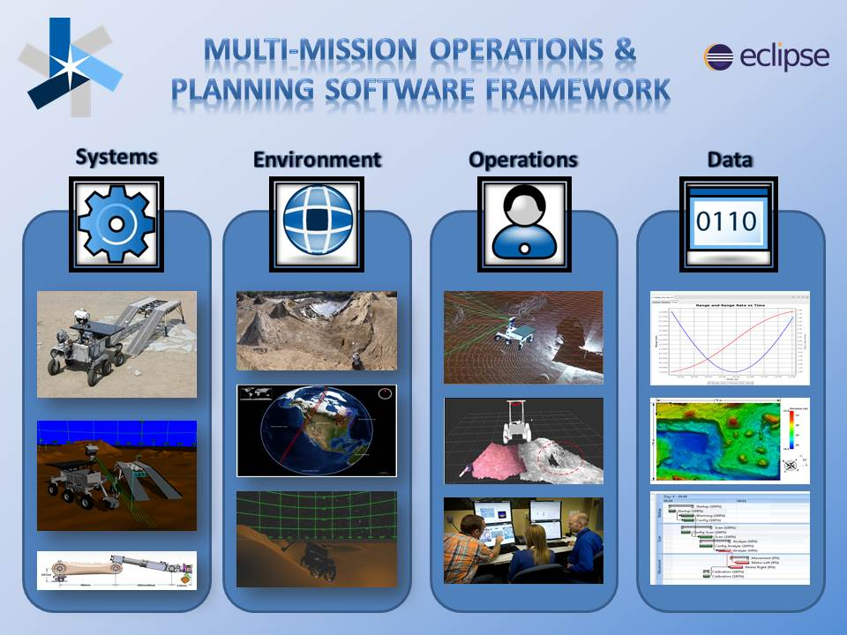

Why Here ?:
Apogy being based on the Eclipse Platform, EMF and many Eclipse other technologies; it seems natural to us to open source it at the Eclipse Foundation.

Apogy has been created from the beginning to promote a modular and extendable software framework to support and encourage functionality contribution to enhance its capability.

The Apogy team encourages users and developers to contribute additional capabilities, which is a fundamental principle of the Eclipse Community. The creation of a strong community of users and committers is of prime importance to continue to improve Apogy.

The Apogy team has been a fervant user of Eclipse and its tools for the past 10 years. The team feels it is now time to give back to the Eclipse community by contributing our work, provide support and encourage collaboration on such a project.

Licenses
Eclipse Public License 1.0

Legal Issues
The current source cod includes dependencies to software licensed under LGPL. Namely:

- JFreeChart (http://www.jfree.org/jfreechart)
- KDTree (http://home.wlu.edu/~levys/software/kd)

Initial Contribution:

The existing code includes all the basics functions of Apogy desbribed above.

Also included are :

- Documentation of concepts and APIs;
- Functional systems model examples and their documentation;
- Units tests used as part of the continuous development cycle.

The Canadian Space Agency holds the Copyrights for all the existing code and documentation under this contribution.

The contribution also includes the Apogy Logo:

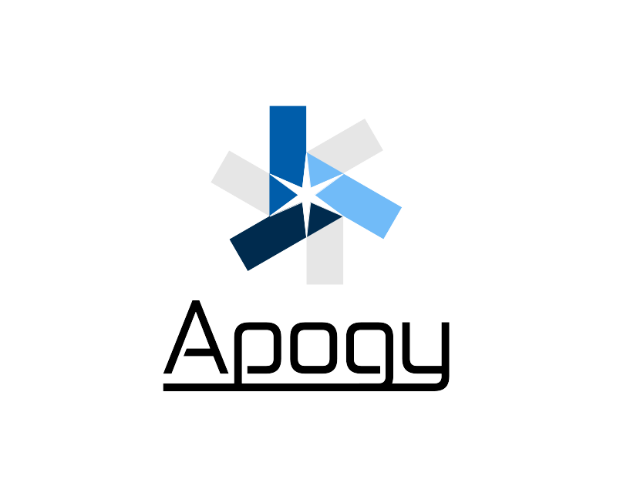

Project Scheduling:

The project releases will align with Eclipse's annual release train.

Future Work:
Currently, the following future work items are planned within the next year:

- Add EMF models and UI support for command scripts. The first scripting language to be targeted is JavaScript. The required JavaScript to Apogy tolling is currently under development;
- Add the required EMF model and UI support to create operator displays at run time. Development on this item is not started.
- Complete the development and integration of the Earth Orbital Worksite, include required 3D viewer support;

Source Code:

Source Repository Type : Git

Repository : TODO

People:

Projects Lead:

- Régent L'Archevêque
- Pierre Allard

Commiters:

- Sébastien Gemme

Mentors:

- Ed Merks
- Pascal Rapicault

Interested Parties

