VRML (.wrl) to Wavefront (.obj) File Conversion Procedure

- If the VRML file is of version 1.0 (#VRML V1.0), first convert it to VRML version 2.0.

  - On Windows, a converter can be found at: http://ftp.carnet.hr/misc/VRML/utilities/converters/vrml1to2/

- Import the VRML file into Blender ():

  - File→Import→X3D Extensible 3D (.x3d/.wrl);

- Delete all non essential elements (Camera, Lamp, Cube, etc.) from the scene. Only keep the required geometry.

- Export the geometry to .obj:

  - File→Export→Wavefront (.obj)

- Setup the Export OBJ settings as shown:
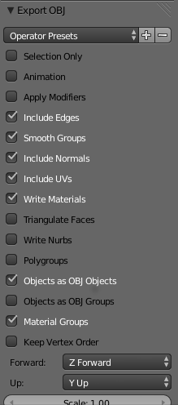
- Export OBJ

