**Writeup PetShop**

**Flag 0:** first I tried all function of website. Then, I found a hidden tag. I delete type=’hidden’ and change value price is 0 🡪 after press checkout I seen a flag.

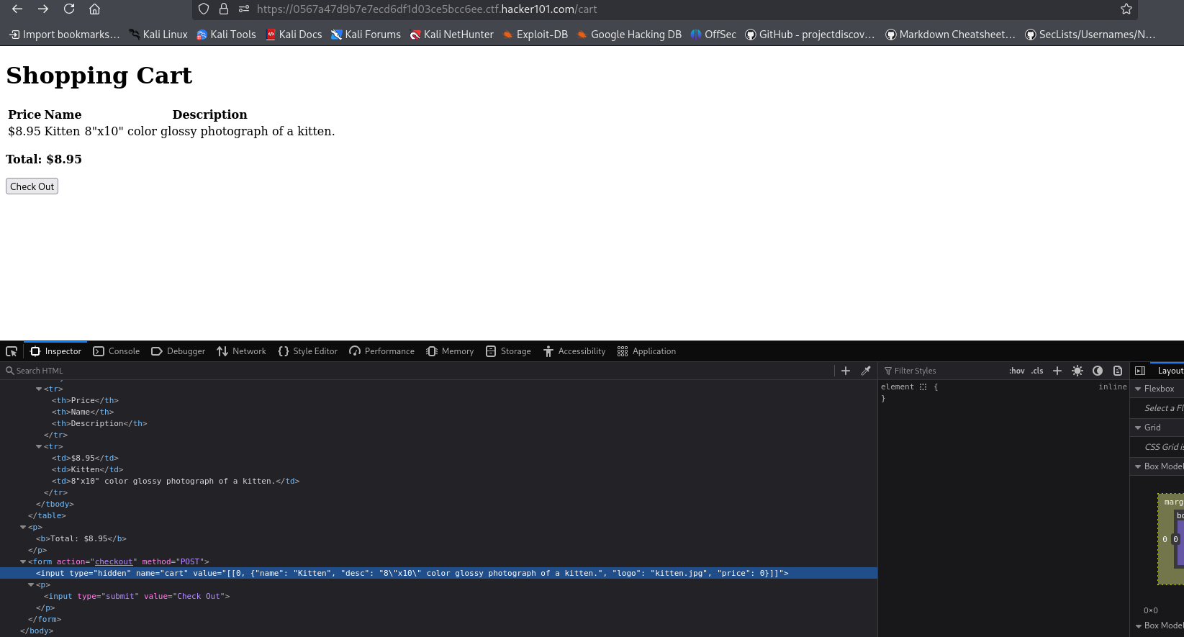

**Flag** **1**: I used gobuster to burpforce dir in website. I really found something.

With command:

goubuster -u “https://0567a47d9b7e7ecd6df1d03ce5bcc6ee.ctf.hacker101.com” -w wordlist.txt

I found:

/edit?id=0, /login (I also try burp parameter and their value)

In /edit?id=0, I used some payload to test but I don’t see change anything…

I thought they stored in elsewhere.

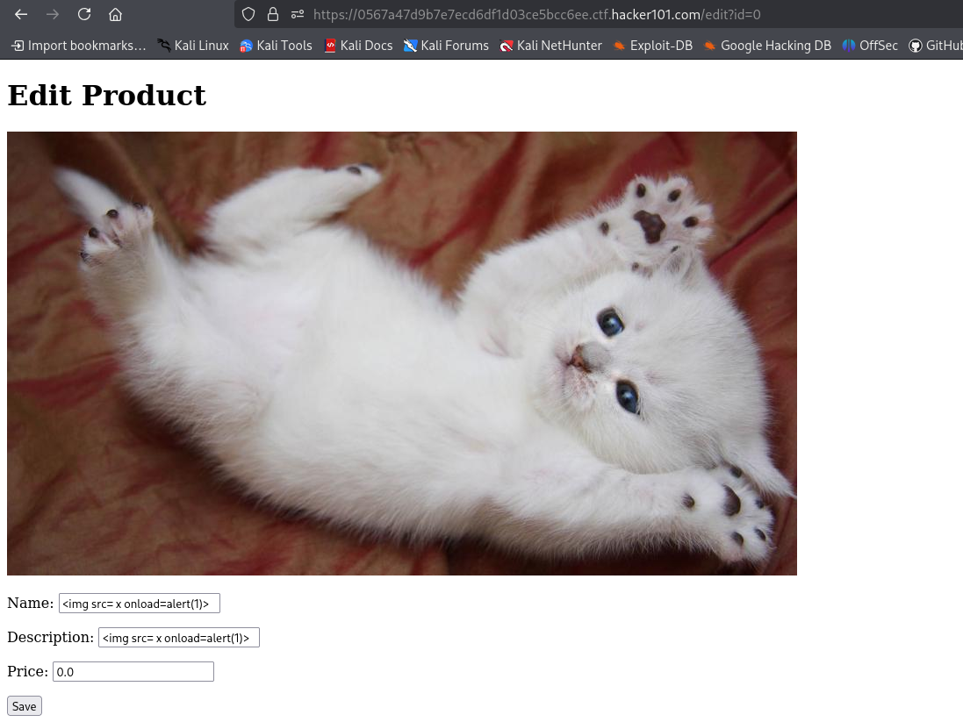

When I come back to /cart i seen the flag. -> done flag 1.

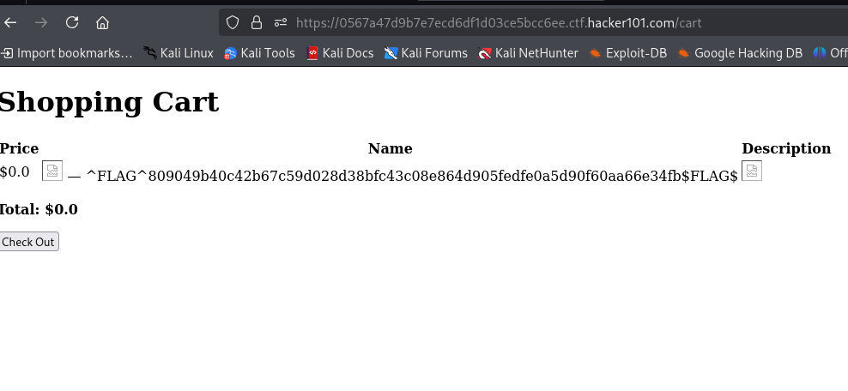

Final flag: I used burpsuite check usename with wordlist of https://github.com/danielmiessler/SecLists/blob/master/Usernames/Names/names.txt

I found username.

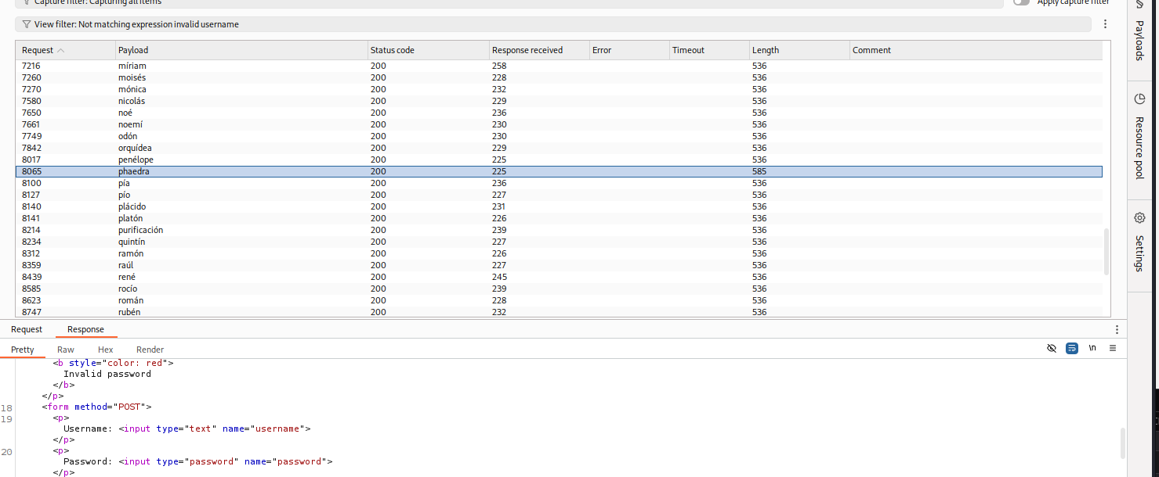

Then I also burpforce password with same executive. Ah I used wordlist in https://github.com/danielmiessler/SecLists/blob/master/Passwords/Common-Credentials/common-passwords-win.txt -> found password.

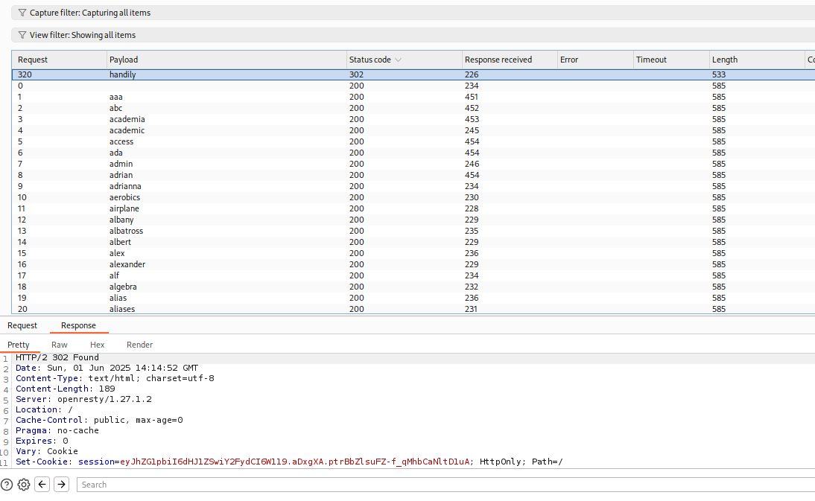

Then login I could watched flag.

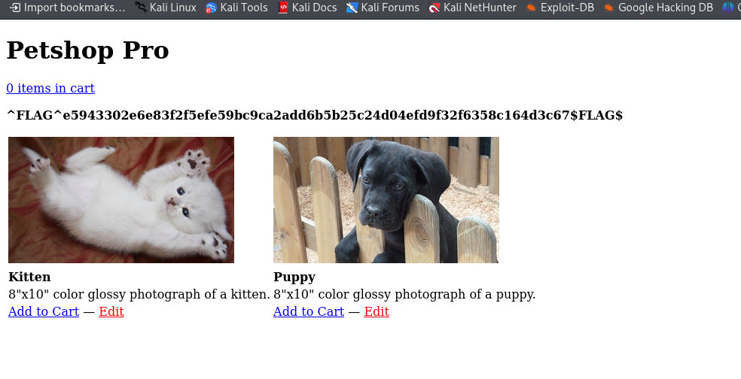

Done.