Home Assignment:

1. Add the resume folder containing the resume files to the existing workspace.
2. write a prompt to implement a batch ingestion workflow for resumes.
3. Configure the workflow to process resumes in batches of 5 or 10 files per run.
4. Validate the ingestion process by testing multiple batches and verifying that all resumes are successfully ingested.

Step1
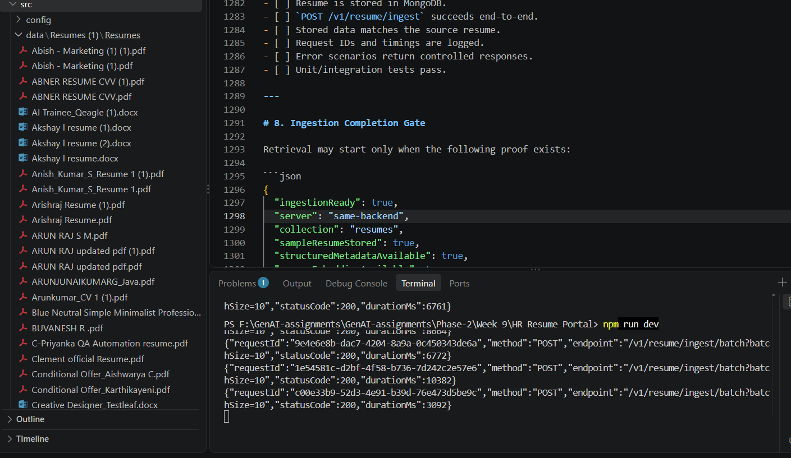
Step2
