
CEE Group Processor
Application Guide
Version 1.7

Table of Contents
1. Introduction 3
1.1. Benefits 3
2. Distribution 3
2.1. Installation 3
2.1.1. Installation prerequisites 3
2.1.2. Language selection. 3
2.1.3. Welcome screen. 4
2.1.4. Destination folder selection 4
2.1.5. Ready to install screen 4
2.1.6. Adding shortcut to the Smartpoint Quick Commands 5
2.1.7. Start menu folder 5
2.2. Application upgrade 6
2.3. Application uninstalling 6
3. Application setup 6
3.1. Application initialization 6
4. Program usage 8
4.1. Main screen controls description 8
4.2. Source PNR editing and error handling 9
4.2.1. PNR parsing logic description 9
4.2.2. Identical Passenger names and missing first names treatment 10
4.2.3. Flight data error treatment 11
4.3. Galileo group booking process 12
5. Support and Troubleshooting 14

- Introduction
CEE Group Processor is a tool that helps agency to create passive group booking in Galileo™ GDS upon PNR data received from airline inventory system, usually by e-mail. Currently, the application supports 1A – Altea (Amadeus) and EK – Emirates systems, but it’s ready to be extended to other systems in the future.
  - Benefits
Application significantly improves working efficiency and brings following features to the agencies:
- Creates passive group booking automatically, including Passenger names, Flight details, Vendor locator and Group name, received by e-mail from the airline.
- Supports all formats of 1A PNR (Passenger or Flight list in the top).
- Can be extended to accept other systems PNR (currently only 1A and EK).
- Automatic reading of clipboard text.
- Smart text processing - there is no need to extract PNR to feed the application. Program finds the data automatically in entire e-mail text. However, only one group PNR could be present in source text.
- Editable source text window. All updates are immediately processed in background.
- Smart error handling.
- Real time booking process monitoring.
- Galileo Smartpoint Quick Commands integration.
- Two languages are available for user interface – English and Czech.
- Distribution
Application is distributed in single executable file gp_setup_x.x.x.x.exe, where x.x.x.x indicates current software version and build.
  - Installation
Run Group Processor distribution file from any folder and follow setup guide in following steps. Ignore and confirm any security warnings that may be issued by Windows.
    - Installation prerequisites
Group Processor communicates with the Galileo TM GDS by sending commands in the background of Smartpoint using Galileo Desktop API. A Viewpoint TCP/IP stack must be configured on a PC.
    - Language selection.
Two different languages can be selected for installation process:
- English
- Czech
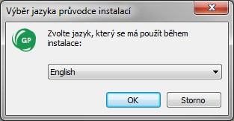
Initial setup language defaults to Windows locales of particular PC, or to the language found in previous Group Processor installation footprint.

    - Welcome screen.
This screen is not interactive and informs about Group Processor version to install.
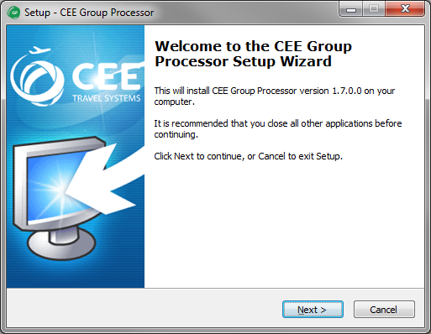
    - Destination folder selection
Setup defaults to store the application files in folder c:\fp\swdir\CEE_Apps\GroupProcessor and it’s recommended to keep it. However, the application works fine from any place.
This dialog is disabled, when running application upgrade.
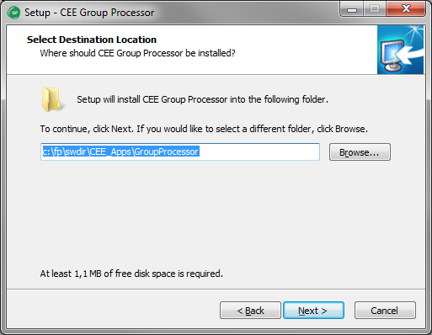
    - Ready to install screen
This screen informs user about final installation details (Destination location and Start Menu folder). Start menu folder CEE Application/Group Processor is hard coded in the application and cannot be changed.
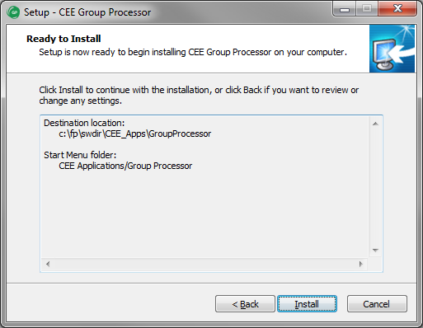

    - Adding shortcut to the Smartpoint Quick Commands
Successful installation is confirmed by last message box where adding of Group Processor command #GRP to the Smartpoint can be selected. This option is enabled by default.
Add to Smartpoint Quick Commands option is disabled, when running application upgrade.
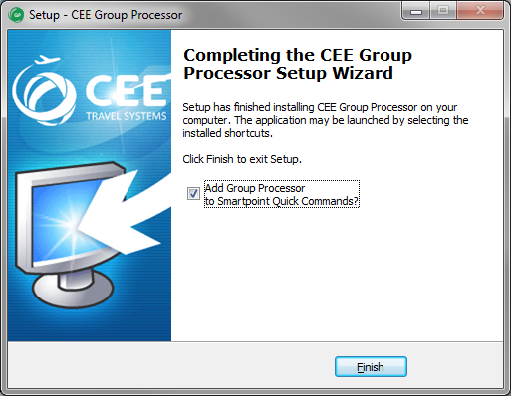
If Add to Smartpoint Quick Commands was selected, installation script confirms the command installation and #GRP shortcut is available after Smartpoint restart.
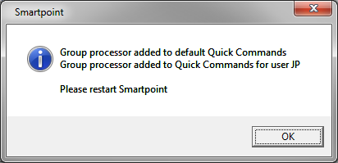
Note:
Smartpoint must be restarted to read new setup and to include CEE Group Processor #GRP command.
    - Start menu folder
Setup creates following four shortcuts in Start menu CEE Application/Group Processor program group. Actual appearance depends on Windows version.
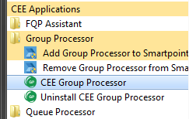
- CEE Group Processor:
runs Group Processor application
- Uninstall CEE Group Processor:
uninstalls all parts of Group Processor, including individual setup file and Smartpoint command
- Add Group Processor to Smartpoint Quick Commands:
this allows to add Group Processor #GRP command to the Smartpoint manually
- Remove Group Processor from Smartpoint Quick Commands:
removes Group Processor command #GRP from Smartpoint setting leaving other shortcuts untouched
  - Application upgrade
If Group Processor has been already installed in a PC, setup shows instead of folder selection dialog a message box, asking user for upgrade confirmation. Also, option to create Smartpoint Quick Command on the last page is disabled.
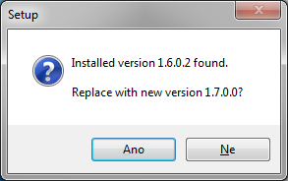
  - Application uninstalling
For complete Group Processor uninstallation, run shortcut Uninstall CEE Group Processor from Startup menu and confirm the command:
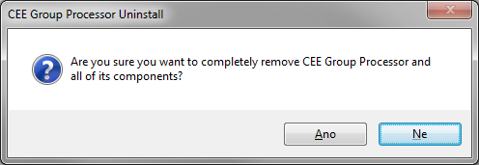
Program uninstall is acknowledged by a message, optional Smartpoint Quick Command removal is silent:
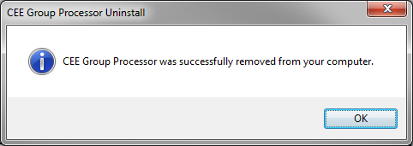
Note:
Uninstall deletes gp.ini file (see below) from active agent profile only.
- Application setup
  - Application initialization
When PC user starts the application for the first time, an individual program setup gp.ini file with default parameters is created in his/her profile. This allows agents sharing the same PC to have private setting of Phone contact, remark and other fixed data. Program startup continues with Setup screen then.
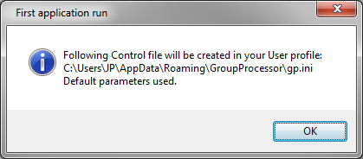
Setup screen description
Setup screen can be invoked anytime with the Setup button (see Main screen description).
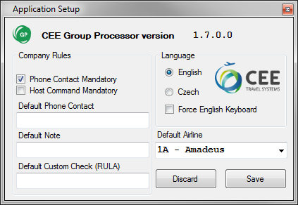

Following data can be altered and stored for future use:
- Phone Contact Mandatory A box with Phone contact on the main screen must be filled to continue with Group booking.
default value: YES
- Host Command Mandatory Specific host command is mandatory before GP starts with booking process. This transaction must be issued manually on Main screen for each PNR, there is no box in Setup with default value for Host Command.
default value: NO
- Default Phone Contact This value goes to the Phone contact box in the Main screen but can be altered there.
default value: blank
- Default Note This value goes to the Note entry box in the Main screen but can be altered there.
default value: blank
- Default Custom Check This value goes to the RULA Code box in the Main screen and can be overwritten there.
default value: blank
- Language User interface can communicate with agents in Czech or English.
default value: Czech for CZ localized Windows, English for others
- Force English Keyboard Force English keyboard layout on Czech PC regardless the Smartpoint setting.
default value: NO, keep system keyboard layout
- Default Airline Airline or Inventory system that will be used for PNR decoding as default (system can be changed on the Main screen).
default value: 1A – Amadeus
An application version number is shown in the top part of the Setup screen.
Save button stores the setting to the gp.ini file, Discard button purges the changes.

- Program usage
  - Main screen controls description
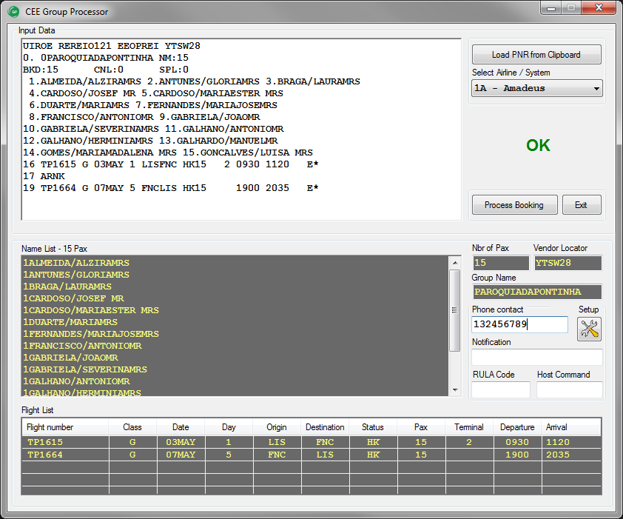

Item Description
Input Data An editable text box with source Group PNR data.
Once booking process starts, this text box converts to the Terminal window to monitor communication with the host.
Load PNR from Clipboard Refreshes Input Data box with Clipboard text data.
Select Airline / System List box to choose between available systems to decode source PNR.
OK Alert field to display PNR decoding errors. There is an OK sign, when no errors found.
Process Booking This button starts the booking process. Button is disabled, when any errors encountered in PNR decoding.
Name List List of Passenger names to book. A total number of PAX follows the header of the box. This box is not editable.
Nbr of Pax Number of Passengers, excluding infants. Value cannot be changed in the box.
Vendor Locator PNR Locator code, information only.
Group Name Name of the Group, not editable.
Phone Contact Phone number to include in the Galileo BF Phone field. Phone number must be entered, if set to mandatory and no default number is defined on Setup.
Setup button This button invokes the Setup screen.
Notification Notepad free text to include in the Galileo BF.
RULA Code Adds RULA element to the PNR. Can be defined with or without PCC in format PCC/VALUE or just VALUE.
RULA value is pre-filled with default data taken from Setup.
Host Command Transaction code to issue before booking starts. This command may be mandatory in accordance to the Setup setting.
There is no default value for Host Command, which must be entered for each booking separately. GP performs no syntax check of data entered in this box.
Flight List List of flights to book. A vertical scrollbar is shown, when flight segments number exceeds five.
Flight is highlighted and marked with ERROR, if any fault is encountered in parsing process. At least one valid flight must be present to start booking process.
  - Source PNR editing and error handling
Application reads automatically text from the Clipboard at startup. The best way to start the booking is copying the e-mail or other text with source PNR to the Clipboard and invoking Group Processor with #GRP command in Smartpoint. Input Data text box can be refreshed anytime pressing the button „Load PNR from Clipboard”.
There is no need to select exact PNR text from the e-mail or other source, but input text should contain only one group booking.
Source PNR is immediately parsed and the results are transferred to Name List, Nbr of Pax, Vendor Locator, Group Name and Flight List non-editable boxes.
If any errors are encountered during the parsing process, green OK sign is replaced with list of errors and „Process Booking” button is disabled. Source PNR text can be then edited within the Input Data box using standard editing keys including shortcuts Ctrl-A, Ctrl-X, Ctrl-C and Ctrl-V. Entered characters are automatically converted to upper case for better readability.
Changes to the source PNR are immediately evaluated.
Following events may be source of errors:
- Scrambled text or other mess in source PNR.
- Missing Vendor Record Locator.
- Discrepancy in total Passenger number, comparing to the Passenger list or booked seats on the flight segments.
- Other flight status than HK.
- Flight departure date must be closer than 335 days ahead.
- Flights with error data are simply ignored, but there must be at least one valid flight to continue with booking.
- PNR must not contain duplicated names.
- GP cannot book Passengers without first name and/or gender.
If more than three errors are encountered, the input is considered as not a PNR text
    - PNR parsing logic description
- Input text is searched for Vendor Record Locator, which is considered as start of PNR.
- All Passenger and Flight details are extracted by regular expressions.
- Identical names are reported as errors and highlighted in the source text.
- Passengers without first name and/or gender are reported and highlighted as errors.
- Program extracts infants from parentheses in Passenger list. This function is limited to 1A PNR.
- For each flight, program checks booked seats number, flight status and departure date limit.
- Segments like ARNK are ignored and may remain in the source.
- Program tolerates one missing index in the flight list numbering.
- If the flight is unknown by Galileo, it is still booked using itinerary and times retrieved from source PNR.
- Program correctly books flights with arrival date on next day, previous day or D+2.
- (Surnames grouping to the families has been discontinued in version 1.6).
    - Identical Passenger names and missing first names treatment
Unfortunately, Galileo™ GDS cannot book duplicated names in the group and first names (or gender) are mandatory. Therefore, the source Passenger list is scanned, such names are highlighted and „Process Booking” button is disabled. Names must be manually altered to continue with booking.
Duplicity and missing first name example, together with missing mandatory Phone contact:
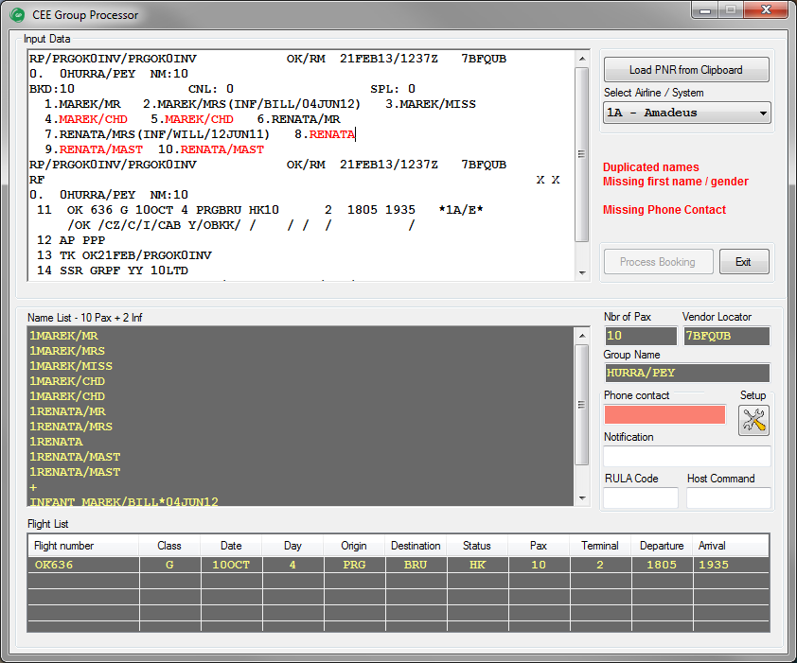

    - Flight data error treatment
This screenshot indicates, how the application treats and highlights errors found in the flight data:
- Flight OK 101 incorrect flight status (HL)
- Flight OK 102 incorrect Passenger count (2 instead of correct 3)
- Flight OK 103 generic error in flight data format
- Flight OK 104 incorrect date (past the allowed window D+335)
Also, Group Processor ignores ARNK segment and tolerates missing flight with index 8 between OK 103 and OK 104.
Because there is no valid flight, the group booking is prohibited.

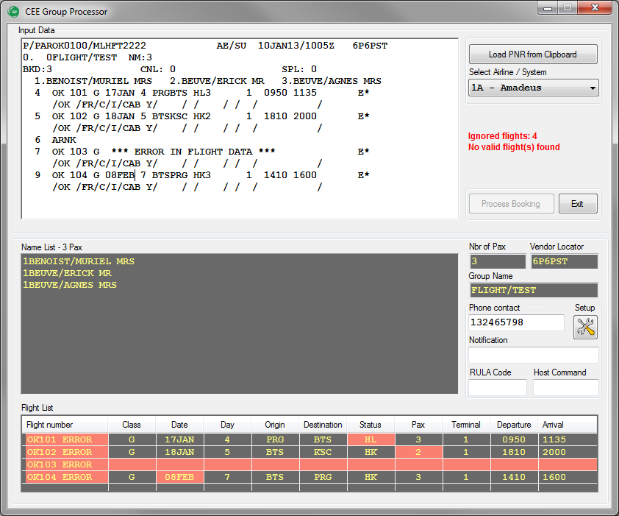

  - Galileo group booking process
If there are no errors in PNR processing, booking can be initiated with button „Process Booking”.
Program first checks if the agent is correctly signed into Galileo and that there is no open BF in the workspace. If so, an alert is displayed, and program brings agent back to the Smartpoint.
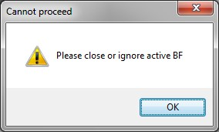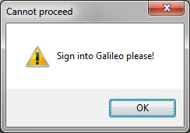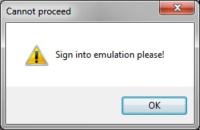
Application also checks host communication reliability during entire booking process.
If all checks pass, program turns Input Data box to Host Communication terminal emulation and starts the booking. Entire process is monitored in the terminal box. Commands sent to host, host replies and internal program comments are colorized for better readability (see the example in the next page).
When the booking is finished, agent can stay in application to investigate communication stream in the terminal window or return to the Smartpoint immediately. When closed, the agent should issue command *ALL + ENTER in Smartpoint to display created Booking file.
Group booking and ticketing must be finalized manually in the Smartpoint.

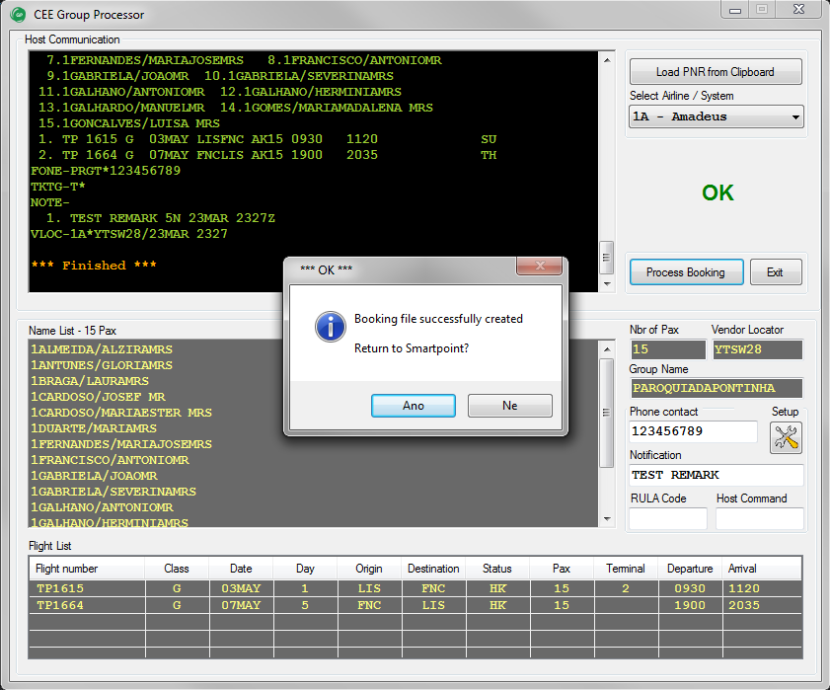

Booking flow example, as displayed in Host Communication window:

Creating Passive Segments for a Group
>N.G/15PAROQUIADAPONTINHA *
>P.T*123456789 *
>T.T* *
>RL.1A*YTSW28 *
>NP.TEST REMARK *
>0TP1615G03MAYLISFNCAK15
FLIGHT NOT FOUND - DEP/ARR TIMES REQUIRED

>0TP1615G03MAYLISFNCAK15/09301120
1. TP 1615 G 03MAY LISFNC AK15 0930 1120 SU
FLIGHT NOT FOUND - CHECK FLIGHT DETAILS
OFFER CAR/HOTEL CAL HOA

>0TP1664G07MAYFNCLISAK15
FLIGHT NOT FOUND - DEP/ARR TIMES REQUIRED

>0TP1664G07MAYFNCLISAK15/19002035
1. TP 1615 G 03MAY LISFNC AK15 0930 1120 SU
2. TP 1664 G 07MAY FNCLIS AK15 1900 2035 TH
FLIGHT NOT FOUND - CHECK FLIGHT DETAILS
OFFER CAR/HOTEL CAL HOA

>R.GROUP-PROCESSOR *
>ER
MINIMUM CONNECT TIME UNAVAILABLE SEGMENTS 01/02

>ER
CP9K4S/5N QSBGN V5A5N AG 99999992 02OCT
1.G/15PAROQUIADAPONTINHA
1. TP 1615 G 03MAY LISFNC AK15 0930 1120 SU
2. TP 1664 G 07MAY FNCLIS AK15 1900 2035 TH
** VENDOR LOCATOR DATA EXISTS ** *VL
FONE-PRGT*123456789
TKTG-T*
NOTE-
1. TEST REMARK 5N 02OCT 1423Z

Continue with Passenger Names...
>N.1ALMEIDA/ALZIRAMRS *
>N.1ANTUNES/GLORIAMRS *
>N.1BRAGA/LAURAMRS *
>N.2CARDOSO/JOSEFMR/MARIAESTERMRS *
>N.1DUARTE/MARIAMRS *
>N.1FERNANDES/MARIAJOSEMRS *
>N.1FRANCISCO/ANTONIOMR *
>N.2GABRIELA/JOAOMR/SEVERINAMRS *
>N.2GALHANO/ANTONIOMR/HERMINIAMRS *
>N.1GALHARDO/MANUELMR *
>N.1GOMES/MARIAMADALENAMRS *
>N.1GONCALVES/LUISAMRS *
>R.GROUP-PROCESSOR *
>ER
CP9K4S/5N QSBGN V5A5N AG 99999992 02OCT
G/00PAROQUIADAPONTINHA
1. TP 1615 G 03MAY LISFNC AK15 0930 1120 SU
2. TP 1664 G 07MAY FNCLIS AK15 1900 2035 TH
** VENDOR LOCATOR DATA EXISTS ** *VL
FONE-PRGT*123456789
TKTG-T*
NOTE-
1. TEST REMARK 5N 02OCT 1423Z

result:
>*ALL
CP9K4S/5N QSBGN V5A5N AG 99999992 02OCT
G/00PAROQUIADAPONTINHA
1.1ALMEIDA/ALZIRAMRS 2.1ANTUNES/GLORIAMRS
3.1BRAGA/LAURAMRS 4.2CARDOSO/JOSEFMR/MARIAESTERMRS
6.1DUARTE/MARIAMRS 7.1FERNANDES/MARIAJOSEMRS
8.1FRANCISCO/ANTONIOMR 9.2GABRIELA/JOAOMR/SEVERINAMRS
11.2GALHANO/ANTONIOMR/HERMINIAMRS 13.1GALHARDO/MANUELMR
14.1GOMES/MARIAMADALENAMRS 15.1GONCALVES/LUISAMRS
1. TP 1615 G 03MAY LISFNC AK15 0930 1120 SU
2. TP 1664 G 07MAY FNCLIS AK15 1900 2035 TH
FONE-PRGT*123456789
TKTG-T*
NOTE-
1. TEST REMARK 5N 02OCT 1423Z
VLOC-1A*YTSW28/02OCT 1423

*** Finished ***

- Support and Troubleshooting
Please contact administrators at helpdesk@cee-systems.com if any problems encountered during this tool usage.
Please be ready to send following details:
- Description of the problem
- Application version (from Setup window)
- Copy of source PNR
- Screenshot of incorrect application reply, if available

