XTRAKTO · INTELLIGENT DOCUMENT PROCESSING

HIGH-LEVEL DESIGN DOCUMENT
ServiceNow — Xtrakto
Integration
High-Level Integration Architecture & Design

DRAFT · v0.1 · April 2026

PREPARED FOR  ServiceNow Client |  | PREPARED BY  Xtrakto IDP Team

DOCUMENT TYPE | High-Level Design (HLD)
ISSUE DATE | April 2026
CLASSIFICATION | Confidential — Internal Use

This document is the property of Xtrakto and is provided to ServiceNow Client for the sole purpose of evaluating and implementing the integration described herein. Reproduction or distribution outside the intended audience is not permitted without prior written consent.

1. Introduction

1.1 Purpose
This document describes the High-Level Design (HLD) for the integration between ServiceNow and Xtrakto. The integration enables AI-driven extraction of claims intake data from inbound First Notice of Loss (FNOL) emails and their attachments, followed by Human-in-the-Loop (HITL) validation, and the return of validated, enriched data to ServiceNow.
The HLD captures the integration architecture, end-to-end sequence flow, interface touchpoints, data model, non-functional requirements and the principal risks and dependencies. It is the basis for subsequent Low-Level Design (LLD), build and test artefacts.

2. Solution Overview

2.1 Background
Today, claims intake from FNOL emails involves manual review of email content and attachments, manual identification of key fields, and manual data entry into ServiceNow. This is time-consuming, prone to inconsistency, and limits throughput during peak claim volumes.
The proposed solution introduces Xtrakto as the AI-driven extraction layer in front of the existing claims intake process. The Xtrakto user interface will be embedded as an iFrame within the existing ServiceNow application, ensuring a seamless and consistent user experience without requiring users to switch between systems. The current ecosystem is retained as a resilience fallback so that claims intake is not dependent on a single component.
Xtrakto leverages Generative AI and Large Language Models (LLMs) to extract information from documents and email content. The platform is deployed on AWS, utilising AWS-native components across each layer of its stack.

2.2 Business Drivers
The integration is driven by the following business outcomes:
- Reduce manual effort and elapsed time for claims intake.
- Improve data quality and consistency across claims records.
- Increase throughput and reduce operational risk during peak volumes.
- Provide a foundation for further automation across the claims lifecycle.

2.3 Objectives
The primary objective of Xtrakto is to automatically extract relevant information from inbound FNOL emails and their corresponding attachments, eliminating the need for manual document review. Specifically, Xtrakto will:
- Extract up to 15 fields across various lines of business from inbound FNOL email content and attachments.
- Reference and enrich additional fields from Dragon to provide a complete data set for validation.
- Present the extracted information to a Human-in-the-Loop reviewer, significantly reducing the time spent manually identifying and entering data from documents.
- Push validated data directly into ServiceNow upon reviewer approval, minimising overall human effort and accelerating claims intake processing.

3. High-Level Architecture

3.1 Overview
- Deployed on AWS within a dedicated Application Account, structured around an isolated Virtual Private Cloud (VPC).
- Built on AWS-native services across the edge, application, AI/ML and storage layers.
- ServiceNow integrates with Xtrakto over authenticated REST APIs.
- Xtrakto reviewer UI is delivered via Amazon CloudFront and embedded in the ServiceNow case interface as an iFrame.
- End-user identity is federated from Okta into Amazon Cognito.
- Public-subnet Application Load Balancer terminates inbound traffic and forwards it to a Private-subnet Network Load Balancer, which routes onward to backend services.
[ Image placeholder ]
Xtrakto High-Level Architecture — to be inserted

3.2 Components
Edge & Identity
- AWS WAF — inspects and filters all inbound HTTP/HTTPS traffic.
- Amazon CloudFront — delivers Xtrakto reviewer UI assets (UI traffic only).
- Okta — enterprise SSO identity provider, federated into Amazon Cognito.
- Amazon Cognito — manages the Xtrakto UI user pool, authentication and session state.
Networking (Application Account VPC)
- Application Load Balancer (Public Subnet) — external entry point for inbound REST and UI calls.
- Network Load Balancer (Private Subnet) — routes traffic onward to backend services, keeping application workloads off the public internet.
Application Services
- Ingestion Service — receives uploaded documents, persists raw payloads to S3 and creates extraction jobs.
- Module Service — hosts the per-line-of-business extraction modules and configuration.
- Amazon DynamoDB — stores job state, the {Job ID ↔ Message ID} mapping, and configuration metadata at low latency.
Xtrakto Core Back End
- Xtrakto Pipeline (AWS Step Functions + Lambda) — orchestrates the document processing stages, each a discrete Lambda function.
- GenAI Orchestration (AWS Step Functions + Lambda) — coordinates calls to the AI/ML services, including prompt assembly, response handling and retry/fallback logic.
AI/ML (AWS Managed Services)
- Amazon Textract — OCR and structured-form extraction for scanned and image-based attachments.
- Amazon Bedrock — managed access to the foundation models used by GenAI orchestration for free-form extraction and reasoning.
Storage
- Amazon S3 — persistent store for raw email and attachments at ingestion, intermediate artefacts, and validated/enriched data sets ready for delivery back to ServiceNow. Server-side encryption with AWS-managed keys.

3.3 Interaction Summary
API path (server-to-server)
- ServiceNow → WAF → Application Load Balancer → Network Load Balancer → Ingestion Service → Step Function pipelines → AWS managed AI/ML services.
- Status and output are returned to ServiceNow via the integration APIs described in Section 5 (Sequence Flow).
UI path (browser-to-service)
- Reviewer opens the case in ServiceNow; the Xtrakto UI is rendered as an iFrame.
- UI assets are served by CloudFront.
- The user is authenticated through Cognito with Okta as the upstream SSO provider.
- Authenticated calls from the UI traverse the same ALB → NLB path to reach the Xtrakto Core Back End.
Persistence
- Amazon S3 — binary documents and validated payloads.
- Amazon DynamoDB — job state and configuration.
- Step Function pipeline operates idempotently while the API and UI layers remain stateless.

4. Extracted Fields
The following fields will be extracted or referenced by Xtrakto, grouped by their source. Rows are colour-coded by category:
■ Email & Attachment | ■ Default value | ■ Dragon (enrichment)

# | Field Name | Source
1 | Policy Number | Email & Attachment
2 | Effective Date | Email & Attachment
3 | Expiration Date | Email & Attachment
4 | Insured Name | Email & Attachment
5 | Claim Date | Email & Attachment
6 | Claim Made Date | Email & Attachment
7 | Insurer Reported Date | Email & Attachment
8 | Accident State | Email & Attachment
9 | Claimant Name | Email & Attachment
10 | Client | Default — Main
11 | Severity | Default — TBD
12 | File Type | Default — Electronic
13 | Coverage Basis | Default — Claims Made
14 | Policy Type | Dragon
15 | Insurance Type | Dragon

5. Sequence Flow
The end-to-end interaction between the Claim Handler, ServiceNow, Xtrakto, S3 Storage and the Dragon Policy system is shown below. The flow is grouped into seven phases and each step is numbered for cross-reference in the supporting sub-sections.
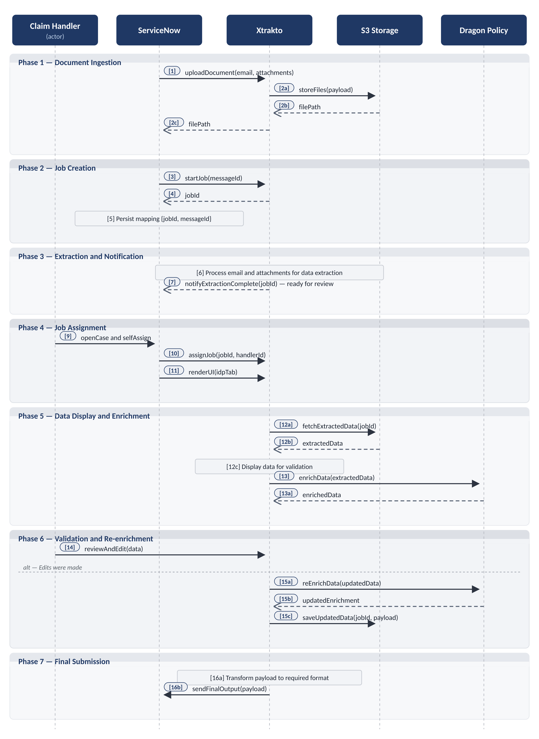

5.1 Flow Walkthrough
Each phase below mirrors the corresponding band of the diagram; numbers in brackets reference the diagram labels.
Phase 1 — Document Ingestion. ServiceNow uploads the FNOL email and attachments to Xtrakto via the File Upload API [1]. Xtrakto persists the payload to S3 and returns the file path [2a–2c], which ServiceNow retains against the case for traceability.
Phase 2 — Job Creation. ServiceNow calls the StartJob API [3] with its Message ID; Xtrakto returns a unique Job ID [4]. ServiceNow stores the {Job ID ↔ Message ID} mapping locally [5] for callback correlation and reconciliation.
Phase 3 — Extraction and Notification. Xtrakto runs the Gen AI / LLM extraction pipeline asynchronously [6] and, on completion, pushes a webhook notification to ServiceNow [7] flagging the job as ready for review. The extracted payload is not transferred to ServiceNow here; it is fetched directly from S3 by the Xtrakto UI in Phase 5.
Note. A generic Get Job Output API is available for ad-hoc retrieval of any Job ID’s extracted data — used outside this flow for diagnostics, reconciliation or downstream automation.
Phase 4 — Job Assignment. When the claim handler opens the case and self-assigns [9], ServiceNow calls the Job Assignment API [10] to bind the handler to the Xtrakto job and renders the Xtrakto UI as an iFrame in the IDP tab [11], passing Job ID and reviewer identity.
Phase 5 — Data Display and Enrichment. The Xtrakto UI fetches the extracted data from S3 [12a/12b] and renders it [12c]. In parallel, Xtrakto calls the Dragon Policy API [13] to retrieve Policy Type and Insurance Type for the extracted Policy Number; these are shown alongside the extracted fields [13a].
Phase 6 — Validation and Re-enrichment. The reviewer inspects and edits the data [14]. If a field affecting enrichment is changed (typically the Policy Number), Xtrakto automatically re-calls the Dragon Policy API [15a/15b]. The validated, re-enriched data is persisted back to S3 [15c].
Phase 7 — Final Submission. On submission, Xtrakto transforms the validated payload to the ServiceNow schema [16a] and delivers it via the Output Delivery API [16b]. ServiceNow updates the case, closing the cycle.

5.2 APIs
The table below lists every API exercised by the sequence above, mapped to the step numbers in the diagram. Detailed request/response schemas, error codes and authentication parameters will be captured in the Low-Level Design.
API / Interface | Direction | Pattern | Purpose
File Upload API | ServiceNow → Xtrakto | Synchronous (REST) | Uploads the FNOL email and all attachments to Xtrakto for storage and downstream processing. Step [1] in the diagram.
StartJob API | ServiceNow → Xtrakto | Synchronous (REST) | Creates a new extraction job for the uploaded payload using the ServiceNow Message ID and returns a unique Job ID. Step [3].
Get Job Output API | ServiceNow → Xtrakto | Synchronous (REST) | Generic Xtrakto endpoint that returns the current status and extracted data set for any Job ID. Not invoked as part of the standard flow; available for ad-hoc calls by ServiceNow (diagnostics, reconciliation, downstream automation).
Job Assignment API | ServiceNow → Xtrakto | Synchronous (REST) | Associates the assigned claim handler with an existing Job ID, enabling per-handler context in the Xtrakto UI. Step [10].
Extraction Completion Webhook | Xtrakto → ServiceNow | Asynchronous (HTTPS) | Push notification sent by Xtrakto when extraction is complete; carries the Job ID and a status indicator. Step [7].
Output Delivery API | Xtrakto → ServiceNow | Synchronous (REST) | Delivers the validated, enriched payload back to ServiceNow for case update on reviewer submission. Step [16b].
Dragon Policy API | Xtrakto → Dragon | Synchronous (REST) | Retrieves Policy Type and Insurance Type for the policy referenced in the extracted data; called on initial display and again on edit. Steps [13] and [15a].
Note. The flow also relies on two non-API touchpoints visible in the diagram. The iFrame UI embed (Step 11) is a browser-level rendering mechanism — ServiceNow loads the Xtrakto reviewer UI inside the IDP tab via an HTML iFrame, not a service call. Amazon S3 (Steps 2a/2b, 12a/12b, 15c) is an internal Xtrakto data store accessed over the AWS SDK from within the Xtrakto VPC; it is not exposed to ServiceNow.

5.3 Error Handling Scenarios
The principal failure scenarios for the sequence above and the design intent for handling them are summarised below. Specific retry counts, timeouts and circuit-breaker thresholds will be agreed during detailed design.
Failure Scenario | Detection | Handling & Fallback
File upload failure (Step 1) | HTTP 5xx, network timeout, or rejected payload from Xtrakto. | Retry with exponential backoff. On persistent failure, route to the existing ecosystem and raise an alert.
StartJob creation failure (Step 3) | Non-2xx response from the StartJob API. | Single retry; on continued failure, flag the Message ID and fall back to the existing ecosystem.
Extraction processing failure (within Step 6) | Webhook callback (Step 7) carries an error status. | Record failure against Job ID; route to the existing ecosystem. Files remain in S3 for diagnostics.
Webhook (Step 7) not received within SLA | ServiceNow does not receive a notification within the agreed timeout window for the Job ID. | Raise an alert. Optionally call Get Job Output ad hoc for diagnostics. After the deadline, route to the existing ecosystem.
Job Assignment failure (Step 10) | Non-2xx response from the Job Assignment API. | Non-blocking warning to handler; retry assignment in background. iFrame remains accessible; assignment reconciles on retry.
iFrame render failure (Step 11) | Browser-side load error, content security policy violation, or expired session. | Show error in UI with a refresh action. If unresolved, re-open the case or complete via the existing ecosystem.
Dragon Policy API unavailable (Steps 13 / 15a) | HTTP 5xx or network timeout from Dragon. | Display data with enrichment fields marked unavailable. Auto-retry on edit and on a periodic background retry.
Dragon Policy returns no match | Empty or 404 response from Dragon for the supplied Policy Number. | Mark fields as “Not found”. Reviewer corrects the Policy Number to re-enrich, or submits manual values.
Output Delivery failure (Step 16b) | Non-2xx response or timeout when delivering the validated payload to ServiceNow. | Retry with exponential backoff. Payload preserved in S3. On persistent failure, raise an alert for manual reconciliation.
Authentication / authorisation failure | HTTP 401 / 403 on any of the integration APIs. | Raise an alert; pause affected calls; refresh credentials per the agreed rotation procedure.
Concurrent updates to the same job | Backend conflict detected on save (e.g., differing version metadata). | Last-write-wins with a warning to the reviewer. Audit log records both update attempts.

5.4 Assumptions
The flow described above is predicated on the following assumptions. These will be re-validated and tracked as confirmed prior to baseline.
- Inbound FNOL emails arrive in ServiceNow and trigger the integration deterministically via existing mailbox routing rules.
- The Message ID generated by ServiceNow is unique, immutable and carried through the full lifecycle of the case.
- Authentication and identity propagation between ServiceNow, Xtrakto and Dragon are agreed and stable (mechanism to be confirmed in the Low-Level Design).
- Network connectivity, firewall rules and DNS between ServiceNow, the AWS-hosted Xtrakto platform and Dragon are in place and meet the agreed latency targets.
- The Dragon Policy API is available, documented and stable for the lifetime of the integration; its data quality is sufficient to drive enrichment without further transformation.
- ServiceNow can render an iFrame within the case interface and pass the required context (Job ID, reviewer identity) to the Xtrakto UI without violating content security policy.
- Supported file formats and maximum payload sizes are agreed in advance and enforced at the upstream mail gateway.
- Reviewers have appropriate permissions in both ServiceNow and Xtrakto for any case routed to them, and their identity is consistent across both systems.
- The existing claims intake ecosystem remains operational throughout rollout and is the agreed fallback path for any case that cannot be processed via Xtrakto.
- All processing is performed within the data residency, retention and protection requirements stipulated in the client’s information-security policy.

6. To-Be Process Maps
This section captures the to-be process maps for claims intake under the Xtrakto-driven flow. Maps will be inserted in the placeholder below as they are finalised.
[ Image placeholder ]
To-be process map(s) to be inserted

