EXL – BRIT SharePoint Upload: API Integration Guide
System-to-system integration • App-only Microsoft Graph API • BRIT-owned, least-privilege, revocable
Overview. EXL uploads deliverables into one designated SharePoint document library in BRIT’s Microsoft 365 tenant through the Microsoft Graph API. It is a system-to-system integration — no user is signed in at upload time; the process authenticates as an application and runs unattended on a schedule or trigger. BRIT owns the application identity and the access grant, scoped to a single site, and can revoke it at any time.

Responsibilities at a glance
BRIT (inside their own tenant) | EXL (the integrating system)
Owns the app registration, permission, and credential; authorizes the app for one site; can revoke access instantly. | Holds the issued credentials securely and uploads files to the designated library via the Microsoft Graph API.

End-to-end flow
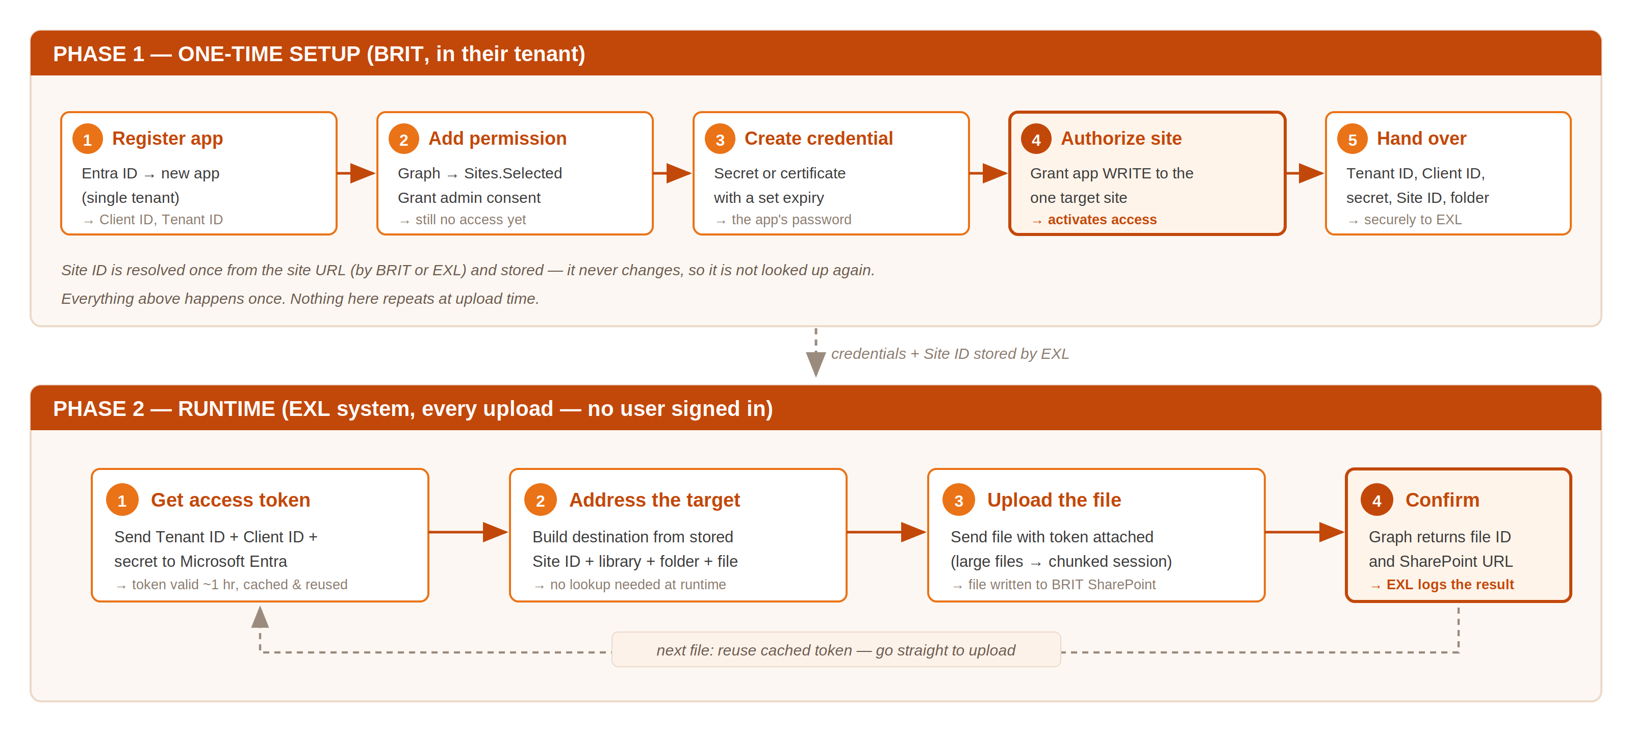
Figure 1 — One-time setup by BRIT, then the repeating runtime sequence performed by EXL.

A. BRIT — one-time configuration (their tenant)
- Register an application in Entra ID (single tenant). Record the Application (client) ID and Directory (tenant) ID.
- Add the API permission — Microsoft Graph application permission Sites.Selected — and grant tenant consent.
- Create a credential — a client secret or, preferably, a certificate — and set a defined expiry.
- Authorize the app for the one target site with write access. This is a one-time grant; until it is done the app has no access to any content.
- Provide the connection details to EXL through a secure channel, including the Site ID (see checklist below).

B. EXL — the API integration (each upload)
- Authenticate — request an app-only access token from Microsoft Entra using the client-credentials flow (Tenant ID + Client ID + secret/certificate). The token is valid for about an hour and is cached and reused.
- Address the destination — build the target from the stored Site ID, document library, folder path, and filename. No lookup is required at runtime.
- Upload the file with the token attached. Standard files upload in a single request; very large files use a chunked upload session that can resume if interrupted.
- Confirm and log — Graph returns the new file ID and its SharePoint URL. EXL records this and retries with backoff if throttled.

Sequence of calls
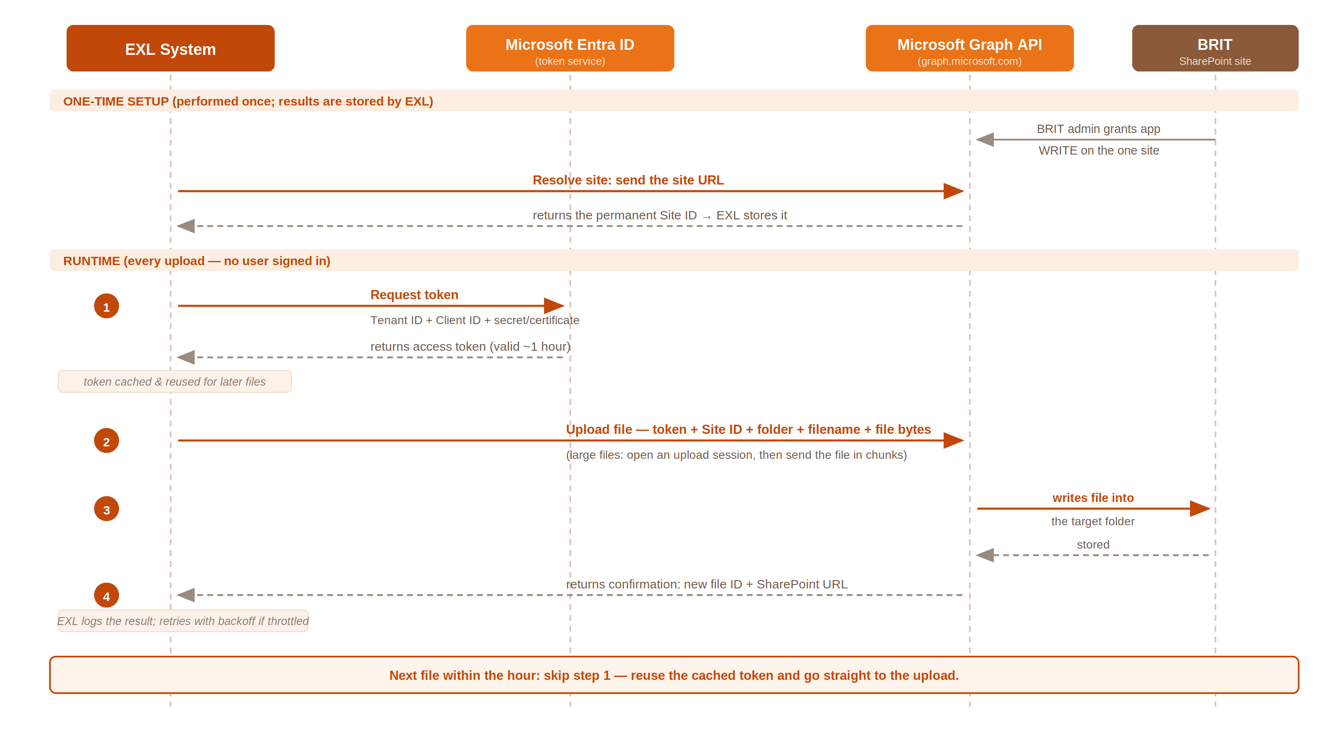
Figure 2 — Call sequence between EXL, Microsoft Entra, Microsoft Graph, and BRIT’s SharePoint site.

Connection details BRIT provides to EXL
Item | Example / note
Directory (tenant) ID | GUID of BRIT’s tenant
Application (client) ID | GUID of the registered app
Client secret or certificate | Secret value (shown once) or certificate pairing
Site ID | Permanent identifier of the target site (avoids a runtime lookup)
Library / folder | e.g. Documents / Deliverables
Granted role & overwrite rule | write (or read,write); replace / rename / fail on duplicates

