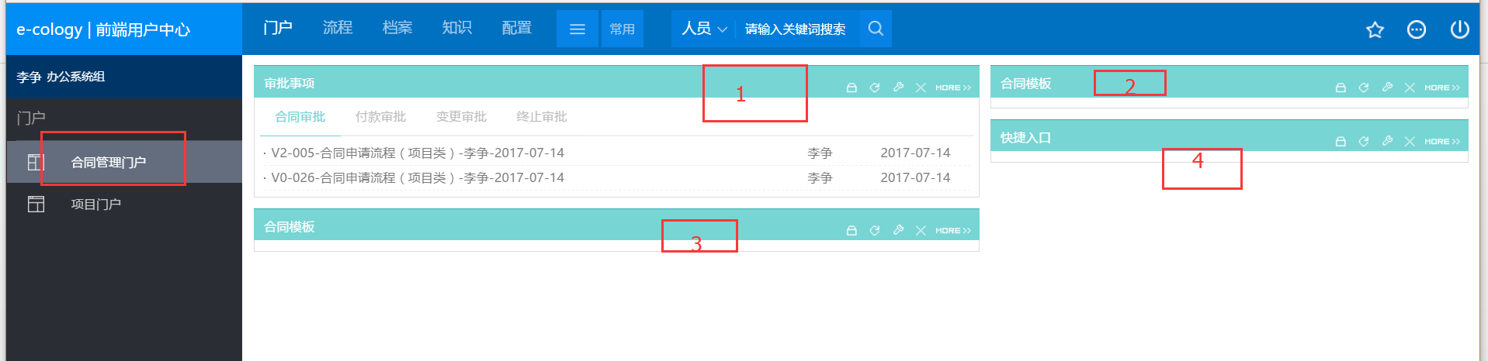

1：  
审批事项

<http://222.92.108.195:10182/page/element/8/Workflow.jsp?ebaseid=8&eid=41&hpid=21&subCompanyId=82&indie=true&needHead=true>

2：

合同模板

<http://222.92.108.195:10182/page/element/7/News.jsp?ebaseid=7&eid=44&hpid=21&subCompanyId=82&indie=true&needHead=true>

3：

合同模板

<http://222.92.108.195:10182/page/element/7/News.jsp?ebaseid=7&eid=43&hpid=21&subCompanyId=82&indie=true&needHead=true>

4：

快捷路口  
<http://222.92.108.195:10182/page/element/29/Iframe.jsp?ebaseid=29&eid=42&hpid=21&subCompanyId=82&indie=true&needHead=true>

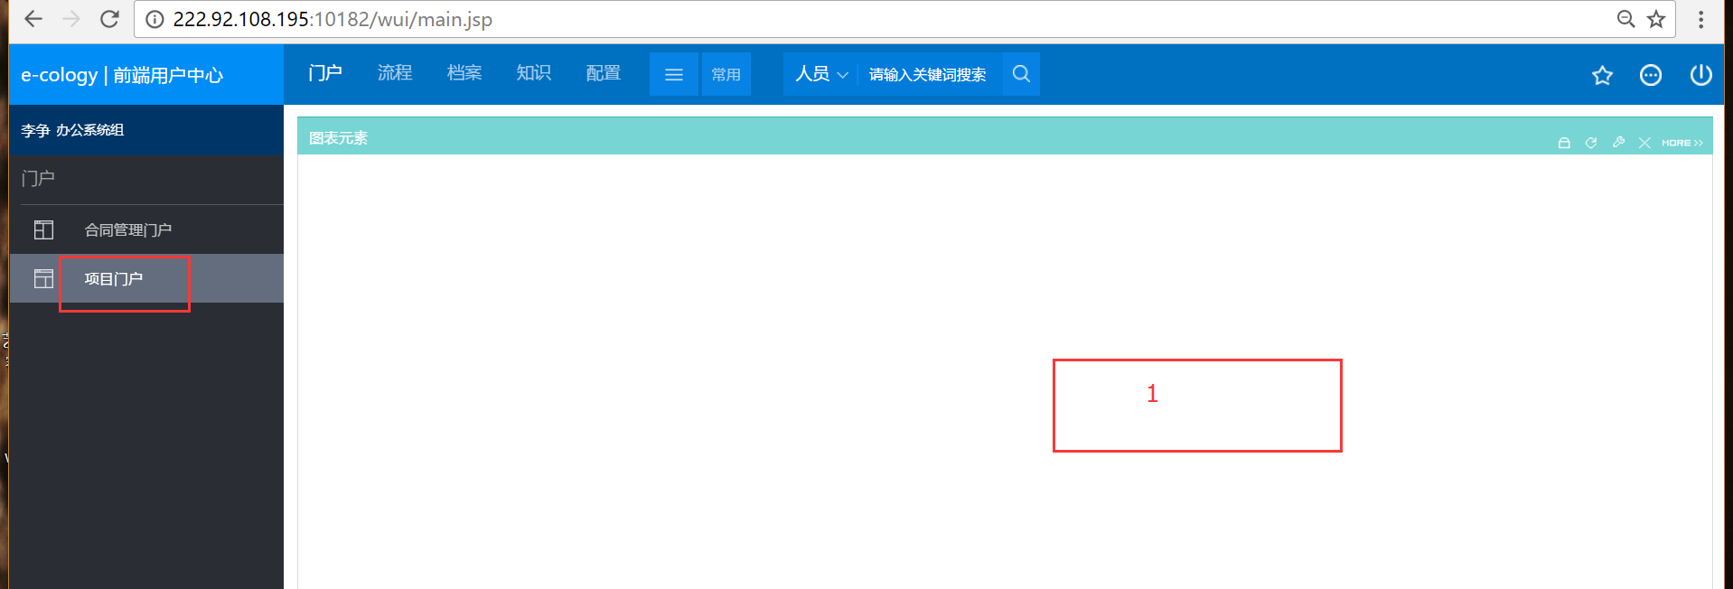  
1：

图标元素  
http://222.92.108.195:10182/page/element/ReportForm/reportformtabs.jsp?ebaseid=reportForm&eid=46&hpid=22&subCompanyId=82&indie=true&needHead=true