## Tomato add for test

New content on 10-28-2021

New for r3 testdfhhdfh

Redfsfdsdfsdfdfhdfhd

Sfgsfgsdg for command line

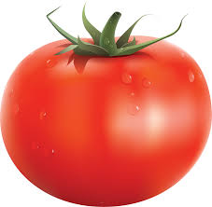

## Cucumber

Green

### Banana

Yello

### Orange

Orange

## Carrot

Carrot

## Radish

Radish

## Milk

Milk

## Stew

Stew Beef