<http://localhost:8102/user/create>

{

"name" : "Shubham",

"userSettings" : {

"bike" : "pulsar"

}

}

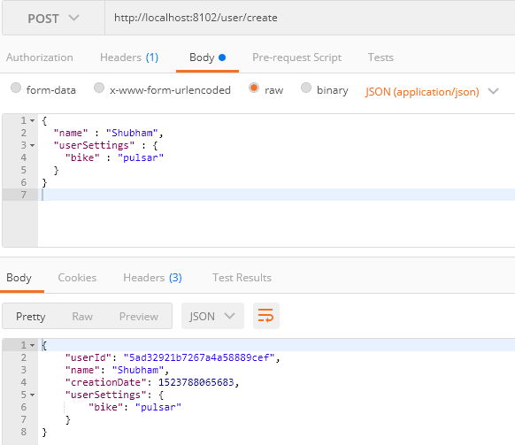

<http://localhost:8102/user/>

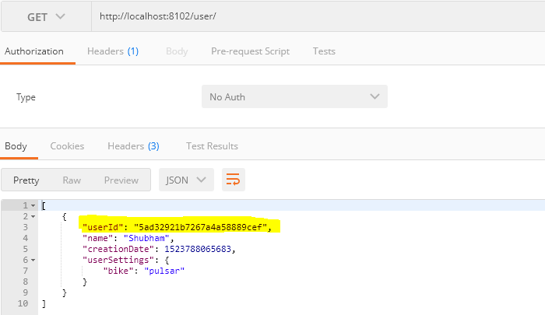

<http://localhost:8102/user/settings/5ad32921b7267a4a58889cef>

