A PRELIMINARY PROJECT REPORT ON
MEDCLOUD:
TRANSMISSION AND ANALYSIS OF MEDICAL DATA

SUBMITTED TO THE UNIVERSITY OF PUNE, PUNE
IN PARTIAL FULFILLMENT OF THE REQUIREMENTS
FOR THE AWARD OF THE DEGREE OF

BACHELOR OF ENGINEERING (Computer Engineering)

BY

ABHIMANYU BHOSLE
ADITI JOSHI
ADITI TATTI
MUKUND MALANI



DEPARTMENT OF COMPUTER ENGINEERING

PUNE INSTITUTE OF COMPUTER TECHNOLOGY
Sr. No. 27, Pune Satara Road, Dhankawadi

PUNE 411043

PUNE INSTITUTE OF COMPUTER TECHNOLOGY
DEPARTMENT OF COMPUTER ENGINEERING

CERTIFICATE
This is to certify that the project report entitled

“ MEDCLOUD :
TRANSMISSION AND ANALYSIS OF MEDICAL DATA”
Submitted by
ABHIMANYU BHOSLE
ADITI JOSHI
ADITI TATTI
MUKUND MALANI

is a bon-a-fide work carried out by them under the supervision of Prof.R.S.Paswan and it is approved for the partial fulfillment of the requirement of University of Pune, for the award of the degree of Bachelor of Engineering (Computer Engineering).

Prof. R.S.Paswan Prof. Dr. G.P.Potdar
Internal Guide Head,
Department of Computer Engineering Department of Computer Engineering
PICT, Pune PICT, Pune

Name:
Signature:
External Examiner

Place: Pune
Date:


CERTIFICATE
This is to certify that the project report entitled
“MEDCLOUD: TRANSMISSION AND ANALYSIS OF
MEDICAL DATA”

Submitted by
Abhimanyu Bhosale Roll No: 4101
Aditi Joshi Roll No: 4103
Aditi Tatti Roll No: 4272
Mukund Malani Roll No: 4237

is a bonafide work carried out by them with the sponsorship from Xtremum Solutions under the supervision of Mr. Kaustubh Kabra and Mr. Swapnil Khorate.

Mr. Kaustubh Kabra
Mr. Swapnil Khorate
External Guide
Place: Pune
Date:

ACKNOWLEDGEMENT

It gives us great pleasure in presenting the project report for our project, entitled as ‘MEDCLOUD : TRANSMISSION AND ANALYSIS OF MEDICAL DATA’. We sincerely thank Prof. Girish Potdar, HOD of Computer Department, PICT for his guidance.

We sincerely thank Prof. R.S.Paswan, our technical internal guide, for her guidance, encouragement and support, which helped us aim towards the best software engineering approach through the lifecycle of the project. Her appreciation of the project has inspired us to undertake such ventures in the future.

Our external guides, Mr.Kaustubh Kabra and Mr. Swapnil Khorate have always been ready to extend their helping hands and share their valuable technical knowledge about the subject, with us.

We are also thankful to the project staff committee for their support and guidance.

ABSTRACT

With massive advancements in technology, each and every sector is trying to harness the powers of technology; however still, healthcare is one sector which has not lent itself to mobile technology advances. Current health care systems use static information which is entered manually by the user. This increases the dependency of data accuracy on the human, which may prove as a huge risk as far as medical data is concerned, since it may have far-reaching consequences. With this paper, we eliminate this risk by automatically fetching the data from various medical devices such as ECG monitors, Gluco-meters, BP machines as well as providing real-time access to it and hence, automate the doctor-patient relationship. However, most of the medical devices available today do not support wireless communication or network connectivity. We also demonstrate a device that enables such extensions to these devices.

INDEX

1. SYNOPSIS
1.1 Group ID 09
1.2 Project Title 10
1.3 Sponsorship 10
1.4 External Guide 10
1.5 Internal Guide 10
1.6 Title of the Project 10
1.7 Technical Keywords 10
1.8 Name of Conferences where paper can be published 10
1.9 Plan of Project Execution 11

2. TECHNICAL KEYWORDS 12
2.1 Project Title 13
2.2 Project Area 13
2.3 Project Technical Keywords 13

3. INTRODUCTION 15
3.1 Concept 16
3.2 Need of Project 16
3.3 Literature Survey 17

4. PROBLEM DEFINITION AND SCOPE 18
4.1 Problem statement 19
4.2 Goals and Objectives 19
4.3 Scope 19
4.4Software Context 19
4.5Major Constraints 20
4.6Area of Project 20

5. SOFTWARE REQUIREMENT SPECIFICATION 21
5.1Purpose and Scope of Document 22
5.2 Overview of responsibilities of developer 22
5.3 Product overview 23
5.4 Usage scenario 23
5.5 User profiles 23
5.6 Use cases 23
5.7 Data model and description 25
5.8 Functional model and description 25
5.9 Description for (function/module/subsystem) 27
5.10 Design constraints 28
5.11 Software interface description 28
5.12 Restriction, limitation and constraints 28
5.13 Mathematical model 28
5.14 Mapping of mathematical model with UML diagram 30

6. PROJECT PLAN 32
6.1Problem definition 33
6.2 Purpose of Document 33
6.3Project Estimates 33
6.4 Project resources 34
6.5 Risk managements 35
6.6 Overview of risk mitigation, monitoring, management 37
6.7 Project schedule 38
6.8 Project task set 39
6.9 Task network 39
6.10 Timing chart 40
6.11 Staff organization 40
6.12 Team Structure 41
6.13 Tracking and control mechanism 42
6.14 Standards, practices and conversion 42

7. DESIGN AND IMPLEMENTATION 44
7.1 Introduction 45
7.2 Overview of Product 45
7.3 Architectural Design 46
7.4 Components 48
7.5 Data Design 48
7.6 Component Design 50
7.7 User Interface Design 53
7.8 Restriction, limitation and constraints 53

8. FUTURE WORK 54
8.1 Future work 55

9. SUMMARY AND CONCLUSION 56
9.1 Summary and conclusion 57

10. LIST OF FIGURES 58
10.1 List of figures 59

11. LIST OF TABLES 60
11.1 List of tables 61

12. ANNEXURES 62
12.1 Annexure A 63
12.2 Annexure B
12.3 Annexure C
12.4 Annexure D
13. REFERENCES 68
13.1 References 69

CHAPTER 1

SYNOPSIS

- SYNOPSIS

  - Group Id: 16

  - Project Title: MedCloud: Transmission and Analysis of Medical Data

  - Sponsorship: Xtremum Solutions

  - External Guide:

- Kaustubh Kabra
- Swapnil Khorate

  - Internal Guide: Prof. R.S.Paswan

  - Title of the Project:

To obtain data directly from medical equipments and store this data directly on the cloud for real time storage and management of individual patient health records and to design an API to provide a common interface for various health and fitness based applications to access this data.

  - Technical Keywords(Ref ACM Keywords):
- Bio Medical Engineering
- Network Protocols
- Databases
- Data Visualization
- Cloud Services
- Mobile Computing
- Algorithms

  - Names of at least two conferences where paper can be published:

- International Conference on Electrical, Electronics and Computer Science (ICEECS)
- ICMIB 2013: International Conference on Medical Information and Bioengineering

  - Plan of Project Execution:
(Use planner or project management tool)
Refer Annexure C

CHAPTER 2

TECHNICAL KEYWORDS

- TECHNICAL KEYWORDS:

  - Project Title: MedCloud: Transmission and Analysis of Medical Data

  - Project Area:

- Health Care
- Cloud Services
- Computer Networks

  - Technical Keywords:

- Internet(TCP/IP)
TCP/IP (Transmission Control Protocol/Internet Protocol) is the basic communication language or protocol of the Internet. It uses the client/server model of communication in which a client requests for information and is provided a service by a server in the network. Using internet the medical device connects to cloud server thereby facilitating transfer of data between the device and cloud server.

- Network Protocols
A protocol is a set of rules that governs the communication between computers on a network. These rules include guidelines that regulate the following characteristics: speed of data transfer, physical topologies, and access methods. Network protocols like HTTP, SMTP,SCP protocol especially for transfer of medical data provide a foundation for internet.

- Cloud services
Cloud provides various types of services including Software as a service(SaaS),Storage as a Service(StaaS).We utilize these services for storage of medical records on the cloud as well as computation and analysis of this data on cloud itself to facilitate faster processing of data.

- Data Visualization:
Data visualization is the study of the visual representation of data meaning "information that has been abstracted in some schematic form, including attributes or variables for the units of information".In our project the use of data visualization is to reconstruct the ECG from the data obtained in digital form.

CHAPTER 3

INTRODUCTION

Introduction
Advancing the field of health informatics has been listed as one of the 14 engineering grand challenges for the 21st century. Activities in this field include acquiring, managing, and using biomedical information, from personal to global levels, to enhance the quality and efficiency of medical care and the response to widespread public health emergencies. Particularly, on the personal level, biomedical engineers envision ‘‘a new system of distributed computing tools that will collect authorized medical data about people and store it securely within a network designed to help deliver quick and efficient care’’.
The idea is to make a constantly updating system which will give you all the necessary details of your current health condition or last updated health condition and simultaneously maintaining your history and learning from it. The user won’t have to worry about his health management, it will be all maintained in the cloud, constantly updated from the device itself. He can share is medical records or give his family access to his Medical Information. This system can also be extended to day to day analysis for people who require it, like type-1 diabetes. They can see their entire history to note when and how it changed.
Current systems rely on Hospitals to update the health records and in then update it online. What we plan to do it to remove this extra node from the entire process of Patient Health Record Management. We plan to optimize it even further by providing extension to the Medical Device which will help us update the information from the device itself. This will make the entire process of scanning from the Device and then updating it online other way round. By that we mean, we will no longer scan something in the context of a Device, we will make scans from the software which will be in the context of a patient. Every scan made by any machine or medical device will be in context of a patient and will be initiated only when the patient is logged in to the network. It eliminates the problem of making multiple entries every time make the system more organized. This is also help the software to keep a record of which patient is being scanned at a particular time and will help the doctor with his current and previous reports with slight analysis of the probable condition.

Concept
Currently, there are around 50,000+ medical applications ( iOS + Android) and all of them are being fairly used by people all over the world. This figure shows that the contemporary mind-set of people is changing and they are ready to use technology in the medical field as well. This high number of apps cover all the areas that come under the medical domain. Improvements in the medical sector in effect means working for the betterment of the society.

  - Need of Project
As stated earlier, there are high number of apps in medical field but the main problem with these apps is that the user has to manually enter his/her detail in it. This eventually affects User Experience(UX) as user has to enter the details each and every time he/she uses that particular app. Some apps do provide data without human intervention but the delay between data transfer is very large on the scale of 30+ seconds. In addition, these apps provide just a superficial diagnosis which does not help the user much. These apps are of no use to doctors and does not assist them in any way. At last, each and every app is centered to a specific problem, i.e. only BP diagnosis or glucose level and so on. There is no app which is generic and provides any medical data transmission.

  - Literature Survey

Our system requires study about various interdisciplinary fields like Biomedical Engineering as we will be working with Medical Data. We have studied about ECG and ways to capture and read the input data. There are various other applications which perform ECG recording and also Real Time visualizations. We have also studied about health record management systems. AirStrip is one of the systems which provides real time view of the patients data. The data is recorded and maintained by the Hospital which in turn sends it to the server which will send it to the application. Waveform patterns, bedside alarm history, and other patient information are sent to clinicians anywhere for immediate visual interpretation, collaboration, and timely patient care. The data that AirStrip provides is not open to all and hence cannot be used by other applications. Microsoft Health Vault is a PHR tool used to store and maintain Health Records. It provides a API to allow users to take and share data. Microsoft Health Vault does not natively support waveforms but it can be made available using your own data type. It doesn't provide support for ECG ML. ECG ML is a ECG Markup Language used to store ECG with simple markup tags which are human readable and also supported across various platforms. The storage and distribution of electrocardiogram data is based on different formats. There is a need to promote the development of standards for their exchange and analysis. Such models should be platform-/ system- and application-independent, flexible and open to every member of the scientific community.

CHAPTER 4
PROBLEM DEFINITION AND SCOPE

Problem Statement and Scope

Problem Statement

To obtain data directly from medical equipments and store this data directly on the cloud for real time storage and management of individual patient health records and to design an API to provide a common interface for various health and fitness based applications to access this data.

  - Goals and Objectives
- To retrieve data from medical devices directly and transfer to cloud / server.
- To store these readings using a universally accessible platform and standard
- To enable the usage of this data for various medical applications by designing an API
- To provide an analysis of the readings
- To design a system compatible with majority of the existing medical devices.

  - Scope
Providing real time access to data fetched directly from a medical device eliminating errors due to manual entry of data and storing this data on the cloud for real time storage and monitoring of patient health records. The patient’s health records may also be visible to doctors for a more detailed analysis. We shall also be providing an API for various mobile based applications as well as web to access this data.

  - Software Context
MedCloud will be used in various applications such as:
- Electrocardiogram Monitoring
- Blood Pressure Monitoring
- Glucose Monitoring
- Calorie monitoring

  - Major Constraints
The major constraints in this project would be:
- The interfacing device should be connected to a wireless Access Point
- The patient should be connected to the internet while using this system.

  - Area of Project

    - Health-Care

    - Cloud

    - Computer Networks

CHAPTER 5

SOFTWARE REQUIREMENT SPECIFICATION

- INTRODUCTION

  - PURPOSE AND SCOPE OF DOCUMENT
- To present a detail of the software requirements and analysis of what is intended to design. A more detailed view of the project will follow which will include the development phases and the deliverables, as well as the project plan.
- To present an analysis of the perceived problem from which a list of specific unambiguous requirements will be formulated from the user’s point of view. The list will include functional, external interface, performance and other requirements.
- Design constraints and attributes leading to the finished product will be specified.
- To discuss the approach adopted to carry the project through the development process to completion. This will include the analysis and design technique used.
- To provide an overview of the interaction between the user and the system, design of the visual appearance of the interface. A description of the interface between the user interface and the software will be included in the subsequent documents.

  - OVERVIEW OF RESPONSIBILITIES OF DEVELOPER
The responsibilities of the Developer can be broadly overviewed as follows:
- Analyzing the requirements of the project.
- Design for recommendations for all workloads as specified.
- Assemble a complete development team.
- Coding and testing the tool with predefined results and check for accuracy.

  - PRODUCT OVERVIEW
An interfacing device is developed which provides data transmission capabilities to currently available medical devices. This data is then transferred onto the cloud which can then be accessed by various applications on multiple platforms.
  - USAGE SCENARIO
This application provides a method for cloud users to engage in secure multimedia conferencing which dynamically adapts to the users specification. Emphasis is also on security of the user by providing various types of encryption techniques.
Through this project we aim to provide a method for health conscious individuals or even patients to continuously monitor their health, essentially, real-time and with high accuracy which is very consequential in the field of medicine, by fetching data directly from the medical devices and providing a detailed analysis.
  - USER PROFILES
- Patient: The end user who uses the medical device for real-time health monitoring.
- Cloud: Provides the platform for storage as well as computation of the data fetched directly from the device.
- Doctor: End User who shall fetch the data from the cloud/server for analysis or patient health record analysis.
- Hospital: The user end where this system shall be most widely deployed.
- Admin: Administers the profiles of the patients and the doctors.
5.6 USE CASES
- Login
- Sign Up
- Logout
- Transmit Data
- View Health Record
- Share Health Record with Doctors
5.6.1 Use Case View

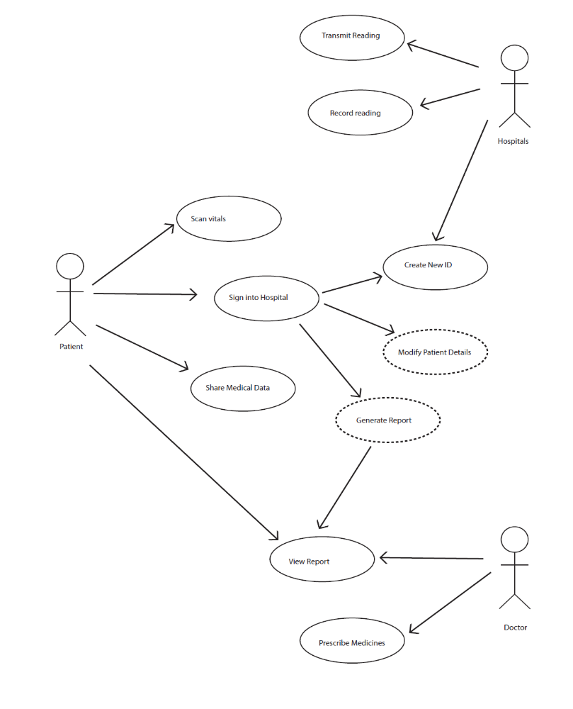 Fig.5.1: Use case diagram for the system
5.7 DATA MODEL AND DESCRIPTION
5.7.1 Data Description
Data at the server end would be stored in a number of databases depending upon the action made or the requirement. The database would include a table which would, maintain a record of all the doctors as well as patients registered in this system. The details of every Client who signs up are maintained here.
5.7.2 Data objects and Relationships
The sequence and class diagram in the High Level Design Document explain the relationship between objects and show the interaction between classes.
5.8 FUNCTIONAL MODEL AND DESCRIPTION
5.8.1 Sequence Diagram
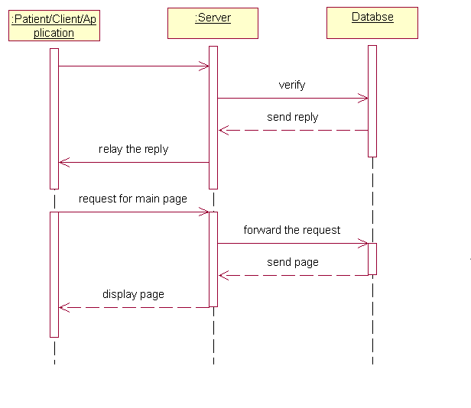
Fig. 5.2: Sequence Diagram for Page Request
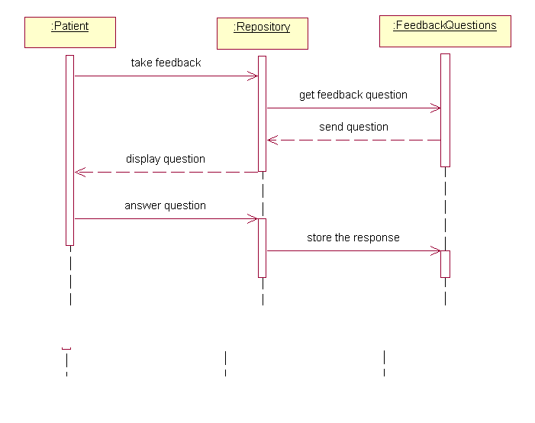
Fig. 5.3: Sequence diagram of feedback system
5.9 DESCRIPTION FOR (Function/Module/Subsystem)
Project will include these main functional modules:
- Data transmission module: Data shall be transmitted directly from the medical device using an intermediate data transmission device.
- Security: To provide security over cloud environment so that user can store and exchange data without any type of data loss.
- Elasticity and Latency Control: To provide higher elasticity over cloud so that storage and computation becomes more useful and cost effective. To provide latency control over network this will provide greater speed for data transmission at distant sites also.
- Access control: The key management algorithms will be provided for authorization, authentication and data access.
- Data Analysis: The data stored onto the cloud in the form of a health record shall be used for analysis and diagnosis of health related disorders.
5.10 DESIGN CONSTRAINTS
- Time Limitations.
- Memory Limitations.
- Interface to other applications.
- The device should be connected to the internet at the time of data transfer.
5.11 SOFTWARE INTERFACE DESCRIPTION
5.11.1 External Machine Interfaces:
The project shall require one external machine interface to transfer the data from the device onto the cloud/server.

5.11.2 External System Interfaces:
No external system interface.

5.11.3 Human Interface
The human interface is limited with Cloud Server. The end user will basically comprise of the doctor and the patient where the patient is provided with a GUI to login and manage his own health records his own records and the doctor is provided with a GUI to analyze records of his patients.

5.12 RESTRICTIONS, LIMITATIONS AND CONSTRAINTS
Issues that impact the design and implementation of software are
- User machines must be connected to IP based network.

5.13 MATHEMATICAL MODEL
Let S be the System including a medical device, a data transmission device , cloud / server, application platform. The system can be defined in terms of three subsystems.

S = { TM , C , API }.
Where
TM is the data transmission module
C is the cloud / server
API is an application programming interface
Each Subsystem can be defined as follows:

    - TM Subsystem
This can be further subdivided into 2 subsystems:-
S1 = { MD , TD }
Where
MD is the medical device
TD is the data transmission device
MD= { I1 , F1 , O1 }
MD accepts input I1 from the patient in the form of analog data
I1 = { A1, A2 , A3…An }
And output is a set of serial data :-
O1= { S1 , S2 , S3...,Sn }

TD is another subsystem which can be defined as-
V= { I2 , F2 , O2 }

I2=O1
Output of the MD is provided as input to TD
O2 is in the form of data packets
O2= {P1 , P2 , P3…, Pn }

    - Cloud/Server SubSystem
This system can be represented as:-
C = { I’1 , F’1 , O’1 }
Where
I’1 refers to the output of the TM sussystem i.e I’1=O2
F’1 refers to the functions for storage and analysis of data
O’1 refers to the output of the system to various peripheral platfoms

API Subsystem
API= { F , P }
Where F is a set of functions and P is a set of processes such that for each function there is one process.

Set F Set P

F1 F2 … … Fi

P1 P2 … … Pi

Fig. 5.4: Mathematical Model
  - MAPPING OF MATHEMATICAL MODELS WITH UML DIAGRAMS
The mathematical models described above are mapped into UML diagrams for visualization.
- The main system S is the overall product we are going to implement in this project.
- The subsystem C describes the cloud environment build up in this project as shown in block diagram and the UML diagrams.
- Set S1 denoting the set of various cloud components is mapped as an actor ‘cloud’.
- The two external users, doctor and patient are other actors, interacting with the system and dealing with input and output operations of the system.
- The Set ‘I’ is the set of inputs that the system accepts from these two external actors. These inputs are verified.
- The Set ‘O’ is the output set produced according to the requests by these actors.
- The subsystem API takes care of all the functions required to provide an interface for all peripheral systems to interact with the server.
- As shown in the UML diagram the patient act as the actor who give inputs.
- According to input and called functions the corresponding process is done.
Such as-
F (I) = P.
Where F is a set of functions
I - set of inputs.
P -set of processes.

CHAPTER 6

PROJECT PLAN

- INTRODUCTION:

  - PROBLEM DEFINITION:
To obtain data directly from medical equipments and store this data directly on the cloud for real time storage and management of individual patient health records and to design an API to provide a common interface for various health and fitness based applications to access this data.

    - MANAGEMENT AND TECHNICAL CONSTRAINTS:
- Hardware Constraints (Wireless module, Various medical devices as per required)
- Wifi range (The device should be in range of a nearby wireless network)
- The bandwidth availability to the wireless network
- Time limitations
- Collaborations with various doctors and hospitals
- Cloud Storage

  - PURPOSE OF DOCUMENT
The purpose of this document is to give the overview of project plan, project schedule, risks involved, team structure and various roles.

  - PROJECT ESTIMATES
    - Historical data used for Estimate
The wireless module will transfer the medical data (according to HL7 standard) from the medical device onto cloud and from there to different platforms
    - Time estimate
The estimated time required to complete the project would be approximately around 5 months, starting with gathering all the requirements, then design and analysis of the complete system in 2 months and remaining time will be required for actually making and testing the system.
    - Cost estimate
The product cost mainly would include the cost for the wireless module and the essential cloud storage required for deployment. No added cost will be required for software purposes. In all, product cost will go approximately around 5000 INR.

  - PROJECT RESOURCES:

Hardware requirement on the server:

Hardware | Minimum | Suggested
Memory | 4 GB | 4 x 4 GB
Disk space | 256 GB | 512 GB
CPU | 1GHz | 2 x 2 GHZ
Bandwidth | 2 Mbps | 8 Mbps

Table 6.1: Hardware requirement on the Server

Hardware requirement at the client:

Hardware | Minimum | Suggested
Memory | 1 GB | 2 GB
Disk space | 64 GB | 128 GB
CPU | 1 GHz | 2 x 2 GHZ
Bandwidth | 1 Mbps | 4 Mbps

Table 6.2: Hardware requirement on the Client

Software resources required:

    - Python Interpreter.
    - Apache Webserver.
    - Mysql Database.
    - Adobe Dreamweaver.
    - Adobe Photoshop.
    - Linux Shell.

  - RISK MANAGEMENT:

PROJECT RISKS:

- Technical Risks:

  - The crashing of wireless device could break the transmission process.
  - The crashing of web-server could cause the medical data to be unavailable.
  - The failure in working of any medical device under consideration could result in stoppage of medical data.
  - Low bandwidth could increase the delay in real time transmission of data.

- Management Risks:

  - Lack of planning
  - Communication gap between project members and project guides (Both Internal and External)
  - Lack of communication in between the project members
  - Lack of management experience and training
  - Lack of authority

RISK TABLE:

No. | Risk | Category | Probability
1 | Changes in the design of the product | Technical, Design | 70%
2 | Lack of communication among the team and with project guides | Project | 5%
3 | Addition of certain requirements, Changes in the requirements | Project | 10%
4 | Incomplete knowledge of the underlying algorithm | Technical | 10%
5 | Release of a product on similar lines by another team | Business | 50%
6 | Experience with development language/ tools/ platform | Project | 10%

Table 6.3: Risk Table

  - OVER-VIEW OF RISK MITIGATION, MONITORING, MANAGEMENT

    - Risk Mitigation
The project should be scheduled in such a way that major modules are completed first so that they get enough time for testing and debugging and secondary modules can be completed as per the remaining time.

    - Risk Monitoring & Management
            - Keep a continuous track of the project by the lines of code and complexity.
            - Keep track of the number of hours spend.
            - Modify the estimates as the project develops as per required and it becomes clearer as the development phase progress.

  - .PROJECT SCHEDULE

Sr. No. | Deliverables | Submission Date | Review Date
1 | Group Formation | 2nd Week of July | --
2 | Synopsis | 2nd Week of August | 3rd Week of August
3 | Guide Allocation
4 | Detail problem Definition, Literature survey , Platforms, SRS(Software Requirement Specifications) | 3rd week of Sept. | 3rd week of Sept.
5 | Project Plan | 4th week of Sept | 4th week of Sept
6 | High Level Design Document | 1st week of Oct. | 1st week of Oct.
7 | Submission for I term  Report consisting of(2,4,5,6) | 2nd week of Oct. | 2nd week of Oct.
8 | Detail Design Document | 3rd week of Jan. | 4th week of Jan.
9 | Test Plan | 3rd week of Feb. | 3rd week of Feb.
9 | Review of Project with Demo | Last Week of March | Last Week of March
10 | Report (Soft Copy) | 1st week of April | 1st week of April
11 | Report (Hard Copy) | 2nd week of April | 2nd week of April

Table 6.4: Project Schedule

  - PROJECT TASK SET
The different task sets that are critical in the project are as follows: –

Sr. no Task ID Name of Task

1. T-1 Research about current medical systems and cloud
2. T-2 Preliminary design of solution.
3. T-3 Refined design of the solution.
4. T-4 Preparation of first prototype.
5. T-5 Revision of the prototype.
6. T-6 Final deliverable.
7. T-7 Testing and documentation.

  - TASK NETWORK:
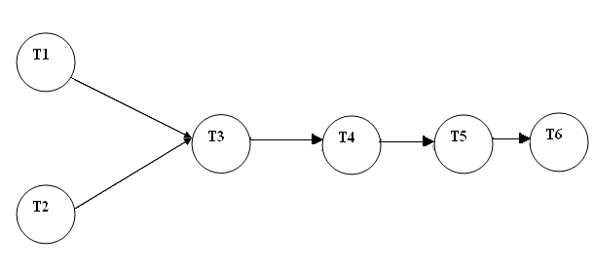

Fig 6.1: Task Network

  - TIMELINE CHART
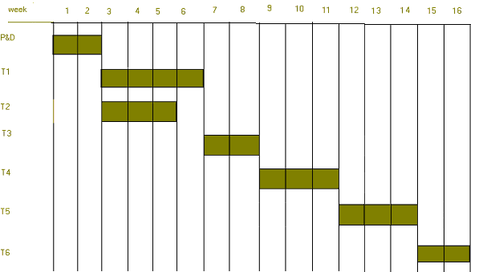

Fig.6.2: Timing Diagram
  - STAFF ORGANIZATION
The manner in which staff is organized and the mechanisms for reporting are noted.

  - TEAM STRUCTURE
Role | Responsibilities | Participant(s)
Project Sponsor | 1.Provide project oversight and guidance  2.Provide resources (finance, medical devices)  3.Review/approve some project elements | Xtremum Solutions
Project Guide | 4.Manages project in accordance to the project plan  5.Provide overall project direction  6.Direct/lead team members toward project objectives  7.Handle problem resolution | Prof. R.S. Paswan
Project Participants | 8.Communicate project goals, status and progress throughout the project to personnel in their area  9.Review and approve project deliverables  10.Coordinates participation of work groups, individuals and stakeholders  11.Assure quality of products that will meet the project goals and objectives  12.Identify risks and issues and help in resolutions | Abhimanyu Bhosle  Aditi Joshi  Aditi Tatti  Mukund Malani
Table 6.5: Team Structure

  - TRACKING AND CONTROL MECHANISMS
Techniques to be used for project tracking and control are identified.
    - Quality assurance and control
Software Quality is defined as conformance to explicitly state, functional and performance requirements, explicitly documented development standards, and implicit characteristics that are expected of all professionally developed sea-wares. Software Quality Assurance (SQA) is an activity that is applied throughout the software process. It involves various steps like:
- Create a set of activities that will help ensure that every software engineering work product exhibits high quality.
- Perform quality assurance activities on every software products.
- Use matrix to develop strategies for improving your software process and as consequence the quality of the product.
- Everyone involved in the software engineering process is responsible for the quality of product.

    - DOCUMENTATION
As a part of ensuring software, project following documents should be prepared:

- Software Requirement Specification
- Software Design Specification
- Risk Mitigation, Monitoring and Management Plan

  - STANDARDS,PRACTICES AND CONVERSIONS
    - Document Standard
All documents are written in Microsoft Word in Font – ‘Times New Roman’ and size 12. The headings are bold with font size ranging from 12 to 14. The documents are fully justified.

    - Coding Standard
All the coding was done in C and Python

    - Review Guidelines
Every team member will update his/her assigned module and send their respective documents to every team member as well as both the guides (internal and external). All the suggested changes by them will be incorporated and the review process will continue in the same way.

    - Metrics
Following metrics will be used to ensure software quality:
- Daily team meeting to discuss progress.
- Meeting with internal guide as well as external guide every week to analyze the progress over previous week.
- Use of Google group and Trello to manage work done by every team member.
- Periodic analysis of the hours being put in by each team member.

    - Quality control through Testing

Every module will be tested thoroughly by designing test cases for each one of them. Each test consists of requirements for performing the test; the exact procedure to be carried out, the correct results of the test and the errors, which the test might expose.

CHAPTER 7

DESIGN AND IMPLEMENTATION

- HIGH LEVEL DESIGN
  - Introduction

    - Purpose
The purpose of this High Level Design Document is to add the necessary detail to the current project description to represent a suitable model for implementation. This document is also intended to help detect contradictions prior to coding, and can be used as a reference manual for how the modules interact with each other.

    - Scope
This document provides detailed description of software context, its usage scenario, data model and description, data object and their relationships, functional model and description, performance issues, software design constraints, software interfacing description, limitations and validation criteria.

  - Overview of Product
(Refer Problem Definition &scope)

  - Architectural Design

Redundant 3-Tier Architecture
Any production environment that is launched in the cloud should also have a redundant architecture for failover and recovery purposes. Typically, you will use a Server Array for your application tier to take advantage of auto-scaling in the cloud; however there may be some scenarios where your application is not designed to auto-scale. In such cases, you can still create a redundant multi-tier architecture where you have redundancy at each tier of your reference architecture. In the example below, there are two load balancer servers, two application servers, as well as master and slave database servers. A redundant architecture will help protect your site/application from system downtime.
This example diagram also demonstrates the use of a striped volume set at the database tier. If your database is large and requires faster backups, you may consider using a set of striped volumes for data storage.

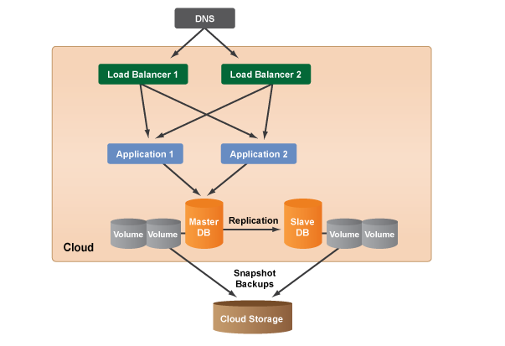
Fig 7.1: 3 Tier Architecture Diagram
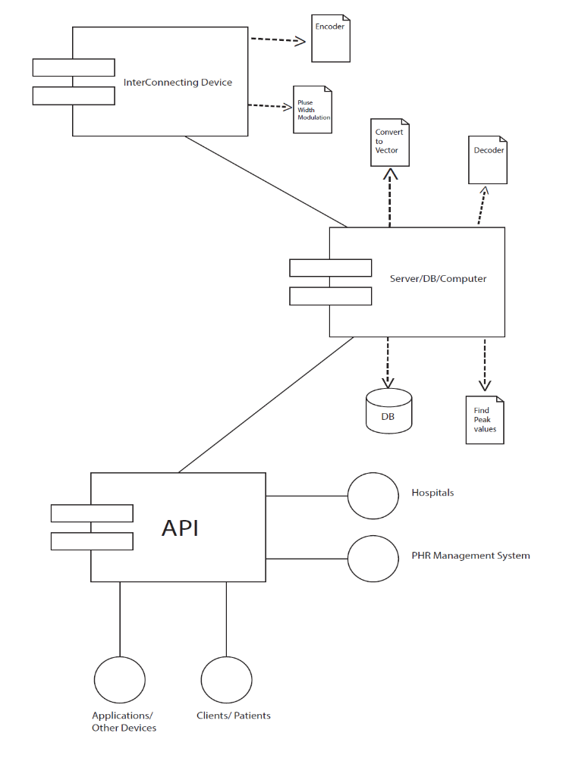

Fig 7.2: Deployment Diagram

The various subsystems can be described as:
- Inter connecting device
This would serve as an interfacing medium between the medical device and the server. The functionality of this hardware device is to read serial data from the medical device and transmit it to the server using TCP/IP stack.
- Server/DB/Computer
This would mainly comprise of the storage space required for patient records and the processing space for the computations and analysis of patient records.
- API
An Application Interface to facilitate interoperability and portability of the available data and analysis over various mediums such as web, android and iOS.

  - Components:
        - Medical Device with Analog output
        - Transmission device
        - Cloud Interface
        - Web Interface
        - Mobile Interface

  - Data Design

    - Internal Software Data Structure

      - Buffers present on the Microcontroller used in the transmitting device
      - TCP/IP Packets used for transmission

    - Global Data Structure
Patient records will be stored using MySQL in various tables, which will serve as a global data structure. These records on processing will be made available to the end-users in the form of an API.

    - Temporary Data Structure

      - Files on the hardware to store incoming excess data
      - Files on the server to unpack the data received in packets from the middleware device

    - Database Description

Data at the server end would be stored in a number of databases depending upon the action made or the requirement. The database would include a table which would, maintain a record of all the doctors as well as patients registered in this system. The details of every Client who signs up are maintained here.

  - Component design
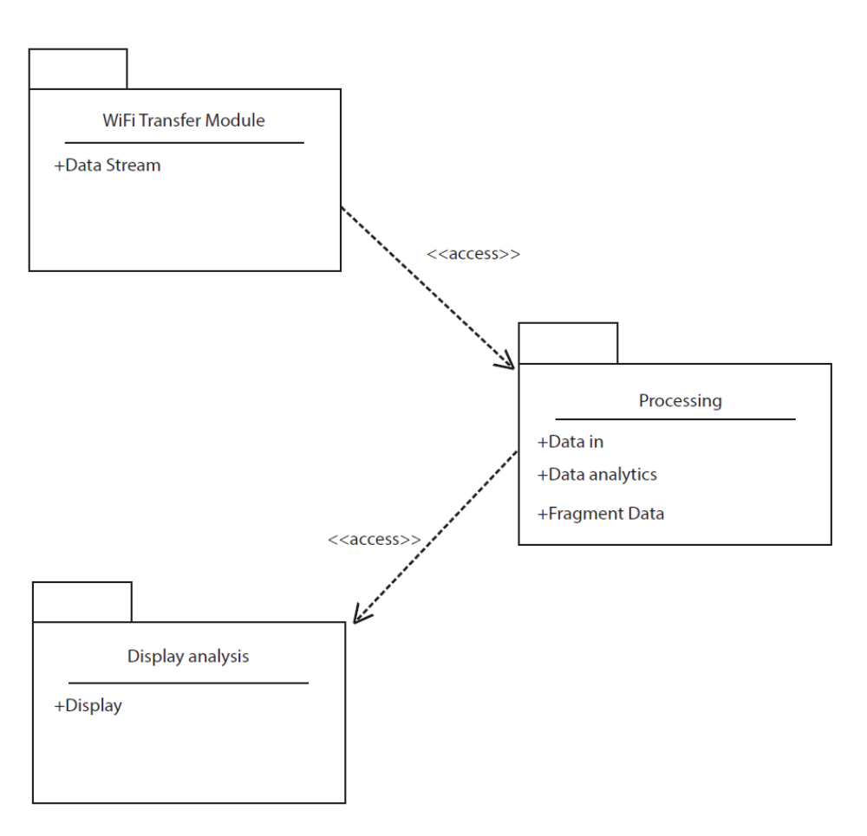
Fig 7.3: Component Diagram

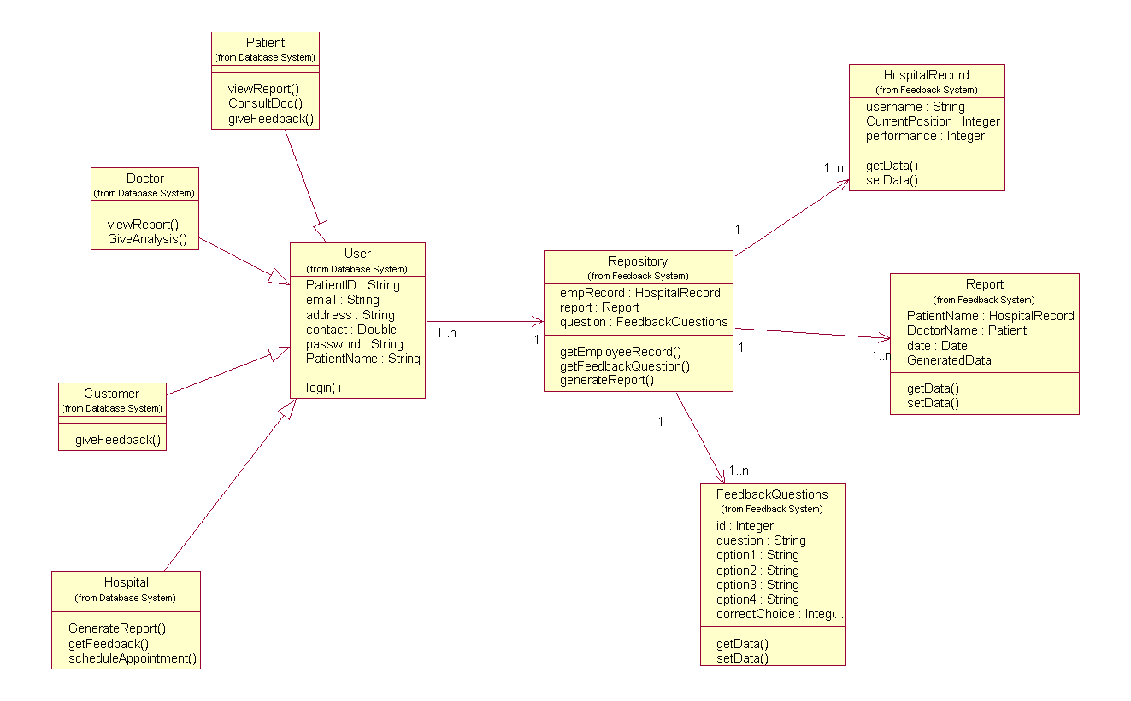
Fig 7.4: Class Diagram

    - Description for Component

      - Processing narrative (PSPEC) for component

        - Medical Device with Analog Output
The monitoring of vital physiological signals has proven to be one of the most efficient ways for continuous and remote tracking of the health status of patients. The medical device can be any such device, for example, Electrocardiogram monitors are often used in many medical service centers and hospitals to diagnose and monitor a person’s health status by measuring their cardiac activity.

        - Transmitting Device

The obtained analog output will first be converted to digital, upon which it would be transmitted to the cloud service for storage using the TCP/IP protocol.

        - Cloud Interface
Cloud Computing is a paradigm of computing in which dynamically scalable and often, virtualized resources are provided as a service over the Internet. In our project, data i.e. patient records along with other details will be stored on the cloud as well as, such records will be processed in order to obtain the analysis. It will act as a medium to store and process data and has been chosen because of its speed universally uniform access.
The cloud has some inherent advantages when it comes to storage. You get:
- Instant Thin Provisioning
- Unlimited Elastic Expansion
- Auto-High Availability
- Availability from Anywhere in the World
- No Hardware Maintenance
- Elastic Storage/CPU, Potential DR
- Utility Billing 5x to 10x Lower

        - Web Interface
A web interface would be provided to the clients of MedCloud, which would allow functionalities such as viewing the analysis of various medical records, sharing them with one’s doctor, etc.

        - Mobile Interface
Information would be provided to the users on mobile platform as well. Mobile platforms on which analysis will be provided are iOS and Android mobile phones.

    - Software Interface Description

      - External Machine Interfaces

The device used to interface with the medical instruments and to transmit the received data to the cloud can be considered as the external machine.

      - Human Interface

- The user being monitored for various health issues.
- The doctor supervising his patients

  - User interface design

    - Description of the user interface
A detailed description of user interface including screen images or prototype is presented.
  - Restrictions, Limitations and Constraints

The middleware transmitting device should be connected to a wireless Access Point

CHAPTER 8

FUTURE WORK

- Future Scope:

At present, We are using just the ECG data of a patient for transmission and analysis. In future, the same could be done with other remaining medical data and analysis could be done on the same. Currently, iOS and Android platforms are targeted for end users which in itself is a big share of current market, but in coming years other mobile platforms like Blackberry, Symbian and so on could be provided access. The system could be provided to various hospitals and private doctors with proper collaboration. The huge number of apps currently in the health sector could make use of the API being provided for patient’s data.

CHAPTER 9

SUMMARY AND CONCLUSION

9.1 SUMMARY AND CONCLUSION:
The project aims to develop the medical records monitoring system over the cloud environment which will allow storage and processing of real-time medical data and provide an interface to access the same.
Until now, in the yearly half phase of our project we are done with the design and architecture of the software product which will be implemented in the final phase. So far the Scope, Problem definition and the necessary modules have been decided. All UML diagrams which define the exact outline of the project are completed and different component modules and their relationship with each other have also been identified. All required keywords have been identified. Software and hardware requirements and specification for implementation of the project are mentioned. We are ready with the high level detailed architectural design of the project. The project plan consisting of the required resources and number of hours required to spend in the implementation of the project is estimated and mentioned in the document.
So at the end of this academic year we will be ready with a product utility which will assist doctors, patient and hospitals alike, to collect, store and analyze medical records.

CHAPTER 10

LIST OF FIGURES

10.1 LIST OF FIGURES
- Use case diagram of the system 24
  - Sequence diagram for page request 26
  - Sequence diagram of feedback system 27
  - Mathematical Model 30
  - Task Network 39
  - Timing Diagram 40
  - 3-Tier Architecture Diagram 46
  - Deployment Diagram 47
  - Component Diagram 50
  - Class Diagram 51

CHAPTER 11

LIST OF TABLES

11.1 LIST OF TABLES

- Hardware required for host 34
- Hardware Required for Host 34
- Risk Table 36
- Project Schedule 38
- Team Structure 41

CHAPTER 12

ANNEXURES

ANNEXURE A

ANNEXURE B

Project Quality and Reliability Testing of Project Design

Introduction
- Testing is one of the important stages in software development cycle.
- Testing is done to verify and validate the software.
- Testing is done at different stages of the project. Each module is developed individually and tested and finally all the modules are integrated together and tested.
- Software testing, depending on the testing method employed, can be implemented at any time in the development process. Traditionally most of the test effort occurs after the requirements have been defined and the coding process has been completed, but in the Agile approaches most of the test effort is on-going. As such, the methodology of the test is governed by the chosen software development methodology.
- Basically there are two types of testing strategies.
- White-Box testing
- Black-Box testing

1. White-box testing
White-Box testing tests internal structures or workings of a program, as opposed to the functionality exposed to the end-user. In white-box testing an internal perspective of the system, as well as programming skills, are used to design test cases. The tester chooses inputs to exercise paths through the code and determine the appropriate outputs. This is analogous to testing nodes in a circuit

2. Black-Box testing
Black-box testing treats the software as a "black box", examining functionality without any knowledge of internal implementation. The tester is only aware of what the software is supposed to do, not how it does it. Black-box testing methods include: equivalence partitioning, boundary value analysis, all-pairs testing, state transition tables, decision table testing, fuzz testing, model-based testing, use case testing, exploratory testing and specification-based testing. Some of these methods are explained below.

Equivalence partitioning-
It is the technique that divides the input data of a software unit into partitions of data from which test cases can be derived. The equivalence partitions are usually derived from the requirements specification for input attributes that influence the processing of the test object. An input has certain ranges which are valid and other ranges which are invalid. Invalid data here does not mean that the data is incorrect, it means that this data lies outside of specific partition.

Boundary value analysis:-
The boundary between two partitions is the place where the behavior of the application changes and is not a real number itself. The boundary value is the minimum (or maximum) value that is at the boundary. Boundary value analysis does not require invalid partitions

Explanatory Testing
Exploratory testing is an approach to software testing that is concisely described as simultaneous learning, test design and test execution. While the software is being tested, the tester learns things that together with experience and creativity, generates new good tests to run. It is a test approach that can be applied to any test technique, at any stage in the development process.

ANNEXURE C

Project Planner

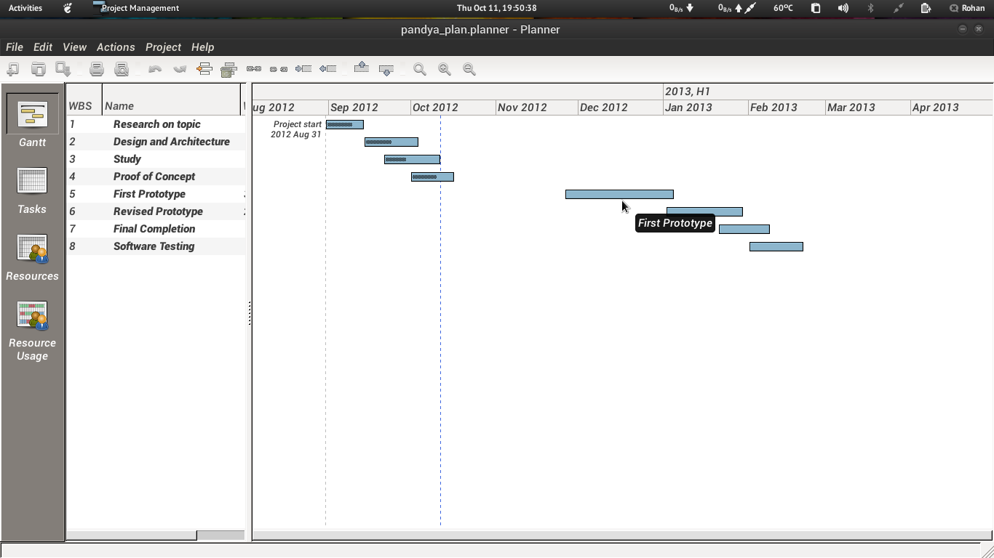
Fig. a Project Timeline

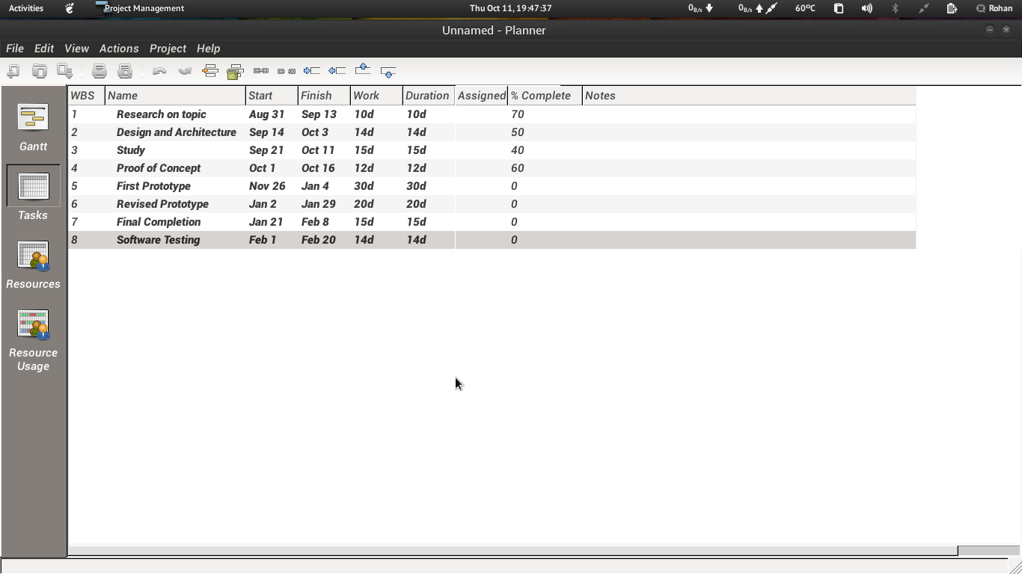
Fig. b Task set

ANNEXURE D

Paper

CHAPTER 13

REFERENCES

13.1 REFERENCES

[1] National Academy of Engineering, Grand challenges for engineering. URL: http://www.engineeringchallenges.org (accessed July 2010).
[2] V.Jones,A.V.Halteren,I.Widya,N.Dokovsky,R.Bults,D.Konstantas,R.Herzog, Mobihealth: Mobile Health Services Based on Body Area Networks, in: Topics in Biomedical Engineering, Springer US, Boston, MA, 2006.
[3] B.-U. Kohler, C. Hennig, R. Orglmeister, The principles of software QRS detection, IEEE Engineering in Medicine and Biology Magazine 21 (1) (2002) 42–57.
[4] Pan, Jiapu; Tompkins, Willis J. A Real-Time QRS Detection Algorithm. IEEE Transactions on Biomedical Engineering, vol. BME-22, pp. 230 – 236, March 2005.

[5] ECG SIGNAL PROCESSING AND HEART RATE FREQUENCY DETECTION METHODS
J. Parak, J. Havlik

[6] ECG Interpretation by Dr White.
ISBN: 978-1-4051-6749-9

[7] Rapid Interpretation of EKG’s by Dale Dubin
ISBN: 0-9120912-06-5

[8] Telemedical Information Systems Alexander Horsch and Thomas Balbach

[9] The Case for Cloud Computing - Robert L. Grossman, University of Illinois at Chicago and Open Data Group.

[10] A. Ranabahu, M. Maximilien, A best practice model for cloud middleware systems, in: Proceedings of the Best Practices in Cloud Computing: Designing for the Cloud, ACM SIGPLAN International Conference on Object-Oriented Programming, Systems, Languages, and Applications, OOPSLA, Orlando, FL, USA, 2009.

