# The REXXENQ0 service

REXXENQ0 is an assembler program which can be invoked from a REXX program, and will itself invoke a further REXX program. However, while the second REXX program is executing a sysplex-wide ENQ will be held.

Parameters can be passed forward as shown. However, if a value or values need to be passed back to the original REXX program, then the stack should be used for communication.

In the example shown in Figure 19 - Example of use of REXXENQ0 the routine MYREXX01 uses REXXENQ0 to invoke MYREXX02. If MYREXX02 passes back information to MYREXX01 it can use the REXX stack.

REXXENQ0 does not make any changes to the REXX stack.

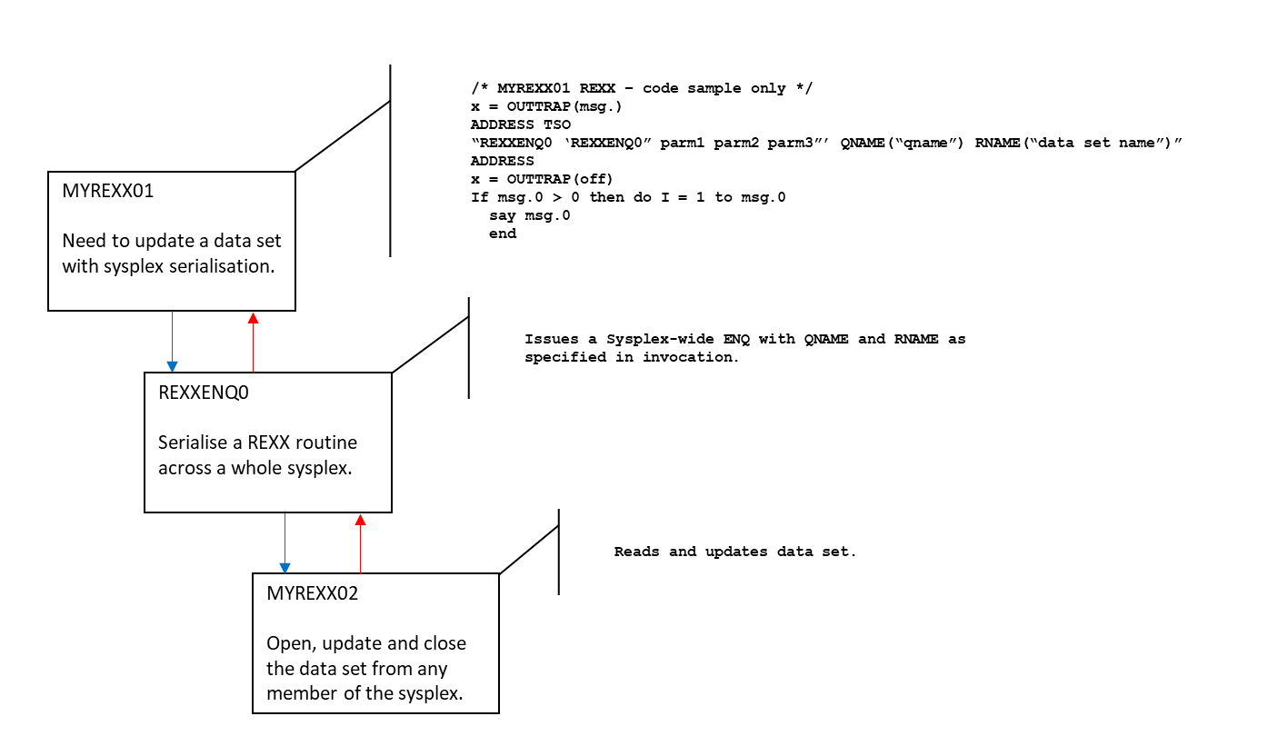

*Figure 19 - Example of use of REXXENQ0*

## Messages from REXXENQ0

REXXENQ0 issues only one message.

**REXXENQ0.001E**

IKJEFTSR RC=rrrrrrrr P4=xxxxxxxx P5=yyyyyyyy P6=zzzzzzzz

**Explanation**

REXXENQ0 will issue this message when a failure occurs. This could be that the routine requested could not be invoked by REXXENQ0, or it could be a failure within the routine that is invoked.

REXXENQ0 makes use of the TSO/E Service Facility to invoke the REXX routine.

In the message are four fields. These should be read in conjunction with the documentation on ‘Using the TSO/E Service Facility IKJEFTSR’ in the IBM manual TSO/E Programming Services SA32-0973-nn.

In that chapter there is a description of the parameter list passed to IKJEFTSR. This uses up to 9 parameters. Parameters 4, 5 and 6 are output parameters which give details of any error statuses.

In the message,

RC is the return code from IKJEFTSR

P4 is the value of parameter 4 after execution.

P5 is the value of parameter 5 after execution.

P6 is the value of parameter 6 after execution.

**System Action**

The request terminates.

**User response**

Examine the values in the message. Common failures are,

* The REXX routine that REXXENQ0 invoked returned with a non-zero return code. Examine messages from that REXX routine to determine what action to take.
* The REXX routine could not be found. Make sure the REXX routine is named correctly and that it is available in the SYSEXEC or SYSPROC datasets.

Lennie Dymoke-Bradshaw  
Reverse Sweep Consulting Limited

Sunday, 15 November 2020