“Report Title Records”
This write up is designed to help you understand how the batch extract process works. It is really important that you understand how this process works if you are going to use this system. The extract process creates Detail records, Index records and History records. A detail/data record is one full page of print data. Once the extract program has created a data record it tries to find a report match using the records in the “Title” file. The “Title” records have data in them that is used to identify a report by the different header fields in the data record. This process is really a locate process. It maybe referred to as a SCAN process but truly there is no scanning taking place. All reports field values that are looked for use a locate process. This locate process is to find a specific report value at a specific spot on the printout (print page). The data record is used to locate these values. Almost all of the fields are either matched or pulled from the data record. The examples below should help you understand this process.

Locate Process.
The “Report Title Data” fields on the “Report System TITLE Display” screen are used to identify a report. There are three sets of values that can be used to identify a “report” (report-id). There are four fields in each set. These are values that will be used to identify a report name and assign a report-id. The four values are 1) Line number on the page 2) Position on that line 3) Length of the value to look for 4) The value itself. There are three sets of these. You can use all three, two or just one to identify a specific report. If the program gets a HIT on these values that data record is assigned a Report-ID. This same locate process is used several times to find other things on the print page. Like Date, this would be the date that is on the report. The extract process supports several date formats. If the report doesn’t have a date on it you can use the system date or a date on the control card in extract job JCL. The same locate process is used to get the Bank number and Branch number. Every report has a “Report-ID” assigned to it.

Report Title Records
There are two types of TITLE records. Primary Report (Report-ID) and Secondary Report (Report-SID) records. These record formats look a lot alike. Secondary Report records (Report-SID) are a little different. You can only have secondary report records if you have a primary record “HIT”. Meaning you have to have a Primary Report-ID assigned before you can have a Secondary Report-SID. Secondary locates use the same locate process that is used for the primary Report-ID. They just use a different record in the “Secondary TITLE” record. The secondary report is used to view a “SUB-SET” of the primary report. Suppose you have a report that is for 20 different branches. This report is 500-pages long and all 20 branches have a “TOTAL” page. Now you have 20 pages that are just total pages. If there is something on each one of those “TOTAL” pages that can be used to identify that page as a “TOTAL” page then you can setup a secondary report record that can be used to locate the values in the secondary Title record. If it gets a HIT then it will create a secondary history record and a secondary index record. If it only gets 20 HITS then it will only create 20 history and 20 index records (secondary report-sid). That is in addition to the normal REPORT-ID index and history records. Now using the Report-ID (primary) and Report-SID (secondary) you can go straight to the first total page. The next page you see after the first “TOTAL” page is the second “TOTAL” page. In this case you would see only the 20 TOTAL pages. Ex: You start with the first total page. Press PF8 to go to the next total page.
The index and history records are built once the locate process has completed. When REPT015, REPT020 has finished running it will have produced new history, index and detail records.

Example # 1: This is screen shot of a title record display.
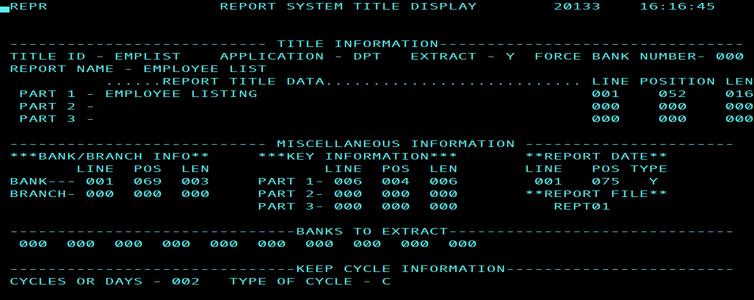

Example # 1: This is the report you want to put into this system. We start out looking for the “Report Title Data”. The best way to get these values correct is to edit a page or two of the report itself. Notice the column and line display. These show you what line to look for and what column as well what the report field itself contains. You will need to locate the top of page. Is this case the “1” in position 1 says this is top of page.

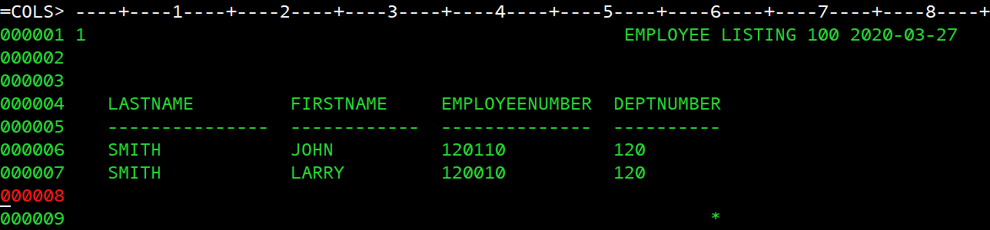
Line 1 is always the TOP PAGE. The printout top of page. This is the “EMPLOYEE LISTING” report.
Notice in this image the title of the report is on LINE 1. The position of the title starts on position 52. The length is 16 for “EMPLOYEE LISTING”. On this report we can identify this report using only one set of values. Now the extract program will assign the report-id value of “EMPLIST”. It gets this from the matching “title” record. The bank number of is on LINE 1 position 69 and the length is 3. The date is on LINE 1 Position 75 with a date type of “Y” (YY-MM-DD).
Also notice in the title record display that the Report file prefix is REPT01. This means that the CICS online files REPT01IX and REPT01DT will need to be defined to CICS. The history records have this Report file prefix value stored in them.
Every print record (page) that has “EMPLOYEE LISTING” that matches this data will have a data, index and history record create by the batch process.

Example # 2: This is another example.
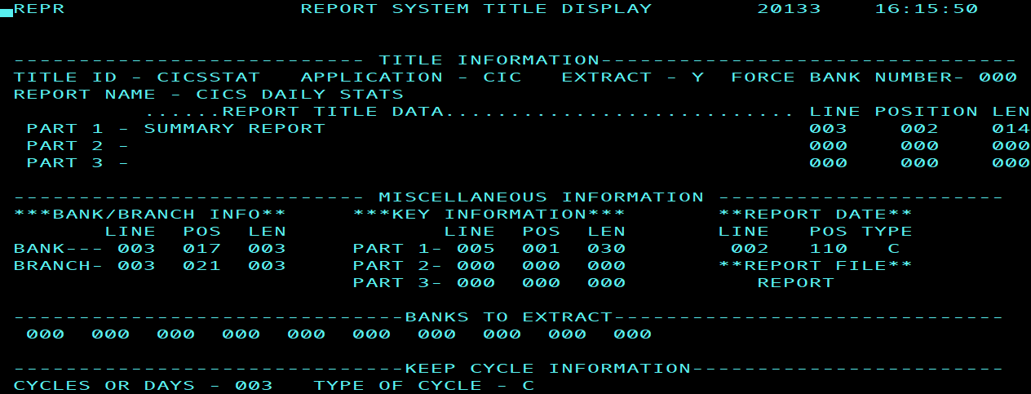
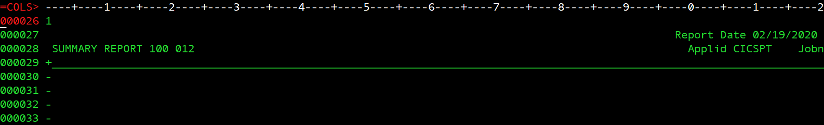
This is the CICS “SUMMARY REPORT”. Notice in this image the title of the report is on LINE 3. The position of the title starts on position 2. The length is 14 for “SUMMARY REPORT”. On this report we can identify this report using only one set of values. The bank number of is on LINE 3 position 17 and the length is 3. The branch is on LINE 3 Position 21 and the length is 3. The date is on LINE 2 Position 110 with a date type of “C” (MM-DD-YYYY).
Also notice that the Report file prefix is REPORT. This means that the CICS online files REPORTIX and REPORTDT will need to be defined to CICS. The history records have this Report file prefix value stored in them.
Every print record (page) that has “SUMMARY REPORT” that matches this data will have a data, index and history record create by the batch process.

“Report Title Secondary Screen”
Example # 3 This example we will create a secondary report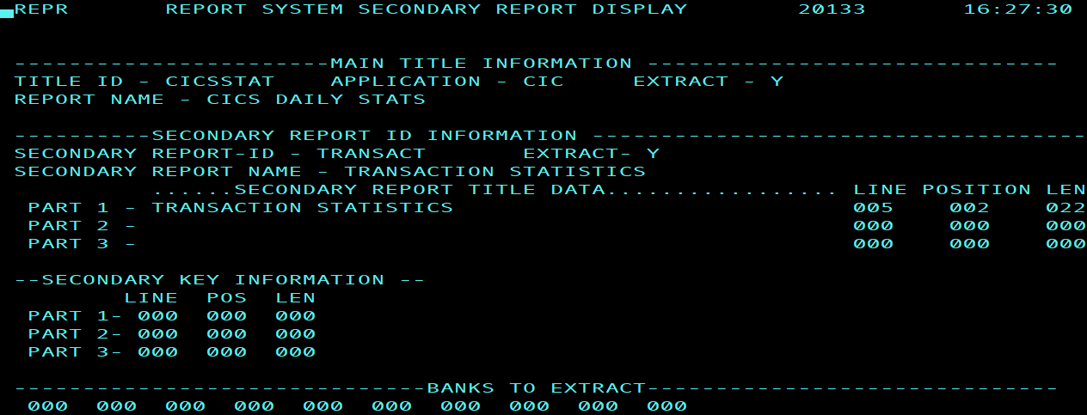
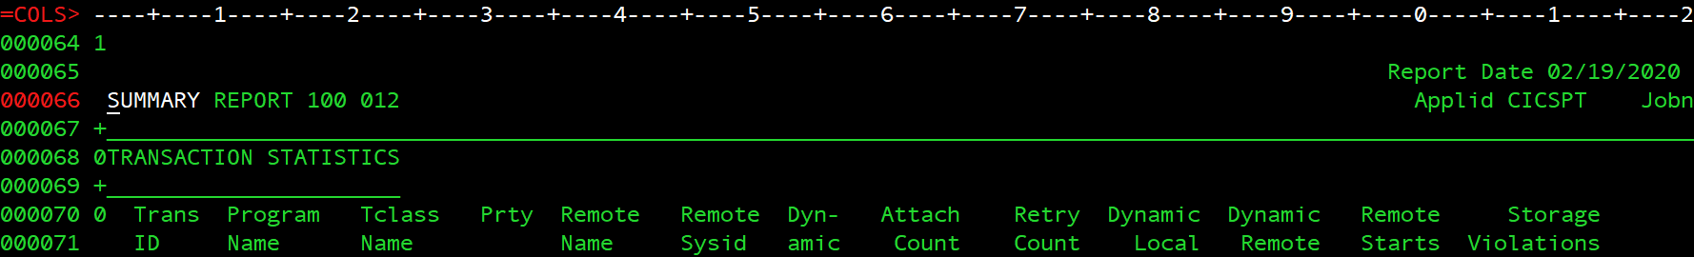
This a secondary report so it has to be a part of a PRIMARY report. Notice this primary report is “SUMMARY REPORT” and the primary REPORT-ID is CICSSTAT and the secondary report is “TRANSACTION STATISTICS” and the REPORT-SID is TRANSACT.
Notice in this image the secondary title of the report is on LINE 5. The position of the secondary title starts on position 2. The length is 22 for “TRANSACTION STATISTICS”. On this report we can identify this report by using only one set of values. The bank number and branch are used from the primary report-id. The date is also used from the primary report-id. The advantage to using a secondary report is you can see all of the “Summary Report”, “Transaction Statistics” pages and see just the “Transaction Statistics” pages without having to see all of the others. If you want to see all of “SUMMARY REPORT” record then don’t use the secondary ID.
Also notice no Report file prefix. The report file is obtained from the primary report-id is used.
Other information about fields in the TITLE records.
The extract field is either “Y”, “N” or “P”. This applies to the batch extract process. Both the primary and secondary records have an extract field. However, the Primary extract flag must be “Y” or “P” for the secondary report to get extracted. If you turn the primary extract flag off and you have secondary extract flag set to “Y” the secondary report won’t get extracted. “P” is used to extract just specific banks for the report.
If the “Force Bank” field is anything other than zero the batch extract process will force the bank number to be what the value of “Force Bank” is and the branch will be zero. Under the “Bank/Branch Info“ if the Bank Line value is zero (default) the batch process will use the force bank number. If the Bank number is not numeric the extract process will put zero in the bank field and zero the branch number.
The application field is used to select reports to extract by application id. This is to simplify the control card process in the batch extract programs. REPT015 or RETP020.
Banks to extract is just in case you want to extract specific banks but not every bank for this specific report.
Key information is used to as a way to view key information from report pages. This is may be used to save time if you trying to browse thru a large report looking a specific account. The information on the key information comes off page itself. You can see these values on the INDEX page view.

