TABLE OF CONTENTS

TABLE OF CONTENTS 1
REPT TRANSACTION 2
OPTIONS MODE 3
OPTIONS SCREEN 4
VIEW MODE 5
VIEW SCREEN 7
DATE LIST MODE 8
DATE LISTS SCREEN 9
TITLES LIST MODE 10
TITLE LISTS SCREEN 11
INDEX MODE 12
INDEX SCREEN 13
REPR TRANSACTION 14
OPTION MODE 15
OPTION SCREEN 17
LIST REPORT ID MODE 18
LIST REPORT-ID SCREEN 19
LIST SECONDARY REPORT ID MODE 20
LIST SECONDARY REPORT-ID SCREEN 21
REPORT ID DETAIL MODE 22
REPORT-ID DETAIL SCREEN 25
SECONDARY REPORT ID DETAIL MODE 26
SECONDARY REPORT-ID DETAIL SCREEN 28
REPU TRANSACTION 29
OPTION MODE 30
OPTION SCREEN 31
LIST MODE 32
LIST SCREEN 34
USER ID MODE 35
USER-ID SCREEN 37
INDEX 38

REPT TRANSACTION

This system will allow you to view reports from a CICS terminal. Several days' reports can be kept on file. Report names and dates are kept to allow you to view more than one days' reports. There are two ways of using REPT. A fast path and by the menus. The fast path can be used to take you directly to a screen without having to use the menus. You have direct access to three screens. The view screen, index screen, & date screen. The correct syntax for this method is: "REPT/X/12345678"
where x --- Is one of three values, "V" to view a report, "I" to access the index screen, "D" to access the date list screen.
where 12345678 --- Is the report ID of the report you want to view.

Example: REPT/V/DEPART press enter
This will bring up the view screen with the first page of the DEPART report. If there is more than one DEPART report on file it will use the most current date. The date used is the date that appears on the report.

The menus can be used to access reports as well. Each different screen has a name. There are five different screens. 1) Options 2) Report Titles list 3) Index list 4) Dates list 5) View report.

On the following pages each screen and the different options available while using those screens are explained. You may have CICS transaction. REPT will use a 27x132 screen format and REPS will use 24x80 screen format.

OPTIONS MODE
This screen has four options. Just enter the number of the option you want to use and any required or optional fields and press the enter key. Listed below is a explanation of the options and the other fields that appear on the screen.

Option ------ Enter into this field the number of the option you wish to use.
Report ID ---- This is the primary name used to access a given report. There should only be one of these per report.
Secondary ID - This field is used primarily to access a subset of a report. That is a report that has totals by Bank, Branch and type. You may set up a secondary ID to view just sub-set of a report.
Report Date -- This is the processing date of the report. The date that is on the report.

Option 1 - This option will list all of the dates that are available to this system for the report ID and secondary report ID that you have entered. You may select which date you would like to use from the screen that is produced by this option. The report ID is the only required field for this option.

Option 2 - This option will display the report keys (in numerical order) that are available to you for the report ID, secondary report ID and date that you put in on this screen. You may select the page you want to look at from the screen that is produced by this option. The report ID is the only required field that you must enter to use this option.

Option 3 - All of the report ID's and their secondary ID's you have access to are listed on the screen that is produced by use of this option. You may select a report from that screen. This option has no required fields. However, you may enter a report ID or a generic report ID. That will be used as a starting point for the display that will be produced by using this option.

Option 4 - This option will take you straight into view mode. It will display the first page that you have access to. The report ID is the only required field that MUST be entered to use this option.

**NOTE** On all options if no date is entered in the date field. The default date will be used. The default date is the most current date on file.

**NOTE** You default bank and branch will help determine what reports you can view.

OPTIONS SCREEN

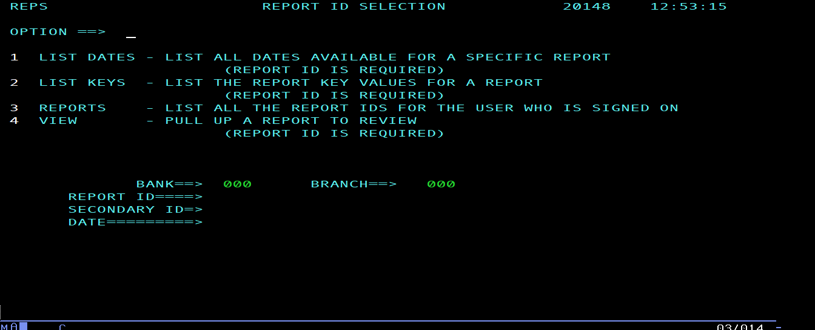

VIEW MODE
This screen is used to view a printout. You can move around in the printout by using the PF keys. See the explanation below on how to use these keys.
Skip==> "n" - A number that you enter to be used with PF4 ,PF5, PF7, PF8, PF11, PF12.
Report date - is the processing date from the printout itself.
ID ---------- This is the name (REPORT ID) that is used to access this report.
SID --------- This is or can be used as a way to access a subset of the main report.
Search=> "string" Is used to search for a string of characters. The string must be enclosed in one of three things. 1) single quotes 2) double quotes or 3) parentheses, may be used. The search will be downward by default. By placing a 'u' as the first character in the search field an upwards search may be done.
Example: u"account" Search upwards in the report.
Example: 'account' Search downwards in the report.
**PF Keys**
PF1 - This PF key will always take you to a help screen.

PF3 - Will take you back one level from where you are. Ex: If you are in view mode (viewing a report) by pressing the PF3 key you will go back to the key index selection screen.

PF4 - 1Will move you up "N" LINES within the page you are currently on. Put in a number, say "10" on the command line and press the PF4 key. This will move you up 10 lines from where you are. But only within the same page. If no number is put on the command line 20 is assumed. You can not go beyond the start or end of a page. To get to the top lines on a page just put a number larger than the number of lines on the page (99). This will take you to the top of the page.

PF5 - 1Will move you down "N" LINES within the page you are currently on. This PF key works just like PF4 except that it moves you down.

PF6 - Pressing this key will search for the string enclosed in quotes that is in the search field. The search will only go for 20 pages. If you get a not found condition, you may press this key again and the search will start back where it left off and go for another 20 pages.

PF7 - 2Will go backwards "N" PAGES. Put a number in the command line, say 5 and press the PF7 key. This will move you backwards 5 pages from where you are. If no number is entered. One will be assumed.

PF8 - 2Moves you forward "N" PAGES. It works just like the PF7 key except it moves forward.

PF11- 1Moves you right "N" positions. Put a number, say 20 on the command line and press the PF11 key. This will move you 20 characters to the right from where you are. It will not move right of position number 133. It will not rap around. If no number is put on the command line then 20 is assumed.

PF12- 1Moves left "N" positions. It functions just like PF11 except it moves to the left.

**NOTE 1 ** The PF4, PF5, PF11, PF12 keys are used to move around on a page. They do not change pages. They either move up, down, left, or right but always on the page you were on when you pressed the key. If you are in 27x132 mode the PF11 an PF12 keys won’t do anything.

**NOTE 2 ** The PF7 & PF8 keys are used to change pages. Where you are on the page will not change only what page you are viewing.
Example: You are on page 5. By pressing the PF8 key (default 1 page) you will move to page 6.

VIEW SCREEN

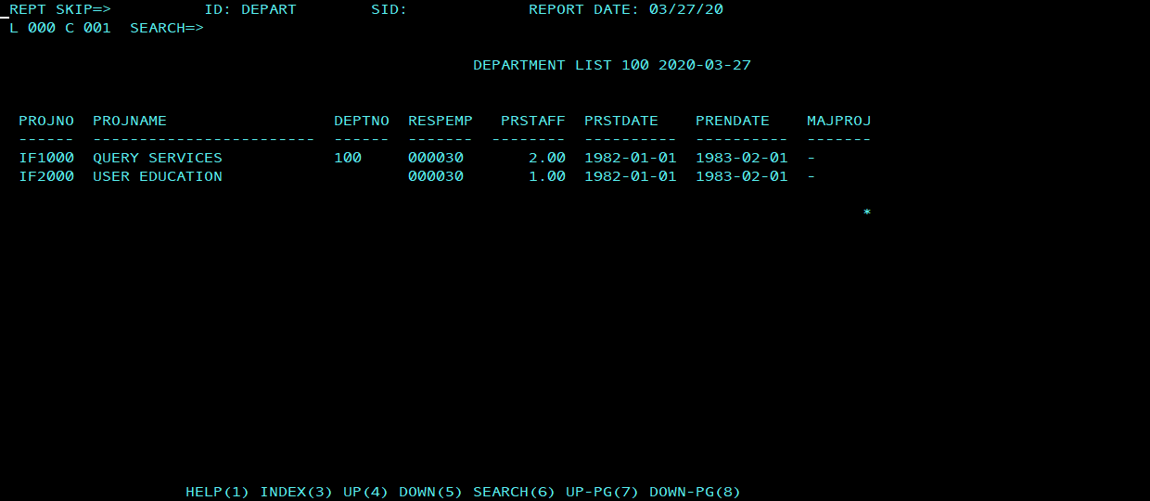

DATE LIST MODE
This screen will display a list of all the report dates available for a specific report ID. You may select a report date to view from this screen. There are two selection options that are available from this screen. They are listed below. Just enter the letter of the option you wish to use in the field next to the report date you want. This screen is know as the "Date mode" screen.

Options

V - Place a "V" in the field next to the report date you want to see. This will select the report for viewing and will return the "view mode" screen.
I - Place a "I" in the field next to the report date you want to see. This will bring up the "index mode" screen. The index screen is a list of index values that are pulled off each page of the report.

PF Keys

PF1 - This PF key will take you to the date help screen.

PF3 - Will return you to the previous screen you were on.

DATE LISTS SCREEN

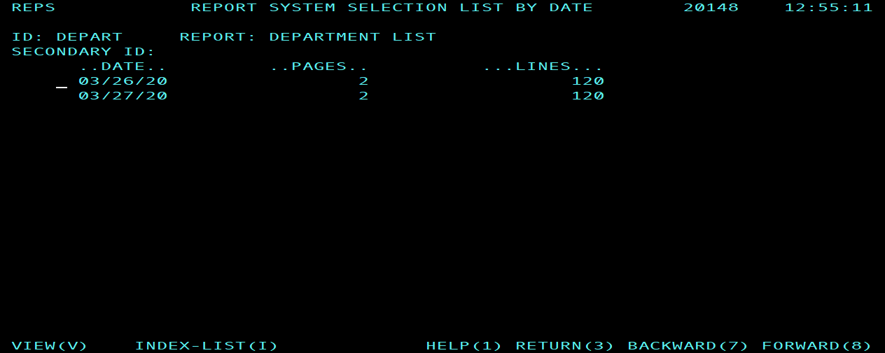

TITLES LIST MODE
This screen will display all of the reports that you have access to. You may select a report by entering a letter in the field next to the report ID field. The options that can be entered in this field are listed below. This screen is know as the "Titles mode" screen.

Options

V - Place a "V" in the field next to the report ID you want to see. This will select the report for viewing and will return the "view mode" screen. The report date that is used is the most current one on file.

I - Place an "I" in the field next to the report ID you want to see. This will bring up the "index mode" screen. The index screen is a list of index values that are pulled off each page of the report. The report date that is used is the most current one on file.

D - Place a "D" in the field next to the report ID you want to see. This will bring up the "date mode" screen. The date screen is a list of report dates that are available for the report you selected.

**PF Keys**
PF1 - This PF key will always take you to a help screen.
PF3 - Will take you back one level from where you are. Ex: If you are in view mode (viewing a report) by pressing the PF3 key you will go back to the key index selection screen.

PF7 - Will go backwards in the list. It will only go one page at a time.

PF8 - Moves you forward. It works just like the PF7 key except it moves forward.

TITLE LISTS SCREEN

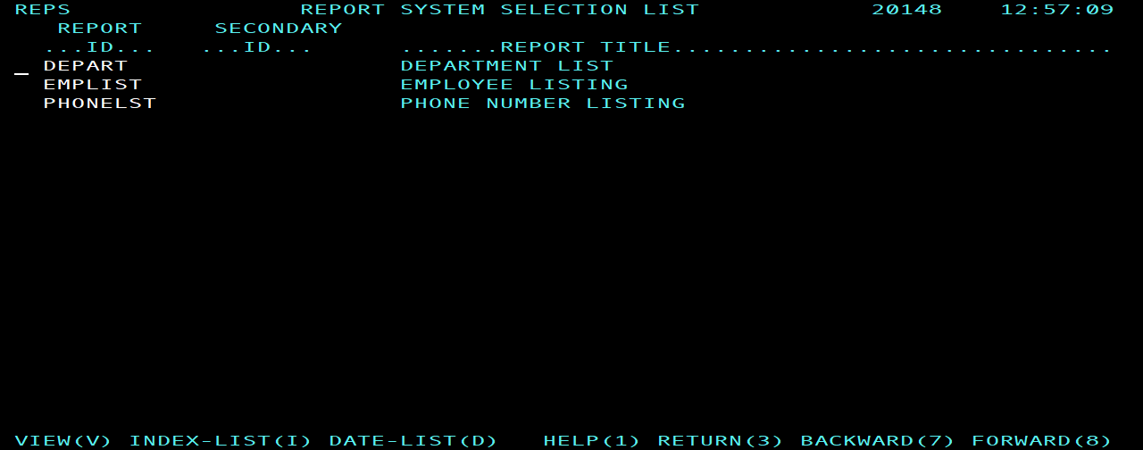

INDEX MODE
This screen will display all of the index/key values that you have access to. The list will be in numerical order. This key value can be anything. However normally this will be the bank/branch and/or account. This value (index/key) is pulled off of each page of the report. Each page may or may not have a unique index/key value. If each page does not have a unique index value the order will be the same as it would have been had you printed it. From this screen you may select the specific page you want to look at. This screen is know as the "Index screen".

Options

V - Place a "V" in the field next to the page key value you want to see. This will select the report for viewing and will return the "view mode" screen.

**PF Keys**
PF1 - This PF key will always take you to a help screen.
PF3 - Will take you back one level from where you are. Ex: If you are in view mode (viewing a report) by pressing the PF3 key you will go back to the key index selection screen.

PF7 - Will go backwards in the list. It will only go one page at a time.

PF8 - Moves you forward. It works just like the PF7 key except it moves forward.

INDEX SCREEN

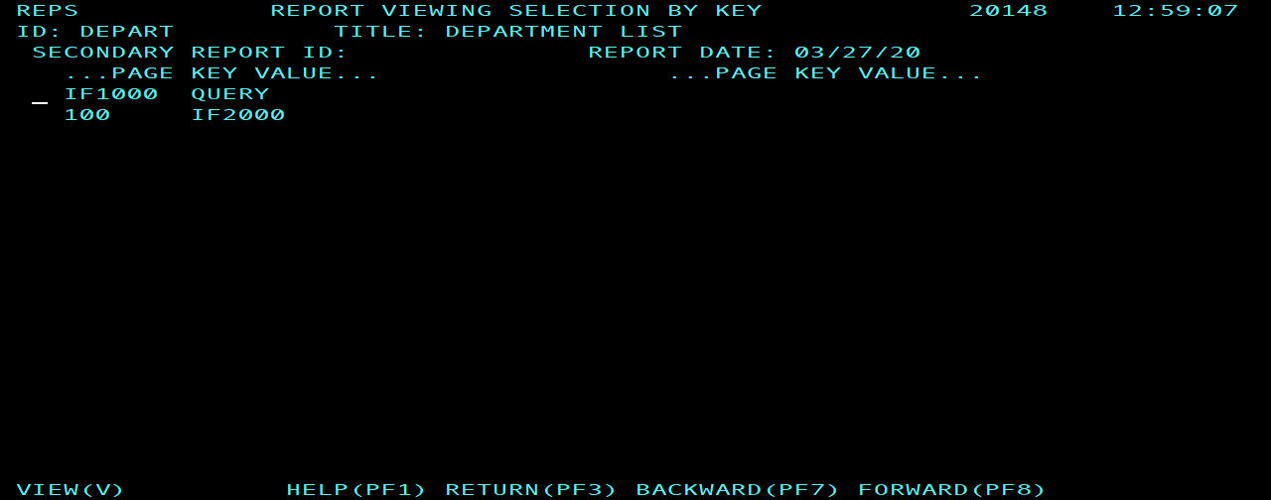

REPR TRANSACTION

This transaction is used to update the report systems TITLE file. To use this transaction just type in REPR and press the enter key. A menu like the one shown in figure 1 will be displayed. This transaction is used to control what reports are put into the on-line files. Also how long reports are to stay on file. There are five screens that are used in this transaction. These screens are listed below. Also an explanation of each field on each screen is provided later in this document.

1. Options, menu screen.
2. List report IDS.
3. Display, add, update, delete, copy report ID record.
4. List Secondary report IDS.
5. Display, add, update, delete, copy secondary ID record.

OPTION MODE

This is a transaction to display, list, add, change, or delete a REPORT ID or secondary REPORT ID record. There are twelve options. Just enter the number or letter of the option you want to use and press the enter key. Listed below is an explanation of the options and the other fields that appear on this screen. The REPORT ID and secondary REPORT ID fields are related to each other. There is one REPORT ID record for each report that is to extracted in to the on-line files. The secondary report id is used to create a subset of the main report (report id). The report is only stored on file one time. The secondary report id creates a different set of index records. That is they are different from the MAIN REPORT ID index records. This allows access to a subset of the main report with just one copy of the report stored on-line.

Option -- Enter into this field the number or letter of the option you wish to use.

REPORT ID or LIST- This is the REPORT ID you which to deal with. A prefix can be used as a starting point for a search or list (option 2).

Secondary REPORT ID - This is the secondary report id. This secondary id is related to the MAIN report id.
OPTIONS

1 - This option will add a new REPORT ID record to the file. The REPORT ID must be entered into the REPORT ID field for this option.

2 - This option will display a list of the report ids on file. You may put in a starting prefix with this option. You may select the report id you want to look at from the screen that is produced by this option.

3 - This option will copy an existing report id record and create a new report id record. The report id (existing report id) must be entered into the REPORT ID field for this option.

4 - Display a REPORT ID record. The REPORT ID must be entered into the REPORT ID field for this option.

5 - Update a REPORT ID record. The REPORT ID must be entered into the REPORT ID field for this option.

6 - Delete a REPORT ID record. The REPORT ID must be entered into the REPORT ID field for this option.

7 - This option will add a new SECONDARY REPORT ID record to the file. The REPORT ID and secondary REPORT ID must be entered into the their fields for this option. You must have REPOT-ID record before you create a SECONDARY REPORT ID.

8 - This option will display a list of the secondary report ids on file. You may put in a starting prefix with this option. You MUST enter the REPORT ID that relates to the secondary report ids you want to see. You may select the secondary report id you want to look at from the screen that is produced by this option.

9 - This option will copy an existing secondary report id record and create a new secondary report id record. The secondary report id (existing secondary report id) must be entered into the secondary REPORT SID field for this option.

A - Display a secondary REPORT SID record. The REPORT ID and secondary REPORT SID must be entered into the their fields for this option.

B - Update a secondary REPORT SID record. The REPORT ID and secondary REPORT SID must be entered into their fields for this option.

C - Delete a secondary REPORT SID record. The REPORT ID and secondary REPORT SID must be entered into their fields for this option.

OPTION SCREEN

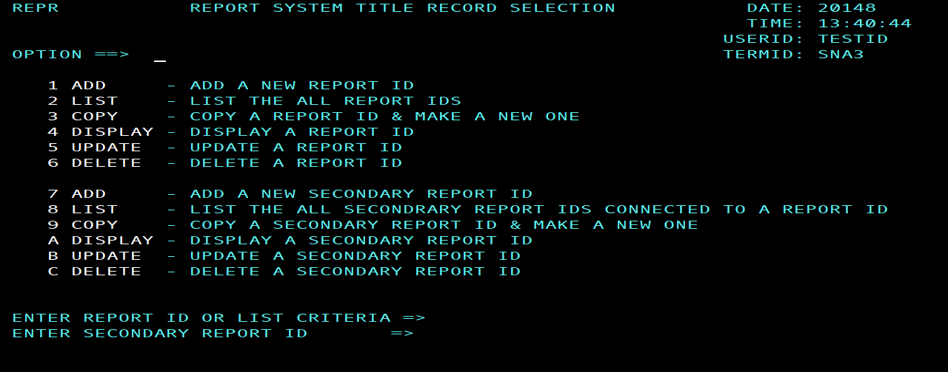

LIST REPORT ID MODE

This screen will display a list of all the REPORT IDs available for your USER ID. You may select a REPORT ID from this screen. There are four selection options that are available from this screen. They are listed below. Just enter the letter of the option you wish to use in the field next to the REPORT ID you want.

Options

C - Place a "C" in the field next to the report id you want to copy. This will select the report id as the record to be copied and will start up the copy function. It will return the COPY FUNCTION screen.

D - Place a "D" in the field next to the report id you want to see. This will select the report id record to be displayed. It will return the DISPLAY screen.

U - Place a "U" in the field next to the report id you want to update. This will select the report id as the record to be updated and will start up the update function. It will return the UPDATE FUNCTION screen.

Z - Place a "Z" in the field next to the report id you want to delete. This will select the report id as the record to be deleted and will start up the delete function. It will return the DELETE FUNCTION screen.

LIST REPORT-ID SCREEN

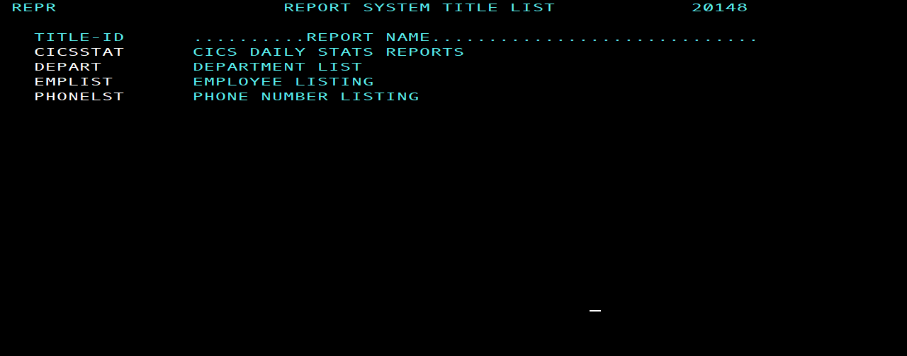

LIST SECONDARY REPORT ID MODE

This screen will display a list of all the secondary REPORT IDs available for your USER ID that are related to the MAIN REPORT ID you put in. You may select a secondary REPORT ID from this screen. There are four selection options that are available from this screen. They are listed below. Just enter the letter of the option you wish to use in the field next to the secondary REPORT ID you want. You must enter a valid main report id with this option.

Options
C - Place a "C" in the field next to the secondary report id you want to copy. This will select the secondary report id as the record to be copied and will start up the copy function. It will return the COPY FUNCTION screen.

D - Place a "D" in the field next to the secondary report id you want to see. This will select the secondary report id record to be displayed. It will return the DISPLAY screen.

U - Place a "U" in the field next to the secondary report id you want to update. This will select the secondary report id as the record to be updated and will start up the update function. It will return the UPDATE FUNCTION screen.

Z - Place a "Z" in the field next to the secondary report id you want to delete. This will select the secondary report id as the record to be deleted and will start up the delete function. It will return the DELETE FUNCTION screen.

LIST SECONDARY REPORT-ID SCREEN

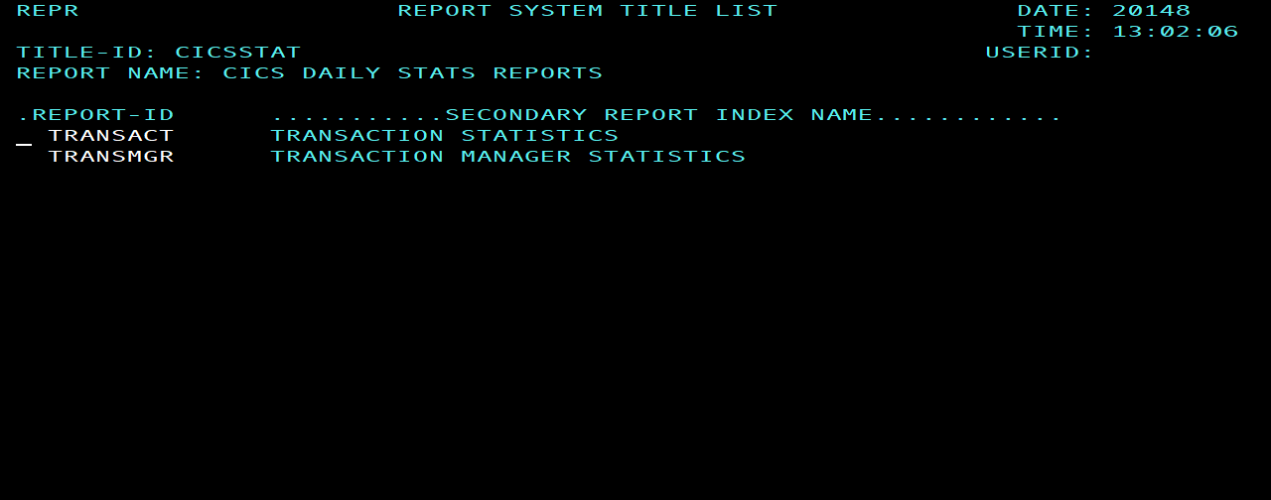

REPORT ID DETAIL MODE

This screen will be displayed when the detail information about a report id record is needed. The second line on this screen will tell you what function you have ask for. The information displayed is used by the batch programs to control what reports are placed in the on-line system. As well as how long those reports will stay on file.

FIELDS:
REPORT ID - Eight position main report id

APPLICATION - three position application name

EXTRACT - Method of extract to use for this report
N - do not extract
Y - extract whole report
P - extract only matching bank numbers

FORCE BANK NUMBER - Three position bank number used with in on-line files to replace the bank number that is on the report itself or to create one if one doesn’t exist.

REPORT NAME - What the report is called

REPORT TITLE DATA - This is the data used to locate a character string within the report page that is unique to this report. This string must be on each page of the report that you want to place on file. It can be all on one line or on some combination of lines but not on more than three lines.

PART 1
String - String of data to look for.
LINE - Line number on which this string is located.
POSITION - Column number on the line where this string starts.
LENGTH - Part 1 length of the character string

PART 2
String - String of data to look for.
LINE - Line number on which this string is located.
POSITION - Column number on the line where this string starts.
LENGTH - Part 2 length of the character string

PART 3
String - String of data to look for.
LINE - Line number on which this string is located.
POSITION - Column number on the line where this string starts.
LENGTH - Part 3 length of the character string

BANK - Location of the bank or organization number on each page.
LINE - Line number of where the bank number is located.
POSITION - Column number on the line where the bank number is.
LENGTH - Length of the bank number.

BRANCH - Location of branch number on each page.
LINE - Line number of where the branch number is located.
POSITION - Column number on the line where the branch number is.
LENGTH - Length of the branch number.

KEY INFORMATION - The data built with these fields will be the index records. This is the data that shows up on the index screen when you are using the "REPT" transaction. It maybe used to access your report on line.

PART 1
LINE - Line number of where the index data is located.
POSITION - Column number on the line where the index data is.
LENGTH - Length of the index data.

PART 2
LINE - Line number of where the index data is located.
POSITION - Column number on the line where the index data is.
LENGTH - Length of the index data.

PART 3
LINE - Line number of where the index data is located.
POSITION - Column number on the line where the index data is.
LENGTH - Length of the index data.

REPORT DATE - Location of the date that's is on each page.
LINE - Line number of where the report date is located.
POSITION - Column number on the line where the report date is.
TYPE - the type or format of the date.
N - mm/dd/yy
C - mm/dd/yyyy
Y - yy/mm/dd

BANKS TO EXTRACT - Use these fields only if you want to select off certain banks. In other words you do not want all banks to be put on file for this report. These fields only apply when the extract type is "P". They also only have a bearing on what the batch programs do. Not the on-line system. When the extract type is "P" only the pages whose bank number matches with a bank number in one of these fields will the page then be placed in the on-line system.

CYCLES OR DAYS - This is the number of cycles or days to keep a report in the on-line system.

TYPE OF CYCLE - This is the type of purge method to be used.
N - Do not purge the reports at all.
C - Keep a certain number of reports on file.
D - Keep the reports on file a certain number of days.

REPORT-ID DETAIL SCREEN

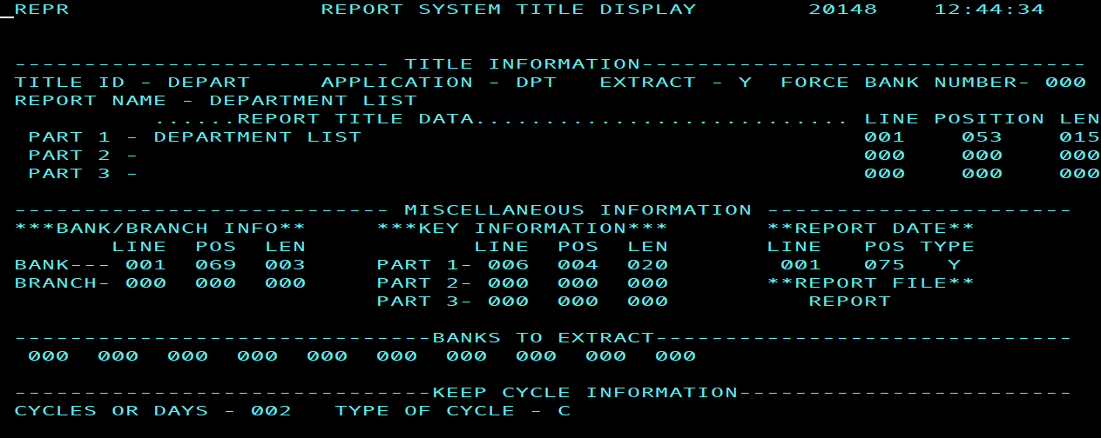

SECONDARY REPORT ID DETAIL MODE

This screen will be displayed when the detail information about a secondary report id record is needed. The second line on this screen will tell you what function you have ask for. The information displayed is used by the batch programs to control what reports are placed in the on-line system.

FIELDS:
REPORT ID - Main report id.

APPLICATION - Main report id application name.

EXTRACT - Method of extract used for main report id.

REPORT NAME - What the main report is called.

SECONDARY REPORT ID - Eight position secondary report id.

EXTRACT - Method of extract USED for secondary report
N - do not extract
Y - extract whole report
P - extract only matching bank numbers

SECONDARY REPORT TITLE DATA - This is the data used to locate a character string within the report that is unique to the subset of pages you which to see. But it must only be unique within the main report itself. This string must be on each page of the report that you want to place on file. It can be all on one line or on some combination of lines but not on more than three lines.

PART 1 (of string)
String - String of data to look for.
LINE - Line number on which this string is located.
POSITION - Column number on the line where this string starts.
LENGTH - Part 1 length of the character string.

PART 2 (of string)
String - String of data to look for.
LINE - Line number on which this string is located.
POSITION - Column number on the line where this string starts.
LENGTH - Part 2 length of the character string.

PART 3 (of string)
String - String of data to look for.
LINE - Line number on which this string is located.
POSITION - Column number on the line where this string starts.
LENGTH - Part 3 length of the character string.

SECONDARY KEY INFORMATION - The data built with these fields will be the index records. You may use these fields to access the report on line.

PART 1
LINE - Line number of where the index data is located.
POSITION - Column number on the line where the index data is.
LENGTH - Part 1 length of the index data.

PART 2
LINE - Line number of where the index data is located.
POSITION - Column number on the line where the index data is.
LENGTH - Part 2 length of the index data.

PART 3
LINE - Line number of where the index data is located.
POSITION - Column number on the line where the index data is.
LENGTH - Part 3 length of the index data.

BANKS TO EXTRACT - Use these fields only if you want to select off certain banks. In other words you do not want all banks to be put on file for this report. These fields only apply when the extract type is "P". They also only have a bearing on what the batch programs do, not the on-line system. When the extract type is "P" only the pages whose bank number matches with a bank number in one of these fields will the page then be placed in the on-line system.

SECONDARY REPORT-ID DETAIL SCREEN

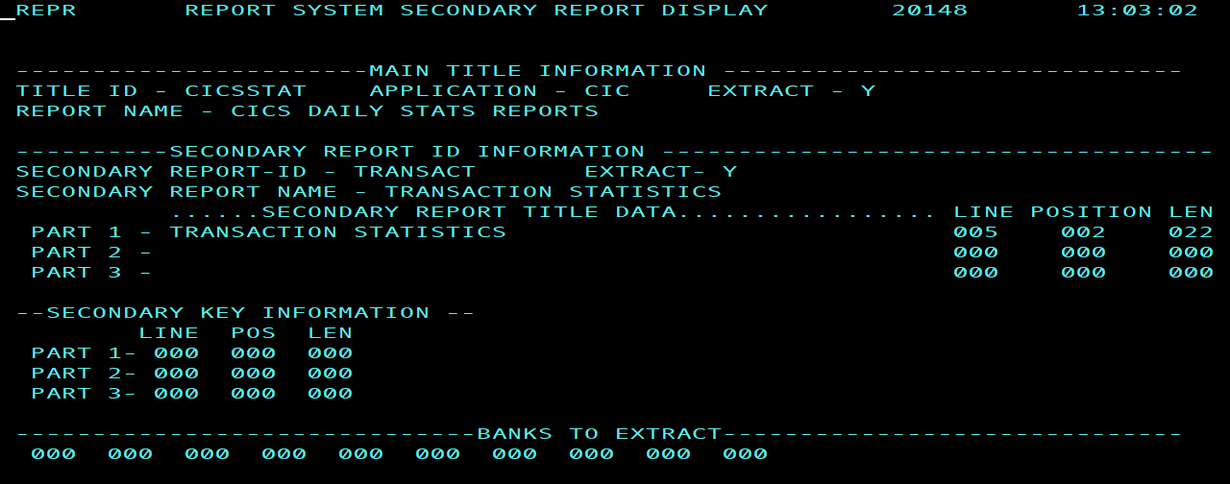

REPU TRANSACTION

This transaction is used to update the report systems USER ID file. To use this transaction just type in REPU and press the enter key. A menu like the one shown in figure 1 will be displayed. This transaction is used to control the access that a user has to the "REPT" report viewing transaction. There are three screens that are used in this transaction.

1. Options screen - Select the function you want to perform.
2. User ID screen - Display detail USER ID information.
3. List screen - This screen will list all of the USER ID records that you have access to.

OPTION MODE

This is a transaction to display, list, add, change, or delete a USER ID record. There are six options. Just enter the number of the option you want to use and press the enter key. Listed below is an explanation of the options and the other fields that appear on the screen.

Option -- Option number of the option you wish to use.
USER ID or LIST- This is the USER ID you which to deal with. Also a prefix to be used as a starting point for a search or list (option 2).
OPTIONS
1 - This option will add a new USER ID record to the file. The new USER ID must be entered into the USER ID field for this option.

2 - This option will display a list of the user ids on file. You may put in a starting prefix with this option. You may select the user id you want to look at from the screen that is produced by this option.

3 - This option will copy an existing user id record and create a new user id record. The user id (existing user id) must be entered into the USER ID field for this option.

4 - Display a USER ID record. The USER ID must be entered into the USER ID field for this option.

5 - Update a USER ID record. The USER ID must be entered into the USER ID field for this option.

6 - Delete a USER ID record. The USER ID must be entered into the USER ID field for this option.

OPTION SCREEN

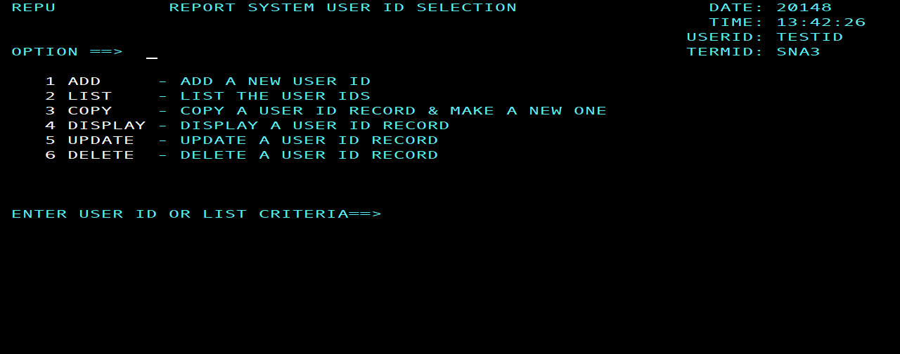

LIST MODE

This screen will display a list of all the USER IDs available for your USER ID. You may select a USER ID from this screen. There are four selection options that are available from this screen. They are listed below. Just enter the letter of the option you wish to use in the field next to the USER ID you want.
Options
C - Place a "C" in the field next to the user id you want to copy. This will select the user id as the record to be copied and will start up the copy function. It will return the COPY FUNCTION screen (user id screen).

D - Place a "D" in the field next to the user id you want to see. This will select the user id record to be displayed. It will return the DISPLAY screen (user id screen).

U - Place a "U" in the field next to the user id you want to update. This will select the user id as the record to be updated and will start up the update function. It will return the UPDATE FUNCTION screen (user id screen).

Z - Place a "Z" in the field next to the user id you want to delete. This will select the user id as the record to be deleted and will start up the delete function. It will return the DELETE FUNCTION screen (user id screen).

LIST SCREEN

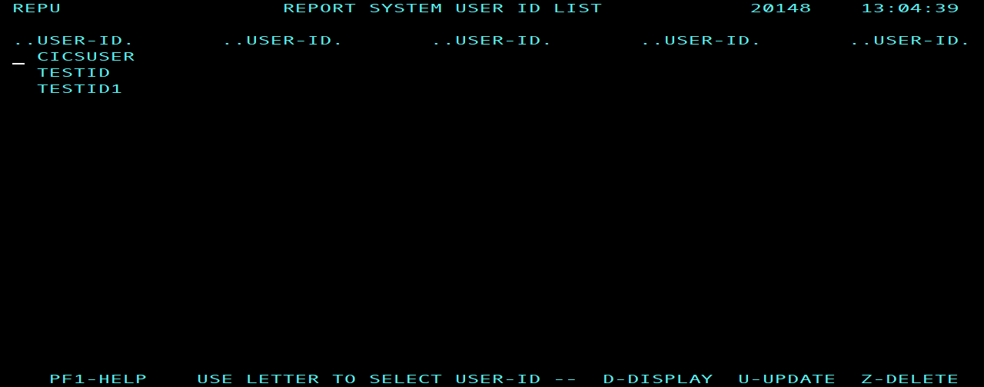

USER ID MODE

This screen is displayed when you add, change, copy, delete, or display a USER ID. This screen is used to display the USER ID record for any given USER ID. Listed below are the fields on this screen and an explanation for each.

RACF ID - This is the USER's ID that they use to sign on CICS with. Using the CESN transaction.

BANK ---- This is the default bank number to be used by the report viewing program "REPT" to help determine what reports this user has access to. This number should match the bank number that will be pulled off the reports. The bank number on the reports that the user will view should match this bank number.

BRANCH -- This is the default branch number to be used by the report viewing program to help determine what reports this user has access to. This number should match the branch number that will be pulled off the reports. The branch number on the reports that the user will view should match this branch number.

REPORT IDS - These fields are used to control what reports a user has access to when using the "REPT" transaction. These report ids are used in conjunction with the access to reports field. See the access to reports field for an explanation of the values of that field.

TYPE OF ACCESS TO REPORTS - The value of this field will determine what reports a user can view with the "REPT" transaction. The valid values for this field are listed below.

"N" - No access at all to the report viewing system.
"A" - Access to all reports and all banks and branches.
"B" - Access to one bank and any branch. This option does not restrict access by report ID only bank number. The user may view any report for the bank number in their user ID record.
"R" - Access to one bank and one branch. This option does not restrict access by report ID only bank and branch number. The user may view any report for the bank number and branch number in their user ID record.
"C" - Access to one bank and any branch and the report ids listed. This option restricts access by report ID and bank number. The user may view only the reports listed in their user ID record for the bank number in their user ID record.
"D" - Access to one bank and one branch and the report ids listed. This option restricts access by report ID, bank number and branch number. The user may view only the reports listed in their user ID record for the bank number and branch number in their user ID record.

UPDATE ACCESS TO SECURITY RECORDS - The value of this field will determine the type of access a user has to this transaction or the USERID (security) file. The valid values for this are listed below.
"N" - No access at all to the report viewing system USERID records.
"A" - Access to all USER ID records for all banks and branches
"B" - Access to all USER ID records for one bank and any branch. This option will restrict access to only one bank number.
"R" - Access to all USER ID records for one bank and one branch. This option will restrict access to only one bank and one branch number.

USER-ID SCREEN

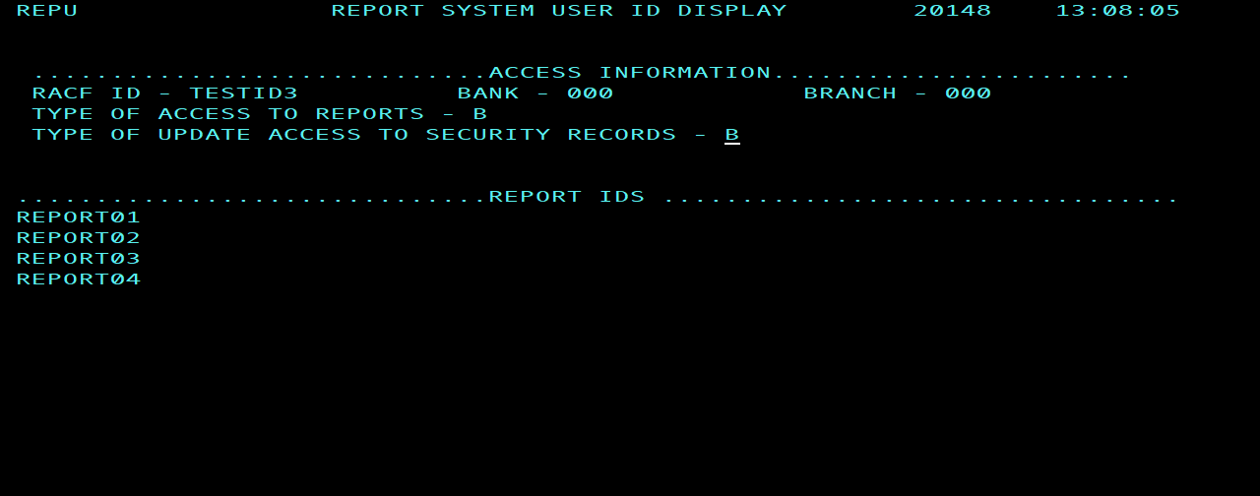

INDEX
A
access to reports · 35
add · 14, 15, 16, 30, 35
application · 22, 26
B
bank · 3, 12, 22, 23, 26, 27, 35, 36
banks to extract · 23, 27
branch · 3, 12, 23, 35, 36
C
copy · 14, 15, 16, 18, 20, 30, 32, 35
cycles · 23
D
date mode · 8, 10
default date · 3
delete · 14, 15, 16, 18, 20, 30, 32, 35
down · 5, 6
E
EXTRACT REPORT · 22, 23, 26, 27
F
find (see search) · 5, 15, 30
force bankXE "bank" number · 22
I
index mode · 8, 10, 12
K
key information · 23, 27
L
left shift · 2, 3, 5, 6, 8, 10, 18, 20, 23, 32
list · 2, 3, 8, 10, 12, 14, 15, 16, 18, 19, 20, 21, 29, 30, 32, 34
P
PF1 · 5, 8, 10, 12
pf11 · 5, 6
PF11 · 5, 6
PF12 · 5, 6
PF3 · 5, 8, 10, 12
PF4 · 5, 6
PF5 · 5, 6
PF6 · 5
PF7 · 5, 6, 10, 12
PF8 · 5, 6, 10, 12
prefix · 15, 16, 30
R
REPORT DATE · 3, 5, 8, 10, 23
REPORT ID · 2, 3, 8, 10, 14, 15, 16, 18, 20, 22, 26, 35
REPORT NAME · 22, 26
report title data · 22, 26
REPT · 2, 23, 29, 35
restrict access · 35, 36
right shift · 5, 6
S
search · 5, 15, 30
secondary id · 3, 14, 15
secondary key information · 27
sid · 5
skip · 5
T
titles mode · 10
top · 5
type of cycle · 24
U
update · 14, 15, 16, 18, 20, 29, 30, 32, 35
USER ID · 18, 20, 29, 30, 32, 35, 36
V
view · 2, 3, 5, 7, 8, 10, 12, 35

