Archiver

Extensions

Version 1.2.0

Issued June 26, 2024
A package to provide additional functionality to the Archiver package.

Archiver Extension V1.2.0 – A package to provide additional functionality to the Archiver package.
Copyright © 2024 Edward G Liss

This program is free software: you can redistribute it and/or modify it under the terms of the GNU General Public License as published by the Free Software Foundation, either version 3 of the License, or any later version.
This program is distributed in the hope that it will be useful, but WITHOUT ANY WARRANTY; without even the implied warranty of MERCHANTABILITY or FITNESS FOR A PARTICULAR PURPOSE. See the GNU General Public License for more details.
Please see https://www.gnu.org/licenses/ for a copy of the GNU General Public License.

This document was produced using LibreOffice Writer.

Table of Contents
Table of Figures 3
Summary Of Changes 3
Introduction 4
About the Archiver Dataset 4
Installation 5
ARCHCOMP – Compare 2 Archive Indecies 6
ARCHCOMP Usage 6
Synchronizing Archives 7
How to Synchronize 8
ARCHDIR – Customized Index Reports 9
ARCHDIR Usage 10
ARCHRST – Reset Version Numbers 11
ARCHUTIL – Unload/Load Utility for Archives 13
ARCHUTIL Usage 13

Table of Figures
Figure 1: Example IDCAMS statement to create an Archive 4
Figure 2: Sample ARCHCOMP Report with option=’group,archextn’ 6
Figure 3: Sample ARCHDIR Default Report 9
Figure 4: Sample ARCHDIR Custom Report 10
Figure 5: Sample ARCHUTIL Report 13

Summary Of Changes
V1.1.0 - A new program ARCHRST was added to reset version numbers. No other programs were changed.
V1.2.0 – A revision to ARCHCOMP to sort by member or group. Also added ability to sync Archive 1 and Archive 2.

Introduction

Welcome to Archiver Extentions. This is a group of programs designed to provide additional feature for users of Archiver. The full use of ARCHIVER is out of scope of this document. Archiver 6.1.5 is pre-installed on TK5 systems. TK5 systems include a copy of the user guide is the DOC folder. It is also can be found at cbttape.org File # 147 ARCHIVER All your non-VSAM datasets to 1 VSAM file .

Archive is a program designed for storage of almost any type of non-VSAM file. The file is stored in a VSAM KSDS (Keyed Sequential Data Set) in a compressed and encrypted format. One possible use of Archiver is for secured storage of production source code.

The collection (so far) consists of PL/I programs to:
- ARCHDIR – Produces directory listings sorted in user selected sequences
- ARCHCOMP – Compares the indecies of two Archiver clusters to highlight differences
- ARCHRST – Resets version number
- ARCHUTIL = Unloads/Loads an Archive cluster to/from files suitable for transmission

About the Archiver Dataset

The Archiver Dataset is a VSAM cluster which must be defined using IDCAMS. Below is an example of the IDCAMS statement to define an Archive.

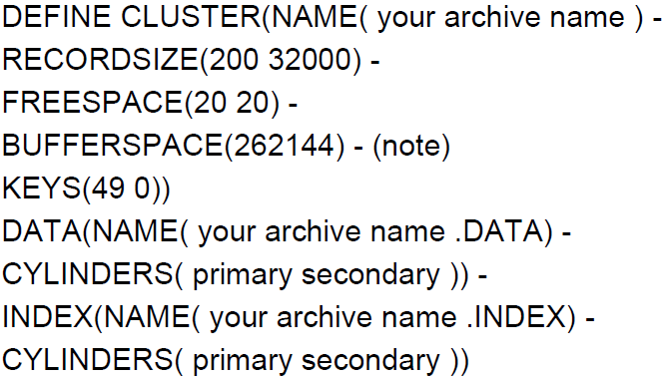Figure 1: Example IDCAMS statement to create an Archive

The recordsize is the part the programs are sensitive to. Work areas are defined with 32,000 bytes of space. The routines to access the archive also assume the maximum record size is 32,000. It is recommended that all archives use the 32000 as the maximum record size. If you reduce the max record size, the programs may also need to be adjusted to the new record size.
For more information about the Archive cluster, see the Archiver Manual section “The Archiver Dataset” for more information.

Installation

- The Archiver Extensions is distributed as a file name Arch-Exten-V1R2M0.zip. This .zip can be downloaded to your PC and the contents extracted.

- ArchExten-V1R2M0.xmi
- RESTTK5.jcl – restore to a TK5 system or systems with NJE38 installed.
- RESTOTHR.jcl – restore to a system without NJE38 installed (uses RECV370).

- On the host MVS system, allocate the dataset userid.ARCHEXTN.XMI with a record size of 80 and blksize of 3120. If the transfer process creates the dataset, it usually defaults to an undefined format.
- BINARY Transfer the .xmi file to the host MVS system into userid.ARCHEXTN.XMI.
- The RESTxxxx JCL defaults the user id to HERC01 and the volume to create the datasets is TSO002. You man need to change these before you submit. Be sure to remove the TYPRUN before you submit the RESTxxxx.jcl.
- The userid.ARCHEXTN.XMI may be deleted since it is no longer required.
- Submit the JCL in ARCHEXTN.V1R2M0.JCL(CLEANUP) to complete the install.

The RESTxxxx job will create the following datasets:
ARCHEXTN.V1R2M0.ASM | ARCHEXTN.V1R2M0.LOADLIB
ARCHEXTN.V1R2M0.COB | ARCHEXTN.V1R2M0.MACLIB
ARCHEXTN.V1R2M0.CNTL | ARCHEXTN.V1R2M0.NCALIB
ARCHEXTN.V1R2M0.INCLLIB | ARCHEXTN.V1R2M0.PLI
ARCHEXTN.V1R2M0.LISTING | ARCHEXTN.V1R2M0.PROCLIB

This 24 bit package was tested on Z/OS. However, for it run on Z/OS, the dataset PL/I (F) runtime “SYS1.PL1LIB” must be present on the Z/OS system.

ARCHCOMP – Compare 2 Archive Indecies

This utility will compare the indecies of two Archives highlighting matching and unmatching entries. The items can be sorted by Member or Group. Optionally, it can report mismatches or a full comparison report. Below is a sample of the report. When both sides of the report are printed, the items in both Archives are present. Note only the index data is compared. No attempt is made to compare the contents.

When a side of a line is blank, there is no matching item on the other side.

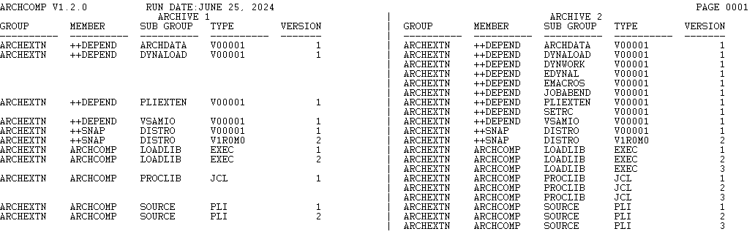Figure 2: Sample ARCHCOMP Report with option=’group,archextn’

ARCHCOMP Usage
The PROC for running ARCHCOMP is called ARCHCOMP. It has 4 keywords with only the SOUT (sysout) having a default of ‘*’. Examples:
//S1 EXEC ARCHCOMP,ARCH1='USER1.SLIM.ARCHIVE',
// ARCH2='HERCEL.SLIM.ARCHIVE'
//*
//S2 EXEC ARCHCOMP,ARCH1='USER1.SLIM.ARCHIVE',
// ARCH2='HERCEL.SLIM.ARCHIVE',
// OPTION=’GROUP,SUMMARY’
//S3 EXEC ARCHCOMP,ARCH1='USER1.SLIM.ARCHIVE',
// ARCH2='HERCEL.SLIM.ARCHIVE',
// OPTION=’GROUP,SLIM’

Synchronizing Archives

ARCHCOMP can be used to synchronize two Archives. A testing archive can have new or modified items copied to a production archive. For a given project, ARCHCOMP will compare the index of the production and the index of the test archive and generate ARCHIVER copy statements to copy any new versions of an item from the test archive to the production archive.

Using proc ARCHCOMP, ARCH1 is the receiving archive and ARCH2 is the sending archive. An example will best describe the process using the following sample.

This above run of ARCHCOMP will generate ARCHIVER copy statements to copy any item in the right side that does not have a corresponding item in the left column. Referring to the above, third line of the right side (“ARCHEXTN ++DEPEND DYNWORK V00001 1”) would be copied to ARCHIVE 1. Upon completion, both sides of the report will be the same as shown below.

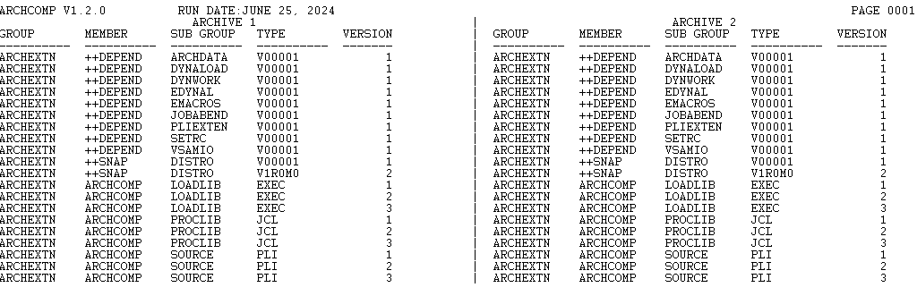

How to Synchronize
In order to synchronize two archives, a two step process is required. Below is the actual JCL used to produce the above examples.

//ARCHCOMP JOB CLASS=B,MSGCLASS=A,MSGLEVEL=(1,1),
// USER=HERCEL,PASSWORD=CUL8TR
//*
//*
//* RUN THE ARCHCOMP
//*
//ARCHCMP1 EXEC ARCHCOMP,
// ARCH1='HERCEL.ARCHEXTN.ARCHIVE',
// ARCH2='HERCEL.SLIM.ARCHIVE',
// OPTION='GROUP,ARCHEXTN'
//CNTLFL DD DSN=&&COPY,UNIT=SYSDA,SPACE=(TRK,(20,20),RLSE),
// DISP=(NEW,PASS)
//*
//ARCH EXEC PGM=ARCHIVER,REGION=4096K
//SYSPRINT DD SYSOUT=*
//ARCHIN DD DSN=HERCEL.SLIM.ARCHIVE,DISP=SHR
//ARCHOUT DD DSN=HERCEL.ARCHEXTN.ARCHIVE,DISP=SHR
//SYSIN DD DSN=&&COPY,DISP=(OLD,DELETE)
//*
//*
//* RUN THE ARCHCOMP
//*
//ARCHCMP2 EXEC ARCHCOMP,
// ARCH1='HERCEL.ARCHEXTN.ARCHIVE',
// ARCH2='HERCEL.SLIM.ARCHIVE',
// OPTION='GROUP,ARCHEXTN'

Step ARCHCMP1 is run to produce the copy statements into the file defined as CNTLFL.
Step ARCH is to run to execute the copy statements generated in step ARCHCMP1.
Step ARCHCMP2 is run to verify/demonstrate what happened.

ARCHDIR – Customized Index Reports

ARCHDIR is a program to print Archiver directory reports sorted in requested order. It is assumed the ARCHIVER is installed in a system library. The LIST Archiver command prints directory reports sorted by member, group, subgroup, type and version order. ARCHDIR provides for printing the directory report sorted in any desired order. Filters can be specified and any notes associated with the members can be printed.

ARCHDIR works by running Archiver with alternate DDNAMES for SYSIN and SYSPRINT. The SYSIN file is created with the following Archiver statements by default:

SET VSAM1DD=ARCHIVE
LIST ITEM=(*,*,*,*),NOTES=Y

ARCHRPT then reads the output from Archiver selecting the appropriate lines, reformatting the lines as requested, sorting the reformatted lines and printing a report. In addition, ALIAS items are listed in their order and also listed after the items the alias refers to. Notes are printed following the item.

An Archiver index consists of 5 items – member, group, sub group, type and version. ARCHDIR lets you select the sort order of the report.

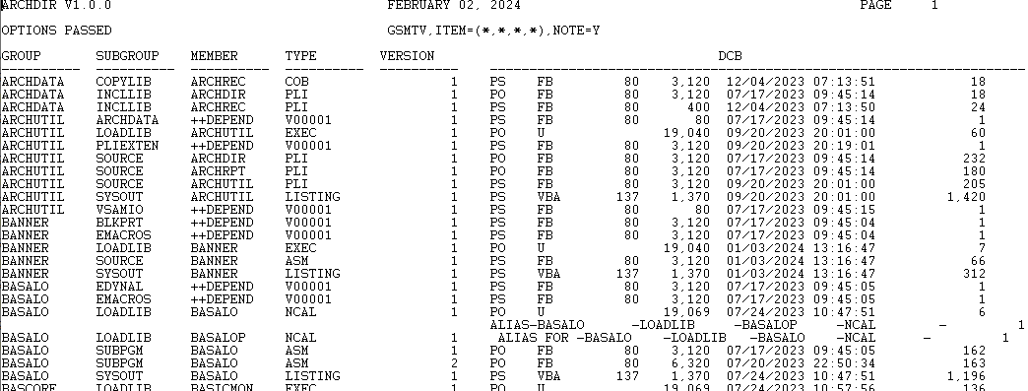Figure 3: Sample ARCHDIR Default Report
Specifying what is to print is done via the EXEC statement PARM. Above is a sample report using all the defaults. To customized the report, there are 3 items that can be passed.

The first item is the order of the data to print. This item consist of 5 characters signifying the order of the columns to be printed. The first character of the column name specifies the order. In the sample, the default item is GSMTV, short for Group, Subgroup, etc

Below is a sample report where the data to print is VMGST

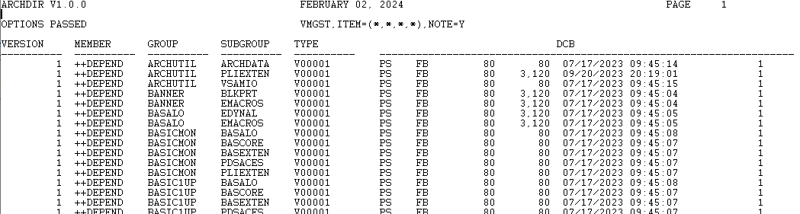Figure 4: Sample ARCHDIR Custom Report

The second parm to ARCHDIR is an ITEM. The general format of item is
ITEM=(*,*,*,*)
This item is passed to ARCHIVER so ARCHDIR does no validation on it. This enables partial report to be printed. For example, you have an Archive with source code in it and you want to only print group items that start with PAY and are type COBOL. The Item to do this would be ITEM=(*,PAY*,*,COBOL,*). Please refer to the Archiver manual for further info about the ITEM

The third item NOTE is also passed to ARCHIVER so ARCHDIR does no validation on it. Please refer to the Archiver manual for further info about NOTE.

ARCHDIR Usage
It is assumed the ARCHIVER is installed in a system library. The full use of ARCHIVER is out of scope of this document.
The JCL member ARCHRPT is a sample of the JCL to run the ARCHRPT. The reporting order is controlled by the exec statement parm. The default parm is ‘MGSTV’. (Member Group Subgroup Type Version). The parm must be 5 characters and only the characters M,G,S,T,V in any order is acceptable. Addition options for the Archiver List command can be added after the sort options. For example:
PARM=’MGSTV,ITEM=(*,*,*,PL1),NOTE=Y’

This example tells ARCHRPT to sort the report in Member, Group, Subgroup, Type and Version order for only members of type PL1. Notes, if any, should be printed. See the Archiver manual for a full explanation of the options for the LIST command.
The PROC for running ARCHDIR is called ARCHDIR. It has 4 keywords with only the SOUT (sysout) having a default of ‘*’. Examples:
//S1 EXEC ARCHDIR,ARCHIVE='HERCEL.SLIM.ARCHIVE'
//S2 EXEC ARCHDIR,ARCHIVE='HERCEL.SLIM.ARCHIVE',SORT=VMGST

ARCHRST – Reset Version Numbers

ARCHRST adjusts version numbers. The best way to describe why this is needed is with an example. Listed below is listing from an ARCHIVE with the items related to a project. Lets assume that version 1 of all the members of the project are production. Subsequent changes result in multiple versions saved in the ARCHIVE while enhancements are being made.

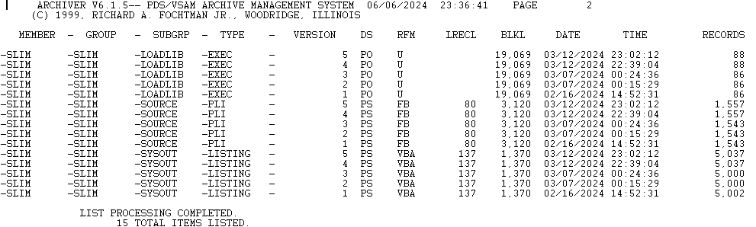
The ARCHRST process for a given project will generate ARCHIVER control statement so the current version become the requested version. In this example, version 5 is the current test version and version 1 is the current production version. What is desired is to make version 5 the next production version. In other words, version 5 should become version 2. In order for this to happen, intermediate test versions must be deleted. In this example, version 2, 3 and 4 must be deleted and version 5 changed to version 2. Notes are added to version 5 to indicate the deletion of versions 2, 3 and 4.

ARCHRST will accomplish this. ARCHRST always assumes the most recent (highest) version is the one to reset. After execution, a LIST ITEM with NOTE=Y will appear as shown below.

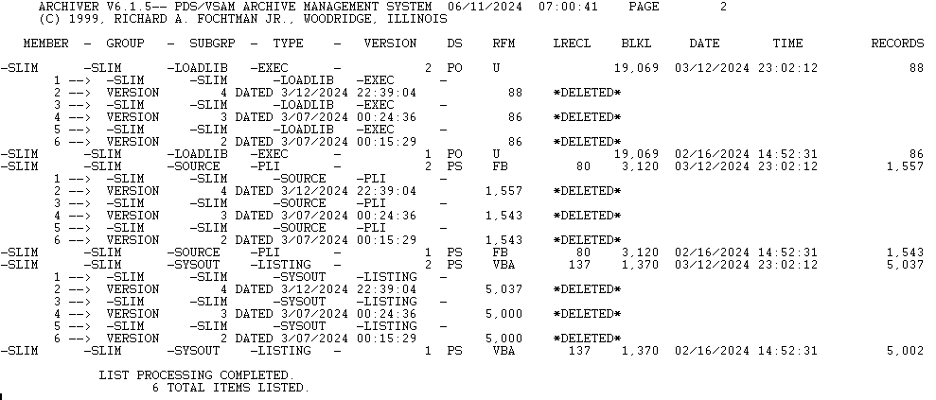

ARCHRST is controlled by EXEC parms. Six words separated by commas must be passed.
- Member
- Group
- Subgroup
- Type
- Desired version
- Action – must to TEST to display what will be done. COMMIT to actually due the changes.

The parm used for the above example is:
PARM=’SLIM,SLIM,*,*,2,COMMIT’

There is a proc set up. Here is how it is coded
//*
//* RUN ARCHRST
//*
//STEP2 EXEC ARCHRST,GROUP=SLIM,MEMBER=SLIM,SUBGRP='*',TYPE='*',
// VERSION=2,COMMIT=COMMIT,
// ARCHIVE='HERCEL.SLIMVER.ARCHIVE'

It is suggested that a TEST run be executed to verify that what you want done is going to be accomplished. It is also suggested to backup the ARCHIVE before running ARCHRST

ARCHUTIL – Unload/Load Utility for Archives

ARCHUTIL produces a sequential version of an Archive that is suitable for transmission. The sequential file is essentially 80 byte card images suitable for XMIT370 or NJE38 transmission.j

Figure 5: Sample ARCHUTIL Report

ARCHUTIL Usage

There are two parts to ARCHUTIL – one to load an archive to a sequential file and the other to unload the sequential file to an archive. There are two procs – one to unload and the other to load.

//S1 EXEC ARCHUTIU, Unload the archive
// ARCHIN='HERCEL.SLIM.ARCHIVE',
// SEQFL='HERCEL.ARCHEXTN.TEST',
// SEQVOL=EVOL03
//S1 EXEC ARCHUTIL, Load the archive
// ARCHOUT='HERCEL.SLIM.ARCHIVE',
// SEQFL='HERCEL.ARCHEXTN.TEST'

The author of Archiver chose to use the term unload to add data to the archive. He also chose to use the term load to take data from an archive.

