Eli Ritter

8/15/2023

IT FDN 110

Assignment #5

**Python Coding Assignment #6**

# **Introduction**

This sixth assignment includes watching a module video on Canvas, reading a chapter from the textbook, reviewing some web pages and videos, applying our knowledge of what we learned in practice, and then documenting our knowledge to prove that we understood the assignment and its readings. Similar to the fifth assignment, if not nearly identical, the sixth assignment relies on using functions to mimic the output of the fifth assignment and its menu’s various choices.

# **Assignment05_Starter.py**

We were made to create a script with a menu that allowed one to do one of the four following things: option one would allow for the user to add a task and its priority level, option two would allow for the user to remove an existing task, option three would allow for the user to save their tasks to a text file, while option four would allow for the user to exit the application. In completing this assignment, much like the last one, I found that I had trouble in getting the code to completely work. For instance, the first couple of functions caused my code to output a duplicate of the prompt that asks the user for a task and priority input. For the most part, it seems to work just fine though, so I assume that my code was completed correctly with its output in mind.

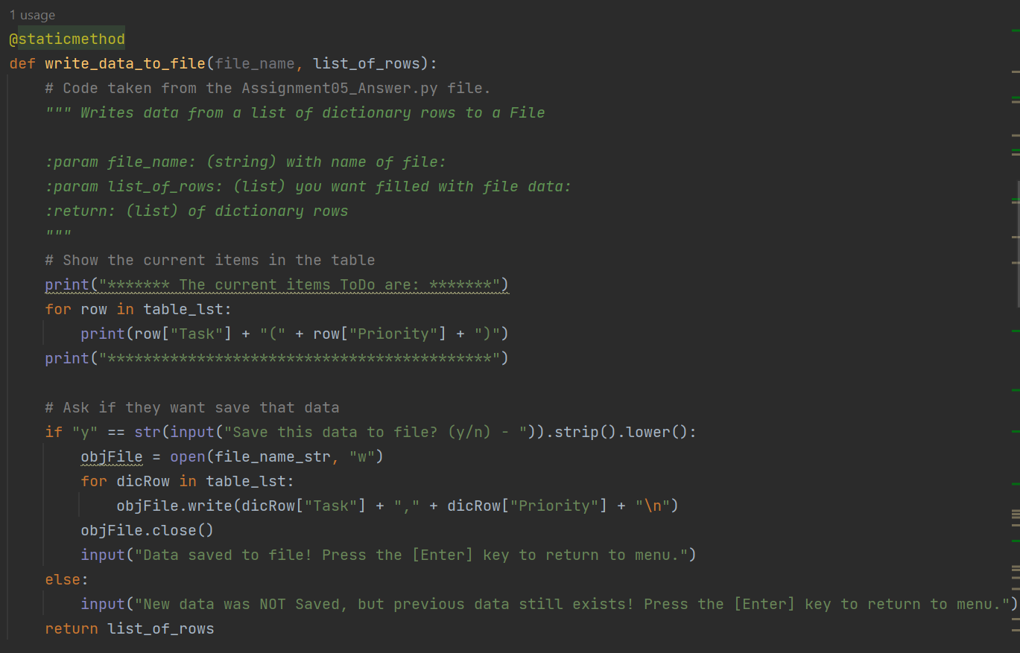

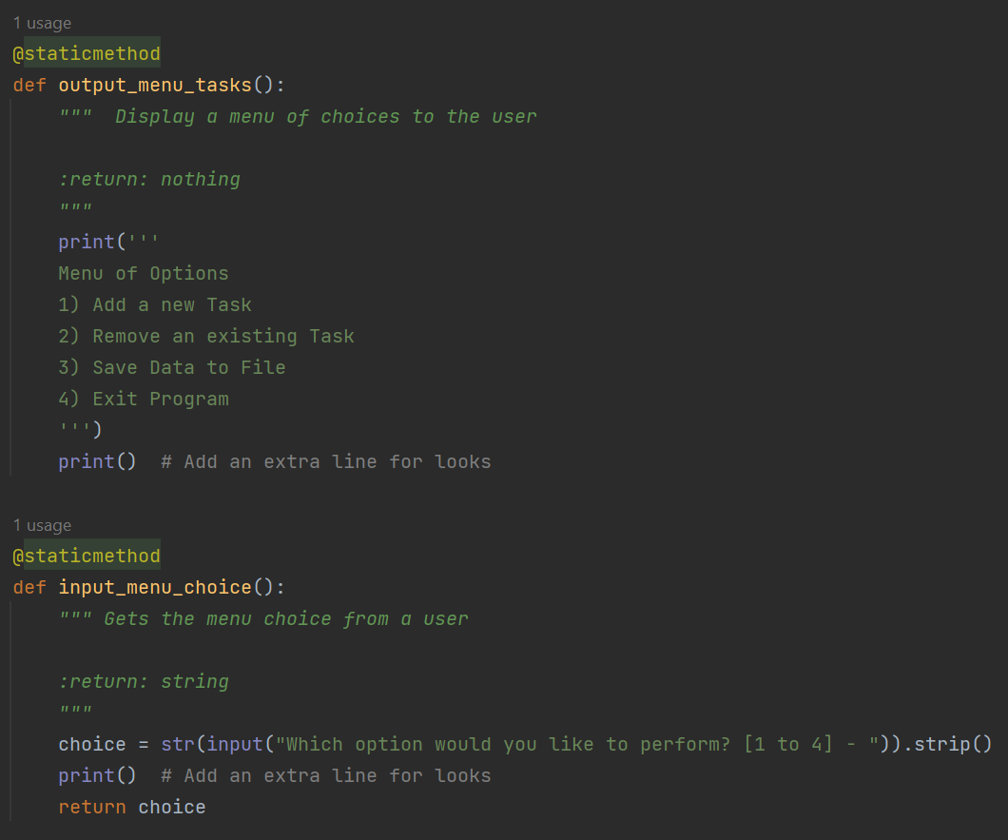

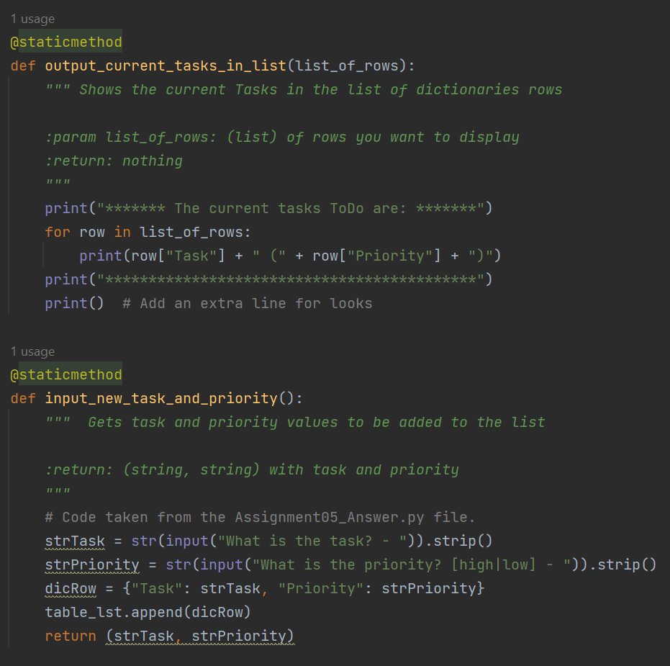

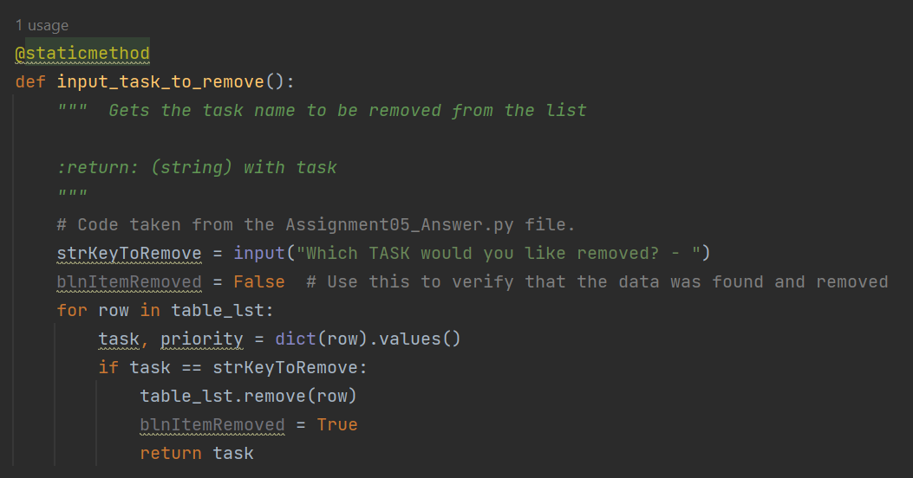

***Figure 1: Assignment06_Starter.py Script in PyCharm***

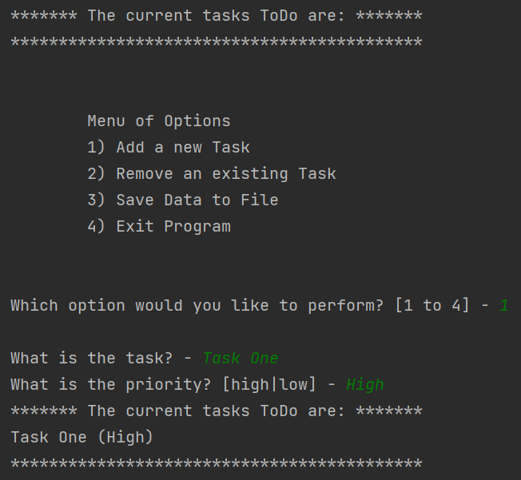

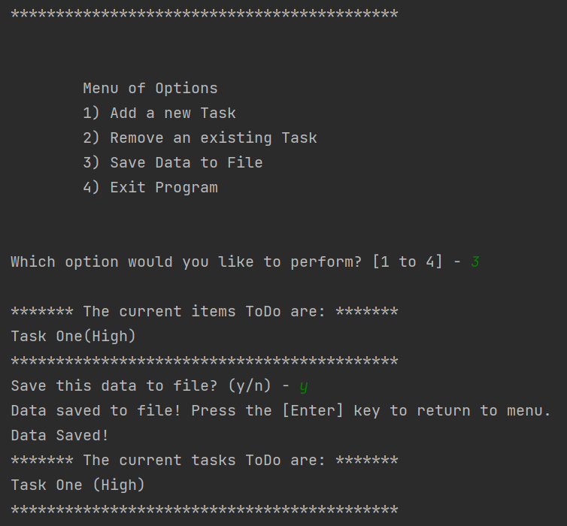

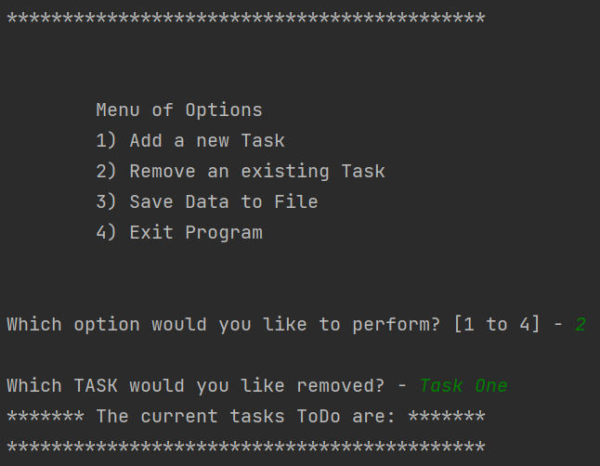

***Figure 2: Assignment06_Starter.py Output in PyCharm***

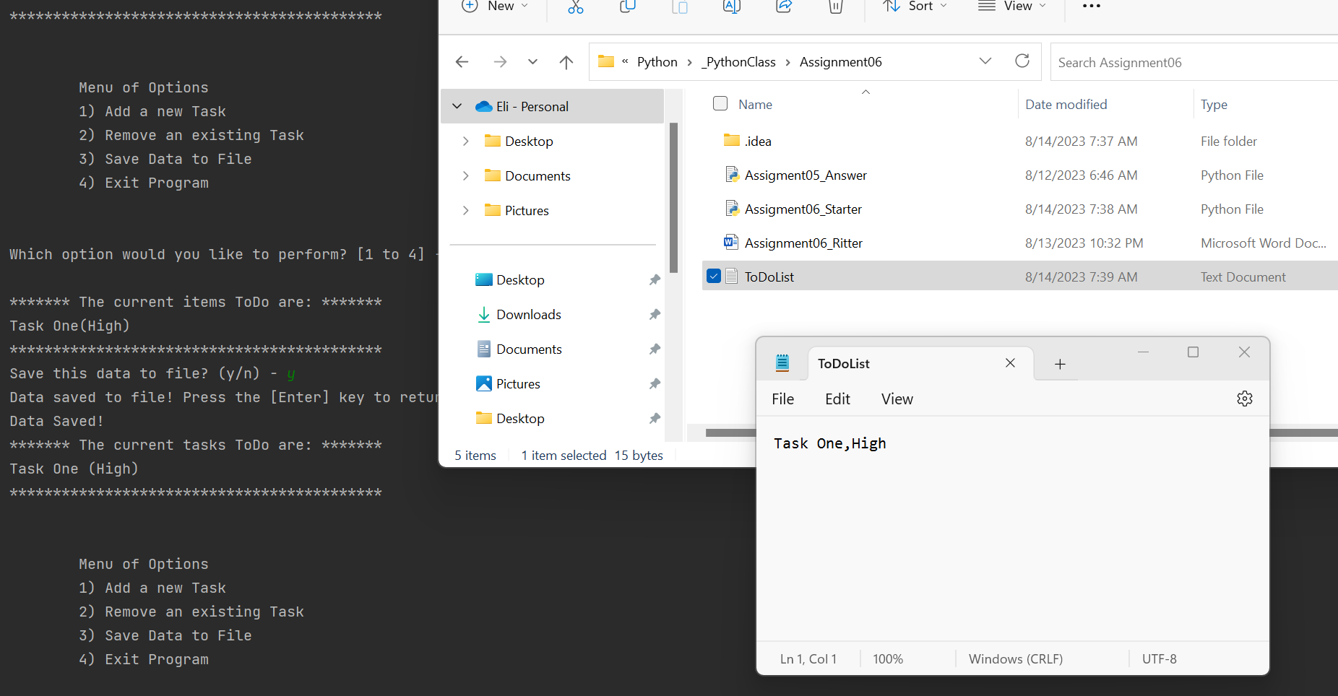

***Figure 3: Assignment06_Starter.py ToDoList.txt Output in PyCharm***

# **Summary**

In short, this assignment can be seen as something that branches from both the fourth and fifth assignments. Though I was unable to get the program running in a command window, the PyCharm version seemed to work just fine. Made to build off of an existing code template, this assignment aims to introduce us to functions; while I had difficulty with the assignment, I think that (by using the answer key from assignment five) I was able to create something that worked.