Eli Ritter

8/21/2023

IT FDN 110

Assignment #7

**Python Coding Assignment #7**

# **Introduction**

This seventh assignment includes watching a module video on Canvas, reading a chapter from the textbook, reviewing some web pages and videos, applying our knowledge of what we learned in practice, and then documenting our knowledge to prove that we understood the assignment and its readings. A bit different when compared to past assignments in that the code no longer relies on a menu, it still asks for input from the user before saving that data to a text file.

# **Assignment07_Starter.py**

We were made to create a script that asked for a user’s ID and name. The script would then save this data to a list before using the pickle function to save this list to a binary file, displaying the contents as well. From a first glance, I believe I got my code to work; most of the information I needed was taken from chapter seven of the textbook (where the pickle function is expanded on in length on page two hundred), while the recording helped somewhat on aspects of the assignment I couldn’t find information for from the textbook. Otherwise, some code was taken from the answer key of assignments five and six, but I didn’t have much difficulty in completing this assignment.

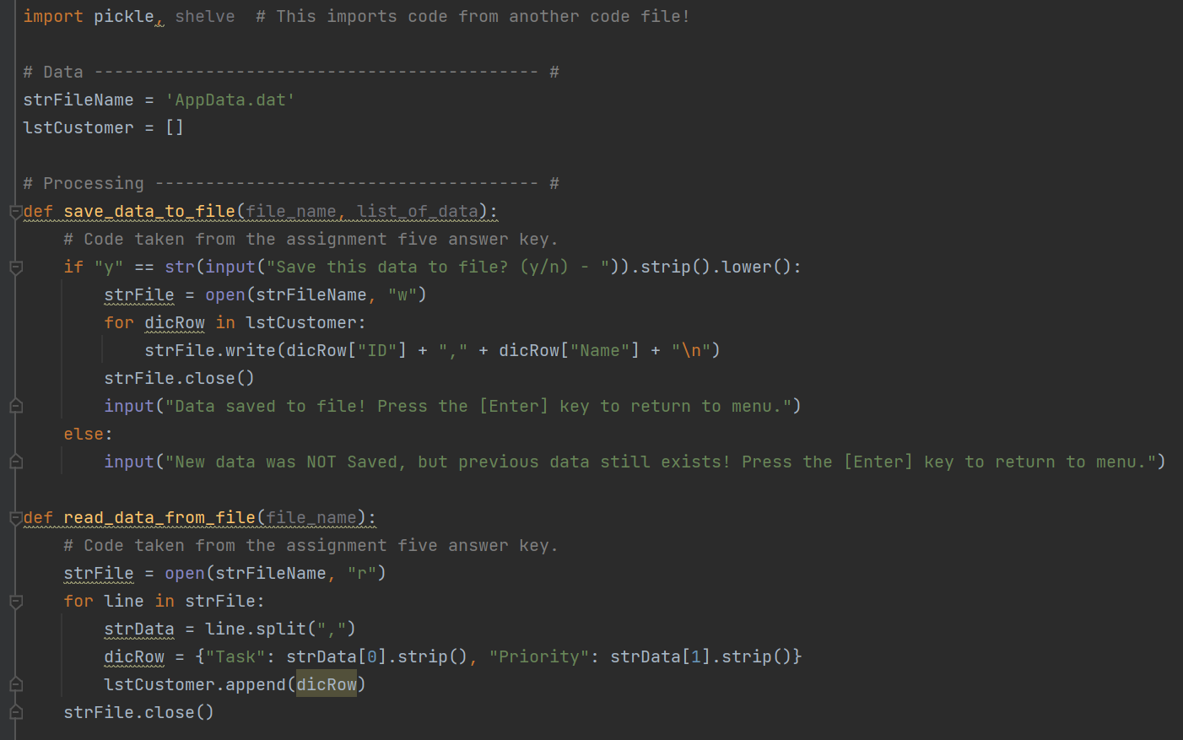

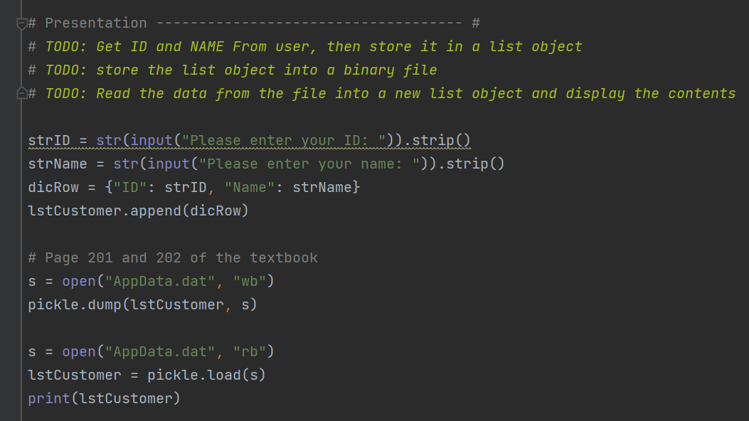

***Figure 1: Assignment07.py Script in PyCharm***

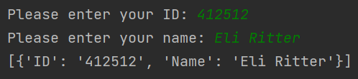

***Figure 2: Assignment07.py Output in PyCharm***

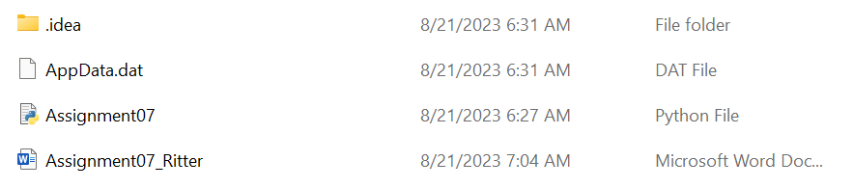

***Figure 3: Assignment07.py AppData.dat Output***

***Figure 4: Assignment07.py Output in Command Shell***

# **Summary**

In short, this assignment can be seen as something relatively new in terms of introducing a new function (the pickle function), but relies on things we already learned (such as user inputs and saving data to other files) that makes it branch from past assignents. Though I think I had a little difficulty at the start, the program seemed to run just fine, and made use of the pickle function in order to save the list to a binary file (as instructed). As a result, I believe my work to have been done correctly, with aid primarily coming from the textbook in order to complete the code.