Eli Ritter

8/7/2023

IT FDN 110

Assignment #5

**Python Coding Assignment #5**

# **Introduction**

This fifth assignment includes watching a module video on Canvas, reading a chapter from the textbook, reviewing some web pages and videos, applying our knowledge of what we learned in practice, and then documenting our knowledge to prove that we understood the assignment and its readings. Similar to the fourth assignment in having a menu that allows for an input from the user, assignment five includes making use of the dictionary function to store and read tasks.

# **Assignment05_Starter.py**

We were made to create a script with a menu that allowed one to do one of the five following things: option one would allow for the user to see their tasks, option two would allow for the user to add new tasks, option three would allow for the user to remove a task, option four would allow for the user to save the tasks to a text file, while option five would allow for the user to exit the application. I’ll admit that this assignment was a little more confusing with compared to the last one with the addition of the dictionary function, and I had trouble in getting my code to work completely. I’ve commented out sections of the code that wouldn’t work when used, but was able to get the general structure of the code to work otherwise, if not in a rather poor fashion.

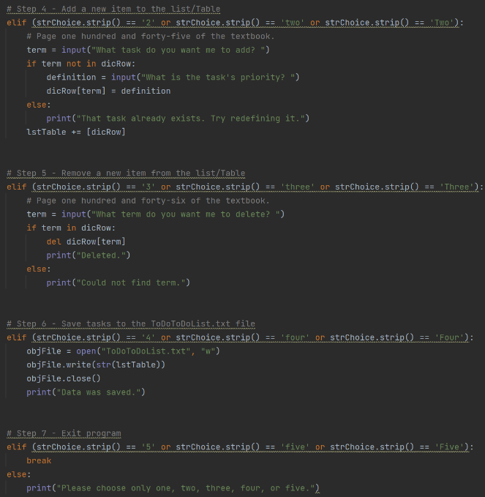

***Figure 1: Assignnment05_Starter.py Script in PyCharm***

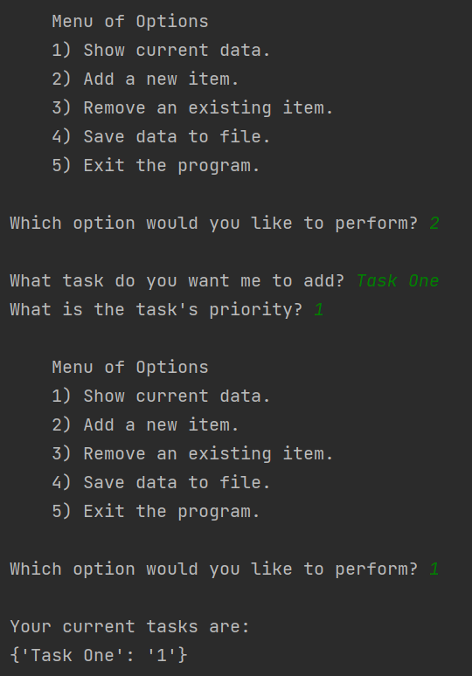

***Figure 2: Example of the Script Running in PyCharm 1***

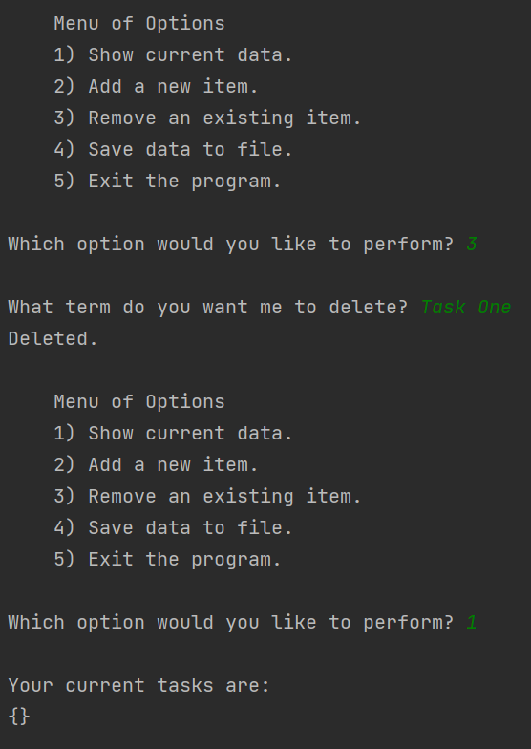

***Figure 3: Example of the Script Running in PyCharm 2***

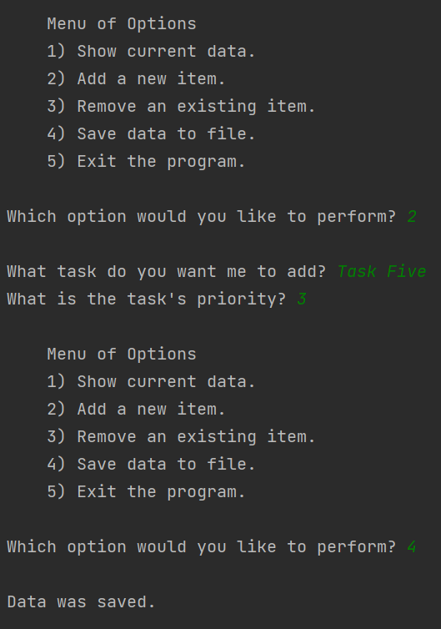

***Figure 4: Example of the Script Running in PyCharm 3***

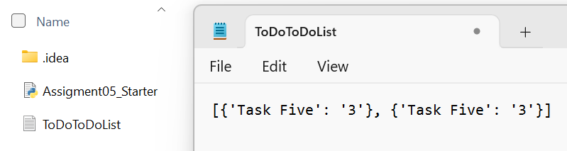

***Figure 5: Example of the ToDoToDoList Text File***

***Figure 6: Assignnment05_Starter.py Script in Command Prompt***

# **Summary**

In short, this assignment can be seen as something that branches from our fourth one, and all the other assignments prior, a gradual jump in difficulty and complexity between the various tasks granted to us. Made to build off of an existing code template, this assignment aims to introduce us to the dictionary function, making use of lists again (alongside a new task to delete an entry from a list) to do so. Though I had difficulty with this assignment, I think that I was able to create a general frame for it at least, having made several of the options functional.