quickdemo

2023-03-20 18:50 - 18:53

# 1 toc

# 2 Template

Define your template by adding sections and configuring the section settings

Each section can be:

- Note (like this) section, free text

- Heading, usefull for grouping sections

- Contents like a table of contents or figures

- Data Table, with data from test results

- Data Graph, for graphical representation of test results

Each section can also have sub sections

The cover page and overall report settings can be found on the settings pane of the Report item above

# 3 Test Result Summary

|  |  |  |  |  |  |  |  |  |
| --- | --- | --- | --- | --- | --- | --- | --- | --- |
| Result Name | Minimum | Average | 90%ile | Maximum | Std. Dev. | Pass | Fail | Other |
| Create Some Files | 0.076 | 0.085 | 0.096 | 0.117 | 0.009 | 54 | 0 | 0 |
| List Some Files | 0.001 | 0.004 | 0.005 | 0.006 | 0.001 | 54 | 0 | 0 |
| Remove Some Files | 0.008 | 0.016 | 0.024 | 0.027 | 0.007 | 54 | 0 | 0 |
| Show the RFS Variables | 0.003 | 0.007 | 0.01 | 0.012 | 0.003 | 54 | 0 | 0 |

# 4 90%ile

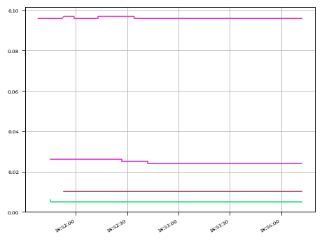

## 4.1 90%ile Data

|  |  |  |  |  |  |  |
| --- | --- | --- | --- | --- | --- | --- |
|  | PrimaryMetric | Minimum | Average | 90%ile | Maximum | Std. Dev. |
|  | Create Some Files | 0.096 | 0.096 | 0.097 | 0.097 | 0.0 |
|  | List Some Files | 0.005 | 0.005 | 0.005 | 0.006 | 0.0 |
|  | Remove Some Files | 0.024 | 0.025 | 0.026 | 0.026 | 0.001 |
|  | Show the RFS Variables | 0.01 | 0.01 | 0.01 | 0.01 | 0.0 |

# 5 test

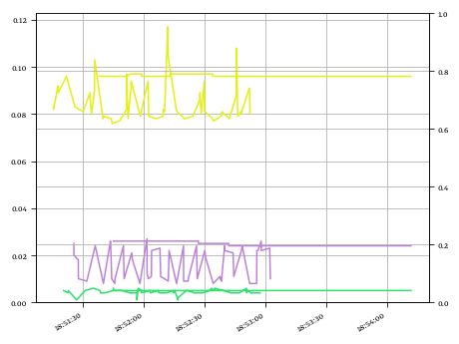

## 5.1 data left

|  |  |  |  |  |  |  |  |
| --- | --- | --- | --- | --- | --- | --- | --- |
|  | Result Name | Minimum | Average | 90%ile | Maximum | Std. Dev. | Count |
|  | Create Some Files - hp-elite-desk-800-g3 | 0.076 | 0.085 | 0.096 | 0.117 | 0.009 | 54 |
|  | List Some Files - hp-elite-desk-800-g3 | 0.001 | 0.004 | 0.005 | 0.006 | 0.001 | 54 |
|  | Remove Some Files - hp-elite-desk-800-g3 | 0.008 | 0.016 | 0.024 | 0.027 | 0.007 | 54 |

## 5.2 data right

|  |  |  |  |  |
| --- | --- | --- | --- | --- |
|  | PrimaryMetric | Agent | MetricValue | Count |
|  | Create Some Files | hp-elite-desk-800-g3 | None | 49 |
|  | List Some Files | hp-elite-desk-800-g3 | None | 47 |
|  | Remove Some Files | hp-elite-desk-800-g3 | None | 45 |

# 6 Response vs Robots

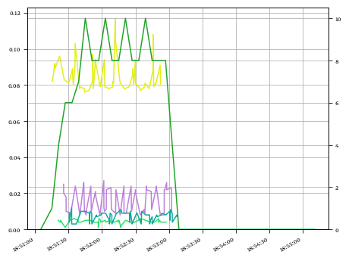

## 6.1 Robots

|  |  |  |  |  |  |  |  |
| --- | --- | --- | --- | --- | --- | --- | --- |
|  | PrimaryMetric | Agent | Minimum | Average | 90%ile | Maximum | Std. Dev. |
|  | 20230320_185055_demo | hp-elite-desk-800-g3 | 0 | 6.667 | 10.0 | 10 | 3.136 |
|  | PreRun | hp-elite-desk-800-g3 | 0 | 0.0 | 0.0 | 0 | 0.0 |

## 6.2 Response

|  |  |  |  |  |  |  |  |
| --- | --- | --- | --- | --- | --- | --- | --- |
|  | Result Name | Minimum | Average | 90%ile | Maximum | Std. Dev. | Count |
|  | Create Some Files - hp-elite-desk-800-g3 | 0.076 | 0.085 | 0.096 | 0.117 | 0.009 | 54 |
|  | List Some Files - hp-elite-desk-800-g3 | 0.001 | 0.004 | 0.005 | 0.006 | 0.001 | 54 |
|  | Remove Some Files - hp-elite-desk-800-g3 | 0.008 | 0.016 | 0.024 | 0.027 | 0.007 | 54 |
|  | Show the RFS Variables - hp-elite-desk-800-g3 | 0.003 | 0.007 | 0.01 | 0.012 | 0.003 | 54 |

# 7 DataTables

## 7.1 Metric

|  |  |  |  |  |  |  |  |
| --- | --- | --- | --- | --- | --- | --- | --- |
|  | เมตริกหลัก | ชื่อตัวแทน | ขั้นต่ำ | เฉลี่ย | เปอร์เซ็นไทล์ที่ 90 | ขีดสุด | ส่วนเบี่ยงเบนมาตรฐาน |
|  | Create Some Files | hp-elite-desk-800-g3 | 0.096 | 0.096 | 0.097 | 0.097 | 0.0 |
|  | List Some Files | hp-elite-desk-800-g3 | 0.005 | 0.005 | 0.005 | 0.006 | 0.0 |
|  | Remove Some Files | hp-elite-desk-800-g3 | 0.024 | 0.025 | 0.026 | 0.026 | 0.001 |
|  | Show the RFS Variables | hp-elite-desk-800-g3 | 0.01 | 0.01 | 0.01 | 0.01 | 0.0 |

## 7.2 ผลลัพธ์

|  |  |  |  |  |  |  |  |
| --- | --- | --- | --- | --- | --- | --- | --- |
|  | ชื่อผลลัพธ์ | ขั้นต่ำ | เฉลี่ย | เปอร์เซ็นไทล์ที่ 90 | ขีดสุด | ส่วนเบี่ยงเบนมาตรฐาน | นับ |
|  | Create Some Files | 0.076 | 0.085 | 0.096 | 0.117 | 0.009 | 54 |
|  | List Some Files | 0.001 | 0.004 | 0.005 | 0.006 | 0.001 | 54 |
|  | Remove Some Files | 0.008 | 0.016 | 0.024 | 0.027 | 0.007 | 54 |
|  | Show the RFS Variables | 0.003 | 0.007 | 0.01 | 0.012 | 0.003 | 54 |

## 7.3 Result Summary

|  |  |  |  |  |  |  |  |  |  |
| --- | --- | --- | --- | --- | --- | --- | --- | --- | --- |
|  | Result Name | Minimum | Average | 90%ile | Maximum | Std. Dev. | Pass | Fail | Other |
|  | Create Some Files | 0.076 | 0.085 | 0.096 | 0.117 | 0.009 | 54 | 0 | 0 |
|  | List Some Files | 0.001 | 0.004 | 0.005 | 0.006 | 0.001 | 54 | 0 | 0 |
|  | Remove Some Files | 0.008 | 0.016 | 0.024 | 0.027 | 0.007 | 54 | 0 | 0 |
|  | Show the RFS Variables | 0.003 | 0.007 | 0.01 | 0.012 | 0.003 | 54 | 0 | 0 |

## 7.4 SQL