**Abdallah Gamal Asaad Metwally …….. Head**

**Mohammad Ali Abuoelzz …… Member**

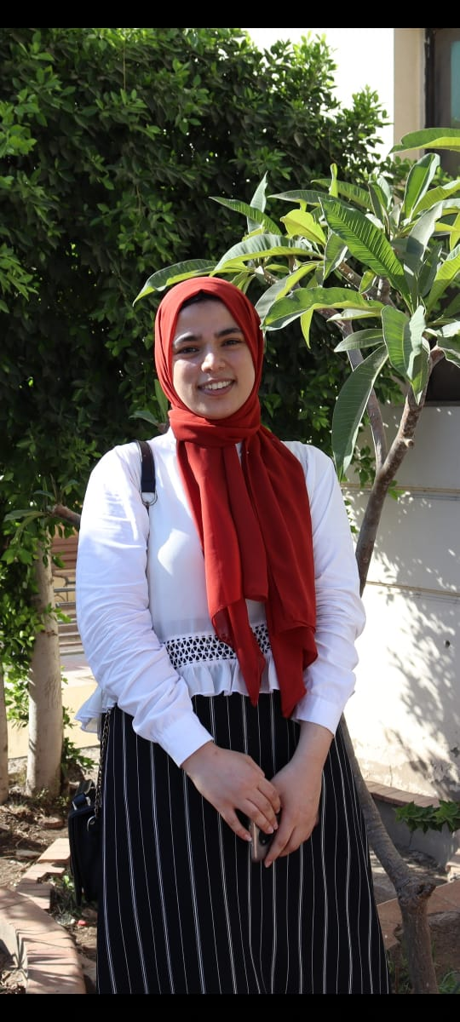

**Manar Mosa Hassan …… Member**

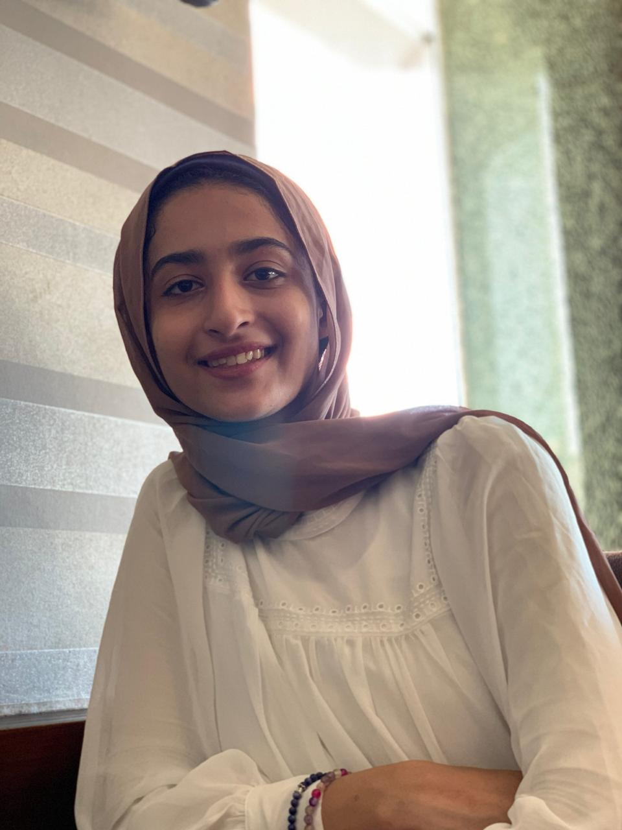

**Mariam yasir El-gharbawi …… Member**