**Update (2018-10-JAN)**

**Infoware(2018-10-JAN)**

**post review**

**After provider feedback for competition of job, customers can review the provider for their work.**

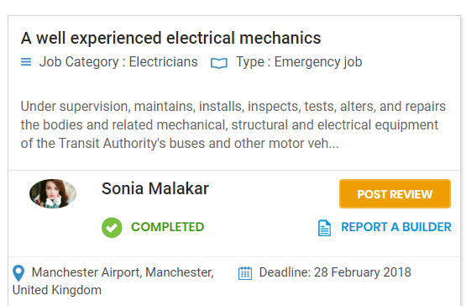

**Click ‘Post review’ button open a popup like below and he gives the review for the quality, price, on-time etc.**

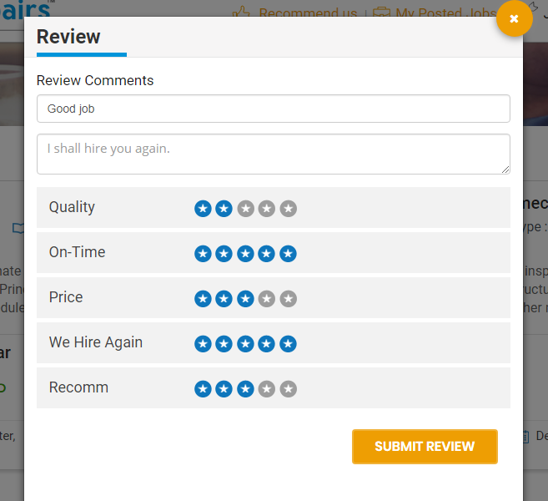

**Customer can only review the provider one time for a job. After successfully give the review the status of the job review changed to ‘reviewed’.**

**Customer can see the review from provider profile.**

**Provider**

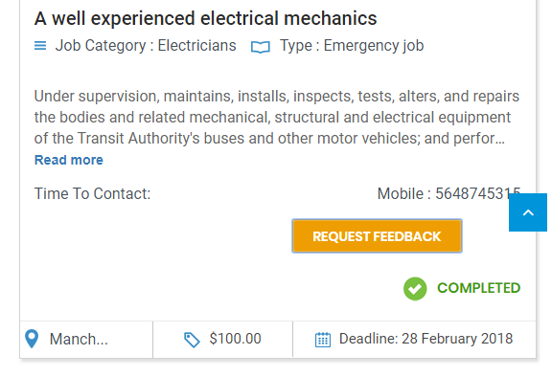

**Until the customer gives the review, provider could send a ‘request feedback’ for the customer review. For request feedback click on the ‘request feedback’ button to open a popup like below.**

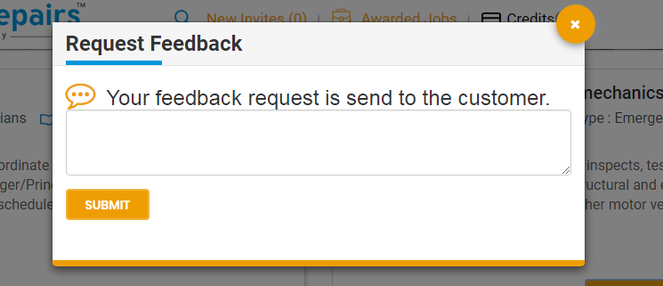

**Request feedback notification will be sent via mail to the customer.**

**Provider can see the individual review from ‘my-profile’ section (bottom of the page)**

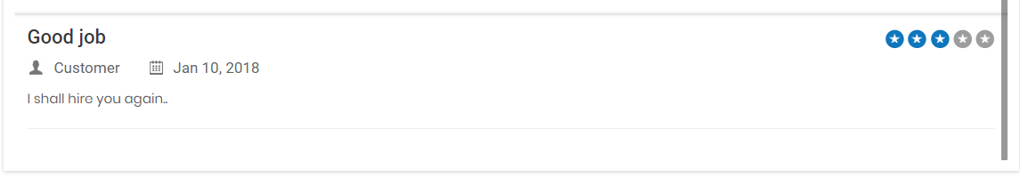

**Average review**



**In the header he/she can see the total average review and no of jobs win and total reviews give by the customer.**

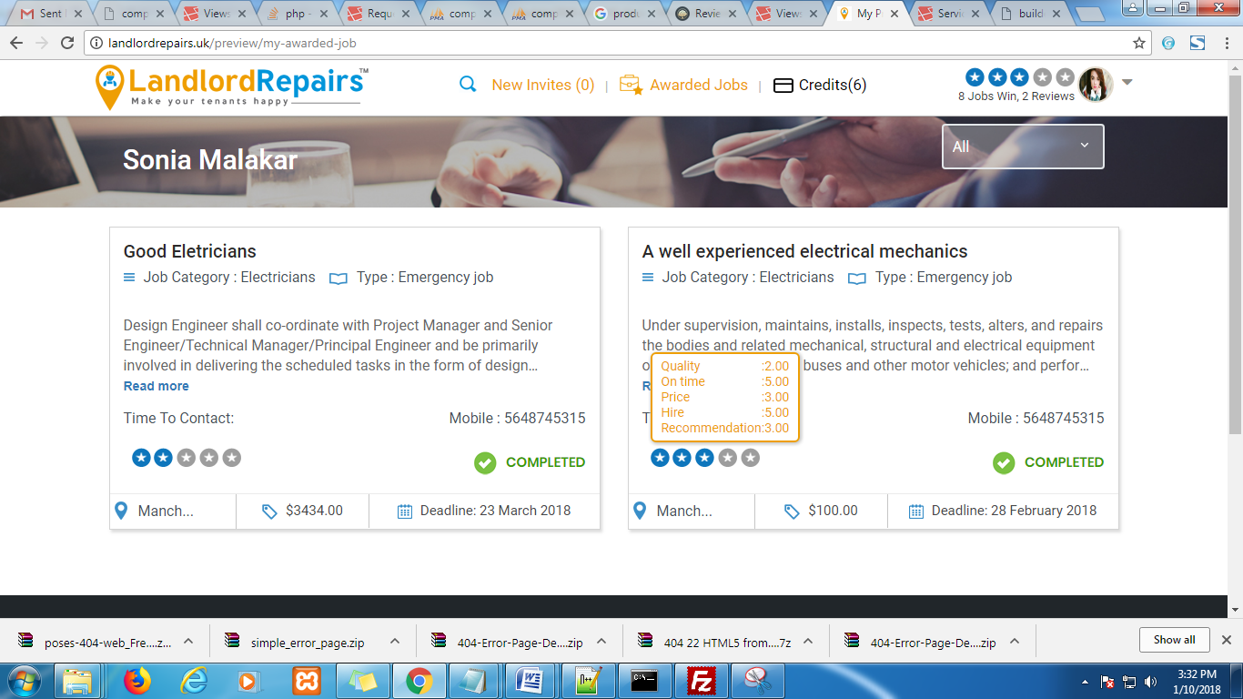

**From awarded job page provider can see the average review and individual review (on mouse over on the review icon) for the job.**

**Provider can filter the awarded job page by ‘this week’, ‘last week’, ‘last moth’**

**This week: 2018-08-jan to** .**2018-14-jan**

**Last week: 2018-01-jan to** .**2018-07-jan**

**Last moth: 2017-01-dec to 2017-31-dec**

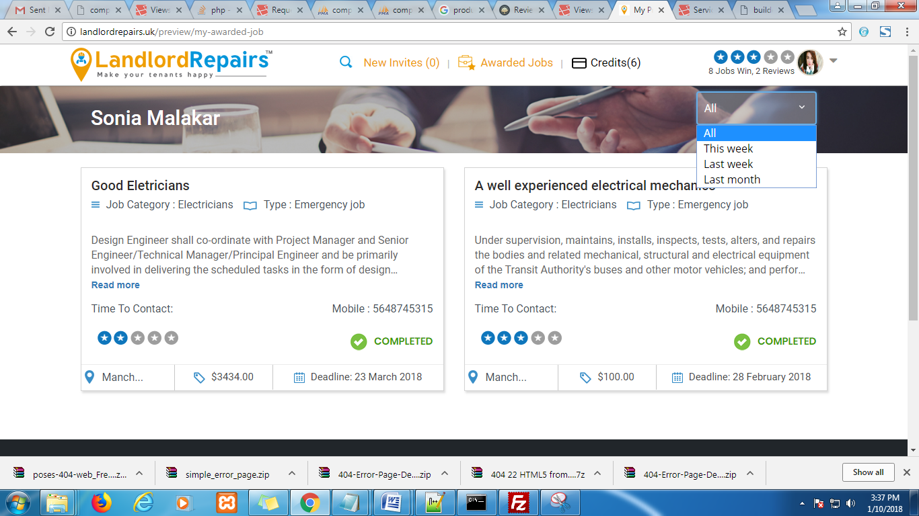

**Customer side**

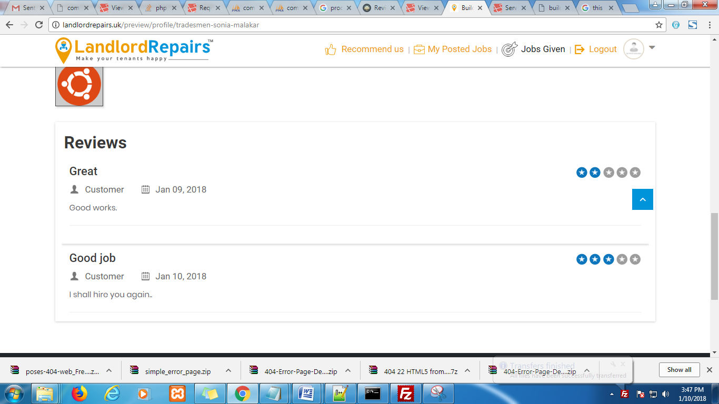

**Customer can see their review from that tradesman’s profile.**

**Also when customers invite or hired some provider they could see provider’s total average review.**

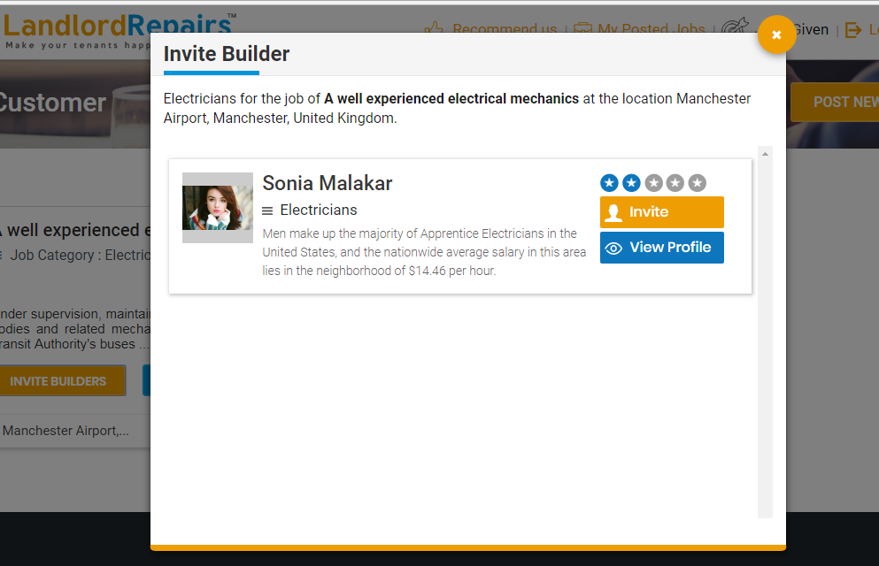

**After successfully job completion, customer can review or report against the builder.**

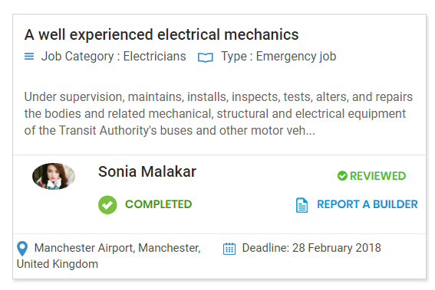

**Click ‘Report a builder’ open a popup, where you can write the report to admin for that builder.**

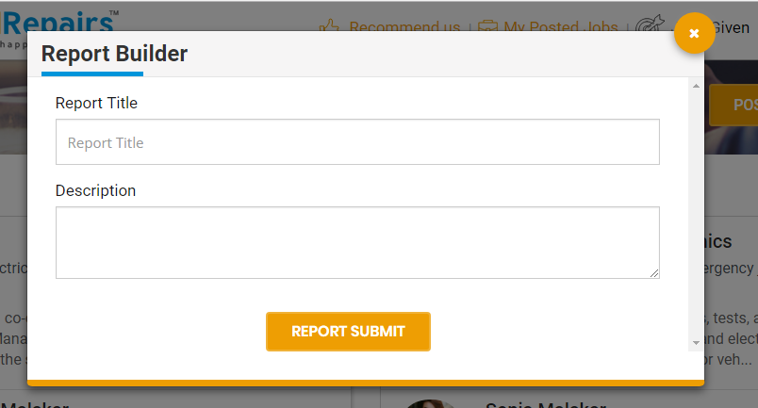

**Admin can see the reports from admin sections.**

**Customer can recommended other customer/tradesman for site.**



**Click ‘Recommended us’ on the header to open a pop up like below where you can recommended either a tradesman or landlords by sending an email to notify that person.**

