**Update (2017-12-DEC)**

Font End URL: <http://landlordrepairs.uk/preview/>

**Infoware(2017-12-DEC)**

**Customer Signup:**



**From home page any user can post any job by provide all details of job post form.**

**After fill up all job information click on next then this user go to the registration page for registration as a customer. If this user complete his/her registration then he/she will be the owner of the posted job and job status will be active. If the user does not complete his/her registration then the job status will be draft.**

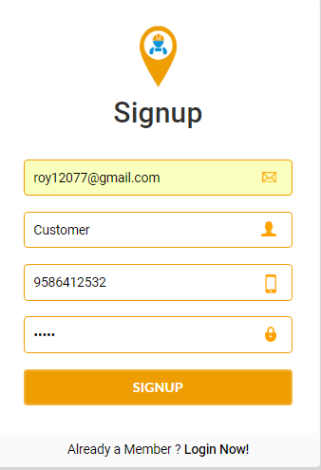

**After fill up the registration form click on “SIGNUP” button then a verification mail has been sent to the register email address and a mobile verification code has been send to the register mobile number.**

**This register user need to verify his email address and verify his mobile number then the user can login in this site.**

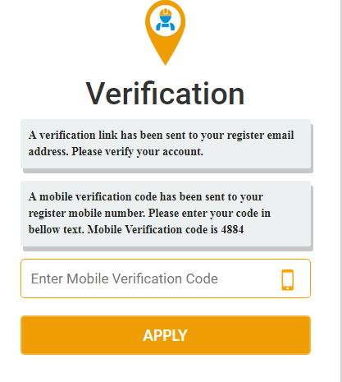

**Enter the verification code into the bellow text and click on apply for mobile verification.**

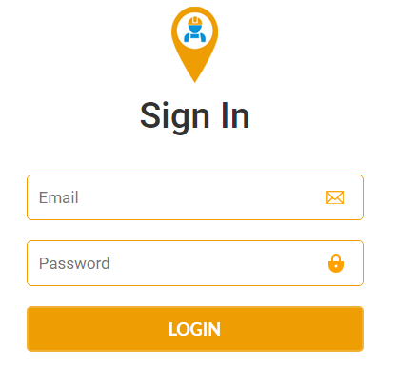

**Click on Login button for login in this site. Only the active user can login in this site.**

**After login as a customer the he can see his posted job from my post page.**



**Click on “Post New Jobs” the popup will be opened from where user can post a new job.**

**Click on Edit icon for edit job.**

**Click on Logout for logout from this site.**

**Tradesmen Signup:**

**Click on “Tradesmen Here” from home page.**



**Click on signup button from tradesmen page for sign up as a Tradesmen.**

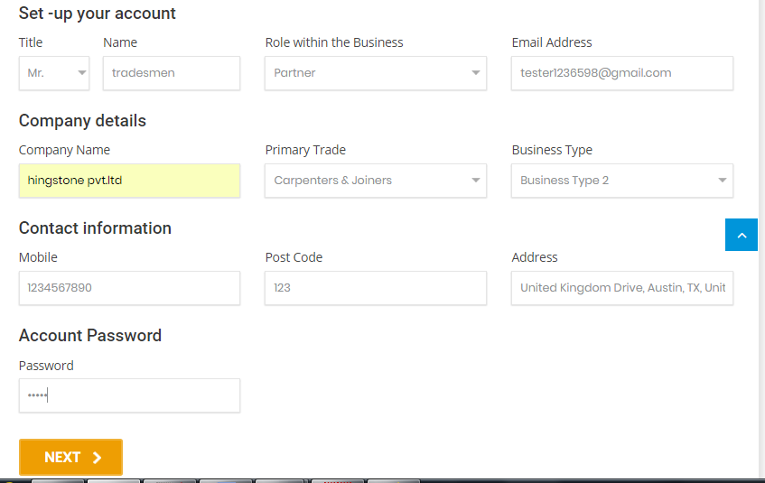

**Provide all information clicks on next button for identity verification.**

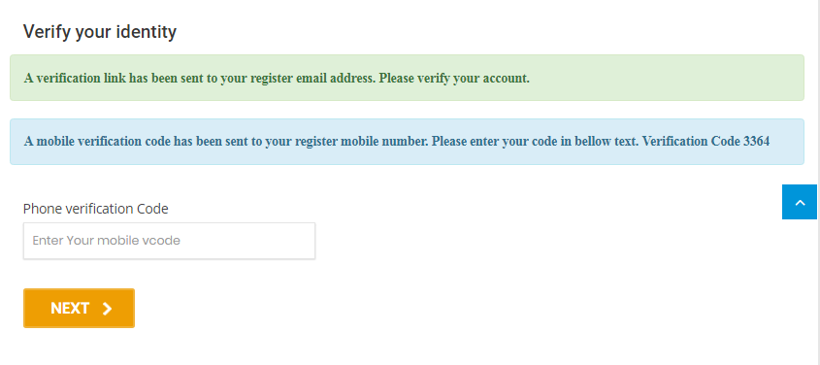

**From identity verification page you can your mobile number. Enter the verification code into the bellow text and click on next for payment page.**

