**Update (2017-13-DEC)**

Admin URL: <http://landlordrepairs.uk/preview/admin>

Username: [info@landlordrepairs.uk](mailto:info@landlordrepairs.uk)

Password: admin

**1- Book local builders trusted by landlords just like you!**

**Infoware(2017-13-DEC): Fixed.**

**2-** ON the United Kingdom - is possible to have cities or town?

**Infoware(2017-13-DEC): From job post area by default you can get the country state for UK.**

3- On the Zip Code —- Can we change to — Post Code.

**Infoware(2017-13-DEC): Fixed.**

4- I do not see the, image icon??

**Infoware(2017-13-DEC): At the time of job post from home page user can upload files by click on “Attach Files” .**

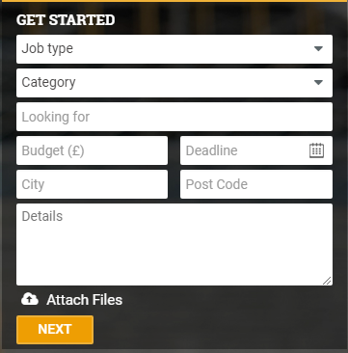

5- just tried to test i get this error Whoops, looks like something went wrong. (2/2) QueryException SQLSTATE[HY000]: General error: 1366 Incorrect integer value: 'rg9 2dr' for column 'zip_code' at row 1 (SQL: insert into `jobs` (`job_type_id`, `looking_for`, `budget`, `deadline`, `city`, `lattitude`, `longitude`, `zip_code`, `job_details`, `user_id`) values (1, carpenter, 100, 17-12-30, United Kingdom, 55.378051, -3.43597299999999, rg9 2dr, we need this done asap please, 0))

**Infoware(2017-13-DEC): Fixed.**

**Tradesman My Profile:**

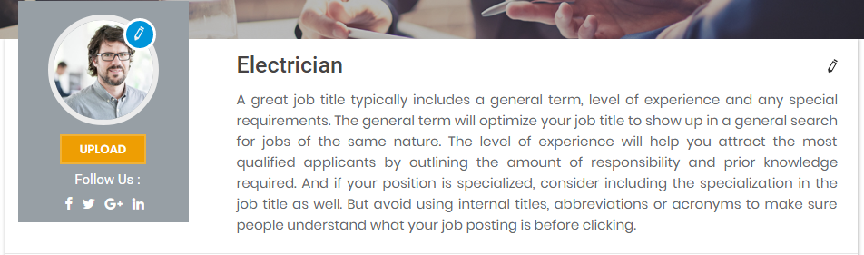

**Click on this edit icon for choose any image for change your profile picture. After choose any profile picture then click on upload button to change this picture.**

**Click on this edit icon then a form will be opened from where user can change his profile title and profile description.**

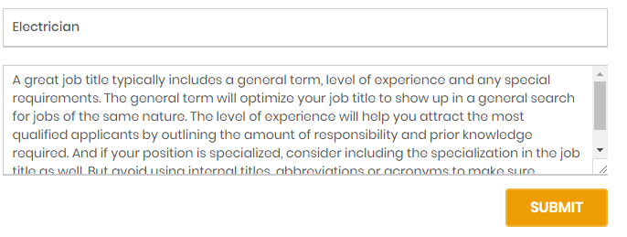

**After any modification click on “Submit” button.**

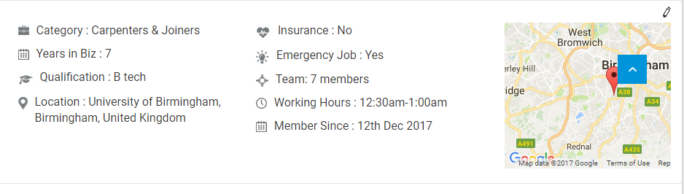

Click on this edit icon then a form will be opened from where user can change his personal information.

**After change value click on submit button.**

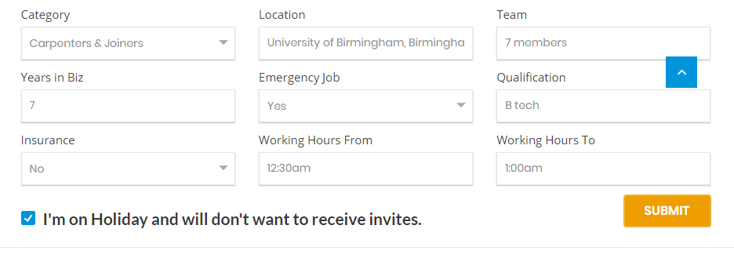

**After any modification click on “Submit” button.**

**Click on “Add New Portfolio” for add portfolio picture. After click on this button a popup will be opened from where user need to add two image for after and before and give the caption for after before image then click on submit.**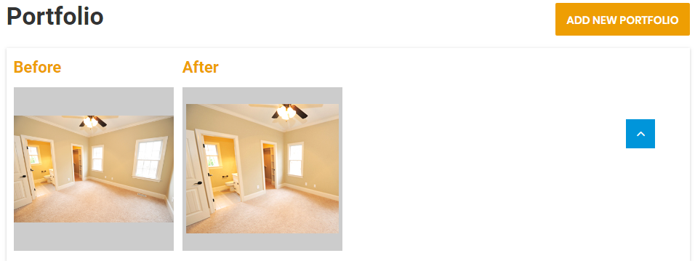

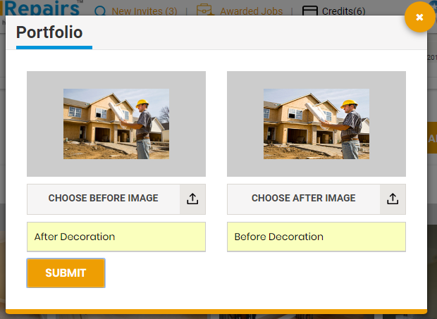

**Click on Edit icon for edit user qualification**

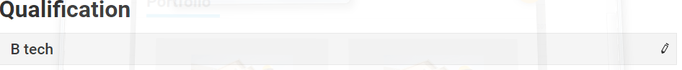

**Click on”Add New Logo” for add any logo. After click on add logo button a popup will be opened from where user can add new logo.**

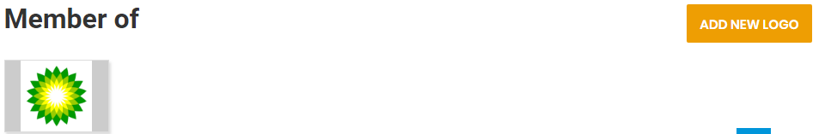

**Admin Panel:**

**Click on “Customer” under the menu User Management.**

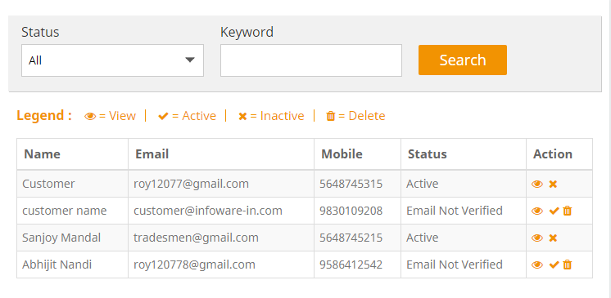

**Click on active/inactive icon for active and inactive any user.**

**Click on “View” icon for view the detail of any customer.**

**Click on delete icon for delete any customer. You can delete that customer who has not verified by their email or phone number.**

**Admin can search customer by their user name or email address of user status.**

**Click on “Tradesmen” under the menu User Management.**

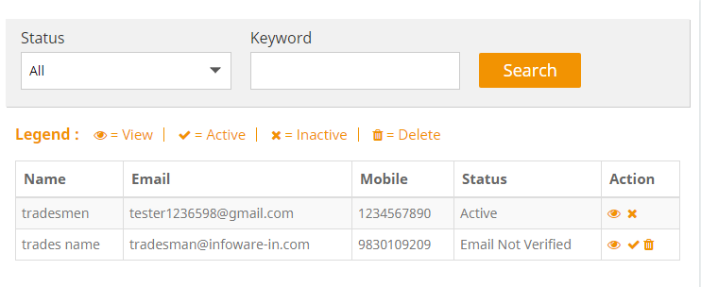

**Click on active/inactive icon for active and inactive any user.**

**Click on “View” icon for view the detail of any tradesmen.**

**Click on delete icon for delete any tradesmen. You can delete that tradesmen who has not verified by their email or phone number.**

**Admin can search tradesmen by their user name or email address of user status.**

**Click on “Package” under the menu Package Management.**

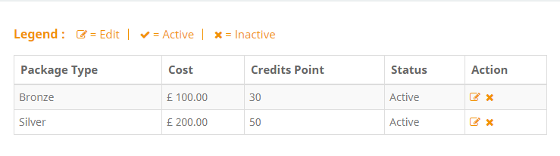

**Click on active/inactive icon for active and inactive any package.**

**Click on “Edit” icon for edit any package.**

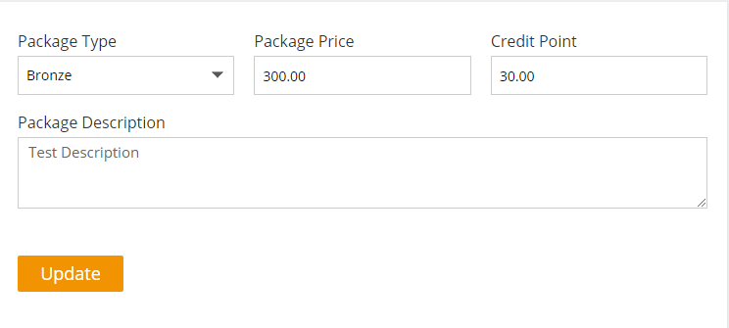

**After edit in edit package page click on “Update” button for update package.**