Update (2018-09-JAN)

Font End URL: <http://landlordrepairs.uk/preview/>

**Infoware(2018-09-JAN)**

My Jobs

URL: http://landlordrepairs.uk/preview/my-jobs



Click on ‘My Posted jobs’ to landing the below page.

Click to create a new job. Open the below popup and you fill up with the related details, then submit it, to post a job.

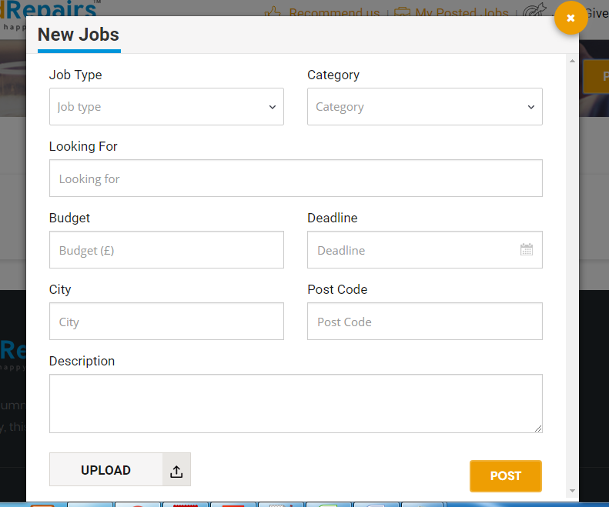

After posting your job you can see it from here, like below

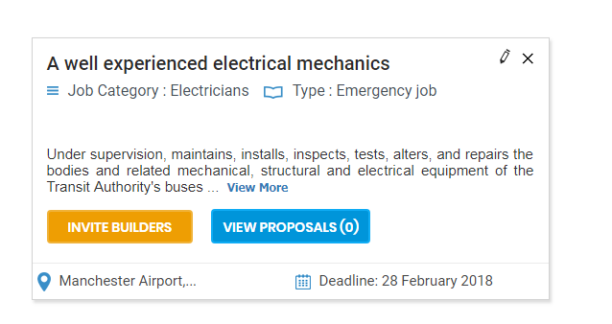

Click ‘view more’ button to see the full description of the job.

Click ‘Invite builders’ to open a pop like below.

Click to edit this job.

Click here to delete this job.

Edit and delete option only be available before sending(invite) any proposal to the builders. 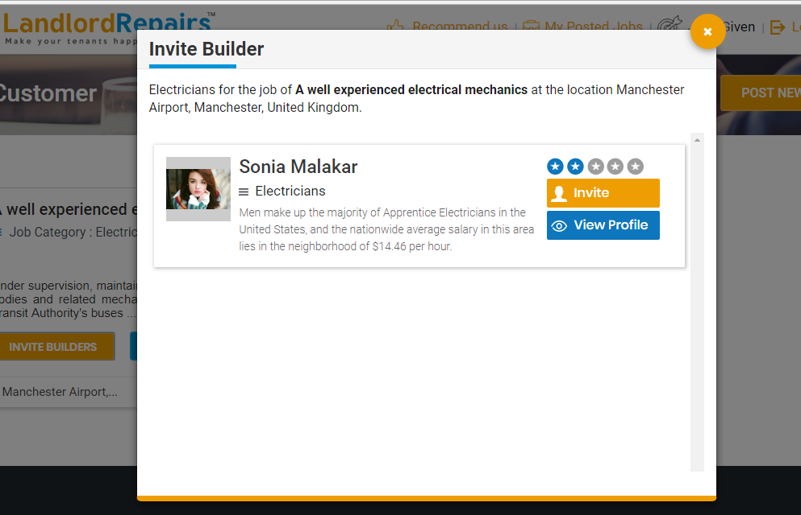

The invite builders list has been generated by the category of the job and within 20 miles of the job location.

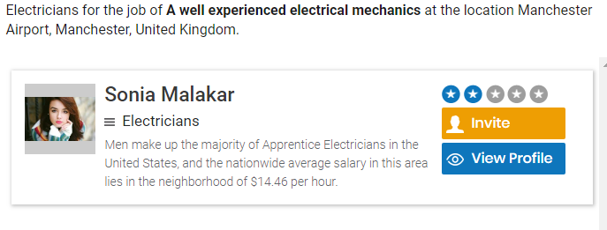

Click on ‘View profile’ to open the builder profile on separate tab.

Click on ‘Invite’ to builder get notified, corresponding notification mail will be sent for the job and the button is changed into ‘invited’(like below).

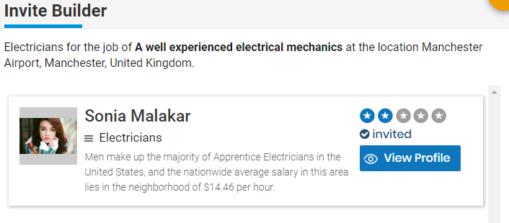

View proposal

http://landlordrepairs.uk/preview/my-invited

**On the builder side** name ‘Sonia Malakar’ see a notification on ‘new invitation’ menu.



One new invitation is came for the job.

Click on ‘New Invitation’ landing to the below page.



Click on ‘Respond ’ button to submit your quote for that job with details(Price, start date, description ..etc). and a notification mail will be sent to the customer.

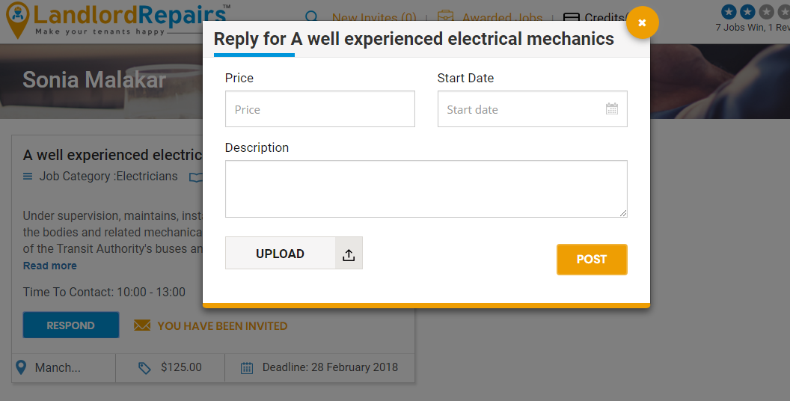

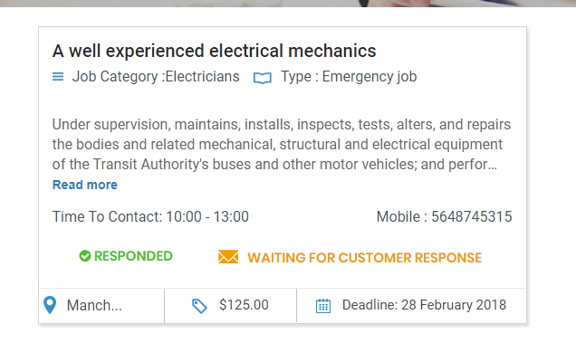

After responded for the job builder has to be wait for the customer response.

**On the customer side**, the proposals for the job have been listed.

URL: http://landlordrepairs.uk/preview/my-jobs



Here you can see the no of proposal sent by the builders.

Click here on open a popup window.

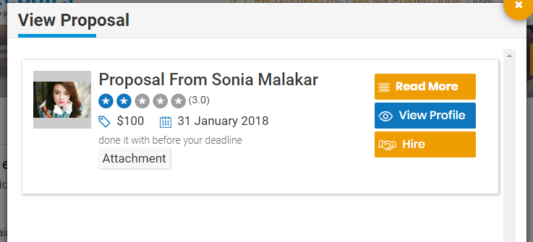

On view proposals you can see the details of the proposal like above. The builder name ‘sonia malakar’

will take $100 and she will be started the work from 31st January to complete the job within deadline.

Click on ‘read more’ to see the proposal details of that builder.

If you hired ‘Sonia Malakar ’ rest of the proposal will automatically be rejected and a notification mail has been sent to the builder.

url:http://landlordrepairs.uk/preview/jobs-given

If you hired a builder for the job then the job is moved to ‘job given’ section



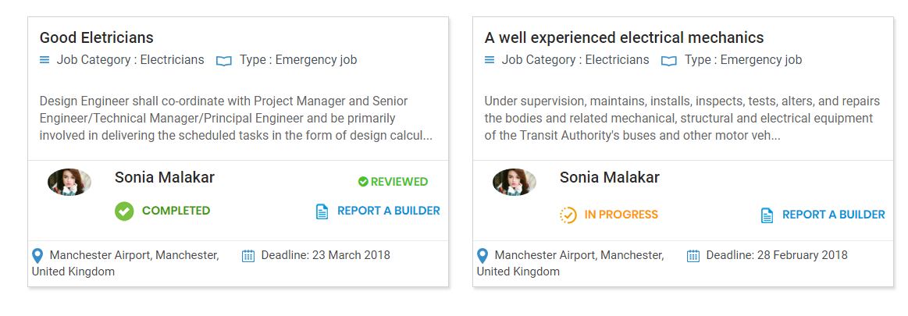

Customer can see it is ‘In Progress’.

URL:http://landlordrepairs.uk/preview/my-awarded-job

On the Builder side, the job is viewed from ‘Awarded jobs’ sections.



When the builder will complete the job he mark the job as completed.

To mark complete click on ‘Mark Complete’ button open a pop up like below.

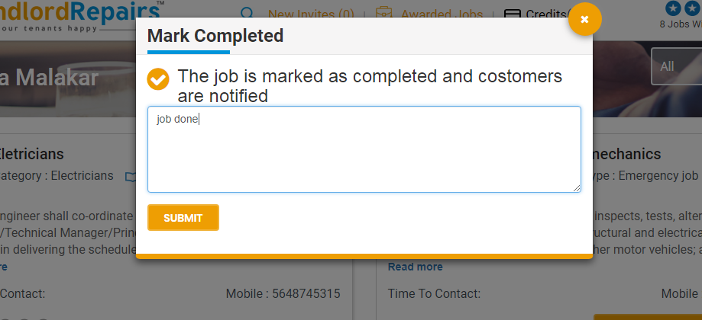

To submit the above post customer get notified for the job competition.(via mail also)

On the Customer side.

http://landlordrepairs.uk/preview/jobs-given

Customer can see that the is being done.

