Update (2018-24-JAN)

Font End URL: <http://landlordrepairs.uk/preview/>

**Infoware(2018-24-JAN)**

Memships Implementations

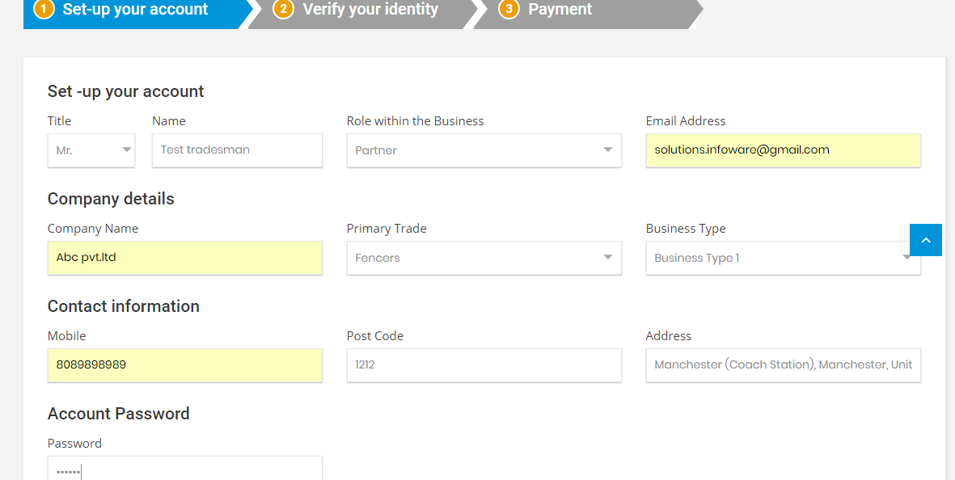

On tradesman signup process after your set-up you will further proceed for verify your identity if email verification and mobile verification is succeed you will see the payment/membership section.

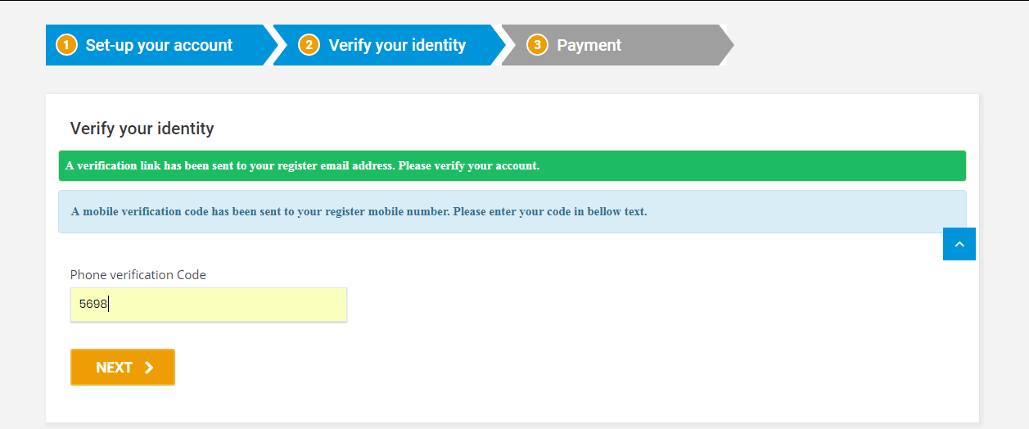

As mobile verification not yet implanted you can proceed with mobile code-5698

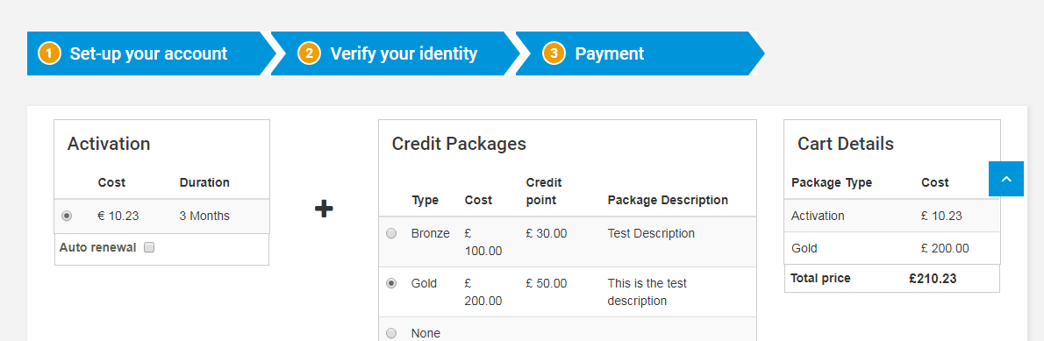

In membership activation is automatically added in your payment cart and with the addition(optional) credit package (Bronze, Gold) you can also add in your cart.

If you select auto renewal, system automatically renew the activation package after three months.

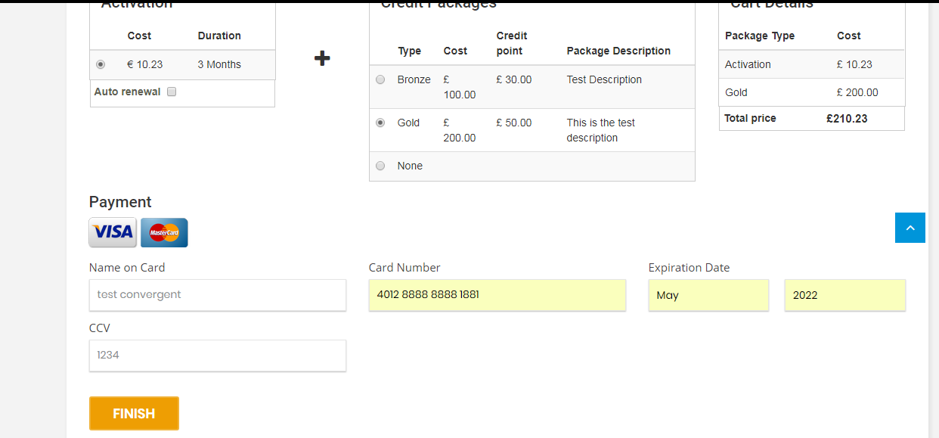

For payment you can fillup with your credit card details and click ‘Finish’ to submit your details.

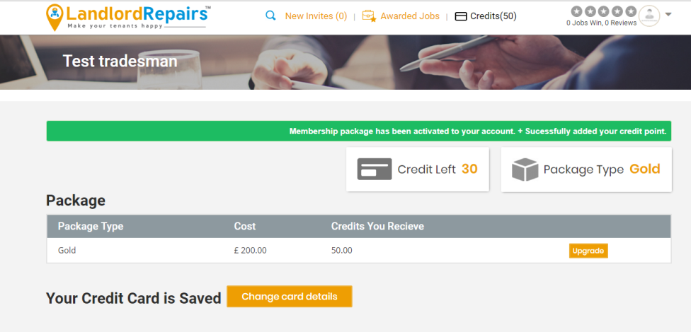

After payment, system automatically credits your point for the corresponding package.

Static content (not yet implemented):-Change card details, Credit left, upgrade

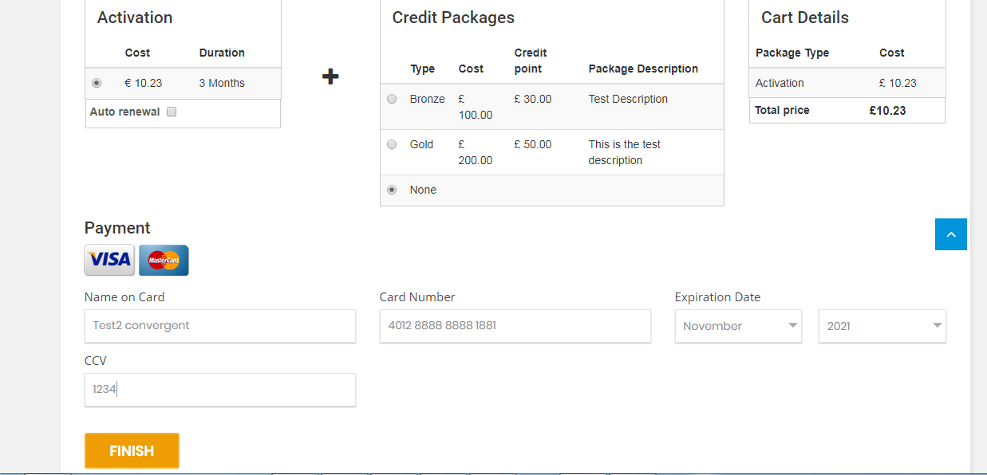

when only you can buy the activation package system redirect to the credit page without credited any point.

From there you can buy your credit packages.

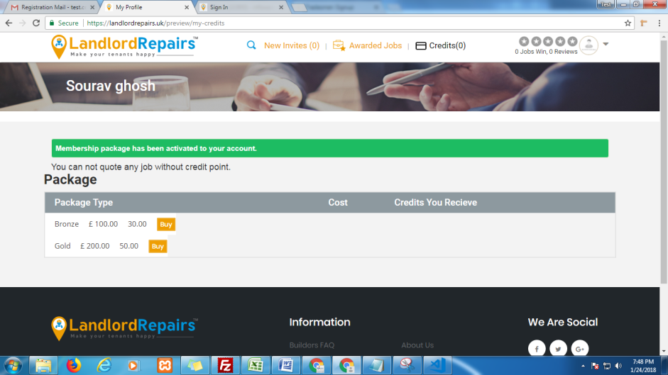

Click on ‘Buy’ to open the below pop of credit card details form. Form here you can buy the credit package and the corresponding point credited to your account.

