**Update (2017-14-DEC)**

**Admin Update:**

1- i had a look at at the admin - On the Dashboard- is missing things like - todays new user ,

builders - landlords - upcoming expiring account - todays booked jobs and builders - new

booked jobs - Users profile on the admin side is missing lots of small info as this is Laravel

admin there is lots of templates of lots of basic features i do not see that on our admin ?

**Infoware(2017-14-DEC):**

2- On the user side we are missing posted jobs- todays booked jobs - last visited the site type

of the posted - non email sent to the user - so on. Who the user awarded the job to - booed

builders.

**Infoware(2017-14-DEC):**

3- We are missing - pages edit pages - add new pages - so on .

**Infoware(2017-14-DEC):**

4- Admin profile is missing name email change email - add subadmin -premisson type ? remove

subadmin ban subadmin .

**Infoware(2017-14-DEC): Click on menu “Change Credential” from admin left menu for change the admin credential such as admin username and password.**

5- On the Builders side dashboard -

5A- booked builders today this week this month , 3 months ago 6 months ago - 12 month ago

so on.

**Infoware(2017-14-DEC):**

5B- profile - is missing reviews profile pic- member since- package type - next payment so

on .

**Infoware(2017-14-DEC): Done.**

5C- map - all the basic things i do not see much on the admin??

**Infoware(2017-14-DEC):**

6- I try agin to reg the step 1 works i will re test it after i active my twilio account so i see

the text alerts coming from them. in less is ok to do it now ?

**Infoware(2017-14-DEC): If any user do not verify by his email or his mobile number then admin can approve this user from admin panel by click on approve icon. After approve any user by admin then the user can login from this site.**

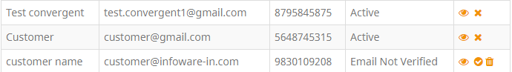

6A- please see the list of categories. 6B- how the builder will add the social links?

Bathroom Fitters

Bricklayers

Carpenters & Joiners

Carpet fitters

Chimney & Fireplace Specialists

Conservatory Installers

Conversion Specialists

Damp Proofing Specialists

Demolition Contractors

Driveway Pavers

Electricians

Extension Builders

Fencers

Flooring Fitters

Gas Engineers

Groundworkers

Handymen

Heating Engineers

Insulation Installers

Kitchen Fitters

Landscape Gardeners

Loft Conversion Specialists

Painters & Decorators

Plasterers

Plumbers

Roofers

Security System Installers

Stonemasons

Tilers

Tree Surgeons

Window Fitters

**Infoware(2017-14-DEC): Done.**

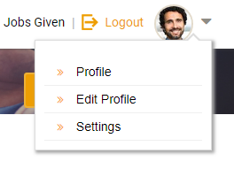

**After login as a customer click on “Edit Profile” for edit customer details.**

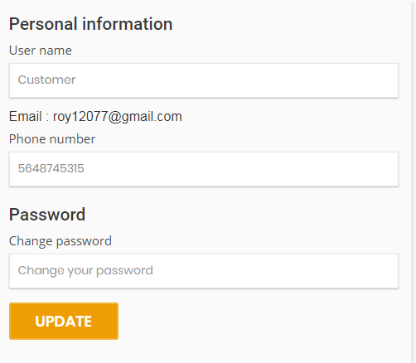

**From edit profile page customer can change his username mobile number and password.**